***Original Research Article***

**"Studies on the extraction of DNA from human: Resourceful material for the identification"**

**The title can be improved**

**ABSTRACT**

The extraction of DNA from human samples is a pivotal process in forensic science, medicine, and genetics, serving as a resourceful tool for identification purposes. This study explores various methods and techniques employed in DNA extraction from human tissues, focusing on their efficiency, reliability, and applicability in different contexts. Additionally, the impact of sample quality, degradation, and contamination on DNA yield and integrity is discussed. Change the abstract focusing more on your study.**INTRODUCTION**

The extraction of DNA from human samples is a critical process in forensic science, medicine, and genetic research, as it provides a unique resource for human identification *(*Barash *et al*., 2024). DNA, as the genetic material of an individual, carries unique markers that can be used for a wide range of applications, including criminal investigations, paternity testing, and genetic diagnostics (*Forensic DNA Typing: Biology, Technology, and Genetics of STR Markers, Second Edition | Office of Justice Programs*, n.d. make the reference in the journal format). The importance of accurate DNA extraction techniques cannot be overstated, as they form the foundation for subsequent analyses such as polymerase chain reaction (PCR) and sequencing, which are essential for human identification (Gupta, 2019).

Various methods have been developed for the isolation of DNA from human tissues, with protocols continually evolving to improve yield, purity, and reliability. Traditional methods, such as organic solvent-based extractions, have been widely used due to their simplicity and cost-effectiveness (Gupta, 2019). However, these methods can sometimes result in low yields or contamination, especially in challenging samples like degraded or ancient forensic evidence (Shah et al., 2017). To address these challenges, newer techniques, such as silica-based column extraction and magnetic bead-based methods, have been introduced, offering higher efficiency and reducing the likelihood of contamination (Haarkötter et al., 2023).

Despite the advances, challenges persist, particularly in forensic applications where evidence may be degraded, contaminated, or available in small quantities. The condition of the sample plays a crucial role in the success of DNA extraction, with factors such as DNA degradation, contamination from environmental sources, and inhibitor presence all affecting the quality and yield of extracted DNA (Bhoyar et al., 2024). Thus, the optimization of extraction methods, especially for compromised samples, remains a key area of research.

This paper explores the various DNA extraction methods from human samples, focusing on their relevance and effectiveness in human identification. this research aims to contribute to the development of more efficient and reliable protocols for human identification. The paper also examines emerging trends in DNA extraction technology and its implications for the future of forensic investigations and genetic testing.

1. **MATERIAL AND METHOD**

**2.1 Sample Collection**

For forensic DNA related issues, the procedure consists of three major steps: extraction of DNA from the samples, PCR amplification of the target DNA sequences and lastly fragment analysis of PCR products using Gel electrophoresis. However, when the substrate for DNA profiling comprises fixed specimens, the isolation of DNA remained the most time consuming and tedious step of the analysis process. The first crucial step in DNA extraction starts with the collection of the sample followed by its appropriate storage. as shown in **Fig.1.** human saliva and cigarette butts of 7 persons were used as resource materials for the criminal identification in the current study.

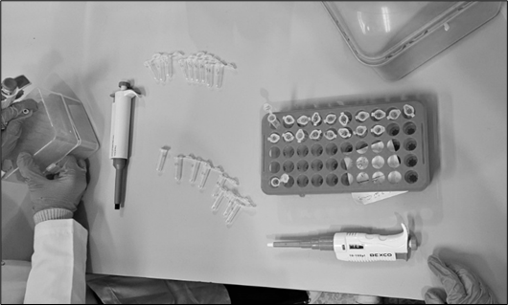

**Fig.1.** Pre-processing for DNA sample collection.

Initially the washed tissues instead of tissue use the word sample were divided into 3 equal parts in order to subject them to 4 independent extraction protocols which include:

1. Phenol Chloroform extraction
2. Salting out extraction
3. Cetyl tri ammonium bromide (CTAB) extraction and mention 4th extraction method

However, one protocol (CTAB) was abandoned due to the repeated failure in extracting any DNA from the tissues as no DNA was noticed on the gel material following gel electrophoresis. Excluding CTAB extraction protocol, other 3 extractions protocols were standardized for the liberation of DNA. Pertinently the standardized protocols that were followed during initial attempts/trials failed to give any positive results of DNA retrieval. While there has been a significant variation in the DNA recovery protocols of different laboratories, it is emphasized that one should optimize the protocols within the means of the individual laboratory (Hedman et al., 2021). Accordingly, a protocol was chosen after deciding the final conditions of proteinase K concentration, incubation temperature, incubation period and complete homogenization of the tissue (Meizarini et al., 2023). However, when standardized phenol chloroform extraction failed to give satisfactory results particularly for aged specimens, the technique was further modified for the liberation of DNA in all the circumstances irrespective of the duration of fixation (Liu et al., 2022). Accordingly, three versions of standardized phenol chloroform method of extraction were attempted and developed thereby making a total of five extraction methods (Shin, 2013). While the tissues were divided into equal parts, variations due to cellularity among some of the tissue sections cannot be excluded. Hence in all the later attempts, tissues were divided into 5 equal parts. Each tissue part was thereafter subjected to an independent extraction protocol after complete homogenization using different various set of reagents/chemicals.

* 1. **Materials required**

Chloroform (99.8%), iso-Propyl Alcohol (99.8%), Ammonium Acetate (98%), Acetone (99.8%), Dithiothreitol (DTT) (99%), Sodium Chloride (99.5%), Glycine (99.5%), Phenol (99.5%), Ethylene Diamine Tetra Acetic Acid (99.5%), Hydrochloric Acid (36.5%) were bought from LobaChemie; Proteinase K, Sodium Acetate, Sodium Chloride, Tris, Sodium Dodecyl Sulphate, Phenol Chloroform isoamyl alcohol mixture, Isoamyl alcohol, Sodium hydroxide pellets, Potassium Chloride, Ammonium Acetate, Monopotassium phosphate, Sodium phosphate dibasicwere procured from Hi Media; Ethanol was taken from Merck Germany; Sodium Lauryl Sulphate “Ultra Pure” was purchased from Otto; QIAamp® was acquired from Qiagen (Germany).

**2.3 Protocols used for DNA extraction**

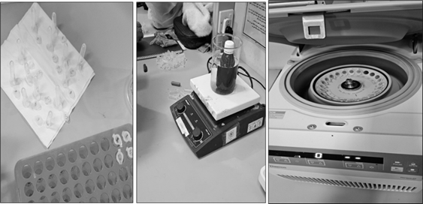

**Fig.2.**Tissue sections prepared for DNA extraction.

Each tissue section prepared at step is shown in **Fig.2.** was subjected to an independent DNA extraction protocol using various reagents. The DNA extraction methods employed in this investigation along with the usual steps followed in independent extraction protocols are as follows.

**2.3.1 Salting out DNA extraction protocol**

For salting out extraction method, the protocol of Rivero *et al*., 2006 and Funabashi *et al*., 2012 was followed but with some modifications. The steps followed were:

Prior to any addition, a tissue was finely chopped using a clean sterilized surgical blade. Following this 1000µl of digestion buffer (10mM Tris-HCl, 1.0mM EDTA and 0.5% Tween 20 at a pH=8.0,) was added to this chopped tissue and was additionally subjected to homogenization using a tissue homogenizer. The homogenized tissue was transferred to a sterilized falcon tube and followed by adding 20mg/ml proteinase K to it. The tubes were then left for overnight incubation (up to 36 hours in some cases) at 56 oC. After the completion of this period, incubation temperature was extended to 95 oC for 10 -25 minutes (usually 15 minutes) for inactivating the proteinase K activity. 400 µl of Ammonium acetate was added to the tube and was again incubated for 10 minutes at 20oC. Following this, step, tubes were briefly vortexed and centrifuged for 12 minutes at maximum speed. The supernatant was then transferred to a new tube and 600 µl of isopropanol was added to this tube. Following this addition, the tube was briefly vortexed and centrifuged at maximum speed for 35 minutes. After the completion of centrifugation, the supernatant was discarded and 250 µl of 70% ethanol was added to the tube containing the pellet. The pellet was washed twice with 70% ethanol. The ethanol was discarded after being used for the washing of the pellet and consequently the pellet was left for air drying. Once the ethanol was completely evaporated, 80 µl of TE solution was added to the pellet and was briefly vortexed. The tube was again incubated at 56 oC for 15 minutes with a view to dissolve the DNA in the TE solution and was thereafter stored in -20 oC. A part of this diluted DNA was subjected to gel electrophoresis and spectrophotometric analysis.

**2.3.2 Phenol chloroform extraction protocol**

A single validated protocol for Phenol-Chloroform extraction was developed by modifying existing methods. The process involved adding TNE buffer to washed tissue, mincing it finely, and homogenizing it. Proteinase K was then added, followed by a 72-hour incubation at 60°C. After incubation, samples were vortexed, centrifuged, and processed for DNA extraction. When this method failed for aged specimens, three modified versions were developed.

The steps of Phenol chloroform method of DNA extraction in its three versions are:

*2.3.2.1 Phenol chloroform extraction (Version-I) protocol*

The DNA extraction process involved adding a phenol/chloroform/isoamyl alcohol mixture to the sample, followed by vortexing and centrifugation. The supernatant was transferred to a new tube while discarding protein debris. This step was repeated with another round of phenol/chloroform/isoamyl alcohol, followed by chloroform/isoamyl treatment twice. The final supernatant was collected for DNA precipitation using sodium acetate or sodium chloride along with cold ethanol, incubated at -80°C for 5 hours or -20°C overnight. After ethanol washes and drying, the DNA pellet was resuspended in TE buffer, incubated at 55°C, and analyzed using gel electrophoresis and spectrophotometry.

*2.3.2.2 Phenol-chloroform extraction (Version-II) protocol*

This modified DNA extraction method used only a phenol/chloroform mix (1:1) initially instead of phenol/chloroform/isoamyl alcohol. After vortexing and centrifugation, the supernatant was transferred to fresh tubes through multiple rounds of phenol/chloroform and phenol/chloroform/isoamyl treatments, followed by additional chloroform/isoamyl washes. DNA precipitation was carried out using 0.1M NaCl (1:5) or isopropanol, along with cold ethanol. After incubation at -80°C for 5 hours or -20°C overnight, ethanol washes were performed, and the DNA pellet was dried at room temperature. The DNA was resuspended in TE buffer, incubated at 55°C, and analyzed using gel electrophoresis and spectrophotometry.

*2.3.2.3 Phenol chloroform extraction (Version-III) protocol*

When formalin-preserved specimens were processed using the previous Phenol/Chloroform extraction methods, DNA recovery significantly declined or failed. To minimize DNA loss, instead of discarding the leftover bottom material (protein debris), it was collected in a fresh tube at each stage. After completing the standard extraction steps, 1000 µl of chloroform/isoamyl alcohol (1:1) was added, followed by vortexing and centrifugation. The supernatant was then transferred and treated again with 500 µl of chloroform/isoamyl alcohol. DNA was precipitated using isopropanol instead of NaCl. After centrifugation, the pellet was washed twice with 70% ethanol, air-dried, and resuspended in TE buffer. The DNA solution was incubated at 56°C for 15 minutes before storage at -20°C. The extracted DNA was analyzed using gel electrophoresis and spectrophotometry.

**2.4 Pre-processing of paraffin embedded tissues for DNA extraction**

For paraffin-embedded specimens, a tissue portion was excised with a sterile blade and placed on a cleaned microscope slide. The slide was heated on a hot plate to melt the paraffin, after which the tissue was carefully separated and transferred to a new slide. Further heating helped remove residual paraffin. The tissue was then washed in 70% alcohol, followed by 95% alcohol. Due to the small tissue size, only two DNA extraction methods were used: the Salting Out method and a commercial kit (mention the 5th method of isolation commercial kit), following previously discussed protocols.

**2.5 DNA integrity**

**Agarose gel electrophoresis:** A 1% agarose gel was prepared by dissolving agarose in 1X TAE buffer, heating, and adding Ethidium Bromide (EtBr) before setting at room temperature. Once set, the gel was placed in a running tank with 1X TAE buffer. Extracted DNA was mixed with loading dye and loaded into wells, though DNA ladders were later omitted. Electrophoresis was run at 100V for 30-50 minutes. The DNA, bound to EtBr, fluoresced under UV light and was imaged. Only DNA verified through visualization was stored at -20°C for spectrophotometric analysis, while non-authenticated samples were discarded.

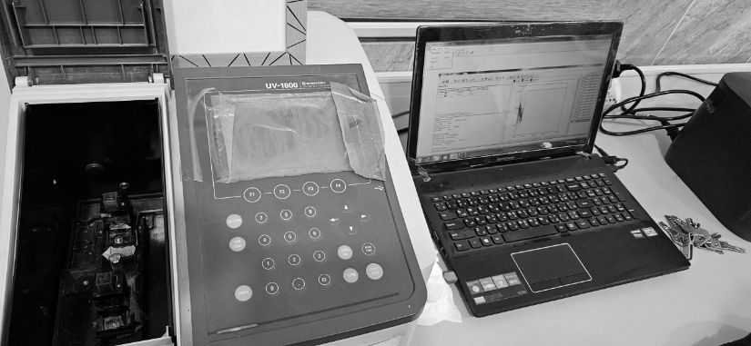**2.6 Quality control assessment using UV spectrophotometer**

**Fig.3.** UV Spectrophotometer.

Ultraviolet spectrophotometry (UV) (**Fig. 3**) was used for DNA quantification using the Evolution 60S Thermo Fisher Scientific spectrophotometer. DNA samples were placed in a quartz cuvette, and absorbance was measured at 260 nm (A260) for nucleic acid concentration and 280 nm (A280) for protein contamination. The DNA purity was determined by the A260/A280 ratio, with values ≥1.8 considered relatively pure. DNA concentration was calculated using the formula: **Concentration (µg/ml) = A260 × dilution factor × 50 µg/ml**.

While UV spectrophotometry is simple and requires minimal purified DNA, it has limitations, especially for low-yield samples from formalin-fixed tissues, where dilution is impractical due to degradation. Only DNA samples with an A260/A280 ratio between **1.8-2.0** were selected for PCR analysis.

**2.7 PCR Amplification**

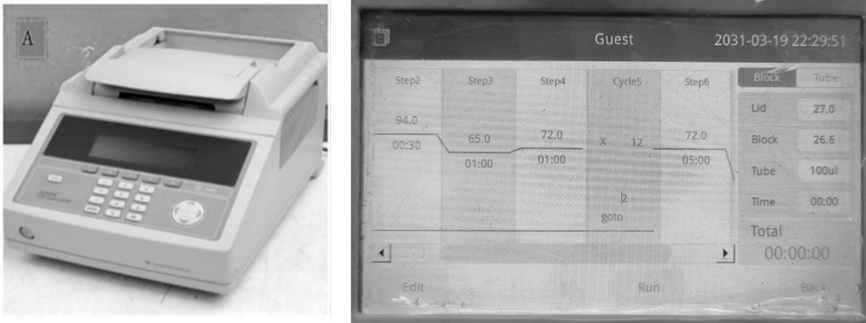

**Fig.4.** PCR thermal cycler and PCR programming.

Samples with an absorbance (A260/A280) ratio in between 1.2 - 1.8 were selected for the PCR amplifications. GlobalFiler® PCR Amplification Kit (Life Technologies) was used for the amplification of DNA extracted from fixed specimens. All PCR assays were conducted using 5 µl of DNA, 7.5 µl of Primer mix, 2.5 µl of Master Mix. The amplifications were performed as per the standardized protocol on a 9700 thermal cycler (**Fig. 4**) specific for degraded samples using up-to 40 PCR cycles (Life Technologies).

Perform a statistical analysis where the five methods can be compared with each other in terms of DNA quality and quantity and also compare the DNA quality and quantity in terms of type of sample collected Cigarette bud and saliva in order to improve the effectiveness of the study.

1. **RESULT AND DISCUSSION:**

**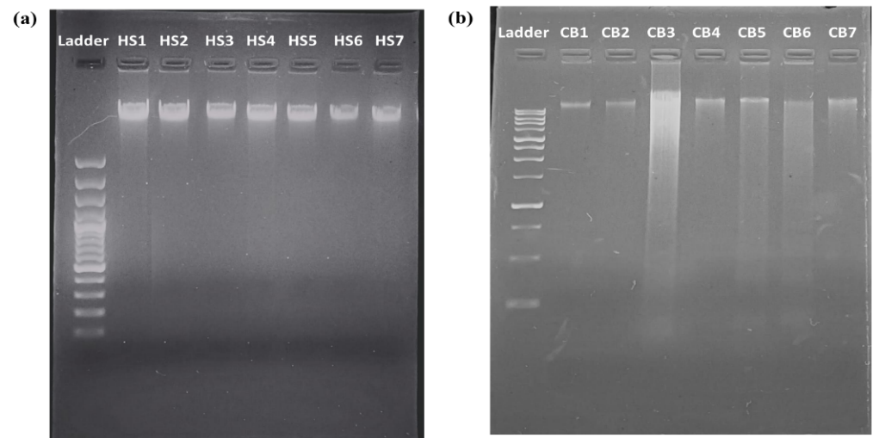  
Fig.5.** Gel electrophoresis of the DNA obtained (a) Human saliva samples (b) Cigarettebud samples.

The DNA bands visualized under UV transmitter chamber is shown in **Fig.5.** in which image (a) is of DNA from human saliva and (b) is DNA obtained from cigarette buds. Mention from which methods the samples came and also mention the negative sample in pictures

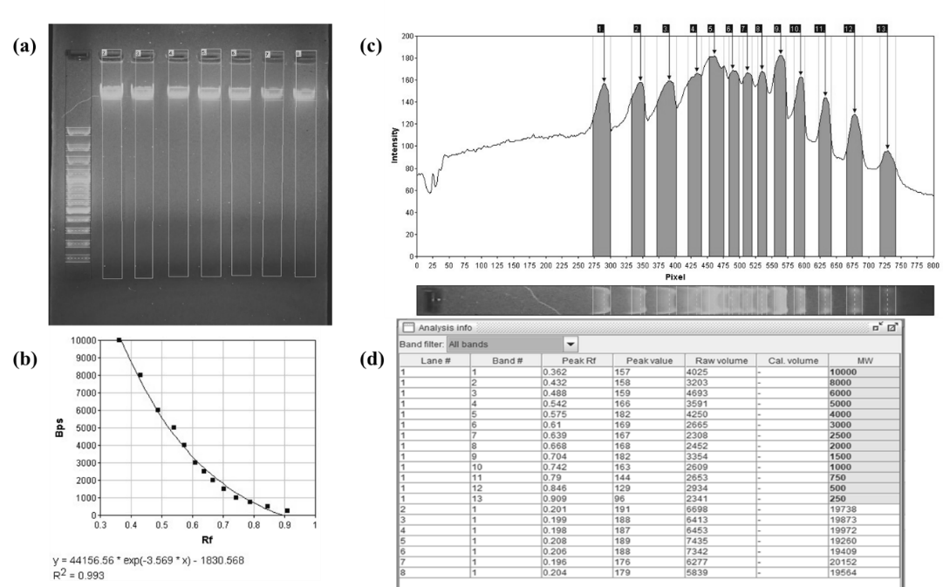

**Fig.6.** Gel analysis of DNA obtained from Human saliva samples.

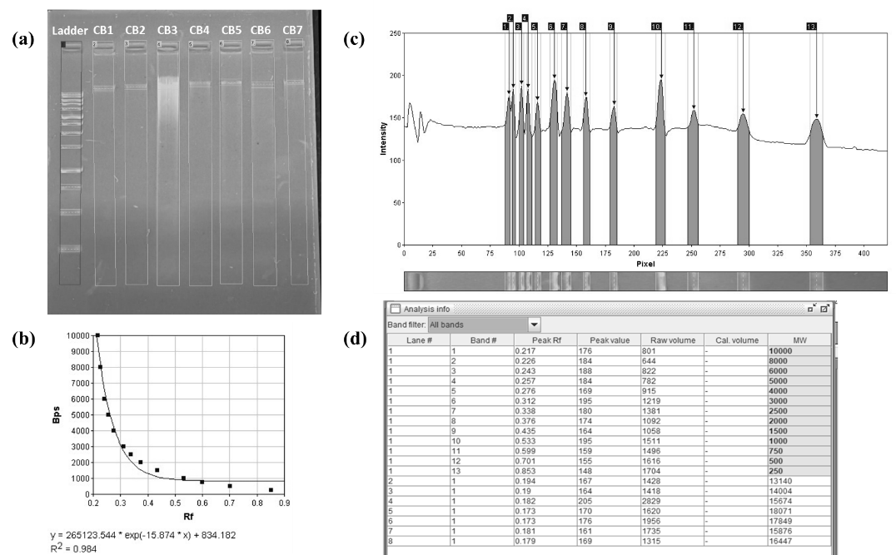

**Fig.7.** Gel analysis of DNA obtained from Cigarette bud samples.

**Fig.6 and Fig.7.** shows the gel analysis of DNA obtained from human saliva samples in which (a) represents the detection of lanes of the DNA run, (b) shows the calibration curve, (c) detection of bands in form of peaks; (d) is the analysis information which shows the result of size of band.

From the gel analysis information of both the gel, it can be easily concluded that the human genomic DNA band size is more than 10,000bp. Any human genomic DNA band falling below 10,000bp is a false result as it cannot be a genomic DNA band.

|  |  |  |  |  |
| --- | --- | --- | --- | --- |
| **Number** | **Human saliva** | **260/280Ab** | **Cigarette butts** | **260/280 Ab** |
| **1** | HS1 | 1.22 | CB1 | 1.65 |
| **2** | HS2 | 1.75 | CB2 | 1.77 |
| **3** | HS3 | 1.93 | CB3 | 1.79 |
| **4** | HS4 | 1.49 | CB4 | 1.66 |
| **5** | HS5 | 1.13 | CB5 | 1.65 |
| **6** | HS6 | 1.71 | CB6 | 1.14 |
| **7** | HS7 | 1.52 | CB7 | 1.77 |

**Table 1.**DNA purity and concentration under UV Spectrophotometer incorporate the concentration column

**Write about among the five methods which method is found to give more DNA in terms of Purity and Concentration and discuss about the five methods in terms of the results what might be the reason for their success and failure.**

1. **CONCLUSION:**

DNA extraction remains fundamental in forensic science, genetics, and medical diagnostics, playing a crucial role in human identification. Future innovations, such as automated extraction systems and molecular biology advancements, will enhance forensic investigations, especially for challenging samples. As DNA-based identification grows in demand, continued research into improved methods is essential. Ultimately, refining DNA extraction techniques will strengthen forensic science, healthcare, and personal identification. Change the conclusion, it should be about your five DNA extraction methods not about your review.

Consent (where ever applicable)

Not applicable.

Ethical approval (where ever applicable)

Not applicable.

**REFERENCES:**

Barash, M., McNevin, D., Fedorenko, V., & Giverts, P. (2024). Machine learning applications in forensic DNA profiling: A critical review. *Forensic Science International: Genetics*, *69*, 102994. https://doi.org/10.1016/j.fsigen.2023.102994

Bhoyar, L., Mehar, P., & Chavali, K. (2024). An overview of DNA degradation and its implications in forensic caseworks. *Egyptian Journal of Forensic Sciences*, *14*(1), 15. https://doi.org/10.1186/s41935-024-00389-y

Birnboim, H. C., & Doly, J. (1979). A rapid alkaline extraction procedure for screening recombinant plasmid DNA. *Nucleic Acids Research*, *7*(6), 1513–1523. https://doi.org/10.1093/nar/7.6.1513

Budelier, K., & Schorr, J. (1998). Purification of DNA by Anion‐Exchange Chromatography. *Current Protocols in Molecular Biology*, *42*(1). https://doi.org/10.1002/0471142727.mb0201bs42

Chockalingam, P. S., Jurado, L. A., & Jarrett, H. W. (2001). DNA Affinity Chromatography. *Molecular Biotechnology*, *19*(2), 189–200. https://doi.org/10.1385/MB:19:2:189

Elkins, K. M. (2013). *Forensic DNA biology: A laboratory manual*. Academic Press.

Evans, J. P. (2001). The complexities of predictive genetic testing. *BMJ*, *322*(7293), 1052–1056. https://doi.org/10.1136/bmj.322.7293.1052

*Forensic DNA Typing: Biology, Technology, and Genetics of STR Markers, Second Edition | Office of Justice Programs*. (n.d.). Retrieved March 6, 2025, from https://www.ojp.gov/ncjrs/virtual-library/abstracts/forensic-dna-typing-biology-technology-and-genetics-str-markers

Green, M. R., & Sambrook, J. (2017). Isolation of High-Molecular-Weight DNA Using Organic Solvents. *Cold Spring Harbor Protocols*, *2017*(4), pdb.prot093450. https://doi.org/10.1101/pdb.prot093450

Gupta, N. (2019). DNA extraction and polymerase chain reaction. *Journal of Cytology*, *36*(2), 116. https://doi.org/10.4103/JOC.JOC_110_18

Haarkötter, C., Gálvez, X., Vinueza-Espinosa, D. C., Medina-Lozano, M. I., Saiz, M., Lorente, J. A., & Álvarez, J. C. (2023). A comparison of five DNA extraction methods from degraded human skeletal remains. *Forensic Science International*, *348*, 111730. https://doi.org/10.1016/j.forsciint.2023.111730

Hedman, J., Akel, Y., Jansson, L., Hedell, R., Wallmark, N., Forsberg, C., & Ansell, R. (2021). Enhanced forensic DNA recovery with appropriate swabs and optimized swabbing technique. *Forensic Science International: Genetics*, *53*, 102491. https://doi.org/10.1016/j.fsigen.2021.102491

Höss, M., & Pääbo, S. (1993). DNA extraction from Pleistocene bones by a silica-based purification method. *Nucleic Acids Research*, *21*(16), 3913–3914. https://doi.org/10.1093/nar/21.16.3913

J Shetty, P. (2020). The Evolution of DNA Extraction Methods. *American Journal of Biomedical Science & Research*, *8*(1), 39–45. https://doi.org/10.34297/AJBSR.2020.08.001234

Liu, A. W., Villar-Briones, A., Luscombe, N. M., & Plessy, C. (2022). Automated phenol-chloroform extraction of high molecular weight genomic DNA for use in long-read single-molecule sequencing. *F1000Research*, *11*, 240. https://doi.org/10.12688/f1000research.109251.1

M. Carpi, F., Di Pietro, F., Vincenzetti, S., Mignini, F., & Napolioni, V. (2011). Human DNA Extraction Methods: Patents and Applications. *Recent Patents on DNA & Gene Sequences*, *5*(1), 1–7. https://doi.org/10.2174/187221511794839264

Meizarini, A., Puteri, A., Yasan, Y. D. R., & Hussaini, H. M. (2023). Optimization of proteinase K incubation protocol duration during DNA extraction from oral squamous cell carcinoma FFPE samples. *Dental Journal (Majalah Kedokteran Gigi)*, *56*(4), 233–237. https://doi.org/10.20473/j.djmkg.v56.i4.p233-237

Meselson, M., Stahl, F. W., & Vinograd, J. (1957). EQUILIBRIUM SEDIMENTATION OF MACROMOLECULES IN DENSITY GRADIENTS. *Proceedings of the National Academy of Sciences*, *43*(7), 581–588. https://doi.org/10.1073/pnas.43.7.581

Miller, S. A., Dykes, D. D., & Polesky, H. F. (1988). A simple salting out procedure for extracting DNA from human nucleated cells. *Nucleic Acids Research*, *16*(3), 1215–1215. https://doi.org/10.1093/nar/16.3.1215

Peterson, E. A., & Sober, H. A. (1956). Chromatography of Proteins. I. Cellulose Ion-exchange Adsorbents. *Journal of the American Chemical Society*, *78*(4), 751–755. https://doi.org/10.1021/ja01585a016

Shi, R., & Panthee, D. R. (2017). A novel plant DNA extraction method using filter paper-based 96-well spin plate. *Planta*, *246*(3), 579–584. https://doi.org/10.1007/s00425-017-2743-3

Shin, J. H. (2013). Nucleic Acid Extraction Techniques. In Y.-W. Tang & C. W. Stratton (Eds.), *Advanced Techniques in Diagnostic Microbiology* (pp. 209–225). Springer US. https://doi.org/10.1007/978-1-4614-3970-7_11

Thomas, S. M., Moreno, R. F., & Tilzer, L. L. (1989). DNA extraction with organic solvents in gel barrier tubes. *Nucleic Acids Research*, *17*(13), 5411–5411. https://doi.org/10.1093/nar/17.13.5411