***Review Article***

**Emerging Threats of Whitefly-Transmitted Plant Viruses: Insights into Global Spread, Management, and Vector-Host Interactions**

**Abstract:**

The whitefly-transmitted viruses ~~harm~~ affect agricultural production systems in vegetables and crops yearly causing wide-scale economic damage of billions of dollars ~~while~~ and compromising global food security especially in hot climate regions. *Bemisia tabaci* ~~stands as the main vector that moves~~ is the primary vector that transmits more than 400 viruses which belong to the Begomovirus, Crinivirus, Ipomovirus and Torradovirus genera. The assessment brings together contemporary knowledge regarding WTVs diversity diversity, virus-vector-host relationships, transmission patterns, and management practices. ~~in addition to virus-vector-host relations and transmission patterns and virus management practices.~~ Begomoviruses are transmited persistently whereas both Criniviruses and Ipomoviruses are transmitted ~~conduct their transmission~~ through semi-persistent methods. Research into whitefly salivary glands has ~~emerged~~ revealed ~~to demonstrate~~ the process of virus-vector coevolution. Viral stability is ~~gets~~ enhanced ~~through the activity of~~ by bacterial endosymbionts including *Rickettsia* and *Hamiltonella* which support virus acquisition and prevent their escape. Whiteflies undergo ~~B~~behavioural changes due to ~~through~~ viral influence ~~hence~~ which improves ~~improving~~ their ability to spread through hosts while simultaneously strengthening their fitness outcomes. The battle against WTVs requires the use of ~~depends on using~~ integrated management methods. Farmers can achieve crop protection by combining Ty-gene-based resistance in tomatoes against Tomato yellow leaf curl virus (TYLCV) with cultural practices, biological and mechanical methods and ~~cultural approaches and biological techniques and mechanical methods as well as~~ responsible insecticide use. Resistance-breaking viral strains pose significant challenges to ~~produce difficulties throughout~~ management programs. CRISPR-Cas9 genome editing represents a new approach for developing broad-spectrum ~~to develop wide-range~~ resistance against viral infections. The epidemiology of ~~W~~whitefly transmitted ~~V~~viruses worsens due to ~~because of~~ climate change ~~shift~~, whitefly biotype variation ~~changes~~ and ~~world~~ global plant material movement ~~transportation~~. The review highlights the urgent need for improved ~~develops an immediate requirement for current~~ virus monitoring systems alongside combined scientific investigations and worldwide research cooperation. Molecular studies should be ~~applied~~ integrated with practical management strategies to sustain WTV control and maintain agricultural stability while protecting worldwide food supplies. This detailed synthesis ~~creates a base for attacking the increasing danger presented by viruses transmitted by whiteflies.~~ lays the foundation for addressing the growing threat posed by whitefly-transmitted viruses.

Keywords: Whitefly-transmitted viruses; *Bemisia tabaci*; Virus-vector interaction; Host plant resistance; Integrated pest management; CRISPR-Cas9; genome editing

**1. Introduction**

Whiteflies, particularly those of the *Bemisia tabaci* species complex, are among the most significant vectors of plant viruses worldwide **(Roditakis et al., 2017)**. Several studies have highlighted their role in the transmission of a diverse range of plant viruses that cause substantial economic losses in agriculture Whiteflies, specifically those belonging to the Hemiptera: Aleyrodidae, *Bemisia tabaci* (a complex of morphologically indistinguishable species), are vectors of many plant viruses. Several genera of these whitefly-transmitted plant viruses include Begomovirus, Carlavirus, Crinivirus, Ipomovirus, and Torradovirus, encompassing several hundred species of emerging and economically significant pathogens that affect important food and fiber crops **(Polston & Capobianco, 2013)**. The importance of whitefly-transmitted viruses has increased dramatically in recent decades, with some reports indicating that *Bemisia tabaci* alone can transmit up to 111 different viruses **(Tiwari et al., 2013)**.

While *Bemisia tabaci* is a well-known vector, other whitefly species can also transmit plant viruses, though their significance may vary depending on the virus and geographical location. *Trialeurodes vaporariorum* for example, can transmit Tomato torrado virus (ToTV) **(Amari et al., 2008)**, and Tomato chlorosis virus (ToCV) (Fiallo-Olivé & Navas-Castillo, 2019a). More investigations must be performed to accurately determine which specific whitefly species play what roles and how they contribute to virus spread among plants **(Kaur et al., 2016)**. The study of vector ~~B~~behaviour requires prioritized attention for effective disease management system development **(Kaur et al., 2016)**. The economic impact of whitefly-transmitted viruses is substantial across different agricultural systems worldwide. Whitefly-transmitted viruses have emerged as a major problem for world agriculture and are responsible for diseases that lead to losses measured in the billions of dollars annually **(Tzanetakis et al., 2013)**. This impact is particularly severe in tropical and subtropical regions, where conditions favour both viral diseases and vector populations. Vegetables play a major role in the livelihoods of the rural poor in Africa, and among the major constraints to vegetable production worldwide are diseases caused by a group of viruses belonging to the genus Begomovirus, family Geminiviridae **(Leke et al., 2015)**. For most of these viruses, whitefly feeding is required for acquisition and inoculation, while for others only probing is required **(Polston & Capobianco, 2013)**. This review synthesizes current knowledge on whitefly-transmitted plant viruses, focusing on their diversity, transmission mechanisms, host-vector interactions, epidemiology, and management strategies.

**2. Diversity of Whitefly-Transmitted Viruses**

**2.1. Begomoviruses**

Begomoviruses represent the largest and most economically important group of whitefly-transmitted viruses. Begomoviruses are vectored in a ~~circulative~~ persistent-circulative manner by the whitefly *Bemisia tabaci* **(Czosnek et al., 2017)**. These viruses belong to the family Geminiviridae and are characterized by their twinned icosahedral particles and circular single-stranded DNA genomes. The disease is caused by whitefly-transmitted geminiviruses (family Geminiviridae, genus Begomovirus) in association with specific, symptom-modulating satellites (betasatellites) and an evolutionarily distinct group of satellite-like molecules known as alphasatellites (Sattar **et al.,** 2013). Begomoviruses can be classified into two major groups based on their genome organization: These are either monopartite or bipartite. Bipartite begomoviruses are composed of circular single-stranded DNA-A and DNA-B; both these components are essential for infection in the New World, while some bipartite begomoviruses are also present in the Old World, but differences are still present. Monopartite begomoviruses are composed of circular single-stranded DNA-A and satellite molecules (DNA α-satellite and β-satellite), which are essential components for the severity of disease in the Old World (Hasan **et al.,** 2019).

Several begomoviruses have emerged as significant threats to agriculture in different regions **(Table 1 & 2)**. Tomato yellow leaf curl disease (TYLCD) caused by tomato yellow leaf curl virus (TYLCV) and a group of related begomoviruses is an important disease which in recent years has caused serious economic problems in tomato (*Solanum lycopersicum*) production worldwide (Yan **et al.,** 2021). Similarly, Cotton leaf curl disease (CLCuD) affects cotton yield and is caused by the whitefly-borne cotton leaf curl viruses that belong to the genus Begomovirus (family Geminiviridae) (Naqvi **et al.,** 2019). The geographical distribution of begomoviruses has expanded in recent years. ToLCNDV was limited to Asian countries until 2012, when it was first reported in Spain, causing severe epidemics in cucurbit crops. A genetically-uniform ToLCNDV population is present in Spain, compatible with a recent introduction (Fortes **et al.,** 2016). Similarly, beginning in 2006, a new type of symptom, stunted upright growth and up-curled leaves with yellowing of the margins and interveinal areas, was observed in tomato and tomatillo plants in the Salama Valley and Sanarate in Guatemala. These symptoms were similar to those induced by the exotic monopartite begomovirus Tomato yellow leaf curl virus (TYLCV). Sequence analyses revealed 97 to 99% identity with isolates of TYLCV-Israel (TYLCV-IL) (Salati **et al.,** 2010).

**2.2. Criniviruses**

Criniviruses represent another important group of whitefly-transmitted viruses. The genus Crinivirus includes the whitefly-transmitted members of the family Closteroviridae. Criniviruses emerged as a major agricultural threat at the end of the twentieth century with the establishment and naturalization of their whitefly vectors, members of the genera *Trialeurodes* and *Bemisia*, in temperate climates around the globe. Several Criniviruses cause significant diseases in single infections whereas others remain asymptomatic and only cause disease when found in mixed infections with other viruses (Tzanetakis **et al.,** 2013).

**Table 1: Examples of Whitefly-Transmitted Viruses Categorized by Genus and Family**

|  |  |  |
| --- | --- | --- |
| Virus Name | Genus | Family |
| Bhendi Yellow Vein Mosaic Virus (BYVMV) | Begomovirus | Geminiviridae |
| Cotton Leaf Curl Burewala Virus (CLCuBuV) | Begomovirus | Geminiviridae |
| Dolichos Yellow Mosaic Virus (DoYMV) | Begomovirus | Geminiviridae |
| Malvastrum Leaf Curl Guangdong Virus (MLCuGV) | Begomovirus | Geminiviridae |
| Mungbean Yellow Mosaic India Virus (MYMIV) | Begomovirus | Geminiviridae |
| Pepper Yellow Vein Mali Virus (PepYVMLV) | Begomovirus | Geminiviridae |
| Pumpkin Yellow Vein Mosaic Virus (PYVMV) | Begomovirus | Geminiviridae |
| Squash Leaf Curl China Virus (SLCCNV) | Begomovirus | Geminiviridae |
| Tobacco Curly Shoot Virus (TbCSV) | Begomovirus | Geminiviridae |
| Tomato Curly Stunt Virus (ToCSV) | Begomovirus | Geminiviridae |
| Tomato Leaf Curl Virus (ToLCGV) | Begomovirus | Geminiviridae |
| Tomato Mottle Leaf Curl Virus (ToMoLCV) | Begomovirus | Geminiviridae |
| Tomato Yellow Leaf Curl Virus (TYLCV) | Begomovirus | Geminiviridae |
| Beet Pseudo-Yellows Virus (BPYV) | Crinivirus | Closteroviridae |
| Cucumber Vein Yellowing Virus (CVYV) | Crinivirus | Closteroviridae |
| Cucurbit Yellow Stunting Disorder Virus (CYSDV) | Crinivirus | Closteroviridae |
| Lettuce Infectious Yellows Virus (LIYV) | Crinivirus | Closteroviridae |
| Potato Yellow Vein Virus (PYVV) | Crinivirus | Closteroviridae |
| Tomato Chlorosis Virus (ToCV) | Crinivirus | Closteroviridae |
| Bean-Associated Cytorhabdovirus (BaCV) | Cytorhabdovirus | Rhabdoviridae |
| Squash Vein Yellowing Virus (SqVYV) | Ipomovirus | Potyviridae |
| Sweet Potato Mild Mottle Virus | Ipomovirus | Potyviridae |
| Pepper Whitefly-Borne Vein Yellows Virus (PeWBVYV) | Polerovirus | Luteoviridae |
| Tomato Chocolate Virus (ToChV) | Torradovirus | Secoviridae |
| Tomato Marchitez Virus (ToMarV) | Torradovirus | Secoviridae |
| Tomato Torrado Virus (ToTV) | Torradovirus | Secoviridae |

The genomic structure of Criniviruses is distinct from begomoviruses. The genome of ToCV is composed of two molecules of single-stranded positive-sense RNA, named RNA1 and RNA2, separately encapsidated in long, flexuous, rod-like virions. ToCV virions are believed to have a bipolar structure. RNA1 contains four open reading frames (ORFs) encoding proteins associated with virus replication and suppression of gene silencing, whereas RNA2 contains nine ORFs encoding proteins putatively involved in encapsidation, cell-to-cell movement, gene silencing suppression and whitefly transmission (Fiallo-Olivé & Navas-Castillo, 2019a).

Criniviruses have a wide host range and are transmitted semi-persistently by whiteflies. In addition to tomato, ToCV has been found to infect 84 dicot plant species belonging to 25 botanical families, including economically important crops. Like all species within the genus Crinivirus, ToCV is semipersistently transmitted by whiteflies, being one of only two criniviruses transmitted by members of the genera *Bemisia* and *Trialeurodes* (Fiallo-Olivé & Navas-Castillo, 2019a). The distribution of criniviruses has expanded globally with the spread of their vectors. Tomato chlorosis virus (ToCV, genus Crinivirus, family Closteroviridae) is an economically important virus in more than 20 countries. In China, ToCV was first detected in 2013 and has already spread throughout the country. ToCV is transmitted in a semi-persistent manner by the whitefly, *Bemisia tabaci*, but not seed (Shi **et al.,** 2018).

**2.3. Ipomoviruses**

Ipomoviruses are another group of whitefly-transmitted viruses that cause significant crop losses. The genus Ipomovirus includes viruses that are transmitted by the whitefly *B. tabaci* in a semipersistent manner (Tiwari **et al.,** 2013). Most plant viruses rely on vector transmission for their spread, and specific interactions between vector and virus have evolved to regulate this relationship. The whitefly *Bemisia tabaci*~~-transmitted~~ transmit cucumber vein yellowing virus (CVYV; genus Ipomovirus, family Potyviridae) is endemic in the Mediterranean Basin, where it causes significant losses in cucurbit crops (Lindenau **et al.,** 2021).

**Table 2: Overview of Whitefly-Transmitted Plant Viruses, Their Genomic Characteristics, and Transmission Dynamics**

|  |  |  |  |  |
| --- | --- | --- | --- | --- |
| Genus | Family | Virus Type | Genome Type | Transmission |
| Begomovirus | Geminiviridae | ssDNA virus | Circular single-stranded DNA | Whitefly |
| Crinivirus | Closteroviridae | ssRNA virus (positive) | Single-stranded RNA (segmented) | Whitefly |
| Cytorhabdovirus | Rhabdoviridae | ssRNA virus (negative) | Linear single-stranded RNA | Aphids/ leafhoppers/ Whitefly |
| Ipomovirus | Potyviridae | ssRNA virus (positive) | Linear single-stranded RNA | Whitefly |
| Polerovirus | Luteoviridae | ssRNA virus (positive) | Linear single-stranded RNA | Aphids/ Whitefly |
| Torradovirus | Secoviridae | ssRNA virus (positive) | Bipartite single-stranded RNA | Whitefly |

**2.4. Other Whitefly-Transmitted Viruses**

Besides the major groups discussed above, several other types of plant viruses are transmitted by whiteflies. The knowledge of genomic data of new plant viruses is increasing exponentially; however, some aspects of their biology, such as vectors and host range, remain mostly unknown. This information is crucial for understanding virus-plant interactions, control strategies, and mechanisms to prevent outbreaks. Typically, rhabdoviruses infect monocot and dicot plants and are vectored in nature by hemipteran sap-sucking insects, including aphids, leafhoppers, and planthoppers. However, several strains of a potentially whitefly-transmitted virus, papaya cytorhabdovirus, were recently described: (i) bean-associated cytorhabdovirus (BaCV) in Brazil, (ii) papaya virus E (PpVE) in Ecuador, and (iii) citrus-associated rhabdovirus (CiaRV) in China (Pinheiro-Lima **et al.,** 2020).

Carlaviruses can also be transmitted by whiteflies. The stem necrosis of soybean is caused by a virus of the Carlavirus and transmitted by the whitefly *Bemisia tabaci*, also infected beans and identified as Cowpea mild mottle virus (Tiwari **et al.,** 2013). Additionally, torradoviruses represent an emerging group of whitefly-transmitted viruses. Torrao or torrado is an emerging disease that is causing serious economic losses in tomato crops of southeastern Spain. The causal agent has been shown to be a new picorna-like plant virus, tentatively named Tomato torrado virus (ToTV) (Amari **et al.,** 2008). A simple assay was devised to analyze whether ToTV can be transmitted by whiteflies. ToTV-CE-infected tomato plants were placed together with three to eight healthy tomato seedlings inside insect-proof glass boxes. Adult *Bemisia tabaci* (100 to 800 individuals in three replicates) or *Trialeurodes vaporariorum* (100 individuals in one replicate) were released into each box. For both treatments, symptoms typically induced by ToTV appeared in one to seven tomato seedlings by 1 week after the release of the whiteflies. ToTV infection was confirmed by molecular hybridization in tissue prints of petiole cross sections at 10 days post-inoculation. These data strongly suggest that both *B. tabaci* and T. vaporariorum can transmit ToTV (Amari **et al.,** 2008).

**3. Mechanisms and Mode of Transmission**

The viral coat protein (or capsid) is a fundamental element in dictating the interaction between plant viruses and their whitefly vectors. Specific epitopes on this protein function as molecular “keys” that facilitate binding to receptor molecules on the whitefly’s cellular surfaces, initiating the acquisition process (Pan **et al.,** 2020). For persistent-circulative viruses such as begomoviruses, successful transmission requires overcoming multiple anatomical barriers within the whitefly. After ingestion, the virus must traverse the gut wall, move through the haemolymph, and finally penetrate the salivary gland barrier. Research has shown that this complex journey is mediated through specific interactions between viral proteins and a suite of whitefly proteins. Notably, proteins such as heat shock proteins (HSPs), vesicle-associated membrane proteins (e.g., VAPB and BtVAMP2), collagen, thioredoxin-like proteins (TLP), and the BtCubam receptor complex (formed by cubilin and amnionless) play integral roles in virus uptake, circulation, and retention. Moreover, clathrin-mediated endocytosis is critical for internalizing the virus into both midgut and salivary gland cells, while the ability of a virus to specifically accumulate in the secretory regions of primary salivary glands is closely linked to transmission efficacy. These tightly coordinated molecular and cellular events underscore the intricate adaptations viruses have evolved to exploit their insect vectors.

Whiteflies are not solitary players in virus transmission; they harbor a diverse array of bacterial endosymbionts, including the obligate symbiont *Portiera aleyrodidarum* and several secondary symbionts such as *Hamiltonella*, *Arsenophonus*, *Rickettsia*, *Wolbachia*, and *Cardinium* (Czosnek & Ghanim, 2017). These symbionts can significantly influence vector competence through various mechanisms. For example, Rickettsia has been linked to enhanced transmission efficiency of viruses like Tomato yellow leaf curl virus (TYLCV) by potentially increasing virus acquisition and retention. This enhancement may be facilitated by bacterial chaperones such as GroEL, which help stabilize viral particles during transit through the vector’s internal milieu (Morin et al., 2000). Furthermore, the horizontal movement of secondary endosymbionts between different whitefly species-and even between whiteflies and their parasitoids-suggests that shifts in the endosymbiotic community can directly impact virus transmission dynamics, thus adding an additional layer of complexity to the epidemiology of plant virus spread.

**3.1. Persistent Circulative Transmission**

Many whitefly-transmitted viruses, particularly begomoviruses, employ a persistent circulative transmission mechanism (Figure 1). The insect ingests viral particles with its stylets. Virions pass along the food canal and reach the oesophagus and the midgut. They cross the filter chamber and the midgut into the haemolymph, translocate into the primary salivary glands and are egested with the saliva into the plant phloem (Naveed **et al.,** 2023). The journey of begomoviruses within their whitefly vector involves multiple barriers. Begomoviruses have to cross several barriers and checkpoints successfully, while interacting with would-be receptors and other whitefly proteins. The bulk of the virus remains associated with the midgut and the filter chamber. In these tissues, viral genomes, mainly from the tomato yellow leaf curl virus (TYLCV) family, may be transcribed and may replicate. However, at the same time, virus amounts peak, and the insect autophagic response is activated, which in turn inhibits replication and induces the destruction of the virus (Naveed **et al.,** 2023).

Some begomoviruses can accumulate in tissues outside the typical transmission pathway. Some begomoviruses invade tissues outside the circulative pathway, such as ovaries and fat cells. Autophagy limits the amounts of virus associated with these organs (Czosnek **et al.,** 2017). The transmission of begomoviruses by *B. tabaci* involves specific molecular interactions. The whitefly *Bemisia tabaci* (Hemiptera: Aleyrodidae) is one of the most important virus vectors, transmitting more than four hundred virus species, the majority belonging to begomoviruses (Geminiviridae), with their ssDNA genomes. Begomoviruses are transmitted by *B. tabaci* in a persistent, circulative manner, during which the virus breaches barriers in the digestive, haemolymph, and salivary systems, and interacts with insect proteins along the transmission pathway. These interactions and the tissue tropism in the vector body determine the efficiency and specificity of the transmission (Ghosh **et al.,** 2021).

**3.2. Semi-Persistent Transmission**

Whitefly transmission of plant viruses in a semi‐persistent manner represents a unique and efficient method of viral dissemination that differs markedly from non‐persistent and persistent mechanisms. In this mode, the virus does not replicate or move systemically within the insect vector; rather, it adheres to the cuticular lining of the whitefly’s foregut during feeding (Czosnek **et al.,** 2002). Upon acquiring

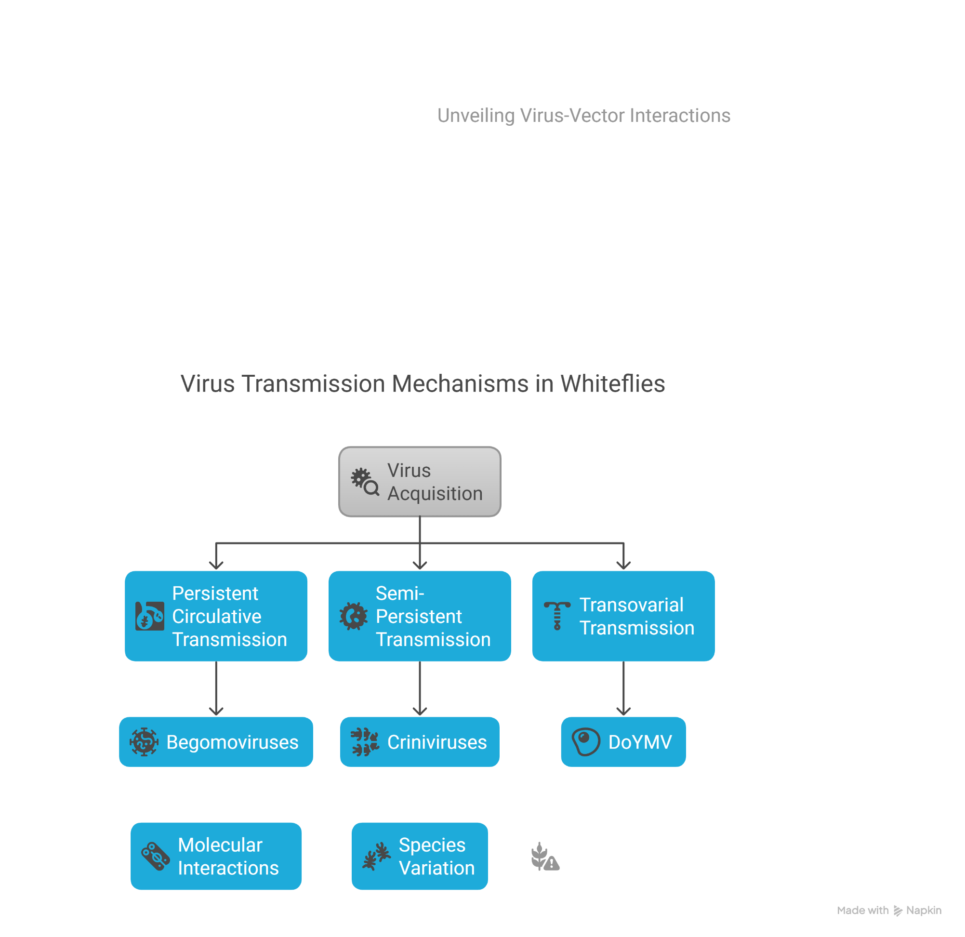

**Figure 1: Virus transmission mechanisms in whiteflies. (Whiteflies transmit plant viruses through three primary mechanisms: persistent circulative transmission (e.g., Begomoviruses), semi-persistent transmission (e.g., Criniviruses), and transovarial transmission (e.g., Dolichos yellow mosaic virus, DoYMV). Each pathway involves distinct modes of virus acquisition, retention, and transmission, contributing to the epidemiology of whitefly-borne viral diseases.)**

the virus from an infected host, the whitefly retains it for a limited period, typically only a few hours or days, which allows rapid inoculation of successive plants during feeding bouts (Ghanim **et al.,** 2001). This mode is mediated by molecular interactions that are less specific than those required for circulative transmission, resulting in a swift acquisition and inoculation process **(Figure 2)**. The transient nature of this attachment means that as the vector molts or as time passes, its ability to transmit the virus diminishes. For example, whiteflies transmit the Tomato Yellow Leaf Curl Virus (TYLCV) in a semi‐persistent manner, acquiring the virus from infected plants and passing it to healthy ones within hours or days (Czosnek **et al.,** 2002). Such insights guide strategies to disrupt transmission and protect crops from damaging virus outbreaks, thus enhancing agricultural resilience.

**3.4. Transovarial Transmission**

Recent studies have revealed that some whitefly-transmitted viruses can be passed to offspring through transovarial transmission **(Figure 3)**. The cultivation of dolichos bean (Lablab purpureus (L.) Sweet) has been severely affected by dolichos yellow mosaic virus (DoYMV, Begomovirus) transmitted by whitefly, *Bemisia tabaci* (Hemiptera: Aleyrodidae). Tests for transovarial transmission of DoYMV in next-generation *B. tabaci* by PCR, real-time PCR, Southern blot hybridization, and biological transmission showed that eggs, laid by DoYMV-exposed *B. tabaci*, carry the virus in a unique pattern. 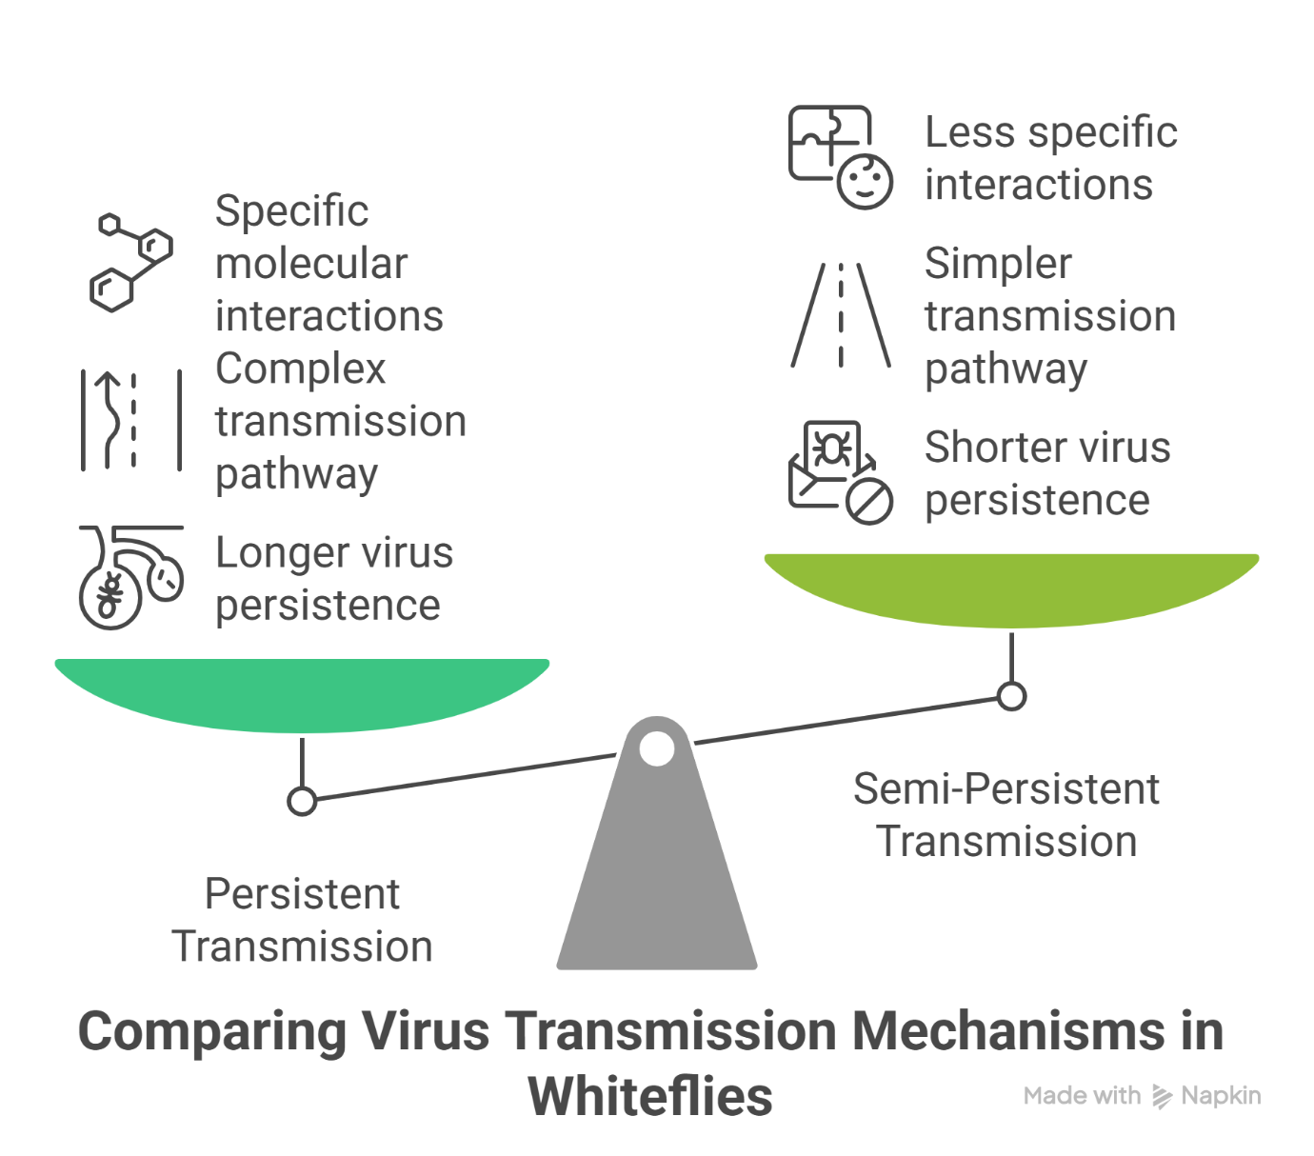

**Figure 2: Comparison of Virus Transmission Mechanisms in Whiteflies: Image illustrates the distinctions between persistent and semi-persistent virus transmission pathways in whiteflies. Persistent transmission involves specific molecular interactions, a complex pathway, and longer virus persistence, while semi-persistent transmission features fewer specific interactions, a simpler pathway, and shorter persistence, highlighting key ecological and molecular differences.**

Only the eggs laid in between 3- and 6-days post virus acquisition by a parent *B. tabaci* were DoYMV positive. When tested individually in real-time PCR, around 31-53% of the eggs carried the virus (Ghosh & Ghanin, 2021).

This transovarial transmission has significant epidemiological implications. The presence of DoYMV in ovaries and F1 eggs was further substantiated by the hybridization of a Cy3-conjugated nucleic acid probe complementary to the viral strand of DoYMV. Viral DNA was also detected in F1 adults and F2 eggs. *B. tabaci* progenies carried not only the DoYMV DNA but were also infective. The F1 adults transmitted DoYMV to all tested plants and produced strong yellow mosaic symptoms. An increase in viral copies from egg to nymphal stage indicated propagation of DoYMV in *B. tabaci*. However, the increase was for a short period and decreased thereafter. The present study provides the first evidence of transovarial transmission and propagation of a bipartite begomovirus in its vector, *B. tabaci* Asia II

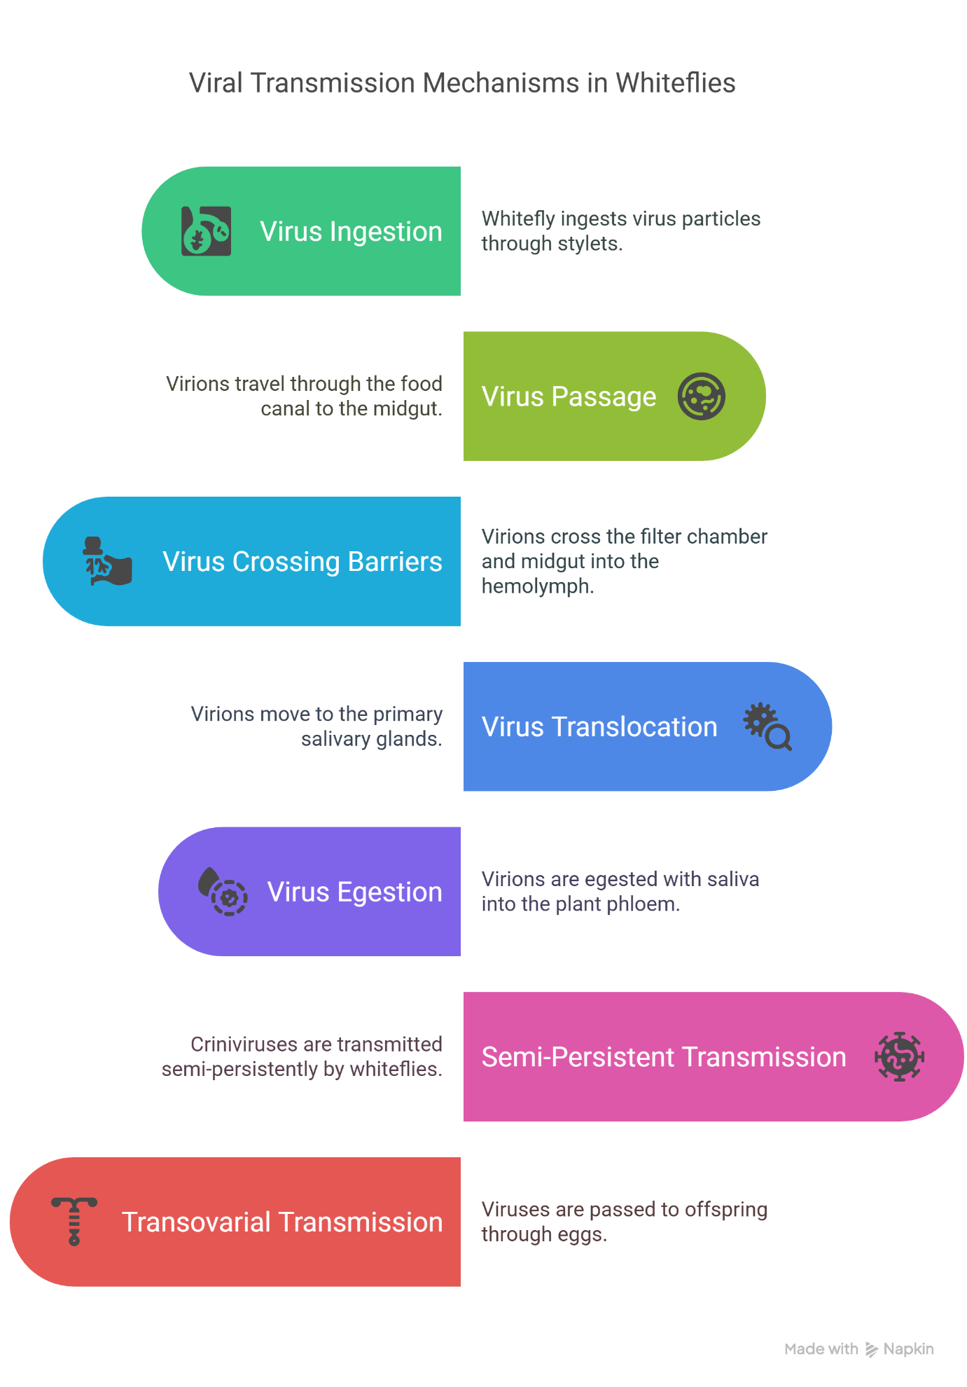

**Figure 3: Virus transmission pathway of transovarial virus within the whitefly body. (Diagram represents the intricate steps in the movement and transmission of transovarial viruses within whiteflies. It captures key processes, including ingestion, internal movement through body barriers, salivary gland infection, and transmission to plants, as well as vertical transmission to offspring via eggs.)**

1. The transovarial transmission and replication of DoYMV in *B. tabaci* have great epidemiological relevance as *B. tabaci* can serve as a major host of the virus to bridge the gap between the cropping seasons (Ghosh **et al.,** 2021).

**4. Host-Vector-Virus Interactions**

**4.1. Virus Effects on Vector Behaviour**

Whitefly-transmitted viruses can significantly influence vector Behaviour, often in ways that enhance their own transmission (Whitfield et al., 2015). Plant viruses can produce direct and plant-mediated indirect effects on their insect vectors, modifying their life cycle, fitness and behaviour (Ingwell et al., 2012; Ziegler Graff, 2020) **(Figure 4)**. Viruses may benefit from such changes leading to enhanced transmission efficiency and spread (Moreno-Delafuente **et al.,** 2013). Studies have shown that viruses can induce changes in vector Behaviour that facilitate transmission. Results of Ethovision video tracking bioassays indicated that TYLCV induced an arrestant behaviour of *B. tabaci*, as viruliferous whitefly adults remained motionless for more time and moved slower than non-viruliferous whiteflies after their first contact with eggplant leaf discs (Moreno Delafuente **et al.,** 2013). In fact, Electrical Penetration Graphs showed that TYLCV-viruliferous *B. tabaci* fed more often from phloem sieve elements and made a larger number of phloem contacts in eggplants than non-viruliferous whiteflies. Furthermore, the duration of the salivation phase in phloem sieve elements preceding sustained sap ingestion was longer in viruliferous than in non-viruliferous whiteflies. This particular probing Behaviour is known to significantly enhance the inoculation efficiency of TYLCV by *B. tabaci* (Moreno-Delafuente **et al.,** 2013).

These Behavioural modifications can create mutually beneficial relationships between viruses and their vectors. Results show evidence that TYLCV directly manipulates the settling, probing and feeding Behaviour of its vector *B. tabaci* in a way that enhances virus transmission efficiency and spread. Furthermore, TYLCV-*B. tabaci* interactions are mutually beneficial to both the virus and its vector because *B. tabaci* feeds more efficiently after acquisition of TYLCV (Moreno-Delafuente **et al.,** 2013). Viruses can also manipulate plant defenses to benefit their vectors. Most plant viruses are vectored by insects and the interactions of virus-plant-vector have important ecological and evolutionary implications. Insect vectors often perform better on virus-infected plants. This indirect mutualism between plant viruses and insect vectors promotes the spread of virus and has significant agronomical effects (Ziegler Graff, 2020). However, few studies have investigated how plant viruses manipulate plant defenses and promote vector performance. Begomoviruses are a prominent group of plant viruses in tropical and sub-tropical agro-ecosystems and are transmitted by whiteflies. Working with the whitefly *Bemisia tabaci*, begomoviruses and tobacco, researchers revealed that C2 protein of begomoviruses lacking DNA satellites was responsible for the suppression of plant defenses against whitefly vectors. They found that infection of plants by tomato yellow leaf curl virus (TYLCV), one of the most devastating begomoviruses worldwide, promoted the survival and reproduction of whitefly vectors (Li **et al.,** 2019).

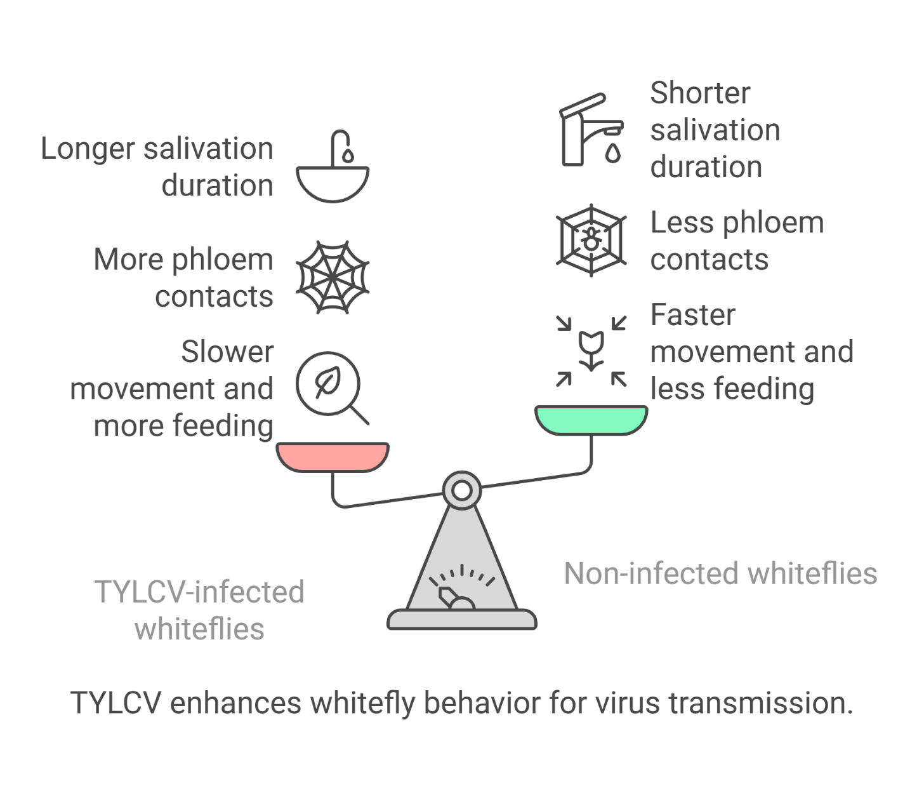

**Figure 4: Behavioural modifications in TYLCV-infected and non-infected whiteflies influencing virus transmission. (This illustration contrasts the Behavioural adaptations in TYLCV-infected whiteflies compared to their non-infected counterparts. Key differences include prolonged salivation duration, increased phloem contact, reduced movement, and enhanced feeding in infected whiteflies, which collectively facilitate efficient virus transmission. In contrast, non-infected whiteflies exhibit shorter salivation duration, decreased phloem contact, faster movement, and reduced feeding activity.)**

**4.2. Virus Replication in Vectors**

Traditionally, it was believed that whitefly-transmitted viruses do not replicate in their vectors. However, recent evidence suggests that some viruses, particularly begomoviruses, may replicate within their whitefly hosts. Viruses pose a great threat to animal and plant health worldwide. Whereas most plant viruses only replicate in plant hosts, some also replicate in their animal (insect) vector. A detailed knowledge of host expansion will give a better understanding of virus evolution, and identification of virus and host components involved in this process can lead to new strategies to combat virus spread. Research has revealed that a plant DNA virus has evolved to induce and recruit insect DNA synthesis machinery to support its replication in vector salivary glands. This sheds light on the understanding of TYLCV-whitefly interactions and provides insights into how a plant virus may evolve to infect and replicate in an insect vector (He **et al.,** 2020).

The mechanism of virus replication in whiteflies involves recruitment of host cellular machinery. Geminiviruses comprise a large family of plant-infecting, single-stranded DNA viruses that cause serious crop losses worldwide. Research reports evidence and insight into the replication of the geminivirus tomato yellow leaf curl virus (TYLCV) in the whitefly (*Bemisia tabaci*) vector and that replication is mainly in the salivary glands. It was found that TYLCV induces DNA synthesis machinery, proliferating cell nuclear antigen (PCNA) and DNA polymerase δ (Polδ), to establish a replication-competent environment in whiteflies. TYLCV replication-associated protein (Rep) interacts with whitefly PCNA, which recruits DNA Polδ for virus replication (He **et al.,** 2020).

Not all begomoviruses replicate in whiteflies, indicating specificity in virus-vector interactions. In contrast, another geminivirus, papaya leaf curl China virus (PaLCuCNV), does not replicate in the whitefly vector. PaLCuCNV does not induce DNA-synthesis machinery, and the Rep does not interact with whitefly PCNA. These findings reveal important mechanisms by which a plant DNA virus replicates across the kingdom barrier in an insect and may help to explain the global spread of this devastating pathogen (He **et al.,** 2020).

**4.3. Impact of Viruses on Vector Fitness**

The relationship between whitefly-transmitted viruses and their vectors is complex, with viruses potentially affecting vector fitness in different ways. The vector, *Bemisia tabaci* Gennadius, was able to complete its life cycle on all plant species, irrespective of SiGMV infection status. However, SiGMV infection in prickly sida and country mallow positively increased the fitness of whiteflies, whereas SiGMV infection in okra negatively influenced whitefly fitness (Gautam **et al.,** 2023).

The impact of virus infection on vector fitness varies depending on the specific virus-vector-plant combination. TYLCV C2 protein suppressed plant defenses by interacting with plant ubiquitin. This interaction compromised the degradation of JAZ1 protein, thus inhibiting jasmonic acid defense and the expression of MYC2-regulated terpene synthase genes. It was further demonstrated that function of C2 protein among begomoviruses not associated with satellites is well conserved and ubiquitination is an evolutionarily conserved target of begomoviruses for the suppression of plant resistance to whitefly vectors. Taken together, these results demonstrate that ubiquitination inhibition by begomovirus C2 protein might be a general mechanism in begomovirus, whitefly and plant interactions (Li **et al.,** 2019).

Virus-induced apoptosis in whiteflies can influence virus transmission and accumulation. Research examined the role of virus-induced apoptosis in the transmission of begomoviruses, a group of single-stranded plant DNA viruses that are transmitted by whiteflies and cause extensive damage to many crops worldwide. It was demonstrated that virus infection can induce apoptosis in the insect vector conferring protection to the virions from degradation, leading to enhanced viral accumulation and transmission to host plants. These findings provide valuable clues for designing new strategies to block the transmission of insect-vectored plant viruses, particularly plant DNA viruses (Wang **et al.,** 2020).

**5. Management of Whitefly‑Transmitted Viruses in Agriculture**

Whitefly‑transmitted viruses threaten global agricultural production by inflicting severe economic losses on a broad range of crops. Integrated management strategies-combining cultural practices, mechanical barriers, biological control, botanical insecticides, chemical control, and advanced genetic tools-are essential to mitigate these impacts **(Figure 5)**. Their success hinges on a deep understanding of virus-vector-host interactions that drive disease spread (Velasco **et al.,** 2020).

**5.1 Host Resistance**

Breeding for resistance remains the cornerstone of sustainable control: six loci (Ty‑1 to Ty‑6) have been introgressed from wild tomato relatives, with Ty‑1 and Ty‑3 underlying most commercial cultivars and often pyramided with Ty‑2 for greater durability (Yan **et al.,** 2021; Verlaan **et al.,** 2013). However, resistance‑breaking strains and satellite‑mediated recombinants have repeatedly overcome single‑gene defenses in South Asia (Sattar **et al.,** 2013). As an alternative, multiplexed CRISPR-Cas9 constructs targeting several viral genes in cotton leaf curl virus reduced accumulation by 60-70% in Nicotiana benthamiana (Binyameen **et al.,** 2021).

**5.2 Vector Management**

Begin with virus‑free seedlings and eliminate weeds and alternate hosts to deprive whiteflies of breeding sites and inoculum sources (Fiallo‑Olivé & Navas‑Castillo, 2019b). Rotate insecticides with different modes of action-paired with compatible biocontrol agents-to forestall resistance and safeguard beneficials (Maluta **et al.,** 2020). Embed these tactics in an ecosystem‑based IPM framework-emphasizing habitat diversification and regional monitoring-to avoid secondary pest surges, as seen in Spain when whitefly suppression coincided with a rebound of aphid‑transmitted viruses (Velasco **et al.,** 2020).

**5.3 Cultural & Mechanical Controls**

**5.3.1 Crop Rotation & Sanitation**

Alternating susceptible crops with non‑hosts and removing infected residues disrupts whitefly life cycles and lowers initial inoculum (Fiallo‑Olivé & Navas‑Castillo, 2019b).

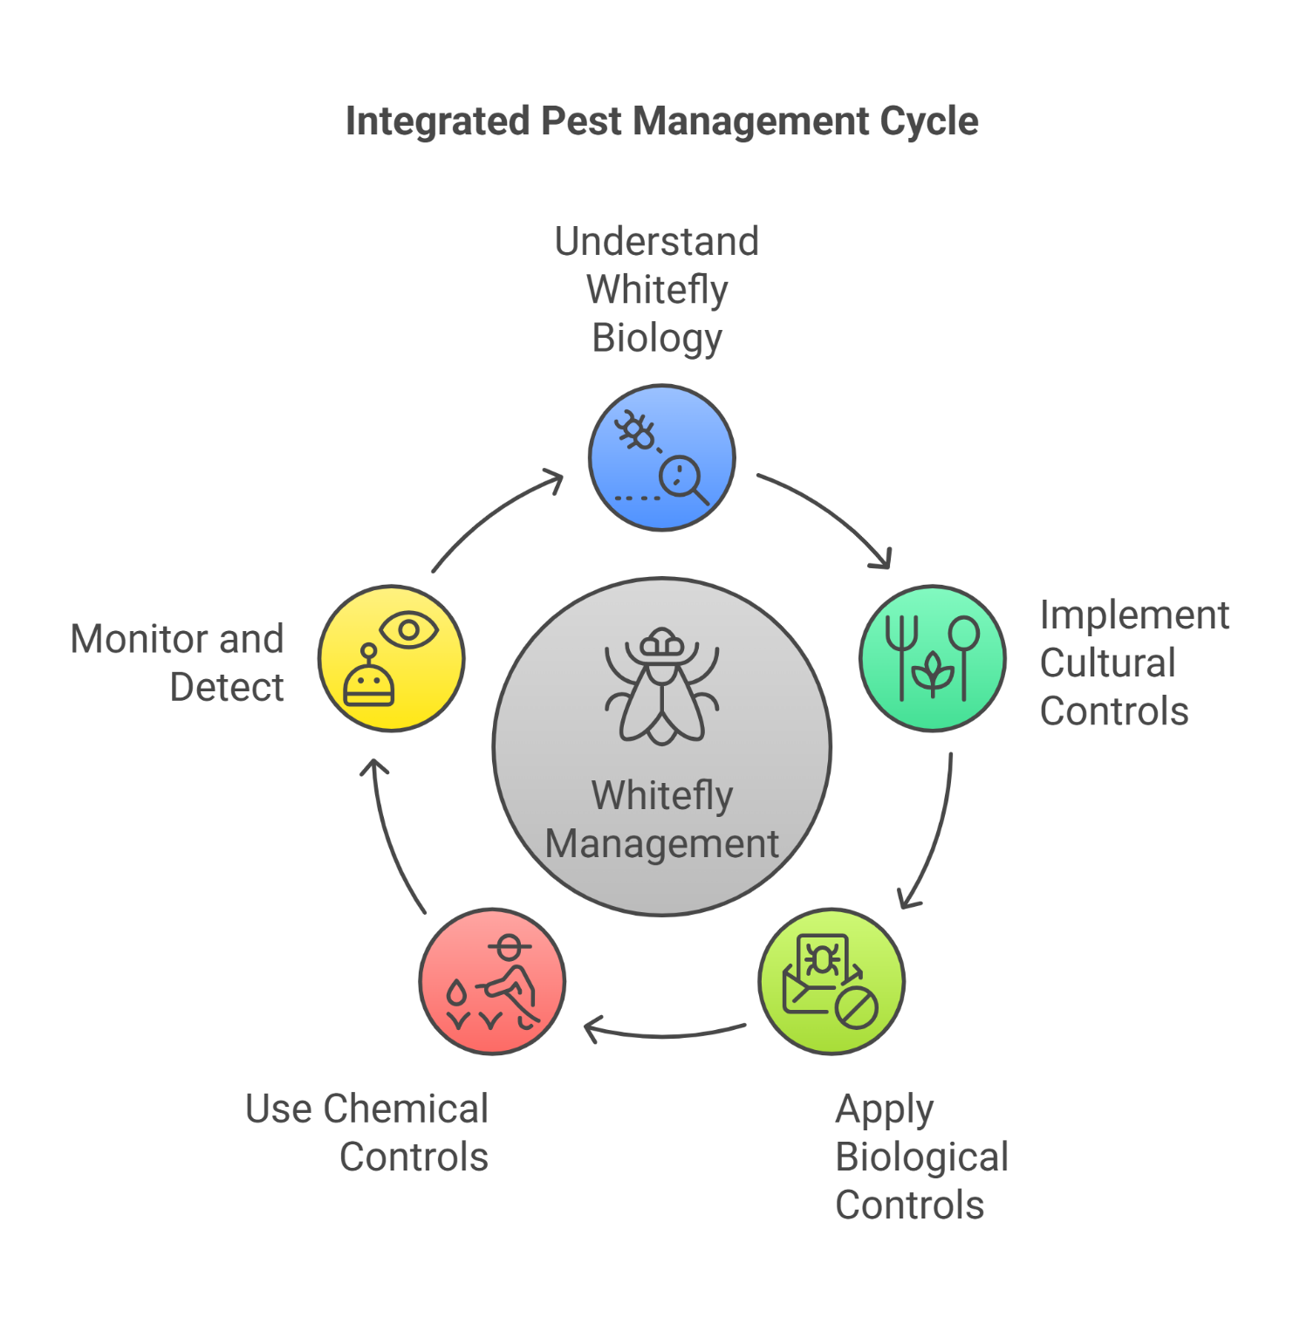

**Figure 5:** Integrated approach to whitefly management emphasizing biological, cultural, and chemical controls. (Diagram outlines a holistic strategy for whitefly management, focusing on five interconnected steps: understanding whitefly biology, implementing cultural controls, utilizing biological methods, applying chemical interventions, and ensuring effective monitoring and detection. The central whitefly management theme illustrates the importance of integrating multiple methods for sustainable pest control.)

**5.3.2 Planting Date & Density**

Scheduling plantings outside peak whitefly flights and thinning stands to enhance airflow reduces vector colonization (Maluta **et al.,** 2020).

**5.3.3 Physical Barriers**

Fine‑mesh netting (10×20 to 10×22 holes/in²) and floating row covers can exclude up to 94% of adults, while yellow sticky traps and UV‑absorbing screens monitor and limit incursion (Velasco **et al.,** 2020).

**5.4 Biological Control**

Using natural enemies offers a targeted, eco‑friendly way to suppress whiteflies. Generalist predators-lady beetles, lacewings and mites like *Amblyseius swirskii,* consume eggs and nymphs, cutting vector numbers before disease spreads (Fiallo‑Olivé & Navas-Castillo, 2019b). Host‑specific parasitoids such as *Encarsia formosa* and *Eretmocerus eremicus* then deposit eggs in or on whiteflies, with larvae destroying their hosts without affecting other beneficial insects **(Kaur et al., 2016)**. Finally, foliar applications of entomopathogenic fungi (*Beauveria bassiana*, *Isaria fumosorosea*) infect and kill adults, providing a sustainable alternative to chemical sprays (Mubarik **et al.,** 2021).

**5.5 Botanical and Chemical Complementation**

Botanical insecticides such as azadirachtin (neem), pyrethrum (Chrysanthemum) and essential oils (rosemary, thyme, clove) offer repellency and larval disruption as a first line of defense (Fiallo‑Olivé & Navas-Castillo, 2019b). Synthetic neonicotinoids and pyrethroids deliver rapid adult knockdown, while insect growth regulators (IGRs) interrupt development with lower non‑target risks. Rotating modes of action, timing applications carefully and combining these treatments with biocontrol agents helps delay resistance, reduce environmental impact and maintain agroecosystem balance (Mubarik **et al.,** 2021).

**6. Conclusion and Future Perspectives**

Whitefly‐transmitted plant viruses pose a growing threat to global agriculture, causing major economic losses across many crops. Understanding the virus-vector-host triangle is crucial for devising new control strategies. *Bemisia tabaci* transmits over 400 virus species-mostly single‐stranded DNA begomoviruses-via a persistent circulative pathway that requires crossing the insect’s gut, haemolymph, and salivary glands through specific interactions with vector proteins (Ghosh & Ghanim, 2021). Begomoviruses infect more than 420 plant species worldwide; their rapid evolution through mutation and recombination underlies their ability to overcome host defenses (Nigam, 2021).

Advances in “omics” technologies-next‐generation sequencing (Metzker, 2010), high‐quality genome assemblies (Chen **et al.,** 2016), and transcriptomic profiling (Kaur **et al.,** 2017) have begun to unravel how whiteflies interact with viruses at the molecular level. These insights support genetic strategies such as RNA interference and multiplexed CRISPR/Cas9 editing to disrupt virus replication (Binyameen **et al.,** 2022).

Climate change intensifies the problem: warmer conditions accelerate whitefly development and extend their geographic range. In a simulated future‐climate study, development time of *Bemisia tabaci* MED shortened by 40% and fecundity rose by one‐third, forecasting more rapid population buildups and increased virus pressure (Milenovic **et al.,** 2023). Adaptive management must therefore integrate host‐resistant varieties, targeted vector suppression, cutting‐edge genetic tools, and ecological tactics. Only interdisciplinary collaboration will yield durable, sustainable solutions to safeguard crops against evolving whitefly‐transmitted viruses.

**References:**

Amari, K., Gonzalez‑Ibeas, D., Gómez, P., Sempere, R., Sánchez‑Pina, M., Aranda, M., Díaz‑Pendón, J. A., Navas‑Castillo, J., Moriones, E., Blanca, J., Hernández‑Gallardo, M., & Anastasio, G. (2008). Tomato torrado virus is transmitted by *Bemisia tabaci* and infects pepper and eggplant in addition to tomato. *Plant Disease*. [https://doi.org/10.1094/PDIS‑92‑7‑1139A](https://doi.org/10.1094/PDIS%E2%80%9192%E2%80%917%E2%80%911139A)

Binyameen, B., Khan, Z., Khan, S. H., Ahmad, A., Munawar, N., Mubarik, M. S., … Qari, S. H. (2021). Using multiplexed CRISPR/Cas9 for suppression of cotton leaf curl virus. *International Journal of Molecular Sciences, 22*(22), 12543. <https://doi.org/10.3390/ijms222212543>

Binyameen, B., Khan, Z., Kumar, R., & Dasgupta, I. (2022). CRISPR/Cas‐mediated resistance against viruses in plants. *International Journal of Molecular Sciences, 23*(4), 2303. <https://doi.org/10.3390/ijms23042303>

Chen, W., Hasegawa, D. K., Kaur, N., Kliot, A., Pinheiro, P. V., Luan, J., … Fei, Z. (2016). The draft genome of whitefly *Bemisia tabaci* MEAM1, a global crop pest, provides novel insights into virus transmission, host adaptation, and insecticide resistance. *BMC Biology, 14*(1), 110. <https://doi.org/10.1186/s12915-016-0321-y>

Czosnek, H., Ghanim, M., & Ghanim, M. (2002). Circulative pathway of begomoviruses in the whitefly vector *Bemisia* tabaci-insights from studies with Tomato yellow leaf curl virus. Annals of Applied Biology, 140(3), 215-231. <https://doi.org/10.1111/j.1744-7348.2002.tb00175.x>

Czosnek, H., Hariton‑Shalev, A., Sobol, I., Gorovits, R., & Ghanim, M. (2017). The incredible journey of begomoviruses in their whitefly vector. *Viruses*. <https://doi.org/10.3390/v9100273>

Fiallo‑Olivé, E., & Navas‑Castillo, J. (2019a). Tomato chlorosis virus, an emergent plant virus still expanding its geographical and host ranges. *Molecular Plant Pathology*. <https://doi.org/10.1111/mpp.12847>

Fiallo‑Olivé, E., & Navas‑Castillo, J. (2019b). Transmission of begomoviruses and other whitefly‑borne viruses: Dependence on the vector species. *Phytopathology, 109*(5), 811-821. <https://doi.org/10.1094/PHYTO-07-19-0273-FI>

Fortes, I. M., Sánchez‑Campos, S., Fiallo‑Olivé, E., Díaz‑Pendón, J. A., Navas‑Castillo, J., & Moriones, E. (2016). A novel strain of tomato leaf curl New Delhi virus has spread to the Mediterranean Basin. *Viruses*. <https://doi.org/10.3390/v8110307>

Gautam, S., Buck, J., Dutta, B., Coolong, T., Sanchez, T., Smith, H. A., Adkins, S., & Srinivasan, R. (2023). Sida golden mosaic virus, an emerging pathogen of snap bean (*Phaseolus vulgaris* L.) in the southeastern United States. *Viruses*. <https://doi.org/10.3390/v15020357>

Ghanim, M., Morin, S., & Czosnek, H. (2001). Rate of Tomato yellow leaf curl virus translocation in the circulative transmission pathway of its vector, the whitefly Bemisia tabaci. Phytopathology, 91(2), 188-196.

Ghosh, A., Roy, B., Nekkanti, A., Das, A., Dhar, S., & Mukherjee, S. (2021). Transovarial transmission of dolichos yellow mosaic virus by its vector, *Bemisia tabaci* Asia II 1. *Frontiers in Microbiology*. <https://doi.org/10.3389/fmicb.2021.755155>

Ghosh, R., & Ghanim, M. (2021). Factors determining transmission of persistent viruses by *Bemisia tabaci*: insights into virus-vector interactions. *Viruses, 13*(9), 1808. <https://doi.org/10.3390/v13091808>

Ghosh, S., & Ghanim, M. (2021). Factors determining transmission of persistent viruses by *Bemisia tabaci* and emergence of new virus-vector relationships. *Viruses*. <https://doi.org/10.3390/v13091808>

Hasan, I., Rasul, S., Malik, T. H., Qureshi, M. K., Aslam, K., Shabir, G., Athar, H., & Manzoor, H. (2019). Present status of cotton leaf curl virus disease (CLCuVD): A major threat to cotton production. *International Journal of Cotton Research and Technology*. <https://doi.org/10.33865/ijcrt.001.01.0240>

He, Y., Wang, Y., Yin, T., Fiallo‑Olivé, E., Liu, Y., Hanley‑Bowdoin, L., & Wang, X. (2020). A plant DNA virus replicates in the salivary glands of its insect vector via recruitment of host DNA synthesis machinery. *Proceedings of the National Academy of Sciences of the United States of America*. <https://doi.org/10.1073/pnas.1820132117>

Ingwell, L. L., Eigenbrode, S. D., & Bosque‑Pérez, N. A. (2012). Plant viruses alter insect behavior to enhance their spread. *Scientific Reports, 2*, 578. <https://doi.org/10.1038/srep00578>

Kaur, N., Chen, W., Zheng, Y., Hasegawa, D. K., Ling, K.-S., Fei, Z., & Wintermantel, W. M. (2017). Transcriptome analysis of the whitefly *Bemisia tabaci* MED during feeding on tomato infected with the crinivirus Tomato chlorosis virus identifies a temporal shift in gene expression and differential regulation of novel orphan genes. *BMC Genomics, 18*(1), 370. <https://doi.org/10.1186/s12864-017-3751-1>

Kaur, N., Hasegawa, D., Ling, K., & Wintermantel, W. (2016). Application of genomics for understanding plant virus-insect vector interactions and insect vector control. *Phytopathology*. [https://doi.org/10.1094/PHYTO‑02‑16‑0111‑FI](https://doi.org/10.1094/PHYTO%E2%80%9102%E2%80%9116%E2%80%910111%E2%80%91FI)

Leke, W. N., Mignouna, D., Brown, J. K., & Kvarnheden, A. (2015). Begomovirus disease complex: Emerging threat to vegetable production systems of West and Central Africa. *Agriculture & Food Security*. [https://doi.org/10.1186/s40066‑014‑0020‑2](https://doi.org/10.1186/s40066%E2%80%91014%E2%80%910020%E2%80%912)

Li, P., Liu, C., Deng, W., Yao, D., Pan, L., Li, Y., Liu, Y., Liang, Y., Zhou, X., & Wang, X. (2019). Plant begomoviruses subvert ubiquitination to suppress plant defenses against insect vectors. *PLoS Pathogens*. <https://doi.org/10.1371/journal.ppat.1007607>

Lindenau, S., Winter, S., & Margaria, P. (2021). The amino‑proximal region of the coat protein of cucumber vein yellowing virus (Family Potyviridae) affects the infection process and whitefly transmission. *Plants*. <https://doi.org/10.3390/plants10122771>

Maluta, N. K. P., Lopes, J. R. S., Fiallo‑Olivé, E., Navas‑Castillo, J., & Lourenção, A. L. (2020). Foliar spraying of tomato plants with systemic insecticides: Effects on feeding behavior, mortality and oviposition of *Bemisia tabaci* (Hemiptera: Aleyrodidae) and inoculation efficiency of tomato chlorosis virus. *Insects, 11*(9), 559. <https://doi.org/10.3390/insects11090559>

Metzker, M. L. (2010). Sequencing technologies-the next generation. *Nature Reviews Genetics, 11*(1), 31-46. <https://doi.org/10.1038/nrg2626>

Milenovic, M., Eickermann, M., Junk, J., & Rapisarda, C. (2023). Life history parameters of *Bemisia tabaci* MED (Hemiptera: Aleyrodidae) in the present and future climate of central Europe, predicted by physically realistic climatic chamber simulation. *Environmental Entomology, 52*(3), 502-509. <https://doi.org/10.1093/ee/nvad023>

Moreno‑Delafuente, A., Garzo, E., Moreno, A., & Fereres, A. (2013). A plant virus manipulates the Behaviour of its whitefly vector to enhance its transmission efficiency and spread. *PLoS ONE*. <https://doi.org/10.1371/journal.pone.0061543>

Morin, S., Ghanim, M., Sobol, I., & Czosnek, H. (2000). The GroEL protein of the whitefly *Bemisia* tabaci interacts with the coat protein of transmissible and non-transmissible begomoviruses in the yeast two-hybrid system. Virology, 276(2), 404-416. <https://doi.org/10.1006/viro.2000.0549>

Mubarik, M. S., Wang, X., Khan, S., Ahmad, A., Khan, Z., Amjid, M., Razzaq, M., Ali, Z., & Azhar, M. (2021). Engineering broad‑spectrum resistance to cotton leaf curl disease by CRISPR-Cas9-based multiplex editing in plants. *GM Crops & Food*. <https://doi.org/10.1080/21645698.2021.1938488>

Naqvi, R., Zaidi, S., Mukhtar, M. S., Amin, I., Mishra, B., Strickler, S., Mueller, L., Asif, M. A., & Mansoor, S. (2019). Transcriptomic analysis of cultivated cotton (*Gossypium hirsutum*) provides insights into host responses upon whitefly‑mediated transmission of cotton leaf curl disease. *PLoS ONE*. <https://doi.org/10.1371/journal.pone.0210011>

Naveed, H., Islam, W., Jafir, M., Andoh, V., Chen, L., & Chen, K. (2023). A review of interactions between plants and whitefly‑transmitted begomoviruses. *Plants*. <https://doi.org/10.3390/plants12213677>

Nigam, D. (2021). Genomic variation and diversification in begomoviruses: implications for host adaptation and disease management. *Plants, 10*(8), 1706. <https://doi.org/10.3390/plants10081706>

Pan, L. L., Chi, Y., Liu, C., Fan, Y. Y., & Liu, S. S. (2020). Mutations in the coat protein of a begomovirus result in altered transmission by different species of whitefly vectors. Virus Evolution, 6(1), veaa014.

Pinheiro‑Lima, B., Pereira‑Carvalho, R. C., Alves‑Freitas, D. M. T., Kitajima, E., Vidal, A. H., Lacorte, C., Godinho, M. T., Fontenele, R., Faria, J. C., Abreu, E., Varsani, A., Ribeiro, S. G., & Melo, F. L. (2020). Transmission of the bean‑associated cytorhabdovirus by the whitefly *Bemisia tabaci* MEAM1. *Viruses*. <https://doi.org/10.3390/v12091028>

Polston, J., & Capobianco, H. (2013). Transmitting plant viruses using whiteflies. *Journal of Visualized Experiments*. <https://doi.org/10.3791/4332>

Roditakis, E., Stavrakaki, M., Grispou, M., Achimastou, A., Waetermeulen, X. V., Nauen, R., & Tsagkarakou, A. (2017). Flupyradifurone effectively manages whitefly *Bemisia tabaci* MED (Hemiptera: Aleyrodidae) and tomato yellow leaf curl virus in tomato. *Pest Management Science*. <https://doi.org/10.1002/ps.4577>

Salati, R., Shorey, M., Briggs, A., Calderón, J., Rojas, M., Chen, L. F., Gilbertson, R., & Palmieri, M. (2010). First report of tomato yellow leaf curl virus infecting tomato, tomatillo, and peppers in Guatemala. *Plant Disease*. [https://doi.org/10.1094/PDIS‑94‑4‑0482C](https://doi.org/10.1094/PDIS%E2%80%9194%E2%80%914%E2%80%910482C)

Sattar, M. N., Kvarnheden, A., Saeed, M., & Briddon, R. W. (2013). Cotton leaf curl disease: An emerging threat to cotton production worldwide. *Journal of General Virology*. [https://doi.org/10.1099/vir.0.049627‑0](https://doi.org/10.1099/vir.0.049627%E2%80%910)

Shi, X., Tang, X., Zhang, X., Zhang, D., Li, F., Yan, F., Zhang, Y., Zhou, X., & Liu, Y. (2018). Transmission efficiency, preference, and Behaviour of *Bemisia tabaci* MEAM1 and MED under the influence of tomato chlorosis virus. *Frontiers in Plant Science*. <https://doi.org/10.3389/fpls.2017.02271>

Tiwari, S. P., Nema, S., & Khare, M. N. (2013). Whitefly: A strong transmitter of plant viruses. *International Journal of Phytopathology*. <https://doi.org/10.33687/PHYTOPATH.002.02.0125>

Tzanetakis, I., Martin, R., & Wintermantel, W. (2013). Epidemiology of criniviruses: An emerging problem in world agriculture. *Frontiers in Microbiology*. <https://doi.org/10.3389/fmicb.2013.00119>

Velasco, L., Ruiz, L., Galipienso, L., Rubio, L., & Janssen, D. (2020). A historical account of viruses in intensive horticultural crops in the Spanish Mediterranean Arc: New challenges for a sustainable agriculture. *Agronomy*. <https://doi.org/10.3390/agronomy10060860>

Verlaan, M. G., Hutton, S. F., Ibrahem, R. M., Kormelink, R., Visser, R. G. F., Scott, J. W., Edwards, J. D., & Bai, Y. (2013). The tomato yellow leaf curl virus resistance genes Ty‑1 and Ty‑3 are allelic and code for DFDGD‑class RNA‑dependent RNA polymerases. *PLOS Genetics, 9*(10), e1003399. <https://doi.org/10.1371/journal.pgen.1003399>

Wang, X., Wang, C., Ban, F., Ghanim, M., Pan, L., Qian, L., Liu, Y., Wang, X., & Liu, S. (2020). Apoptosis in a whitefly vector activated by a begomovirus enhances viral transmission. *mSystems*. [https://doi.org/10.1128/mSystems.00433‑20](https://doi.org/10.1128/mSystems.00433%E2%80%9120)

Whitfield, A. E., Falk, B. W., & Rotenberg, D. (2015). Insect vector-mediated transmission of plant viruses. *Virology, 479–480*, 278–289. <https://doi.org/10.1016/j.virol.2015.03.026>

Yan, Z., Wolters, A., Navas‑Castillo, J., & Bai, Y. (2021). The global dimension of tomato yellow leaf curl disease: Current status and breeding perspectives. *Microorganisms*. <https://doi.org/10.3390/microorganisms9040740>

Ziegler‑Graff, V. (2020). Molecular insights into host and vector manipulation by plant viruses. *Viruses, 12*(3), 263. <https://doi.org/10.3390/v12030263>