***Original Research Article***

**Dietary *Bacillus amyloliquefaciens* as a tool for boosting health in Amur common carp (*Cyprinus carpio haematopterus*)**

**ABSTRACT**

|  |
| --- |
| The use of probiotics in aquaculture has gained increasing attention as a sustainable strategy to enhance fish health and immunity. This study investigates the effects of dietary supplementation with *Bacillus amyloliquefaciens* on the haematological and immune parameters of Amur common carp (*Cyprinus carpio haematopterus*). A feeding trial was conducted in which fish were divided into four groups and fed diets containing 0% (control- T0), 0.5% (T1), 1% (T2) and 1.5% (T3) *Bacillus amyloliquefaciens* (108 CFU g-1) supplementation for a period of 90 days. The haematological parameters such as RBC (1.64±0.06×106/mm3), WBC (1.22±0.03×105/mm3), haemoglobin (12.7±0.12 g/dl), platelets (1.38±0.01×105/mm3), haematocrit (37.1±0.17%), MCV (224.85±0.6 fl), MCH (76.97±0.18 pg) and MCHC (34.23±0.15%) showed higher significance (*P*<0.05) in treatment T1 in comparison to all the treatment groups and control. Also, there observed highest total serum protein (5.53±0.14 g/dl), albumin (2.18±0.1 g/dl), globulin (3.35±0.04 g/dl) and albumin/globulin ratio (0.65±0.01) in T1 with significant highest difference (*P*<0.05). Statistically significant enhancement (*P*< 0.05) of immune parameters such as Nitroblue Tetrazolium assay (1.46±0.018), lysozyme activity (7.10±0.033×104 IU/ml), phagocytic activity (39.97±0.26%) and total myeloperoxidase assay (1.15±0.032) was detected in Amur common carp fed with T1 diet. The 0.5% probiotic inclusion (T1) yielded the most pronounced enhancements in haematological and immune parameters, indicating that this concentration may be optimal for improving fish health. The findings suggest that *Bacillus amyloliquefaciens* can serve as a beneficial probiotic in aquaculture, enhancing disease resistance and overall physiological well-being in Amur common carp. These results contribute to the growing body of evidence supporting probiotic use as a natural alternative to conventional disease management strategies promoting sustainable aquaculture practices. |

*Keywords: Probiotic, Bacillus amyloliquefaciens, Haematology, Immune response, Cyprinus carpio haematopterus*

**1. INTRODUCTION**

As a food-producing sector, aquaculture offers numerous opportunities to alleviate poverty, hunger and malnutrition, while also driving economic growth and promoting better resource utilization (FAO, 2020; FAO, 2024). Global aquaculture production is forecasted to grow between 102 and 105 million tons by 2027 according to FAO outlooks (Froehlich *et al*., 2017). The rising per capita demand for fish, coupled with global population growth has necessitated improvements in aquaculture production (FAO, 2020; Bossier and Ekasari, 2017).

The incidence of microbial pathogens is one of the most significant factors that influences the fish industry (Zorrilla *et al*., 2003). Significant losses have occurred in intensive fish culture and have subsequently confined aquaculture production (Subasinghe, 2005). Conventional approaches to the control of diseases include the use of chemicals such as antimicrobial drugs, pesticides and disinfectants that adversely affect fish and lead to immune-suppression, disturbances of the gastrointestinal bacterial populations and reduced disease resistance. The need to improve aquaculture production has been promoted by rising demand per capita in together with world population growth (FAO, 2020). Nonetheless, sustainable development of the aquaculture sector has been challenged by a limited supply of natural resources and its adverse effects on the environment (Naylor *et al*., 2021).

Immunostimulants are regarded as natural compounds that can increase the resistance of a host to diseases, particularly infectious diseases by enhancing their immune system (Guardiola *et al*., 2016). Some of the most well-known immunostimulants include pre or/ probiotics as well as herbal plants, which show that great promise at not only improving the health status of cultured fish or shellfish, but also growth and nutrient utilization (Hoseinifar *et al*., 2016).

Probiotics are traditionally defined as “a live microbial feed supplement which beneficially affects the host animals by improving microbial balance” (Fuller, 1989). The FAO/WHO definition of a probiotic is “live microorganisms which when administered in adequate amounts confer a health benefit on the host” (Hill *et al*., 2014). In aquaculture, probiotics are used as safe additive to enhance the health of the host by enhancing growth, providing nutrients, modulating microbial colonization, improving immune responses, improving feed utilization, increasing digestive enzyme activities and digestibility, improving water quality and controlling diseases (Selim and Reda, 2015). Various probiotics such as *Arthrobacter*, *Bacillus*, *Enterococcus*, *Lactobacillus*, *Lactococcus*, *Micrococcus*, *Pediococcus*, *Aeromonas*, *Burkholderia*, *Enterobacter*, *Vibrio*, *Pseudomonas*, *Rhodopseudomonas*, *Roseobacter* and *Shewanella* have been discovered and used to enhance growth and immunity of aquaculture species over the years (Van Hai, 2015).

Among the various probiotic species discovered, *Bacillus* species are documented to enhance the growth metabolism, digestive enzyme activity, antioxidant enzyme activity, expression of immune related genes as well as stress related genes and above all improving the ability of the fish to be resistant against pathogenic microbes (Cha *et al*., 2013). *Bacillus* species also enhances better feed utilization in fish leading to better growth rate (Adineh *et al*., 2013).

*Bacillus amyloliquefaciens* belongs to the super kingdom Bacteria, within the Bacillaceae family and *Bacillus* genus. It is an endospore-forming, Gram-positive, rod-shaped bacterium with a chain-forming cell morphology (Abriouel *et al*., 2011). It was first isolated in 1943 and considered as a part of *Bacillus subtilis* until the 1980s (Welker and Campbell, 1967; Priest *et al*., 1987). Basically, this species of bacteria is found in various environmental conditions mainly in food, plants, soil and water. However, research on *B. amyloliquefaciens* as a probiotic in aquatic hosts is relatively uncommon. Although numerous studies have investigated the effects of various probiotics on the immune systems of different fish species, information regarding the effect *Bacillus amyloliquefaciens* on Amur common carp (*Cyprinus carpio haematopterus*) is scarce. So, the present study was designed to evaluate the effect of *Bacillus amyloliquefaciens* on haematological parameters and immune response in Amur common carp (*Cyprinus carpio haematopterus*).

**2. MATERIALS AND METHODS**

**2.1 EXPERIMENTAL DESIGN**

The fry of Amur common carp was procured from Fisheries Research and Information Centre, Hesarghatta, Bengaluru and reared to fingerling stage in Research and Instructional Fish Farm, College of Fisheries, Mangaluru. Prior to start of the experiment, fish were acclimatized to experimental condition and fed with dry pellet diet. The study was conducted indoor in 12 FRP tanks of 250 L capacity and for a period of 90 days. The experiment was carried out in triplicates and stocking density of 15 fish/tank was maintained. Water exchange was performed weekly to maintain the water quality and continuous aeration was ensured throughout the experimental period.

**2.2 FEED INGREDIENTS, FORMULATION AND ANALYSIS**

The ingredients used in the formulation of different experimental diets were fish meal, rice bran, groundnut oil cake, tapioca flour, vitamin-mineral premix and probiotic (*Bacillus amyloliquefaciens*). All the dry ingredients were purchased from the local market except probiotic. The probiotic powder was procured from an online platform namely Mark nature. All the ingredients except probiotic was ground and sieved to get particles of uniform size. The sieved ingredients were packed in high density polythene bags and stored at room temperature. Vitamin and mineral premix in the form of Chelated Agrimin Forte, a product of Virbac Animal Health Pvt. Ltd, India was procured locally and added.

**2.3 FORMULATION AND PREPARATION OF EXPERIMENTAL DIETS**

**Table 1: The different inclusion level of feed additives for 90 days of experiment.**

|  |  |  |
| --- | --- | --- |
| Treatments | Feed additives | Incorporation level |
| T0 | Without any additive | - |
| T1 | *Bacillus amyloliquefaciens* (108 CFU g-1) | 0.5% |
| T2 | *Bacillus amyloliquefaciens* (108 CFU g-1) | 1% |
| T3 | *Bacillus amyloliquefaciens* (108 CFU g-1) | 1.5% |

The required quantities of ingredients were weighed accurately, mixed and hand kneaded to required consistency with just enough water (1: 0.8) to get smooth dough. The dough so obtained was cooked under steam in a pressure cooker at 105°C for 20 to 30 min. The cooked feed was cooled to room temperature rapidly by spreading in an enamel tray and required dose of probiotics was diluted with water properly and vitamin-mineral premix was added, mixed and blended. The dough was extruded through a pelletizer having 3 mm dia. Pellets were dried in a hot air oven at 60°C till the moisture content was reduced to less than 10%. Diets were packed separately in high density polythene bags, labelled and stored air tight for further use.

**2.4 COLLECTION OF BLOOD SAMPLES**

At the end of the experimental period i.e., after 90 days, blood samples were collected randomly. The selected fish were anesthetized using clove oil prior to the collection of blood. Blood was drawn from the caudal peduncle region of the fish using a 1 mL of heparinized syringe and transferred to EDTA tubes for the estimation of haematological parameters.

For serum sample collection, briefly 1 mL of blood was collected using 1 mL syringe and immediately released into 1.5 mL Eppendorf tubes without anticoagulant. The tubes were then incubated at room temperature for one hour and stored in a refrigerator (4°C) for 4 h. After incubation, the samples were centrifuged at 1500g for 5 min at 4°C and the anticipated serum was gathered using a micro-pipette and stored at -80°C for further evaluation.

* 1. **HAEMATOLOGICAL PARAMETERS**

Blood samples collected from fish were used to determine the haematological parameters such as total red blood cell count (RBC), haemoglobin concentration (Hb), haematocrit (Ht), mean corpuscular volume (MCV), mean corpuscular haemoglobin (MCH), mean corpuscular haemoglobin concentration (MCHC) and total white blood cell count (WBC). Red and white blood cell counts obtained manually with a haemocytometer using Natt-Herrick’s solution for dilution (Stoskopf, 1993). Direct smears for differential WBC were made immediately following blood collection. The smears obtained from non-heparinised blood sample were first air dried and stained with May-Grünwald-Giemsa for leukocyte differential count and examined under oil immersion at 100x magnification (Sahan and Duman, 2010). Mean corpuscular volume (MCV), mean corpuscular haemoglobin (MCH) and mean corpuscular haemoglobin concentration (MCHC) were determined by standard formulas described by Stoskopf (1993).

* MCV (fl) = Hct (%) x 10 / RBC count
* MCH (pg) = Hb (g/dl) x 10 / RBC count
* MCHC (g/dl) = Hb (g/dl) x 100 / Hct (%)

The total serum protein will be estimated by Biuret and the Bromocresol Green (BCG) dye binding method using total protein and albumin kit (Qualigens Diagnostics, Mumbai). Albumin was estimated by the BCG binding method. The absorbance of standards and tests were measured against the blank in a spectrophotometer at 630 nm. Globulin was calculated by subtracting albumin values from total serum protein. The albumin/globulin ratio (A/G) was calculated by dividing albumin values by globulin values.

**2.6 IMMUNE PARAMETERS**

**2.6.1 Nitroblue Tetrazolium (NBT) assay**

The test was performed as described by Anderson and Siwicki (1993). The test was performed in flat bottomed microtitre plates. The activated phagocytes (neutrophils and macrophages) are characterized by their ability to adhere to glass or plastic and produce oxygen free radicals. Nitroblue tetrazolium(NBT) in its reaction with oxygen free radicals is reduced to blue formazan, the extent of which can be determined by spectrophotometrically. The procedure is as follows:

The blood collected from the caudal vein of fish was centrifuged at 3000 rpm for 6 min. The buffy coat of 50μl containing leucocytes was dispensed into a microtitre plate and incubated for 1 h and 50μl of 0.3% NBT was added to the plate and incubated for 1 h. The contents of the well were carefully removed and the adhered cells were fixed by adding methanol and incubated for 2-5 min. Then the plates were rinsed 3-4 times with 70% methanol and air dried. The blue formazan was solubilized by adding 60μl of 2M KOH. On the top of it, 70 μl of Dimethyl Sulphoxide (DMSO) was added. The results were read on an ELISA reader at 620 nm using KOH and DMSO mixture as blank.

**2.6.2 Lysozyme activity**

Lysozyme activity of fish in each group was measured with the turbidimetric method described by Parry *et al*. (1965) using 0.2 mg mL-1 lyophilized *Micrococcus luteus* as the substrate in 0.05M phosphate buffer (pH 6.2). Various amounts of serum (25-100μl) were added to 2 ml of the suspension and the absorbance was measured at 0.5 and 4.5 min intervals at 530 nm (25ºC). A lysozyme unit was defined as the activity of enzyme producing a decrease in absorbance of 0.001 min-1.

**2.6.3 Phagocytic Activity (PA)**

Phagocyte activity was performed using the method of Cunningham, modified by Smith and Romme (1997), 200 *μ*L of blood was placed on the cover glass, incubated in a wet chamber at 28ºC for 20 min and washed with Hanks buffered salt solution (HBSS, Sigma) supplemented with 0.002% human albumin (HA, Sigma). A mixture of 20% autologous serum and 80% of *Candida albicans* cells (equivalent to 1 × 106) in HBSS-AH was added to the cover glass; then, the glass was incubated (28◦C, 40 min, in wet chamber), washed, incubated again with HBSS-AH (28ºC, 20 min) and washed. Staining was realized with Wrights solution (Sigma) for 1 min, rinsed and dried. A Zeiss microscope (100X) was used to determine the ability of 100 to 200 phagocytic cells from blood to phagocyte *Candida albicans.* The phagocytic index (PI) was expressed as the average number of yeast engulfed per cell and calculated by dividing the total number of yeast engulfed by the cell count, which in this case was 100 to 200 phagocytic and nonphagocytic cells. The percentage of active cells (% AC) was measured by counting the combined total of 100 to 200 phagocytic and non-phagocytic cells and expressing the result as the percentage of positive phagocytic cells.

**2.6.4 Total Myloperoxidase Assay (MPO)**

The myeloperoxidase assay (MPO) was measured according to Quade and Roth (1997). About 10 μl of serum were diluted with 90 μl of Hank’s balanced salt solution (HBSS) without Ca2+ or Mg2+ in 96-well plates. Then 35 μl of freshly prepared 20 mM 3, 3’, 5, 5’- tetramethylbenzidine hydrochloride (TMB) and 5 mM H2O2 (Genei, Bengaluru, India) were added. The colour change reaction was stopped after 2 min by adding 35 μl of 4 M sulfuric acid (H2SO4). The optical density was read at 450 nm (BioTek Synergy HTX ELISA reader).

**2.7 STATISTICAL ANALYSIS**

One-way ANOVA was used to determine significance of difference between treatments. Differences among means were tested at the 5% probability level using Duncan Multiple Range test.

**3. RESULTS AND DISCUSSION**

The RBC count was higher in test diet T1 (1.64±0.06×106/mm3), consequently T2 (1.63±0.05×106/mm3), T3 (1.56±0.01×106/mm3) and T0 (1.14±0.04×106/mm3) exhibited respective RBC counts. There observed greater significant difference (*P*<0.05) among all the treatment groups and control (Table 2 and Fig. 1). The WBC count of the fish fed with test diet T1 was found to significantly higher (*P*<0.05) than the other treatment groups and control. The highest count of WBC was recorded in T1 (1.22±0.03×105/mm3) followed by T2 (0.98±0.04×105/mm3), T3 (0.84±0.02×105/mm3) and T0 (0.59±0.03×105/mm3) (Fig. 2).

The haemoglobin concentration was highest in T1 (12.7±0.12 g/dl), succeeded by T2 (12.4±0.11 g/dl) followed by T3 (11.2±0.03 g/dl) and T0 (7.2±0.09 g/dl) respectively. There was a high significant difference between all the treatment groups and control (Fig. 3). The highest value of platelet was found in T1 (1.38±0.01×105/mm3) followed by T2 (1.37±0.03×105/mm3), T3 (0.58±0.05×105/mm3) and T0 (0.23±0.02×105/mm3). The results in all treatment groups and control showed high significant difference (*P*<0.05) (Fig. 4). The haematocrit value obtained was found to be highest in the treatment group T1 (37.1±0.17%) succeeded by T2 (36.5±0.28%), T3 (34.6±0.24%) and T0 (23.3±0.35%). It was noticed to have high significant difference (*P*<0.05) between all the treatment groups and control (Fig. 5).

The highest MCV was observed with the value of 224.85±0.6 fl in T1 followed by 223.93±0.57 fl in T2, 221.79±0.54 fl in T3 and 204.39±0.25 fl in T0. By the data obtained, it can be considered that there observed high significant difference (*P*<0.05) between all the treatment groups and control (Fig. 6). The MCH value obtained was highest in T1 (76.97±0.18 pg) followed by T2 (76.07±0.12 pg), T3 (75.61 pg), T3 (71.79±0.36 pg) and T0 (63.16±0.37 pg). There observed higher significant difference (*P*<0.05) between treatment groups and control (Fig. 7). The highest value of MCHC was recorded in T1 (34.23±0.15%) followed by T2 (33.97±0.35%), T3 (32.37±0.14%) and T0 (30.9±0.1%). The results in all treatment groups and control showed high significant difference (*P*<0.05) (Fig. 8).

**Table 2. Details of haematological analysis of Amur common carp recorded in different treatment and control groups.**

|  |  |  |  |  |
| --- | --- | --- | --- | --- |
| Parameters | Treatments | | | |
| **T0** | **T1** | **T2** | **T3** |
| RBC (106/mm3) | 1.14±0.04c | 1.64±0.06a | 1.63±0.05a | 1.56±0.01b |
| WBC (105/mm3) | 0.59±0.03d | 1.22±0.03a | 0.98±0.04b | 0.84±0.02c |
| Hb (g/dl) | 7.2±0.09c | 12.7±0.12a | 12.4±0.11a | 11.2±0.03b |
| Platelet (105/mm3) | 0.23±0.02c | 1.38±0.01a | 1.37±0.03a | 0.58±0.05b |
| Hct (%) | 23.3±0.35c | 37.1±0.17a | 36.5±0.28a | 34.6±0.24b |
| MCV (fl) | 204.39±0.25d | 224.85±0.6a | 223.93±0.57b | 221.79±0.54c |
| MCH (pg) | 63.16±0.37d | 76.97±0.18a | 76.07±0.12b | 71.79±0.36c |
| MCHC (%) | 30.9±0.1d | 34.23±0.15a | 33.97±0.35b | 32.37±0.14c |

RBC: Red blood cells; WBC: White blood cells; Hb: Haemoglobin; Hct: Haematocrit; MCV: Mean corpuscular volume; MCH: Mean corpuscular haemoglobin; MCHC: Mean corpuscular haemoglobin concentration. Results are presented as Mean±SE of triplicate observation. Means in the same row with different superscripts are significantly different (*P*<0.05).

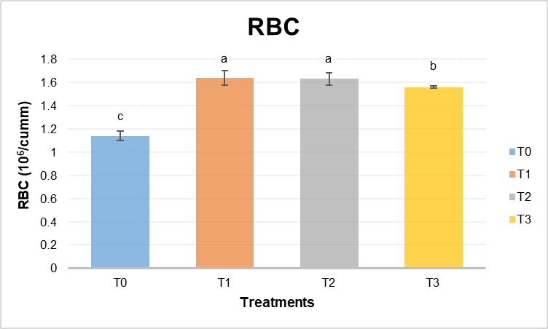

**Fig. 1. Red blood cells (RBC) count of Amur common carp fed with different treatment diets and control diet.**

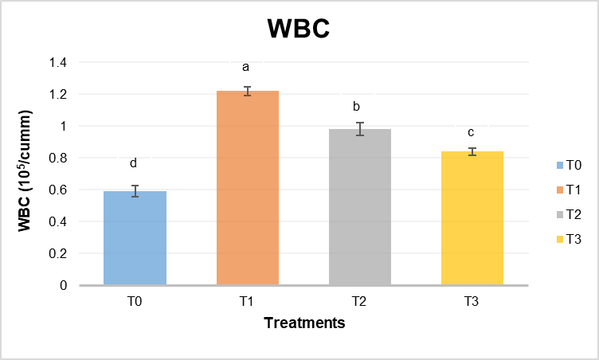

**Fig. 2. White blood cells (WBC) count of Amur common carp fed with different treatment diets and control diet.**

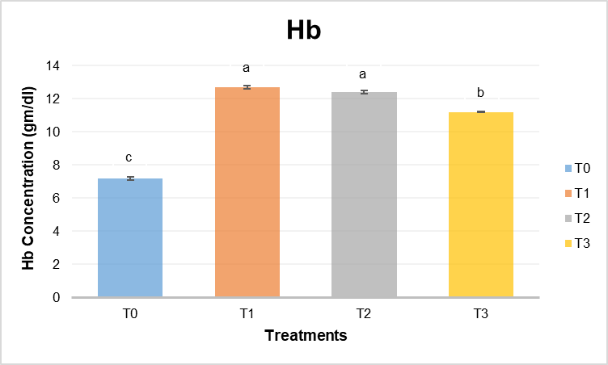

**Fig. 3. Haemoglobin (Hb) concentration of Amur common carp fed with different treatment diets and control diet.**

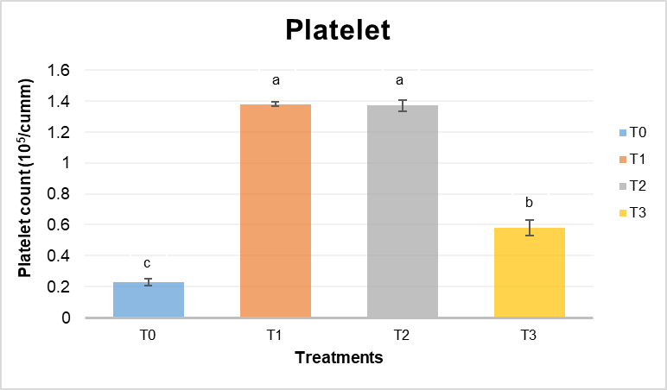

**Fig. 4. Platelets count of Amur common carp fed with different treatment diets and control diet.**

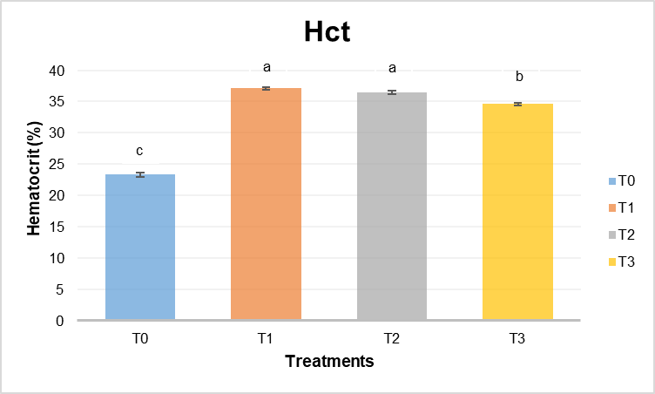

**Fig. 5. Haematocrit (Hct) concentration of Amur common carp fed with different treatment diet and control diet.**

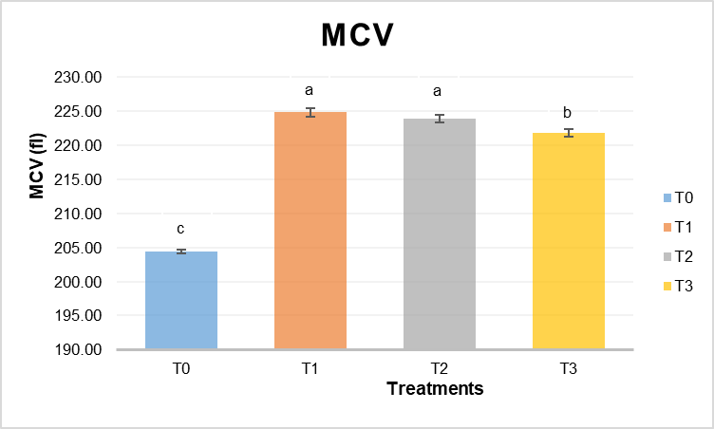

**Fig. 6. Mean corpuscular volume (MCV) of Amur common carp fed with different treatment diets and control diet.**

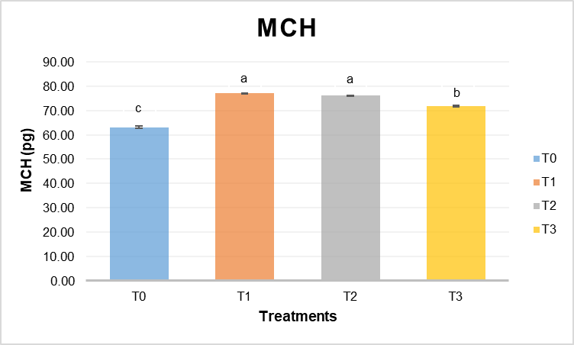

**Fig. 7. Mean corpuscular haemoglobin (MCH) of Amur common carp fed with different treatment diets and control diet.**

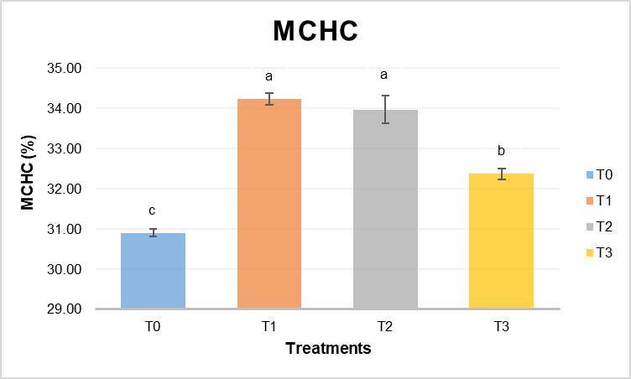

**Fig. 8. Mean corpuscular haemoglobin concentration (MCHC) of Amur common carp fed with different treatment diets and control diet.**

The highest value of total serum protein was displayed in T1 (5.53±0.14 g/dl) followed by T2 (5.12±0.08 g/dl), T3 (4.89±0.11 g/dl) and T0 (2.92±0.09 g/dl). There was high significant difference (*P*<0.05) found between all the treatment groups and control (Table 3 and Fig. 9). The serum albumin level showed higher significant difference (*P*<0.05) between all the treatment groups and control. The highest serum albumin level was observed in T1 (2.18±0.1 g/dl) succeeded by T2 (1.92±0.09 g/dl), T3 (1.77±0.12 g/dl) and lowest was found in T0 (1.03±0.04 g/dl) (Fig. 10). The obtained results displayed high significant difference (*P*<0.05) between all the treatment groups and control. The highest value of serum globulin was observed in T1 (3.35±0.04 g/dl) followed by T2 (3.2±0.06 g/dl), T3 (3.12±0.07 g/dl) and T0 (1.89±0.05 g/dl) (Fig. 11). The greater value of albumin/globulin ratio was displayed in T1 (0.65±0.01), consequently T2 (0.6±0.02), T3 (0.57±0.04) showed respective values and lower value was found in T0 (0.54±0.02). The results of all the treatment groups and control exhibited high significant difference (*P*<0.05) (Fig. 12)

**Table 3. Details of serum parameters of Amur common carp in different treatment and control groups.**

|  |  |  |  |  |
| --- | --- | --- | --- | --- |
| Parameters | Treatments | | | |
| **T0** | **T1** | **T2** | **T3** |
| Total serum protein (g/dl) | 2.92±0.09d | 5.53±0.14a | 5.12±0.08b | 4.89±0.11c |
| Albumin (g/dl) | 1.03±0.04d | 2.18±0.1a | 1.92±0.09b | 1.77±0.12c |
| Globulin (g/dl) | 1.89±0.05c | 3.35±0.04ab | 3.2±0.06b | 3.12±0.07b |
| Albumin-Globulin ratio | 0.54±0.02cd | 0.65±0.01ab | 0.6±0.02bc | 0.57±0.04bcd |

Results are presented as Mean ± SE of triplicate observations. Means with different superscripts are significantly different (*P*<0.05).

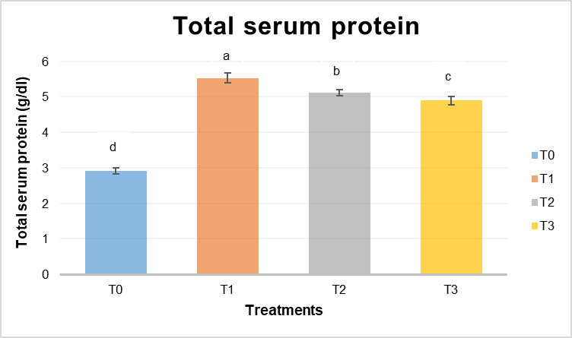

**Fig. 9. Total serum protein of Amur common carp fed with different treatment diets and control diet.**

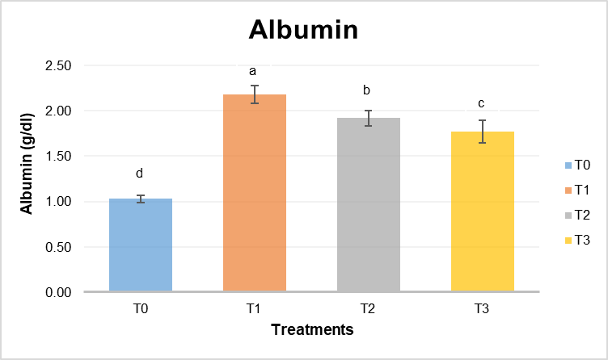

**Fig. 10. Serum albumin of Amur common carp fed with different treatment diets and control diet.**

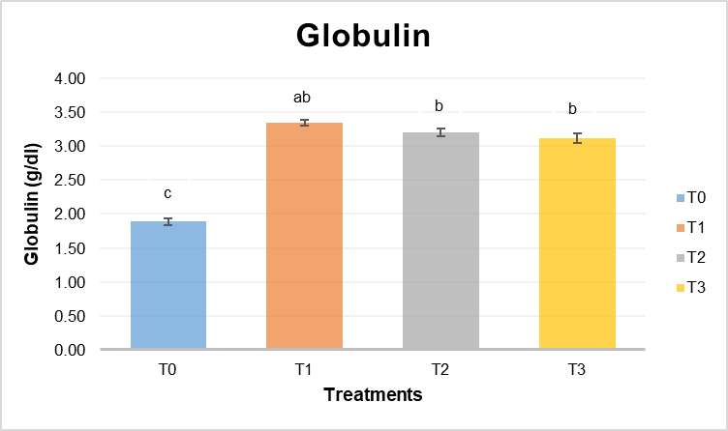

**Fig. 11. Serum globulin of Amur common carp fed with different treatment diets and control diet.**

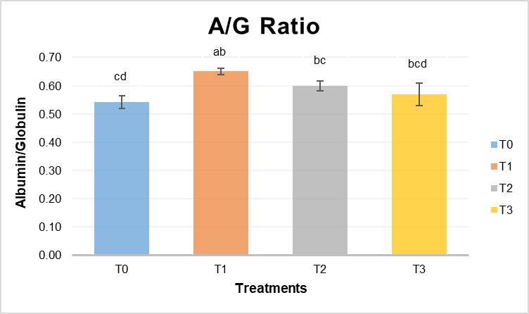

**Fig. 12. Albumin and Globulin ratio of Amur common carp fed with different treatment diets and control diet.**

It was observed to have significant difference (*P*<0.05) between the control and treatment groups in case of NBT assay. The obtained values were significantly higher in T1 (1.46±0.018) followed by T2 (1.08±0.012), T3 (1.07±0.019) and T0 (0.37±0.012) (Table 4 and Fig. 13). The lysozyme activity was recorded highest in T1 (7.10±0.033×104 IU/ml) succeeded by T2 (4.33±0.036×104 IU/ml), T3 (2.87±0.053×104 IU/ml) and T0 (0.68±0.053×104 IU/ml). The fish fed with test diet T1 showed significantly higher difference (*P*<0.05) compared to other treatment groups and control (Fig. 14). The values obtained under phagocytic activity showed significant difference (*P*<0.05) between the treatment groups and control. The phagocytic activity was found to be significantly higher in T1 (39.97±0.26%), consequently T2 (35.64±0.20%), T3 (30.09±0.18%) and T0 (22.94±0.35%) (Fig. 15). The total myeloperoxidase assay provided values that depicted significant difference (*P*<0.05) between the treatment groups and control. The significantly higher value was obtained in the fish fed with test diet T1 (1.15±0.032) followed by T2 (1.09±0.009), T3 (1.06±0.038) and T0 (0.53±0.025) (Fig. 16).

**Table 4. Details of immunological parameters of Amur common carp in different treatment groups and control.**

|  |  |  |  |  |
| --- | --- | --- | --- | --- |
| Parameters | Treatments | | | |
| **T0** | **T1** | **T2** | **T3** |
| NBT assay  (450nm) | 0.37±0.012c | 1.46±0.018a | 1.08±0.012b | 1.07±0.019b |
| Lysozyme activity (104 IU/ml) | 0.68±0.053d | 7.10±0.033a | 4.33±0.036b | 2.87±0.053c |
| Phagocytic activity (%) | 22.94±0.35d | 39.97±0.26a | 35.64±0.20b | 30.09±0.18c |
| Total MPO assay (450nm) | 0.53±0.025d | 1.15±0.032a | 1.09±0.009bc | 1.06±0.038c |

Results are presented as Mean ± SE of triplicates observation. Means with different superscripts are significantly different (*P*<0.05). NBT: Nitroblue tetrazolium, MPO: Myeloperoxidase

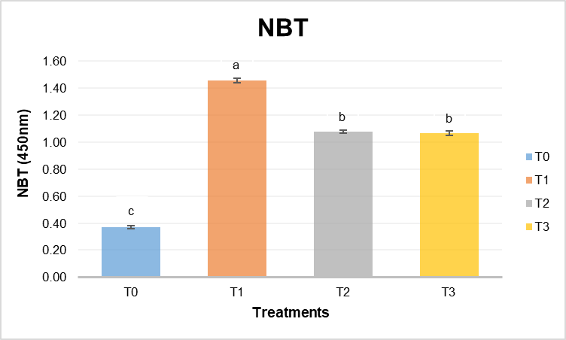

**Fig. 13.** **Nitroblue Tetrazolium (NBT) assay** **of Amur common carp in different treatment groups and control.**

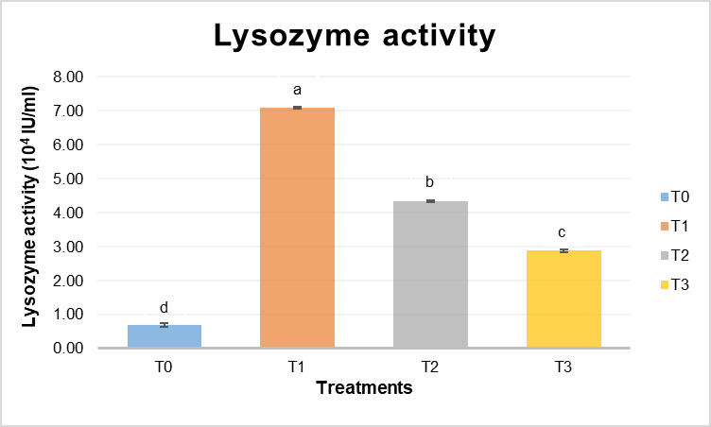

**Fig. 14. Lysozyme activity (104 IU/ml) of Amur common carp in different treatment groups and control.**

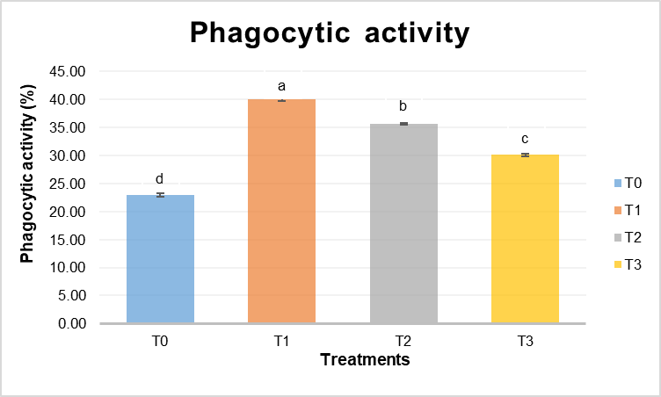

**Fig. 15. Phagocytic activity (%) of Amur common carp in different treatment groups and control.**

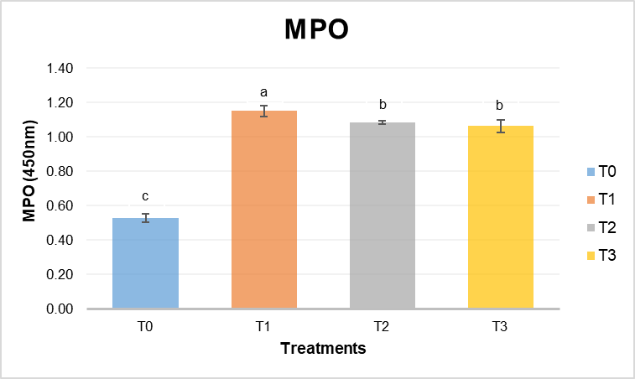

**Fig. 16. Myeloperoxidase assay of Amur common carp in different treatment groups and control.**

Probiotics like *Bacillus subtilis* administered orally at 108 CFU/g diet was the most effective dose for enhancing immune response and disease resistance in Japanese eel (*Anguilla japonica*) (Lee *et al*., 2017). Significant improvements in superoxide anion production and myeloperoxidase activity were observed in *Catla catla* fed with *Bacillus amyloliquefaciens* at rates of 1×107 to 1×109 CFU/g diet (Das *et al*., 2013). Similarly, dietary supplementation of *Bacillus amyloliquefaciens* (2.1×109 CFU/g) for 2 months significantly increased the respiratory burst responses of tilapia (Saputra *et al*., 2016). In rohu (*Labeo rohita*) and striped catfish (*Pangasianodon hypophthalmus*), *Bacillus amyloliquefaciens* also significantly enhanced the respiratory burst response of leucocytes (Thy *et al*., 2017; Mukherjee *et al*., 2019). In Nile tilapia, non-specific immune parameters were improved by dietary administration of *Bacillus amyloliquefaciens* at levels of 106 and 104 CFU/g after a 30-day feeding trial (Selim and Reda, 2015).

Giri *et al*. (2013) reported that the fish fed with *Lactobacillus. plantarum* at 10⁷ CFU g⁻¹ and 10⁸ CFU g⁻¹ exhibited comparable immunological and growth responses. Similarly, according to Mohapatra *et al*. (2014), higher and elevated NBT (nitroblue tetrazolium) activity was recorded in *Labeo rohita* fingerlings fed with a probiotic mixture containing *Bacillus subtilis* (10⁸ CFU g⁻¹), *Lactobacillus rhamnosus* (10⁸ CFU g⁻¹) and *Saccharomyces cerevisiae* (10⁷ CFU g⁻¹). Park *et al*. (2017) noted that during oxidative respiratory burst, myeloperoxidase (MPO) is most likely released by the azurophilic granules of neutrophils. Fish fed with a probiotic combination of *Lactobacillus plantarum* (10⁸ CFU g⁻¹) and *Bacillus subtilis* (10⁸ CFU g⁻¹) exhibited significantly higher MPO values than those fed with the control diet, aligning with the findings of Salinas and Picchietti (2008).

The study on the effect of *Lactobacillus acidophilus* on haematological parameters of *C. catla* revealed a significant increase in RBC count, Hb%, Hct% and red cell indices like MCV, MCH and MCHC (Renuka *et al*., 2014). *Saccharomyces cerevisiae* at 5%, 7.5% and 10% concentrations in *L. rohita* diets showed the highest TEC, Hb and HCT at 5% supplementation (Tewary *et al*., 2011). *Labeo rohita* fed with *Lactobacillus rhamnosus* (10⁸ CFU g-1) significantly increased hemoglobin (Hb), red blood cell (RBC) count, white blood cell (WBC) count and total serum protein levels (Mohapatra *et al*., 2014). *Lactobacillus plantarum* fed at a rate of 10⁸ CFU g⁻¹ enhanced RBC count, hemoglobin concentration, hematocrit levels and total immunoglobulin levels in *Oreochromis niloticus* (Pirarat *et al*., 2011). Dietary inclusion of *Lactobacillus casei* (10⁹ CFU g⁻¹) increased WBC count, total protein, albumin and globulin levels, with improved lysozyme activity in*Cyprinus carpio*(Hoseinifar *et al*., 2018). *Salmo salar* fed with *Pediococcus acidilactici* (10⁸ CFU g⁻¹) increased RBC count, hemoglobin, hematocrit and serum lysozyme activity (Merrifield *et al*., 2010).

**CONCLUSION**

In conclusion, all the haematological and immune parameters that were tested in the Amur common carp were improved by the dietary administration of *Bacillus amyloliquefaciens* at different levels of after 90 days feeding trial. The study demonstrated that the dietary supplementation with *Bacillus amyloliquefaciens* significantly improved the haematological and immune parameters of Amur common carp (*Cyprinus carpio haematopterus*). Fish fed with probiotic-supplemented diets, particularly at 0.5% inclusion of *Bacillus amyloliquefaciens*, exhibited higher RBC, WBC, haemoglobin, haematocrit and immune response indicators compared to the control group. These findings suggest that *Bacillus amyloliquefaciens* enhances fish health, making it a promising probiotic candidate for sustainable aquaculture practices.

**REFERENCES**

Abriouel, H., Franz, C. M. A. P., Omar, N. B., & Galvez, A. (2011). Diversity and applications of *Bacillus* bacteriocins. *FEMS Microbiology Reviews, 35*(1), 201–232.

Adineh, H., Jafaryan, H., Sahandi, J., & Alizadeh, M. (2013). Effect of *Bacillus* spp. probiotic on growth and feeding performance of rainbow trout (*Oncorhynchus mykiss*) larvae. *Bulgarian Journal of Veterinary Medicine, 16*(1), 29–36.

Anderson, D. P., & Siwicki, A. K. (1995). Basic hematology and serology for fish health programs. *Fish Health Section Blue Book.*

Bossier, P., & Ekasari, J. (2017). Biofloc technology application in aquaculture to support sustainable development goals. *Microbial Biotechnology, 10*(5), 1012–1016. https://doi.org/10.1111/1751-7915.12758

Cha, J. H., Rahimnejad, S., Yang, S. Y., Kim, K. W., & Lee, K. J. (2013). Evaluations of *Bacillus* spp. as dietary additives on growth performance, innate immunity, and disease resistance of olive flounder (*Paralichthys olivaceus*) against *Streptococcus iniae* and as water additives. *Aquaculture, 402*, 50–57.

Das, A., Nakhro, K., Chowdhury, S., & Kamilya, D. (2013). Effects of potential probiotic *Bacillus amyloliquefaciens* FPTB16 on systemic and cutaneous mucosal immune responses and disease resistance of catla (*Catla catla*). *Fish & Shellfish Immunology, 35*(5), 1547–1553.

Food and Agriculture Organization (FAO). (2020). *The State of World Fisheries and Aquaculture (SOFIA)*. FAO.

Food and Agriculture Organization (FAO). (2024). *The State of World Fisheries and Aquaculture.* FAO.

Froehlich, H. E., Smith, A., Gentry, R. R., & Halpern, B. S. (2017). Offshore aquaculture: I know it when I see it. *Frontiers in Marine Science, 4*, 154.

Fuller, R. (1989). Probiotic in man and animals. *Journal of Applied Bacteriology, 66*, 131–139.

Giri, S. S., Sukumaran, V., & Oviya, M. (2013). Potential probiotic *Lactobacillus plantarum* isolated from the gut of *Labeo rohita* and its effect on growth performance and immune response. *Fish & Shellfish Immunology, 34*(2), 660–666.

Guardiola, F. A., Porcino, C., Cerezuela, R., Cuesta, A., Faggio, C., & Esteban, M. A. (2016). Impact of date palm fruits extracts and probiotic enriched diet on antioxidant status, innate immune response and immune-related gene expression of European seabass (*Dicentrarchus labrax*). *Fish & Shellfish Immunology, 52*, 298–308.

Hill, C., Guarner, F., Reid, G., Gibson, G. R., Merenstein, D. J., Pot, B., Morelli, L., Canani, R. B., Flint, H. J., Salminen, S., Calder, P. C., & Sanders, M. E. (2014). Expert consensus document: The International Scientific Association for Probiotics and Prebiotics consensus statement on the scope and appropriate use of the term probiotic. *Nature Reviews Gastroenterology & Hepatology, 11*(8), 506–514.

Hoseinifar, S. H., Ringø, E., Masouleh, A. S., & Esteban, M. A. (2016). Probiotic, prebiotic and synbiotic supplements in sturgeon aquaculture: A review. *Reviews in Aquaculture, 8*, 89–102.

Hoseinifar, S. H., Zoheiri, F., Dadar, M., Van Doan, H., Faheem, M., Mirvaghefi, H., & Imanpour, M. R. (2018). Effects of dietary *Lactobacillus casei* and *Saccharomyces cerevisiae* on immune-related gene expression, hematological parameters, and disease resistance in common carp (*Cyprinus carpio*). *Aquaculture*, 493, 151–156.

Lee, S., Katya, K., Park, Y., Won, S., Seong, M., Hamidoghli, A., & Bai, S. C. (2017). Comparative evaluation of dietary probiotics *Bacillus subtilis* WB60 and *Lactobacillus plantarum* KCTC3928 on the growth performance, immunological parameters, gut morphology, and disease resistance in Japanese eel, *Anguilla japonica*. *Fish & Shellfish Immunology, 66*, 150–158.

Merrifield, D. L., Dimitroglou, A., Foey, A., Davies, S. J., Baker, R. T. M., Bøgwald, J., Castex, M., & Ringø, E. (2010). The current status and future focus of probiotic and prebiotic applications for salmonids. *Aquaculture, 302*(1-2), 1–18.

Mohapatra, S., Chakraborty, T., Prusty, A. K., Das, P., Paniprasad, K., & Mohanta, K. N. (2014). Use of different microbial probiotics in the diet of *Labeo rohita* fingerlings: Growth, immunity, and disease resistance. *Aquaculture Research, 45*(6), 928–938.

Mukherjee, S. K., Das, M., & Chakraborty, S. (2019). Immune enhancement of *Pangasianodon hypophthalmus* through the use of *Bacillus amyloliquefaciens*: A potential biocontrol agent. *Aquaculture Research, 50*(3), 893–902.

Naylor, R. L., Hardy, R. W., Buschmann, A. H., Bush, S. R., Cao, L., Klinger, D. H., Little, D. C., Lubchenco, J., Shumway, S. E., & Troell, M. (2021). A 20-year retrospective review of global aquaculture. *Nature, 591*(7851), 551–563.

Park, S. C., Shimamura, I., Fukunaga, M., Mori, K. I., & Nakai, T. (2017). The effect of probiotics on the immune responses of fish: Insights from the role of myeloperoxidase activity. *Aquaculture, 481*, 40–45.

Parry Jr., R. M., Chandan, R. C., & Shahani, K. M. (1965). A rapid and sensitive assay of muramidase. *Proceedings of the Society for Experimental Biology and Medicine, 119*(2), 384–386.

Pirarat, N., Pinpimai, K., Endo, M., Katagiri, T., Ponpornpisit, A., & Maita, M. (2011). Modulation of intestinal morphology and immunological status of Nile tilapia (*Oreochromis niloticus*) by *Lactobacillus rhamnosus* GG. *Fish & Shellfish Immunology, 30*(1), 89–93.

Priest, F. G., Goodfellow, M., Shute, L. A., & Berkeley, R. C. W. (1987). *Bacillus amyloliquefaciens* sp. nov., nom. rev. *International Journal of Systematic Bacteriology, 37*(1), 69–71.

Quade, M. J., & Roth, J. A. (1997). A rapid, direct assay to measure degranulation of bovine neutrophil primary granules. *Veterinary Immunology and Immunopathology, 58*, 239–248.

Renuka, K. P., Venkateshwarlu, M., & Ramachandra Naik, A. T. (2014). Effect of probiotic (*Lactobacillus acidophilus*) on hematological parameters of *Catla catla* (Hamilton). *International Journal of Current Microbiology and Applied Sciences, 3*(8), 326–335.

Sahan, A., & Duman, S. (2010). Effect of β-glucan on haematology of common carp (*Cyprinus carpio*) infected by ectoparasites. *Medical Aquaculture Journal, 3*(1), 1–7.

Salinas, I., & Picchietti, S. (2008). The mucosal immune system of teleost fish. *Fish & Shellfish Immunology, 25*(5), 434–445.

Saputra, F., Shiu, Y. L., Chen, Y. C., Puspitasari, A. W., Danata, R. H., Liu, C. H., & Hu, S. Y. (2016). Dietary supplementation with xylanase-expressing *Bacillus amyloliquefaciens* R8 improves growth performance and enhances immunity against *Aeromonas hydrophila* in Nile tilapia (*Oreochromis niloticus*). *Fish & Shellfish Immunology, 58*, 397–405.

Selim, K. M., & Reda, R. M. (2015). Improvement of immunity and disease resistance in the Nile tilapia, *Oreochromis niloticus*, by dietary supplementation with *Bacillus amyloliquefaciens*. *Fish & Shellfish Immunology, 44*(2), 496–503.

Smith, D. L., & Romme, F. (1997). A rapid micro method for the stimulation of phagocytic-microbicidal activity of human peripheral blood leucocytes in vitro. *Journal of Immunological Methods, 17*, 241–247.

Stoskopf, M. K. (1993). *Clinical Pathology.* In M. K. Stoskopf (Ed.), *Fish Medicine* (pp. 882). W.B. Saunders Company.

Subasinghe, R. P. (2005). Epidemiological approach to aquatic animal health management: Opportunities and challenges for developing countries to increase aquatic production through aquaculture. *Preventive Veterinary Medicine, 67*(2-3), 117–124.

Tewary, D. K., Patra, B. C., & Mohapatra, A. (2011). Effect of *Saccharomyces cerevisiae* supplementation on the hematological parameters of *Labeo rohita*. *Aquaculture Nutrition, 17*(6), e115–e121.

Van Hai, N. (2015). Research findings from the use of probiotics in tilapia aquaculture: A review. *Fish & Shellfish Immunology, 45*(2), 592–597.

Welker, N. E., & Campbell, L. L. (1967). Unrelatedness of *Bacillus amyloliquefaciens* and *Bacillus subtilis*. *Journal of Bacteriology, 94*(4), 1124–1130.

Zorrilla, I., Chabrillón, M., Arijo, S., Díaz-Rosales, P., Martínez-Manzanares, E., Balebona, M. C., & Morinigo, M. A. (2003). Bacteria recovered from diseased cultured gilthead seabream (*Sparus aurata L.*) in southwestern Spain. *Aquaculture, 218*(1-4), 11–20.