Original Research Article

IDEANTIFICATION OF NEW SOURCES OF TOLERANCE TO LEAF CURL-MOSAIC COMPLEX DISEASE IN CHILLI PEPPER (Capsicum spp.)

ABSTRACT
Chilli leaf curl-mosaic complex (ChiLCMC) disease is a major constraint in chilli (Capsicum spp.) production, causing significant yield losses in India. The disease, transmitted primarily by whiteflies, aphids, and grafting, manifests through symptoms such as leaf curling, vein swelling, and plant stunting, leading to severe economic losses. Chemical control of disease vectors poses environmental risks, necessitating the identification of disease-tolerant genotypes for sustainable management. This study aimed to screen chilli genotypes for ChiLCMC tolerance through natural infection, graft transmission and molecular validation of resistance markers.
Sixty-four genotypes from three Capsicum species were evaluated under natural epiphytotic conditions, and thirty promising genotypes were subjected to artificial screening via graft transmission. Virus titre estimation using polymerase chain reaction (PCR) with virus-specific primers was conducted to assess infection levels. Six genotypes (Venjaramood Local II, KD-2, Unda Chilli, AP-1, IC-208580, and IC-570376) remained symptomless post-grafting, indicating potential tolerance. PCR analysis revealed the presence of Geminiviruses and Bromoviruses in some asymptomatic genotypes, suggesting their ability to suppress symptom expression despite viral replication. The use of degenerate Deng primers detected viral presence in tolerant genotypes, while coat protein-specific primers confirmed the absence of chilli leaf curl virus in most resistant lines.
These findings identify novel sources of ChiLCMC tolerance, which can be integrated into breeding programs to develop high-yielding, disease-resistant hybrids/varieties. Such approaches contribute to sustainable chilli cultivation by reducing reliance on chemical controls and promoting eco-friendly farming practices.
Keywords: Chilli, Chilli leaf curl-mosaic complex, Graft transmission, Virus titre estimation, Disease tolerance, Breeding
INTRODUCTION
Chilli leaf curl-mosaic complex (ChiLCMC) disease is the most important one affecting vast areas of chilli growing regions in India. Chilli, an important cash crop worldwide, is highly susceptible to leaf curl and mosaic disease, which usually is observed as a complex disease. Yield losses of up to hundred percent have been reported in chilli due to viral diseases like ChiLCMC (9). The complex disease is predominantly transmitted by whiteflies, aphids and grafting. It is reported that even a single whitefly can transmit the virus, while eight whiteflies on a plant can cause 100% disease transmission. Characteristic symptoms of the complex disease, caused by Geminiviruses and Bromoviridae encompass the curling of leaves, thickening and swelling of veins, shortened internodes and petioles, leaf crowding, yellow mottling, distorted leaves, and overall stunting of the plant(10).
While chemicals like insecticides and pesticides are very effective in controlling the insects that transmit diseases in cultivated crops, they impose a serious threat to the environment and the living beings. Alternatively, identification of lines that are resistant to the diseases and using them as parents in hybridisation programmes to develop superior disease tolerant hybrids can be adopted. Hence, the objective of the investigation work was to identify the sources of tolerance to ChiLCMC disease through artificial screening by adopting graft transmission technique and to further validate the molecular markers reported for resistance to both chilli leaf curl and chilli mosaic diseases.
MATERIALS AND METHODS
Plant materials and experimental conditions
Sixty-four genotypes of chilli, belonging to three different cultivated species namely, Capsicum annuum, Capsicum chinense and Capsicum frutescense were procured from the National Bureau of Plant Genetic Resources, Kerala Agricultural University and farmers’ field. The genotypes were subjected to screening under natural epiphytotic conditions during the summer of 2023 (unpublished). Thirty genotypes, found to be tolerant under field conditions were subjected to artificial screening using graft transmission technique.
Graft transmission
To confirm tolerance to ChiLCMC disease, artificial screening of the genotypes using graft transmission technique was adopted by using a susceptible variety Vellayani Athulya as the scion, after confirming for the presence of viruses using virus coat protein specific primers. Wedge grafting technique, where the end of the scion is cut into a wedge-shaped structure, is inserted into a split in the rootstock, and covered by a polyethylene cover supported by midrib of coconut leaf(7). A total of five replications were made for all thirty genotypes and the grafted plants were kept undisturbed for two to three weeks under insect proof net house, misted daily for one hour (Figure 1 and figure 2).
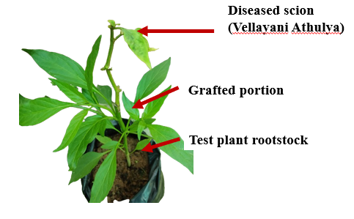
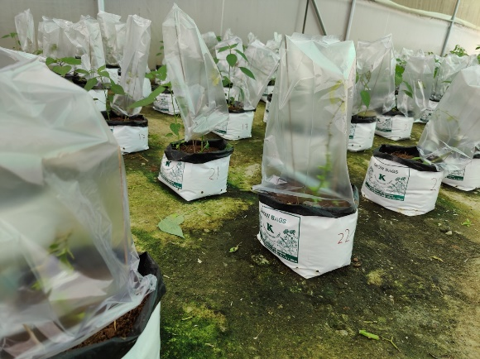
Fig.1. Grafted plant after 30 days Fig.2. Virus inoculated genotypes under insect proof condition

4
3
2
1

5
6

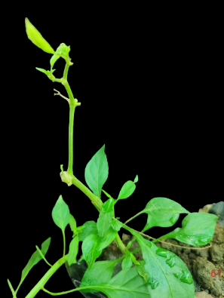
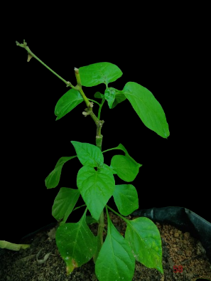
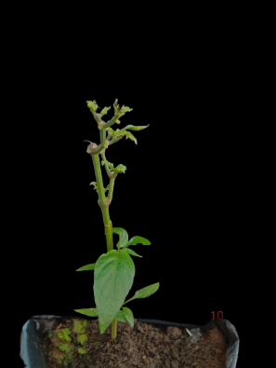
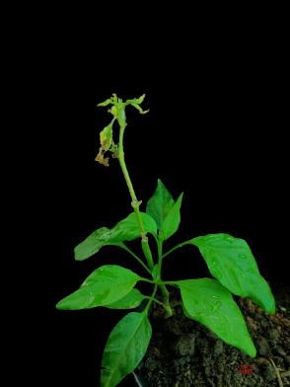
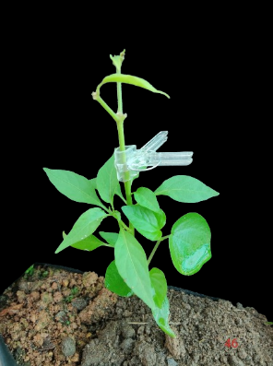
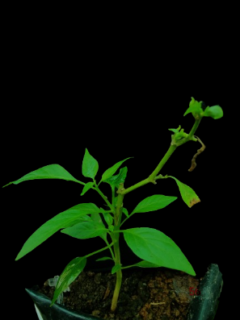
Fig.3. Chilli genotypes confirmed as tolerant after one month of graft transmission;
1.Venjaramood Local II; 2.KD-2; 3. Unda Chilli (Vadakara Local); 4.AP-1; 5.IC-208580; 6.IC-570376

Virus titre estimation
The virus titre in each genotype selected for disease tolerance after graft transmission of the viruses was estimated based on polymerase chain reaction using virus specific primers. The titre of each virus, ie., chilli leaf curl virus and mosaic virus were estimated separately as even though the disease is a complex, it is caused by individual viruses. Leaf curling in chilli plants is attributed to infection by begomoviruses of Geminiviridae family whereas mosaic symptoms are associated with cucumovirus infection, a genus within the Bromoviridae family(2). The details of primers used to determine the virus titre is given in table 1.

Table 1. The details of primers used to estimate the virus titre
Marker name | Sequence | Annealing temperature |  | Product size (bp) |  | Reference
Leaf curl virus
Deng 541-F | TAATATTACCKGWKGVCCSC | 49ºC | 520 bp |  | (3)
Deng 540-R | TGGACYTTRCAWGGBCCTTCACA | 49ºC
CLA 7F | TTAACATGTTTGACAACGAGCCTAGAA | 56ºC | 540 bp |  | (6)
CLA 8R | TTCATTTCTTAAGGGTATTTAGGACAA | 56ºC
AVF9 | ATGTCGCAAGCGAGCCTAGCCAGATAT | 42ºC | 750 bp |  | (8)
AVR10 | TGTAATTCGTATACACGAGTTCATA | 42ºC
Mosaic virus
RsCMV F | ATG GAC AAA TCT GAA TCA AC | 59ºC | 657 bp |  | (11)
RsCMV R | TCA AAC TGG GAG CAC CC | 59ºC

RESULTS
Immune reaction was shown by six genotypes after graft transmission among the thirty genotype that were screened for tolerance under natural whitefly attack in field conditions. They were also high yielding types (unpublished) (Figure 3).
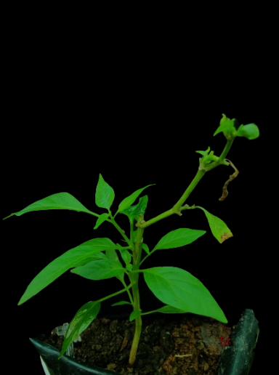
Leaf curl or Begomovirus titre estimation using degenerate Deng 541-F/ Deng 540-R primer owed presence of virus in two genotypes IC-570376 and AP-1 along with susceptible genotype and susceptible variety used as control (Figure 4). But the use of virus coat protein specific primers CLA 7F/ CLA 8R and AVF9/AVR10 showed a different story. The primer pair CLA 7F/CLA 8R successfully amplified only in the control samples (Figure 5), whereas AVF9/AVR10 produced multiple bands (Figure 6), indicating non-specific primer binding. A gradient PCR was attempted, but the results remained unchanged.
For mosaic virus, the titre was estimated using a coat protein specific RsCMV primer (Figure 7). While the highest band intensity was observed in the susceptible variety, all the genotypes, except for AP-1 and IC-208580 showed the presence of virus.

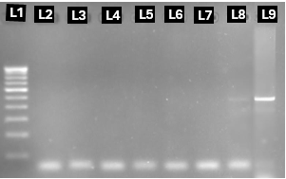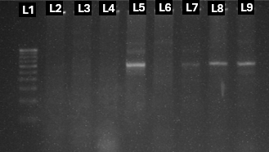+
Fig.4. Amplification of ChiLCV using degenerate Deng primer
Fig.5. Amplification of ChiLCV using coat protein gene specific (Partial) primer CLA 7F/CLA 8R
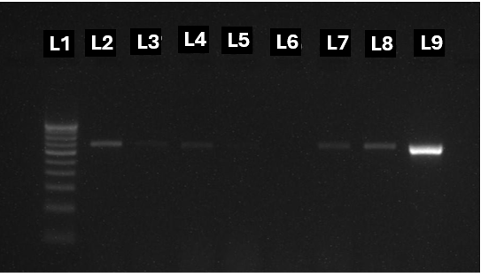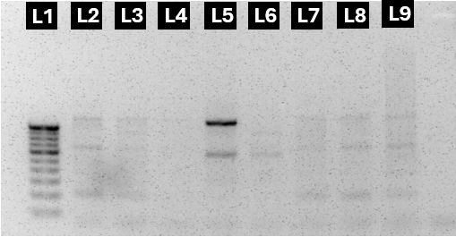
Fig.7. Amplification of ChiLCV using coat protein specific primer
Fig.6. Amplification of ChiLCV using coat protein specific primer AVF9/AVR10
L1= Marker, L2= Venjaramood Local II, L3= KD-2, L4 = Unda Chilli (Vadakara Local), L5 = AP-1, L6 = IC-208580, L7= IC-570376, L8 =IC-572486 (Susceptible), L9 = Vellayani Athulya
DISCUSSION
Identification of new sources of resistance is of utmost importance in any resistance breeding programme and to identify these, there is a need of availability of large number of genotypes. Cultivated Capsicum spp. including C.annuum, C. frutescens etc possess important genes in them that confer disease and pest resistance. Grafting, a widely utilised technique when other methods fail, is a successful method to transmit viruses from a diseased plant to a healthy one(1). Hence a total of thirty tolerant genotypes screened for tolerance to chilli leaf curl mosaic complex disease under natural epiphytotic conditions in a previous study, were subjected to artificial screening by adopting graft transmission technique. Six genotypes among the thirty studied were symptom less after grafting with a diseased plant, showing their tolerance to the disease complex.
Virus titre assessment is a vital step in the study of infectivity of any disease, to study plant-virus interactions, effectiveness of resistance mechanisms adopted by the plants and to develop effective control strategies. Genotypes exhibiting disease resistance reactions can still harbour enough load of virus that can be detected at molecular level as evidenced from the works conducted by (4) and (5). In our study, presence of Geminiviruses and Bromoviruses, causing leaf curl disease and mosaic disease respectively, were found in some genotypes that did not show disease symptom expression during its transmission via graft transmission technique. This can be attributed to the ability of the genotypes to suppress the symptom expression even when the virus replication is happening inside them.
The Deng primer being a degenerate primer is designed to identify a range of whitefly transmitted geminivirus. This may include Curtovirus, Topocuvirus etc. along with Begomoviruses (3). This maybe the reason for the amplifications of viral particles observed in tolerant genotypes when Deng primers were used. CLA7F/CLA8R is a specific primer that amplifies the coat protein gene of chilli leaf curl virus, and this virus was present only in the susceptible variety, Vellayani Athulya, confirming that the genotypes were tolerant to chilli leaf curl virus. Presence of multiple bands in gel electrophoresis when chilli leaf curl virus coat protein specific AVF9/AVR10 primer was used, was troubleshooted by utilising gradient PCR as well as by varying the primer concentrations but the results remained consistent. Hence, problems like low primer specificity etc. maybe the reason for this result.
This study focuses on the screening of chilli germplasm for tolerance to leaf curl-mosaic complex disease. The sources identified in this study can be utilised in breeding programmes to develop disease tolerant hybrids with high yielding capacity, which can lead to sustainable, environment friendly farming practices.
REFERENCES
1. Bhat AI, Rao GP, Bhat AI, Rao GP. 2020. Transmission through grafting and budding. Springer
2. Creamer R. 2024. Bell pepper. In Viral Diseases of Field and Horticultural Crops:401-9: Elsevier. Number of 401-9 pp.
3. Deng D, McGrath P, Robinson D, Harrison B. 1994. Detection and differentiation of whitefly‐transmitted geminiviruses in plants and vector insects by the polymerase chain reaction with degenerate primers. Annals of applied Biology 125:327-36
4. Gupta N, Reddy K, Bhattacharyya D, Chakraborty✉ S. 2021. Plant responses to geminivirus infection: guardians of the plant immunity. Virology journal 18:143
5. Jeevalatha A, Siddappa S, Kumar A, Kaundal P, Guleria A, et al. 2017. An insight into differentially regulated genes in resistant and susceptible genotypes of potato in response to tomato leaf curl New Delhi virus-[potato] infection. Virus Research 232:22-33
6. Kumar R, Kumar V, Kadiri S, Palicherla SR. 2016. Epidemiology and diagnosis of chilli leaf curl virus in central India, a major chilli growing region. Indian Phytopathol 69:61-4
7. Kumar S, Kumar S, Singh M, Singh AK, Rai M. 2006. Identification of host plant resistance to pepper leaf curl virus in chilli (Capsicum species). Scientia horticulturae 110:359-61
8. Senanayake D, Varma A, Mandal B. 2012. Virus–vector relationships, host range, detection and sequence comparison of Chilli leaf curl virus associated with an epidemic of leaf curl disease of chilli in Jodhpur, India. Journal of Phytopathology 160:146-55
9. Srivastava A, Mangal M, Saritha R, Kalia P. 2017. Screening of chilli pepper (Capsicum spp.) lines for resistance to the begomoviruses causing chilli leaf curl disease in India. Crop protection 100:177-85
10. Thakur H, Jindal SK, Sharma A, Dhaliwal MS. 2018. Chilli leaf curl virus disease: a serious threat for chilli cultivation. Journal of Plant Diseases and Protection 125:239-49
11. Vinodhini J, Rajendran L, Abirami R, Karthikeyan G. 2021. Co-existence of chlorosis inducing strain of Cucumber mosaic virus with tospoviruses on hot pepper (Capsicum annuum) in India. Scientific reports 11:8796

