***In vitro* evaluation of plant growth promoting rhizobacteria isolates against *Fusarium oxysporum* f. sp. *ciceri***

# ABSTRACT

Chickpea (*Cicer arietinum* L.) is one of the most important pulse crops, contributing significantly to global pulse production. However, its productivity is severely constrained by Fusarium wilt, caused by *Fusarium oxysporum* f. sp. *ciceri*. The present study evaluates the antagonistic potential of native Plant Growth Promoting Rhizobacteria (PGPR) isolates collected from the Marathwada region, Maharashtra, against this pathogen. A total of 19 PGPR isolates were screened using an in vitro dual culture assay, where inhibition of fungal mycelial growth ranged from 39.63% to 86.67%. Among these, the isolate CPA2 exhibited the highest inhibition (86.67%), followed by CPP4 (85.22%) and CPJ1 (83.48%). The antagonistic activity of PGPR is attributed to the production of bioactive compounds such as siderophores, antibiotics, and hydrolytic enzymes that suppress pathogen growth. The study suggests that these native PGPR isolates have the potential to be developed as biocontrol agents for sustainable management of Fusarium wilt in chickpea cultivation.

**Keywords:** Chickpea, Fusarium wilt, *Fusarium oxysporum* f. sp. *ciceri*, PGPR, biocontrol, Marathwada region.

## Introduction

Chickpea (*Cicer arietinum* L.) Bengal gram, or Garbenzo bean is an annual legume of the family Fabaceae subfamily Faboideae. World's third most important pulse crop after beans (*Phaseolus vulgaris* L.) and peas (*Pisum sativum* L.). The primary center of origin of Bengal gram is stated to be eastern Mediterranean, although its likely origin is in Southwestern Asia with Ethiopia serving as the secondary origin. It is widely cultivated throughout various subtropical and warm temperate climates and it supplies 20 percent of the world's pulses. Major producers of chickpeas include India, Pakistan and Mexico. About 90 percent of the world’s production of chickpeas is produced in six nations, India, Australia, Turkey, Myanmar, Pakistan and Ethiopia. It grows best as a post-monsoon cool season crop in semi-arid regions of the sub- continent with a crop duration of 80 to 170 days.

Globally, Bengal gram is produced in an area of 137 lakh ha. with a production of 142.4 lakh tonnes and a productivity of 1038 kg/ha (Anonymous, 2019b). India supplies 70 percent of the world’s Bengal gram production of 116.2 lakh tonnes cultivated under 112 lakh ha. With Productivity of 1036 kg/ha in 2020-21 (Anonymous, 2021). The output of all pulses in 2020-21 was dominated by chickpeas, which accounted for 49.30 percent of total pulses production. India is the largest producer of world gram production followed by Australia, Myanmar, and Ethiopia (Anonymous, 2019b).

Maharashtra contributes a total area of 20.38 lakh ha. under chickpea cultivation with a production of 17.29 lakh tonnes and productivity of 848.55 kg/ha. (Anonymous, 2020). It is one of the significant *rabi* pulse crops grown in the Marathwada region of Maharashtra state. In the Marathwada region, chickpea was cultivated on an area of 10.59 lakh ha. with a production of

7.96 lakh tonnes and productivity of 707.56 kg/ha (Anonymous, 2020).

Plant Growth Promoting Rhizobacteria sp. secrete several metabolites that trigger plant growth and prevent pathogen infection. Limited studies have been conducted to understand the physiological changes that occur in crops in response to protecting adverse environmental conditions. This review describes the current understanding of PGPR sp.-induced physiological changes in plants as an adaptation to abiotic and biotic stresses. During water scarcity, salinity and heavy metals accumulate in soil the PGPR sp. produces exopolysaccharides and siderophores which prevent the movement of toxic ions and adjust the ionic balance and water transport in plant tissues while controlling the pathogenic microbial population. In addition, the synthesis of indole-3- acetic acid, gibberellic acid and1-aminocyclopropane-1- carboxylate (ACC) deaminase by PGPR regulates the intracellular phytohormone metabolism and increases plant stress tolerance. Cell-wall-degrading substances, such as chitosanase, protease, cellulase, glucanase, lipopeptides and hydrogen cyanide from PGPR sp. damage the pathogenic bacteria, fungi, nematodes, viruses and pests to control their populations in plants and agricultural lands. The typical plant metabolism is affected by unfavorable environmental stimuli, which suppress crop growth and yield. Abiotic and biotic stress factors that have detrimental effects on crops are mitigated by PGPR-induced physiological changes, including the regulation of water transport, nutrient uptake, and the activation of the antioxidant and defense systems. PGPR association stimulates plant immunity against stresses by altering stress-responsive genes, proteins, phytohormones, and related metabolites.

This review describes the beneficial effect of PGPR sp. on crop plants, which improves plant productivity under unfavorable climatic conditions, and the current understanding of the mitigation mechanism of PGPR sp. in stress-tolerant and/or stress-resistant plants. (Radhakrishna *et al*., 2017).

**MATERIALS AND METHODS**

## 3.4 Collection of rhizosphere soil samples for PGPR isolates.

The rhizosphere soil samples were collected from healthy chickpea plants from three agroclimatic zones of the Marathwada region, Maharashtra, India. Soil samples were collected randomly at a depth of 0-15 cm using standard protocols. From each location, five random samples were collected and pooled together to get a representative composite soil sample by quartering technique. About 100 g of soil from each location was properly labeled with the requisite information, sealed, and stored in the refrigerator till further studies.

## Isolation

The rhizosphere samples were collected from healthy chickpea plants using standard protocol. After drying and processing, ten grams of soil sample was suspended in 90 ml of sterile water and serial dilutions of the suspensions were made in sterile water blanks. One milliliter of 10-4 to 10-7 dilutions was plated on Nutrient agar medium (NAM). The plates were incubated for 4-5 days at 28 ± 2 °C and observed light yellow off-white-coloured colonies. Based on the descriptions of Chhabra and Sharma (2019), PGPR isolates were identified. The isolates were purified and maintained on Nutrient agar medium (NAM) plates and stored at 4 °C.

## Antagonism of PGPR isolates.

The PGPR isolates were tested for their antagonistic properties against the wilt-causing fungus *Fusarium oxysporum* f. sp*. ciceri* by dual culture method (Karimi *et al*. (2012). In dual culture, 20 ml of sterilized and cooled nutrient agar was poured into sterile petri plates and allowed to solidify. Bacterial culture of 5 mm diameter cut from the margin of 5 days actively growing cultures of both test pathogen and antagonists were placed opposite to each other on PDA in Petri plates (90 mm). The Petri plates with a disc of the *Fusarium* alone served as the control. Each treatment was replicated three times. The inoculated petri plates were incubated at 28 ± 2 °C for 7 days.

## Experiment Details

Design : CRD (Completely Randomized Design) Treatments : Twenty

Replications : Three

Observations on linear mycelial growth of the test pathogen and biocontrol agents were measured, and percent growth inhibition of the test pathogen was calculated by applying the formula given by Vincent (1947) as follows.

C - T

Per cent inhibition (I) =……………….. × 100

C

Where,

C= Colony growth of Pathogen in control (mm)

T= Colony growth of Pathogen in dual culture plate (mm)

# RESULTS AND DISCUSSION

In the dual culture test, all nineteen isolates of PGPR inhibited the mycelial growth of *Fusarium oxysporum* f. sp*. ciceri* with percent growth inhibition ranging from 39.63 to 86.67 percent. All the isolates inhibited the growth of tested fungi significantly. The results of the dual culture technique indicated that in (Table 1 and Plate 1).

Among the nineteen PGPR isolates tested, significant percent growth inhibition of *Fusarium oxysporum* f. sp*. ciceri* was reported in eight isolates ranging from 71.26 to 86.67 percent with radial growth ranging from 12.00 to 25.87 mm. Among these eight isolates, PGPR isolate CPA2 was proved most effective with maximum inhibition (86.67 %) of *Fusarium oxysporum* f. sp. *ciceri* with radial growth 12.00 mm which was at par with isolate CPP4 with 85.22 per cent inhibition and radial growth 13.30 mm followed by isolate CPJ1 with 83.48 per cent inhibition and radial growth 14.87 mm followed by isolates CPN2, CPB2 and CPB1, which were found significantly at par with each other with 79.63, 79.26 and 77.85 per cent inhibition with radial growth 18.33 mm, 18.67 mm and 19.93 respectively. It was followed by isolates CPL2, and CPO2 with 74.07, 71.26 percent inhibition, and radial growth of 23.33 mm and 25.87mm, respectively.

The difference in percent inhibition of mycelial radial growth indicated differences in antagonistic activity among all the isolates of PGPR against *Fusarium oxysporum* f. sp. *ciceri.* The variability in the antagonistic ability of PGPR isolates against pathogens showed clear-cut differences in results obtained.

It may also be due to the production of volatile or non-volatile toxic metabolites like antibiotics, aldehydes, ketones, cyanide, ethylene, organic acids, and other factors like siderophores which played an indirect role in the inhibition of pathogen growth.

**Table 1: *In vitro* evaluation of Plant Growth Promoting Rhizobacteria isolates against most virulent *Fusarium oxysporum* f. sp. *ciceri***

|  |  |  |  |
| --- | --- | --- | --- |
| **Sr. no.** | **Isolate code** | * **Colony growth (mm)** | * **Inhibition (%)** |
| 1 | CPP1 | 45.20 | 49.78  (44.87) |
| 2 | CPP2 | 40.33 | 55.19  (47.98) |
| 3 | CPP3 | 51.20 | 43.11  (41.04) |
| 4 | **CPP4** | 13.30 | 85.22  (67.39) |
| 5 | CPN1 | 54.33 | 39.63  (39.01) |
| 6 | **CPN2** | 18.33 | 79.63  (63.17) |
| 7 | CPN3 | 51.67 | 42.59  (40.74) |
| 8 | **CPJ1** | 14.87 | 83.48  (66.02) |
| 9 | CPJ2 | 39.67 | 55.93  (48.40) |
| 10 | CPA1 | 45.87 | 49.04  (44.45) |
| 11 | **CPA2** | 12.00 | 86.67  (68.58) |
| 12 | CPL1 | 48.87 | 45.70  (42.54) |
| 13 | **CPL2** | 23.33 | 74.07  (59.39) |
| 14 | CPO1 | 38.67 | 57.04  (49.05) |
| 15 | **CPO2** | 25.87 | 71.26  (57.58) |
| 16 | **CPB1** | 19.93 | 77.85  (61.93) |
| 17 | **CPB2** | 18.67 | 79.26  (62.91) |
| 18 | CPH1 | 53.43 | 40.63  (39.60) |
| 19 | CPH2 | 46.87 | 47.93  (43.81) |
| 20 | Control | 90.00 | - |
| **SE(m)±** | | 0.81 | 0.55 |
| **C. D. (P=0.01)** | | 2.32 | 1.59 |

*Figures in the parenthesis are angular transformed value

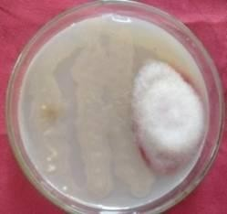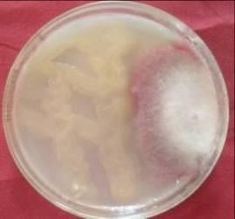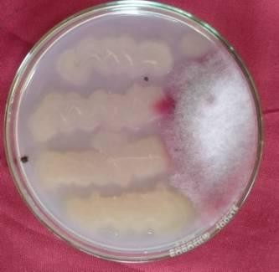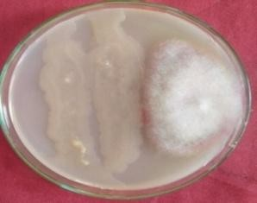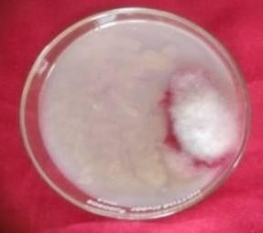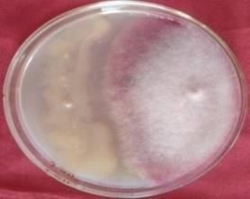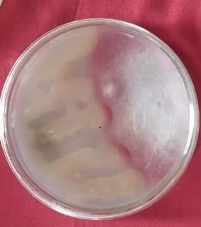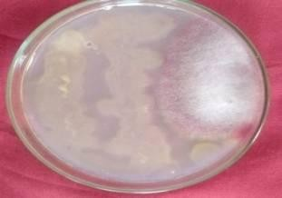

**Plate 1: *In vitro* efficacy of eight Plant Growth Promoting Rhizobacteria isolates against most virulent**

***Fusarium oxysporum* f. sp*. ciceri***

The results were consistent with reports of Kala *et al.* (2016), Wavare *et al*. (2017), and Thaware *et al*. (2017), who reported the highest mycelial growth inhibition of *Fusarium oxysporum* f. sp. *ciceri* (81.59 %) by *Pseudomonas fluorescens*. Similarly, brigido *et al*. (2019) studied *in vitro* hyphal inhibition of *F*. *oxysporum* f. sp. *ciceris* race 5 and suppression of *Fusarium* wilt. Nineteen *Bacillus, Paenibacillus*, *Pseudomonas,* and *Stenotrophomonas* spp. of the 23 bacterial isolates in the study significantly (P < 0.05) inhibited the *in vitro* hyphal growth of *F. oxysporum* f. sp. *ciceris* race 5 However, the extent of inhibition varied among isolates. Kapali *et al*. (2016) also reported the highest inhibition (82.25 %) by *Pseudomonas fluorescens*. Whereas Kadam *et al*. (2019) recorded a higher rate of inhibition (86.49%) Similar findings were also reported by Landa *et al*. (2001), Hesamedian *et al*. (2009), Kandoliya and Vakharia (2013), Chandar *et al.* (2016), Kapali *et al*. (2016), Zaim *et al*. (2018), Pandey *et al.* (2022) and Dewi *et al.* (2023).

# REFERENCES

Anonymous (2019a). U. S. Department of Agriculture. Agricultural research service. Food Data Central, 2019.Retrieved from- fdc.nal.usda gov. Accessed on laly 20,2022.

Anonymous (2019b). FAOSTAT-Food and Agriculture Data 2019. Retrieved from - <https://www.fao.org/faostat>. Accessed on June 5, 2022.

Anonymous (2020). Annual report of research work on pulses, Agricultural Research Station, Badnapur, 2019-2020.

Anonymous (2021). Agricultural Market Intelligence Centre (AMIC) Report, ANGRAU, Lam. Retrieved from- [www.agricoop.nic.in](http://www.agricoop.nic.in/). Accessed on July 20, 2022.

Brígido, C., Singh, S., Menéndez, E., Tavares, M. J., Glick, B. R., Félix, M. D. R., Oliveira, S. and Carvalho, M. (2019). Diversity and Functionality of Culturable Endophytic Bacterial Communities in Chickpea Plants. *Plants*, 8-42.

Chhabra, D. and Sharma, P. (2019).Non-rhizobial bacteria from chickpea (*Cicer arietinum* L.) tissues and their antagonistic traits. *Journal of Applied and Natural Science.*11 (2), 346- 351.

Chandar, K., Gangopadhyay, S., and Godara S.L. (2016). Eco-friendly management of wilt caused *by Fusarium oxysporum* f.sp.c*iceri* in chickpea. *Legume Research*, 39 (1): 129-134.

Dewi, R. R., Rahmah, S. M., Taruna, A. T., Aini, L. Q., Fernando, I., Abadi, A. L., & Syib’li, M. A. (2023). The effectiveness comparison between the application of indigenous arbuscular mycorrhizal fungal community and *stenotrophomonas maltophilia* to suppress fusarium wilt incidence on local garlic plant (lumbar hijau). *AGRIVITA Journal of Agricultural Science,* 45(1), 131-146.

Hesamedin Ramezani, (2009). Efficacy of some fungal and bacterial bioagents against *Fusarium oxysporum* f.sp*. ciceri* on chickpea. *Plant Protection Journal.* 1:1,108- 113.

Kala, C., Gangopadhyay, S. & Godara, S.L. (2016). Eco-friendly management of wilt caused by *Fusarium oxysporum* f. sp. *ciceri* in chickpea. *Legume Research.* 39(1), 129-134.

Kandoliya, U.K. and Vakharia, D.N. (2013). Molecular characterization of *Pseudomonas fluorescens* inhibiting the chickpea wilt pathogen *in vitro*. *Internat. J. Plant Protec.,* 6(2) : 241-246.

Kapali, S., Gade, R. M., Shitole A. V. and Aswathi, S. (2016). Isolation and Characterization of *Pseudomonas fluorescens* and *Bacillus subtilis* and their *in vitro* Evaluation. *Advances in Life Sciences* 5(16), ISSN 2278- 3849, 5856-5859.

Karimi K., Amini J., Harighi B.,Bahramnejad B.(2012). Evaluation of biocontrol potential of *Pseudomonas* and *Bacillus* spp. against *Fusarium* wilt of chickpea. *AJCS,* 6(4):695-703.

Kadam, D. S., Apet, K. T., Jadhav, R.R.,and Kakde, N. B. (2019). *In vivo* Evaluation of Bioagents/Consortia on Turmeric Rhizome Rot caused by *P. aphanidermatum. Int.J.Curr.Microbiol.App.Sci*, 8(11): 1812-1818.

Landa. B. B., Navas-Cortés, J. A.., Hervás, A. and Jiménez-Díaz R. M. (2001). Influence of temperature and inoculum density of *fusarium oxysporum*

f. sp. *ciceris* on suppression of *fusarium* wilt of chickpea by rhizosphere bacteria. *The American Phytopathological Society,* Vol. 91, No. 8.

Pandey, M., Maurya, A.K., John V. and Kumar M. (2022) Evaluation of different isolates of *Pseudomonas fluorescens* against *Fusarium oxysporum* f. sp. *ciceri*, causing wilt of chickpea (*Cicer arietinum* L.). *Annals of Phytomedicine* 11(2): 806-813.

[Radhakrishnan, R., Abeer Hashem](http://loop.frontiersin.org/people/245863/overview) and [Elsayed F. A.](http://loop.frontiersin.org/people/298326/overview) (2017) [*Bacillus*: A](http://journal.frontiersin.org/article/10.3389/fphys.2017.00667/abstract) [biological](http://journal.frontiersin.org/article/10.3389/fphys.2017.00667/abstract) [tool for](http://journal.frontiersin.org/article/10.3389/fphys.2017.00667/abstract) [crop improvement through Bio-Molecular changes in adverse](http://journal.frontiersin.org/article/10.3389/fphys.2017.00667/abstract) [environments.](http://journal.frontiersin.org/article/10.3389/fphys.2017.00667/abstract)

Thaware, D.S., Kohire, O.D. & Gholve, V.M. (2017). Cultural, morphological, and molecular variability of *Fusarium oxysporum* f. sp. *ciceri* isolates by RAPD method. *International Journal of Current Microbiology and Applied Sciences.* 6(4), 2721-2734.

Wavare, S.H., Gade R.M. and Shitole, A.V. (2017). Antifungal efficacy of floral extracts, biocontrol agents, and fungicides against *Fusarium oxysporum* f.sp. *ciceri. Indian Phytopath*. 70(2): 191-199.

Zaim, S., Bekkar, A. A. and Belabid, L. (2018). Efficacy of *Bacillus subtilis* and *Trichoderma harzianum* combination on chickpea *Fusarium* wilt caused by *F.oxysporum*.f.sp. *ciceris. Arc. Phytopatho. Pl. Prot*., 51:3-4, 217-226.