***Review Article***

**Harnessing the Power of Flash Vacuum Expansion: A Comprehensive Review of Applications in Food Technology**

**Abstract**

The continuous demand for safe, high-quality, and nutritionally superior food has catalysed the evolution of innovative food processing technologies. Flash Vacuum Expansion (FVE) stands out as a transformative method, bridging the gap between traditional thermal and non-thermal techniques by leveraging the principles of rapid pressure manipulation and thermal efficiency. Through the application of high-saturated steam pressure followed by abrupt decompression, FVE restructures biological matrices, delivering notable enhancements in drying speed, microbial decontamination, and the recovery of valuable bioactive compounds. This review delves into the multifaceted applications of FVE in food processing, spanning laboratory experiments to full-scale industrial practices. The technology has proven instrumental in accelerating drying processes for fruits and vegetables, resulting in significant reductions in processing time and energy costs. Furthermore, FVE optimizes the extraction of essential oils, antioxidants, and other nutraceutical components, enriching the functional and nutritional profiles of food products. Its efficacy in microbial decontamination, including the eradication of spores and vegetative cells, alongside the mitigation of allergenic and anti-nutritional factors, underscores its versatility. Over recent decades, FVE has reshaped food processing paradigms, enhancing both product quality and operational efficiency. This article examines the current advancements, successful industrial implementations, and untapped potential of FVE, positioning it as a pivotal technology for future food processing innovations.

**1. Introduction**

Food processing technology aims to meet the demand for high-quality, nutritious, convenient, and fresh food products. However, currently employed traditional methods encounter challenges in terms of efficiency and quality. In response, modern physical processing technologies have emerged as effective solutions, distinguished by their efficiency, sustainability, and intelligence. Among these innovations, Flash Vacuum Expansion (FVE) has gained recognition as a groundbreaking approach with immense potential for transforming the food sector (Ayala-Zavala *et al.,* 2024). Renowned for its ability to enhance product quality while reducing operational costs, FVE stands out for its versatility across diverse food products and by-products. Furthermore, its scalability from laboratory settings to industrial applications underscores its practicality and relevance in modern food processing. This review explores the applications and transformative potential of FVE, positioning it as a key technology in addressing contemporary challenges in food technology.

**2. Flash vacuum expansion**

The Flash Vacuum Expansion (FVE) method is a thermo-mechanical technique based on rapid thermodynamic transformations. It operates as a high-temperature, high-pressure, short-time (HTST) processing technology, utilizing sudden pressure drops to induce expansion and modify material properties efficiently. It involves subjecting a pre-heated biological material to an abrupt vacuum environment, causing instantaneous vaporization of part of the water content within the plant tissues. This process induces the texturing of the product while simultaneously causing rapid cooling of the matrix. This method is referred to by several names such as / flash-detente/ detente instantanee controlee (DIC) (in French), as well as flash-release/ flash relaxation /instant controlled pressure drop technology

This process can be utilized to facilitate drying, decontamination, and juice expression, as well as the extraction of valuable, healthy components from various plant materials (Paranjpe *et al.,* 2012). FVE enables the complete extraction of bioactive compounds from plant tissues, a

feat not achievable with traditional methods. Additionally, it can be employed for pigment extraction, tissue disintegration, and as a pre-treatment for juice extraction. Furthermore, FVE can decrease enzyme activity in plant products, thereby enhancing the stability and nutritional quality of the final food product

**3. Working principle**

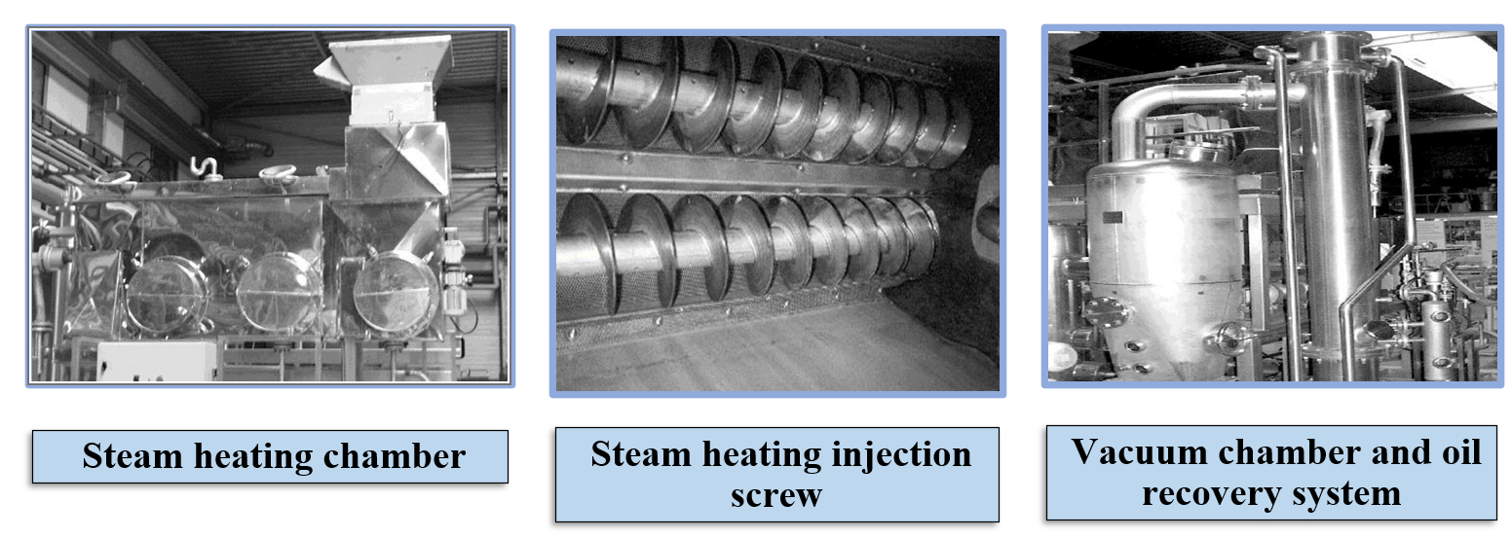 **Fig.1. Components of FVE industrial equipment (**Paranjpe *et al.*, 2012)

The FVE / DIC process involves the samples to saturated steam (60-90 °C at temperatures between 60 and 90 °C under pressure levels ranging from 100 to 900 kPa for a brief duration in seconds, followed by a rapid, controlled pressure drop exceeding 500 kPa per second. This abrupt drop results in an ultimate vacuum with an absolute pressure of 10 to 5 kPa. This instant controlled pressure drop is the core of DIC technology, which triggers immediate auto vaporization of water, rapid cooling of the sample, and the expansion and and creation of cells within the matrix (Louka and Allaf, 2002; Mounir *et al.,*2015). Additionally, this process promotes the rapid expulsion of certain molecules, thereby significantly enhancing food processing efficiency (Allaf and Allaf, 2013).

**4. Steps in the DIC/ FVE process**

FVE is a five-step thermo-mechanical process designed for precision and efficiency. The first step is the introduction of food material into the DIC reactor under atmospheric pressure. This is followed by the vacuum establishment phase, where the reactor is brought to a final absolute pressure of 10 to 5 kPa, to optimize subsequent processing conditions. The next step, hydrothermal treatment, involves injecting saturated steam into the reactor to reach and maintain a target pressure for a specific duration to ensure effective thermal processing. The core of the process lies in the subsequent abrupt pressure-drop phase, where a rapid and controlled pressure release creates a vacuum (10 to 5 kPa), triggering key physical and structural transformations in the material. Finally, the reactor undergoes the atmospheric re-equilibration phase, restoring atmospheric pressure to complete the cycle. Depending on the characteristics of the food matrix and the desired outcomes, steps 2 through 4 can be repeated in multiple cycles to achieve enhanced processing results. This structured approach ensures flexibility and adaptability across a wide range of food applications (Pech-Almeida *et al.,* 2021).

**5. DIC/ FVE** **equipment**

The DIC processing of foods involves the precise control of various operating parameters by DIC equipment, and the process relies on specialized equipment designed to precisely control and monitor various operational parameters, ensuring consistent and effective processing (Brat *et al*., 2001). This chamber is seamlessly connected to a cylindrical quartz vacuum vessel via a manually operated pneumatic valve capable of rapid actuation (103 kPa; opening time of 0.5 seconds).

The vacuum vessel maintains a pressure range between 5 and 10 kPa, achieved using a vacuum pump integrated with a closed water-cooling circuit linked to a condenser. This setup ensures efficient and continuous vacuum generation during processing. The system also facilitates the collection of steam-heating liquors, formed by the condensation of steam on the food surface and exudates from the inner juices of the material. These liquors are efficiently gathered at the base of the steam-heating chamber, contributing to the overall functionality of the system.

This advanced configuration of FVE equipment not only ensures precise control over pressure fluctuations throughout the process but also maximizes efficiency in energy and resource utilization. The integrated design of steam generation, vacuum creation, and liquor collection underscores the adaptability and effectiveness of FVE technology in modern food processing applications.

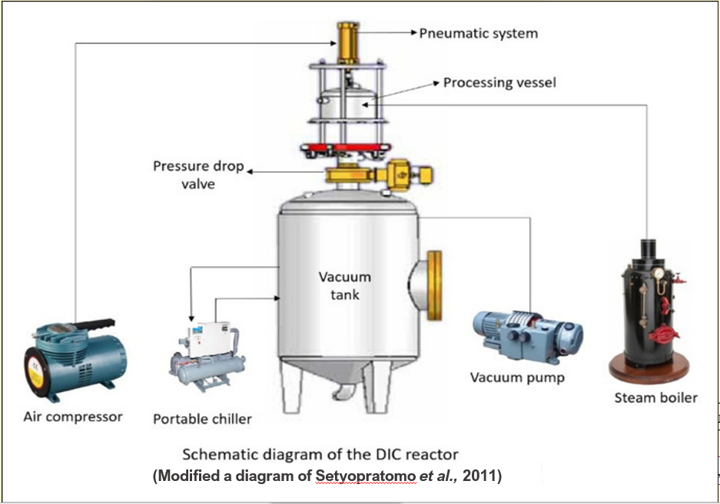

**Fig. 2. Schematic diagram of a DIC reactor (Setyopratomo *et al*., 2011)**

**6. Advantages of Flash Vacuum Expansion**

* **Enhanced Rheological and Textural Properties:** FVE improves the structural and sensory attributes of food materials, resulting in superior product quality.
* **Energy Efficiency:** The process demonstrates moderate energy requirements, making it cost-effective and environmentally sustainable.
* **Chemical-Free Processing:** FVE offers a novel approach to producing food products without the use of synthetic chemicals, aligning with consumer preferences for clean-label products.
* **Extended Shelf Life:** By improving the storage quality, FVE significantly enhances the shelf life of processed foods.
* **Improved Extraction Efficiency:** The technology excels in extracting phytochemicals, polyphenols, and other bioactive compounds, boosting the nutritional and functional profiles of food.
* **Optimized Texturing:** It minimizes undesirable textural changes in food while enhancing the nutritional and functional attributes of the final product.
* **Reduced Drying Time:** FVE accelerates the drying process, delivering high-quality dehydrated products in a significantly shorter time frame.
* **Versatility in Wine Production:** FVE serves as an effective substitute for traditional maceration techniques, offering potential improvements in wine production processes.

**7. Applications of Flash Vacuum Expansion**

* **Food Drying and Texturing:** Ideal for swell drying, FVE enhances the textural quality of food products.
* **Juice and Puree Extraction:** Improves yield and quality of juices and purees by efficiently releasing cellular components.
* **Essential Oil Extraction:** Facilitates the efficient extraction of essential oils with minimal thermal degradation.
* **Antioxidant Compound Recovery:** Boosts the extraction of antioxidant compounds, preserving their bioactivity.
* **Vegetable Oil Extraction:** Enhances oil recovery from plant matrices with improved efficiency.
* **Reduction of Allergens:** Effectively reduces allergenic proteins in food products, making them safer for sensitive consumers.
* **Mitigation of Antinutritional Factors:** Reduces antinutritional compounds, improving the nutritional profile of foods.
* **Oil Deodorization:** Provides an efficient method for removing unwanted volatile compounds in oils.
* **Microbial Decontamination:** Ensures food safety by eliminating microbial contaminants, including spores and pathogens.

**7.1. Food Drying/ Swell drying and texturing**

FVE offers an innovative approach to expanding biological matrices in drying operations, enhancing traditional methods by reducing total drying time, texturing food material, and improving the nutritional and functional properties of the final products. FVE technology can be integrated with various drying techniques, including Convective Air Drying (CAD), which suffers from drawbacks like product shrinkage, extended drying periods, and susceptibility to microbial contamination. By coupling CAD with FVE treatment, known as "Swell-drying," overall product quality can be enhanced, offering operational convenience, ease of implementation, and reduced energy consumption, alongside a wide range of applicable products and treatment modes (Louka and Allaf, 2004; Mounir *et al.,* 2012). Swell-drying typically involves an airflow pre-drying stage, followed by a DIC texturing stage and a final air-drying stage, with the pre-drying stage often crucial for reaching the glass transition in fruits and vegetables to prevent collapse after the DIC pressure drop (Mounir *et al.,* 2011). However, DIC treatment can also be applied directly to fresh food, underscoring its versatility and potential impact on optimizing the drying process, influenced by food polymer structure, kinetics, energy consumption, and final product quality attributes.

**7.1.1. Effect of DIC treatment on drying of fruits and vegetables**

DIC (Détente Instantanée Contrôlée) treatment offers a transformative approach to drying fruits and vegetables, effectively addressing the common issues of volume loss and cell collapse seen in traditional drying methods. By expanding internal pores, DIC restores the produce to its original volume, which enhances texture and retains bioactive compounds while also ensuring efficient decontamination. This technology increases operational efficiency by lowering both energy usage and drying time, making it a more sustainable option for processing fruits and vegetables. The adoption of DIC technology in drying processes represents a major step forward, significantly improving the preservation and quality of fruits and vegetables, with considerable benefits for the food processing industry.

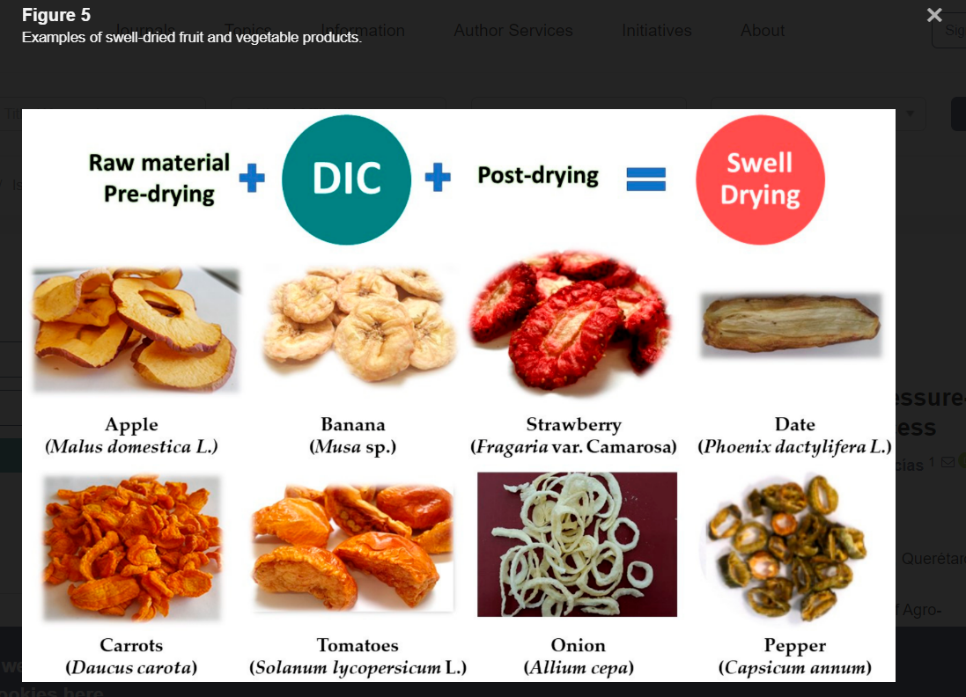**Fig. 3. Examples of swell dried fruit and vegetable products (Pech-Almeida *et al.,* 2021)**

**7.1.1.1 Fruit drying**

**Applications of Swell-Drying in Apple Processing**

One of the most extensively studied fruits for swell-drying is the apple (Malus domestica). Utilizing Flash Vacuum Expansion (FVE) or DIC in apple processing offers numerous benefits including a faster post-drying phase, increased quercetin content, excellent rehydration ratio, maintenance of crisp texture, and reduced polyphenol oxidase (PPO) activity.

Mounir *et al.* (2012) conducted a study on swell-drying apples and its effects on quercetin content. They divided the process into three stages: an initial Convective Air Drying (CAD) pre-drying stage, followed by a DIC texturing stage, and a final CAD drying stage. They found that DIC-textured samples had a significantly shorter post-drying phase (achieving a final water content of 0.04 g H2O/g dry basis from an initial 0.14 g H2O/g dry basis) requiring only one hour, compared to six hours for non-textured samples. Additionally, DIC treatment (300 kPa for 80 seconds) resulted in a significant increase in quercetin content (500%-700% more than the initial amount).

Said *et al.* (2015) explored DIC texturing in the dehydrofreezing of apple slices—a method that reduces tissue damage and drip loss during thawing by pre-dehydrating food to a desired water content before freezing. Their study highlighted that the initial water content (critical value at 1.66 g H2O/g dry basis) was the key factor influencing apple firmness after DIC treatment.

Gao *et al*. (2017) demonstrated that combining CAD and DIC treatments effectively reduced PPO activity in apple slices, thereby minimizing browning. The high temperatures involved in DIC treatment were found to inactivate the PPO enzyme.

Xiao *et al.* (2018) examined the effects of DIC texturing on the cell wall polysaccharides of apple slices and their correlation to texture. Their findings indicated that apples pre-dried to a water content of 0.3 g H2O/g dry basis, then DIC-textured, and finally vacuum-dried, resulted in crisp apple chips with an excellent honeycomb-like structure and high rehydration ratio due to the homogeneous porous structure and large specific surface area.

Li *et al*. (2021) investigated the mechanisms of DIC treatment in developing crisp-textured apple cubes. They found that the optimal water content after pre-drying (between 0.134–0.248 g H2O/g dry basis) was crucial for achieving the highest expansion and crisp texture in apple cubes.

**Applications of Swell-Drying to Other Fruits**

Setyopratomo *et al*. (2012) studied swell-drying on bananas (*Musa paradisiaca*), focusing on dehydration kinetics, water and oil holding capacity, and nutritional characteristics. They found that DIC texturing increased effective water diffusivity by 23%, water holding capacity by 290%, and reduced oil holding capacity by 15%, while inhibiting the transformation of banana starch to reducing sugars.

Nouviaire *et al*. (2001) explored the DIC texturing of strawberries (*Fragaria vesca var. vesca*) and found that it significantly increased expansion rate (up to 2.4 times) and reduced drying time (by up to 63%). The optimal pressure conditions for achieving a crisp texture were between 220 and 350 kPa.

Maritza *et al*. (2012) and Alonzo-Macias *et al*. (2013) further confirmed that DIC significantly enhances drying and rehydration kinetics of strawberries, increasing effective diffusivity and preserving high levels of bioactive molecules (phenols, flavonoids, anthocyanins, and antioxidant activities).

Santiago-Mora *et al*. (2017) compared freeze-drying and swell-drying for preserving the antioxidant capacity and bioactive compounds of berry cactus (*Myrtillocactus geometrizans*). They concluded that DIC is as effective as freeze-drying, with optimal conditions being 450 kPa for 25 seconds at a water content of 0.20 g H2O/g dry basis.

Mounir *et al.* (2020) applied swell-drying to develop ready-to-eat snacks and expanded granule powders from Zaghloul dates (*Phoenix dactylifera L*.). They found that DIC treatment (600 kPa for 22 seconds) significantly improved expansion ratio (146%) and color intensity (59%).

Overall, these studies demonstrate that FVE/DIC technology significantly improves drying efficiency, texture, bioactive compound retention, and overall quality of dried fruits, making it a valuable method for food processing industries.

**7.1.1.2 Vegetable Drying with DIC Technology**

DIC technology offers significant advantages in vegetable drying, including enhanced expansion, improved rehydration, reduced drying time, and preservation of nutritional and sensory qualities. The specific conditions for DIC processing vary by vegetable but generally involve optimizing pre-treatment, water content, pressure, and treatment duration to achieve the desired quality attributes.

**Carrots (*Daucus carota*)**

The initial studies on the impact of DIC texturing on vegetables were conducted on carrots by Louka and Allaf (2004) and Louka *et al.* (2004). The DIC treatment was evaluated based on expansion ratio, color, and degree of cooking. The critical aspects identified for optimal DIC processing of carrots include:

Correct selection of water content (W) to prevent caramelization (optimal W was 0.25 g H2O/g dry basis (db)). Optimal DIC conditions were determined to be 0.25 g H2O/g db, 450 kPa, and 25 seconds.

Nguyen *et al.* (2014) examined the impact of DIC on drying kinetics and physical properties of dried carrots, finding increased porosity, absolute expansion, and effective water diffusivity by 3.2 times compared to control samples.

Sahyoun *et al.* (2016) investigated the effects of various pre-treatments (blanching, freezing/thawing, and steaming) before DIC texturing. Results showed that intermediate freezing/thawing and DIC steaming significantly reduced drying times due to enhanced cellular breakdown and water diffusion.

Peng *et al.* (2018) found that coupling freezing and osmotic dehydration with DIC improved carrot texture and porous characteristics, enhancing the overall quality.

**Potatoes (*Solanum tuberosum*)**

Louka and Allaf (2002) studied DIC texturing of potatoes and identified optimal conditions as 0.15 g H2O/g db, 700 kPa, and 40 seconds. This process reduced drying time from 220 minutes to 100 minutes for swell-dried samples. Thickness of roughly 3 mm was crucial to avoid resistance to deformation.

Iguedjtal *et al*. (2008) reported that DIC texturing increased surface area and shelf stability compared to CAD, with DIC samples showing a 45% increase in surface area and lower water activity.

**Tomatoes (*Solanum lycopersicum*)**

Louka *et al.* (2004) indicated that swell-drying provided firm structure after rehydration and preserved phenolic compounds and antioxidant capacity. Hadibi *et al.* (2021) showed that DIC reduced drying time and preserved tomato paste quality.

**Onions (*Allium cepa*)**

Louka *et al.* (2004) applied DIC technology to onions, resulting in threefold expansion, controlled colour, 55% reduction in drying time, 99% reduction in microbial contamination, and a 223% improvement in effective diffusivity and initial availability compared to CAD.

**Green Moroccan Pepper (*Capsicum annuum*)**

Tellez-Perez *et al*. (2012) found that DIC treatment at 600 kPa for 20 seconds significantly reduced drying time and improved rehydration kinetics by increasing starting accessibility and effective diffusivity by 125% and 272%, respectively.

**Cassava (*Manihot esculenta*)**

Setyopratomo *et al.* (2009) studied swell drying of fresh cassava roots and found substantial improvements in water holding capacity (6.6 times), oil holding capacity (5 times), and an 85.7% reduction in initial bacterial count.

**Other Vegetables**

DIC treatment has been applied to other vegetables such as broccoli (Louka *et al*., 2004), okra pods (Mounir *et al.,* 2020), and beetroots (Alonzo-Macias *et al.,* 2020). Across these studies, DIC effectively intensified drying kinetics, reduced energy consumption, and preserved the bioactive molecules and microstructure of the final products.

**7.2. Impact of Flash vacuum expansion (FVE)** **process on food components extraction**

The Flash Vacuum Expansion (FVE) process, including the Détente Instantanée Contrôlée (DIC) technology, has proven effective in enhancing the extraction of valuable food components. This process leverages rapid pressure drops to create instant vaporization, leading to structural changes in plant materials. These changes, such as increased porosity and reduced cellular integrity, enhance the efficiency of extracting various compounds from food materials. The FVE process, particularly with DIC technology, offers substantial benefits for extracting juices, purees, essential oils, antioxidants, and vegetable oils. The process enhances yields, improves the quality of extracts, and operates as a green and sustainable method, making it a valuable tool in food processing and the extraction of natural active molecules.

**Juice/Puree Extraction**

The Flash Vacuum Expansion (FVE) process has been widely studied for its effects on the extraction and quality of fruit purees. FVE involves applying a high vacuum to rapidly expand and burst the cell walls of fruits, leading to improved extraction efficiency. This method enhances the quality of the extracted juice or puree by preserving color, flavor, and nutritional properties while reducing enzymatic activity and improving stability.

1. **Passion Fruit Puree**: Brat *et al.* (2001) highlighted that FVE significantly improved the yield of passion fruit puree, achieving a yield of approximately 50% of fruit weight. This is double the yield obtained using traditional juice extractors. The FVE-processed puree exhibited higher consistency and viscosity compared to conventional methods, which can enhance the texture and mouthfeel of the final product.
2. **Grape Juice**: Paranjpe *et al.* (2012) observed that FVE-treated grape juice had a significantly higher yield (75.55g/100g) and a higher concentration of total polyphenols (5.69mg/g) compared to juice extracted using traditional enzyme processing methods. Additionally, FVE resulted in a lower impedance (8.72kU), indicating improved extraction efficiency and better-quality juice.
3. **Avocado Mash**: Manuel *et al.* (2016) found that FVE effectively reduced lipoxygenase activity by up to 70%, which is crucial for preventing undesirable changes in flavour and colour. The antioxidant capacity of avocado mash remained stable for up to 15 days without the need for preservatives, showcasing FVE’s capability to maintain the quality of avocado-based products.
4. **Avocado Puree**: Marco *et al.* (2019) reported that FVE-processed avocado puree received high sensory scores for grainy texture, color, and fibrous attributes. However, it scored lower for homogeneity, fatty, and unctuous descriptors, indicating that while FVE enhances certain sensory properties, it may impact others.
5. **Purple Passion Fruit Puree**: Arias *et al.* (2022) demonstrated that FVE combined with steam blanching resulted in purees with higher content of cell wall and bioactive compounds. The FVE treatment also improved the shear-thinning flow behaviour of the puree and extended its shelf life up to 90 days, highlighting the combined benefits of FVE and steam blanching in enhancing puree quality.
6. **Mango Puree**: Marin-Castro *et al.* (2022) reported that FVE improved colour stability and increased soluble solids by approximately 9%. The total phenolic content also increased, which contributes to enhanced antioxidant capacity, indicating that FVE can significantly benefit the quality of mango puree.
7. Goldenberry Puree: The FVE process combined with vacuum pulping achieved a microbial reduction of over 6 log CFU/g while preserving β-carotene and ascorbic acid content (4–12%) (Arias *et al*, 2023). With a shelf life of up to 90 days at 4 °C and an energy consumption of 0.30 kWh/kg, FVE offers an efficient, low-investment method for producing high-quality goldenberry purée.

**Essential Oil Extraction**

Traditional essential oil extraction methods often involve high energy consumption and may alter the natural composition of the oils. FVE offers a solvent-free and time-efficient alternative that preserves the essential oil's desired features while improving extraction efficiency.

1. **Citrus Peels**: Pierre *et al.* (2001) found that FVE produced essential oils from lemon, sweet orange, mandarin, and grapefruit peels with yields comparable to traditional methods. The oils were enriched in monoterpene hydrocarbons, which are valuable for their aromatic properties.
2. **Lavender**: Besombes *et al.* (2010) reported that FVE significantly enhanced lavender essential oil yield and reduced extraction time compared to traditional hydro distillation methods. This improvement underscores FVE’s efficiency in essential oil extraction.
3. **Common Myrtle**: Berka-Zougali *et al.* (2012) demonstrated that DIC treatment resulted in a 10% improvement in yield and a better-quality fragrance with increased antioxidant activity, compared to other extraction methods.
4. **Rosemary**: Allaf *et al.* (2013) found that FVE treatment improved the yield and quality of rosemary essential oil, with a higher content of valuable oxygenated compounds, which are crucial for the oil's aroma and therapeutic properties.
5. **Orange Peels**: FVE treatment of orange peels led to a significant increase in essential oil extraction efficiency and reduced processing time, making it a viable alternative to traditional methods.
6. **Black Cumin**: Feyzi *et al*. (2017) reported that FVE outperformed traditional extraction methods in terms of both quality and quantity of essential oils from *Bunium persicum*, highlighting its effectiveness in enhancing oil yield and preserving quality.
7. **Pinot Noir Wine**: Samoticha *et al.* (2017) observed that FVE increased phenolic compounds and antioxidant activity in both must and wine, with a notable increase in anthocyanins, which are essential for colour and health benefits.
8. **Hyssopus Officinalis**: Rashidi *et al.* (2018) confirmed that FVE provided higher yields and better-quality essential oils compared to other extraction methods, making it a preferred choice for obtaining essential oils from Hyssopus officinalis.

**Table. 1. 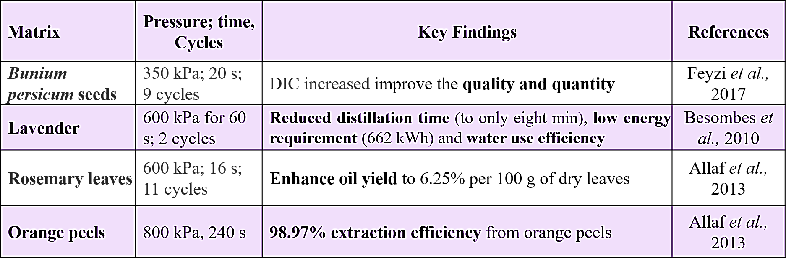Key research findings on essential oil extraction**

**Extraction of Antioxidant Compounds**

Thermal drying processes can often lead to a reduction in antioxidant concentrations. FVE technology has emerged as an effective method for preserving and enhancing the extraction of antioxidant compounds from various plant materials.

1. **Orange Peels**: Louati *et al.* (2019) reported significant increases in major phenolic compounds in orange peels after FVE treatment, demonstrating its effectiveness in enhancing antioxidant properties.
2. **Malaysian Roselle**: Amor and Allaf (2009) observed a 135% improvement in anthocyanin extraction yield with FVE treatment, highlighting its potential in enhancing antioxidant capacity in roselle extracts.
3. **Pomegranate Peel**: Ranjbar *et al.* (2016) found that FVE treatment improved total phenolic content and antioxidant activity in pomegranate peel extracts, suggesting that FVE is effective in preserving and enhancing antioxidant compounds.
4. **Olive Leaves**: Mkaouar *et al.* (2015, 2016) reported significant improvements in phenolic content and antioxidant capacity after DIC treatment of olive leaves, making it a valuable method for extracting antioxidants from this source.
5. **Grape Stalks**: Sanchez-Valdepenas *et al.* (2015) found that FVE pre-treatment improved phenolic extraction from grape stalks, indicating its effectiveness in enhancing antioxidant properties.
6. 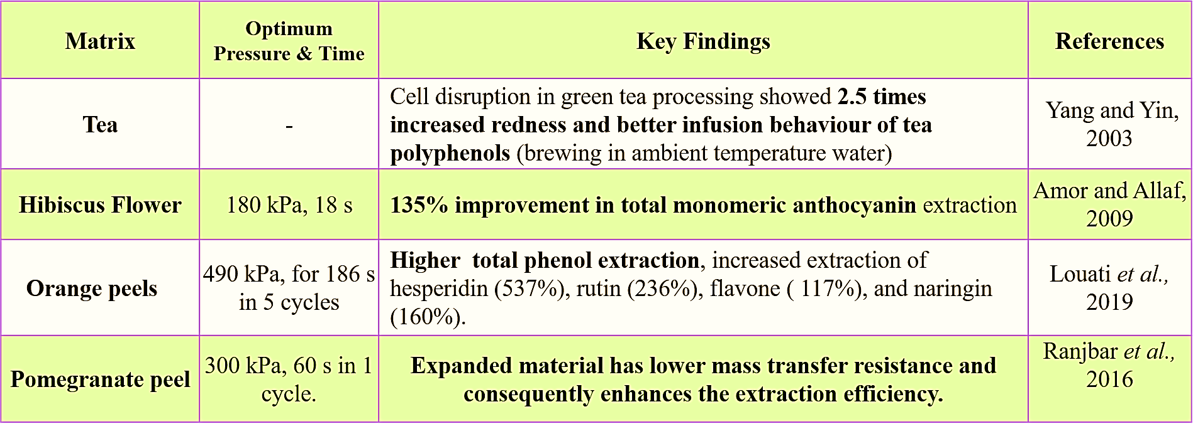**Green Tea**: DIC treatment enhanced cell disruption and improved the infusion behaviour of tea polyphenols and amino acids, contributing to higher antioxidant activity in green tea extracts (Yang and Yin, 2003).

**Table. 2. Key research findings on the extraction of antioxidant compounds**

**Vegetable Oil Extraction**

FVE technology has shown promise in improving the extraction of vegetable oils by modifying cell structures and increasing oil yield.

1. **Rapeseed**: Allaf *et al*. (2014) reported that FVE treatment significantly increased oil yield from rapeseed, demonstrating its effectiveness in enhancing oil extraction efficiency.
2. **Safflower Oil**: Eikani *et al*. (2019) found that FVE treatment increased the yield of safflower oil by 70.43%, highlighting its potential for improving oil extraction processes.
3. **Sunflower Seeds**: Zeaiter *et al.* (2019) showed that FVE pre-treatment improved oil availability and biochemical composition from sunflower seeds, indicating its benefits in oil extraction.
4. 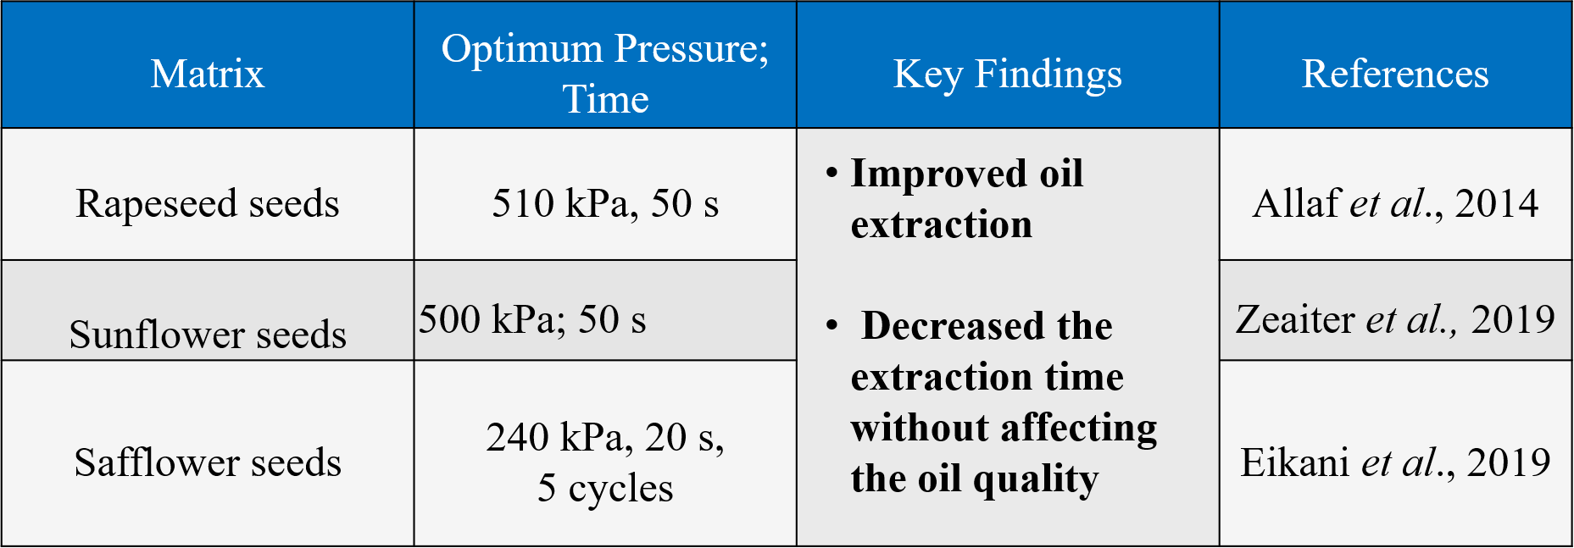**Soybean Seeds**: Jablaoui *et al.* (2020) demonstrated that FVE treatment increased oil yield from soybean seeds without degrading biochemical quality, while also reducing extraction time and energy costs.

**Table. 3. Key research findings on vegetable oil extraction**

### **7.3. Impact of DIC Technology on Food Safety and Quality**

**7.3.1. Microbial Decontamination**

**DIC Processing**: The use of Dynamic Vacuum Expansion (DIC) technology has shown considerable effectiveness in reducing microbial contamination in food products.

1. **Cassava Flour**: DIC treatment at 400 kPa for 12 seconds significantly reduced bacterial content in cassava flour from 605,000 CFU/mL to 86,500 CFU/mL, marking an 85.7% reduction (Setyopratomo *et al*., 2009).
2. **Onions**: Swell-drying onions under 350 kPa and 15 seconds decreased the initial bacterial count from 875,000 germs/g to 100 germs/g, demonstrating DIC's efficacy in microbial reduction (Albitar *et al.,* 2011).
3. **Bacillus stearothermophilus**: DIC was effective in destroying spores of Bacillus stearothermophilus at 280 kPa for 30 seconds, illustrating its ability to inactivate spore-forming bacteria (Debs-Louka, 2000).
4. **Efficiency Factors**: The effectiveness of DIC treatment is influenced by factors such as steam generation within cells and pressure-drop time. Multiple cycles of DIC treatment can further enhance decontamination (Allaf & Allaf, 2013).

**7.3.2. Allergens Reduction**

**Legumes and Cereals**: DIC processing has proven beneficial in reducing allergens in various food products.

1. **Beans, Chickpeas, Peanuts, Lentils, Soybeans**: Cuadrado *et al.* (2011) observed a reduction in allergenic immunoreactivity in these legumes when treated with DIC at 600 kPa for 180 seconds.
2. **Pistachios and Cashews**: Vicente *et al.* (2020) reported that increasing pressure and temperature during DIC treatment (700 kPa and 120 seconds) reduced allergenic protein content in pistachios and cashews.
3. **Wheat Flour**: DIC treatment at 700 kPa for 60 seconds lowered the immunoreactivity to gluten in wheat flour (Triticum aestivum), although further studies are required to specify immunoreactivity variations among individuals (Mahroug *et al*., 2020).

**7.4. Other Applications**

**7.4.1. Reduction of Antinutritional Compounds**

1. **Legumes**: DIC processing effectively reduces antinutritional compounds such as oligosaccharides, inositol phosphates, trypsin inhibitors, and lectins in legumes including soybeans, lupins, lentils, chickpeas, and peanuts. A significant reduction was achieved with DIC at 600 kPa for 1 minute (Pedrosa *et al*., 2012).
2. **Rapeseeds**: DIC treatment has proven efficient in detoxifying rapeseeds, with glucosinolate content decreasing by 40% after 1 minute and 98% after 7 minutes of treatment (Haddad & Allaf, 2007).
3. **Common Beans**: DIC treatment reduced levels of phytates (from 26% to 23%), saponins (from 65.7% to 44%), phenolic compounds (from 99% to 4–14%), and tannins (from 73% to 23%) in common beans, improving their nutritional quality (Cardador-Martinez *et al*., 2020).

**7.4.2. Oil Deodorization**

**Edible Oils**: DIC technology aids in the deodorization of oils by vaporizing free fatty acids and odoriferous compounds. Multi-Flash instant auto vaporization (MFA) using multiple DIC cycles can achieve perfect deodorization and de-solvation during the processing and refining of edible fats and oils (Chakrabarti & Jala, 2019).

**8. Future Perspectives**

Despite the promising potential of Flash Vacuum Expansion (FVE) in transforming food processing methods, additional research is crucial to optimize and expand its applications (Pech-Almeida *et al.,* 2021). The future research should focus on:

1. **Coupling of Infrared and Microwave Drying Techniques**: Investigating the synergy between infrared and microwave drying with FVE to enhance efficiency and effectiveness in drying processes.
2. **Industrial Application**: Exploring the scalability of FVE extraction technology to industrial levels to better understand its feasibility and economic impact.
3. **Microbial Decontamination Fundamentals**: Delving into the underlying mechanisms of microbial decontamination achieved through FVE treatments to improve safety and efficacy.
4. **Mycotoxin Decontamination Mechanisms**: Evaluating how FVE impacts the decontamination of food mycotoxins, which will help in mitigating the risks associated with these toxins.
5. **Development of Functional Foods**: Developing new functional food products from dried legumes or extracted proteins using FVE, which could lead to innovative food solutions and improved nutritional profiles.

**9. Conclusion**

Flash Vacuum Expansion (FVE) represents a groundbreaking approach to expanding biological matrices, thereby enhancing the extraction and preservation of biologically active compounds. Its application spans a wide range of products, including both foods and by-products, whether processed in laboratory settings or on an industrial scale. FVE effectively reduces drying times for fruits and vegetables, enhances the extraction of essential oils and vegetable oils, and improves the extraction of antioxidant components. Additionally, it offers robust microbial decontamination, targeting both vegetative microorganisms and spores, and reduces non-nutritional and allergenic components. FVE-treated products benefit from extended shelf life, high consumer acceptance, and excellent sensory, hygienic, and nutritional quality. This innovative physical processing technique holds significant potential to advance conventional food processing methods while maintaining or even enhancing sensory quality parameters.

**Disclaimer (Artificial Intelligence)**

Author(s) hereby declares that generative AI technologies such as Large Language Models, etc. have been used during the writing or editing of manuscripts.

**Details of the AI usage are given below:**

1. ChatGPT

**10. References**

Albitar, N., Mounir, S., Besombes, C., and Allaf, K. 2011. Improving the drying of onion using the instant controlled pressure drop technology. *Dairy. Technolgy.* 29: 993–1001.

Allaf, T. and Allaf, K. 2013. Instant Controlled Pressure Drop (D.I.C.) in Food Processing: from Fundamental to Industrial Applications. Springer, New York, USA. 531p.

Allaf, T., Fine, F., Tomao, V., Nguyen, C., Ginies, C., and Chemat, F. 2014. Impact of instant controlled pressure drop pre-treatment on solvent extraction of edible oil from rapeseed seeds. *Oilseeds and fats, Crops and Lipids*. 21: 301-311.

Alonzo-Macias, M., Cardador-Martinez, A., Mounir, S., Montejano-Gaitan, G., and Allaf, K. 2013. Comparative study of the effects of drying methods on antioxidant activity of dried strawberry (Fragaria var. camarosa). *Journal of Food Research*. 2: 92–107.

Alonzo-Macias, M., Cardador-Martinez, A., Besombes, C., Allaf, K., Tejada-Ortigoza, V., Soria-Mejia, M.C., Vazquez-Garcia, R., and Tellez-Perez, C. 2020. Instant controlled pressure drop as blanching and texturing pre-treatment to preserve the antioxidant compounds of red dried beetroot (*Beta vulgaris L*.). *Molecules* 25: 4132-4147.

Amor, B. B. and Allaf, K. 2009. Impact of texturing using instant pressure drop treatment prior to solvent extraction of anthocyanins from Malaysian roselle (*Hibiscus sabdariffa*). *Food Chemistry*. 115: 820–825.

Arias, C., Rodriguez, P., Cortes, M., Soto, I., Quintero, J., and Vaillant, F. 2022. Innovative process coupling short steam blanching with vacuum flash-expansion produces in one single stage high-quality purple passion fruit smoothies. *Foods.* 11(6): 832-845.

Arias, C., Rodríguez, P., Soto, I., Vaillant, R., Cortés, M., and Vaillant, F. 2023. Flash vacuum expansion, a low-cost and energy-efficient alternative process to produce high-quality fruit puree: Application to *Physalis peruviana*. *Heliyon*. 9(6): e16969. 2405-8440.

Ayala-Zavala, J., Castillo-Romero, T. J., Salgado-Cervantes, M., Marín-Castro, U., Vargas-Ortiz, M., Pallet, D., and Servent, A. 2024. Flash Vacuum Expansion: Effect on Physicochemical, Biochemical and Sensory Parameters in Fruit Processing. *Food Reviews International*. 40(3): 833.

Brat, P., Olle, D., Reynes, M., Cogat, P.O., and Brillouet, J.M. 2001. Preparation of passion fruit puree by flash vacuum expansion. *Journal of food science*. 66(4): 542-547.

Berka-Zougali, B., Ferhat, M.A., Hassani, A., Chemat, F., and Allaf, K.S. 2012. Comparative study of essential oils extracted from Algerian Myrtus communis L. leaves using microwaves and hydrodistillation. *International Journal of Molecular Sciences* 13: 4673–4695.

Besombes, C., Berka-Zougali, B., and Allaf, K. 2010. Instant controlled pressure drop extraction of lavandin essential oils: fundamentals and experimental studies. *Journal of Chromatography A.* 1217: 6807–6815.

Cardador-Martinez, A., Martinez-Tequitlalpan, Y., Gallardo-Velazquez, T., Sanchez-Chino, X.M., Martinez-Herrera, J., Corzo-Rios, L.J., and Jimenez-Martinez, C. 2020. Effect of instant controlled pressure-drop on the non-nutritional compounds of seeds and sprouts of common black bean (*Phaseolus vulgaris* L.). *Molecules* 25(6): 1464-1479.

Chakrabarti, P.P. and Jala, R.C.R. 2019. Processing technology of rice bran oil. In: Cheong, L.Z. and Xu, X. (eds), *Rice Bran and Rice Bran Oil* (1st Ed.). AOCS Press, Champaign, IL, USA, pp. 55–95.

Cuadrado, C., Cabanillas, B., Pedrosa, M.M., Muzquiz, M., Haddad, J., Allaf, K., Rodriguez, J., Crespo, J.F., and Burbano, C. 2011. Effect of instant controlled pressure drop on IgE antibody reactivity to peanut, lentil, chickpea and soybean proteins. *International Archives of Allergy and Immunology* 156: 397–404.

Debs-Louka, E. 2000. Microorganisms’ destruction by controlled thermal mechanical process in solid or powdery products: application on spices and aromatic herbs. Ph.D. thesis, Universite de La Rochelle, La Rochelle, France, 235p.

Eikani, M.H., Khandan, N., and Feyzi, E. 2019. Enhancing bio-oil extraction using instant controlled pressure drop texturing. *Food and Bioproducts Processing* 117: 241–249.

Feyzi, E., Eikani, M.H., Golmohammad, F., & Tafaghodinia, B. (2017). Extraction of essential oil from Bunium persicum (Boiss.) by instant controlled pressure drop. *Journal of Chromatography A* 1530, 59–67. doi: 10.1016/j.chroma.2017.11.033

Gao, K., Zhou, L., Bi, J., Yi, J., Wu, X., Zhou, M., Wang, X., and Liu, X. 2017. Evaluation of browning ratio in an image analysis of apple slices at different stages of instant controlled pressure drop-assisted hot-air drying (AD-DIC). *The Journal of the Science of Food and Agriculture.* 97: 2533–2540.

Haddad, J. and Allaf, K. 2007. Effect of instantaneous controlled pressure drop on the glucosinolate content of rapeseed. *International Journal of Food Science & Technology.* 42: 799–803*.*

Hadibi, T., Boubekri, A., Mennouche, D., Benhamza, A., Besombes, C., and Allaf, K. 2021. Solar–geothermal drying/instant controlled pressure drop-swell drying of mechanically dewatered tomato paste. The Journal of Food Process Engineering. 44 [on-line]. Available: <https://doi.org/10.1111/jfpe.13811> [20 Dec. 2022].

Iguedjtal, T., Louka, N., and Allaf, K. 2008. Sorption isotherms of potato slices dried and texturized by controlled sudden decompression. *The Journal of Food Process Engineering.* 85: 180–190.

Jablaoui, C., Besombes, C., Jamoussi, B., Rhazi, L., and Allaf, K. 2020. Comparison of expander and instant controlled pressure-drop DIC technologies as thermomechanical pretreatments in enhancing solvent extraction of vegetal soybean oil. *The Arabian Journal of Chemistry*. 13: 7235–7246.

Li, X., Bi, J., Jin, X., Lyu, J., Wu, X., Li, B., and Li, X. 2021. Study on the mechanism of volume expansion and texture formation of apple cube dried by instant controlled pressure drop drying (DIC). *The Journal of Food Process Engineering*. 293 [on-line]. Available: <https://doi.org/10.1016/j.jfoodeng.2020.110379> [20 Dec. 2022].

Louka, N. and Allaf, K. 2002. New process for texturizing partially dehydrated biological products using controlled sudden decompression to the vacuum: application on potatoes. *The Journal of Food Process Engineering*. 67: 3033–3038.

Louka, N. and Allaf, K. 2004. Expansion ratio and color improvement of dried vegetables texturized by a new process "controlled sudden decompression to the vacuum": application to potatoes, carrots and onions. *The Journal of Food Process Engineering*. 65: 233–243.

Louka, N., Juhel, F., and Allaf, K. 2004. Quality studies on various types of partially dried vegetables texturized by controlled sudden decompression: general patterns for the variation of the expansion ratio. *The Journal of Food Process Engineering.* 65: 245–253.

Manuel, V.O., Adrien, S., Guadalupe, R., Dominique, P., and Marco, S.C. 2016. Effect of thermal stage in the processing of avocado by flash vacuum expansion: effect on the antioxidant capacity and the quality of the mash. *The Journal of Food Processing and Preservation*. 41(5): 1745–4549.

Mkaouar, S., Bahloul, N., Gelicus, A., Allaf, K., and Kechaou, N. 2015. Instant controlled pressure drop texturing for intensifying ethanol solvent extraction of olive (*Olea europaea*) leaf polyphenols. *Separation and Purification Technology*. 145: 139–146.

Mkaouar, S., Gelicus, A., Bahloul, N., Allaf, K., and Kechaou, N. 2016. Kinetic study of polyphenols extraction from olive (*Olea europaea* L.) leaves using instant controlled pressure drop texturing. *Separation and Purification Technology*. 161: 165–171.

Maritza, A.M., Sabah, M., Anaberta, C.M., Montejano-Gaitan, J.G., and Allaf, K. 2012. Comparative study of various drying processes at physical and chemical properties of strawberries (*Fragaria* var camarosa). *Procedia Engineering*. 42: 297–312.

Mahroug, H., Benatallah, L., Takacs, K., Bouab, H., Zidoune, M.N., and Allaf, K. 2020. Impact of instant controlled pressure drop (DIC) treatment on chemical, functional and immunological properties of wheat gluten. *Arabian Journal of Science and Engineering*. 45: 575–586.

Marco, S.C., Servent, A., Maraval, I., Vargas, O.M., and Pallet, D. 2019. Flash vacuum expansion process: effect on the sensory, colour and texture attributes of avocado (*Persea americana*) puree. *Plant Foods for Human Nutrition*. 74(3): 370-375.

Marin-Castro, U.R., Salgado-Cervantes, M., Pallet, D., Vargas-Ortiz, M., and Servant, A. 2022. Flash vacuum expansion: an alternative with potential for Ataulfo and Manila mango processing. *Journal of Food Science and Technology*. 59(8): 3063-3072.

Mounir, S., Allaf, T., Mujumdar, A.S., and Allaf, K. 2012. Swell drying: coupling instant controlled pressure drop DIC to standard convection drying processes to intensify transfer phenomena and improve quality—an overview. *Drying Technology*. 30: 1508–1531.

Mounir, S., Allaf, T., Sulaiman, I., and Allaf, K. 2015. Instant controlled pressure drop (DIC) texturing of heat-sensitive spray-dried powders: phenomenological modelling and optimization. *Drying Technology*. 33: 1524–1533.

Mounir, S., Amami, E., Allaf, T., Mujumdar, A., and Allaf, K. 2020. Instant controlled pressure drop (DIC) coupled to intermittent microwave/airflow drying: process performance and quality attributes. *Drying Technology*. 38: 695–711.

Mounir, S., Besombes, C., Al-Bitar, N., and Allaf, K. 2011. Study of instant controlled pressure drop DIC treatment in manufacturing snack and expanded granule powder of apple and onion. *Drying Technology*. 29: 331–341.

Mounir, S., Ghandour, A., Tellez-Perez, C., Aly, A.A., Mujumdar, A.S., and Allaf, K. 2020. Phytochemicals, chlorophyll pigments, antioxidant activity, relative expansion ratio, and microstructure of dried okra pods: swell-drying by instant controlled pressure drop versus conventional shade drying. *Drying Technology*. 39: 2145-2159.

Nguyen, T.H., Lanoiselle, J.L., and Allaf, K. 2014. Effect of instant controlled pressure drop DIC treatment on the properties of dried carrot. In: Proceedings of the 19th International Drying Symposium (IDS 2014), 24–27 August 2014, Lyon, France, 9p.

Nouviaire, A., Louka, N., Rezzoug, S., and Allaf, K. 2001. Drying-texturing of strawberries using the Controlled Instant Release process coupled with convection drying. Optimization using design of experiments methodology.  *Scifood.* 21:177–192.

Paranjpe, S.S., Ferruzzi, M., and Morgan, M.T. 2012. Effect of a flash vacuum expansion process on grape juice yield and quality. *Food Science and Technology*. 48: 147-155.

Pech-Almeida, J.L., Tellez-Perez, C., Alonzo-Macias, M., Teresa-Martinez, G.D., Allaf, K., Allaf, T., and Cardador-Martinez, A. 2021. An overview on food applications of the instant controlled pressure-drop technology, an innovative high pressure-short time process. *Molecules.* 26: 1-37.

Pedrosa, M.M., Cuadrado, C., Burbano, C., Allaf, K., Haddad, J., Gelencser, E., Takacs, K., Guillamon, E., and Muzquiz, M. 2012. Effect of instant controlled pressure drop on the oligosaccharides, inositol phosphates, trypsin inhibitors and lectins contents of different legumes. *Food Chemistry*. 131: 862–868.

Peng, J., Bi, J., Yi, J., Wu, X., Zhou, M., Lyu, J., and Liu, J. 2018. Engineering texture properties of instant controlled pressure drop (DIC) dried carrot chips via modulating osmotic conditions. *Food and Bioprocess Technology.* 11: 1674–1685.

Pierre, B., Didier, O., Anne, L.G., Max, R., and Jean, M.B. 2001. Essential oils obtained by flash vacuum expansion of peels from lemon, sweet orange, mandarin and grapefruit. *Fruits* 56: 395–402.

Ranjbar, N., Eikani, M.H., Javanmard, M., and Golmohammad, F. 2016. Impact of instant controlled pressure drop on phenolic compounds extraction from pomegranate peel. *Innovative Food Science and Emerging Technologies*. 37: 177–183.

Rashidi, S., Eikani, M.H., and Ardjmand, M. 2018. Extraction of Hyssopus officinalis L. essential oil using instant controlled pressure drop process. *Innovative Food Science and Emerging Technologies.* 1579: 9–19.

Sahyoun, W., Zerrouq, F., and Allaf, K. 2016. Comparative study of various pre-treatments coupled to vacuum drying in terms of structural, functional and physical properties of carrot *Daucus carota*. *International journal of scientific and engineering research*. 2: 49–63.

Said, B.H.L., Bellagha, S., and Allaf, K. 2015. Optimization of instant controlled pressure drop (DIC)-assisted dehydrofreezing using mechanical texture measurements versus initial water content of apple. *Food and Bioprocess Technology*. 8: 1102–1112.

Samoticha, J., Wojdylo, A., Chmielewska, J., and Oszmianski, J. 2017. The effects of flash release conditions on the phenolic compounds and antioxidant activity of Pinot Noir red wine. *European Food and Bioprocess Technology*. 243: 999-1007.

Sanchez-Valdepenas, V., Barrajon, E., Vegara, S., Funes, L., Marti, N., Valero, M., and Saura, D. 2015. Effect of instant controlled pressure drop (DIC) pre-treatment on conventional solvent extraction of phenolic compounds from grape stalk powder. *Industrial Crops and Products*. 76: 545–549.

Santiago-Mora, P.D., Cardador-Martinez, A., Tellez-Perez, C., Montejano-Gaitan, J.G., and Del-Campo, M.S.T. 2017. In-vitro antioxidant capacity and bioactive compounds preservation post-drying on berrycacti (*Myrtillocactus geometrizans*). *Food Research International*. 6: 121–133.

Setyopratomo, P., Fatmawati, A., and Allaf, K. 2009. Texturing by instant controlled pressure drop DIC in the production of cassava flour: impact on dehydration kinetics, product physical properties and microbial decontamination. In: Proceedings of the World Congress on Engineering and Computer Science, 20–22 October 2009, San Francisco, USA, pp. 1–6.

Setyopratomo, P., Fatmawati, A., Sutrisna, P.D., Savitri, E., and Allaf, K. 2011. The dehydration kinetics, physical properties and nutritional content of banana textured by instantaneous controlled pressure drop. *Asia-Pacific Journal of Chemical Engineering*. 7: 726–732.

Tellez-Perez, C., Sabah, M.M., Montejano-Gaitan, J.G., Sobolik, V., Martinez, C.A., and Allaf, K. 2012. Impact of instant controlled pressure drop treatment on dehydration and rehydration kinetics of green moroccan pepper (*Capsicum annuum*). *Procedia Engineering*. 42: 1077–1101.

Vicente, F., Sanchiz, A., Rodriguez-Perez, R., Pedrosa, M., Quirce, S., Haddad, J., Besombes, C., Linacero, R., Allaf, K., and Cuadrado, C. 2020. Influence of instant controlled pressure drop (DIC) on allergenic potential of tree nuts. *Molecules* 25: 1742-1757.

Xiao, M., Yi, J., Bi, J., Zhao, Y., Peng, J., Hou, C., Lyu, J., and Zhou, M. 2018. Modification of cell wall polysaccharides during drying process affects texture properties of apple chips. Journal of Food Quality. [on-line]. Available: https://doi.org/10.1155/2018/4510242 [20 Dec. 2022].

Yang, Y. and Yin, J. 2003. The mathematical model of tea rolling. *International Journal of Tea Science*. 23: 38–40.

Zeaiter, A., Besombes, C., Rhazi, L., Haddarah, A., Hamieh, T., and Allaf, K. 2019. How does instant autovaporization deepen the cold press-extraction process of sunflower vegetal oil. *Journal of Food Engineering***.** 263: 70–78.