**Introgression of Blast Resistannce Gene in Rice through Marker Assisted Breeding in Terai Region of West Bengal**

**ABSTRACT**

The marker-assisted breeding approach is viewed as one of the fastest methods for developing or improving well-adapted, high-yielding rice cultivars to make them tolerant to biotic stresses like rice blast. The Terai region of West Bengal is recognized for its extensive rice cultivation under rain fed conditions. Gontra Bidhan1 is a popular rice variety in this area, boasting a promising yield of 5 t/ha and a maturity period of 118 days. It is a dual-season variety with superior quality attributes. However, in addition to these quality points, it suffers significant yield losses due to rice blast disease in the region. To mitigate the losses from disease attacks, introgression of resistance gene through marker assisted breeding is an effective way. The *Pi54* resistance (R) gene has been well-characterized for broad-spectrum blast resistance in northern India. By introgression of *Pi54* gene into Gontra Bidhan1 through marker-assisted backcross breeding, durable resistance to blast disease can be achieved. During the cropping season Kharif 2022, crossing of Gontra Bidhan1 with Pusa Samba 1850, recipient and donor parent of *Pi54* gene respectively, was done at the Agricultural Instruction Farm of Uttar Banga Krishi Viswavidyalaya, West Bengal. F1 plants were raised and validated using polymorphic SSR marker RM206 and functional marker Pi54 MAS. Three hybrid plants with heterozygous *Pi54* gene were identified. Two heterozygotes were selected for further breeding programs by crossing with the recipient parent. Consequently, 23 BC1F1 out of total 55 BC1F1 were found to be heterozygous, and they were advanced for next generation. Where, out of 104 BC1F2 plants, 23 individuals were found homozygous for the *Pi54* gene by foreground analysis with the functional marker and they show the same molecular band as the donor parent Pusa Samba 1850 for targeted gene.

**Keywords:** Rice, Blast, Marker Assisted Selection (MAS), SSR, Functional marker

**Introduction**

Rice (*Oryza Sativa* L*.*) serves as a vital food source in Southeast Asia, where nearly half of the global population resides (Mohiuddin *et al*., 2014). About 92% of the rice produced is cultivated and consumed by the Asian peoples, who make up 55% of the world's total population (Wilson and Talbot, 2009). It is projected that rice production needs to rise to approximately 136 million tonnes by 2050 to accommodate the growing population (Anonymous, 2015). Despite a nearly threefold increase in rice production over the last thirty years (Christopher, 2002), it is essential to continue enhancing yield productivity and developing new varieties to satisfy the increasing global demand (De-Filippis, 2014).

As the most populous nation, India has a significant need to provide food for its expanding population. In terms of area, West Bengal ranks 13th among India's 35 states and Union Territories, characterized by a high population density and the smallest per capita land area among them. West Bengal holds the richest variety of rice biodiversity and is considered as foremost rice growing region of the nation (Adhikari *et al*., 2011). The diverse ecotypes of rice that have spontaneously evolved in this state are so varied that scientists once referred to them as *Oryza sativa* var. *benghalensis* (Chatterjee *et al*., 2008).

In West Bengal, there are three primary rice growing seasons: winter rice (Aman-rainfed), summer rice (Boro-irrigated), and autumn rice (Aus). The average yields for Aus, Aman, and Boro in West Bengal were 2009 kg ha-1, 2309 kg ha-1, and 3259 kg ha-1, respectively, with the overall state average rice yield being 2573 kg ha-1, highlighting the considerable role of Boro rice in total production (Samanta *et al*. 2004 & Anonymous, 2009). Given the significance of Boro rice in eastern and northeastern India, efforts have been made to create a Boro rice variety with higher yield potential.

Despite ongoing advancements in rice breeding initiatives, considerable yield losses due to diseases continue to affect rice production. Rice blast stands out as one of the most harmful diseases hindering rice output, caused by the fungus *Magnaporthe grisea* (anamorph: *Pyricularia grisea*), which can result in total yield loss in areas experiencing severe outbreaks (Chauhan *et al*. 2021). This disease was initially documented as “rice fever” in China by Soong Ying-shin in 1637 and was later noted in Japan by Imochi-byo in 1704 (Couch *et al*., 2005). In India, it was first identified in Tamil Nadu in 1913 (Padmanabhan;1965) and became increasingly prevalent and damaging, following the introduction of semi-dwarf and high-yielding varieties during the Green Revolution (Waller *et al*., 1987; Khush *et al*., 1978).

Gontra Bidhan1 (GB1) is a well-known rice variety in West Bengal, widely distributed across the Bankura, Coochbehar, and South Dinajpur districts, covering areas of 36,340 ha, 14,390 ha, and 20,000 ha respectively, as documented in the “PRODUCTION ORIENTED SURVEY 2017” by ‘AICRIP’ under ICAR-IIRR. It can be cultivated successfully in both Kharif and Rabi seasons. In comparison to other traditional varieties, it exhibits superior quality characteristics (Mitra *et al*., 2014). However, its yield potential is significantly harmed by its susceptibility to blast disease (Mondal *et al*., 2021).

Farmers and consumers are eager for rice blast management through resistant cultivars, as this can lead to a reduction in fungicide use, lower agrochemical pollution in rice fields, and decreased production costs. Genetic resistance has been a key method of controlling blast disease and is expected to remain so in the future. The resistance found in newly developed rice cultivars against blast caused by *M. oryzae* may diminish due to the high instability of this fungus's genome or the regular breakdown of resistance under natural conditions (Bonman, 1992a; Bonman *et al*., 1992b; Zeigler *et al*., 1994).

The most effective way to prevent the disease is through genetic enhancement with resistant varieties (Khush *et al*., 1989). Harnessing resistance (R) genes and germplasm presents effective strategies to tackle these destructive diseases (Ni *et al*., 2015).

The current need for innovative technologies that can expedite the selection process and enhance the reliability of breeding material analysis is significant for crop breeding (Jiang *et al*. 2015). One such method is the utilization of molecular markers (Usatov *et al*. 2014). The advancement of DNA (or molecular) markers has fundamentally transformed the fields of plant genetics and breeding; among the various uses of DNA markers in breeding, marker-assisted selection (MAS) stands out as particularly promising for the development and enhancement of cultivars.

Analyzing DNA markers offers several notable benefits in contrast to examining morphological and histological traits. For instance, whether a DNA marker is present or absent is independent of environmental conditions or the developmental stage of the tissue being analyzed (Ali *et al*. 2014). DNA markers remain unaffected by selection pressure. Additionally, they are spread throughout the genome and typically exhibit high levels of polymorphism (Singh *et al*. 2015). Almost any gene, locus, or specific allele could potentially be marked, indicating that numerous specific markers may exist (Platten *et al*. 2013).

This study aimed to incorporate the blast resistance gene *Pi54* into Gontra Bidhan1 from Pusa 1850 and identify the blast-resistant recombinant by employing marker-assisted selection for developing lines contains the *Pi54* gene in homozygous state. It has been noted that the dominant blast resistance gene *Pi54* (formerly known as *Pi-kh*) provides resistance to *M. oryzae* in India (Sharma *et al*., 2005; Ramkumar *et al*., 2011) and this gene has been successfully cloned and functionally validated (Sharma *et al*., 2005; Rai *et al*., 2011).

**2. Materials and Methods**

**Plant materials:** The current research was carried out at the Agricultural Instruction Farm of Uttar Banga Krishi Viswavidyalaya in Pundibari, Cooch Behar district during the Kharif season of 2021. The study focused on developing rice lines resistant to blast through backcross breeding. Gontra Bidhan1 (GB1), a well-known rice variety that is susceptible to blast, served as the recurrent parent, while the donor parent was Pusa Samba 1850, a near-isogenic line with blast resistance developed by the Indian Institute of Agricultural Research (IARI), which contains blast resistance gene *Pi54*. This variety has a seed maturity period of 140-145 days and an average yield of 4.77 t/ha. Gontra Bidhan1 (GB1) (IET-17430) has been developed through selection from farmers' field and was officially recognized as a variety by Bidhan Chandra Krishi Viswavidyalaya in 2008. It has a growth duration of 118 days an average yield of 5t/ha (Dasgupta *et al*., 2020).

**Development of BC1F2 population:** F1 seeds were produced by crossing Gontra Bidhan1 (GB1) with Pusa Samba 1850. To create BC1F1 seeds, true F1 plants are selected and then backcrossed with the recurrent parent. In the BC1F1 generation, plants undergo foreground selection followed by phenotypic selection to identify heterozygous plants for the targeted gene. The selected BC1F1 plants are then selfed to produce the BC1F2 populations. The entire breeding scheme is represented in Figure 1.

**DNA extraction and PCR amplification:** Genomic DNA was extracted and quantified from both parental and population samples on each generation, using 100mg of plant tissue that was ground to a fine powder in liquid nitrogen with a pre-chilled mortar and pestle, employing Cetyl trimethyl ammonium bromide (CTAB) (Sambrook and Russell, 2001). Tissues underwent homogenization using a pestle in a CTAB buffer (2% CTAB; 0.1 M Tris, pH 8; 0.02 M EDTA, pH 8; 1.4 M NaCl) and were incubated at 60°C for 45 minutes, with gentle swirling for mixing at intervals. The DNA was separated from the lysis mixture by adding an equal volume of a chloroform: isoamyl: alcohol mixture, followed by gentle mixing and centrifugation at 10,000 rpm for 10 minutes to collect the supernatant. This was then mixed with 600µl of isopropanol and left at -20°C for 1 hour.

After centrifugation at 10,000 rpm for 4 minutes, the pellet was washed with 70% ethanol, air-dried, and re-suspended in 1X TE (10 mM Tris Base and 1 mM EDTA) buffer. To this DNA solution, 20µl of DNase-free RNase was added, and it was incubated at 37°C for 1 hour. The resulting DNA samples were stored at -20°C until PCR amplification was carried out.

The quality and purity of the DNA, after RNase treatment, were evaluated using 0.8% agarose 1X TAE (40 mM Tris-acetate and 1 mM EDTA) gel. The DNA quality was assessed via 0.8% agarose gel electrophoresis at 90 V for 30-45 minutes, and quantified using a spectrophotometer (MULTISKAN Sky; Thermo Scientific), then diluted with sterilized milli-Q water to a final concentration of 25 ng/μl.

PCR was carried out using a thermal cycler (Veriti; Applied Biosystems). Each 20 µl PCR reaction mixture consisted of 1µl of genomic DNA, 2µl of 10X PCR Buffer, 0.8µl of dNTPs, 0.8µl of each primer pair (Barcode Biosciences), 0.4µl of MgCl2, and 0.3µl of Taq DNA polymerase and makeup with nuclease free water. The PCR process involved one cycle of denaturation at 94°C for 5 minutes, followed by 34 cycles at 94°C for 30 seconds, 52°C for 30 seconds, and 72°C for 45 seconds, concluding with a final extension at 72°C for 10 minutes and cooling at 4°C indefinitely.

**Gel electrophoresis and documentation**: The PCR products were separated on a 1.5% agarose gel prepared by dissolving 1.5g of agarose in 100 ml of 1X TAE buffer. After boiling the agarose and allowing it to melt for 5 to 10 minutes, ethidium bromide was added (0.5μg/ml) and mixed thoroughly. A DNA sample (5μl) and 2μl of 6X loading dye were pipetted into the wells. A 100bp molecular weight DNA ladder (SRL) was loaded into one of the wells for standard marker purposes, enabling easy detection of the PCR product's molecular weight, and the image was captured with the Gel Documentation system (iBright 750; Invitrogen) after the gel electrophoresis was completed.

**Cropping season**

**Kharif 2023**

**Rabi 2022-2023**

**Kharif 2022**

**Rabi 2023-24**

**GB1**

**Pusa Samba 1850**

**F1**

**BC1F1**

**GB1**

**BC1F2**

rr

RR

Rr

rr

1Rr:1rr

1RR:2Rr:1rr

**Figure 1- Development of BC1F2 population from cross Gontra Bidhan1×Pusa Samba 1850**

**3. Results and Discussion**

In the beginning parental polymorphism was studied to validate the markers for presence or absence of the targeted gene (Figure 2) by using linked and functional markers (Table 1). The first filial generation (F1) was developed through controlled mating between GB1 and the donor parent (Pusa Samba 1850) during Kharif 2022(Figure 3). In Rabi 2022-2023, individual F1s were spaced and planted in separate blocks alongside their parents. The 'true' F1s were identified by their amplification pattern using linked and functional markers. A total of 3 F1 plants were confirmed for their heterozygosity (Figure 4) and subsequently used as female parents in a backcross with the recurrent parent GB1 as male to generate BC1F1 plants.

During Kharif 2023, 55 BC1F1 plants were space planted in separate blocks with their respective parents. Due to the segregation of the desired dominant gene and the potential for obtaining individuals in an equal 1:1 ratio, foreground selection was conducted using functional markers. A total of 23 authentic BC1F1 plants, which are exhibit the targeted gene in a heterozygous state, were selected.

In Kharif 2024, seeds from the selected true BC1F1 individuals were separately sown in blocks, with each block representing the progeny of a specific BC1F1 individual. Phenotypic and genotypic screenings were performed, and out of 104 BC1F2 plants, 23 were identified as homozygous for the targeted gene *Pi54*, sharing the same molecular band as the donor parent Pusa Samba 1850, following foreground analysis with the functional marker (Pi54 MAS).

|  |  |  |  |  |
| --- | --- | --- | --- | --- |
| Marker | Primer sequence | AT (oC) | Size (bp) | Reference |
| RM 206 | F - ATCGATCCGTATGGGTTCTAGC | 49 | 147 | Sharma *et al.,* 2005 |
| R - GTCCATGTAGCCAATCTTATGTGG |
| Pi54 MAS | F - CAATCTCCAAAGTTTTCAGG | 52 | 216 | Ramkumar *et.al.,* 2011 |
| R -GCTTCAATCACTGCTAGACC |

**Table 1 - List of foreground selection molecular markers and their sequence information.**

500-

**RM 206**

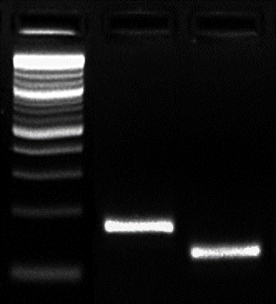

**M**

200-

400-

300-

100-

**G**

**P**

**Pi54 MAS**

**M**

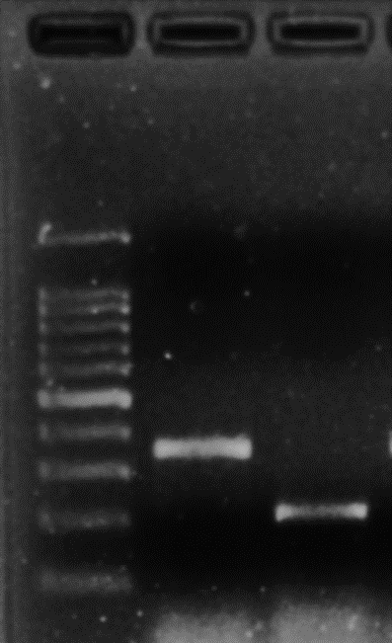

200-

100-

300-

400-

500-

**P**

**G**

Figure2- parental polymorphism study with gene linked & functional markers. Gel Lanes **M:** 100bp molecular weight ladder**; G-**Recurrent parent ‘Gontra Bidhan1’, **P-** Donor parent ‘Pusa Samba 1850’.

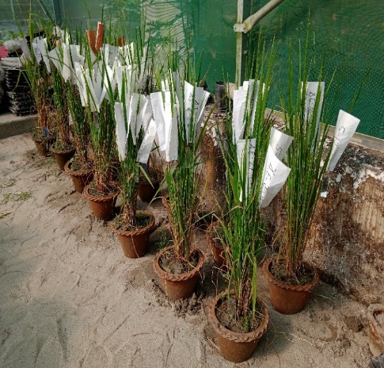

Figure 3**- a.** Emasculated panicles with bagging, **b.** Checking seed set

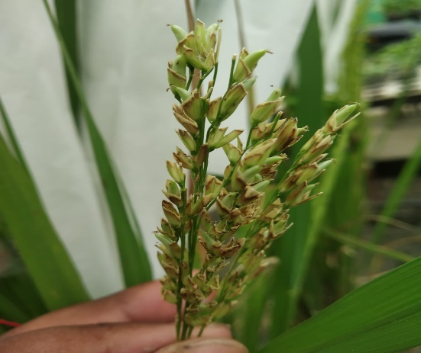

**a**

**b**

Pi54 MAS

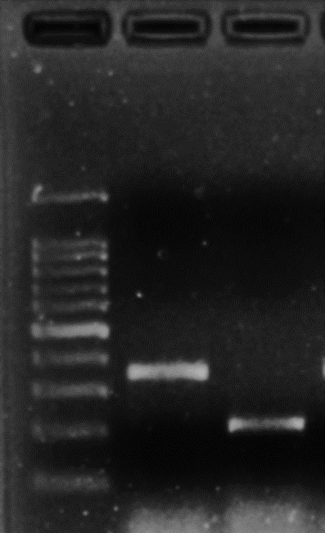

200-

100-

300-

400-

500-

600-

1500-

M

GONTRA BIDHAN 1

PUSA SAMBA

1850

-216 (R)

-359 (S)

500-

**Pi54 MAS**

**G**

**1**

**P**

**2**

**M**

**3**

500-

**2**

**1**

**3**

**G**

**M**

**P**

400-

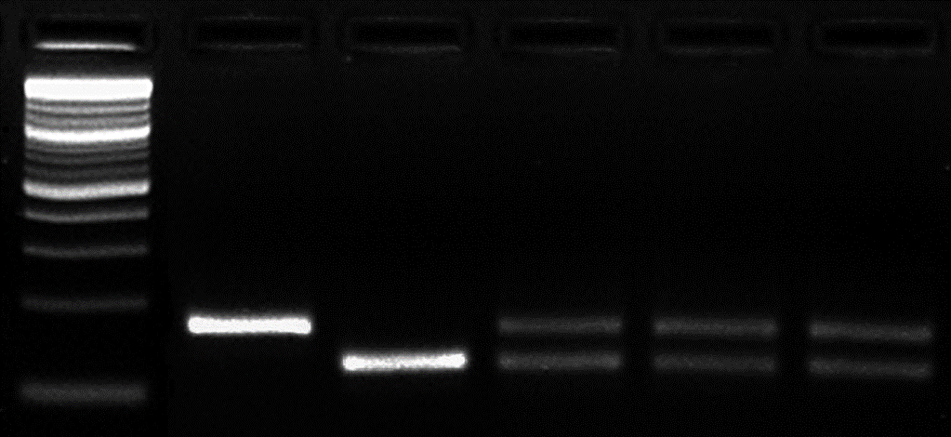 

100-

300-

**RM 206**

100-

200-

400-

300-

200-

Figure 4 **-** validation of first filial generation with gene linked & functional markers. **Gel Lanes M:** 100bp molecular weight ladder; **G**-Recurrent parent ‘Gontra Bidhan1’, **P**-Donor parent ‘Pusa Samba 1850’, **Number 1 to 3** – F1s.

**4. Conclusion**

The research performed for the improvement of Gotra Bidhan1 rice variety, which is a popular rice cultivar in west Bengal, against rice blast disease through marker assisted breeding approach. The Blast resistant gene *Pi54* has been successfully introgressed from donor parent Pusa samba 1850 through Back cross breeding along with molecular validation. The breeding generation is advanced to the BC1F2 generation where 23 individual lines show presence of targeted gene in homozygous. As it is in the initial stage of the whole breeding process further research and improvements are still going on. The developed lines will be utilized as breeding materials for the development of Blast resistant varieties.

**References**

Adhikari, B., Bag, M. K., Bhowmick, M. K., & Kundu, C. (2011). Status paper on rice in West Bengal. Rice knowledge management portal, 27.

Ali, M. N., Yeasmin, L., Gantait, S., Goswami, R., & Chakraborty, S. (2014). Screening of rice landraces for salinity tolerance at seedling stage through morphological and molecular markers. Physiology and Molecular biology of plants, 20, 411-423.

Anonymous. (2009). Estimates of area & production of principal crops in West Bengal. Evaluation wing, Directorate of Agriculture, Government of West Bengal, Kolkata-700 025. pp 227.

Anonymous (2015). *Vision 2050*: ICAR-Indian Institute of Rice Research, Rajendranagar, Hyderabad- 500030, Telangana, India.

Bonman, J. M. (1992)a. Durable resistance to rice blast disease—environmental influences. Breeding for Disease Resistance, 115-123.

Bonman, J. M., Khush, G. S., & Nelson, R. J. (1992)b. Breeding rice for resistance to pests. Annual review of Phytopathology, 30(1), 507-528.

Chatterjee, S. D., Adhikari, B., Ghosh, A., Ahmed, J., Neogi, S. B., & Pandey, N. (2008). The rice bio-diversity in West Bengal. *Department of Agriculture, Govt. of West Bengal*, *50*.

Chauhan, R., Kapila, R. K., & Rathour, R. (2021). Introgression of rice blast and bacterial leaf blight resistance genes into HPR2143 rice variety through marker assisted selection and anther culture. International Journal of Chemical Studies, 9(1), 991-997.

Christopher S. Rice Today 2002;1(2):4-5.

Couch, B. C., Fudal, I., Lebrun, M. H., Tharreau, D., Valent, B., Van Kim, P., ... & Kohn, L. M. (2005). Origins of host-specific populations of the blast pathogen Magnaporthe oryzae in crop domestication with subsequent expansion of pandemic clones on rice and weeds of rice. *Genetics*, *170*(2), 613-630.

Dasgupta, P., Das, A., Datta, S., Banerjee, I., Tripathy, S., & Chaudhuri, S. (2020). Understanding the early cold response mechanism in IR64 indica rice variety through comparative transcriptome analysis. BMC genomics, 21, 1-18.

De-Filippis, L. F., & Ahmed, P. (2014). Improvement of Crops in the era of climatic change. *New York, CT: Springer*.

Jiang, G. L. (2015). Molecular marker-assisted breeding: a plant breeder’s review. *Advances in plant breeding strategies: breeding, biotechnology and molecular tools*, 431-472.

Khush, G. S. (1978). Breeding methods and procedures employed at IRRI for developing rice germ plasm with multiple resistance to diseases and insects.

Khush, G. S., Mackill, D. J., & Sidhu, G. S. (1989). Breeding rice for resistance to bacterial blight. *Bacterial blight of rice*, *1*, 207-217.

Mitra, B., Mookherjee, S., & Biswas, S. (2014). Promotion of short duration rice variety Gotra Bidhan-1 (IET 17430) through front line demonstrations in terai region of West Bengal. Journal of Crop and Weed, 10(1), 111-114.

Mohiuddin, A. K. M., Karim, N. H., & Sultana, S. (2014). Development of improved doubled-haploids through anther culture of indica rice (*Oryza sativa* L.). *Ann Biol Res*, *5*(10), 6-13.

Mondal, D., Kantamraju, P., Jha, S., Sundarrao, G. S., Bhowmik, A., Chakdar, H., ... & Choudhury, A. (2021). Evaluation of indigenous aromatic rice cultivars from sub-Himalayan Terai region of India for nutritional attributes and blast resistance. Scientific reports, 11(1), 4786.

Ni, D., Song, F., Ni, J., Zhang, A., Wang, C., Zhao, K., ... & Li, L. (2015). Marker-assisted selection of two-line hybrid rice for disease resistance to rice blast and bacterial blight. Field Crops Research, 184, 1-8.

Padmanabhan, S.Y. Recent advances in the study of blast disease of rice. Madras Agri. J. (1965), 564–583.

Platten, J. D., Egdane, J. A., & Ismail, A. M. (2013). Salinity tolerance, Na+ exclusion and allele mining of HKT1; 5 in Oryza sativa and O. glaberrima: many sources, many genes, one mechanism?. BMC plant biology, 13, 1-16.

PRODUCTION ORIENTED SURVEY (2017) All India Coordinated Rice Improvement Programme (AICRIP),ICAR-Indian Institute of Rice Research,Rajendranagar, Hyderabad 500 030, TS, India

Rai, A. K., Kumar, S. P., Gupta, S. K., Gautam, N., Singh, N. K., & Sharma, T. R. (2011). Functional complementation of rice blast resistance gene Pi-k h (Pi54) conferring resistance to diverse strains of Magnaporthe oryzae. Journal of Plant Biochemistry and Biotechnology, 20, 55-65.

Ramkumar, G., Srinivasarao, K., Mohan, K. M., Sudarshan, I., Sivaranjani, A. K. P., Gopalakrishna, K., ... & Madhav, M. S. (2011). Development and validation of functional marker targeting an InDel in the major rice blast disease resistance gene Pi54 (*Pik h*). *Molecular breeding*, *27*, 129-135.

Sambrook, J., Russell, D.W., (2001). Molecular Cloning: A Laboratory Manual. Cold Spring Harbor, New York. INTERNATIONAL RICE GENOME SEQUENCING PROJECT (IRGSP)., 2005, The map-based sequence of the rice genome. Nature., 436:793–800.

Samanta, S. K., Mallik, S., SD, S., & UP, R. (2004). Varietal improvement of rice in West Bengal. *Genetic improvement of rice varieties of India*, 1101-1159.

Sharma, T. R., Shanker, P., Singh, B. K., Jana, T. K., Madhav, M. S., Gaikwad, K., ... & Rathour, R. (2005). Molecular mapping of rice blast resistance gene Pi-k h in the rice variety Tetep. Journal of Plant Biochemistry and Biotechnology, 14, 127-133.

Singh, A. K., Singh, P. K., Arya, M., Singh, N. K., & Singh, U. S. (2015). Molecular screening of blast resistance genes in rice using SSR markers. The plant pathology journal, 31(1), 12.

Usatov, A. V., Klimenko, A. I., Azarin, K. V., Gorbachenko, O. F., Markin, N. V., Tikhobaeva, V. E., ... & Getmantseva, L. V. (2014). DNA-markers of sunflower resistance to the downy mildew (Plasmopara halstedii).

Usatov, A. V., Kostylev, P. I., Azarin, K. V., Markin, N. V., Makarenko, M. S., Khachumov, V. A., & Bibov, M. Y. (2016). Introgression of the rice blast resistance genes *Pi1*, *Pi2* and *Pi33* into Russian rice varieties by marker-assisted selection. *Indian Journal of Genetics and Plant Breeding*, *76*(01), 18-23.

Waller, J. M. (1987). Rice Diseases. By SH Ou Slough, UK: Commonwealth Agricultural Bureaux (1985) pp. 380, UK£ 38.00, USA $70, elsewhere£ 41.00. *Experimental Agriculture*, *23*(3), 357-357.

Wilson, R. A., & Talbot, N. J. (2009). Under pressure: investigating the biology of plant infection by Magnaporthe oryzae. *Nature Reviews Microbiology*, *7*(3), 185-195.

Zeigler, R. S., Leong, S. A., & Teng, P. S. (Eds.). (1994). Rice blast disease. Int. Rice Res. Inst..