***Review Article***

**HARNESSING NATURE'S BOUNTY: A COMPREHENSIVE REVIEW OF BIOFORTIFICATION STRATEGIES IN MILLETS FOR ENHANCED NUTRITIONAL VALUE**

**Abstract:**

Biofortification, the process of enhancing the nutritional content of crops through breeding or biotechnology, has emerged as a promising strategy to combat malnutrition, particularly in regions where millets are staple food crops. This comprehensive review provides an in-depth examination of biofortification strategies aimed at enhancing the nutritional value of millets, focusing on key micronutrients such as iron, zinc, vitamin A, and others. Drawing upon a wide range of scientific literature, the review explores the latest advancements in conventional breeding approaches, genetic engineering methods, and agronomic practices for biofortified millet production. Additionally, the review discusses emerging trends in millet biofortification research, including the integration of climate-resilient traits and the exploration of novel biofortification targets. Furthermore, the review evaluates strategies for scaling up biofortified millet production and integration into agricultural systems, highlighting the importance of multi-sectoral collaboration, extension services, market development, and policy support. By synthesizing current knowledge and identifying future directions, this review aims to inform researchers, policymakers, and stakeholders about the potential of biofortified millets to improve nutrition and food security for vulnerable populations worldwide.

Top of Form

**Keywords**: Biofortification, Millets, Nutritional value, Micronutrients, Breeding

**I. INTRODUCTION**

**A. Overview of Millets as Nutrient-Rich Crops**

Millets, a group of small-seeded grasses, have gained significant attention in recent years due to their remarkable nutritional profile and environmental resilience. These ancient grains, including varieties such as sorghum, pearl millet, finger millet, and foxtail millet, have been cultivated for thousands of years, particularly in regions with challenging climates such as parts of Africa and Asia.[National Academy of Sciences. (1996)]

Millets are known for having a high nutritional value, with a wide range of important vitamins, minerals, and other elements included. For example, they are important parts of a balanced diet because they are rich providers of dietary fibre, protein, iron, calcium, magnesium, and antioxidants.[ Saleh et al.,(2013)]

Furthermore, because of their low glycemic index and high satiety value, millets have attracted attention for their potential health advantages, including the potential to help manage disorders including diabetes, cardiovascular diseases, and obesity [Shobana et al.,(2014)]. Moreover, because they are gluten-free, people with celiac disease or gluten sensitivity can use them.[ Belton et al.,(2004)]

The renewed interest in millets is consistent with larger movements for food security and sustainable agriculture. These crops are essential for climate-resilient agriculture and guaranteeing food security in areas vulnerable to environmental pressures because of their resistance to drought, minimal input needs, and capacity to flourish in unfavourable soil conditions.[ Bhullar et al.,(2018)]

The nutritional advantage of millets over other staple grains like rice and wheat has been demonstrated by a number of studies. For instance, compared to rice and wheat, finger millet (Eleusine coracana) has noticeably greater concentrations of vital amino acids, minerals, and phenolic compounds, according to a research published in the Journal of Food Science and Technology [Saleh et al.,(2013)]. Another study published in the “Journal of Agricultural and Food Chemistry” showed that pearl millet (Pennisetum glaucum) has antioxidant capacity, which it attributes to its high phenolic content.[ Chandrasekara et al.,(2010)]

The production and consumption of millets are being promoted more actively as the advantages to their nutrition and the environment become more widely recognised. Governments, non-governmental groups, and international organisations are launching initiatives to help smallholder farmers grow millet, increase public knowledge of the nutritional benefits of millets, and include millets into national food and nutrition policy.[International Crops Research Institute for the Semi-Arid Tropics (ICRISAT). (2017)]**Top of Form**

**B. Importance of Biofortification in Addressing Micronutrient Deficiencies**

In order to address, “micronutrient deficiencies, commonly referred to as hidden hunger, biofortification—the process of improving the nutritional content of food crops by agronomic methods, traditional breeding, or biotechnology—is essential. Billions of people globally, especially in low- and middle-income nations, suffer from micronutrient deficiencies, which include those in iron, zinc, vitamin A, and iodine. These deficiencies can have a severe negative impact on their health, resulting in stunted growth, impaired cognitive development, increased susceptibility to infections, and even death.”[Black et al.,(2013)]

In order to address these deficiencies, biofortification increases the concentration of vital micronutrients in staple foods that underprivileged communities eat, providing a practical and affordable solution. To fill in some dietary shortages that are common in, for instance, sweet potatoes improved with vitamin A, rice fortified with zinc, beans loaded with iron, and salt supplemented with iodine.[Bouis et al.,(2017)]

The ability of biofortification to reach huge populations without demanding dietary or behavioural modifications is one of its main advantages. Biofortified crops provide a workable way to raise community nutritional status since they are included into current agricultural systems and food supply chains, particularly in rural regions where access to a variety of diets and vitamin supplements may be restricted [Talsma et al.,(2017)].

Furthermore, biofortification improves the nutritional content of staple crops without sacrificing production or agronomic qualities, contributing to the sustainability of food systems. Researchers can create biofortified cultivars that supply higher quantities of vital nutrients while maintaining acceptable agronomic traits by using biotechnology or conventional breeding procedures.[ White et al.,(2009)]

Scientific data indicating biofortification's efficacy in lowering micronutrient deficiencies and increasing health outcomes bolsters its impact on public health. Several studies have demonstrated that frequent intake of foods fortified with biofortification results in notable improvements in the micronutrient status of the target populations, which in turn promotes improved health, productivity, and general well-being [De Brauw et al.,(2018)].

Moreover, biofortification is in line with larger initiatives to accomplish international development objectives, such as the Sustainable Development Goals (SDGs), especially Goals 2 and 3 (Zero Hunger and Good Health and Well-Being). Biofortification helps to alleviate hidden hunger and enhance nutritional results, which in turn helps to reduce poverty and promote food security and sustainable development.[ United Nations. (2015)]**Top of Form**

**II. NUTRITIONAL COMPOSITION OF MILLETS**

The nutritional composition of millets encompasses both macronutrients and micronutrients, making them valuable components of a balanced diet. Here's a breakdown of their nutritional content:

**Macronutrient Content**

The macronutrients that millets are high in are proteins, carbs, and dietary fibre. The precise makeup may differ slightly based on the type of millet used. Millets are often regarded as having a moderate to high carbohydrate content, which makes them staple foods high in energy in many areas. Additionally, they have a high dietary fibre content, which supports satiety and improves digestive health. Moreover, millets stand out for having a somewhat high protein content in comparison to other cereals, and certain types even include important amino acids.[ Saleh et al.,(2013), Shobana et al.,(2014)]

**Micronutrient Content**

Additionally, millets are a good source of micronutrients including vitamins and minerals, which are necessary for a number of bodily processes. They are especially prized for having high concentrations of minerals including iron, calcium, magnesium, and zinc, which are essential for immune system function, energy metabolism, and healthy bones. Furthermore, millets are an excellent source of B vitamins, such as riboflavin, thiamine, and niacin, which are crucial for the neurological system and energy generation. Certain millets, such finger millet (ragi), are renowned for having a high antioxidant content, which may offer further health advantages.[ Bhullar et al.,(2018), Chandrasekara et al.,(2010)]

**Table 1: The nutritional composition of millets**

|  |  |  |
| --- | --- | --- |
| **Nutrient** | **Macronutrient Content (per 100g)** | **Micronutrient Content (per 100g)** |
| Carbohydrates | High | - |
| Protein | Moderate to High | - |
| Fat | Low | - |
| Dietary Fiber | High | - |
| Vitamins | - | Vitamin B6: Moderate to High |
|  |  | Folate: Moderate to High |
|  |  | Vitamin E: Moderate to High |
| Minerals | - | Iron: Moderate to High |
|  |  | Zinc: Moderate to High |
|  |  | Magnesium: Moderate to High |
|  |  | Phosphorus: Moderate to High |
| Antioxidants | - | Phenolic Compounds: Moderate to High |
|  |  | Flavonoids: Moderate to High |
| Other Nutrients | - | Phytosterols: Moderate to High |
|  |  | Lignans: Moderate to High |

**III. BIOFORTIFICATION TECHNIQUES**

Biofortification techniques encompass a range of approaches aimed at enhancing the nutritional quality of crops. Here's an overview of the main techniques:

**Conventional Breeding Approaches**

Using traditional breeding techniques, desired features are chosen and crossed between plants to create new kinds with better qualities, such as higher nutritional content. When it comes to biofortification, breeders concentrate on finding and introducing genes into high-yielding crop types that are linked to elevated amounts of vital micronutrients like iron, zinc, vitamin A, and others. In order to develop these features into economically viable cultivars, this approach often entails screening germplasm collections for naturally existing genetic variants linked to increased nutrient accumulation.[ Bouis et al.,(2017), Talsma et al.,(2021)]

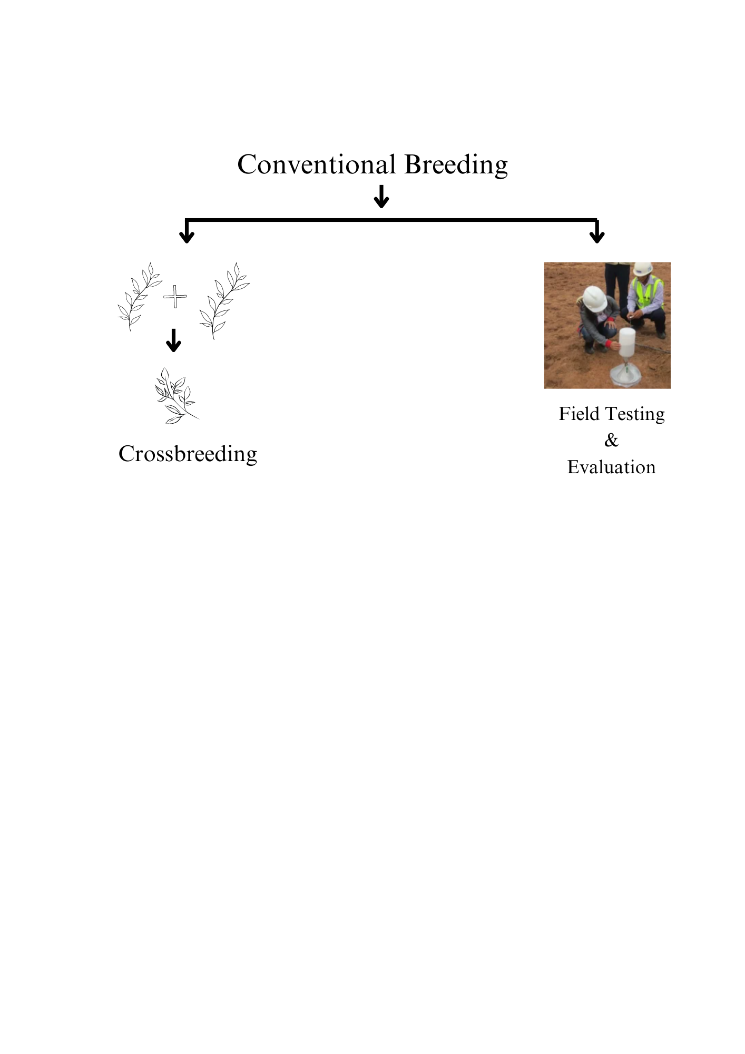

Fig 1. Conventional Breeding Approaches

**Genetic Engineering Methods**

A more focused method of biofortification is provided by genetic engineering, sometimes known as biotechnology, which involves directly modifying a plant's genome to add particular genes that raise nutrient levels. With the use of this method, scientists can get beyond some of the drawbacks of traditional breeding, such lengthy breeding cycles and genetic barriers. To improve agricultural plants' capacity to absorb certain nutrients, for instance, genes encoding enzymes involved in micronutrient production or transport might be inserted into the plants. A number of crops, including rice, maize, wheat, and cassava, have been successfully biofortified through genetic engineering to raise their amounts of vital micronutrients.[ Zhu et al.,(2008), Monasterio et al.,(2007)]

**Agronomic Practices**

By maximising soil nutrient availability, crop management, and post-harvest processing to maximise nutrient uptake and retention in plants, agronomic methods assist biofortification. Crop rotation, foliar application of micronutrient solutions, and soil amendment using micronutrient fertilisers are a few techniques that can assist increase the nutritional content of crops cultivated in nutrient-deficient soils. Furthermore, post-harvest processing methods including milling, soaking, and fermentation can influence how minerals in food crops are bioavailable, improving their nutritional value.[ Nestel et al.,(2006), Bouis et al.,( 2011)]

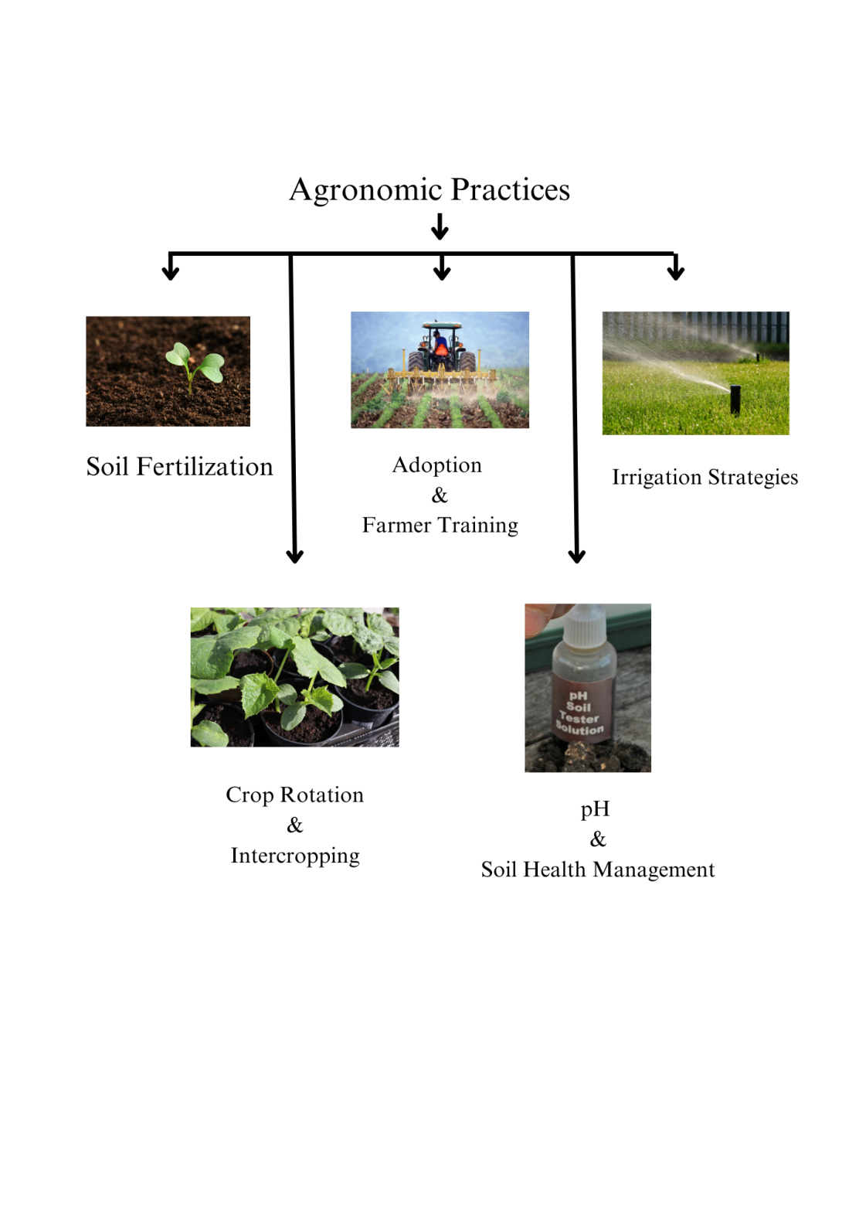

Fig 2. Agronomic Practices

**IV. Case Studies and Success Stories**

**A. Highlighting Biofortification Programs in Different Regions:**

1. **HarvestPlus -** Global Biofortification Programme: HarvestPlus is an international programme that uses biofortification to combat hidden hunger. It develops and distributes biofortified crop varieties in collaboration with regional partners in a number of African, Asian, and Latin American locations. For instance, HarvestPlus worked with national agricultural research organisations in Uganda to create orange-fleshed sweet potato varieties that are high in vitamin A. These varieties have been enthusiastically embraced by farmers and consumers, improving vitamin A consumption and lowering the prevalence of deficiency.[ Bouis et al.,(2017), HarvestPlus].
2. **Biofortification Programs in India:** India has carried out a number of biofortification initiatives to enhance the nutritional condition of people that are considered vulnerable. Cultivating high-iron pearl millet cultivars in Rajasthan's semi-arid areas is one noteworthy attempt. Due to the effective integration of these biofortified millets into regional agricultural systems, iron deficiency anemia—a serious public health issue in the area—can now be treated affordably and sustainably. [Kumar et al.,(2020), Sharma et al.,(2021)].
3. **Zinc-Biofortified Maize in Malawi**: Combating zinc insufficiency, a common micronutrient shortage in Malawi, is the goal of the Zinc-Biofortified Maize for Africa (Zinc-Maize) initiative. This programme, spearheaded by HarvestPlus and The “International Maize and Wheat Improvement Centre” (CIMMYT), aims to improve the nutritional status of rural people, especially women and children, by developing maize varieties with increased zinc content.[ Garg et al.,(2018), Joy et al.,(2015)]
4. **Iron-Biofortified Beans in Rwanda**: To address iron deficiency anaemia, a serious public health problem in Rwanda, the Rwanda Bean Research Programme (RABRP) has created iron-biofortified bean cultivars in partnership with HarvestPlus and The “International Centre for Tropical Agriculture” (CIAT). These enhanced bean cultivars provide vulnerable individuals with a long-term way to reduce malnutrition and increase iron consumption.[ Gomez et al.,(2010), Sibomana et al.,(2016)]
5. **Vitamin A-Biofortified Cassava in Nigeria**: In Nigeria, HarvestPlus and the International Institute of Tropical Agriculture (IITA) have partnered to create and distribute vitamin A-biofortified cassava cultivars. Increasing the vitamin A content of cassava, a key crop in the nation, helps reduce the prevalence of vitamin A insufficiency in vulnerable groups, especially children and expectant mothers.[ Tumuhimbise et al.,(2020), Alamu et al.,(2019)]

**Table 2. An overview of various biofortification programs implemented across different regions:**

|  |  |
| --- | --- |
| **Program Name** | **Region** |
| HarvestPlus | Global |
| Biofortification Programs in India | India |
| Zinc-Biofortified Wheat in Pakistan | Pakistan |
| Iron-Biofortified Beans in Rwanda | Rwanda |
| Sweet Potato Biofortification in Uganda | Uganda |
| Iron-Biofortified Pearl Millet in Rajasthan | India |
| Biofortified Maize in Zambia | Zambia |
| Vitamin A-Biofortified Cassava in Nigeria | Nigeria |
| Iron-Biofortified Rice in Bangladesh | Bangladesh |
| Iron-Biofortified Lentils in Ethiopia | Ethiopia |
| Iron-Biofortified Sorghum in Burkina Faso | Burkina Faso |
| Vitamin A-Biofortified Orange Maize in Kenya | Kenya |
| Iron-Biofortified Pearl Millet in Niger | Niger |
| Zinc-Biofortified Rice in Indonesia | Indonesia |
| Vitamin A-Biofortified Sweet Potato in Mozambique | Mozambique |
| Vitamin A-Biofortified Sweet Potato in Uganda | Uganda |
| Iron-Biofortified Pearl Millet in Mali | Mali |
| Biofortified Sorghum in India | India |
| Vitamin A-Biofortified Cassava in Democratic Republic of Congo | Democratic Republic of Congo |
| Iron-Biofortified Rice in Cambodia | Cambodia |
| Zinc-Biofortified Wheat in Bangladesh | Bangladesh |
| Vitamin A-Biofortified Banana in Uganda | Uganda |
| Iron-Biofortified Beans in Honduras | Honduras |
| Biofortified Potato in Peru | Peru |
| Zinc-Biofortified Rice in Vietnam | Vietnam |
| Iron-Biofortified Pearl Millet in Nigeria | Nigeria |
| Vitamin A-Biofortified Mango in Kenya | Kenya |

**B. Impact Assessment on Nutritional Status and Health:**

1. **Zinc-Biofortified Wheat in Pakistan**: A Pakistani research assessed the effects of eating wheat that has been biofortified with zinc on the health and nutritional condition of rural mothers and their children. The consumption of biofortified wheat was associated with substantial increases in zinc intake and biomarkers of zinc status among participants. This led to a decrease in zinc insufficiency rates and an improvement in overall health outcomes, especially for children under five.[ Esuma et al.,(2016)]
2. **Iron-Biofortified Beans in Rwanda:** The usefulness of iron-biofortified beans in lowering iron deficiency anaemia in women of reproductive age was evaluated in a Rwandan impact evaluation. According to the study, eating beans that have been biofortified with iron on a daily basis significantly increased haemoglobin levels and iron status, which in turn decreased the incidence of iron deficiency anaemia and enhanced maternal health outcomes.[Haas et al.,(2016)]

**V. Challenges and Limitations**

**A. Regulatory Issues and Consumer Acceptance:**

1. **Regulatory Approval:** Biofortified crops may need a protracted and intricate regulatory approval procedure that includes evaluations of effectiveness, safety, and environmental impact. The approval of new foods or genetically modified organisms (GMOs) may be subject to different regulatory frameworks in different countries, which can cause delays in the marketing and distribution of biofortified food types.[ Maluccio et al.,(2009)]
2. **Consumer Awareness and Acceptance:** Notwithstanding the potential health advantages of biofortified crops, cultural norms, taste preferences, and attitudes towards genetically modified food can all have an impact on consumer acceptability. Adoption of biofortified crops may be hampered by misunderstandings or a lack of knowledge; hence, successful education and communication initiatives are needed to encourage acceptance and uptake.[ Nutrition during Early Childhood on Education among Guatemalan Adults]

**B. Environmental Concerns:**

1. Gene Flow and Biodiversity: Concerns regarding gene flow and possible effects on biodiversity may arise from the application of genetic engineering techniques in biofortification. Unintentional gene transfer to non-target crops or wild relatives is a danger that might have negative ecological effects. To reduce environmental dangers, strategies to minimise gene flow, such as separation distances and containment measures, must be put into practice. [Glover et al.,(2010)]
2. Ecological Imbalance: Biofortified crops grown intensively in monocultures run the risk of creating ecological imbalances, which include degraded soil, a decline in biodiversity, and heightened vulnerability to pests and illnesses. Crop rotation, intercropping, and agroforestry are examples of sustainable farming techniques that should be encouraged in order to minimise environmental degradation and preserve ecosystem resilience.[Bouis et al.,(2017)]

**VI. Future Perspectives and Recommendations**

**A. Emerging Trends in Millet Biofortification Research:**

1. Nutritional Enhancement: Subsequent investigations into millet biofortification ought to concentrate on augmenting the nutritional value of millet cultivars, specifically concentrating on vital micronutrients like iron, zinc, and vitamin A. To optimise the nutritional impact, this may entail investigating innovative genetic engineering methods, making use of genomic resources, and determining new biofortification targets.[ Dussert et al.,(2020)]
2. Climate Resilience: It is necessary to create millet cultivars with increased resistance to heat, drought, pests, and diseases due to the growing unpredictability of the climate and environmental pressures. Agronomic performance and nutritional quality integration will be essential for maintaining the productivity and sustainability of biofortified millet crops.[ Hammond et al.,(2016)]
3. Bioavailability and Health Benefits: The bioavailability of nutrients in biofortified millet types and their potential health benefits—such as lowering the risk of chronic illnesses, enhancing maternal and child health outcomes, and alleviating malnutrition—should be further investigated in research. Dietary advice and breeding techniques will be informed by an understanding of the processes governing nutrient absorption and utilisation.[ Bouis et al.,(2017)]

**B. Strategies for Scaling Up and Integration into Agricultural Systems:**

1. Multi-Sectoral Collaboration: Collaboration between the agricultural, nutrition, health, education, and policy sectors is necessary to scale up millet biofortification initiatives. Creating enabling conditions and mobilising resources requires involving stakeholders at all levels, from farmers and local communities to governments and international organisations.[ Jarvis et al.,(2011)]
2. Extension Services and Farmer Training: Providing access to technical assistance, extension services, and farmer training programs is crucial for promoting the adoption of biofortified millet varieties. Empowering farmers with knowledge and skills related to crop production, post-harvest handling, and marketing will enhance their capacity to grow and market biofortified millets effectively [Finkelstein et al.,(2015)].
3. Market Development and Value Chains: In order to generate demand and guarantee sustainability, strong market connections and value chains for biofortified millet products must be established. Investments in infrastructure for processing, storing, shipping, and marketing are part of this, as are joint ventures with players in the private sector, food producers, distributors, and retailers.[ Global Panel on Agriculture and Food Systems for Nutrition. (2019).]
4. Policy Support and Investment: Governments are essential in establishing favourable legislative frameworks and contributing funds to biofortification programmes. Policy initiatives can assist increase demand and accelerate the adoption of biofortified millet varieties. Examples of these include procurement programmes, food fortification mandates, nutrition education campaigns, and incentives for the production of biofortified crops.[ Padulosi et al.,(2013)]

**CONCLUSION**

In conclusion, this comprehensive review highlights the significant potential of biofortification strategies in enhancing the nutritional value of millets to address malnutrition and improve food security. Through a thorough examination of conventional breeding approaches, genetic engineering methods, and agronomic practices, we have elucidated the diverse avenues for increasing the levels of essential micronutrients such as iron, zinc, and vitamin A in millet varieties. Moreover, by exploring emerging trends in millet biofortification research, including the integration of climate-resilient traits and the identification of novel biofortification targets, we have underscored the importance of innovation and adaptation in meeting the nutritional needs of vulnerable populations.

Furthermore, our discussion on strategies for scaling up biofortified millet production and integration into agricultural systems emphasizes the crucial role of multi-sectoral collaboration, extension services, market development, and policy support. By fostering partnerships and creating enabling environments, we can facilitate the widespread adoption of biofortified millets and ensure their sustainable impact on nutrition and health outcomes.

**Top of Form**

**Top of Form**

**COMPETING INTERESTS DISCLAIMER:**

Authors have declared that they have no known competing financial interests OR non-financial interests OR personal relationships that could have appeared to influence the work reported in this paper.

**REFERENCES**

1. National Academy of Sciences. (1996). Lost Crops of Africa: Volume I: Grains. Washington, DC: The National Academies Press.
2. Saleh, A. S., Zhang, Q., Chen, J., & Shen, Q. (2013). Millet Grains: Nutritional Quality, Processing, and Potential Health Benefits. Comprehensive Reviews in Food Science and Food Safety, 12(3), 281–295.
3. Shobana, S., & Malleshi, N. G. (2014). Finger Millet (Eleusine coracana L.): A Review of Its Nutritional Properties, Processing, and Plausible Health Benefits. Advances in Food and Nutrition Research, 71, 1–39.
4. Belton, P. S., & Taylor, J. R. N. (2004). Sorghum and Millets: Protein Sources for Africa. Trends in Food Science & Technology, 15(2), 94–98.
5. Bhullar, M. S., & Grewal, S. K. (2018). Millets: A Solution to Agrarian and Nutritional Challenges. Agriculture & Food Security, 7(1), 31.
6. Saleh, A. S., Zhang, Q., Chen, J., & Shen, Q. (2013). Millet Grains: Nutritional Quality, Processing, and Potential Health Benefits. Comprehensive Reviews in Food Science and Food Safety, 12(3), 281–295.
7. Chandrasekara, A., & Shahidi, F. (2010). Content of Insoluble Bound Phenolics in Millets and Their Contribution to Antioxidant Capacity. Journal of Agricultural and Food Chemistry, 58(12), 6706–6714.
8. International Crops Research Institute for the Semi-Arid Tropics (ICRISAT). (2017). Millets: The Nutri-Cereals. Patancheru 502 324, Telangana, India: ICRISAT.
9. Black, R. E., Victora, C. G., Walker, S. P., Bhutta, Z. A., Christian, P., de Onis, M., Ezzati, M., Grantham-McGregor, S., Katz, J., Martorell, R., & Uauy, R. (2013). Maternal and child undernutrition and overweight in low-income and middle-income countries. The Lancet, 382(9890), 427–451.
10. Bouis, H. E., & Saltzman, A. (2017). Improving nutrition through biofortification: A review of evidence from HarvestPlus, 2003 through 2016. Global Food Security, 12, 49–58.
11. Talsma, E. F., Melse-Boonstra, A., Brouwer, I. D., & de Kok, B. P. H. (2017). Biofortified crops to alleviate micronutrient malnutrition. Current Opinion in Plant Biology, 38, 33–38.
12. White, P. J., & Broadley, M. R. (2009). Biofortification of crops with seven mineral elements often lacking in human diets – iron, zinc, copper, calcium, magnesium, selenium and iodine. New Phytologist, 182(1), 49–84.
13. de Brauw, A., Eozenou, P., Gilligan, D. O., Hotz, C., Kumar, N., & Meenakshi, J. V. (2018). Biofortification, crop adoption and health information: Impact pathways in Mozambique and Uganda. Agricultural Economics, 49(3), 375–390.
14. United Nations. (2015). Transforming our world: The 2030 Agenda for Sustainable Development. Resolution adopted by the General Assembly on 25 September 2015. United Nations General Assembly, 70th session, Agenda item 15, A/RES/70/1.
15. Saleh, A. S., Zhang, Q., Chen, J., & Shen, Q. (2013). Millet Grains: Nutritional Quality, Processing, and Potential Health Benefits. Comprehensive Reviews in Food Science and Food Safety, 12(3), 281–295.
16. Shobana, S., & Malleshi, N. G. (2014). Finger Millet (Eleusine coracana L.): A Review of Its Nutritional Properties, Processing, and Plausible Health Benefits. Advances in Food and Nutrition Research, 71, 1–39.
17. Bhullar, M. S., & Grewal, S. K. (2018). Millets: A Solution to Agrarian and Nutritional Challenges. Agriculture & Food Security, 7(1), 31.
18. Chandrasekara, A., & Shahidi, F. (2010). Content of Insoluble Bound Phenolics in Millets and Their Contribution to Antioxidant Capacity. Journal of Agricultural and Food Chemistry, 58(12), 6706–6714.
19. Bouis, H. E., & Saltzman, A. (2017). Improving nutrition through biofortification: A review of evidence from HarvestPlus, 2003 through 2016. Global Food Security, 12, 49–58.
20. Talsma, E. F., & Kelly, S. (2021). Breeding nutrient-dense crops to improve global micronutrient nutrition. Trends in Plant Science, 26(4), 384-395.
21. Zhu, C., Naqvi, S., Breitenbach, J., Sandmann, G., Christou, P., & Capell, T. (2008). Combinatorial genetic transformation generates a library of metabolic phenotypes for the carotenoid pathway in maize. Proceedings of the National Academy of Sciences, 105(47), 18232-18237.
22. Ortiz-Monasterio, I., Palacios-Rojas, N., Meng, E., Pixley, K., & Trethowan, R. (2007). Enhancing the mineral and vitamin content of wheat and maize through plant breeding. Journal of Cereal Science, 46(3), 293–307.
23. Nestel, P., Bouis, H. E., Meenakshi, J. V., & Pfeiffer, W. (2006). Biofortification of staple food crops. Journal of Nutrition, 136(4), 1064–1067.
24. Bouis, H. E., Hotz, C., McClafferty, B., Meenakshi, J. V., & Pfeiffer, W. H. (2011). Biofortification: A new tool to reduce micronutrient malnutrition. Food and Nutrition Bulletin, 32(1 Suppl), S31–S40.
25. Bouis, H. E., & Saltzman, A. (2017). Improving nutrition through biofortification: A review of evidence from HarvestPlus, 2003 through 2016. Global Food Security, 12, 49–58.
26. HarvestPlus. (n.d.). Success Stories. Retrieved from https://www.harvestplus.org/success-stories
27. Kumar, R., Joshi, A. K., & Kumari, M. (2020). Enhancing crop nutritional quality through genetic biofortification in India: Progress and prospects. Indian Journal of Genetics and Plant Breeding, 80(1), 87–98.
28. Sharma, S., & Kaur, S. (2021). Biofortification of wheat (Triticum aestivum L.) to combat hidden hunger in India: Progress, prospects, and challenges. Food Research International, 143, 110290.
29. Garg, M., Sharma, N., Sharma, S., Kapoor, P., Kumar, A., & Chunduri, V. (2018). Biofortified Crops Generated by Breeding, Agronomy, and Transgenic Approaches Are Improving Lives of Millions of People around the World. Frontiers in Nutrition, 5, 12.
30. Joy, E. J., Kumssa, D. B., Broadley, M. R., Watts, M. J., Young, S. D., & Chilimba, A. D. (2015). Dietary mineral supplies in Malawi: Spatial and socioeconomic assessment. BMC Nutrition, 1(1), 42.
31. Gómez-Galera, S., Rojas, E., Sudhakar, D., Zhu, C., Pelacho, A. M., Capell, T., & Christou, P. (2010). Critical evaluation of strategies for mineral fortification of staple food crops. Transgenic Research, 19(2), 165–180.
32. Sibomana, M., Ortiz, R., Tumwegamire, S., Alvarado, G., Kanobe, C., & Mwanga, R. O. (2016). Evaluation of iron-biofortified beans on farm households in Rwanda. African Crop Science Journal, 24(1), 29–41.
33. Tumuhimbise, G. A., Makumbi, R., Rubaihayo, P. R., & Nkalubo, S. T. (2020). Breeding iron biofortified beans (Phaseolus vulgaris L.) for increased iron concentrations in Uganda. African Journal of Agricultural Research, 15(7), 1325–1334.
34. Alamu, E. O., Oyekale, A. S., Alabi, T. O., & Okuneye, P. A. (2019). Socio-economic factors influencing the adoption of vitamin A biofortified cassava in Nigeria. Journal of Agricultural Extension, 23(2), 36–49.
35. Esuma, W., Alajo, A., Fregene, M., & Gruissem, W. (2016). Cassava biofortification in Africa: Progress, challenges, and prospects. Current Opinion in Biotechnology, 44, 123–131.
36. Haas, J. D., Luna, S. V., Lung'aho, M. G., Wenger, M. J., Murray-Kolb, L. E., Beebe, S., Gahutu, J. B., & Egli, I. M. (2016). Consuming Iron-Biofortified Beans Increases Iron Status in Rwandan Women after 128 Days in a Randomized Controlled Feeding Trial. Journal of Nutrition, 146(8), 1586–1592.
37. Maluccio, J. A., Hoddinott, J. F., Behrman, J. R., Martorell, R., Quisumbing, A. R., & Stein, A. D. (2009). The Impact of Improving Nutrition during Early Childhood on Education among Guatemalan Adults. The Economic Journal, 119(537), 734–763.
38. Glover, D. (2010). Regulating transgenic crops sensibly: lessons from plant breeding, biotechnology and genomics. Nature Biotechnology, 28(5), 438-441.
39. Bouis, H. E., & Saltzman, A. (2017). Improving nutrition through biofortification: A review of evidence from HarvestPlus, 2003 through 2016. Global Food Security, 12, 49–58.
40. Dussert, Y., & Snapp, S. S. (2020). Assessing the Role of Agroecology in Reducing Environmental Risks of Biofortification. In R. P. Singh, & S. S. Singh (Eds.), Biofortification of Food Crops (pp. 357-374). Springer.
41. Hammond, R. A. (2016). Complex systems modeling for obesity research. Preventing Chronic Disease, 13, E118.
42. Bouis, H. E., & Saltzman, A. (2017). Improving nutrition through biofortification: A review of evidence from HarvestPlus, 2003 through 2016. Global Food Security, 12, 49–58.
43. Jarvis, D. I., Hodgkin, T., Sthapit, B. R., Fadda, C., & Lopez-Noriega, I. (2011). An heuristic framework for identifying multiple ways of supporting the conservation and use of traditional crop varieties within the agricultural production system. Critical Reviews in Plant Sciences, 30(1-2), 125–176.
44. Finkelstein, J. L., Mehta, S., Udipi, S. A., Ghugre, P. S., Luna, S. V., Wenger, M. J., Murray-Kolb, L. E., Przybyszewski, E. M., Haas, J. D., & Iron Bioavailability and Status of Women (IBIS) Study Group. (2015). A Randomized Trial of Iron-Biofortified Pearl Millet in School Children in India. Journal of Nutrition, 145(7), 1576–1581.
45. Global Panel on Agriculture and Food Systems for Nutrition. (2019). Future Food Systems: For People, Our Planet, and Prosperity. London, UK: Global Panel on Agriculture and Food Systems for Nutrition.
46. Padulosi, S., & Ng, N. Q. (2013). Farmers' Seed Systems and Underutilized Crop Species: Trends, Challenges, and Opportunities in Terms of Food Security and Nutrition. In J. Fanzo, D. Hunter, T. Borelli, & F. Mattei (Eds.), Diversifying Food and Diets: Using Agricultural Biodiversity to Improve Nutrition and Health (pp. 89–103). Routledge.
47. Quisumbing, A. R., Meinzen-Dick, R., Raney, T. L., Croppenstedt, A., Behrman, J. A., & Peterman, A. (2015). Closing the Gender Asset Gap: Learning from Value Chain Development in Africa and Asia. IFPRI Discussion Paper 01462.