**GENETIC VARIATION AND TRAIT RELATIONSHIPS ANALYSIS IN PURSLANE ACCESSIONS: INSIGHTS FROM GENE ACTION PREDICTION AND PRINCIPAL COMPONENT ANALYSIS**

**ABSTRACT**

This study focuses on gene action prediction and principal component analysis of biometric and physiological traits in fifteen purslane accessions was conducted during march – may 2022 in Namakkal district under pot culture. Frequency distribution analysis revealed skewed traits such as leaf length and leaf thickness with significant skewness levels, while other traits exhibited non-significant skewness. Moderate skewness was observed in traits like plant height, number of branches, and dry weight. The platykurtic nature of traits indicated the influence of multiple genes. Test statistics analysis revealed varying gene actions, with additive gene action dominating most traits, except for traits like leaf length showing positive excess kurtosis. PCA demonstrated that the first four principal components explained 91.10% of cumulative variance, indicating their substantial influence. These components highlighted the contributions of different traits to total variability, offering insight into their interrelationships. Notably, PC 1 and PC 2 accounted for most variation. Outliers among purslane accessions were identified, reflecting unique genetic characteristics. The combination of gene action prediction and PCA provides comprehensive insights into genetic influences on traits, suggesting strategies for purslane breeding programs. The presence of additive gene action with duplicate epistasis underscores the potential for trait enhancement in advanced generations. These findings offer promising avenues for developing improved purslane cultivars with desirable traits, contributing to its sustainable utilization. Further research is needed to fully harness the genetic potential of these accessions in purslane breeding efforts.

*Keywords: Common Purslane, Diversity, Purslane gene action, Skewness, Kurtosis, Principal component analysis.*

1. **INTRODUCTION**

*Portulaca oleracea* L., commonly known as purslane, has garnered attention due to its remarkable nutritive, therapeutic, pharmacological, and phytoremediation properties. The genetic diversity present within and between populations of organisms is encapsulated by genetic variation. This diversity, coupled with a grasp of desirable traits and effective selection techniques, underpins successful plant breeding endeavors (Nachimuthu *et al*., 2014). In the framework of APG III taxonomy, Portulaca stands as the sole genus within the Portulacaceae family, comprising over 100 widely dispersed species adaptable to diverse environmental conditions (Ocampo and Columbus, 2012). Exploration into the genetic regulation of vital traits in purslane has been limited but significant. Some genes responsible for these traits have been identified, shedding light on their genetic basis (Kumar *et al*., 2021). In a study by Li *et al*. (2020), purslane's genome was annotated with 151 genes, contributing to a total genome length of 156,533 bp. Quantitative traits can be classified based on their value, growth-related attributes, and polygenic nature. Genetic diversity contributes to the variability of these traits, governed by the genes orchestrating tissue growth and development (Wibowo and Armaniar, 2019). Genetic analyses, encompassing measures like skewness and kurtosis, provide insights into the nature of epistasis and the impact of multiple genes. The distribution pattern of quantitative data, often adhering to a normal curve, can manifest leptokurtic or platykurtic shapes depending on the genes involved. Skewed distributions denote different gene interactions – negative skewness indicating duplicate epistasis and positive skewness suggesting complimentary epistasis and additive gene activity (Roy, 2000). To comprehend the genetics of pivotal purslane traits, an analysis was conducted employing estimated skewness and kurtosis, offering insights into their genetic underpinnings and variability.

1. **MATERIALS AND METHODS**

The diversity exists among the 15 purslane accessions collected from various regions of Tamil Nadu, the study was conducted during march – may 2022 in Tiruchengode, Namakkal district. The experiment was laid out in completely randomised design with three replications in pot culture.

**2.1 Statistical analysis**

The skewness and kurtosis were estimated through descriptive statistics. The test statistics (Z) was calculated just to know the probability at 5% level of significance. The statistical software SAS through online cloud access was used in the experiment.

SE (skewness) = $\sqrt{6/n}$

Calculated “t” value = Skewness / SE

SE (kurtosis) = $\sqrt{24/n}$

Calculated “t” value = Kurtosis / SE

Where,

SE= Standard error

n = Number of observations

The calculated “t” value is compared with table “t” value at (n-1) degrees of freedom. The significance was checked at 5% probability level as measure of presence of kurtosis and skewness.

1. **RESULT AND DISCUSSION**

**3.1 Gene action prediction**

Frequency distribution for biometric and physiological traits are shown in Table 1 and Fig. 1. The following traits viz., leaf length (-1.79) with duplicate epistasis and leaf thickness (1.21) with complementary epistasis were highly skewed and showed significant level of skewness. The remaining all traits have observed non-significant skewness with moderate and symmetric distribution. Bulmer (1979) states that skewness between 1 to 0.5 or -1 to -0.5 is called moderately skewed, < -1 or > 1 it’s highly skewed and 0.5 to -0.5 it’s symmetrically skewed. As opined by Samak *et al.* (2011), the number and action of genes need to be studied to increase the effectiveness of selection and breeding programmes. Carroll *et al.* (2015) suggests that additive gene actions are alleles that are inherited from parents or can inherit to offspring so the desired traits with additive gene action could selected for selection program. Generally biometric traits are influenced by many genes (Ardiarini and Adiredjo, 2022). The result demonstrated that all biometric and physiological traits are lesser than 3 fall under platykurtic indicates the influence of many genes in all the traits.

The test statistics (Zs) results demonstrated, nonsignificant traits ranging from -0.98 to 1.40 and leaf thickness (1.92) were symmetrically skewed with additive gene action, whereas leaf length (-2.83) was positively skewed. The result of test statistics (Zk) demonstrates the non-significant traits ranging from -0.75 to 1.06 were close to normal curve exhibited with neither positive nor negative kurtosis (platykurtic), which indicates that all these traits were controlled by many genes with additive gene action. But significance was observed for leaf length (1.94) denotes the positive excess kurtosis (leptokurtic) which signifies the trait controlled by lesser number of genes (not monogenic) with additive gene action. Similar results are found by Wibowo and Armaniar (2019) on prediction of gene action for soya beans and by Showkath Babu *et al.* (2017) on prediction of gene action for Dolichos Bean.

**3.2 Principal component analysis (PCA)**

To display the discriminative analysis of the PCA all the biometric and physiological traits were chosen. The cumulative variance of 91.10% by the first four principal components (39.58%, 36.46%, 8.01% and 7.05% respectively) with Eigen value of greater than 1.0 (fig.2.) indicates that the identified traits within the axes exhibited great influence on the population panel (Table 2.) other principal component has eigen values less than 1.

The different quantitative and qualitative traits contribute for total variation calculated for each component. PCA captures as much of the variance in the original dataset as possible with a reduced number of variables with principal components, which are linear combinations of the original variables. Most of the variation seen among the purslane accessions from various locations was explained by PC 1 (39.58%) and PC 2 (36.46%) while the remaining components had no discriminatory power. But PC 3 accounted for 8.01 per cent variation was loaded on total chlorophyll content, total carotenoid content, total anthocyanin content and relative water content which were physiological variables and possess a crucial role in selection. Considering the above fact scatter plot for variables was drawn between PC 1, PC 2 and PC 3 allowed the original variables to be condensed into a lower number of variables. The analysis identified the most important variables for classifying the variation showed in fig. 3a, 3b & 3c. Another scatter plot for accessions was drawn between PC 1, PC 2 and PC 3 (fig. 4.) illustrated a clear pattern of grouping of purslane accessions by variable plane and identified the outliners was occupied by the following accessions PA 3, 4, 5, 7, 10, 12 & 15 all these accessions were widely scattered across different quarters. Similar findings were previously reported for physico-chemical properties of purslane by Desta *et al.* (2020) with PC 1 explains 46.16 % of variations while the second component explains only 1.36 % of variations. Sdouga *et al.* (2020) analysed the percentage of variability for morphological traits and phenolic compounds between wild and cultivated varieties of common purslane and revealed that the first two PCs accounted for 50.73% of the whole variation observed in the dataset. Alam *et al.* (2016) confirmed 82.9 % of the total variation among all the accessions studied for the morphology and major mineral nutrient composition of purslane.

1. **CONCLUSION**

The study provides valuable insights into the genetic variation and trait relationships among 15 purslane accessions. Outliners represents the accessions that deviate significantly from the main clusters and exhibit unique genetic characteristics. The combination of gene action prediction and PCA allows for a comprehensive understanding of the genetic factors influencing both biometric and physiological traits. The presence of additive gene action with duplicate epistasis suggests that selection in advanced generations can be a powerful approach for enhancing desired traits in purslane breeding programs. These findings offer promising opportunities for the development of improved purslane cultivars with superior biometric and physiological traits, contributing to the sustainable and efficient utilization of this valuable plant resource. However, further research and validation are necessary to fully utilize the genetic potential of these accessions and their applications in purslane breeding programs.

**REFERENCES**

Alam, M A, Juraimi, A S, Rafii, M, Hamid, A A, Aslani, F, & Hakim, M. 2016. Salinity-induced changes in the morphology and major mineral nutrient composition of purslane (Portulaca oleracea L.) accessions. *Biological research,* **49**: 1-19.

Ardiarini, N R, & Adiredjo, A L. 2022. Genetic Variability and Gene Action for Several Traits in F4 and F5 Population of Rice. *Plant breeding and biotechnology,* **10**(1): 31-36.

Babu, B S, Jagadeesh, B, Ramesh, S, Keerthi, C, & Sowmya, H. 2017. Third and Fourth Degree Statistics-Based Genetics of Quantitative Traits in Dolichos Bean (Lablab purpureus L.). *Int. J. Curr. Microbiol. App. Sci,* **6**(10): 2551-2558.

Bulmer, M G. (1979). *Principles of statistics*: Courier Corporation.

Carroll, S B, Doebley, J, Griffiths, A J, & Wessler, S R. (2015). *Introduction to genetic analysis*: Springer.

Desta, M, Molla, A, & Yusuf, Z. 2020. Characterization of physico-chemical properties and antioxidant activity of oil from seed, leaf and stem of purslane (Portulaca oleracea L.). *Biotechnology Reports,* **27**: e00512. doi:https://doi.org/10.1016/j.btre.2020.e00512

Kumar, A, Sreedharan, S, Singh, P, Achigan-Dako, E G, & Ramchiary, N. 2021. Improvement of a Traditional Orphan Food Crop, Portulaca oleracea L. (Purslane) Using Genomics for Sustainable Food Security and Climate-Resilient Agriculture. *Frontiers in Sustainable Food Systems,* **5**: 711820.

Li, C, Li, J, Cao, T, Li, K, & Tang, T. 2020. Characterization of the complete chloroplast genome of a medicinal plant, Portulaca oleracea. *Mitochondrial DNA Part B,* **5**(3): 2962-2963. doi:10.1080/23802359.2020.1791016

Nachimuthu, V V, Robin, S, Sudhakar, D, Raveendran, M, Rajeswari, S, & Manonmani, S. 2014. Evaluation of rice genetic diversity and variability in a population panel by principal component analysis. *Indian journal of science and technology,* **7**(10): 1555-1562.

Ocampo, G, & Columbus, J T. 2012. Molecular phylogenetics, historical biogeography, and chromosome number evolution of Portulaca (Portulacaceae). *Molecular phylogenetics and evolution,* **63**(1): 97-112.

Roy, D. (2000). *Plant breeding: Analysis and exploitation of variation*: Alpha Science Int'l Ltd.

Samak, N A, Hittalmani, S, Shashidhar, N, & Biradar, H. 2011. Exploratory Studies on Genetic Variability and Genetic Control for Protein and Micronutrient Content in F4, and F5, Generation of Rice (Oryza sativa L.). *Asian Journal of Plant Sciences,* **10**(7): 376-379.

Sdouga, D, Branca, F, Kabtni, S, Di Bella, M C, Trifi-Farah, N, & Marghali, S. 2020. Morphological Traits and Phenolic Compounds in Tunisian Wild Populations and Cultivated Varieties of Portulaca oleracea L. *Agronomy,* **10**(7): 948. Retrieved from https://www.mdpi.com/2073-4395/10/7/948

Weish, J R, & Mogea, J P. 1991. Dasar-dasar genetika dan pemuliaan tanaman.

Wibowo, F, & Armaniar, A. 2019. Prediction of gene action content of Na, K, and Chlorophyll for Soybean Crop Adaptation to Salinity. *Jerami Indonesian Journal Of Crop Science,* **2**(1): 21-28.

**Table 1. Estimation of range, mean, standard deviation, variance, skewness, kurtosis and test statistics for purslane accessions**

|  |  |  |  |  |  |  |  |  |  |  |  |  |
| --- | --- | --- | --- | --- | --- | --- | --- | --- | --- | --- | --- | --- |
| S.No | Traits | Range | | Mean | SD | Variance | Skewness | Zs | Gene action | Kurtosis | Zk | No. of genes |
| **Min** | **Max** |
| 1. | **HT** | 9.65 | 30.82 | 22.03 | 6.06 | 36.67 | -0.50 | -0.79ns | AD + DE | -0.22 | -0.18ns | Polygenic |
| 2. | **BR** | 1.60 | 3.99 | 2.60 | 0.70 | 0.49 | 0.51 | 0.80ns | AD + CE | -0.15 | -0.12ns | Polygenic |
| 3. | **SG** | 0.82 | 0.33 | 0.55 | 0.14 | 0.02 | 0.28 | 0.45ns | AD + CE | -0.52 | -0.41ns | Polygenic |
| 4. | **IN** | 7.61 | 26.30 | 17.40 | 5.47 | 29.97 | -0.21 | -0.33ns | AD + DE | -0.40 | -0.32ns | Polygenic |
| 5. | **NL** | 39.27 | 150.83 | 100.49 | 35.21 | 1239.14 | -0.27 | -0.43ns | AD + DE | -1.02 | -0.80ns | Polygenic |
| 6. | **LA** | 0.24 | 1.63 | 0.9 | 0.38 | 0.14 | 0.18 | 0.29ns | AD + CE | 0.22 | 0.18ns | Polygenic |
| 7. | **LL** | 0.82 | 2.14 | 1.79 | 0.40 | 0.16 | -1.79 | -2.83** | AD + DE | 2.45 | 1.94** | Polygenic |
| 8. | **LB** | 0.43 | 1.62 | 1.04 | 0.33 | 0.11 | 0.15 | 0.24ns | AD + CE | -0.34 | -0.27ns | Polygenic |
| 9. | **LT** | 0.64 | 1.34 | 0.88 | 0.20 | 0.04 | 1.21 | 1.92** | AD + CE | 1.34 | 1.06ns | Polygenic |
| 10. | **SPY** | 50.97 | 112.36 | 78.50 | 18.73 | 350.76 | 0.46 | 0.73ns | AD + CE | -0.62 | -0.49ns | Polygenic |
| 11. | **DW** | 7.67 | 18.90 | 11.43 | 3.31 | 10.97 | 0.88 | 1.40ns | AD + CE | 0.40 | 0.32ns | Polygenic |
| 12. | **TCL** | 0.66 | 1.91 | 1.27 | 0.33 | 0.11 | 0.42 | 0.67ns | AD + CE | 0.29 | 0.23ns | Polygenic |
| 13. | **TCC** | 0.13 | 0.36 | 0.23 | 0.07 | 0.004 | 0.21 | 0.34ns | AD + CE | -0.54 | -0.43ns | Polygenic |
| 14. | **TAC** | 3.31 | 19.25 | 9.57 | 5.31 | 28.18 | 0.54 | 0.85ns | AD + CE | -0.94 | -0.75ns | Polygenic |
| 15. | **Fat** | 3.71 | 6.03 | 4.98 | 0.69 | 0.47 | -0.47 | -0.74ns | AD + DE | -0.49 | -0.39ns | Polygenic |
| 16. | **Fiber** | 2.75 | 5.73 | 4.23 | 0.79 | 0.62 | -0.22 | -0.35ns | AD + DE | 0.11 | 0.09ns | Polygenic |
| 17. | **Oxalates** | 0.47 | 0.74 | 0.63 | 0.09 | 0.01 | -0.60 | -0.95ns | AD + DE | -0.62 | -0.49ns | Polygenic |
| 18. | **RWC** | 75.75 | 92.05 | 82.67 | 5.20 | 27.03 | 0.62 | 0.98ns | AD + CE | -0.77 | -0.61ns | Polygenic |

HT-plant height, BR-number of branches, SG-stem girth, IN-number of internodes, NL-number of leaves, LA-leaf area, LL-leaf length, LB-leaf breadth, LT-leaf thickness, SPY-single plant yield, DW-dry weight, TCL-total chlorophyll content, TCC-total carotenoid content, TAC-total anthocyanin content and RWC-relative water content.

SD-Standard deviation

Z-Test statistics for skewness and kurtosis

AD-Additive gene action, DE-Duplicate epistasis, CE-Complementary epistasis

**- significant at *p*<0.05, ns-non-significant

**Table 2. Eigen value and percent of total variation and component matrix for the principal component axes**

|  |  |  |  |  |
| --- | --- | --- | --- | --- |
| **Principal components** | **1** | **2** | **3** | **4** |
| **Eigen value** | 7.12 | 6.56 | 1.44 | 1.27 |
| **Proportion** | 39.58% | 36.46% | 8.01% | 7.05% |
| **Cumulative** | 39.58% | 76.04% | 84.05% | 91.10% |
| **Component matrix** | | | | |
| **Plant height** | 0.22 | 0.28 | -0.18 | 0.05 |
| **Number of branches** | 0.30 | 0.10 | -0.28 | 0.18 |
| **Number of internodes** | 0.27 | -0.21 | -0.18 | 0.23 |
| **Stem girth** | 0.26 | 0.25 | -0.04 | 0.14 |
| **Number of leaves** | 0.24 | -0.20 | -0.28 | 0.29 |
| **Leaf area** | 0.15 | 0.29 | 0.28 | -0.22 |
| **Leaf length** | 0.08 | 0.35 | -0.08 | -0.14 |
| **Leaf breadth** | 0.18 | 0.26 | 0.25 | -0.31 |
| **Leaf thickness** | -0.20 | 0.12 | 0.29 | 0.58 |
| **Dry weight** | 0.32 | 0.07 | 0.07 | 0.25 |
| **Single plant yield** | 0.19 | 0.27 | -0.13 | 0.19 |
| **Total chlorophyll content** | 0.12 | -0.33 | 0.31 | 0.03 |
| **Total carotenoid content** | 0.16 | -0.32 | 0.24 | -0.06 |
| **Total anthocyanin content** | 0.16 | -0.33 | 0.19 | 0.11 |
| **Fat content** | 0.36 | -0.05 | 0.14 | -0.12 |
| **Oxalates** | 0.33 | -0.09 | 0.13 | -0.19 |
| **Fiber content** | 0.35 | -0.06 | 0.11 | -0.10 |
| **Relative water content** | -0.02 | 0.24 | 0.52 | 0.37 |

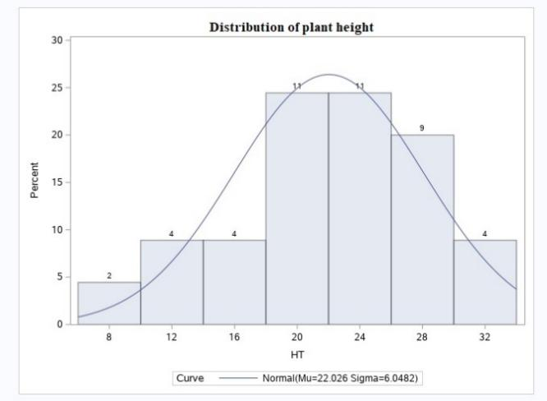

**Fig.1. Frequency distribution for biometric traits of purslane accessions**

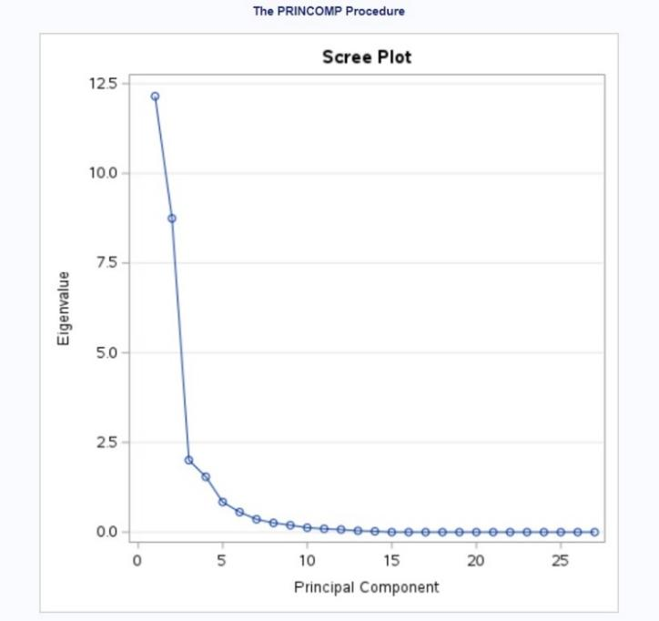 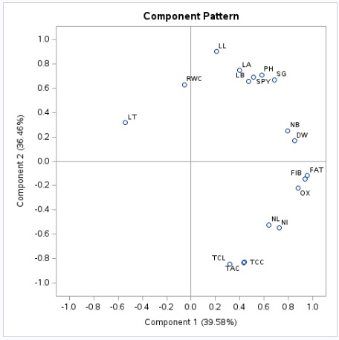

**Fig. 2.** **Scree plot** **Fig. 3a.** **Variables scatter plot for PC1 & 2**

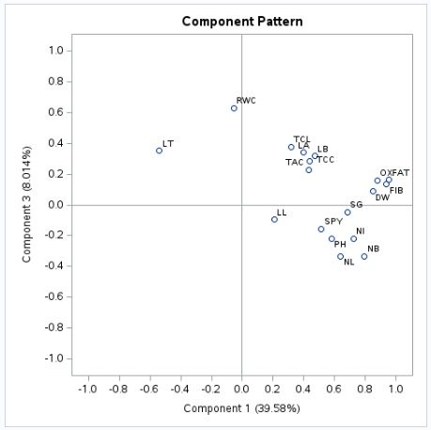

**Fig. 3b.** **Variables scatter plot for PC1 & 3 Fig. 3c.** **Variables scatter plot for PC2 & 3**

HT-plant height, BR-number of branches, SG-stem girth, IN-number of internodes, NL-number of leaves, LA-leaf area, LL-leaf length, LB-leaf breadth, LT-leaf thickness, SPY-single plant yield, DW-dry weight, TCL-total chlorophyll content, TCC-total carotenoid content, TAC-total anthocyanin content and RWC-relative water content.

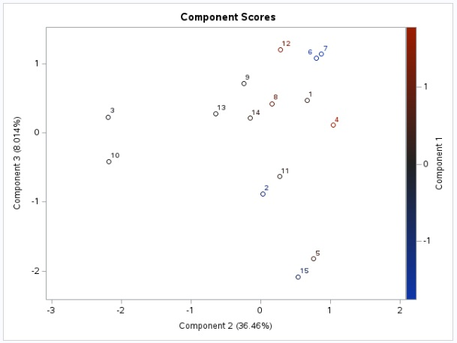

**Fig. 4.** **Accessions scatter plot for PC 1, 2 & 3**