**Impact of Methamphetamine on Electrolytes, Lipid Profile, and Protein Metabolism: Insights into Biochemical Alterations and Toxicity Mechanisms**

**Abstract**

**Background:** Methamphetamine (METH) is a strong stimulant of the central nervous system. It is well known for its recreational usage and significant potential for misuse. It is also implicated to cause physiologic changes on the gastrointestinal health. **Research** **Objectives:** The study investigates the chronic effect of METH on electrolytes, Lipids, and Proteins in Wistar rats. **Methodology:** using appropriate and standard method. **Results and Discussion:** Results obtained show that METH induced significant biochemical alterations in serum electrolytes. (Table 1) indicated ~~eluviations~~ elevations in sodium (Na⁺), potassium (K⁺), chloride (Cl⁻), and bicarbonate (HCO₃⁻) ions. Fecal electrolytes (Table 2) indicated increase in **(**Na⁺, Cl⁻, and K⁺). Conversely, the bicarbonate (HCO₃⁻) ion level was reduced. The lipid profile result (Table 3) showed increased levels in total cholesterol (TC), triacylglycerides (TG), and low-density lipoprotein (LDL-C) with reduction in high-density lipoprotein (HDL-C). Myeloperoxidase (MPO) level in stomach, ileum and liver tissues (Table 4) showed significant increase. Serum protein showed reduction level, and Na+-K+-ATPase showed increased activity (Table 5). **Conclusions and recommendations and contribution to knowledge:** These findings shed light to the debilitating nature of methamphetamine on the gastrointestinal function, particularly to those individuals who indulge in illicit use of METH for a prolonged time (Fig.1).

**Keywords:** Methamphetamine**,** Electrolytes,Lipids profile**,** Proteins, Rats

**Summary Box/ Key Messages**

**What is already known on this topic?**

Methamphetamine (METH) is widely recognized for its stimulant effects on the central nervous system and its potential for abuse. Previous research has highlighted its role in inducing neurotoxicity, cardiovascular dysfunction, and oxidative stress. However, its impact on gastrointestinal function and biochemical homeostasis remains underexplored.

**What this study adds?**

This study provides novel insights into the biochemical disruptions caused by chronic METH use, specifically alterations in serum and fecal electrolytes, lipid profiles, protein metabolism, and enzymatic activity. The observed increase in inflammatory markers and Na⁺-K⁺-ATPase activity suggests potential mechanisms through which METH affects gastrointestinal and systemic physiology.

**How this study might affect research, practice, or policy?**

The result findings emphasize the importance for further research on METH-induced gastrointestinal dysfunction and its long-term consequences. The results may inform clinical approaches for managing METH-related metabolic disturbances and provide a foundation for public health strategies aimed at mitigating the physiological risks associated with chronic METH use.

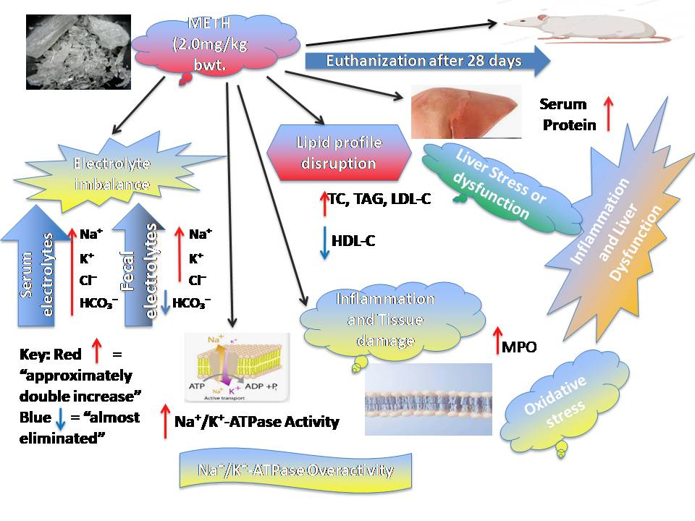

Fig. 1: Graphical Abstract Image

**Abbreviations ~~(Remove abbreviations)~~**

ANOVA

analysis of variance

ApoA1

apolipoprotein A1

ATP

Adenosine triphosphate

ATPase

Adenosine triphosphatase

Cl⁻

Chloride

DAMPs

damage-associated molecular patterns

FFAs

free fatty acids

HCO₃⁻

Bicarbonate

HDL

high-density lipoprotein

HDL-C

high-density lipoprotein cholesterol

HPA

hypothalamic-pituitary-adrenal

K⁺

Potassium

LDL

low-density lipoprotein

LDL-C

low-density lipoprotein cholesterol

LPL

lipoprotein lipase

METH

Methamphetamine

MPO

Myeloperoxidase

Na⁺

Sodium

Na+-K+-ATPase

Sodium-potassium-adenosine phosphatase

NDLEA

National Drug Law Enforcement Agency

SPF

Specific pathogen-free

TCA

Tricyclic antidepressant

TC

Total cholesterol

TG

Triacylglycerides

SDS

sodium dodecyl sulfate

SNS

sympathetic nervous system

RCT

reverse cholesterol transport

**INTRODUCTION**

**Background**: Methamphetamine (METH) is a strong stimulant of the central nervous system. It is well known for its recreational usage and significant potential for misuse. Beyond addiction, its consequences on the body include systemic metabolic changes, neurotoxicity, and extreme oxidative stress [1]. Chronic METH use has been linked to notable changes in biochemical parameters, such as dysregulation of protein metabolism and disruptions in lipid profiles [2], which add to the drug's pervasive physiological and toxicological consequences. It is essential to comprehend these metabolic alterations in order to create treatment plans that will mitigate the toxicity caused by METH.  
This study seeks to use appropriate and standard method to examine the biochemical effects of METH in factors such protein metabolism, lipid profiles, and electrolyte balance in a controlled experimental environment using Wistar rats. The aim is to determine the degree of METH-induced toxicity.

The use of Wistar rats as an experimental model for studying the biochemical effects of METH is justified based on their physiological and metabolic similarities to humans [3]. Rodent models, particularly Wistar rats, are widely used in toxicological and pharmacological research due to their well-characterized biochemical pathways, ease of handling, and controlled breeding conditions [4].

**Objectives:** The study seeks to investigate the chronic effects of methamphetamine (METH) on biochemical parameters, specifically **electrolytes, lipids, and proteins**, in Wistar rats. This includes assessing alterations in **serum and fecal electrolytes, lipid profiles, serum protein levels,** and **Na⁺-K⁺-ATPase activity** to understand the physiological impact of prolonged METH exposure on gastrointestinal and systemic metabolism. The secondary objectives of the research are: to assess the effect of METH on electrolyte balance; assess the alterations in lipid metabolism; determine the oxidative and inflammatory effects of METH on gastrointestinal tissues; examine METH-induced changes in protein metabolism, and investigate the activity of Na⁺-K⁺-ATPase in response to METH exposure.

**METHODS**

**Ethical Statement**

Ethical approval for the study was granted by the PAMO University of Medical Sciences Animal Research Ethics Committee (Approval number: PUMS/REC/2023008). The National Research Council guidelines [4] for the handling and management of laboratory animals were strictly adhered to during the experiment. The ARRIVE1 reporting guideline was used [5].

**Study design**

The animals were randomly shared into two (2) groups, each consisting of 25 animals (n = 25). Group 1, the normal control, was fed standard rat chow. Group 2 received methamphetamine (2.0 mg/kg body weight), orally experimental period?. The experimental animals were used to assess the parameters: serum electrolytes (sodium, potassium, chloride, and bicarbonate ions); fecal electrolytes, serum cholesterol (total cholesterol, triacylglyceride, high-density lipoprotein cholesterol, and low-density lipoprotein cholesterol) levels; stomach, ileum and liver myeloperoxidase levels; and serum protein; and serum sodium-potassium ATPase levels.

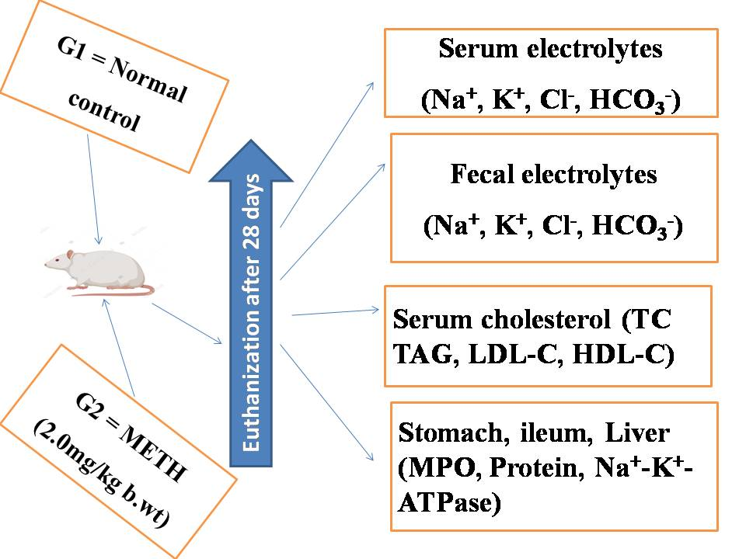

Fig. 2. Experimental procedures

**Reagents and chemicals:** High standard reagents and chemicals were used for the research.Methamphetamine (10 g) was procured from the National Drug Law Enforcement Agency (NDLEA) and stored at a temperature below 25°C for the study.

**Tissue collection:** The method of [6] was used for tissue collection. Following the four-week treatment period, the animals were subjected for 12-hour without food before they were sacrificed by atlanto-occipital dislocation. A surgical cut on the abdomen was done to access the visceral, and blood samples were obtained via cardiac perforation using a hypodermic syringe and needle. The blood samples were transferred into red top tubes, centrifuged at 4000 rpm for 15 minutes, and the resulting serum was stored at 4°C for further analysis.

**Determination of serum biochemical parameters:** The total serum cholesterol was determined using the method described by [7] with a Dialab kit, and absorbance was measured at 546 nm. The level of HDL and LDL cholesterol in plasma were assessed following [8]. The method of [9] was used to determine the level of triacylglycerol in plasma. Standard procedure was maintained in the determination of sodium and potassium levels. The level of chloride ion was evaluated by ion selective electrode while bicarbonate ion level was assessed by the titration method using neutral red indicator.

**Assay of Na+-K+-ATPase specific activity:** A quick assay for Na+-K+-ATPase specific activity was done following the method of [10].

**Protein assay:** The Sakar [10] method was employed. Following sodium dodecyl sulfate (SDS) treatment, a 0.3 ml aliquot from the same reaction mixture of the Na+-K+-ATPase assay was utilized straight away, and 0.3 ml of 30% TCA was added to the solution. The turbidity was measured at 340 nm after the tubes were incubated for 30 minutes at room temperature. For the standard protein assay, bovine serum albumin produced in 0.2% SDS was utilized [11]. Using the Lowry et al. [12] technique, the protein levels of the stock solution were also ascertained.

**Determination of fecal electrolytes:** One gram of fecal material was obtained from the different groups. The fecal material was put in 50ml barrel. Fifteen ml of distilled water was then added and left to homogenize for 3 minutes. The homogenate was filtered using a Whatman filter paper. The supernatant was then transferred into plastic containers and frozen at -150C. The electrolytes Na+, K+ and Cl- were determined by the principle of ion selective electrode (already described for serum electrolytes). The HCO3- ion was determined using a bicarbonate ion-selective electrode, following the manufacturer's guidelines.

**Experimental animals**

Fifty (50) male Wistar rats with weights between 180 and 200 g were sourced from the animal facility at the Department of Physiology, Faculty of Basic Medical Sciences, PAMO University of Medical Sciences, Port Harcourt, Rivers State, Nigeria.

**Housing and husbandry**

The study was conducted in a controlled animal research facility to meet specific pathogen-free (SPF) standards. Wistar rats were housed in polycarbonate cages with stainless steel wire tops, with five rats per cage to allow for movement and social interaction. The cages were lined with autoclaved wood shavings, changed twice weekly to maintain hygiene. The rats were habituated for seven days before the 28-day treatment period, during which they were kept under controlled conditions (27±2°C) with a 12-hour light-dark cycle and provided free access to standard rat food and distilled water. To promote natural behaviors and reduce stress, the rats were provided with **shredded paper nesting material** and **PVC tubes** for hiding and exploration. Daily clinical observations assessed their health, mobility, and behavior. At the end of the study, the rats were humanely sacrificed using carbon dioxide inhalation followed by cervical dislocation, ensuring minimal suffering, in compliance with international ethical guidelines.

**Sample size**

**50 Wistar rats** were utilized for the research, **five rats per cage**, ensuring appropriate housing conditions while maintaining statistical power for biochemical analyses.

The size of the study was determined with reference to earlier work that evaluated biochemical alterations in response to methamphetamine exposure [13]. A **power analysis** was conducted using **G*Power software,** with the following parameters: Effect size (d) = 1.5 (Kim et al, 2019); Statistical importance (α) = 0.05; Power (1-β) = 0.8; Two-tailed t-test for independent groups.

**Allocating animals to experimental groups**

Group allocation and randomization:A total of 50 Wistar rats were arbitrarily allocated to two groups, control and METH (n = 25 per group) using a computer-generated randomization method to ensure unbiased distribution. Randomization was stratified based on initial body weight to ensure balanced distribution across the groups, minimizing variability due to weight differences. Control animals received distilled water, while the METH group received 2.0 mg/kg body weight of methamphetamine. Daily treatment was done same time each day to control for day-to-day influences. All animals were observed for behavioral and physiological changes at fixed intervals. Blood samples were collected at consistent time points across both groups to avoid variability due to diurnal changes.

**Experimental outcomes**

Primary Outcomes: Serum and Fecal Electrolyte Levels: Assessment of sodium (Na⁺), potassium (K⁺), chloride (Cl⁻), and bicarbonate (HCO₃⁻) concentrations to determine METH-induced electrolyte imbalances.

Lipid Profile Alterations: Measurement of total cholesterol (TC), triacylglycerides (TG), low-density lipoprotein (LDL-C), and high-density lipoprotein (HDL-C) to evaluate dyslipidemia associated with METH exposure.

Protein Metabolism: Analysis of serum protein levels and Na⁺-K⁺-ATPase activity as indicators of metabolic disruption.

Secondary Outcomes: Oxidative Stress Markers: Quantification of myeloperoxidase (MPO) activity in stomach, ileum, and liver tissues to assess inflammation and oxidative damage.

Histopathological Changes: Examination of gastrointestinal and hepatic tissues for structural alterations associated with METH toxicity.

Body Weight and Physiological Observations: Monitoring weight changes and general health status as additional indicators of systemic toxicity.

**Statistical methods**

Statistical analysis was performed using one-way analysis of variance (ANOVA) to determine significant differences between the Control and METH-treated groups. A Tukey- Post-hoc analysis was conducted to further explore differences between groups. A p-value of <0.05 was considered statistically important. The individual animal (n = 25 per group) served as the unit of analysis for all biochemical assessments, including electrolyte levels, lipid profiles, protein metabolism, and oxidative stress markers. Data distribution was done using the Shapiro-Wilk test to confirm normality. The Levene’s test, a key assumption for ANOVA was used to ensure equal variances across groups.

**RESULTS**

**Table 1: Baseline data**

|  |  |  |
| --- | --- | --- |
| **Parameter** | **Control Group (n=25)** | **METH Group (n=25)** |
| **Weight (g)** | 190 ± 10 | 188 ± 9 |
| **Age (weeks)** | 6–8 | 6–8 |
| **Sex** | Male | Male |
| **Microbiological Status** | SPF, healthy | SPF, healthy |
| **Diet & Water** | *Ad libitum* | *Ad libitum* |
| **Light/Dark Cycle** | 12:12 h | 12:12 h |
| **Temperature (°C)** | 27 ± 2 | 27 ± 2 |
| **Humidity (%)** | 50–60 | 50–60 |

**Numbers analyzed:**

All **50 Wistar rats** used in the study were included in the final analysis. Each animal was assessed for **electrolyte balance, lipid profile, protein metabolism, and oxidative stress markers** as per the study design.No animals or datasets were excluded from the analysis. All animals **completed the experimental protocol without mortality, severe illness, or complications that required removal from the study.**

**Outcomes and estimation:**

All results are expressed as Mean ± SEM (n = 3). Statistically significant differences between control and METH-treated groups were considered at P < 0.05.

**Effect of methamphetamine administration on serum electrolytes**

The administration of methamphetamine (METH) resulted in significant alterations in the serum electrolyte levels. The data presented as Mean ± SEM shows significant increases in sodium (Na⁺), chloride (Cl⁻), potassium (K⁺), and bicarbonate (HCO₃⁻) levels in the METH-treated group compared to the control (P < 0.05).

**Table 2: Effect of Methamphetamine Administration on Serum Electrolytes**

|  |  |  |  |  |
| --- | --- | --- | --- | --- |
| GROUP | Na+ (mmol/l) | Cl- (mmol/l) | K+ (mmol/l) | HCO3- (mmol/l) |
| CONTROL | 139.16±0.82 | 62.86±0.41 | 3.24±0.03 | 36.10±0.83 |
| METH | 150.50±0.47* | 79.29±0.37* | 6.29±0.05* | 76.21±0.57* |

*All values are expressed as Mean ± SEM (n = 3). (P<0.05) = statistically significant*

**Effect of methamphetamine administration on fecal electrolytes**

Similarly, fecal electrolyte analysis expressed significant changes in the METH group, with increased levels of sodium (Na⁺), chloride (Cl⁻), and potassium (K⁺) in relation with control group. Conversely, bicarbonate (HCO₃⁻) levels showed a statistical decrease.

**Table 3: Effect of Methamphetamine Administration on Fecal Electrolytes**

|  |  |  |  |  |
| --- | --- | --- | --- | --- |
| GROUP | Na+ (mmol/l) | Cl- (mmol/l) | K+ (mmol/l) | HCO3- (mmol/l) |
| CONTROL | 53.71±26.85 | 15.55±0.73 | 2.13±0.01 | 34.82±0.56 |
| METH | 61.16±30.58* | 23.12±0.31* | 2.56±0.03* | 26.86±0.52 * |

*All values are expressed as Mean ± SEM (n = 3). (P<0.05) = statistically significant*

**Effect of methamphetamine administration on lipid profile markers**

The lipid profile in the METH-treated rats expressed statistical increases in total cholesterol (TC), triacylglycerides (TG), and low-density lipoprotein (LDL-C) compared to controls, while high-density lipoprotein (HDL-C) levels were significantly reduced.

**Table 4: Effect of Methamphetamine Administration on Lipid Profile Markers**

|  |  |  |  |  |
| --- | --- | --- | --- | --- |
| GROUP | TC (mmol/l) | TG (mmol/l) | HDL-C (mmol/l) | LDL-C (mmol/l) |
| CONTROL | 1.43±0.01 | 0.78±0.00 | 0.94±0.02 | 0.41±0.00 |
| METH | 1.63±0.00* | 0.99±0.02* | 0.80±0.00* | 0.63±0.00* |

*All values are expressed as Mean ± SEM (n = 3). (P<0.05) = statistically significant*

**Effect of methamphetamine administration on myeloperoxidase (MPO),** **serum proteins and Na+-K+-ATPase**

Myeloperoxidase (MPO) levels significantly increased in the stomach, liver, and ileum of METH-treated rats. Additionally, serum proteins were significantly reduced, while Na+-K+-ATPase activity showed a significant increase in the METH group.

**Table 5: Effect of Methamphetamine Administration on Myeloperoxidase (MPO), Serum Proteins, and Na+-K+-ATPase**

|  |  |  |  |  |  |
| --- | --- | --- | --- | --- | --- |
| GROUP | STOMACH (ηmoles/mg protein) | LIVER (ηmoles/mg protein) | ILEUM (ηmoles/mg protein) | SERUM PROTEINS (g/dL) | Na+-K+-ATPase (IU/L) |
| CONTROL | 1.70±0.30 | 0.82±0.42 | 1.13±0.07 | 6.01±0.09 | 118.08±0.51 |
| METH | 2.16±0.23* | 1.50±0.02* | 2.65±0.00* | 4.58±0.02* | 151.98±0.24* |

*All values are expressed as Mean ± SEM (n = 3). (P<0.05) = statistically significant*

**Adverse events**

There were no significant adverse events observed during the course of the experiment. No animals displayed signs of distresses that would have necessitated intervention.

**DISCUSSION**

**Interpretation/scientific implications:** The results of this study highlight significant biochemical alterations induced by methamphetamine (METH) in serum electrolytes, lipid profile, and protein metabolism in Wistar rats. The alterations in electrolyte levels of (K+ and HCO3-) may possibly be due to the effects of the psycho-stimulant nature of METH that triggers widespread physiological and biochemical changes. These findings are consistent with previous studies that reported methamphetamine-induced cell damage, especially in skeletal muscles, that can cause the release of intracellular potassium into the blood s tream [3,13,14]. The increase in HCO3- ion level in the METH treated group may be due to a compensatory response to acid-base imbalances such as metabolic alkalosis, resulting in increased serum bicarbonate levels, which can exacerbate electrolyte derangements as reported by [13].

The observed increase in fecal electrolytes (Na+ and K+) in the METH treated group could be due to METH stimulatory effects on the sympathetic nervous system (SNS), which could alter intestinal motility and increased fluid secretion into the intestinal lumen. That resulted in increased loss of Na+ and K+ through the feces, due to impaired reabsorption in the colon. Our findings are in line with the reports of Furness *et al.* [15], who documented that the inflammatory microenvironment changes the structure and function of junctions between epithelial cells through direct and indirect mechanisms, affecting the permeability of the epithelial barrier. Prakash et al. [16] found that damage to the intestinal mucosa and epithelial barrier results in increased intestinal permeability, which is a significant factor in the pathophysiology of METH users. These findings further support the idea that METH's effects on the intestinal lumen may cause leakage into the gut lumen and fecal electrolyte excretion. The significant increase in fecal chloride (Cl-) in the METH treated group in relation with the control may be due to METH-induced intestinal hypersecretion that resulted in increased Cl- loss in feces. The decreased fecal bicarbonate (HCO3-) in the animals administered with METH as compared to control may be as a result of increased gut motility that shortens the contact time for bicarbonate reabsorption in the intestines. This is supported by the reports of [17].

The observed elevated levels of TC, TG, LDL-C, and lowered HDL-C level in the METH-treated animals may be assumed that METH may have stimulated catecholamine release, especially norepinephrine and epinephrine which activate lypolysis in adipose tissue via β-adrenergic receptors [18]. This may have resulted in increased free fatty acids (FFA) release. The excess FFAs are usually taken up by the liver and utilized for cholesterol synthesis. Hence, the elevated TC levels could be due to increased hepatic cholesterol production. Our findings are consistent with those of [19], who found a link between METH usage and cardiovascular disease and higher serum cholesterol levels. However, our findings did not align with the findings of [6], who reported a decrease in serum levels as dosage increased. Given that our administered dose was significantly lower (2.0 mg/kg) than that of [6], this discrepancy in results may be dose dependent. The observed increase TG level in METH treated group compared to control may have been due to impairment of lipoprotein lipase (LPL) activity, reducing the clearance of TG-rich lipoproteins, which may have resulted in the accumulation of TG in the blood [20]. Our result is in consonance with the report of [6]. The HDL-C, (a “good” cholesterol), showed a statistical reduction in the animals administered with METH in relation to control. This trend is similar to the report of [6]. The reduction in HDL-C could impair reverse cholesterol transport (RCT). This could be due to the down regulating effect of METH on apolipoprotein A1 (ApoA1), a key structural component of HDL, resulting in the impairment of HDL formation that implied lower levels of HDL-C [21]. The METH treated animals exhibited elevated levels of LDL-C. This could be due to the increased cholesterol synthesis that resulted in greater secretion of LDL particles by the liver, as reported by [22].

**The expressed** MPO levels in the liver, stomach and ileum of animals treated with METH as compared to control group may be due to METH-induced damage through direct cytotoxicity and ischemia [23]. According to [24], damaged tissues generate damage-associated molecular patterns (DAMPs), which attract neutrophils and raise MPO levels in the afflicted areas. The observed lower serum protein level in animals administered with METH in relation with control group could be due to the impact of METH on protein metabolism resulting in lower serum proteins level [25]. Reports from [26] have it that METH is hepatotoxic. It causes liver damage which in turn impairs the synthesis of serum proteins, including albumin and globulins. According to [27], METH may also affect serum proteins via hyperactivating the hypothalamic-pituitary-adrenal (HPA) axis, which increases the concentration of cortisol. Cortisol promotes proteolysis in muscles and other tissues, and this may lead to reduction in circulating protein levels [28].

The Na+-K+-ATPase activity in METH treated animals was shown to increase more than in the control group. This may be attributed to the METH induced effect of increasing cathecholamine release, which in turn disturbs ionic homeostasis, resulting in elevated intracellular Na+ and Ca2+ [29]. The cells increase Na+-K+-ATPase activity, which aggressively pumps Na+ out of the cell and K+ into the cell, in an attempt to restore ionic equilibrium [30]. Another possible mechanism by which METH impacts on Na+-K+-ATPase activity could be that METH increased cellular energy demand and ATP turnover, partly by stimulating Na+-K+-ATPase to counteract ionic disruptions [31]. These findings underscore the need for comprehensive treatments targeting both metabolic and oxidative stress to address the systemic toxicity associated with chronic METH use.

**Study Limitations and Potential Sources of Bias:** This study has several limitations. The small sample size (n=3 per group) limits generalisability, and a larger sample would improve statistical power. Only one METH dose (2.0mg/kg) was tested, which may not capture the full range of METH-induced effects; future studies should explore dose-response relationships. While Wistar rats are commonly used, they may not fully replicate human responses, and the use of only male rats may introduce gender bias. Lastly, the study did not assess long-term METH effects, and further research is needed to evaluate chronic alterations and recovery after cessation.

**Generalisability/translation:**

Although this study provides valuable insights into methamphetamine-induced biochemical alterations in Wistar rats, caution is needed when translating these findings to humans or other species due to species-specific differences in metabolism and drug responses. The effects observed with the 2.0mg/kg METH dose may vary with different doses or conditions. Further research in other species, especially primates, is necessary to confirm the relevance of these findings to human biology.

**COMPETING INTERESTS DISCLAIMER:**

Authors have declared that they have no known competing financial interests OR non-financial interests OR personal relationships that could have appeared to influence the work reported in this paper.

**Data Availability Statement:** Data are available upon reasonable request from the corresponding author.

**References:**

1. Kim M, Jang WJ, Shakya R, Choi B, Jeong CH, Lee S. Current understanding of methamphetamine-associated metabolic changes revealed by the metabolomics approach. Metabolites. 2019;9(10):195. doi:10.3390/metabo9100195.

2. Orozco-Beltran D, Gil-Guillen VF, Redon J, et al. Lipid profile, cardiovascular disease, and mortality in a Mediterranean high-risk population: The ESCARVAL-RISK study. PLoS One. 2017;12(10):e0186196.

**3. Zheng T, Liu L, Shi J, Yu X, Xiao W, Sun R, et al.** The metabolic impact of methamphetamine on the systemic metabolism of rats and potential markers of methamphetamine abuse. Mol Biosyst. 2014 Jul;10(7):1968-77. doi: 10.1039/c4mb00158c. PMID: 24825823.

**4. National Research Council (US) Committee for the Update of the Guide for the Care and Use of Laboratory Animals.** Guide for the Care and Use of Laboratory Animals. 8th ed. Washington (DC): National Academies Press (US); 2011. Available from: <https://www.ncbi.nlm.nih.gov/books/NBK54050/> doi:10.17226/12910.

5. Kilkenny C, Browne WJ, Cuthill IC, Emerson M, Altman DG. Improving bioscience research reporting: the ARRIVE guidelines for reporting animal research. PLoS Biol. 2010;8(6):e1000412. PMID: 20613859

6. Ajayi AI, Okoro IO. Effects of methamphetamine exposure on the lipid profile and cardiovascular risk in Wistar rats. J Appl Sci Environ Manag. 2024;28(10B Suppl):3347-51.

7. Allain CC, Poor LS, Chan CSG, Richmond W, Fu PC. Enzymatic determination of total serum holesterol. Clin Chem. 1974;20(4):470-5.

8. Castelli WP, Garrison RJ, Wilson PWF, Abbott RD, Kalousdian S, Kannel WB. Incidence of coronary heart disease and lipoprotein cholesterol levels: The Framingham Study. JAMA. 1977;238(5):493-7. doi:10.1001/jama.1977.03280050027020.

9. Fossati P, Prencipe L. Serum triglycerides determined colorimetrically with an enzyme that produces hydrogen peroxide. Clin Chem. 1982;28(10):2077-80.

10. Sarkar S. A rapid and sensitive assay method for measuring Na⁺-K⁺-ATPase activity. Anal Biochem. 2002;307(1):109–13.

11. Vera JC. Measurement of microgram quantities of protein by a generally applicable turbidimetric procedure. Anal Biochem. 1988;174:187–96.

12. Lowry OH, Rosebrough JH, Farr AL, Randall RJ. Protein measurement with Folin phenol reagent. J Biol Chem. 1951;193:265-75.

13. Kim M, Jang WJ, Shakya R, Choi B, Jeong CH, Lee S. Current understanding of methamphetamine-associated metabolic changes revealed by the metabolomics approach. Metabolites. 2019 Sep 20;9(10):195. doi:10.3390/metabo9100195. PMID:31547093.

14. Edinoff AN, Kaufman SE, Green KM, et al. Methamphetamine use: A narrative review of adverse effects and related toxicities. Health Psychol Res. 2022;10(3).

15. Furness JB, Kunze WA, Clerc N. Nutrient tasting and signaling mechanisms in the gut. II. The intestine as a sensory organ: neural, endocrine, and immune responses. Am J Physiol. 1999;277(5):G922–G928. doi:10.1152/ajpgi.1999.277.5.G922.

16. Prakash MD, Tangalakis K, Antonipillai J, Stojanovska L, Nurgali K, Apostolopoulos V. Methamphetamine: effects on the brain, gut and immune system. Pharmacol Res. 2017;120:60–7. doi:10.1016/j.phrs.2017.03.009.

17. Levi S, Sandle GI. Disorders of sodium transport in the human colon. Gut. 2003;52(4):593–7. doi:10.1136/gut.52.4.593.

18. Mullins GR, Wang L, Raje V, Sherwood SG, Grande RC, Boroda S, et al. Catecholamine-induced lipolysis causes mTOR complex dissociation and inhibits glucose uptake in adipocytes. Proc Natl Acad Sci U S A. 2014;111(49):17450–5. doi:10.1073/pnas.1410530111.

19. Kevil CG, Goeders NE, Woolard MD, Bhuiyan MS, Dominic P, Kolluru GK, et al. Methamphetamine use and cardiovascular disease. Arterioscler Thromb Vasc Biol. 2019;39(9):1739–46. doi:10.1161/ATVBAHA.119.312461.

20. Heffernan MA, Jiang WJ, Thorburn AW, Ng FM. Effects of oral administration of a synthetic fragment of human growth hormone on lipid metabolism. Am J Physiol Endocrinol Metab. 2000;279(3):E501–E507. doi:10.1152/ajpendo.2000.279.3.E501.

21. Vekic J, Stefanovic A, Zeljkovic A. Obesity and dyslipidemia: a review of current evidence. Curr Obes Rep. 2023;12(3):207–22. doi:10.1007/s13679-023-00518-z.

22. Mohammed NS, Ali ZQ, Mohamed AS, Mirza SA. The impact of methamphetamine on liver injury in Iraqi male addicts. Toxicol Rep. 2024;13:101806. doi:10.1016/j.toxrep.2024.101806.

23. Annawald K, Streckfuss-Bömeke K, Meyer T. Methamphetamine-induced cardiotoxicity: in search of protective transcriptional mechanisms. Herz. 2024;49(5):434–40. doi:10.1007/s00059-024-05279-6.

24. Pittman K, Kubes P. Damage-associated molecular patterns control neutrophil recruitment. J Innate Immun. 2013;5(4):315–23. doi:10.1159/000347132.

25. Madhuvanthi M, Lathadevi GV. Serum proteins alteration in association with body mass index in human volunteers. J Clin Diagn Res. 2016;10(6):CC05-7. doi:10.7860/JCDR/2016/18278.8047.

26. Halpin LE, Gunning WT, Yamamoto BK. Methamphetamine causes acute hyperthermia-dependent liver damage. Pharmacol Res Perspect. 2013;1(1):e00008. doi:10.1002/prp2.8.

27. Zuloaga DG, Jacobskind JS, Raber J. Methamphetamine and the hypothalamic-pituitary-adrenal axis. Front Neurosci. 2015;9:178. doi:10.3389/fnins.2015.00178.

28. Lee DY, Kim E, Choi MH. Technical and clinical aspects of cortisol as a biochemical marker of chronic stress. BMB Rep. 2015;48(4):209-16.

29. Kistamás K, Hézső T, Horváth B, Nánási PP. Late sodium current and calcium homeostasis in arrhythmogenesis. Channels (Austin). 2021;15(1):1-19. doi:10.1080/19336950.2020.1854986.

30. Pivovarov AS, Calahorro F, Walker RJ. Na+/K+-pump and neurotransmitter membrane receptors. Invert Neurosci. 2018;19(1):1. doi:10.1007/s10158-018-0221-7.

31. Staples JF, Buck LT. Matching cellular metabolic supply and demand in energy-stressed animals. Comp Biochem Physiol A Mol Integr Physiol. 2009;153(2):95–105. doi:10.1016/j.cbpa.2009.02.010.