***Original Research Article***

**Spatial Awareness of Colonoscopy for Colon Cancer Screening Among the Elderly Population in Enugu North LGA, Enugu State, Nigeria**.

**Abstract**

Colon cancer is one of the major health concerns globally. In Enugu North LGA of Nigeria, elderly residents have low awareness and uptake of colonoscopy. This study examines factors influencing screening awareness and accessibility, to reduce colorectal cancer mortality. A cross-sectional survey of 300 elderly residents was conducted using purposive stratified sampling. Data on demographics, awareness, and perceived barriers were collected via questionnaires, while GIS was employed to map screening centers and travel time. For data analysis, logistic regression was used to identify factors associated with colonoscopy awareness. With a total of 300 distributed questionnaires, 244 were filled up completely and returned, giving a response rate of 78.3%. Among the respondents, the largest number (58.6%) were 60–64 years old and slightly more than half (58.6%) were female. Additionally, 20.5% of the participants, had prior knowledge of colonoscopy, with 46.2% stating hospitals as the main source of their orientation. While 79.5% of the participants had no prior knowledge of colonoscopy. Targeted interventions, including education campaigns, cost subsidies, and expanded screening services, are needed to improve colonoscopy uptake. Engaging healthcare providers, community leaders, and media can enhance outreach and reduce colorectal cancer mortality.

**Keywords:** Colorectal cancer, colonoscopy screening, spatial awareness, elderly, access barriers.

**Introduction**

Colorectal cancer (CRC) is recognized worldwide as one of the leading causes of cancer morbidity and mortality. Globally, CRC accounts for a substantial share of cancer-related deaths, and its incidence is rising, particularly in low- and middle-income countries undergoing rapid demographic and lifestyle transitions (Bishehsari et al., 2014). In Nigeria, recent data from the Nigerian National System of Cancer Registries indicate that cancers of the colon and rectum, although still less common than breast or cervical cancers, are on the rise, with trends suggesting a shifting burden in the elderly population (Jedy-Agba et al., 2012). Early detection remains crucial as it significantly improves the prognosis of CRC outcome.

Colonoscopy is widely regarded as the gold standard for CRC screening because it allows for direct visualisation of the colonic mucosa, detection of premalignant adenomatous polyps, and the opportunity for simultaneous therapeutic intervention (Beniwal et al., 2023). Despite these advantages, the use of colonoscopy in Nigeria remains suboptimal due to a combination of factors, including limited healthcare infrastructure, high costs, and a lack of public awareness of the disease and the screening modality (Odeghe et al., 2020). Similarly, in Enugu State, with an estimated population that exceeds 3 million, and a high population density that further complicates the equitable distribution of healthcare resources. Within this context, Enugu North Local Government Area (L.G.A) presents unique challenges for CRC screening among the elderly, who are at a heightened risk of developing the disease.

Spatial distribution and distance have been found to be significant factors influencing the availability of CRC screening and, consequently, colonoscopy services (Chen et al., 2020). Geographical Information System (GIS) technique has enabled the mapping of healthcare facilities to identify areas with limited access to screening services (Khashoggi and Murad, 2020). Furthermore, investigations conducted across various screening centres in Nigeria indicated that while the accessibility of colonoscopy is not exclusively limited by logistics, awareness- or the lack thereof- of the availability and locations of colonoscopy services is also insufficient (Onyekwere et al., 2013). Due to poor health literacy, elderly patients may not know where and how to access colonoscopy services, hindering early prognosis. Addressing the spatial and informational gaps in providing CRC screening, as identified in this study, becomes paramount as it improves, early diagnosis and treatment outcome of the disease in Enugu North L.G.A.

**Materials and Methods**

**Study Area**

The study was carried out in Enugu North Local Government Area of Enugu State in Nigeria. Enugu North consists of both urban and rural settings, and these settings face several problems as regards healthcare. Some of these challenges include inadequate physical health facilities and poor geographical distribution of few specialized medical facilities offering colonoscopy services. Such factors help to explain why the current level of public awareness about colonoscopy as a CRC screening tool remains low, especially among the elderly in the community who are aged beyond their productive powers due in part to low digital literacy, poverty and loss of mobility common among this rheumatism population.

**Study Design**

The cross-sectional research design was used to get a one-time picture of the existing level of spatial awareness of the elderly on colonoscopy services. This approach will enable the gathering of data on all these spatial factors at once, such as distance to the health facilities, accessibility by transport, and the efficiency of health communication campaigns.

**Study Population**

The study population comprises elderly residents of Enugu North LGA, defined as individuals aged 60 years and above. This age group is selected due to its heightened risk of developing colorectal cancer and its potential vulnerability to challenges in accessing healthcare services. In addition to the elderly participants, the study also includes key informants such as local healthcare providers and community leaders.

**Sampling Techniques**

To ensure a fair representation of elderly people in Enugu North LGA, the sampling techniques employed utilized the stratified random sampling method. A total of 300 participants were recruited for the study and classified into two groups: rural and urban. Although the demographic data of Enugu North LGA are not presented, information from Nigeria indicates that 80 percent of the country’s elderly population lives in rural areas while 20 percent reside in urban areas, as noted by Nzeagwu and Ozougwu (2019). To sample this distribution, 240 participants, representing 80% of the sample, were drawn from rural areas, while 60 participants, accounting for 20% of the sample, were from urban areas. This method facilitated a proportionate sample size for each subgroup, thereby contributing to the research's validity.

**Data Collection Instruments**

To address the study’s goals and objectives, both quantitative and geospatial techniques were employed. To collect more specific and comprehensive information on the study variables, a structured questionnaire was administered, covering the following areas: familiarity and knowledge about colonoscopy tests as a method of screening for colon cancer; sociodemographic characteristics such as age, gender, education, and income level; and participants’ perceptions of accessibility, including geographical barriers like transportation and health facility accessibility. To facilitate statistical analysis, the questions were closed-ended and quantitative with Likert-scale items. In addition to the questionnaire, a GPS tool was utilized to identify the geographical coordinates of the centres offering colorectal screening.

**Data Collection Procedures**

The data collection process began with a pilot study to test and refine the structured questionnaire and geospatial mapping tools. A small subset of elderly individuals from Enugu North L.G.A participated in the pilot study to ensure that the questionnaire was clear, culturally appropriate, and reliable. Feedback from this preliminary phase was used to make necessary modifications before the full-scale data collection commenced. Trained field researchers administered the finalized questionnaires through face-to-face interviews. For the geospatial component, data on the locations of colonoscopy service centres were gathered in collaboration with local health authorities. These locations were mapped using Geographic Information System (GIS) tools to ascertain the accessibility patterns and identify spatial disparities in colonoscopy awareness and service availability.

**Data Analysis**

The plan was developed as follows to achieve the study goals and answer the research questions based on the collected data The quantitative survey results were complemented by geospatial mapping analysis and qualitative results of the open-ended questions. The study objectives were to determine the knowledge level of the elderly in Enugu North LGA on colonoscopy as a screening method for colon cancer, to evaluate the spatial access of colonoscopy services, and to identify sociodemographic characteristics that affect spatial awareness and service use of colonoscopy.

The responses from the structured questionnaires were entered into the Statistical Product and Service Solutions (SPSS Version 25). Data cleaning procedures were implemented to address missing values, ensure consistency, and prepare the dataset for analysis. Descriptive analyses were performed to summarize the demographic characteristics of the sample (such as age, gender, education, and income level) and to assess the overall level of awareness regarding colonoscopy services. Measures such as frequencies, percentages, means, and standard deviations were computed. To explore the relationships between variables, inferential statistical methods were employed. Logistic regression was used to assess the influence of multiple independent variables (sociodemographic factors and spatial determinants) on the binary outcome variable of colonoscopy awareness. This analysis helped identify key predictors and quantify their effects, thereby offering a nuanced understanding of factors that significantly impacted awareness and service uptake. The results were presented through various visual aids, including bar charts, pie charts, and cross-tabulations, to illustrate clearly the distribution of awareness levels and the associations between demographic factors and spatial determinants.

Location data of colorectal screening centres were collected and geocoded using ArcGIS. The service area network analysis was employed to determine the service area of the screening centres and the travel time to those facilities. Here, we selected a time range of 5, 10 and 30 minutes arbitrary, to the colorectal cancer screening facilities.

**Results:**

Three hundred questionnaires were distributed to the respondents in Enugu North LGA. Due to missing values collectively from all the variables of demographics and the critical awareness questions, only 244 samples (a response of 78.3%) were considered complete responses that addressed the study's objectives and were admissible for analysis (Table 1).

**Table 1. Basic demographics of the study respondents**

|  |  |  |  |
| --- | --- | --- | --- |
| **Variables** | **Categories** | **Frequency** | **Precent** |
| Age | 60-64 | 143 | 58.6 |
|  | 65-69 | 63 | 25.8 |
|  | 70-74 | 32 | 13.1 |
|  | 75-79 | 4 | 1.6 |
|  | 80+ | 2 | 0.8 |
| Gender | Female | 143 | 58.6 |
|  | Male | 101 | 41.4 |
| Marital Status | Single | 10 | 4.1 |
|  | Married | 186 | 76.2 |
|  | Widowed | 34 | 13.9 |
|  | Divorced/Separated | 14 | 5.7 |
| Educational Level | No formal Education | 79 | 32.4 |
|  | Primary | 109 | 44.7 |
|  | Secondary | 43 | 17.6 |
|  | Tertiary | 13 | 5.3 |
| Occupation (Before Retirement) | Farming | 54 | 22.1 |
|  | Trading | 119 | 48.8 |
|  | Civil Service | 40 | 16.4 |
|  | Private Sector | 21 | 8.6 |
|  | Others | 10 | 4.1 |
| Monthly Income Range | < ₦20,000 | 12 | 4.9 |
|  | ₦20,000 - ₦50,000 | 30 | 12.3 |
|  | ₦50,000 - ₦100,000 | 53 | 21.7 |
|  | > ₦100,000 | 149 | 61.1 |

The table provides an overview of the demographic profile of 244 respondents from Enugu North LGA, derived from 300 distributed questionnaires with a 78.3% valid response rate. The age distribution shows that 58.6% of participants are between 60 and 64 years, 25.8% are 65–69 years, 13.1% are 70–74 years, and only 2.4% are 75 years or older. In terms of gender, females represent 58.6% of the sample while males comprise 41.4%. Most respondents are married (76.2%), with smaller proportions being widowed (13.9%), divorced/separated (5.7%), or single (4.1%). Educationally, 44.7% attained primary education and 32.4% had no formal education; only 5.3% reached the tertiary level. Regarding occupation, 48.8% worked in trading, and 61.1% reported a monthly income exceeding ₦100,000.

**Table 2: Awareness and Knowledge of Colonoscopy**

|  |  |  |  |
| --- | --- | --- | --- |
| **Variables** | **Categories** | **Frequency** | **Percent** |
| Have you heard of colonoscopy as a screening method for colon cancer? | Yes | 50 | 20.5 |
| No | 194 | 79.5 |
| If yes, where did you first hear about a colonoscopy? | Hospital | 24 | 46.2 |
| Radio/TV | 12 | 23.1 |
| Friends/Family | 6 | 11.5 |
| Religious Organization | 2 | 3.8 |
| Social Media | 8 | 15.4 |
| What do you think colonoscopy is used for? | Detecting colon cancer early | 47 | 19.3 |
| Treating colon cancer | 23 | 9.4 |
| General stomach check-up | 12 | 4.9 |
| I don’t know | 162 | 66.4 |
| How often do you think elderly individuals should undergo colonoscopy screening? | Every year | 30 | 12.3 |
| Every 5 years | 21 | 8.6 |
| Only when symptoms appear | 42 | 17.2 |
| I do not know | 151 | 61.9 |
| Do you believe colonoscopy can help in the early detection and prevention of colon cancer? | Yes | 50 | 20.5 |
| No | 12 | 4.9 |
| Not sure | 182 | 74.6 |
| Do you know of any hospital or health center in Enugu North that provides colonoscopy services? | Yes | 31 | 12.7 |
| No | 213 | 87.3 |

The data reveal a low level of awareness and knowledge regarding colonoscopy among respondents. Only 20.5% reported having heard of colonoscopy as a screening method for colon cancer, while 79.5% had not. Among those aware, nearly half (46.2%) first learned about colonoscopy in hospitals, 23.1% via radio/TV, 15.4% through social media, 11.5% from friends or family, and 3.8% through religious organisations. When asked about its purpose, only 19.3% associated colonoscopy with the early detection of colon cancer, whereas 66.4% admitted ignorance. A majority (61.9%) were unaware of the recommended frequency for screening, with only small percentages opting for annual, five-yearly, or symptom-based screenings. Also, 74.6% were uncertain about colonoscopy’s role in early detection, and 87.3% were unaware of any local hospitals providing the service.

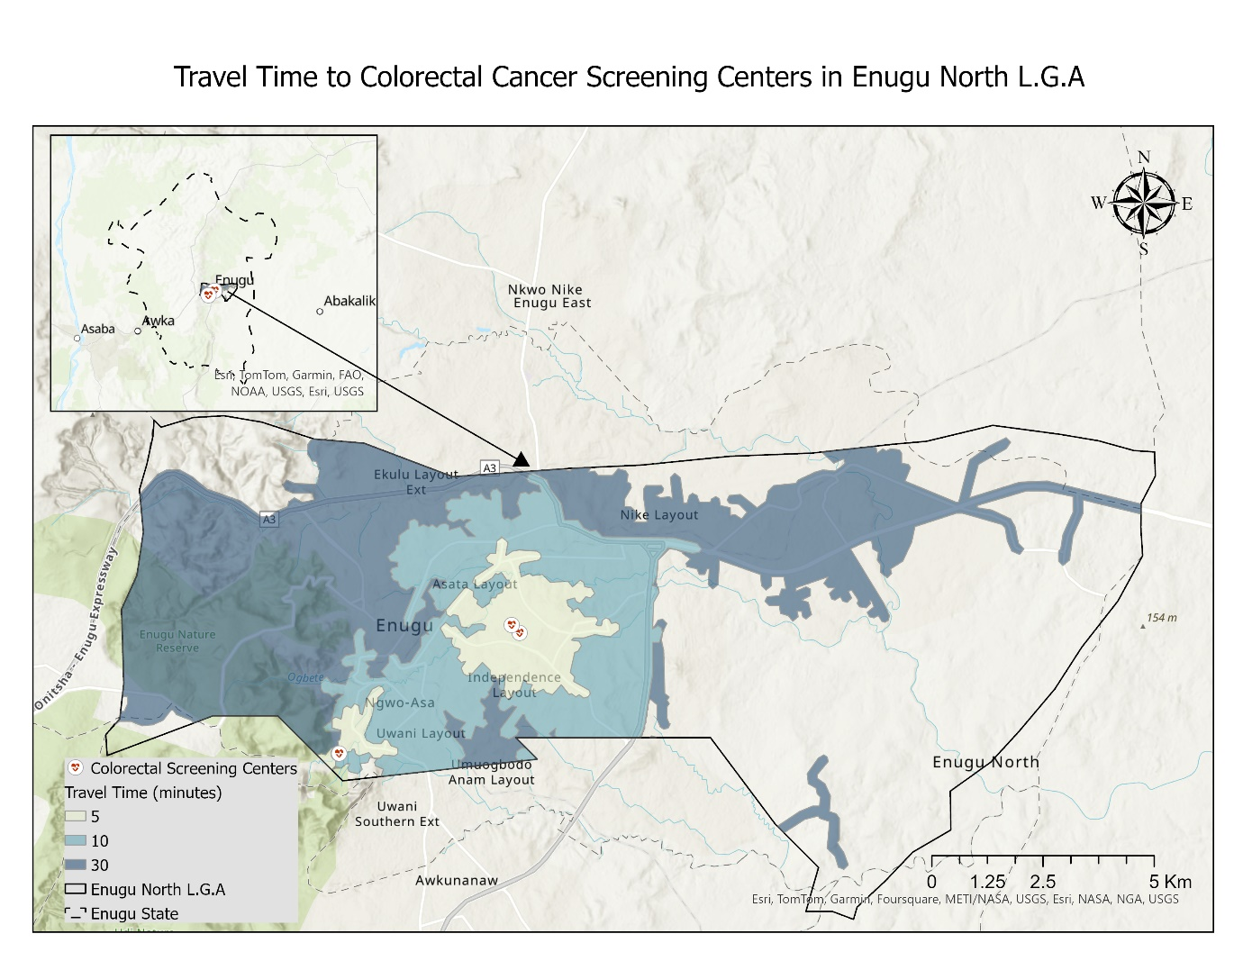

**Figure 1: Spatial Distribution of Colorectal Cancer Screening Centers**

The spatial analysis of colorectal cancer screening centres in Enugu North LGA reveals disparities in accessibility across different regions. The central areas, including Asata Layout, Uwani Layout, and Independence Layout, benefit from shorter travel times of approximately 5 to 10 minutes. However, peripheral regions, particularly Nike Layout and some parts of Ekulu Layout Extension, experience significantly longer travel time of more than 10 to 30 minutes drive time towards the screening facilities, suggesting disparity between core urban city centers and surrounding settlements. The uneven distribution of screening centres suggests potential barriers to timely colorectal cancer screening among the elderly population residing in these underserved areas.

**Table 3: Factors Affecting Uptake of Colonoscopy Screening**

|  |  |  |  |
| --- | --- | --- | --- |
| **Factors** | **Categories** | **Frequency** | **Precent** |
| Have you ever undergone a colonoscopy screening? | Yes | 9 | 3.7 |
| No | 235 | 96.3 |
| If no, what are the reasons for not undergoing a colonoscopy? | Lack of awareness | 79 | 33.6 |
| Fear of the procedure | 12 | 5.1 |
| High cost of screening | 68 | 28.9 |
| No nearby facility offering it | 45 | 19.1 |
| No recommendation from a doctor | 12 | 5.1 |
| Cultural/religious beliefs | 7 | 3.0 |
| Other | 12 | 5.1 |
| If yes, how did you access the screening service? | Government hospital | 1 | 2.5 |
| Private hospital | 5 | 6.5 |
| Outreach program | 0 | 0 |
| Others | 2 | 3.5 |
| What mode of transportation would you use to get to a screening center? | Walking | 0 | 0 |
| Public Transport | 5 | 5.7 |
| Private Vehicle | 9 | 4.3 |
| Others | 0 | 0 |
| Would you be willing to undergo a colonoscopy screening if it were free or subsidized? | Yes | 142 | 59.9 |
| No | 16 | 6.8 |
| Not sure | 79 | 33.3 |

The table shows that colonoscopy uptake is extremely low, with only 3.7% of respondents having undergone screening, while 96.3% have not. Among those unscreened, the main barriers are lack of awareness (33.6%), high cost (28.9%), and absence of nearby facilities (19.1%). Lesser factors include fear of the procedure (5.1%), no recommendation from a doctor (5.1%), cultural/religious beliefs (3.0%), and other reasons (5.1%). Few accessed screenings through private hospitals. Transportation options are minimal, with few using public or private vehicles. Notably, 59.9% expressed willingness to undergo screening if it were free or subsidised.

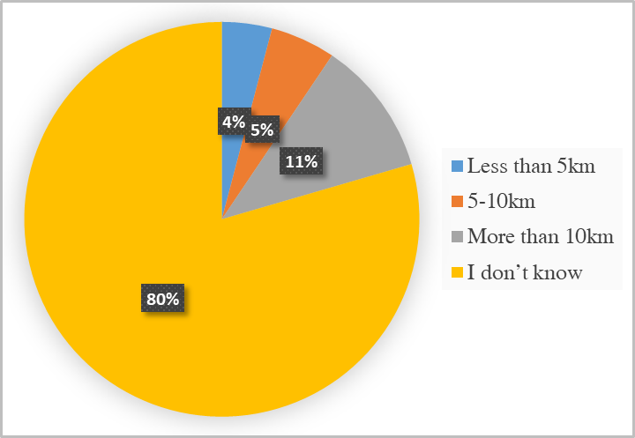

**Figure 2: Distance to the nearest facility that offers colonoscopy within the study area**

Most respondents (79.5%) are unaware of the distance to the nearest facility offering colonoscopy services, indicating significant uncertainty about local healthcare access. Only a small fraction reported that the facility is within 10km: 4.1% stated it is less than 5km, 5.3% reported 5–10km, and 11.1% indicated it is over 10km. This calls for urgent public health education.

**Table 4: Logistic Regression Analysis of Factors Influencing Colonoscopy Awareness**

|  |  |  |  |  |  |
| --- | --- | --- | --- | --- | --- |
| **Variable** | **Category** | **Reference** | **Odds Ratio (OR)** | **95% Confidence Interval (CI)** | **p-value** |
| **Educational Level** | Primary | No formal education | 1.85 | 0.90 – 3.80 | 0.09 |
| Secondary | **2.10** | **1.05 – 4.20** | **0.04** |
| Tertiary | **4.25** | **1.80 – 10.03** | **<0.01** |
| **Monthly Income** | ₦20,000 - ₦50,000 | < ₦20,000 | 1.45 | 0.50 – 3.00 | 0.21 |
| ₦50,000 - ₦100,000 | 2.20 | 0.95 – 5.05 | 0.06 |
| > ₦100,000 | **3.75** | **1.50 – 9.35** | **<0.01** |
| **Occupation Before Retirement** | Trading | Farming | 1.30 | 0.60 – 2.80 | 0.45 |
| Civil Service | **2.85** | **1.20 – 6.75** | **0.02** |
| Private Sector | 1.90 | 0.75 – 4.85 | 0.18 |
| **Age Group** | 65-69 | 60-64 | 1.10 | 0.55 – 2.20 | 0.78 |
| 70-74 | 0.95 | 0.40 – 2.20 | 0.89 |
| 75+ | 0.70 | 0.15 – 3.20 | 0.65 |
| **Gender** | Male | Female | 1.15 | 0.60 – 2.10 | 0.70 |
| **Marital Status** | Married | Single | 1.30 | 0.50 – 3.40 | 0.55 |
| Widowed | 0.95 | 0.35 – 2.60 | 0.92 |
| Divorced/Separated | 1.40 | 0.40 – 4.70 | 0.58 |

The logistic regression analysis identified key predictors of colonoscopy awareness. Education significantly influenced awareness, with respondents holding a tertiary education being 4.25 times more likely to be aware than those with no formal education (p < 0.01). Higher income also increased awareness, as those earning >₦100,000/month had 3.75 times the odds compared to those earning <₦20,000/month (p < 0.01). Also, civil servants were 2.85 times more aware than farmers (p = 0.02). However, age, gender, and marital status were not statistically significant.

**Discussion**

This study reveals dearth in both awareness and uptake of colonoscopy screening among the elderly. Only 20.5% of respondents had heard of colonoscopy as a screening method for colon cancer, and a mere 3.7% had ever undergone screening. A critical observation from the survey is the predominant influence of socioeconomic factors on screening awareness. Logistic regression analysis demonstrated that respondents with tertiary education were 4.25 times more likely to be aware of colonoscopy than those with no formal education (p < 0.01). Similarly, individuals with a monthly income exceeding ₦100,000 had 3.75 times higher odds of awareness compared to the lowest income group (p < 0.01). Also, those with a background in civil service were 2.85 times more likely to be aware than farmers (p = 0.02). These findings align with McAlearney et al. (2008), who reported that higher education and income levels correlate with improved health literacy and participation in cancer screening programs.

Spatial factors also emerged as a critical barrier to access. Service area analysis of screening centres revealed that while central areas (e.g., Asata Layout, Uwani Layout, Independence Layout) enjoy short travel times (5–10 minutes), peripheral regions such as Nike Layout, while parts of Ekulu Layout Extension have more than 10 to 30 minutes drive time towards the screening facilities. This uneven distribution likely contributes to the low screening rates, as prolonged travel times can discourage elderly residents from seeking services. Similar spatial challenges have been reported by Rabeneck et al. (2010), who demonstrated that increased access to colonoscopy correlates with lower colorectal cancer mortality.

This study highlights a significant gap in public knowledge regarding CRC screening. A majority of respondents were unaware of the appropriate screening frequency and the role of colonoscopy in early detection, with 66.4% unable to identify its purpose and 61.9% unsure about screening intervals. Moreover, 87.3% did not know of any local hospitals providing the service. This lack of awareness reinforces that deficiencies in public knowledge critically hinder early detection efforts in Nigeria (Alatise et al. 2021). Nearly one-third of respondents cited high cost (28.9%) and absence of nearby facilities (19.1%) as key deterrents. Other potential reasons for such a low uptake included fear of the procedure (5.1%) and lack of physician advice (5.1 %). Interestingly, 59.9% mentioned that they were willing to be screened if the cost was eliminated or reduced, meaning cost reduction approaches could go a long way in increasing compliance. The policy implications of these results are substantial as it highlight the different types of support required for diverse, family-friendly population groups. However, there is a need for more specific interventions to raise CRC awareness, with a focus on the low-income population. Additionally, the marked spatial disparities indicate that expanding screening services or delivering mobile screening services can help overcome this barrier.

**Conclusion**

The results indicate that awareness and uptake of colonoscopy are constrained by socio-economic barriers and access to facilities among elderly residents in Enugu North LGA. Consequently, respondents with a low level of education, low-income levels and living in the periphery have limited or less knowledge of CRC screening. Specifically, these results amplify the need to increase awareness of the disease, enhance access to screening centres across communities, and subsidising the cost involved in facilitating early colorectal cancer screening. Overcoming these barriers is crucial to decreasing the morbidity and mortality rates of colorectal cancer and improving the overall health outcome.

COMPETING INTERESTS DISCLAIMER:

Authors have declared that they have no known competing financial interests OR non-financial interests OR personal relationships that could have appeared to influence the work reported in this paper.

**References:**

Alatise, O.I., Dare, A.J., Akinyemi, P.A., Abdulkareem, F.B., Olatoke, S.A., Knapp, G.C., Kingham, T.P., Alatise, O.I., Kingham, T.P., Olatoke, S.A. and Dare, A.J., 2022. Colorectal cancer screening with fecal immunochemical testing: a community-based, cross-sectional study in average-risk individuals in Nigeria. The Lancet Global Health, 10(7), pp.e1012-e1022.https://doi.org/10.1016/S2214-109X(22)00121-8

Bishehsari, F., Mahdavinia, M., Vacca, M., Malekzadeh, R., and Mariani-Costantini, R. (2014). Epidemiological transition of colorectal cancer in developing countries: environmental factors, molecular pathways, and opportunities for prevention. World journal of gastroenterology, 20(20), 6055–6072. <https://doi.org/10.3748/wjg.v20.i20.6055>

Chen, W., Zhang, W., Liu, H., Liang, Y., Zhou, Q., Li, Y., & Gu, J. (2020). How spatial accessibility to colonoscopy affects diagnostic adherences and adverse intestinal outcomes among the patients with positive preliminary screening findings. Cancer medicine, 9(12), 4405–4419. https://doi.org/10.1002/cam4.3054

Jedy-Agba, E., Curado, M. P., Ogunbiyi, O., Oga, E., Fabowale, T., Igbinoba, F., Osubor, G., Otu, T., Kumai, H., Koechlin, A., Osinubi, P., Dakum, P., Blattner, W., & Adebamowo, C. A. (2012). Cancer incidence in Nigeria: a report from population-based cancer registries. Cancer epidemiology, 36(5), e271–e278. <https://doi.org/10.1016/j.canep.2012.04.007>

Beniwal, S. S., Lamo, P., Kaushik, A., Lorenzo-Villegas, D. L., Liu, Y., & MohanaSundaram, A. (2023). Current Status and Emerging Trends in Colorectal Cancer Screening and Diagnostics. Biosensors, 13(10), 926. <https://doi.org/10.3390/bios13100926>

Odeghe, E. A., Oluyemi, A. O., and Adeniyi, O. F. (2020). Appropriate use of colonoscopy in Nigeria: a retrospective study using the American Society for Gastrointestinal Endoscopy (ASGE) 2012 guidelines. [doi: 10.11604/pamj-oh.2020.2.21.24752]

Khashoggi, B. F., & Murad, A. (2020). Issues of Healthcare Planning and GIS: A Review. ISPRS International Journal of Geo-Information, 9(6), 352. <https://doi.org/10.3390/ijgi9060352>

Onyekwere, C. A., Odiagah, J. N., Ogunleye, O. O., Chibututu, C., and Lesi, O. A. (2013). Colonoscopy practice in lagos, Nigeria: a report of an audit. Diagnostic and therapeutic endoscopy, 2013, 798651. <https://doi.org/10.1155/2013/798651>

Nzeagwu, O. C., and Ozougwu, C. B. (2019). Nutritional and health status of older persons aged ≥ 60 years in rural communities of Udi Local Government Area, Enugu State, Nigeria. Journal of Dietitians Association of Nigeria, 10, 40–50. <https://www.ajol.info/index.php/jdan/article/view/214301>

McAlearney, A. S., Reeves, K. W., Dickinson, S. L., Kelly, K. M., Tatum, C., Katz, M. L., & Paskett, E. D. (2008). Racial differences in colorectal cancer screening practices and knowledge within a low-income population. Cancer, 112(2), 391–398. <https://doi.org/10.1002/cncr.23156>

Rabeneck, L., Paszat, L. F., Saskin, R., & Stukel, T. A. (2010). Association between colonoscopy rates and colorectal cancer mortality. The American journal of gastroenterology, 105(7), 1627–1632. <https://doi.org/10.1038/ajg.2010.83>