Original Research Article
Effect of the system intensification on growth and yield of mustard varieties

ABSTRACT
The gradual changes in season and temperature are making mustard growing more challenging. The method of planting is the main factor that determines the optimal growth and development of mustard. A study of growth and production was carried out on three mustard hybrid varieties viz. 45S46, Kesari 5100, and Kesari Gold, using three tiers of planting techniques: S₁: broadcasting, S₂: line sowing, and S₃: system of mustard intensification, over the course of two years (2021–22 and 2022–23). The experiment was laid out in a split plot design replicated thrice. The results showed that system of mustard intensification was significantly higher responses in seedling growth and yield characteristics than the direct sowing of broadcasting and line sowing methods. The variety V₃ was found most superior in terms yield traits. The most significant interaction effect was observed in V₃S₃ treatment combinationwhich recordedhighest yield characteristics, seed yield (1875.26 kg ha⁻¹), dry matter content (115.0 g), leaf area index (4.46), and crop growth rate (6.43 g/m2/day). The maximum production efficiency was found in V₃S₃ (18.16 kg ha⁻¹ day⁻¹) in 2022, whereas in 2023 it was maximum in V₁S₃ (19.76 kg ha⁻¹ day⁻¹).The mustard intensification system is a potential agricultural invention that aids in production, reduces import demands, and encourages efficient and sustainable mustard farming.
KEYWORDS: Mustard; system of mustard intensification; planting method; yield

1 INTRODUCTION
The Brassica species, commonly known as rapeseed-mustard, is the third most important oilseed crop cultivated worldwide after soybean and palm, and is one of the most commercially significant agricultural commodities.India produces around 11% of the world's rapeseed mustard, making it the third-largest producer after China and Canada. It is the second most important edible oilseed in India after groundnut, with an area of 8.06 million hectares and a productivity of 1458 kg ha⁻¹ in 2021–2022, accounting for 27.8% of the country's oilseed economy. In most states throughout the country, mustard is grown. Mustard is grown widely in West Bengal under irrigated conditions (Ray et al., 2015), yielding approximately 0.76 million tons with a productivity of 1250 kg ha⁻¹ year-round (GoI, 2022). Over the past two decades, it has gained popularity in the North Bengal regions. Nevertheless, the majority of farmers still use fairly simple management techniques by direct sowing to produce mustard as a paira crop in the rice field by disseminating it with residual soil moisture.Consequently, when compared to a single crop, this crop's growth and production performance are consistently inferior (Banerjee et al., 2018). Further, the first two weeks of October is the best time of year to plant the oilseed Brassica in India. However, because kharif rice harvesting is delayed, these crops are not planted until November or the first week of December. As a result of delayed seeding, mustard productivity eventually declines.
System intensification is one of the strategies that, by managing natural resources properly and using a variety of crops in different agro-ecologies, increases agricultural productivity while conserving resources and promoting sustainability and climate resilience(Adhikari et al., 2018; Rathore et al., 2020). A variety of crops, such as rice, wheat, sugarcane, and mustard, can benefit from the use of agricultural intensification techniques. A novel strategy for increasing oilseed production above the traditional planting system, the system of mustard intensification (SMI) raises mustard productivity through adjustments to soil, plant, moisture, and nutrient management techniques. This method of increasing seedling growth and yield through root intensification through transplanting mustard seedlings is already being used in some irrigated rapeseed-mustard-growing regions of India (Chaudhary et al., 2016; Pandit et al., 2022). This system of intensification techniques for mustard is improving the efficiency of input utilization, improving yield, and resolving the issue of delayed sowing. By altering management strategies, it also enhances root growth, improving soil function and protects the crop from biotic and abiotic stress (Adhikariet al., 2018). Compared to other methods like broadcasting and line sowing, SMI transplants mustard seedlings with a wide spacing, providing for proper plant density and root system development from early crop growth.Plant-microorganism interactions were found to be greater in terms of water and nutrient uptake when there was a large root system presents (Anaset al., 2011; Thakur et al., 2013). But there is still a lack of proper methodology and effective cultivation practices through the system of mustard intensification. In order to compare the growth, yield, and physiological characteristics of three distinct mustard varieties, as well as the effects of their interactions, the current study was conducted using three different methodologies: broadcasting, line sowing, and SMI technology.
2 MATERIALS AND METHOD
2. 1 Experimental location
The experiment was conducted at the Regional Research Station (OAZ), Uttar Banga Krishi Viswavidyalaya, Majhian, Dakshin Dinajpur, W.B., India, which is located at latitude 26019'86''N and longitude 89023'53''E. Its average elevation is 43 meters above mean sea level. The soil of the study area wasclay loam with acidic in nature.The experiment was conducted in two rabi seasons of 2021-22 and 2022-23.
2.2 Experimental materials and sowing methodology
Three varieties of mustard viz. 45546 (V₁), 5100 (V₂), and Gold (V₃) were used for the study. These varietieswere collected from the Uttar Banga Krishi Viswavidyalaya, Pundibari, Coochbehar, West Bengal, India. Three different sowing methodology was implemented such as S₁: Broadcasting direct sowing(Convectional method); S₂:Line sowing (direct); and S₃: System of Mustard Intensification (SMI) (transplanting method) were followed each of these varieties. Each treatment was evaluated in three replication.
2.3 Management of different planting methods
In conventional method seeds were sown in broadcasting without maintaining the spacing and line sowing practices with seed sown in line with proper spacing.In the system of mustard intensification, 12 days old seedling was prepared in small micropots (2 cm×2.5 cm size). Cultural management, fertilizer application, intercultural operation, irrigation, and plant protection measures for all the three methods are presented in Table 1. A preliminary assessment of soil fertility was conducted and is shown in Table 2.
2.4 Seedling parameter
After three week of planting in different system among the variety, the seedling growth study was determined. Different seedling parameter such as root length (cm), shoot length (cm), number of leaves, fresh root weight (gm), fresh shoot weight(gm), dry root weight (gm), dry shoot weight (gm) were measured each of the treatments.
2.5 Observation ofgrowth and yield parameter of mustard
Several yield-attributing characteristics, including plant height (cm), number of primary branches, number of secondary branches, number of leaves plant⁻¹, NPPM= number of plant per m²,number of siliqua plants⁻¹, test weight (gm), and seed yield kg ha⁻¹were estimated throughout the growth period. The total chlorophyll content (mg/100g fresh weight)was measured according toprotocol of Davies (1976).The dry matter content (gm) was calculated as the dry weights of the plant components at 90 DAS. Five plants of each variety were picked at their individual growing periods. The leaf area index (LAI), and crop growth rate (CGR) was measured during maturity of the plants. The harvest index (HI) was estimated after harvesting of the crop using following formula:
Harvest index (%) = Grain yield / Biological yield × 100.
The production efficiency (kg ha⁻¹ day⁻¹) of different treatments were calculated using following formula:
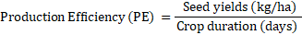
2.6 Statistical design and analysis
A split plot design was used for the experiment, and each treatment was replicated three times. Using two-way ANOVA, the significance and interactions between treatments were assessed using SPSS 20.0 software.Differences between treatment means were compared using Duncan test at a 5% probability level (p = 0.05). The correlation and biplot analysis was performed using R statistical software.
3 RESULTS AND DISCUSSION
3.1 Seedling growth determination
The growth characteristics of the seedlings were significantly (p <0.05) impacted by the various varieties, seeding techniques, and their combinations (Figure 1). The different sowing methods had a substantial impact on the growth of mustard seedlings at three week age (Figure 2). Among the variety V₃ was found most effective for seedling growth of shoot length, number of leaves, fresh shoot weight, fresh shoot weight, dry root weight and dry shoot weight. V₁ was found promising for root length.The most effective treatments, considering SMI, had the highest root length, shoot length, number of leaves, fresh shoot weight, fresh shoot weight, dry root weight and dry shoot weightwith an increase of 144.63%, 70.35%, 65.14%, 95.93%, 131.99%, 1500%, and 99.26% over the conventional broadcasting method and 110.35%, 27.81%, 31.58%, 423.91%, 115.77%, 814.29% and 61.08% over the line sowing methods, respectively.The seedling characteristics interaction effects of between variety and sowing methods also found significant variable each other. Among all the treatments V₃S₃ was found most superior for seedling characteristics of shoot length, number of leaves, fresh shoot weight, fresh shoot weight, dry root weight and dry shoot weight (Figure 1).
3.2 Interaction effects of yield component traits
Three variety of different genetic backgrounds were used for screening under several of sowing methods by evaluating the morphological characters.Growth and various yield attributes of mustard were significantly influenced by different sowing dates and varieties (Table 2). The results of the analysis of variance showed a high degree of variability with significant differences among the three variety and the treatments (sowing methods) combination for all the characters studied. Mean performance genotypes and the treatments are represented in Table 3. The maximum root length, plant height, number of primary branch, number of secondary branch, pod number per plant, number of siliquaplant⁻¹, seed yield, test weight, were recorded in SMI, and were statistically superior to the conventional method and line sowing. The early flowering was also observed in SMI, whereas delay flowering and maximum number of plant leaf per meter square was found in conventional broadcasting method followed by line sowing. The increase in root length, plant height, number of primary branch, number of secondary branch, number of siliqua plant⁻¹, number of leaves plant⁻¹, seed yield, test weight,and harvest index in the SMImethod was 54.34%, 15.34%, 351.14%, 418.44%, 118.41%, 120.78%, 16.03%, 32.18%, and 13.94% over the conventional and 37.46%, 11.26%, 203.65%, 278.12%, 83.85%, 14.36%,24.46%,and 20.78% over the line sowing method, respectively.
The results revealed that the variety V₁ significantly superior over others for plant height, early flowering and test weight. The number of primary branch, number of secondary branch, pod number per plant were found most superior in V₂ and whereas, number of siliqua plant⁻¹, number of plant leaf per meter square, and seed yield were maximum in V₃ (Table 3).
The SMI approaches showed a considerable improvement in growth, yield components, and yield when variety and sowing methods were combined. The maximum, number of siliqua plant⁻¹, number of plant leaf per meter square, and seed yield were maximum were significantly greater in the V₃S₃treatment combination than in the other treatments. The second-highest increases in plant growth, yield variables and yield were obtained with the V₂S₃ combination. Conversely, all the corresponding values were significantly minimal for the V₁S₁ combination(Table 3). Contrary, harvest index is estimated with seed and biological yield and presented in the Table 3. It was found significantly higher in V₂ and least value of harvest index was observed in V3. SMI planting method was resulted in significantly higher harvest index than the harvest index in other direct seeding. However, interestingly V₂S₃ was observed with maximum harvest index (13.25%) whereas minimum value recoded in V₃S₂.
3.3 Chlorophyll content, dry matter accumulation, leaf area index and crop growth rate
The total chlorophyll content among the varieties significantly varied (Table4). Maximum chlorophyll content among was found in V₁ followed by V₃. Significantly higher chlorophyll content was recorded in SMI with 9.49% and 4.58% increase over direct and line sowing methods, respectively. The interaction effect was maximum found in V₁S₃ followed by V₃S₃ and least value in V₂S₁. Dry matter accumulation (DMA) at maturity stage of mustard growth is presented in Table 4. Data showed that the dry matter accumulation at maturitygrowth stage of mustard significantly affected by combined effect of planting methods. The highest DMA was recordedin V₃S₃ (115.0 g), whereas, lowest in V₂S₁ (15.69 g). DMA per plant was significantly influenced bymustard planting methods. However, DMA in direct sowing broad casting and line sowing method was found statistically at par each other. LAI was found significant even at maturity stage, higher LAI was recorded in transplanted V₃at all the planting methods (Table 4).The SMI technique of wider scale resulted in higher LAI, which increases 63.56% and 40.32% compared conventional and line sowing methods (Table 4). The crop growth rate was estimated during maturity stage and found significantly higher in V₃ (4.64) and least value of was observed in V₂ (4.54). SMI planting method was resulted in significantly crop growth rate. The maximum treatment interaction effect of crop growth rate was obtained from V₃S₃ whereas minimum value recoded in V₃S₁.
3.4 Correlation analysis and principle component analysis of growth and yield component traits
The correlation coefficient analysis of mustard varieties with different sowing methods resulted the traits particularly root length, plant height, number of leaf plant⁻¹, number of siliqua plant⁻¹, test weight and total chlorophyll content were found significant and positive associated with seed yield (Figure 3). Root length was found positive significant association with all the characteristics except number of plant per m², and fifty percent flowering. On the other hand plant height also found significantly and positively correlated with seed yield, number of siliqua plant⁻¹, test weight, total chlorophyll content, dry matter content, root length, number of leaf plant⁻¹, leaf area index, crop growth rate, and number of secondary branch. Plant height significant negative association was observed for number of leafs plant⁻¹ and fifty percent flowering. Dry matter content was found significant association for all the characteristics except seed yield. The leaf area index and crop growth rate was found significant positive association with root length, plant height, number of leaf plant⁻¹, number of primary branch, number of secondary branch, number of siliqua plant⁻¹, test weight, harvest index,dry matter content and total chlorophyll content (Figure 3).
The PCA analysis detected the parameters that were most responsible for growth and seed yield characteristics of mustard treatment combination. The PCA indicated that the first two principal components explained 90.70% of the variance in all traits tested (Figure 4). In the first principal component, 79.8% of the contribution was mainly from root length, plant height, number of leaf plant⁻¹, number of primary branch, number of secondary branch, number of siliqua plant⁻¹, test weight, harvest index, seed yield, number of siliqua plant⁻¹, leaf area index, crop growth rate, dry matter content and total chlorophyll content. The first PCA indicated maximum characters contributed from V₃S₃ followed by V₂S₃ and V₁S₃ treatments. In the second principal component, accounted 10.9% contribution from the number of plant per m², and fifty percent flowering of V₃S₁, V₃S₂ and V₁S₂ treatments.
3.5 Production efficiency of mustard
The production efficacy of mustard varieties under different planting methods in 2022 and 2023 is presented in Figure 5. The maximum production efficiency was found in V₃S₃ (18.16 kg ha⁻¹ day⁻¹) in 2022, whereas in 2023 it was maximum in V₁S₃ (19.76 kg ha⁻¹ day⁻¹).The highest production efficiency was obtained by V₁S₃, V₃S₃, andV₃S₃were significantly higher by 61.21% and 31.70%, 61.51% and 13.10%, 36.68% and 13.12% over broadcasting and 30.14% and 16.03%, 35.99% and 14.81%, 28.28% and 14.01% over line sowing in both the year of 2022 and 2023, respectively (Figure 5).
4 DISCUSSION
Effective sowing techniques and seedling quality, which are controlled by seeding density in the field, have a significant impact on mustard productivity. The methods of planting had a substantial impact on the growth of the mustard seedlings.When compared to conventional and line sowing methods, the SMI approach showed better root growth and higher seedling height.This is because low-density plants are given the proper quantity of light, nutrients, and space to flourish, it was observed. Because of the impact of spacing in the SMI method, a significant amount of variation was seen in the case of root length per seedling of mustard.The method of planting of SMI and comparison with the conventional methods for root growth and yield is shown in Figure 6a-g. According to Jimba and Adedeji (2003), greater spacing in nurseries boosts the biomass of seedlings and roots. In this instance, increased plant density might have led to less light interception per plant, which might have decreased biomass accumulation and photosynthesis per plant.There will also be more competition for water and minerals between the seedlings' roots when they are spaced closer together. Under SMI, the plants are able to invest in robust root growth in addition to shoot growth. Therefore, at a larger plant density in the SMI, the amount of carbon delivered to the roots can be greatly enhanced. Statistically higher fresh shoot weight, root weight, dry shoot and dry root mass were recorded in SMI over conventional method (Figure 1). Compared to other enhanced wheat farming techniques, more root length and volume were observed in wheat using system of wheat intensification (Dhar et al., 2015).One possible explanation for the variance in the number of leaves in the SMI methods over conventional caused by plant densities is inter-plant competition, which rises as planting density.In contrast to direct sowing of closer spacing, Hasan et al. (2017) also assert that the maximum number of leaves per plant is achieved by providing sufficient space for both vertical and horizontal development at the proper spacing.The fresh and dry weight of shoots increased with increasing spacing, this could be as a result of less competition for light, water, and nutrients.Wider spacing plants in the SMI get adequate light and nutrients, allowing them to reach their maximum fresh weight (Hasan et al., 2017). The fresh weight of roots varied significantly as a result of seedling spacing under transplanting. Under conventional methods, a higher plant density results in less light interception per plant, which lowers photosynthesis and biomass build-up. As a result, using traditional and line sowing techniques can significantly lower the amount of carbon delivered to the roots. The maximum dry shoot and root weight was discovered in SMI, however the difference in the direct sowing method is not significant. Similarly, it was shown that when the spacing increased, the dry matter content increased as fewer plants competed for nutrients during growth phases (Niraula and Timilsina, 2020).
By altering traditional crop, soil, water, and nutrient management practices, the crop intensification system improved food security, sustainability, productivity, profitability, and climate change resilience (Gupta et al., 2018). In contrast, the SMI production system in the current study improves the number of branches, root growth, plant growth, and siliqua of mustard because it makes better use of resources including moisture, nutrients, solar radiation, and leaf orientation, all of which boost photosynthesis (Pandit et al., 2022). Similar findings on the enhancement of growth and yield characteristics in wheat by the SWI approach have also been proposed recently (Singh et al., 2024).The growth and yield parameters of mustard were affected significantly by methods of planting. All of the growth and yield characteristics that affected the mustard crop's seed yield were negatively impacted when direct sowing was implemented. This could have led to insufficient growth and photosynthetic translocation from source to sink, which would have ultimately resulted in a decreased yield (Panda et al., 2004). The greatest output under SMI might be attributed to enhanced crop growth rate, maximum planting density, and better plant development, which could have resulted in an effective metabolism and provided each mustard plant with the ideal growing circumstances to optimize siliqua. This result implies that the system of mustard root intensification transplantation holds considerable promise for the cultivation of mustard varieties (Chaudhary et al., 2016; Singh et al., 2006). The higher seed yield in case of V₃ (1721.69 q/ha) might be due to more number of branches, siliquae, and test weight (Raquibullah et al., 2006). In B. carinata, transplanted crops exhibited considerably greater improved leaf-area index, number of primary and secondary branches, siliqua, oil production, protein content, and net returns compared to direct-seeded (Kauret al., 2017). When SMI techniques are used with adequate irrigation facilities, the oxygen flow to roots is improved, which reduces the production of aerenchyma and results in a stronger, healthier root system that may have benefits for nutrient uptake (Gupta et al., 2018). Under SMI, the yield per unit area may have increased because of adequate spacing, maximum utilization of photo and thermal energy, light interception, and moisture availability by individual mustard plants, which resulted in a markedly higher accumulation of dry matter, yield attributes, and harvest index (Kumar et al., 2024). Different mustard cultivars under various crop establishment techniques had a notable impact on plant height and branches (Table 3). Among the crop establishment method SMI was most superior followed by line sowing method than conventional method. Direct sowing also showed the effect, with V₁ variety recording the highest plant height in comparison to V₃ and V₂. Direct mustard seeding, however, produced lower plant heights in all varieties when compared to transplanting SMI (Table 3); this could be because transplanting offers the additional benefit of advance growth (Al-Doori, 2013). According to Su et al. (2015), closer spacing under broad casting and line sowing techniques speeds up resource competition among plants, which has a negative impact on crop phenological development.
Among the varieties, V₃ recorded a significantly higher dry matter accumulation (52.83 g plant⁻¹) than V₂ (39.21 g plant⁻¹), but it was comparable to V₁ (50.31 g plant⁻¹). This is likely due to genetic characters that have a higher capacity to use photosynthates more efficiently for maximum leaf area index, number of primary and secondary branches plant⁻¹, and finally dry matter accumulation (Patel et al., 2022). SMI was found to have the highest dry matter accumulation (103.33 gm plant⁻¹) due to its larger photosynthetic regions, more branches, and wider plant canopy (Rathore et al., 2014; Banerjee et al., 2017). Increased dry matter accumulation under transplanted brassica was reported earlier (Rathore et al., 2022). For leaf area index maximum value recorded in V₃ (4.64) (Table 4). Adoption of SMI with wide spacing in the current study yielded statistically greater LAI than the traditional cultivation approach. Similar trends in LAI enhancement under transplanting techniques were also observed by Rana et al. (2020). Furthermore, a wider row arrangement in transplanting method resulted in a greater leaf area per plant than the high plant density and narrow row arrangement of direct sowing method (Singh et al., 2024). Crop growth rate (g m⁻² day⁻¹) was significantly influenced by various sowing methods and varieties. CGR increased with the advancement of crop growth and planting methods (Lallu et al., 2010). Mustard seeded on SMI had the highest crop growth rate among the other sowing techniques.The harvest index of variety V₂ was substantially higher. The maximum harvest index from conventional planting was statistically comparable to that from transplanting geometry (Chaudhary et al., 2016). Theproduction efficiency of mustard cultivation significantly achieved from the SMI methods. This could be because of the maximum plant height, leaf area, and number of leaves, which led to a greater accumulation of photosynthates and higher output productivity (Padhan et al., 2023).
5 Conclusion
In direct seeding resulted in lower growth and yield characteristics in all the varieties compared to system of mustard intensification in transplanting of mustard. The SMI is a resource-conserving technology that has been developed to enhance the mustard crop yields by improving the root length and plant growth characteristics. When the implementation of SMI is contrasted with the traditional way of mustard establishment, notable benefits are seen. The SMI combined with planting density is significantly reducing the effects of plant lodging by enhancing crop growth and physiological characteristics such as LAI, DMC, and CGR. Simultaneously, adoption of SMI technique in mustard resulted in an increase in total chlorophyll content. Concurrently, growing of V₃genotypes demonstrated notableincreases in mustard seed yields, as well as physiological characteristics. The correlation coefficient analysis of mustard varieties with different sowing methods resulted the traits particularly root length, plant height, number of leaf plant⁻¹, number of seed plant⁻¹, test weight and total chlorophyll content were significant and positive associated with seed yield. Compared to traditional broadcasting techniques, SMI technology saves time and prevents unnecessary seed waste. Adopting of this technology, it is an important step in the direction of oilseed production in India's old alluvial gangetic plains becoming self-sufficient. SMI provides a comprehensive approach to mustard farming by streamlining cultivation procedures, increasing resource efficiency, and encouraging sustainability.

Data availability statement
The data presented in this study are available upon request from the corresponding authors.
Conflict of interests
The authors have declared no conflict of interests exists.
References
Adhikari, P., Araya, H., Aruna, G., Balamatti, A., Banerjee, S., Baskaran, P., Barah, BC., Behera, D., Berhe, T., Boruah, P., Dhar, S., Edwards, S., Fulford, M., Gujja, B., Ibrahim, H., Kabir, H., Kassam, A., Khadka, B., Koma, YS., Natarajan, US., Perez, R., Sen, D., Sharif, A., Singh, G., Styger, E., Thakur, A.K., Tiwari, A., Uphoff, N., Verma, A. (2018). System of crop intensification for more productive, resource-conserving, climate-resilient, and sustainable agriculture: experience with diverse crops in varying agro-ecologies. International Journal of Agricultural Sustainability 16, 1–28.
Al-Doori, S.A.M. (2013). Response of yield, yield components and seed quality of some rapeseed genotypes (Brassica napus L.) to plant density under rainfed conditions. College of Basic Education Research Journal 12, 957-68.
Anas, I., Rupela, O.P., Thiyagarajan, T.M., Uphoff, N. (2011). A review of studies on SRI effects on beneficial organisms in rice soil rhizospheres. Paddy and Water Environment 9, 53–64.
Banerjee, H., Chatterjee, S., Sarkar, S., Gantait, S., Samanta, S. (2017). Evaluation of rapeseed-mustard cultivars under late sown condition in coastal ecosystem of WestBengal. Journal of Applied and Natural Science 9, 940-949.
Banerjee, H., Samanta, S., Dutta, A., Sarkar, S., Garai, S. (2018). Selection of rapeseed-mustard varieties in coastal region of West Bengal: A way forward to rice-fallow intensification. Journal of Indian Society of Coastal Agricultural Research 36, 54-63.
Chaudhary, S., Shukla, A., Bhushan, C., Neg, M.S. (2016). Assessment of the system of root intensification in rapeseed-mustard (Brassica species). Indian Journal of Agronomy 61, 119-122.
Davies, BH. (1976). Carotenoids. In: Goodwing, T.W. (Ed.). Chemistry and Biochemistry of Plant Pigments (2 nd Edn.). Academic Press, London, UK, 38‒165.
Dhar, S., Barah, B.C., Vyas, A.K., Uphoff, N. (2015). Comparing system of wheat intensification (SWI) with standard recommended practices in the north-western plain zone of India.Archives Agronomy and Soil Science 62, 994–1006.
Gupta, G., Dhar, S., Kumar, A., Kamboj, N.K., Kumar, V. (2018). System of crop intensification integrated management of crops for improving sustainability and resilience to climate change. Indian Farming 68, 14–17.
Hasan, M., Tahsin, A., Islam, M., Ali, M., Uddain, J. (2017). Growth and yield of lettuce (Lactuca sativa L.) influenced as nitrogen fertilizer and plant spacing. Journal of Agriculture and Veterinary Science 62-71.
Jimba, S., Adedeji, A. (2003). Effect of plant spacing in the nursery on the production of planting materials for field establishment of Vetiver grass. Tropicultura. 21,199-203.
Kaur, M., Virender, S., Sharma, P. (2017). Performance of canola oilseed rape (Brassica napus), Ethiopian mustard (Brassica carinata) and Indian rape (Brassica rapa) inthe intercropping system. Indian Journal of Agronomy 62, 211-214.
Kumar, P., Singh, R.V., Kaushik, S., Kumar, P., Kumar, A., Yadav, V., Qidwai, S. (2024). Effect of Sowing Dates on Performance of Different Mustard Varieties (Brassica juncea L.) in Western Uttar Pradesh, India. International Journal of Plant & Soil Science 36, 91-98.
Lallu, R.S., Baghel, V.S., Srivastava, S.B.L. (2010). Assessment of mustard genotypes for thermos-tolerance at seed development stage. Indian Journal Plant Physiology 15, 36-43.
Ministry of Agriculture and Farmer’s Welfare. (2022). Agricultural Statistics at a Glance. Retrieved from www.agricoop.nic.in &amp; http://desagri.gov.in
Niraula, N., Timilsina, A. (2020). Effects of Seeding Density on Growth Attributes of Broad leaf Mustard in Nursery Bed. International Journal of Applied Sciences and Biotechnology 8, 65-70.
Panda, B.B., Bandyopadhyay, S.K., Shivay, Y.S. (2004). Effect of irrigation level, sowing dates and varieties on yield attributes, yield, consumptive water use and water-use efficiency of Indian mustard (Brassica juncea). Indian Journal of Agricultural Sciences 74, 339-342.
Pandit, T.K., Roy, S., Das, B. (2022). Optimization of Intra-Row Spacing for Yield Enhancementin System of Mustard Intensification (SMI) Techniques. International Journal of Bio-resource and Stress Management 13, 1170-1175.
Patel, S., Rathore, S.S., Shekhawat, K., Singh, V.K., Singh, R.K., Babu, S., Iquebal, M.A. (2022). Sustaining Indian mustard (Brassica juncea) productivity and soil health through varietal diversification under diverse production systems. Indian Journal of Agronomy 67, 105-107.
Padhan, S.R., Jat, S.L., Singh, A.K., Parihar, C.M., Pooniya, V., Kumar, S., Meena, M.C., Radheshyam, Kumar, A., Darjee, S. (2023). Nitrogen dose and placement in conservation agriculture for augmenting crop growth, productivity and profitability of Indian mustard (Brassica juncea). Indian Journal of Agricultural Sciences 93, 1326–1332.
Rana, K., Parihar, M., Singh, J.P., Singh, R. K. (2020). Effect of sulfur fertilization, varieties and irrigation scheduling on growth, yield, and heat utilization efficiency of Indian mustard (Brassica Juncea L.). Communications in Soil Science and Plant Analysis 51, 265-275.
Raquibullah, S.M., Begum, F., Mondal, M.R.I., Kader, M.A., Amin, M.R. (2006). Performance of rapeseed–mustard genotypes under early, optimum and late sowing conditions. International Journal of Sustainable Agriculture Technology 2, 1–7.
Rathore, S.S., Kapila, K., Rajanna, G.A. (2020). Land configurations in surface drip irrigation forenhancing productivity, profitability and water-use efficiency of Indian mustard (Brassica juncea) under semi-arid conditions. Indian Journal of Agricultural Sciences 90, 1538–43.
Rathore, S.S., Babu, S., Shekhawat, K., Singh, V.K., Upadhyay, P.K., Singh, R.K., Aj, R., Singh, H., Zaki, F.M. (2022). Oilseed Brassica Species Diversification and Crop Geometry Influence the Productivity, Economics, and Environmental Footprints under Semi-Arid Regions. Sustainability 14, 22-30.
Rathore, S.S., Shekhawat, K., Premi, O.P., Kandpal, B.K., Chauhan, J.S. (2014). Productivity, water use efficiency and sustainability of pressurized irrigation systems for mustard undersemi-arid conditions of Rajasthan. Indian Journal of Agronomy 59, 112-118.
Ray, K., Sengupta, K., Pal, A.K., Banerjee, H. (2015). Effects of sulphur fertilization on yield, S uptake and quality of Indian mustard under varied irrigation regimes. Plant Soil Environment 61, 6-10.
Singh, R.K., Upadhyay, P.K., Dhar, S.G.A.R., Singh, V.K., Kumar, R. (2024). System of wheat intensification (SWI): Effects on lodging resistance, photosynthetic efficiency, soil biomes, and water productivity. PLoS ONE 19(4): e0299785.
Singh, T., Singh, D.K., Sidhu, M.S. (2006). Effect of genotype, seedling age and row spacing on performance of transplanted African mustard (Brassica carinata) under late-sown conditions. Indian Journal of Agronomy 51, 221-224.
Su, W., Liu, B., Liu, X., Li, X., Ren, T., Cong, R., Lu, J. (2015). Effect of depth of fertilizer banded-placement on growth, nutrient uptake and yield of oilseed rape (Brassica napus L.). European Journal of Agronomy 62, 38-45.
Thakur, A.K., Rath, S., Mandal, K.G. (2013). Differential responses of system of rice intensification (SRI) and conventional flooded-rice management methods to applications of nitrogen fertilizer. Plant and Soil 370, 59–71.

Table 1. Cultivation management practices of different planting methods
Sl No. | Particulars | Treatment details
Sl No. | Particulars | Broadcasting method (S₁) | Line sowing method (S₂) | System of mustard Intensification (S₃)
1. | Seed rate | 6 kg/ha | 4 kg/ha | 400 g/ha
2. | Nursery management | Not required | Not required | Small miropot (2 cm × 2.5 cm) required and placing one seed in each
3. | Methods of sowing | Broadcasting | Line sowing | Transplanting after two week
4. | Spacing | Broad casting  No proper spacing | Rectangular crop geometry 30 cm x  30 cm | Square crop geometry (45 cm x 45 cm)
5. | Date of sowing/ Transplanting | Sowing: 22nd November 2021 and 2022 | Sowing: 22nd November 2021 and 2021 | Sowing: 22nd November 2021 and 2022  Transplanting: 5th November 2021 and 2022
6. | Irrigation | 2-3 required.  At the time of branching, flowering, silique formation, and seed development stages | 3-4 required.  At the time of branching, flowering, silique formation, and seed development stages | 4-5 required.  Shallow irrigation at 15, 30, 45, 60, and 80 DAT
7. | Weed management | Herbicide approach  Pendimethalin@1.5ml/lit | Pendimethalin @1.5ml/lit | Mechanical weeding
8. | Nutrient  management | Primarily fertilizer-based, all fertilizers are applied at the time of sowing, except for nitrogen  NPK @ 60:40:40 kg ha⁻¹ | NPK @ 60:40:40 kg ha⁻¹ | NPK @ 60:40:40 kg ha⁻¹  Applied 50% N before planting.  1/3 dose of N15-20 DAT  45 DAT 1/3 dose of N
9. | Pest management | Three spray required ofImidacloprid@2.5ml/lit | Three spray required of Imidacloprid @2.5ml/lit | Two spray required of Imidacloprid @2.5ml/lit
10. | Date of harvesting | 25th February 2023 and 2024 | 23rd February 2023 and 2024 | 22nd February 2023 and 2024

Table 2.Physico-chemical properties of the experimental site
Particulars | Years
Particulars | 2021-22 | 2022-23
a. Mechanical composition
Sand | 20.46 | 20.10
Silt | 27.23 | 27.49
Clay | 52.31 | 52.41
Textural class | Clay loam soil
Bulk Density (Mg m⁻³) | 1.29 | 1.31
Particle Density (Mg cm⁻³) | 2.67 | 2.68
b. Chemical properties
Organic carbon (%) | 0.48 | 0.50
pH (1:2.5Soil:water suspension) | 5.25 | 5.27
Electrical conductivity(mmhos cm⁻¹) | 5.6 | 5.5
Available Nitrogen (kg ha⁻¹) | 265 | 262
Available phosphorus (kg ha⁻¹) | 42 | 39
Available potassium (kg ha⁻¹) | 310 | 316
Available S (µg g⁻¹ in soil) | 14 | 13
Available B (µg g⁻¹ in soil) | 0.32 | 0.34

Table 3. Effect of different variety and sowing methods on growth, and yield traits of mustard (Pooled data)
Treatments | RL | PH | NPB | NSB | FF | NSPP | NLPP | NPPM | SY | TW | HI
V₁ | 23.35a | 156.28a | 7.51c | 11.17b | 38.67a | 211.35b | 27.39b | 43.67b | 1618.79b | 5.34a | 13.70a
V₂ | 20.77b | 143.92c | 8.91a | 11.83a | 40.67b | 118.99c | 24.81c | 41.33b | 1346.71c | 4.38c | 13.74a
V₃ | 23.08a | 150.63b | 8.08b | 11.00c | 42.33c | 418.86a | 30.33a | 53.00a | 1721.69a | 5.00b | 12.75b
SE (m)± | 0.25 | 0.83 | 0.05 | 0.05 | 0.41 | 2.77 | 0.37 | 2.68 | 15.40 | 0.05 | 0.19
LSD (P < 0.05) | 1.00 | 3.36 | 0.22 | 0.20 | 1.86 | 11.18 | 1.50 | 9.55 | 62.09 | 0.20 | 0.53
S₁ | 18.33c | 141.32c | 3.50c | 4.50c | 43.67a | 173.36c | 18.72c | 66.33a | 1476.32b | 4.35c | 11.48b
S₂ | 20.58b | 146.51b | 5.20b | 6.17b | 41.67b | 197.20b | 22.48b | 59.67a | 1497.88b | 4.62b | 10.83c
S₃ | 28.29a | 163.00a | 15.79a | 23.33a | 36.33c | 378.64a | 41.33a | 12.00b | 1713.00a | 5.75a | 13.08a
SE (m)± | 0.20 | 1.33 | 0.06 | 0.07 | 0.52 | 5.45 | 0.28 | 7.95 | 12.73 | 0.08 | 0.21
LSD (P < 0.05) | 0.62 | 4.17 | 0.21 | 0.22 | 2.03 | 18.29 | 0.89 | 24.77 | 39.67 | 0.24 | 0.56
Interaction (V×S)
V₁S₁ | 19.26d | 145.32cd | 4.00f | 4.50g | 42.00b | 132.58e | 18.45g | 62.00c | 1405.19c | 4.27e | 11.06e
V₁S₂ | 21.60c | 149.98cd | 5.50e | 6.50e | 40.00b | 156.23d | 22.48e | 57.00d | 1611.70b | 5.17c | 11.16e
V₁S₃ | 29.20a | 173.54a | 13.03c | 22.50b | 34.00e | 345.25b | 41.25b | 12.00g | 1839.49a | 6.59a | 13.01b
V₂S₁ | 16.88e | 138.90d | 2.50g | 3.50h | 44.00a | 96.25f | 16.45h | 59.00d | 1385.59d | 4.64d | 11.47d
V₂S₂ | 18.98d | 141.83d | 4.00f | 4.50g | 41.00b | 110.25f | 20.45ef | 53.00f | 1230.29e | 3.92f | 11.13e
V₂S₃ | 26.46b | 151.04c | 20.22a | 27.50a | 37.00d | 150.48d | 37.52c | 12.00g | 1424.24c | 4.59de | 13.25a
V₃S₁ | 18.86d | 139.74d | 4.00f | 5.50f | 45.00a | 291.25d | 21.25e | 78.00a | 1638.17b | 4.15e | 11.90c
V₃S₂ | 21.16c | 147.72cd | 6.11d | 7.50d | 44.00a | 325.12c | 24.52d | 69.00b | 1651.65b | 4.78d | 10.19f
V₃S₃ | 29.22a | 164.43b | 14.13b | 20.00c | 38.00 | 640.20a | 45.23a | 12.00g | 1875.26a | 6.06b | 12.96b
SE (m)± | 0.27 | 2.13 | 0.11 | 0.11 | 0.43 | 5.53 | 0.53 | 0.84 | 23.30 | 0.07 | 0.18
LSD (P < 0.05) | 1.11 | 6.45 | 0.34 | 0.34 | 1.58 | 16.73 | 1.62 | 2.56 | 70.45 | 0.22 | 0.51
RL= Root length (cm), PH= Plant height (cm), NPB= Number of primary branch, NSB= Number of secondary branch, FF= fifty percent flowering, NSPP= Number of siliqua plant⁻¹, NLPP= Number of leaves plant⁻¹, NPPM= Number of plants per m², SY= Seed yield, TW= Test weight (gm),HI= Harvest index (%), V₁=45S46, V₂=Kesari 5100, V₃=Kesari Gold, S₁=Broadcasting method, S₂=Line sowing, S₃=System of Mustard Intensification (SMI). LSD=Least significance difference at 5% levelDifferent letters within the same column indicate significant differences at P < 0.05 according to DMRT test.

Table 4. Effect of different variety and sowing methods on chlorophyll content and physiological attributes of mustard (Pooled data)
Treatments | TCC | DMC | LAI | CGR
V₁ | 72.47a | 50.31b | 3.24b | 4.60b
V₂ | 68.74b | 39.21c | 3.38a | 4.58b
V₃ | 71.62a | 52.83a | 3.32ab | 4.64a
SE (m)± | 0.42 | 0.78 | 0.02 | 0.001
LSD (P < 0.05) | 1.44 | 2.16 | 0.08 | 0.04
S₁ | 67.74c | 17.72c | 2.62c | 3.55c
S₂ | 70.92b | 21.29b | 3.05b | 4.09b
S₃ | 74.17a | 103.33a | 4.24a | 6.19a
SE (m)± | 0.52 | 1.19 | 0.08 | 0.12
LSD (P < 0.05) | 2.62 | 4.26 | 0.18 | 0.31
Interaction (V×S)
V₁S₁ | 69.71c | 18.23e | 2.46e | 3.56d
V₁S₂ | 71.92b | 22.70de | 3.11c | 4.13c
V₁S₃ | 75.77a | 110.00b | 4.15b | 6.12b
V₂S₁ | 65.03d | 15.69e | 2.76d | 3.62d
V₂S₂ | 68.69c | 16.93e | 2.96cd | 4.11c
V₂S₃ | 72.50b | 85.00c | 4.11b | 6.01b
V₃S₁ | 68.47c | 19.25e | 2.63d | 3.48d
V₃S₂ | 72.15b | 24.25d | 3.08c | 4.02c
V₃S₃ | 74.24a | 115.00a | 4.46a | 6.43a
SE (m)± | 0.49 | 1.1 | 0.04 | 0.07
LSD (P < 0.05) | 2.03 | 3.46 | 0.13 | 0.25
TCC= Total chlorophyll content (mg/100g), DMC=Dry matter content (gm), LAI= Leaf area index, CGR= Crop growth rate (g/m2/day), V₁=45S46, V₂= Kesari 5100, V₃= Kesari Gold, S₁= Broadcasting method, S₂= Line sowing, S₃= System of Mustard Intensification (SMI). LSD=Least significance difference at 5% level Different letters within the same column indicate significant differences at P < 0.05 according to DMRT test.

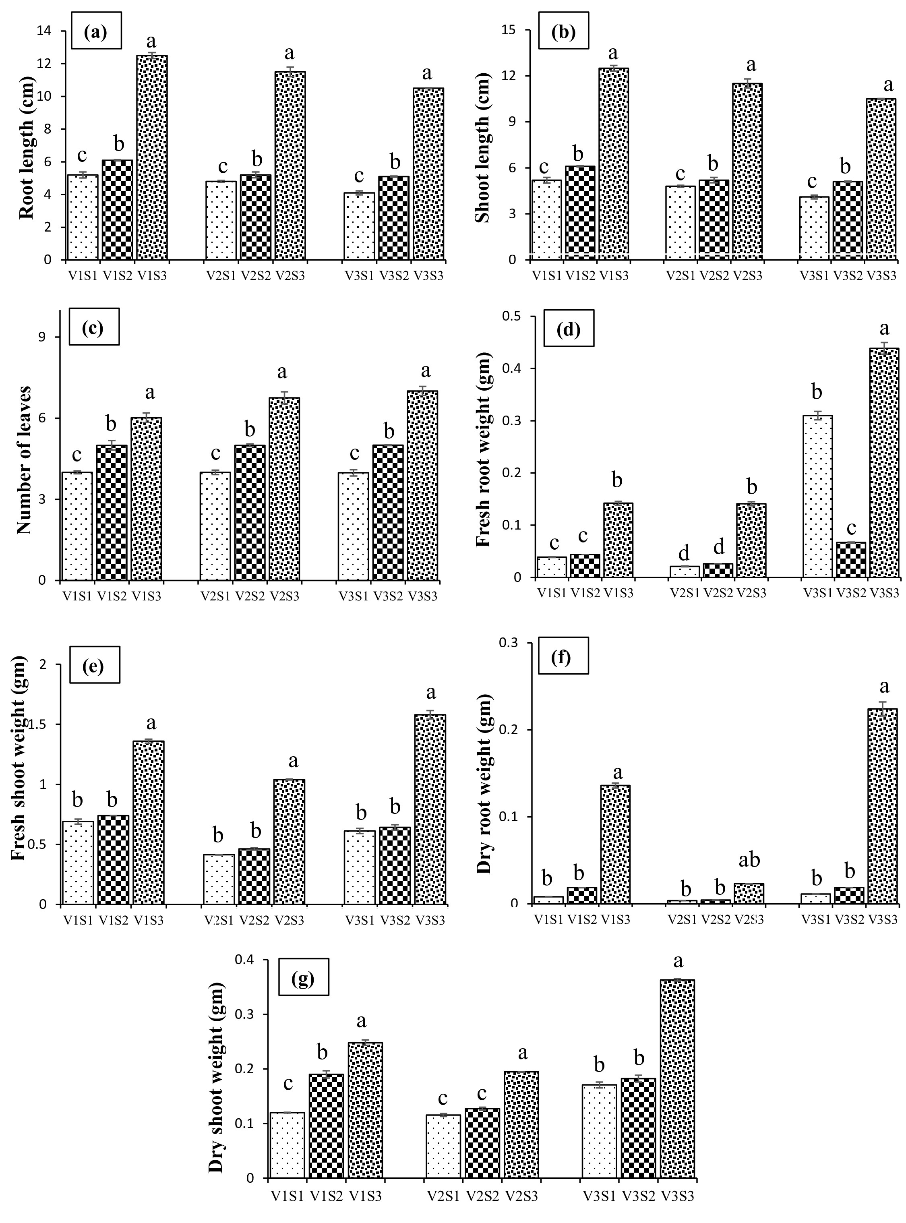
Figure 1. Effect of different variety and planting methods on seedling growth mustard. (a)Root length (cm), (b)Shoot length (cm), (c)Number of leaves, (d)Fresh root weight (gm), Fresh shoot weight (gm),(e)Dry root weight (gm), (f)Dry shoot weight (gm). Means sharing different letters are significantly (p ≤ 0.05) different from each other.

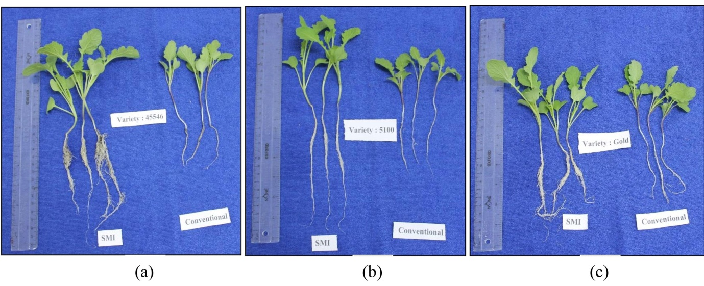
Figure 2. Comparison of seedling characteristics of Conventional and SMI methods in different varieties of mustard. (a) Variety 45S46, (b) Kesari 5100, (c) Kesari Gold.

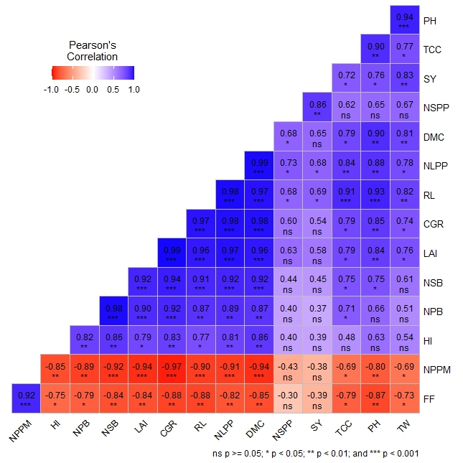
Figure 3. Correlation of growth and yield traits of mustard.
RL=root length (cm), PH =plant height (cm), NPB=number of primary branches, NSB=number of secondary branches, NLPP=Number of leaf per plant, NPPM= number of plant per m², NSPP=number of siliqua plants⁻¹, TW=test weight (gm), SY=seed yield kg ha⁻¹,TCC= total chlorophyll content (mg/100g fresh weight), DMC= dry matter content (gm), LAI=leaf area index (LAI), CGR=crop growth rate (CGR),HI= The harvest index (%),
*Significant (p ≤ 0.05), ** Highly significant (p ≤ 0.01), *** Highly significant (p ≤ 0.001), ns= non-significant.

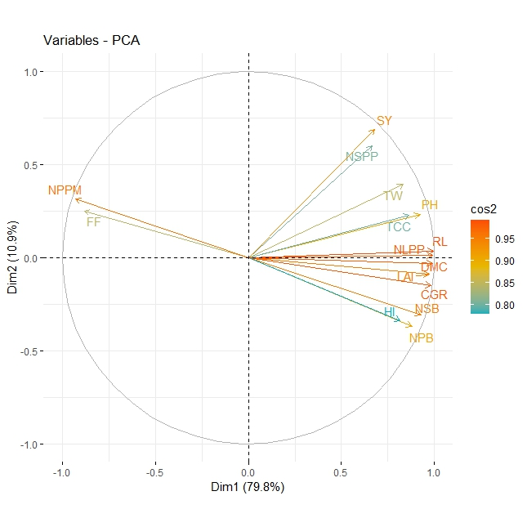
Figure 4. Principle component analysis (PCA) of growth and yield traits of mustard.
RL=root length (cm), PH =plant height (cm), NPB=number of primary branches, NSB=number of secondary branches, NLPP=Number of leaf per plant, NPPM= number of plant per m², NSPP=number of siliqua plants⁻¹, TW=test weight (gm), SY=seed yield kg ha⁻¹,TCC= total chlorophyll content (mg/100g fresh weight), DMC= dry matter content (gm), LAI=leaf area index (LAI), CGR=crop growth rate (CGR), HI= The harvest index (%).

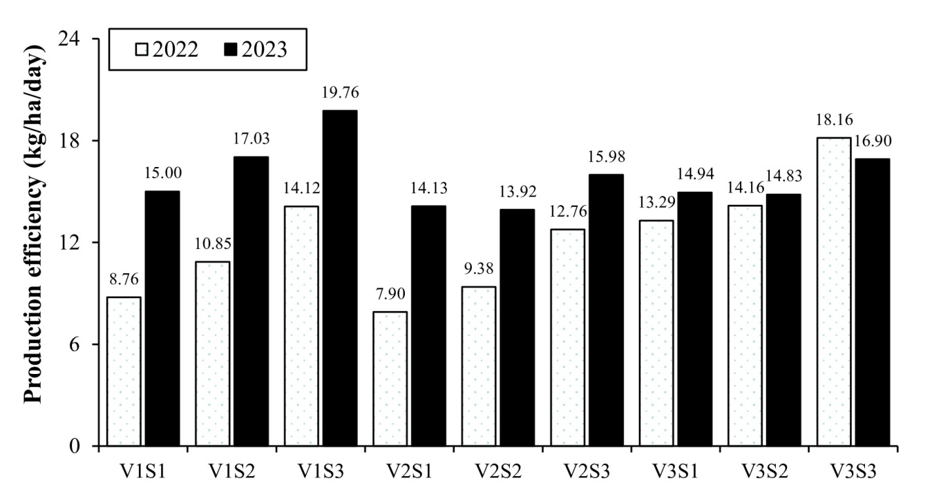
Figure 5. Production efficiency (kg ha⁻¹ day⁻¹) of different treatment combination of mustard for 2022 and 2023
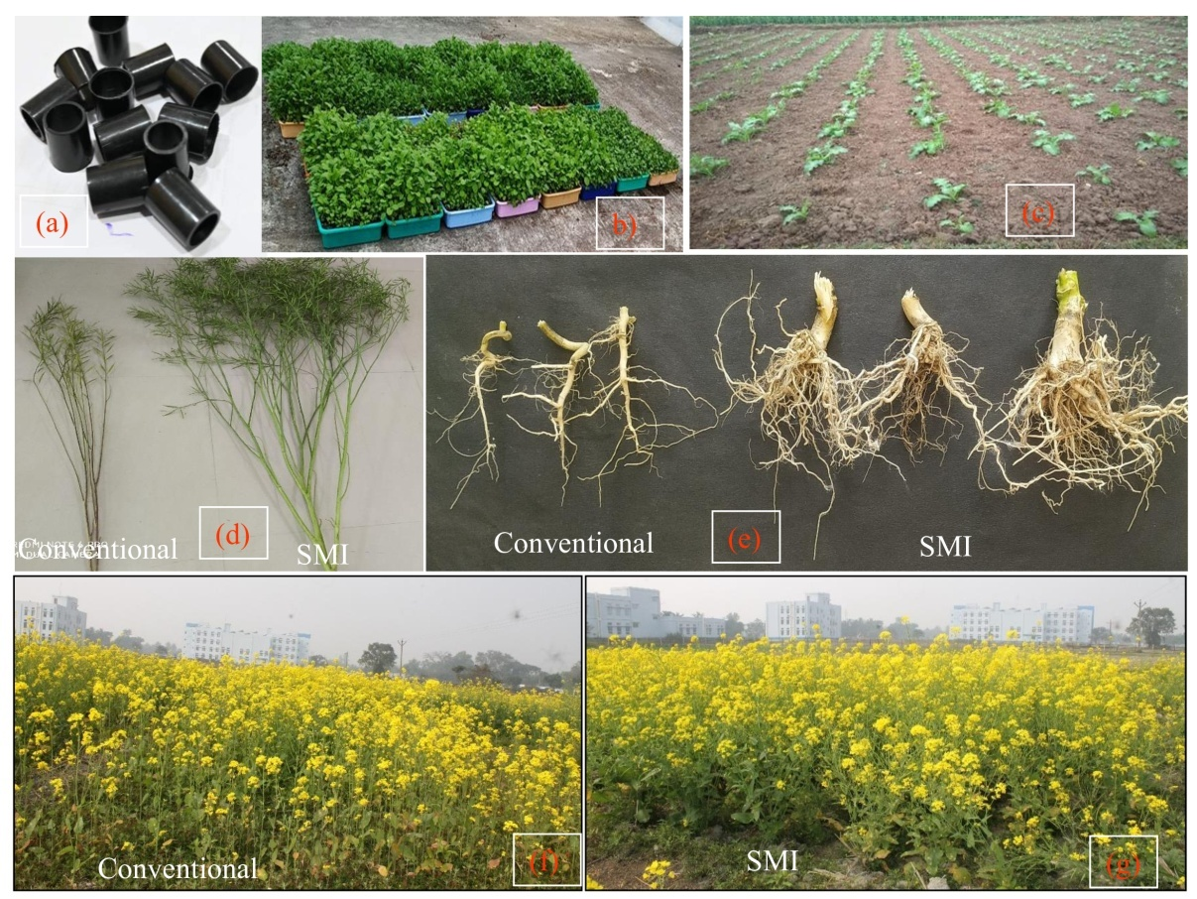

Figure 6. Different practices of system of mustard intensification (SMI). (a) micropots (b) Nursery preparation in trays, (c) Crop geometry of SMI (45cm × 45cm), (d) plant growth comparison with conventional methods, (e) root growth comparison with conventional methods, (f) field view of conventional methods, (f) field view of SMI.

