One new record of Thaxterogaster subgenus Scauri (Agaricales) from India

ABSTRACT
The present study from Arunachal Pradesh (India) introduces a new record of the genus Thaxterogaster, named T. pallidopurpurascens. This study is supported by morpho-molecular evidence. The species was discovered from temperate to subalpine coniferous forests of the Himalayas. The study provides detailed macro and micro-morphological characteristics, illustrations of the specimen, and molecular phylogenetic analysis.

Keywords: Agaricales; Basidiomycota; macrofungi; morphology; phylogenetic inferences.

- INTRODUCTION

The family Cortinariaceae R. Heim ex Pouzar em. Niskanen & Liimat. belongs to the suborder Agaricineae Fr. and the order Agaricales Underw. (Basidiomycota R.T. Moore) (Bose et al., 2024a). This is one of the largest families in Basidiomycota, with over 3,157 accepted species and several undescribed species (Soop et al., 2019; Kalichman et al., 2020; Liimatainen et al., 2020; Liimatainen et al., 2022). However, it is highly unfortunate to state that only 37 members of the Cortinariaceae family have been identified from tropical, subtropical, and temperate regions of India, one of the megadiverse countries of the world (Bose et al., 2024a; Bose et al., 2024b; Bose et al., 2025). Species of the Cortinariaceae have a cosmopolitan distribution, ranging from tropical to arctic regions. They also form important ectomycorrhizal associations with many vascular plants from families like Pinaceae, Fagaceae, Dipterocarpaceae, Myrtaceae, Salicaceae, Fabaceae, Betulaceae, Nothofagaceae, Rosaceae, and others, providing access to nitrogen and aiding in carbon cycling (Liimatainen et al., 2022; Garnica et al., 2005). Members of this family should be investigated and documented scientifically because it possesses several strikingly important characteristics necessary for ecological sustainability. They serve as indicators of ecological fluctuations, such as changes caused by radioactive deposits, industrial air pollution, and acidification (Høiland & Jensen, 2000). In concern to their economic importance, they serve as potential delicacies. For example, Thaxterogaster multiformis (Fr.) Niskanen & Liimat. and T. purpurascens (Fr.) Niskanen & Liimat., are widely consumed in China (Dai et al., 2010). Thaxterogaster turmalis (Fr.) Niskanen & Liimat. has antitumor properties (Dai et al., 2008), while Cortinarius infractus (Pers.) Fr. contains two significant alkaloids, infractopicrin and 10-hydroxy-infractopicrin, used for potential cure of Alzheimer's disease (Geissler et al., 2010). Cortinarius steglichii N. Arnold, Palfner, Peintner & Huymann, reported from Chilean Nothofagus Forest, produces an important secondary metabolite namely steglichon (a diterpenoid) which has antibacterial and anticancer activity (Lam et al., 2024). Additionally, certain species within this family have been utilized as commercial dyes. Nevertheless, many members are known to be highly toxic and may cause severe intoxication if inadvertently ingested, including Cortinarius orellanus Fr. and C. rubellus Cooke (Høiland & Jensen, 2000). Based on the surveyed IUCN data, species of this family need to be conserved due to the severe threats they face leading to their extinction. For instance, Calonarius meinhardii (Bon) Niskanen & Liimat., C. murellensis (Cors. Gut., Ballarà, Cadiñanos, Palazón & Mahiques) Niskanen & Liimat., C. osloensis (Brandrud, T.S. Jeppesen & Frøslev) Niskanen & Liimat., C. atrovirens (Kalchbr.) Niskanen & Liimat., Phlegmacium stjernegaardii (Brandrud & Frøslev) Niskanen & Liimat., Cortinarius phrygianus Fr., C. Nouhra & Kuhar, and many others are at risk, with the list continuing to grow (https://www.iucnredlist.org).

Initially, Singer (1951) established Thaxterogaster as a sequestrate genus to accommodate taxa with Cortinarius-like spores but characterized by basidiomata with a reduced stipe and a basally exposed hymenium with a loculate to lamellate gleba (Peintner et al., 2002). Singer and Smith considered this genus as representatives of Gastromycetes (Singer & Smith, 1958). Later, Moser (1964) and Horak and Moser (1965) observed that Thaxterogaster and Cortinarius are closely related and stated that Thaxterogaster is polyphyletic due to links between species or groups of species of Thaxterogaster and different subgenera of Cortinarius. Based on recent studies on available species in this genus it is understood that morphologically, species of Thaxterogaster are characterized by the presence of small to large sized agaricoid (phlegmacioid, myxacioid) or sequestrate basidiomata exhibiting range of colours from white, ochraceous, greenish, brown to purple; lamellae adnate, adnexed or emarginate, when young appear white, pale grey, pale brown, green, purple or with a purplish tint; stipe cylindrical, clavate, rooting or bulbous, bulb rounded to marginate white, pale brown, purple, some species with greenish colours, in some species usually turning deeper purple when bruised (Liimatainen et al., 2022; Ghosh et al., 2023).

Earlier, the entire classification was solely based on both macro and micro-morphological characterizations. Later on, with the aid of the sequences derived from nrDNA internal transcribed spacer (ITS), Peintner et al. (2001) showed that Thaxterogaster was nested within Cortinarius. As a result, Thaxterogaster was synonymized with Cortinarius sensu lato (Peintner et al., 2002). Recently, Liimatainen et al. (2022) considered Thaxterogaster as an independent genus and divided it into six subgenera: Thaxterogaster Niskanen & Liimatainen, Cretaces Niskanen & Liimatainen, Multiformes Niskanen & Liimatainen, Riederorum Niskanen & Liimatainen, Scauri Niskanen & Liimatainen, and Variegati Niskanen & Liimatainen. They recognized 23 sections: Multiformes, Cremeolini (both belonging to the subg. Multiformes); Vibratiles, Microspermi, Verniciori, Olorinati, Caustici (all belonging to the subg. Vibratiles); Thaxterogaster, Alboaggregati (both belonging to the subg. Thaxterogaster); Purpurascentes, Scauri (both belonging to the subg. Scauri); Rapacea, Gigasperma, Malvacei, Turmales, Pinophili, Austricyanites, Lustrati, Laquelli, Austrovaginati (these nine sections are highly challenging and do not belong to any particular subgenus); Cretaces (belongs to the subg. Cretaces); Riederorum (belongs to the subg. Riederorum) and Variegati (belongs to the subg. Variegati) based on targeted capture sequencing and shallow whole genome sequencing (Liimatainen et al., 2022; Xie et al., 2023; Wang et al., 2025).

This is the second largest genus in Cortinariaceae, with nearly two hundred species worldwide and is currently considered to be a bihemispherical genus (Wang et al., 2025). In India, only five species of Thaxterogaster have been reported: T. carneus S.S. Ahmed & Z.A. Reshi, T. indopurpurascens (Dima, Semwal, Brandrud, V. Papp, & V.K. Bhatt) A. Ghosh, D. Chakr., K. Das & Vizzini, T. purpurascens (Fr.) Niskanen & Liimat., T. shoreae A. Ghosh, D. Chakr., K. Das & Vizzini and T. thindii A. Bose & D. Chakr (Bose et al., 2024a; Bose et al., 2025). As mentioned above, Thaxterogaster subgenus Scauri includes two sections: sect. Scauri and sect. Purpurascentes (Liimatainen et al., 2022). The species of sect. Purpurascentes are characterized by mostly stipitocarpic or few sequestrate basidiomata; hemispherical pilei; lamellae and stipe surfaces that usually turn deeper purple when bruised; and a positive iodine-based reaction (Saar et al., 2014; Soop et al., 2019; Liimatainen et al., 2014, 2022).

During a routine macrofungal survey conducted in the Tawang District of Arunachal Pradesh, India, several specimens from the genera Thaxterogaster were collected. After careful examination of both macro and micro-morphological characteristics followed by molecular phylogenetic studies, our specimen was identified as Thaxterogaster pallidopurpurascens Zhu L. Yang & Zi R. Wang, a new record to India and was found to be a representative of the subgenus Scauri, sect. Purpurascentes. This study provides detailed macro and micro-morphological descriptions of this species, along with its nrITS-based molecular phylogenetic analysis.

- MATERIAL AND METHODS

  - Morphological Studies
Thorough and an extensive macrofungal explorations to the Tawang district of Arunachal Pradesh in general and near Sangestar Tso (commonly known as Madhuri Lake) in particular were undertaken during the rainy season of 2023 (July to August), which led to the collection of several fresh basidiomata belonging to Cortinariaceae. Macro-morphological characters were recorded and analyzed from fresh basidiomata in the field. Photographs of the samples were taken both in the field and in the basecamp with the aid of Sony DSC-HX400V Cyber-shot camera. Color codes and terms were based on Kornerup and Wanscher (1978). After noting all the macro-morphological characters, dissected samples were placed for drying in an aluminium field drier. Macro-chemical colour test was carried out with 5% KOH and 10% KOH solutions on surface of pileus and stipe of fresh basidiomata. Micro-morphological characters were observed from free hand sections of dried materials mounted in a solution of 5% KOH, 1% Phloxin, and 1% ammoniacal Congo red with an Olympus CX 41 compound microscope. Drawings of the anatomical features were made with a drawing tube attached to Olympus CX 41 compound microscope at 1000× magnification. Micro-photographs were taken with a dedicated camera attached to an Olympus BX 53 microscope. Basidiospores were examined in Melzer’s reagent and measured in side view, excluding ornamentations. Basidiospore measurements and length/width ratios (Q) are represented as: minimum–mean–maximum. Basidium length excludes the length of sterigmata. Forty (40) and twenty (20) measurements were taken for basidiospores and other micromorphological structures, respectively. The studied specimens were deposited in the Central National Herbarium (CAL), Howrah.
  - DNA extraction, PCR amplification and sequencing
Following the manufacturer's instructions, 100 mg of dried mushroom samples were used to extract genomic DNA using the InstaGeneTM 127 Matrix Genomic DNA isolation kit. The primers ITS1-F and ITS4 were used to amplify the ITS gene region (White et al., 1990; Gardes & Bruns, 1993). Initial denaturation at 94°C for 3 minutes, 35 cycles of denaturation at 94°C for 1 minute, annealing at 50°C for 30 seconds, and extension at 72°C for 1 minute comprised the PCR conditions. The ultimate extension was maintained for seven minutes at 72°C. The QIAquick PCR Purification Kit was then used to purify the PCR products. The amplifying primers are used in both ×l DNA analyzers. Using Sequence Scanner, the obtained sequence's quality was examined. In this study, four sequences (two from each species) were generated from one species (Thaxterogaster pallidopurpurascens) and deposited in GenBank (www.ncbi.nlm.nih.gov/genbank/) (Table 1.). To edit the final tree, Inkscape ver. 0.92.4 was used.
  - Phylogenetic Analysis
The nrITS sequences of the newly recorded Thaxterogaster pallidopurpurascens and the top BLASTn hits confirmed that our specimens belong to the genus Thaxterogaster. Species related to T. pallidopurpurascens were selected for phylogenetic analysis based on BLASTn results with >90% identity. Close relatives were sourced from GenBank (https://www.ncbi.nlm.nih.gov/genbank) and relevant published studies (Wang et al., 2025; Xie et al., 2023; Xie et al., 2024; Ghosh et al., 2023). A total of 66 taxa were included in the analysis, with Thaxterogaster persicanus (Soop) Niskanen & Liimat. used as the outgroup. The raw nrITS dataset was compiled independently. Sequence alignment was performed using the online version of the MAFFT v. 7 program (https://mafft.cbrc.jp/alignment/software/). Phylogenetic analysis was carried out using the Maximum Likelihood (ML) inference method in IQ-TREE v2.4.0 (Nguyen et al., 2015), with TN+F+G4 (BIC) as the best-fitting model identified by ModelFinder (Kalyaanamoorthy et al., 2017). An ultrafast bootstrap with 1000 replicates was applied to calculate nodal support values. Gaps in the alignment were treated as missing data during the phylogenetic analysis (Fig 1). DNA sequences (Table 1) are deposited in NCBI GenBank (https://www. ncbi.nlm.nih.gov/genbank/).
- RESULTS AND DISCUSSION
3.1 Phylogenetic inferences
In our maximum likelihood (ML) phylogenetic analysis (Fig. 1), the nrITS data matrix included 66 taxa and 650 nucleotide positions (with gaps). The nrITS dataset consisted of 479 conserved sites, 161 variable sites, 121 parsimony-informative sites, and 40 singleton sites and 219 distinct patterns. The rate parameters were as follows: A-C: 1.00000, A-G: 3.02584, A-T: 1.00000, C-G: 1.00000, C-T: 5.18360, G-T: 1.00000. The base frequencies were A: 0.242, C: 0.201, G: 0.205, and T: 0.353.
Our Indian samples (GenBank accession numbers: PP892258 and PP892259) grouped with Thaxterogaster pallidopurpurascens, originally described from China (GenBank accession numbers: PQ013324 and PQ013325), with strong support for this clade (ML bootstrap = 95%).

3.2 Taxonomy
Thaxterogaster pallidopurpurascens Zhu L. Yang & Zi R. Wang (Wang et al. 2025) (Fig. 2–3)

Description: Pileus 40–70 mm in diam., convex when young; margin entire; surface moist and sticky when wet, greyish violet (17C4) near the margin, greyish brown to light brown (6D3–4) in the center, turning brown (6E7) with KOH. Lamellae adnate, crowded, greyish violet to dull violet (17B4–D4), turning purple (15B6–7) when bruised; lamellulae present in 3 series. Stipe 55–120 × 17–33 mm, sub-clavate to sub-bulbous, slightly curved; surface violet-white (17A2) with white faint dark blond to pale violet (5D4–17C3) reticulation with fine fibrils and remnants of brownish universal veil of the mature basidiomata; base bulbous. Basal mycelium white. Pileus context solid and fleshy, grey (5B1) but changing to violet-white to pale violet (17A2–A3) after 10 minutes. Stipe context solid, grey (5B1) but changing to greyish violet (17B4–C4) after 10 minutes. Smell indistinct. Spore print rusty brown (6D7).

Basidiospores 9.4–12.50–15.3 × 4.9–6.06–7.2 μm (n= 40), Q= 1.51–1.71–2.17, oval to elliptical, moderately to strongly verrucose, dextrinoid. Basidia 40–49 × 12–20 μm, clavate, 4-spored; sterigmata triangular. Sterile marginal elements 16–18 × 4–6 μm, cylindrical to clavate, colourless and thin-walled. Cheilocystidia 28–45 × 4.3–7.5 μm, cylindrical to subcylindrical, occasionally present. Pileipellis 140–145 μm thick, ixocutis, two-layered; suprapellis 56–62 μm thick, made up of loosely interwoven somewhat parallel hyphae (55–61 × 1.5–2.3 μm); subpellis 85–92 μm thick, consisting of slightly inflated, cylindrical, compactly arranged cells (36–53 × 7.6–10.6 μm). Clamp connections present in all tissues.

Additional specimen examined: INDIA. Arunachal Pradesh, Tawang district, Sangestar Tso, in temperate forest under Rhododendron sp., 17 Aug 2023, alt. 4297 m, N 27°42′46.20″E 91°53′37.95″, Arvind Parihar, AP 23-63, GenBank accession numbers: PP892258 and PP892259 (ITS); (CAL 2007).

Remarks: The presence of a sticky pileus with large basidiospores, along with ITS-based phylogenetic analysis, places T. pallidopurpurascens in the subgenus Scauri, section Purpurascentes. The ITS sequence data, combined with morphological features such as ellipsoidal basidiospores, a greyish-brown central tint on the pileus, and a double-layered pileipellis with a thin glutinous surface layer, confirm that our Indian specimens belong to T. pallidopurpurascens, a species originally described from Yunnan, China (Wang et al. 2025). Although the macro and micro-morphological features mostly agree with the Chinese specimen, the latter has emarginate deep violet lamellae and lacks cheilocystidia (Wang et al., 2025).
Phylogenetically, Thaxterogaster purpurascens (Fr.) Niskanen & Liimat., (originally reported from Europe) is quite close to present Indian collections. However, T. purpurascens is separated by possessing a distinct marginate bulbous base, relatively paler pileus and smaller basidiospores (Saar et al., 2014; Ghosh et al., 2023; Xie et al., 2023; Xie et al., 2024; Wang et al., 2025).

CONCLUSION
It is a grave reality that Cortinariaceae, the largest mushroom-producing family in the order Agaricales, is severely understudied in India. Despite its rich diversity of species, very little work is still being done worldwide, unlike the family Boletaceae Chevall., which also forms ectomycorrhizal associations with defined host trees (Sweta et al., 2025). This stands in contrast to other dominant ectomycorrhizal mushroom genera, such as Russula (1320 species worldwide, over 180 taxa in India), Lactarius (640 species worldwide, 83 taxa in India), Amanita (709 species worldwide, 65 species in India), and Lactifluus (178 species worldwide, 31 taxa in India), which are well-studied and scientifically identified in the country (Kalichman et al., 2020). As a result, much of the existing research is based on biased sampling. For instance, to establish an authentic and well-analyzed phylogenetic estimation of Indian Cortinariaceae species, we lack sufficient taxonomical and molecular data. Consequently, there remains a significant gap in studies on morphotaxonomy and molecular phylogeny within this family.
This genus is highly adaptable because its members can thrive in diverse habitats. As a result, morphological plasticity is a prominent feature, even within the same species belonging to Thaxterogaster (Wang et al., 2025).

Most of the research on this genus has been conducted in Europe, North America, New Zealand, and Australia (Wang et al., 2025). However, to properly establish our Indian samples, we need verified data on Indian Cortinariaceae members. This data can be obtained from reliable sources such as GenBank (https://www.ncbi.nlm.nih.gov/genbank), the UNITE database (https://unite.ut.ee), Barcode of Life Database (BOLD) Systems (https://www.boldsystems.org/), Index Fungorum (https://www.indexfungorum.org/), and MycoBank (https://www.mycobank.org/). Therefore, Cortinariaceae family should become a major area of focus in India in coming years to address the gaps and enable unbiased future analyses of this family.

REFERENCES
Bose, A., Niskanen, T., Datta, S., Ghosh, A., Vizzini, A. & Das, K. (2024a). Two new species and a new record of Cortinarius subgenus Telamonia (Agaricales) from India. European Journal of Taxonomy 970: 38–60. Doi.org/10.5852/ejt.2024.970.2747

Bose, A., Uniyal, P., Vizzini, A. & Das, K. (2024b). Morphotaxonomy and molecular phylogeny unveil one new species and two new records of Phlegmacium (Cortinariaceae) from India. Nordic Journal of Botany 2024: e04552. Doi: 10.1111/njb.04552

Bose, A., Chakraborty, D., Datta, S. & Das, K. (2025). One New Species of Thaxterogaster Subgenus Riederorum (Agaricales) from India. International Journal of Plant & Soil Science 37: 180–187. DOI: 10.9734/ijpss/2025/v37i25317
Dai, Y.C. & Yang, Z.L. (2008). A revised checklist of medicinal fungi in China, Mycosystema 27: 801–824.
Dai, Y.C., Zhou, L.W., Yang, Z.L., Wen, H.A., Bau, T. & Li, T.H. (2010). A revised checklist of edible fungi in China. Mycosystema 29: 1–21.
Garnica, S., Weiß M., Oertel, B. & Franz, O. (2005). A framework for a phylogenetic classification in the genus Cortinarius (Basidiomycota, Agaricales) derived from morphological and molecular data. Canadian Journal of Botany 83: 1457–1477. https://doi.org/10.1139/b05-107
Gardes, M. & Bruns, T.D. (1993). ITS primers with enhanced specificity for basidiomycetes-application to the identification of mycorrhizae and rusts. Molecular Ecology 2: 113–118. https://doi.org/10.1111/j.1365 294X.1993.tb00005.x
Geissler, T., Brandt, W., Porzel, A., Schlenzig, D., Kehlen, A., Wessjohann, L. & Arnold, N. (2010). Acetylcholinesterase inhibitors from the toadstool Cortinarius infractus. Bioorganic & medicinal chemistry 18: 2173–2177.
Ghosh, A., Chakraborty, D., Hembrom, M.E., Vizzini, A., & Das, K. (2023). Thaxterogaster shoreae, a new species of Thaxterogaster subg. Scauri sect. Purpurascentes from Sal Forest of India based on morphology and molecular phylogeny. Taiwania 68(1): 23‒30. Doi: 10.6165/tai.2023.68.23
Høiland, K. & Holst-Jensen, A. (2000). Cortinarius phylogeny and possible taxonomic implications of ITS rDNA sequences, Mycologia 92: 694–710. https://doi.org/10.1080/00275514.2000.12061210
Kalichman, J., Kirk, P. M. & Matheny, P. B. (2020). A compendium of generic names of agarics and Agaricales Taxon 69: 425–447. doi.org/10.1002/tax.12240
Kalyaanamoorthy, S., Minh, B.Q., Wong. T.K.F., Heaseler, A.V. & Jermiin, L.S. (2017). ModelFinder: fast model selection for accurate phylogenetic estimates. Nature methods 14:587–589. https://doi.org/10.1038/nmeth.4285
Kornerup, A., & Wanscher, J. H. (1978). Methuen handbook of colour (3rd ed.). Eyre Methuen.
Lam, Y.T., Schmitz, L., Huymann, L., Dhar, D., Morgan, I., Rennert, R., Davari, M.D., Peintner, U., Palfner, G. & Arnold, N. (2024). Cortinarius steglichii: a taxonomical and chemical novelty from Chile. Mycological Progress 23:55. https://doi.org/10.1007/s11557-024-01983-z
Liimatainen, K., Niskanen, T., Dima, B., Kytövuori, I., Ammirati, J.F. & Frøslev, T.G. (2014). The largest type study of Agaricales species to date: bringing identification and nomenclature of Phlegmacium (Cortinarius) into the DNA era. Persoonia-Molecular Phylogeny and Evolution of Fungi 33: 98–140, https://doi.org/10.3767/003158514X684681
Liimatainen, K., Niskanen, T., Dima, B., Ammirati, J. F., Kirk, P. M., & Kytövuori, I. (2020). Mission impossible completed: unlocking the nomenclature of the largest and most complicated subgenus of Cortinarius, Telamonia. Fungal Divers. 104: 291–331. doi.org/10.1007/s13225-020-00459-1
Liimatainen, K., Kim, J. T., Pokorny, L., Kirk, P. M., Dentinger, B., & Niskanen, T. (2022). Taming the beast: a revised classification of Cortinariaceae based on genomic data. Fungal Diversity 112: 89–170. doi.org/10.1007/s13225-022-00499-9
Nguyen, L.T., Schmidt, H.A., Von Haeseler, A. & Minh, B.Q. (2015). IQ–TREE: a fast and effective stochastic algorithm for estimating maximum–likelihood phylogenies. Molecular Biology Evolution 32: 268–274. https://doi.org/10.1093/molbev/msu300
Peintner, U., Moser, M., & Vilgalys, R. (2002). Thaxterogaster is a taxonomic synonym of Cortinarius: New combinations and new names. Mycotaxon, 81: 177–184. Peintner, U., Moser, M.M., Thomas, K.A. & Manimohan, P. (2003). First records of ectomycorrhizal Cortinarius species (Agaricales, Basidiomycetes) from tropical India and their phylogenetic position based on rDNA ITS sequences. Mycol. Res. 107: 485–494.
Saar, G., Dima, B., Schmidt-Stohn, G., Brandrud, T.E., Bellù, F., Frøslev, T.G., Oertel, B. & Soop, K. (2014). Cortinarius Untergattung Phlegmacium Sektion Purpurascentes in Europa. Journal des J.E.C. 14: 140–161.
Singer, R. & Smith, A.H. (1958). Studies on secotiaceous fungi—I: A monograph of the genus Thaxterogaster. Brittonia. 10: 201–216. https://doi.org/10.2307/2804951
Soop, K., Dima, B., Cooper, J.A., Park, D., & Oertel, B. (2019). A phylogenetic approach to a global supraspecific taxonomy of Cortinarius (Agaricales) with an emphasis on the southern mycota. Persoonia - Molecular Phylogeny and Evolution of Fungi, 42: 261–290. doi.org/10.3767/persoonia.2019.42.10
Rajput, S., Chakraborty, D., Das, K., Ghosh, A. & Sharma, Y.P. (2025). First report of Caloboletus panniformis (Boletaceae) from India, Indian Phytopathology 1–8. https://doi.org/10.1007/s42360-025-00828-3.
Wang, Z. R., Zhou, S. Y., Liu, F. F. & Yang, Z. L. (2025). The genus Thaxterogaster (Cortinariaceae): phylogeny and species diversity in Western China. Mycology, 1–39. https://doi.org/10.1080/21501203.2024.2441178
White, T.J., Bruns, T.D., Lee, S.B. & Taylor, J.W. (1990). Amplification and Direct Sequencing of Fungal Ribosomal RNA Genes for Phylogenetics. In: Innis, M.A., Gelfand, D.H., Sninsky, J.J. and White, T.J., Eds., PCR Protocols: A Guide to Methods and Applications, Academic Press, New York, 315-322.
Xie, M.L., Feng, N., Lin, W.F., Su, W.Y., Li, Y. & Yang, Z.Q. (2023). Morphological and Phylogenetic Characterization of Three Novel Thaxterogaster (Cortinariaceae) Species from China with an Emphasis on Their Subtropical Distribution. Journal of Fungi 9:1058. https://doi.org/10.3390/jof9111058
Xie, M.L., Yu, Y., Long, P., Chen, Z.H., Wang, Z.R., Ma, H.X., Wei, T.Z., Liao, J.P., Li, C.T., Yang, Z.Q. & Li, Y. (2024). New insights into Cortinarius: Novel taxa from subtropical China. Mycology. https://doi.org/10.1080/21501203.2024.2434584.

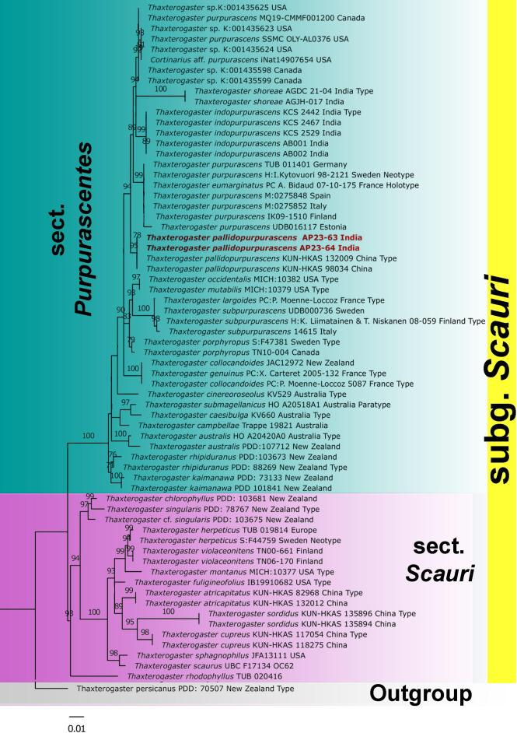
Fig. 1. Phylogram generated by Maximum Likelihood (ML) analysis based on ITS sequence data for Thaxterogaster pallidopurpurascens and allied species. ML bootstrap support values (MLbs) ≥ 70% are shown. The new species is highlighted in red to mark their phylogenetic positions in the tree.
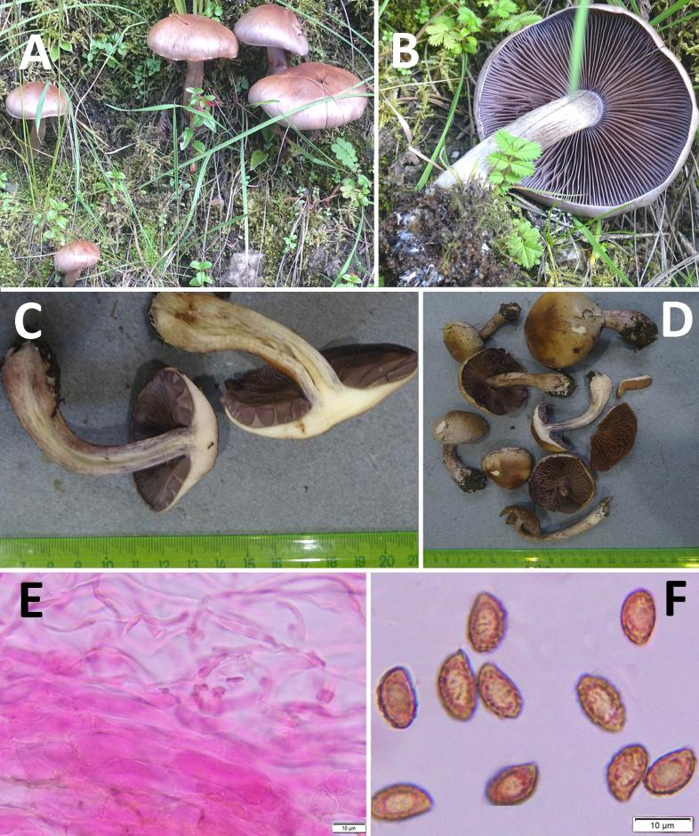
Fig. 2. Thaxterogaster pallidopurpurascens. (A–D) Fresh basidiomata, (E) transverse section through pileipellis of pileus, (F) basidiospores. Scale bars: E–F = 10 µm.

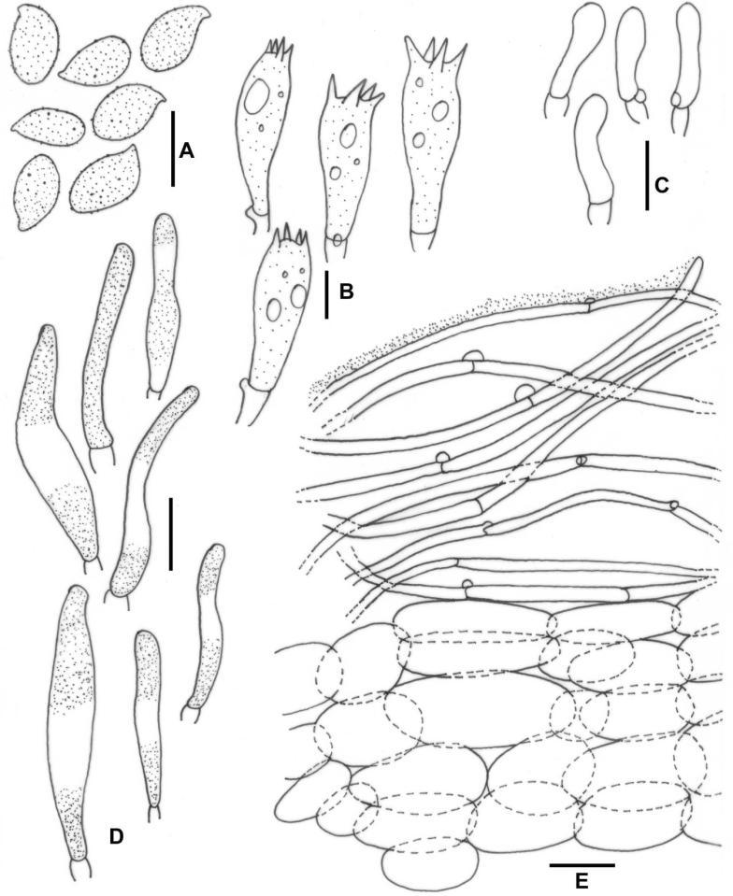
Figure 3. Thaxterogaster pallidopurpurascens. (A) Basidiospores. (B) Basidia. (C) Sterile marginal elements. (D) Cheilocystidia. (E) Transverse section of pileipellis through pileus. Scale bars: A–E= 10 µm.

