*Original Research Article*

Assessment of Phenotypic Stability and Yield Performance in Three-Line Rice (Oryza sativa L.) Hybrids Across Nigeria Agro-Ecologies.

.

ABSTRACT

|  |
| --- |
| Rice (Oryza sativa L.) production in Nigeria faces significant challenges, with current average yields of 2.0 t/ha falling well below the global average of 4.5 t/ha. This study evaluated four hybrid rice genotypes (IR138867H, IR138840H, IR138982H and IR138758H) against three commercial checks (FARO 44, FARO 66, and FARO 68) across two contrasting agro-ecological zones in Nigeria. Using a randomized complete block design with three replications, key agronomic traits such as flowering time, plant height, panicle length, tiller number, maturity period, 1000-grain weight, and grain yield were assessed. Results indicated that plant height and panicle length were significantly influenced by environmental factors (*P* = .05). The hybrid IR138982H demonstrated superior performance with grain yields of 6.55 t/ha, representing a 42% yield advantage over the best commercial check. Significant (*P* = .05) difference in genotype-environment interactions were observed for flowering time, plant height, and grain yield, emphasizing the importance of location-specific hybrid deployment strategies. These findings have identified IR138982H as a promising hybrid candidate for improving rice productivity in Nigeria, supporting efforts to enhance domestic production and reduce import dependence. |

*Keywords: Grain yield, Hybrid, Nigeria, Rice, Stability*

1. INTRODUCTION

Rice (Oryza sativa L.) is a staple crop of global significance, serving as a fundamental component of human nutrition and culture for nearly 10,000 years (Molina et al., 2011). Rice production and consumption is perhaps the most critical economic activity, and it is believed that nearly every day, rice food is taken by half of the population globally at least once (Wang et al., 2023). Nigeria is the largest rice producer in Africa but still faces a significant production gap, with an estimated production of 8.9 million metric tons of paddy rice in 2023 (Statista, 2024). After processing, this translated to approximately 5.2 million metric tons of milled rice (Statista, 2024). However, domestic production remains insufficient to meet national demand, which was estimated at 7.8 million metric tons in 2023, leaving a supply gap of about 2.6 million metric tons (USDA Foreign Agricultural Service, 2023).

Hybrid rice is important for improving food security and enhancing crop production. Keeping this in view, more work is required to increase its productivity to combat the food scarcity issue (Durand-Morat et al., 2011). Heterosis is a unique way to harness the hybrid power of plants. Due to their yield advantages and economic importance, several hybrid rice varieties have been commercialized in more than 40 countries. Hybrid rice offers significant potential for the development of the seed industry to ensure higher rice yields worldwide. Hybrid rice technology is one of the strategies to meet this immense challenge (Mahalingam et al., 2013).

The cultivation of hybrid rice is a technology that allows for an increase in grain yield of 20-25% relative to the grain yield of conventional cultivars (Janaiah and Hossain 2000). However, the main challenge for this technology is related to seed production, which currently has high production cost and low seed yield. Therefore, agronomic techniques that could enhance f lowering synchrony of parent lines in the field are essential for an efficient production system of hybrid rice seeds.

Therefore, hybrid rice is very important for food security in poor tropical countries with higher population and less arable land (Santiaguel and Quipot, 2012). Hybrid rice technology has attracted the attention of researchers and decision makers in many countries to break the yield ceiling of HYV rice (Hossain et al, 2003). All major rice-producing countries in the world have been investing in applying hybrid rice technology, and, in recent years, the seed industry has also been involved in hybrid rice research and development (Mao, 2001).

In Nigeria, efforts are been led by the African Agricultural Technology Foundation (AATF), the AfricaRice Center, and Value Seeds Limited to advance the development of indigenous hybrid rice varieties with the potential to achieve yields exceeding 10 tons per hectare. This initiative is strategically aimed at enhancing farmers' livelihoods and reducing Sub-Saharan Africa's reliance on rice imports. However, its adoption in Nigeria remains constrained by several factors, including economic, agronomic, and infrastructural limitations. This study presents findings from a multi-institutional collaboration involving the Hybrid Rice Development Consortium (HRDC), the International Rice Research Institute (IRRI), Value Seeds Limited, and the National Cereal Research Institute (NCRI) by the evaluation of three-line hybrid rice varieties across multiple locations in Nigeria to assess the agronomic performance of hybrid rice varieties relative to commercial checks, analyze the extent of G×E interactions on key yield-related traits, and provide recommendations for hybrid rice adoption in different rice-growing areas of Nigeria.

2. material and methods

**2.1 Study Site Location**

The research was conducted in two (2) locations at the National Cereal Research Institute, Badeggi which lies between (Lat. 9.076847ᵒ and long. 6.046724ᵒ) and Rice Research Station, Value Village, Zaria (Lat. 11.2197517ᵒ and long. 7.778111ᵒ).

The study was conducted in two key lowland rice-growing environment of Nigeria; Zaria LGA, Kaduna State, and Badeggi, Katcha LGA, Niger State, selected based on their agro-climatic significance, historical relevance to rice cultivation, and suitability for evaluating genotype-by-environment interactions, with Zaria representing rice production under rain-fed and irrigated conditions and Badeggi serving as a hub for intensive lowland rice farming, ensuring broad applicability of findings to national rice production strategies (Figure 1A & B).

Table 1 presents meteorological data for the 2024 season in Badeggi and Zaria, showing seasonal variations in air temperature, relative humidity, and rainfall. Rainfall peaks between June and September, coinciding with high relative humidity, while November to February is marked by minimal rainfall, lower humidity, and relatively stable temperatures.

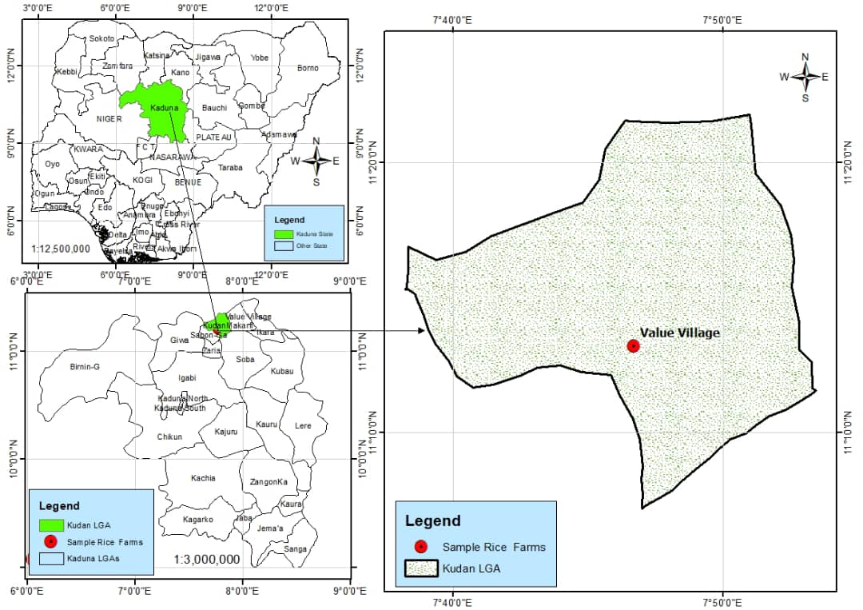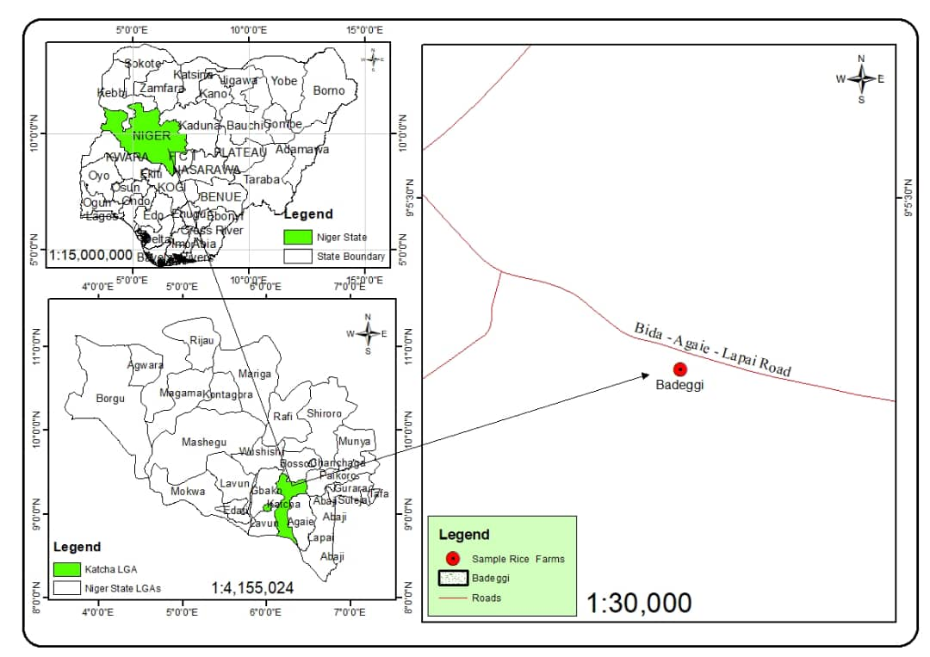

**A**

**B**

**Fig. 1. Geospatial Representation of Rice Farming Research Sites in Kaduna and Niger States, Nigeria**

**Table 1. Monthly Variations in Air Temperature, Relative Humidity, and Rainfall in Badeggi and Zaria**

|  |  |  |  |
| --- | --- | --- | --- |
| **Month** | **AIR TEMPERATURE (°C)** | **RELATIVE HUMIDITY (%)** | **RAINFALL (mm)** |
| **Badeggi** |  |  |  |
| July | 27.07 | 81.24 | 114.22 |
| August | 27.25 | 78.53 | 111.51 |
| September | 26.84 | 82.48 | 241.05 |
| October | 27.09 | 79.59 | 125.25 |
| November | 26.82 | 53.18 | 0.51 |
| December | 26.84 | 40.53 | 0.00 |
| **Zaria** |  |  |  |
| January | 22.4 | 19.5 | 0 |
| February | 25.25 | 15.2 | 0 |
| March | 29.3 | 27 | 6 |
| April | 29.85 | 37.65 | 19.5 |
| May | 29.85 | 52.45 | 170.5 |
| June | 26.35 | 72.05 | 179.9 |
| July | 26.4 | 71.2 | 111.7 |
| August | 25.8 | 76.25 | 321.9 |
| September | 26.85 | 71.55 | 229 |
| October | 26.8 | 50.25 | 7.6 |
| November | 26.4 | 27.85 | 5.6 |
| December | 23.7 | 20.3 | 0 |

**2.2 Experimental Design**

The experiment included four (4) rice hybrids (IR138867H, IR138840H, IR138982H and IR138758H) and three (3) Nigeria commercial checks (FARO 44, Faro 66 and FARO 68) the seven genotypes were sown in a nursery bed and transplanted 21 days later. The trials were laid out in a randomized complete block design with 3 replications. Each treatment was planted in 3 x 4m plot size with 20 x 20 cm intra and inter-row spacing.

**2.3 Determination of Morphological and Yield Data**

The data were recorded on five randomly selected plants from each replication for various quantitative traits studied; Days to first flowering, days to fifty percent flowering, plant height (cm), panicle length (cm), panicle per square meter, number of tillers per plant, days to eighty-five percent maturity, grain length, days to maturity, 1000 grain weight (g) and grain yield (t/ha).

**2.4 Statistical Analysis**

A combined Analysis of Variance (ANOVA) was done for all agronomic traits; Days to first flowering, days to fifty percent flowering, plant height (cm), panicle length (cm), panicle per square meter, number of tillers per plant, days to eighty-five percent maturity, grain length, days to maturity, 1000 grain weight (g) and grain yield (t/ha) across environments using the PROC GLM procedures in SAS 9.2 package (SAS Institute, Cary, NC).

3. results and discussion

3.1 Results

The combined analysis of variance (ANOVA) for four hybrid rice genotypes and three commercial checks revealed significant environmental influences (p < 0.05–0.01) on plant height and panicle length (Table 3). These results indicate that variations in climatic and soil conditions across the study locations had a notable effect on plant architectural traits. However, traits such as panicles per square meter, number of tillers, days to maturity, and grain yield did not exhibit significant location effects, suggesting that these parameters remained stable across environments.

Significant genotypic variations (p < 0.05) were observed for days to flowering, days to 50% flowering, plant height, panicle length, panicles per square meter, 1000-grain weight, days to maturity, and grain yield. The genotype × environment (G×E) interaction effects were significant for panicle length, days to 50% flowering, plant height, and grain yield, indicating differential genotypic responses across locations.

The mean performance of the hybrids and check varieties (Table 3) showed considerable variation in phenological and agronomic traits across locations. The check variety Faro 66 exhibited the longest duration to first flowering (87 days) and 50% flowering (99 days), whereas IR138982H and IR138867H were the earliest to flower (74 and 72 days, respectively). Plant height varied significantly, ranging from 71.33 cm in IR138758H to 92.10 cm in IR138982H, with significant environmental effects observed. Panicle length was longest in IR138982H (26.40 cm) and Faro 68 (26.30 cm), demonstrating genetic influence. Tillering capacity varied, with IR138982H producing the highest panicle density (12.1 panicles/m²). Maturity duration ranged from 86 days in IR138758H to 94 days in Faro 44, highlighting genotypic differences in crop duration.

Days to flowering exhibited a significant G×E interaction, with IR138867H flowering 21 days earlier at Badeggi (61 days) than at Zaria (82 days), demonstrating strong environmental influence on phenological development. Plant height showed a 17.2% reduction in Zaria compared to Badeggi, with IR138867H reaching 98.47 cm in Badeggi but only 81.53 cm in Zaria, likely due to soil and climatic stress. Panicle length was significantly affected by location, with IR138867H showing a 25.5% reduction in panicle length at Zaria (22.00 cm) compared to Badeggi (29.53 cm), suggesting an environmental effect on panicle development. Grain yield demonstrated a strong G×E interaction, with IR138982H achieving the highest yield (7.57 t/ha) at Zaria, while Faro 66 had the lowest yield at Badeggi (3.06 t/ha), reinforcing the importance of location-specific adaptation in hybrid rice performance.

Yield data (Table 4) showed that IR138982H recorded the highest mean grain yield (6.55 t/ha), outperforming the commercial checks with yield advantages of 31.26% over Faro 44, 64.75% over Faro 66, and 22.91% over Faro 68. The second-highest performing hybrid, IR138867H, yielded 6.36 t/ha, with respective yield advantages of 27.47%, 60.2%, and 19.34% over Faro 44, Faro 66, and Faro 68. Conversely, IR138758H had the lowest hybrid yield at 4.14 t/ha, failing to exceed the performance of Faro 68 and demonstrating negative yield advantages of -17.03% compared to Faro 44 and -22.31% relative to Faro 68. Among the check varieties, Faro 68 (5.33 t/ha) was the highest-yielding, surpassing Faro 44 (4.99 t/ha) and Faro 66 (3.97 t/ha), reinforcing that some inbred varieties remain competitive under specific environmental conditions.

**Table 2. Mean square from the analysis of variance of 4 rice hybrids and 3 Checks evaluated for yield and yield component in Badeggi and Zaria during 2024 wet season**

|  |  |  |  |  |  |  |  |  |  |  |  |  |
| --- | --- | --- | --- | --- | --- | --- | --- | --- | --- | --- | --- | --- |
| **SOV** | **Df** | **DTF** | **D50F** | **PLHT (cm)** | **Pan.Lgth (cm)** | **Pan c/m²** | **NoTillers** | **D85%Mat.** | **GL (mm)** | **1000 GW (g)** | **Dmat.** | **GYLD (t/ha)** |
| Rep | 2 | 67.17 | 405.8 | 181.90 | 0.40 | 9.45 | 11.30 | 105.50 | 0.001 | 0.00 | 7.00 | 4.84 |
| Env. | 1 | 572.02ns | 0.00 ns | 344.0** | 101.84** | 7.54 ns | 26.31 ns | 0.00 ns | 0.00 ns | 0.001 ns | 0.00 ns | 2.45 ns |
| Genotypes | 6 | 841.97** | 7847.7** | 515.88** | 32.82** | 10.13 ns | 22.43* | 12905.7** | 0.59** | 0.01** | 7494.2** | 6.21** |
| Env. X Genotype | 6 | 1016.3** | 0.00 | 48.27* | 13.38** | 2.84 ns | 1.87 ns | 0.00 ns | 0.00 ns | 0.00 ns | 0.00ns | 2.81** |
| Error | 26 | 142.35 | 15.3 | 17.64 | 3.61 | 7.27 | 8.61 | 16.90 | 0.000 | 0.00 | 1.90 | 0.76 |
| **Keys**: **\*, \*\*** = Significant at P≤0.05 and P≤0.01 respectively; **NS** = Not Significant; **SOV** = Source of variation; **Df** = Degrees of freedom; **DTF** = Days to flowering; **D50F** = Days to 50% flowering; **PLHT** = Plant height; **Pan.Lgth** = Panicle length; **Pan c/m²** = Panicles per square meter; **NoTillers** = Number of tillers; **D85%Mat.** = Days to 85% maturity; **GL** = Grain length; **1000 GW (g)** = 1000-grain weight; **Dmat**. = Days to maturity; **GYLD** = Grain yield | | | | | | | | | | | | |

**Table 3. Mean performance of 4 rice hybrids and 3 Checks evaluated for yield and yield component in Badeggi and Zaria during 2024 wet season**

|  |  |  |  |  |  |  |  |  |  |  |  |
| --- | --- | --- | --- | --- | --- | --- | --- | --- | --- | --- | --- |
| **Genotypes** | **DTF** | **D50F** | **PLHT (cm)** | **Pan.Lgth (cm)** | **Pan c/m²** | **NoTillers** | **D85%Mat.** | **GL (mm)** | **1000 GW (g)** | **Dmat.** | **GYLD (t/ha)** |
| IR138867H | 72.00ᵇ | 90.00ᶜ | 90.00ᵇ | 25.77ᵃ | 11.80ᵃ | 14.00ᵃ | 115.00ᶜᵈ | 0.81ᵈ | 0.23ᵇ | 91.00ᶜᵈ | 6.36ᵃᵇ |
| IR138840H | 69.00ᵇ | 86.00ᶜ | 90.10ᵇ | 24.97ᵃ | 12.10ᵃ | 14.00ᵃ | 114.00ᶜᵈ | 0.84ᵃᵇ | 0.23ᵇ | 90.00ᵈ | 5.88ᵃᵇᶜ |
| IR138982H | 74.00ᵃᵇ | 96.00ᵇ | 89.97ᵇ | 25.87ᵃ | 12.20ᵃ | 14.00ᵃ | 112.00ᵈ | 0.85ᵃ | 0.25ᵇ | 92.00ᶜ | 6.55ᵃ |
| IR138758H | 71.00ᵇ | 90.00ᶜ | 71.33ᵈ | 21.00ᵇ | 8.60ᵃ | 9.00ᵇ | 118.00ᶜ | 0.82ᵇᶜ | 0.19ᶜ | 86.00ᵉ | 4.14ᵈ |
| Faro 44 | 77.00ᵃᵇ | 105.00ᵃ | 92.10ᵇ | 26.30ᵃ | 12.00ᵃ | 13.00ᵃᵇ | 138.00ᵃ | 0.83ᵇ | 0.25ᵇ | 94.00ᵇ | 4.99ᶜᵈ |
| Faro 66 | 87.00ᵃ | 99.00ᵇ | 83.20ᶜ | 21.33ᵇ | 10.80ᵃ | 11.00ᵃᵇ | 125.00ᵇ | 0.80ᵈ | 0.23ᵇ | 0.00ᶠ | 3.97ᵈ |
| Faro 68 | 48.00ᶜ | 0.00ᵈ | 101.67ᵃ | 26.40ᵃ | 11.70ᵃ | 12.00ᵃᵇ | 0.00ᵉ | 0.00ᵉ | 0.29ᵃ | 102.00ᵃ | 5.33ᵇᶜ |
| MSerror | 142.35 | 4.84 | 17.64 | 3.61 | 7.27 | 8.61 | 16.86 | 0 | 0 | 1.93 | 0.76 |
| CV% | 16.81 | 15.3 | 4.75 | 7.75 | 23.82 | 23.34 | 3.98 | 2.48 | 8.46 | 1.75 | 16.43 |
| **LSD₀.₀₅** | **\*\*** | **\*\*** | **\*\*** | **\*\*** | **NS** | **\*** | **\*\*** | **\*\*** | **\*\*** | **\*\*** | **\*\*** |
|  | | | | | | | | | | | |
| **Environment** | |  |  |  |  |  |  |  |  |  |  |
| Zaria | 74.67 | 80.76 | 85.48 | 22.96 | 11.74 | 11.78 | 103.24 | 0.71 | 0.23 | 79.33 | 5.56 |
| Badeggi | 67.29 | 80.76 | 91.2 | 26.08 | 10.9 | 13.36 | 103.24 | 0.71 | 0.24 | 79.33 | 5.08 |
| MSerror | 142.35 | 4.84 | 17.64 | 3.61 | 7.27 | 8.61 | 16.86 | 0 | 0 | 1.93 | 0.76 |
| CV | 16.81 | 15.3 | 4.75 | 7.75 | 23.82 | 23.34 | 3.98 | 2.48 | 8.46 | 1.75 | 16.43 |
| **LSD₀.₀₅** | **NS** | **NS** | **\*\*** | **\*\*** | **NS** | **NS** | **NS** | **NS** | **NS** | **NS** | **NS** |
| **Key: DTF** = Days to flowering; **D50F** = Days to 50% flowering; **PLHT** = Plant height; **Pan.Lgth** = Panicle length; **Pan c/m²** = Panicles per square meter; **NoTillers** = Number of tillers; **D85%Mat**. = Days to 85% maturity; **GL** = Grain length; **1000 GW (g)** = 1000-grain weight; **Dmat**. = Days to maturity; **GYLD** = Grain yield; **NS** = Not significant; **\*** = Significant at p ≤ 0.05; **\*\*** = Significant at p ≤ 0.01; **CV** = Coefficient of variation; **LSD₀.₀₅** = Least significant difference at 5% probability level; **MSerror** = Mean square error. | | | | | | | | | | | |

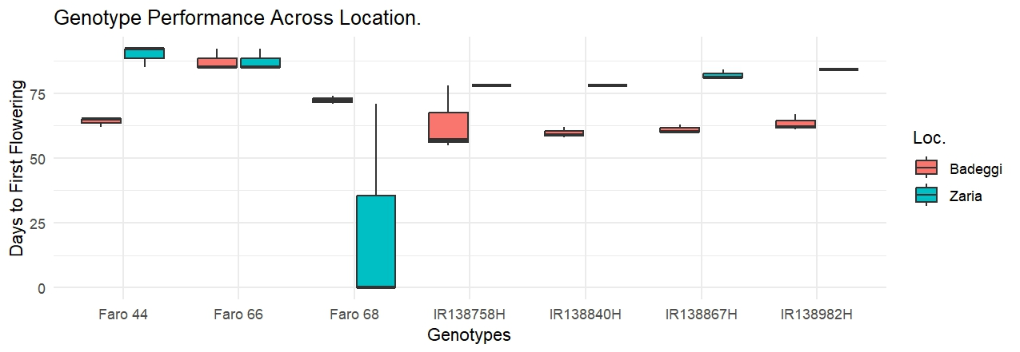

**Fig. 2. Genotype × Environment interaction effects on Days to first flowering in Badeggi and Zaria environment.**

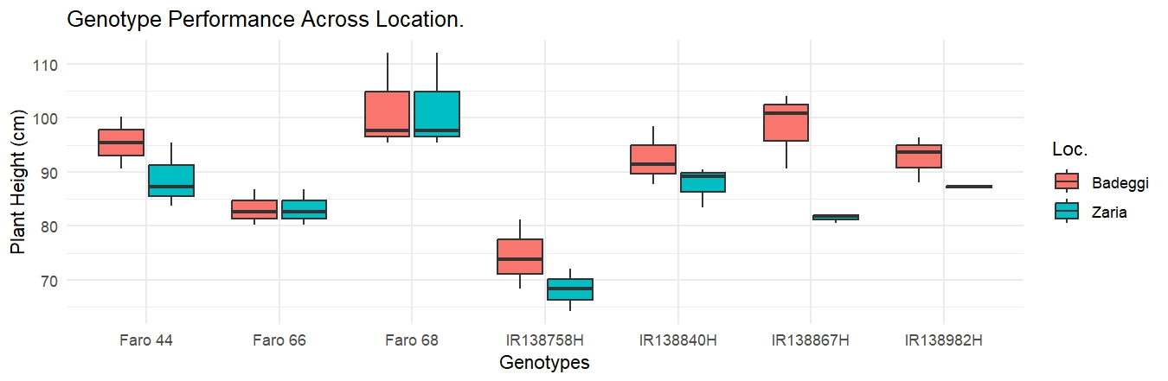

**Fig. 3. Genotype × Environment interaction effects on Plant height (cm) in Badeggi and Zaria environment.**

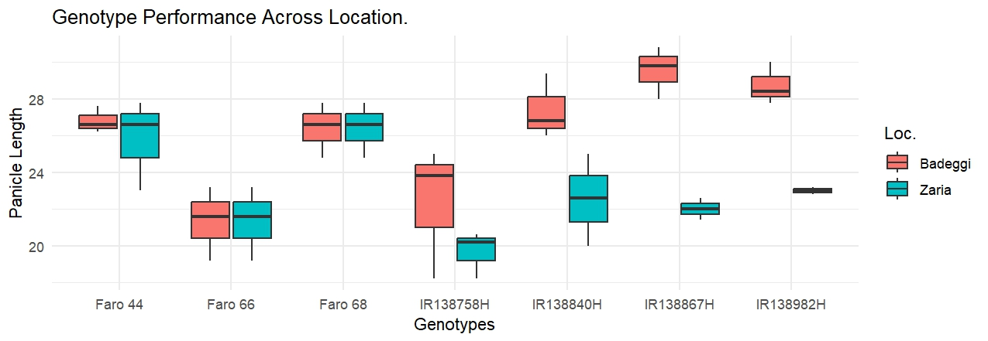

**Fig. 4. Genotype × Environment interaction effects on Plant length (cm) in Badeggi and Zaria environment.**

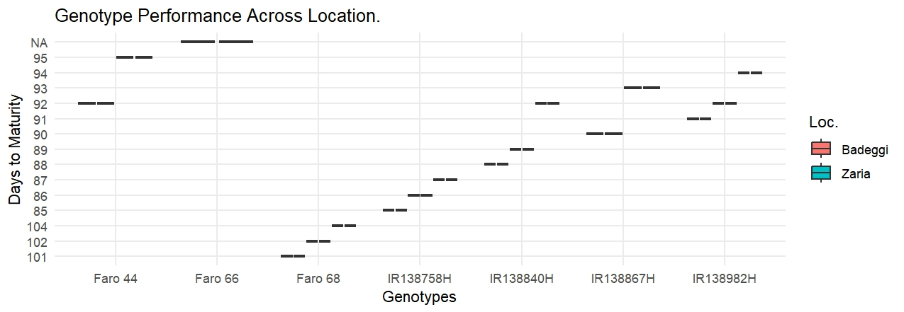

**Fig. 5. Genotype × Environment interaction effects on Days to maturity in Badeggi and Zaria environment.**

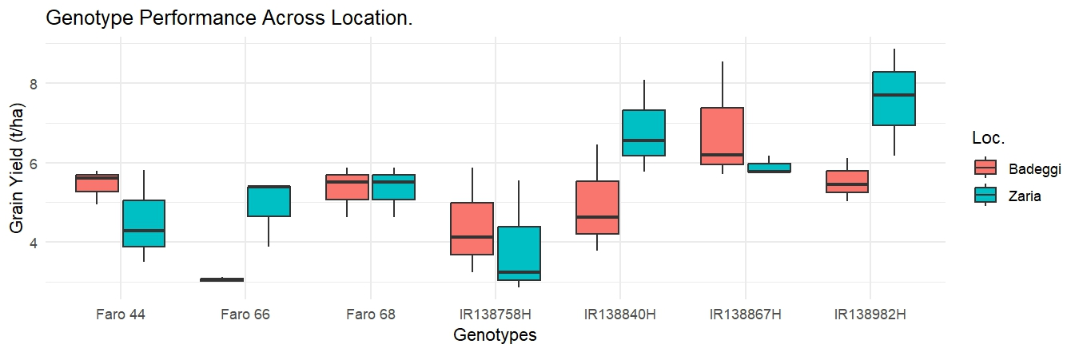

**Fig. 6. Genotype × Environment interaction effects on Grain Yield (t/ha) in Badeggi and Zaria environment.**

**Table 4. Estimates of standard heterosis for rice hybrids**

|  |  |  |  |  |
| --- | --- | --- | --- | --- |
|  |  | **Average yield advantage over check (%)** | | |
| **Hybrids** | **GYLD (t/ha)** | **Faro 44** | **Faro 66** | **Faro 68** |
| IR138867H | 6.36 | 27.47 | 60.2 | 19.34 |
| IR138840H | 5.88 | 17.82 | 48.11 | 10.31 |
| IR138982H | 6.55 | 31.26 | 64.75 | 22.91 |
| IR138758H | 4.14 | -17.03 | 4.28 | -22.31 |
| Check - Faro 44 | 4.99 |  |  |  |
| Check - Faro 66 | 3.97 |  |  |  |
| Check - Faro 68 | 5.33 |  |  |  |
| Grand Mean | 5.32 |  |  |  |
| **CV%** | 16.43 |  |  |  |

3.2 Discussion

The results showed that hybrid rice exhibited superior agronomic performance compared to commercial checks, with IR138982H and IR138867H showing the highest yield advantages. The presence of significant genotypic and environmental effects on flowering time, plant height, and yield-related traits confirms the necessity of environmentally optimized hybrid selection strategies.

The significant environmental effects on plant height and panicle length align with findings by Li et al. (2021) and Zhao et al. (2020), who reported that variations in soil properties, water availability, and temperature influence rice plant architecture. These results suggest that specific hybrids may require tailored agronomic practices in different regions to optimize plant development and grain production.

The significant genotypic variation in flowering time, plant height, and grain yield indicates that genetic factors strongly regulate phenotypic expression across environments. These findings are consistent with those of Khan et al. (2023), who observed substantial genetic diversity in yield-related traits across rice genotypes. The superior yield performance of IR138982H and IR138867H aligns with previous research on hybrid rice (Durand-Morat et al., 2011; Yuan et al., 2024). These hybrids' ability to outperform checks by over 30% confirms the yield-boosting potential of heterosis and supports hybrid deployment for food security in Nigeria.

The significant G×E interactions for flowering time, plant height, and yield reinforce the need for location-specific hybrid selection. Moreira et al. (2020) emphasized that high-throughput phenotyping and environmental modeling can enhance understanding of such interactions, allowing breeders to develop hybrids tailored to specific agro-ecological zones. The yield disparity between IR138982H (6.55 t/ha) and Faro 66 (3.06 t/ha) at different sites underscores the importance of targeted varietal deployment based on agro-ecological conditions.

Furthermore, the superior yield of Faro 68 over IR138758H suggests that improved inbred varieties can still outperform low-performing hybrids under specific environmental conditions (Niang et al., 2017b). This points out the necessity of hybrid adaptation trials before widespread commercialization. While hybrid adoption is critical for boosting national rice productivity, the results indicate that not all hybrids consistently outperform inbred checks, suggesting that both hybrids and improved inbreds have roles in sustainable rice production.

4. Conclusion

The findings from this study revealed that hybrid rice varieties exhibited significant variability in agronomic traits, including days to maturity and grain yield, across different environments in Nigeria. The hybrid IR138982H showed better performance in terms of early flowering (74 days), shorter maturity duration (86–87 days), and highest grain yield (6.55 t/ha), making it a promising candidate for large-scale adoption, particularly in short-season agro-ecologies. The significant genotype × environment (G×E) interactions observed, particularly for flowering time and grain yield, validates the importance of environmental adaptation in hybrid rice selection. For successful hybrid adoption, further multi-season evaluations, seed production improvements, and participatory trials with farmers is recommended to maximize yield potential and ensure economic viability for smallholder farmers.

**COMPETING INTERESTS DISCLAIMER:**

Authors have declared that they have no known competing financial interests OR non-financial interests OR personal relationships that could have appeared to influence the work reported in this paper.

References

Cooper, M., & Somrith, B. (1997). Implications of genotype-by-environment interactions for yield adaptation of rainfed lowland rice: Influence of flowering date on yield variation. In S. Fukai, M. Cooper, & J. Salisbury (Eds.), Breeding strategies for rainfed lowland rice in drought-prone environments (pp. 104–114). Australian Centre for International Agricultural Research.

Durand-Morat, Alvaro, Wailes, Eric J., & Chavez, Eddie C. (2011). Hybrid rice and its impact on food security and the pattern of global production and trade. Paper presented at the Southern Agricultural Economics Association, Corpus Christi, TX.

Dushyantha Kumar, B. M., Purushottam, A. P., Raghavendra, P., Vittal, T., Shubha, K. N., & Madhuri, R. (2020). Genotype-environment interaction and stability for yield and its components in advanced breeding lines of red rice (Oryza sativa L.). Bangladesh Journal of Botany, 49(3), 425–435.

Hossain, M., Janaiah, A., & Husain, M. (2003). Hybrid rice in Bangladesh: Farm-level performance. The Bangladesh Development Studies, 29(2), 35–66.

Ibrahim, A., & Saito, K. (2022). Assessing genetic and agronomic gains in rice yield in sub-Saharan Africa: A meta-analysis. Field Crops Research, 287, 108652. <https://doi.org/10.1016/j.fcr.2022.108652>

Janaiah, A., & Hossain, M. (2000). Hybrid rice for food security in the tropics: An evaluation of farm-level experiences. Paper presented at the 3rd International Symposium on Hybrid Rice, Directorate of Rice Research, Hyderabad, India.

Khan, M. A. R., Mahmud, A., Ghosh, U. K., Hossain, M. S., Siddiqui, M. N., Islam, A. K. M. A., Anik, T. R., Rahman, M. M., Sharma, A., Abdelrahman, M., Ha, C. V., Mostofa, M. G., & Tran, L.-S. P. (2023). Exploring the Phenotypic and Genetic Variabilities in Yield and Yield-Related Traits of the Diallel-Crossed F5 Population of Aus Rice. Plants, 12(20), 3601. <https://doi.org/10.3390/plants12203601>

Li, H., Wang, X., Chen, L., & Zhang, Q. (2021). Environmental regulation of rice plant architecture: From phenotype to molecular mechanisms. Journal of Experimental Botany, 72(4), 1203–1218.

Li, Y., Gao, Z., Chen, Q., & Zhu, X. (2020). Source-sink relationship and its effect on yield formation in rice. Journal of Integrative Agriculture, 19(1), 45–56.

Mahalingam, A., Saraswathi, R., Robin, S., Marimuthu, T., Jayaraj, T., & Ramalingam, J. (2013). Genetics of stability and adaptability of rice hybrids (Oryza sativa L.) for grain quality traits. African Journal of Agricultural Research, 8 (22), 2673–2680. <https://doi.org/10.5897/ajar12.1035>

**Mao, C. X. (2001).** Improving seed production to speed up the global commercialization of hybrid rice. In S. Peng & B. Hardy (Eds.), Rice research for food security and poverty alleviation (p. 692). Proceedings of the International Rice Research Conference, 31 March–3 April 2000, International Rice Research Institute, Los Baños, Laguna, Philippines.

Molina, J., Sikora, M., Garud, N., Flowers, J. M., Rubinstein, S., Reynolds, A., Huang, P., Jackson, S., Schaal, B. A., Bustamante, C. D., Boyko, A. R., & Purugganan, M. D. (2011). Molecular evidence for a single evolutionary origin of domesticated rice. Proceedings of the National Academy of Sciences, 108(20), 8351–8356.

Mongiano, G., Titone, P., Pagnoncelli, S., Sacco, D., Tamborini, L., Pilu, R., & Bregaglio, S. (2020). Phenotypic variability in Italian rice germplasm. *European Journal of Agronomy*, *120*, 126131. https://doi.org/10.1016/j.eja.2020.126131

Moreira, F. F., Oliveira, H. R., Volenec, J. J., Rainey, K. M., & Brito, L. F. (2020). Integrating high-throughput phenotyping and statistical genomic methods to genetically improve longitudinal traits in crops. Frontiers in Plant Science, 11, 681.

Niang, A., Becker, M., Ewert, F., Dieng, I., Gaiser, T., Tanaka, A., Senthilkumar, K., Rodenburg, J., Johnson, J., Akakpo, C., Segda, Z., Gbakatchetche, H., Jaiteh, F., Bam, R. K., Dogbe, W., Keita, S., Kamissoko, N., Mossi, I. M., Bakare, O. S., ... Saito, K. (2017b). Variability and determinants of yields in rice production systems of West Africa. Field Crops Research, 207, 1–12. <https://doi.org/10.1016/j.fcr.2017.02.014>

Santiaguel, A. F., & Quipot, L. M. (2012). Hybrids head for the tropics. Rice Today, 11(3), 40–41.

Statista. (2024). Production volume of paddy rice in Nigeria from 2010 to 2023. Retrieved from <https://www.statista.com/statistics/1300736/production-volume-of-paddy-rice-in-nigeria/>

USDA Foreign Agricultural Service. (2023). Nigeria grain and feed update. Retrieved from <https://www.fas.usda.gov/data/nigeria-grain-and-feed-update-6>

Wang, X., Chang, X., Ma, L., Bai, J., Liang, M., & Yan, S. (2023). Global and regional trends in greenhouse gas emissions from rice production, trade, and consumption. Environmental Impact Assessment Review, 101, 107141.

Wei, X., et al. (2021). Flowering time regulation in rice: Integration of genetic and environmental signals. Journal of Experimental Botany, 72(8), 2833–2847.

Yang, W., Gao, M., Yin, X., Liu, J., Xu, Y., & Li, X. (2022). The coordinated regulation mechanism of rice plant architecture and stress tolerance: A review. Frontiers in Plant Science, 13, 1087378.

Yuan, R., Mao, Y., Zhang, D., Wang, S., Zhang, H., Wu, M., Ye, M., & Zhang, Z. (2024). The formation of rice tillers and factors influencing it. Agronomy, 14(12), 2904. <https://doi.org/10.3390/agronomy14122904>

Zhang, L., Zhang, F., Zhou, X., Poh, T. X., Xie, L., Shen, J., Yang, L., Song, S., Yu, H., & Chen, Y. (2022). The tetratricopeptide repeat protein OsTPR075 promotes heading by regulating florigen transport in rice. The Plant Cell, 34(10), 3632–3646.

Zhang, Y., Zhang, B., Yan, D., Dong, W., Yang, W., Li, D., & Wu, W. (2022). Natural variation in the Tn1a promoter regulates tillering in rice. Plant Biotechnology Journal, 20(9), 1723–1735.

Zhao, C., Zhang, Y., & Du, J. (2020). Crop phenomics: Current status and perspectives. Plant Phenomics, 2020, 8674209.