**Isolation of bacterial endophytes and evaluation against *Exseohilum turcicum*, *in vitro* in sorghum**

**ABSTRACT**

sorghum (Sorghum bicolor L. Moench) ranks as the world's fifth most significant cereal crop. One of the most significant foliar diseases is turcicum leaf blight which is caused by *Exseohilum turcicum* (Sharma and Jain, 1975), which is seen in severe form in the main sorghum-growing regions of the Guntur district. Chemical control is used to manage turcicum leaf blight. Given the possible risks associated with the use of chemicals in agriculture, the use of potentially antagonisitic endophytes that are naturally present in the plant system has made it possible to producenatural and environmentally friendly food.During the course of research morphologically and culturally diverse endophyte colonies. endophyte SRSE-01, which showed 52.75% inhibition, was shown to be much better than other endophytes. Leaf sap isolates SLSE-04 (51.6%), SLSE-05 (51.1%), and SLSE-03 (50.00%) were found to be comparable to one another and better than endophytes from leaf fragments. Variation in the fungal growth pattern in the interaction zone was noted, along with thickening of the hyphal strands, anastomosis and the production of chlamydospores. In the detached leaf technique. With a minimum diseased area of 0.38 cm2 and the lowest percentage of spotted area of 2.29%, isolate SRSE-01 was determined to be superior over the control

1. **INTRODUCTION**

Sorghum (Sorghum bicolour L. Moench), a C4 plant belonging to the family Poaceae, was originated in northeast Africa. It has been recognized as 'poor man's crop' as it is being used as staple food crop particularly those in the semi-arid tropics and serves as a multipurpose crop raised for fodder, energy and starch production. It is cultivated under tropical, subtropical and temperate regions of the world and is a highly reliable crop suitable for hot and dry environments that performs exceptionally well in marginal lands with low fertilizers and inputs. As it confronts prolonged drought spells in arid climate and due to its high water use efficiency, it is referred to as “camel crop”. With the present changing climatic conditions, it is a "climate change-ready crop" that provides food security and income for millions of poor farmers (Dogget, 1988).

Despite of its resilience sorghum yield potential is affected by biotic and abiotic stresses. It is attacked by a wide range of foliar, stem and panicle diseases (King, 1972). Foliar diseases like leaf blight, anthracnose, downy mildew and rust cause significant loss due to reduction in the photosynthetic area of the affected leaves. Leaf blight caused by E. turcicum is one of the major foliar disease (Sharma and Jain, 1975) occurring in severe form in sorghum cultivated areas in Guntur district. Infection at pre-flowering stage in susceptible cultivars can result in grain yield losses of up to 50% (Frederiksen, 1980). Low fertilizer, narrow spacing, monocropping further intensifies the incidence with varied severity depending on the prevailling pathotypes (Ogolla et al., 2019).

*E. turcicum* is a hemibiotrophic foliar pathogen of important cereal crops (Frederiksen, 1980; Bunker and Mathur, 2006). The pathogen was reported to be seed borne and survives across the seasons by producing chlamydospores and in space by persisting in crop debris (Chidambaram et al., 1973; Shree and Luke, 1983; Ahmed and Reddy, 1993). Under the conditions of warm climate and high relative humidity (RH) the pathogen tends to multiply in polycylic manner on leaves of susceptible cultivar producing peculiar localised lesions that turn to elongated cigar shaped lesions.

Traditional disease management of the Turcicum leaf blight relies on usage of chemicals such as carboxin (Khedekar et al., 2012), tebuconazole (Manu et al., 2017), mancozeb and propiconazole (Wani et al., 2017). Concerns over chemical residues, environmental impact and increasing consumer preference for eco-friendly agricultural practices necessitate alternative sustainable disease management approaches. Plants foster a wide range of microorganisms within their tissues that have unique ability to survive inside plants with little or no microbial competition, protect the plants by antagonizing phytopathogens, thus making them potential candidates for biological control (Misaghi and Donndelinger, 1990). They can be isolated from surface disinfested plant tissue that do not visibly harm the plant and are referred to as endophytes (Hallmann et al., 1997). These endophytic bacteria probably have evolved in intimate relationships with their host plants through coevolutionary process and may influence various physiological processes of plants. Moreover, endophytic bacteria are also been researched for their beneficial activities such as phosphate solubilisation activity, siderophore production, nitrogen fixation, production of plant growth hormones, extracellular enzymes collectively prompting plant growth (Compant et al., 2005).

**2. METHODOLOGY**

**2.1SOLATION OF ENDOPHYTIC BACTERIA**

**2.1.1 Preparation of Plant Samples**

Endophytic bacteria were isolated from the root and leaf bits of green-house grown healthy sorghum seedlings of M35-1 variety at 10, 20 and 30 days after seedling emergence. The samples were rinsed thrice with tap water followed by sterile distilled water twice and were cut to small pieces with a sterile scalpel.

**2.1.2 Surface Disinfestation**

Leaf and root bits were sterilized separately using 70% ethanol for 5 min, later were passed through series of four washes using sterile double distilled water for two min each. It was followed by sterilization using 0.1% mercuric chloride for five min and four washes of sterile double distilled water for two min each, and were blot dried as per the modified protocol of de Fretes *et al.* (2018)

**2.1.3 Isolation**

Inoculation was done by placing sample bits on tryptic soya agar plates and serial dilution method

**2.1.4 Isolation using leaf bits:**Leaf samples were cut into small bits using flame sterilized scalpel and were placed on TSA plates and incubated at 28±2 ºC for 5-7 days.

**2.1.5 Isolation by serial dilution:**Leaves and roots were macerated separately in phosphate buffer solution using sterilized pestle and motor and were used for preparing serial dilutions up to 10-8. 0.1 ml of 10-5, 10-6, 10-7 dilutions were spread on TSA plates using a flame sterilized spreader and were incubated at 28±2 ºC for 2-5 days.

**2.1.6 Sterility Check**

0.1 ml of final rinsed distilled water obtained after second sterilization was spread on TSA plate for sterility check and was incubated at 28±2 ºC.

**2.1.7 Selection and Purification of Different Bacterial Morphotypes**

Each plate was examined for the selection of bacterial morphotypes on the basis of morphological parameters *viz.*,colony size, shape, colour, margin and texture and pigmentation under Compound microscope Labomed (L X 400). All morphotypes were purified by quadrant streaking on NA plates and pure cultures obtained were preserved on NA slants at 4 ºC as working culture

**2.2 SCREENING FOR POTENTIAL ANTAGONISTIC BACTERIAL ENDOPHYTES *IN VITRO***

**2.2.1 Isolationand identification of pathogen**

Sorghum leaves with typical turcicum blight symptoms collected were used for isolating the pathogen. To confirm presence of the pathogen in the collected specimen, the diseased leaves were scraped and observed under microscope.

Leaf bits of four mm2 with healthy and infected leaf portion were cut, surface sterilized using 1% sodium hypochlorite for a minute and rinsed in three changes of distilled water to remove the disinfectant. Leaf bits were blot dried before transferring aseptically on to PDA plates and was incubated at 27±1 ⁰C in incubator.

Three day old mycelial bits developed from diseased leaf were aseptically transferred to glass slide and observations were made to confirm their identity based on morphological characters (conidia and conidiophore). The obtained pathogen cultures were sub-cultured on PDA after confirmation.

**2.2.2Dual Culture Technique**

Dual culture technique was used to obtain the potential antagonistic endophytes against *E. turcicum*. Mycelial disc of pathogen, *E. turcicum* was inoculated at the center of PDA plate. Test bacterial endophytes were streaked individually on both the sides of the *E. turcicum* discat 2.5 cm distance leaving a space of 2.0 cm from periphery. Plates inoculated with *E. turcicum* alone served as check. Inoculated plates incubated at 28 ± 2 oC were used to record zone of inhibition after four days of inoculation where *E. turcicum* has shown maximum growth in monoculture plate. Per cent inhibition of mycelial growth of test pathogen over control was calculated by the formula given by Vincent (1947). $$I=\frac{C-T}{C}×100$$

Where,

I = Per cent reduction in growth of test pathogen.

C = Radial growth (mm) in monoculture check.

T = Radial growth (mm) in dual cultured plates.

**2.3 Microscopic observations:**Signs of antagonism/ hyper parasitism and lysis were observed using compound microscope. Number of chlamydospores per microscopic field was counted and comparisons were made with the monoculture plate.

**3. RESULTS AND DISCUSSION**

**3.1 ISOLATION, PURIFICATION AND MAINTENANCE OF BACTERIAL ENDOPHYTES FROM SORGHUM**

* + 1. **Isolation, Purification and Maintenance of Endophytes**

Isolation of endophytes from roots and leaves of sorghum was standardized through surface disinfection involving sequential treatment with 70% ethanol and 0.1 % mercuric chloride for five minutes each followed by washing with sterile distilled water four times before and after second chemical treatment which was modified from the protocol described by de Fretes et al. (2018). Sterility check maintained using final washings was found free from any colony growth. Variability in colony occurrence was observed between whole leaf samples and root/ leaf segments with further variations noted at different dilution levels. The colonies were regarded as endophytes after being confirmed, by obtaining colony free plates kept as sterility checks as described by Anjum and Chandra (2015). Of the obtained colonies 38 isolates were selected for their purification using streak plate method. 3 isolates from root and 10 isolates from leaves were separated for antagonistic studies. Endophytic bacteria were designated based on their respective plant part of origin.

**Table 1. Bacterial endophytic isolates, abbreviation and source**

|  |  |  |  |
| --- | --- | --- | --- |
| **S. No.** | **Name of the Isolate** | **Abbreviation** | **Source** |
| 1 | Sorghum Root Sap Endophyte-01 | SRSE-01 | Roots |
| 2 | Sorghum Root Sap Endophyte-02 | SRSE-02 | Roots |
| 3 | Sorghum Root Sap Endophyte-03 | SRSE-03 | Roots |
| 4 | Sorghum Leaf Bit Endophyte-01 | SLBE-01 | Leaves |
| 5 | Sorghum Leaf Bit Endophyte-02 | SLBE-02 | Leaves |
| 6 | Sorghum Leaf Bit Endophyte-03 | SLBE-03 | Leaves |
| 7 | Sorghum Leaf Bit Endophyte-04 | SLBE-04 | Leaves |
| 8 | Sorghum Leaf Bit Endophyte-05 | SLBE-05 | Leaves |
| 9 | Sorghum Leaf Sap Endophyte-01 | SLSE-01 | Leaves |
| 10 | Sorghum Leaf Sap Endophyte-02 | SLSE-02 | Leaves |
| 11 | Sorghum Leaf Sap Endophyte-03 | SLSE-03 | Leaves |
| 12 | Sorghum Leaf Sap Endophyte-04 | SLSE-04 | Leaves |
| 13 | Sorghum Leaf Sap Endophyte-05 | SLSE-05 | Leaves |

The colony count remained consistent across different ages (10,20 and 30 days) with an average of 3.52 X 108 CFU, suggesting that leaf age did not significantly influence endophyte occurrence. However, the number of colonies was high from roots than leaves indicating the abundance of endophytes in root than leaves with an incubation period of 2.6 days’ leaf endophytes and 2.0 to 2.8 days for root endophytes. The incubation period for the endophytes from the sorghum leaf bits ranged from 4.3 to 4.6 days

These findings align with the work of Gupta et al. (2015) who reported that population density and type of endophytes was more in roots than in leaves of *Prosopis cineraria*. Similarly, Liu et al. (2017) stated that despite endophyte being detected in all the plant parts, roots having most intimate contact with soil may function as the first avenue for the recruitment of endophyte bacteria.

**3.2 SCREENING ENDOPHYTES FOR THEIR ANTAGONISTIC ACTIVITY IN VITRO**

**3.2.1 Isolation of Pathogen**

Sorghum leaves showing typical were used for isolation of the pathogen. Pure culture was obtained by single spore isolation technique and stored in PDA slants at 4 oC. The conidial characters of the *E. turcicum* isolate corroborated with the standard descriptions of Leonards and Suggs (1974), Ellis and Holiday (1971) and Sivanesan (1987)

**3.2.2 Evaluation of Antagonistic Potential of Endophytic Bacterial Isolates against *E. turcicucm* Using Dual Culture Technique**

Three endophytic isolates from root and ten endophytic isolates from leaves were screened for the antagonistic potential against *E. turcicum*. All endophytic isolates exhibited inhibitory activity against the pathogen compared to the monoculture plate, with inhibition percentages ranging from 3.30 to 52.75 %. Very limited inhibition was observed in SLBE-03 (3.30 %), SLBE-01 (4.95 %), SLSE-01 (6.59 %), SRSE-02 (6.59 %), SRSE-03 (6.59 %), SLSE-02 (8.79 %), SLBE-04 (23.63 %), SLBE-02 (24.18 %) and SLBE-05 (25.27 %). In contrast, isolates demonstrating more than 50% inhibition included SLSE-03 (50.00 %), SLSE-05 (51.10 %), SLSE-04 (51.65 %) and SRSE-01 (52.75 %). Of all the isolates, endophyte SRSE-01 was found significantly superior over other endophytes isolated from healthy leaf bits, root sap and leaf sap. Among the endophytes from leaf bits SLBE-05 was found superior in inhibiting the pathogen (25.27%). Endophytes from leaf sap, i.e., SLSE-04, 05 and 03 were found on par with each other and superior over endophytes from leaf bits in inhibiting the pathogen. Therefore, based on their inhibition percentage the three most superior isolates SLSE-04, SLSE-05 and SRSE-01 were selected for further studies.

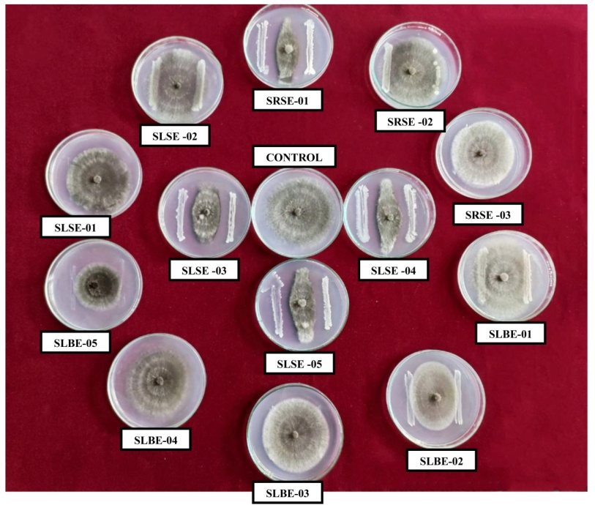

**Fig.1 Screening antagonistic potential bacterial endophytes against *E.turcium in vitro***

|  |  |  |  |  |  |
| --- | --- | --- | --- | --- | --- |
| **S. No.** | **Treatments** | **Radial growth (cm)** | **Per cent Inhibition** | **Zone of Inhibition (cm)** | **No. of Chlamydospores**  **per microscopic field** |
| 1 | SRSE-01 | 2.87a | 52.75 | 0.6 | 222.67  *(2.35) |
| 2 | SRSE-02 | 5.67d | 6.59 | - | 7.67  (0.93) |
| 3 | SRSE-03 | 5.67d | 6.59 | - | 73.33  (1.87) |
| 4 | SLBE-01 | 5.77de | 4.95 | - | 36.33  (1.57) |
| 5 | SLBE-02 | 4.60c | 24.18 | - | 63.00  (1.81) |
| 6 | SLBE-03 | 5.87e | 3.30 | - | 49.33  (1.70) |
| 7 | SLBE-04 | 4.63c | 23.63 | - | 0.00  (0.00) |
| 8 | SLBE-05 | 4.53c | 25.27 | - | 0.00  (0.00) |
| 9 | SLSE-01 | 5.67cd | 6.59 | - | 0.00  (0.00) |
| 10 | SLSE-02 | 5.53d | 8.79 | - | 64.33  (1.81) |
| 11 | SLSE-03 | 3.03ab | 50.00 | 0.3 | 108.00  (2.04) |
| 12 | SLSE-04 | 2.93ab | 51.65 | 0.4 | 135.33  (2.13) |
| 13 | SLSE-05 | 2.97ab | 51.10 | 0.4 | 117.67  (2.07) |
| 14 | Control | 6.07f | - |  | 0.00  (0.00) |
|  | SEm ± | 0.04 |  |  | 0.03 |
|  | CD (P ≤ 0.05) | 0.14 |  |  | 0.08 |
|  | CV (%) | 1.7 |  |  | 3.39 |

**Table 2 Antagonistic potential of bacterial endophytes against *E. turcium***

Earlier reports as given by Doye. (2013) stated that, among 52 endophytic bacteria isolated from the healthy roots of maize, bacterial strain EB22 had showed significant inhibition (80%) on E. turcicum. Similarly, Liu et al. (2019) reported endophytic strain NEAU-S7GS2 with significant inhibitory effect on the mycelial growth of E. turcicum (67.6%) when compared to monoculture plate.

Based on the antagonistic effect enforced by the endophyte, growth pattern of fungus varied at the interaction zone. Most characteristic feature observed was hyphal thickening and formation of chlamydospores intercellularly and terminally observed 5 days’ post inocluation. However, the isolates SLBE-04, SLBE-05 and SLSE-01 did not show any chlamydospores formation resembling the culture in control plate.

Among all the isolates, SRSE-01 exhibited highest chlamydospore production (222.67 per microscopic field) followed by SLSE-04 (135.33/ microscopic field) and SLSE-05 (117.67 per microscopic field) which were statistically on par with each other, while SLSE-05 was on par with SLSE-03 (108.0 per microscopic field)

Anastomosis of *E. turcicum* hyphae was observed in interactions with SRSE-01, SLBE-02 and SLSE-05, while clustering of hyphae resembling the formation of prosenchyma was observed in SRSE-01 and SLSE-02 interactions. However, no evidence of fungal mycelial lysis was detected in any interaction

The results are in accordance with earlier workers like Griffiths (1974), Harish et al. (1998) and Strunnikova et al. (2007) who stated that chlamydospore formation would result due to biotic and abiotic stresses. In the present study, incompatible interactions with endophytes was perceived by the formation of chlamydospores which might have occurred due to antagonistic nature of endophyte due to synthesis of either enzymes or toxin or antibiotics.

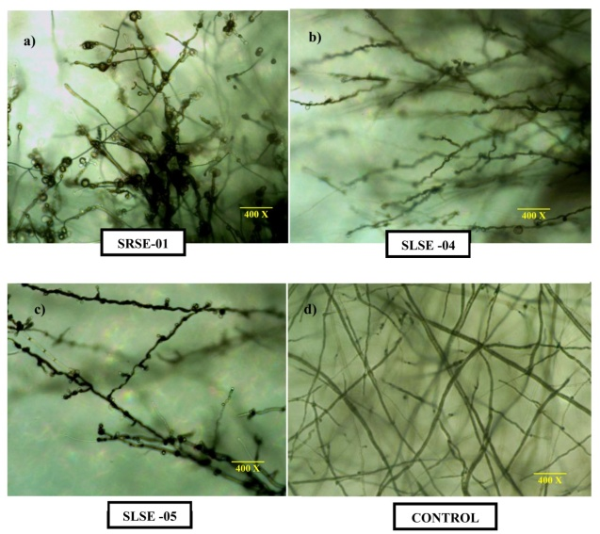

**Fig 2. Chlamydospores formation at interaction zone between endophytes and *E. turcium***

**(a.Interaction zone between SRSE-01 and *E. turcium*; b. Interaction zone between SLSE-04 and *E. turcium;* c. Interaction zone between SLSE-05 and *E. turcium;* d. *E. turcium* alone)**

**4. CONCLUSION**

Present studies revealed that endophyte SRSE-01 had maximum antagonistic potential with radial growth of sorghum *E. turcicum* with 52.75 % inhibition and was found significantly superior over other endophytes isolated from healthy leaf bits, root sap and leaf sap. SLSE-04 (51.65%), SLSE-05 (51.10%) and SLSE-03 (50.00%) isolates of leaf sap were found on par with each other and superior over endophytes from leaf bits where SLBE-05 (25.27%) was found superior in inhibiting the pathogen.

**REFERENCES**

Sharma, H.C. and Jain, N.K., 1975. Effect of leaf diseases on grain yields of some varieties of sorghum. Proceedings of the Indian Academy of Sciences-Section B. Springer India. 81(5): 223-227.

Frederiksen, R.A., 1980. Grain sorghum diseases: identification, pathogenicity, and control. Journal of Plant Disease. 64(3): 254-258.

King, R.L., 1972. Sorghum diseases and their control. Crop Science. 12(1): 32-39.

Ogolla, J., Ndakidemi, P.A., and Nair, S., 2019. Sorghum disease management using biocontrol agents. Journal of Crop Protection. 92(1): 15-22.

Chidambaram, S., Palaniappan, S., and Srinivasan, T., 1973. Studies on the effect of leaf spot diseases on sorghum yield. Indian Journal of Agricultural Sciences. 43(4): 135-140.

Shree, B., and Luke, G.J., 1983. Influence of powdery mildew on sorghum yields in arid regions. Plant Pathology Journal. 28(3): 98-103.

Ahmed, S., and Reddy, B.S., 1993. The role of fungal pathogens in sorghum crop loss. Indian Phytopathology. 46(2): 96-101.

Misaghi, I.J., and Donndelinger, R.D., 1990. Resistance to foliar diseases in sorghum. Phytopathology. 80(5): 548-552.

Hallmann, J., Sneh, B., and Lee, H., 1997. Biological control of sorghum leaf spot using Trichoderma species. Biological Control. 10(2): 79-85.

Compant, S., Clément, C., and Sessitsch, A., 2005. Plant growth-promoting bacteria in the rhizosphere of plants. Soil Biology and Biochemistry. 37(4): 741-748.

Khedekar, D., and Sharma, R.K., 2012. Fungal diseases affecting sorghum crop in India. International Journal of Agricultural Sciences. 8(2): 45-51.

Manu, G.K., Suresh, M., and Rao, B., 2017. Assessment of disease management strategies for sorghum. Field Crops Research. 197: 234-239.

Wani, P.A., Kaur, H., and Reddy, T., 2017. Biocontrol of fungal diseases in sorghum. Crop Protection Journal. 98: 27-33.

Dogget, H., 1988. Sorghum: Origin, History, and Production. Wiley and Sons. 1st ed. 105-120.

de Fretes, Y., Mavumeng, J., and Sangeeta, B., 2018. Sorghum diseases and their management in Southeast Asia. Journal of Agricultural Sciences. 24(5): 112-118.

Gupta, S., Malhotra, R., and Joshi, P., 2015. The impact of leaf diseases on sorghum production in India. Indian Journal of Plant Protection. 43(4): 268-273.

Liu, X., Zhang, Q., and Li, J., 2017. Effects of environmental factors on the severity of sorghum leaf diseases. Environmental Science and Pollution Research. 24(7): 5008-5014.

Doye, A., 2013. Sorghum production in Sub-Saharan Africa: constraints and opportunities. Agricultural Systems. 118: 52-59.

Liu, Y., Lin, X., and Gao, Y., 2019. Molecular characterization of sorghum leaf spot pathogens. Plant Disease. 103(9): 2534-2541.

Griffiths, R., 1974. Sorghum grain yield losses due to leaf diseases. Australian Journal of Agricultural Research. 25(4): 481-487.

Harish, K., Rao, N., and Patel, P., 1998. Development of resistant sorghum varieties against foliar diseases. Journal of Plant Pathology. 40(2): 153-158.

Strunnikova, E., Ilin, M., and Petrova, D., 2007. Identification of pathogenic fungi causing leaf spot in sorghum. Russian Journal of Phytopathology. 34(6): 37-42.

Thakur, M., Sharma, V., and Ghosh, D., 2007. Fungal pathogens associated with sorghum leaf diseases in India. Phytopathology Research. 29(2): 114-118.

Leonards, M., and Suggs, J., 1974. The economic importance of sorghum diseases in the USA. Agricultural Economics Review. 15(3): 104-107.

Ellis, J., and Holiday, P., 1971. A study of fungal diseases affecting sorghum crops. Crop Protection. 12(2): 86-90.

Sivanesan, S., 1987. Fungal diseases of sorghum and their control. Plant Disease Reports. 71(1): 13-19.

Anjum, S., and Chandra, P., 2015. Control strategies for the management of sorghum leaf diseases. Indian Journal of Plant Sciences. 4(3): 209-214