Original Research Article
Bacterial Load and Antimicrobial Resistant Genes in Bacteria Isolated from African Salad Consumed in Port Harcourt, Nigeria

ABSTRACT
Background: The rising prevalence of foodborne infections poses serious challenge due to the development of antimicrobial resistant strains. Aim: This study aimed to evaluates the prevalence of antimicrobial resistant bacteria and their resistant genes in African salad commonly consumed in West Africa. Methods: The study used a cross-sectional approach to sample the food from different vendors across the two major local government areas (LGAs) in the Port Harcourt Metropolis: Obio/Akpor and Port Harcourt City. Conventional and molecular techniques were used to isolate pathogens and detect the resistance genes. Results: The findings from this study showed the most prevalent bacteria was Proteus mirabilis 3 (27.3%) with Peter Odili Road (98.6±62.5 CFU/ml) as the location with the highest bacterial load while Borokiri (36.9±34.0 CFU/ml), had the lowest level of bacterial loads. The microbial load based on the local government area showed Obio/Akpor (65.6±51.7 CFU/ml) has the higher microbial load than Port Harcourt City (63.1±47.7 CFU/ml). The bacterial isolated showed the highest MAR indices in Woji (0.65±0.20) and the lowest indices in Ikoku (0.39±0.17). The average MAR indices of bacteria in Obio/Akpor (0.56±0.16) were marginally higher than those bacteria in Port Harcourt City Local Government (0.54±0.19). Proteus species and Providentia huaxiensis had the highest level of MAR indices ranging from 0.73 to 0.80 for Proteus species and 0.8 for Providentia huaxiensis. The prevalence of betalactamase genes that were detected. There was a significant burden (p=0.0002) of the bla_{TEM} gene observed in the Obio/Akpor LGA 7 (63.4%) than the PHC LGA 4 (36.6%). Conclusion: Overall, antibiotic resistance bacteria in Abacha tend to be present in remote towns with high human activities.

Keywords: Foodborne pathogens, antibiotic resistance, African salad

1. INTRODUCTION

African salad is a ready to eat (RTE) meal that is popularly known as Abacha (Eluu et al., 2018). African salad is loved and enjoyed by many especially by the Igbo tribes in Nigeria as it constitutes part of their traditional meal during festive season. It is made up of shredded cassava, ugba (ukpaka), crayfish, dry pepper, salt, maggi (seasoning cubes), palm oil, African nutmeg, potash, garnished with some freshly sliced pepper, onion, garden eggs, utazi or garden egg leaves. It can be served with any protein of your choice such as fried / dried fish, stock fish, kpomo (cow skin), goat meat etc. Traditionally, it is served palm wine especially in the Eastern Nigeria (Oranusi et al., 2013; Osewa, 2013).
African salad when consumed in large amount, serves as a great source of energy as it is rich in carbohydrate, protein, minerals, and vitamins. Most of its nutrient is intact as it is prepared with little or no heat, thus, making it a high-risk food if not hygienically prepared as it could be easily contaminated by coliforms and other food borne pathogens. Microbial contamination of African salad is via poor hygiene, improper washing of ingredient or utensils and or the use of contaminated water supply. Some studies shows that Ugba (a fermented oil bean) is one great source by which African salad is been contaminated as the fermenting microbes was not destroyed with heat after fermentation of the bean (subjected to heat). When one eats such unhygienically prepared salad, it results in foodborne diseases (foodborne illness or food poisoning (Issa-Zacharia and Said Seif, 2023; Oranusi et al., 2013).
Foodborne disease (FBD) is any illness resulting from the ingestion of contaminated food. Such contaminants can be of bacteria, viral, or parasitic origin. Food pathogen when ingested usually establishes itself and multiplies in the human host. Whereas food poisoning occurs when a toxigenic pathogen establishes itself in food or food product and produces a toxin, which is then ingested by the human host. Categorically, foodborne illness can be categorized as (a) foodborne infection and (b) foodborne intoxication. Foodborne infections have an incubation time for symptoms to appear unlike foodborne intoxication. Generally, foodborne diseases worldwide are still a problem, and outbreaks can cause health and economic losses (Bintsis, 2017; Ifeadike et al., 2014).
Globally, over 200 different foodborne diseases have been identified. However, a certain population is at high risk of becoming ill. These populations include children, the elderly, pregnant women, people taking certain medications or immune suppressed (e.g., cancer patients, diabetics) or in healthy people exposed to a very high dose of an organism. Common symptoms include diarrhea and / or vomiting typically lasting 1 to 7 days. Other symptoms are abdominal cramps, nausea, fever, joint / back aches and fatigue (Bintsis, 2017; Adley and Ryan, 2016).
According to a report made by World Health Organization (WHO) more than 5000 children die every day from the ingestion of contaminated food and water (Oguwike et al., 2014). Studies has identified some Pathogens associated with the contamination of African salads they are Salmonella spp., Shigella spp., Staphylococcus aures, Bacillus spp., Escherichia coli, Enterococci and Serracia (Oranusi et al., 2013). Another study reveals the presence of Salmonella spp, Bacillus spp, Enterococci, Serracia. According to Oranusi et al., (2013), reveals that the predominant bacterial isolated from African salad are Bacillus spp., Staphylococcus spp., Escherichia coli, Enterococci and Serracia spp. (Ire, 2024; Bintsis, 2017; Oguwike, 2014; Oranusi et al., 2013).
Previous research has shown that RTE salad is a haven for a host of microorganisms which may carry antibiotic resistance genes (ARGs) (Zhou et al., 2020; Monsi et al., 2025). Food contaminated with antibiotic-resistant pathogenic bacteria is an important threat to public health and bacteria that have developed resistance to commonly used antimicrobial agents, can cause serious illnesses and even death. Apart from causing human infection, they also serve as host for antimicrobial resistance genes and these pathogens easily transfer antibiotic-resistant elements to unrelated and related bacterial species via horizontal gene transfer (Laxminarayan et al., 2013).
Foodborne diseases are still a global health problem, and outbreaks can cause health and economic losses (Bintsis, 2017). Globally, over 200 different foodborne diseases have been identified (Bintsis, 2017). African salad being prepared with little or no heat, makes it a high-risk food if not hygienically prepared, as it could be easily contaminated (Ifeadike et al., 2014). Microorganisms pose the threat of having resistant genes that may be difficult to treat giving rise to public health concerns (Oguwike et al., 2014; Bintsis, 2017). There is an alarming increase in antimicrobial resistance in every region of the world mostly in developing countries which Nigeria is one of them (Laxminarayan et al., 2013). According to the World Health Organization (WHO) more than 5000 children die every day from the ingestion of contaminated food (Oguwike et al., 2014).
Estimations of the burden of food-borne disease are complicated by the fact that very few illnesses can be definitively linked to food. Often these links are only made during outbreak situations. Studies determining the burden of acute gastroenteritis provide the basis for estimating the burdens due to food and specific pathogens commonly transmitted by food. Analysis of foodborne outbreak data is one approach to estimate (Bhaskar, 2017).
Everyone is at high risk of foodborne diseases including the elderly, pregnant women, people taking certain medications or immune suppressed (e.g., cancer patients, diabetics) or healthy people exposed to a very high dose of an organism. There is a paucity of data on the microbial pathogens associated with African salad sold especially within Port Harcourt. Educating the public on the microbial contamination/hygienic level of African salad and promoting safe consumption and production of food is in line with the sustainable development goals. To identify antimicrobial resistant bacteria genes found in African salad consumed in Port Harcourt, Nigeria.

2. material and methods

2.1 Study Area
This study was carried out in Port Harcourt metropolis, the capital of Rivers State, southern Nigeria. It has a Latitude of 4.75ºN and a longitude of 7ºE. It lies along the Bony Rivers and is located in Niger Delta (Britannica, 2019) as shown in Fig. 1.
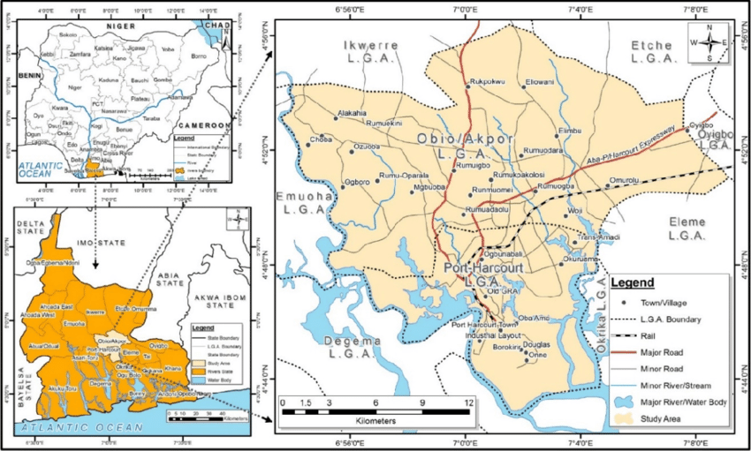
Fig. 1. Map of study location. Adapted from Toko et al. 2020.
2.2 Experimental Design
A cross-sectional study design was adopted for this study as samples were taken a particular point in time.
2.3 Sample Collection
A total of 40 ready-to-eat African salad were purchased from different vendors. Two samples were collected from each location. For each vendor, the samples were collected into two containers; A sterile wide mouth container and Styrofoam plate popularly called foil plate. They were properly labelled and transported in an ice box to the Microbiology Laboratory of the Rivers State University, Health Services Department for immediate microbial analyses. The sampled locations were UST Maingate, Azikiwe, Mile 1 Diobu, Ikoku, Ada-George, Iwofe, Agip, Amadi-Ama, Choba, Rumuokoro, Rumuola, Rumuokwuta, Garrison, Waterlines, Marine Base, Borokiri, Trans-Amadi, Woji, Peter Odili Road, and Elelenwo.
2.4 Microbial Analyses of Samples
One gram (1 g) of purchased African salad were serially diluted 10¹ to 10⁵ in a sterile normal saline and an aliquot 0.1 ml volumes of each sample homogenate were inoculated by spread plate method onto a freshly prepared nutrient agar, MacConkey agar, mannitol salt agar, Salmonella shigella agar, and blood agar plates for total aerobic count respectively. All media were reconstructed and sterilized according to the manufacturer’s instructions. The plates were incubated at 37⁰C for 18-24 hours and examined for growth. After incubation, the colonies on the nutrient agar plates were carefully examined and counted. The total heterotrophic count was calculated by multiplying the number of colonies counted with the dilution factor.
Bacterial identification was done using pour cultures from the isolates. Pure cultures were obtained by streaking representative colonies of different isolates on Nutrient agar plates and incubated at 37⁰C for 24 hours. When pure cultures were obtained, further identification with Gram staining and biochemical tests were carried out. The biochemical analysis carried out includes motility test, catalase test, coagulase test, indole test, citrate utilization test, oxidase test, sugar fermentation test, methyl red test, Voges-Proskauer test, and starch hydrolysis test (Cheesbrough, 2000).

2.5 Antibiotic Susceptibility Testing of Bacterial Isolates
The bacteria inoculum was prepared by culturing the bacterial strain on Mueller Hinton agar plates to form visible colonies. The colonies were suspended in sterile saline to create bacterial suspension, which was then adjusted to match the 0.5 McFarland standard (ensures a uniform bacterial concentration of approximately 1-2 x 10⁸ CFU/ml). The bacterial suspension was spread across the entire agar surface using a sterile swab stick. The plate was streaked in multiple directions to ensure even distribution of the bacteria. Within 15 minutes of inoculation, antibiotic disks were placed onto the agar surface using sterile forceps. The Disk was lightly pressed to ensure full contact with the agar. The inoculated plates were incubated at 37⁰C for 16 – 24 hours. Immediately after incubation, the zone of inhibition was measured by measuring the clear zone around the antibiotic disks. The diameter of each zone, including the disk, was recorded in millimeters. These measurements were compared against established interpretive criteria to determine susceptibility (Clinical and Laboratory Standard Institute (CLSI), 2021. The antibiotics used were Cefotaxime 25 µg, Ceftriaxone sulbactam 45 µg, Cefuroxime 30 µg, Cefexime 5 µg, Imipenem/Cilastatin 10/10 µg, Amoxicillin clavulanate 30 µg, Ampiclox 10 µg, Gentamicin 10 µg, Ofloxacin 5 µg, Levofloxacin 5 µg, Ciprofloxacin 5 µg, Azithromycin 15 µg, Erythromycin 15 µg, Nalidixic Acid 30 µg, Nitrofurantoin 30 µg. The MAR index was calculated and interpreted using the formula: a/b, where ‘a’ represents the number of antibiotics to which an isolate was resistant, and ‘b’ represents the total number of antibiotics tested.
2.6 Molecular Identification of Bacterial Isolates and Resistant Genes
The bacterial DNA was extracted according to manufacturer’s using the ZymoBIOMICS DNA Microprep Kit (Zymo Research, USA). The bacterial DNA was quantified using the NanoDrop spectrophotometer (Thermo Fisher Scientific, USA). Primers designed to amplify the conserved region (16S ribosomal RNA (rRNA) gene) were used to amplify bacteria DNA present in a sample (Table 1). The Applied Biosystems PCR Thermal Cycler 9700 was used for this analysis. PCR amplification was carried out under the following conditions: Initial denaturation at 94°C for 5 minutes, followed by 35 cycles of denaturation 94°C at 40 seconds, annealing at 58°C 40 seconds, and Elongation at 72°C for 1 minutes and 30 seconds. And a final denaturation was done at 72°C for 5 minutes. The PCR amplicons were immediately utilized for Gel Electrophoresis and stored at -20°C for further analysis. The gel electrophoresis was used to analyze and visualize the DNA fragments based on their size/lengths on a 2% agarose gel with Safe Green dye (30 µl) added for visibility.
Table 1. Primers sequences
Gene | Primers
16S rRNA | Forward: 5’-GTGYCAGCMGCCGCGGTAA-3’  Reverse: 5’-GGACTACNVGGGTWTCTAAT-3’
bla_{SHV} | Forward: 5`- AGGATTGACTGCCTTTTTG-3`  Reverse: 5`-ATTTGCTGATTTCGCTCG-3`
bla_{TEM} | Forward: 5`-TTGGGTGCACGAGTGGGTTA-3`  Reverse: 5`-TAATTGTTGCCGGGAAGCTA-3`

2.7 Gene Sequencing
Sanger sequencing of the PCR products was done to confirm bacteria species. The following procedure were followed to ascertain exact nucleotides sequence in a DNA fragment: PCR products were purified, and sequencing reactions were set up using the BigDye™ Direct Cycle Sequencing Kit. The primers, tagged with M13 sequencing primers, were utilized for sequencing. Sequencing reactions were purified and loaded onto a genetic analyzer for capillary electrophoresis. The obtained sequencing data were then analyzed to confirm and identify the bacteria species.
2.8 Data Analysis
Data were presented as percentages as well as mean standard deviation. Bar charts were generated using GraphPad Prism. Statistical comparison was done using student t test and statistical significance was considered at a confidence interval of 95%.

3. results

3.1 Conventional and Species Detection of Bacterial Isolates Associated with Abacha
Conventional PCR successfully detected the 16S rRNA gene region specific to bacteria species in all 10 samples (Fig. 2). The amplification of the targeted DNA region confirmed the presence of bacterial DNA in the samples, validating the specificity of the PCR assay for bacterial species identification. As shown in the image below, the expected band size [300-350 bp] was detected in bacteria samples. Sanger sequencing of the PCR products yielded high-quality chromatograms with clear peaks. Sequencing data were analysed using bioinformatics tools. BLAST searches against reference databases identified the species isolated from each sample. The dominant bacteria species identified included Proteus mirabilis (samples 3A, 4 and 12), Myroides odoratimimus (samples 7 and 9), Flavobacterium tibetense (sample 11), Proteus alimentorum (sample 15), Citrobacter cronae (sample 16), Kosakonia quasisacchari (samples 18 and 24), and Providencia huaxiensis (sample 19). The bacteria with the top hit searches were used and are available in Table 2. The prevalence of the bacteria isolated from the Abacha are Proteus mirabilis 2 (20.0%), Myroides odoratimimus 2 (20.0%), Proteus alimentorum 1 (10.0%), Citrobacter cronae 1 (10.0%), Kosakonia quasisacchari 2 (20.0%), Providencia huaxiensis 1 (10.0%) and Flavobacterium tibetense 1 (10.0%) as shown in Table 3.

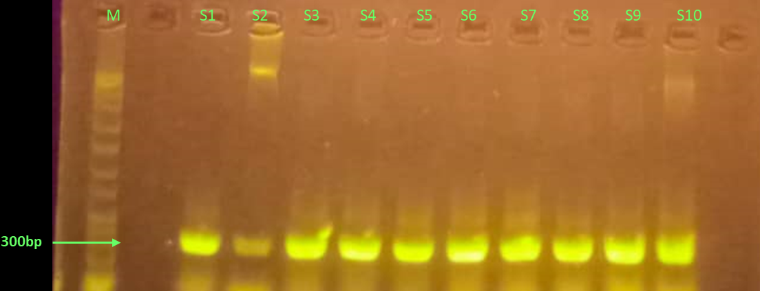
Fig. 2. Bands Generated from Conventional 16S rRNA PCR. Lane M is a 1 kb ladder, S1-10 are bacteria samples.
Table 2. Sequences Identity of the 16S rRNA of the Isolated Bacteria
Sample | Sequencing | Conventional | E value | Acc Len | Acc number
3A | Proteus mirabilis | E. coli | 2.00E-142 | 1497 | NR_114419.1
12 | Proteus mirabilis | E. coli | 2.00E-135 | 1497 | NR_114419.1
7 | Myroides odoratimimus | Bacillus spp | 8.00E-144 | 1484 | NR_042354.1
9 | Myroides odoratimimus | Bacillus spp | 8.00E-134 | 1484 | NR_042354.1
18 | Kosakonia quasisacchari | Salmonella spp | 3.00E-102 | 1536 | NR_169476.1
24 | Kosakonia quasisacchari | S. aureus | 1.00E-124 | 1536 | NR_169476.1
11 | Flavobacterium tibetense | S. aureus | 7.00E-71 | 1482 | NR_179722.1
15 | Proteus alimentorum | Salmonella spp | 4.00E-131 | 1380 | NR_163665.1
16 | Citrobacter cronae | Klebsiella spp | 3.00E-126 | 1462 | NR_170426.1
19 | Providencia huaxiensis | Klebsiella spp | 3.00E-140 | 1528 | NR_174258.1
*Legends: Acc – accession

Table 3. Prevalence of Isolated Bacteria in Abacha
Bacteria | Frequency | Prevalence
Proteus mirabilis | 3 | 27.3
Myroides odoratimimus | 2 | 18.2
Proteus alimentorum | 1 | 9.1
Citrobacter cronae | 1 | 9.1
Kosakonia quasisacchari | 2 | 18.2
Providencia huaxiensis | 1 | 9.1
Flavobacterium tibetense | 1 | 9.1

3.2 Microbial Load and Multiple Antimicrobial Resistance Indices in Bacterial Isolates in Abacha

Another objective of the study was to assess the microbial load present in Abacha. Table 4 showed the level of bacteria isolated from each location sampled. It was observed that Peter Odili Road (98.6±62.5 CFU/ml), Ada-George (84.0±28.9 CFU/ml) and UST maingate (82.5±78.1 CFU/ml) are the top three locations with the highest bacterial loads while Borokiri (36.9±34.0 CFU/ml), Rumuokuta (49.6±39.4 CFU/ml) and Choba (50.1±29.9 CFU/ml) should the lowest level of bacterial loads. The microbial load based on the Local Government Area showed the Obio/Akpor LGA (65.6±51.7 CFU/ml) has the higher microbial load than Port Harcourt City LGA (63.1±47.7 CFU/ml) (Fig. 3).
The bacterial MAR indices show the highest indices in Woji (0.65±0.20), Peter Odili Road (0.65±0.19) and Amadi Ama (0.65±0.16). On the other hand, the lowest indices of bacteria were found in Ikoku (0.39±0.17), Garrison (0.41±0.16) and Marine Base (0.42±0.14). Similar to the findings on the bacterial load, the MAR indices of bacteria in Obio/Akpor (0.56±0.16) were marginally higher than those bacteria in Port Harcourt City Local Government (0.54±0.19) (Fig. 4).

Table 4. Microbial Load and MAR Indices of Abacha According to Locations
Locations | Bacteria load (CFU/ml) | MAR Indices
Ada-George | 84.0±28.9 | 0.58±0.13
Agip | 73.0±50.9 | 0.63±0.18
Amadi Ama | 71.0±52.7 | 0.65±0.16
Azikiwe | 69.6±61.6 | 0.63±0.19
Borokiri | 36.9±34.0 | 0.54±0.19
Choba | 50.1±29.9 | 0.50±0.20
Elelenwo | 66.4±48.1 | 0.63±0.21
Garrison | 58.5±50.9 | 0.41±0.16
Ikoku | 69.3±79.0 | 0.39±0.17
Iwofe | 55.1±34.0 | 0.54±0.09
Marine Base | 71.1±38.8 | 0.42±0.14
Mile 1 Diobu | 71.9±52.0 | 0.63±0.16
Peter Odili Road | 98.6±62.5 | 0.65±0.19
Rumuokoro | 56.8±42.6 | 0.55±0.12
Rumuokuta | 49.6±39.4 | 0.59±0.20
Rumuola | 73.75±66.1 | 0.53±0.12
Trans-Amadi | 66.6±46.7 | 0.63±0.18
UST maingate | 82.5±78.1 | 0.55±0.13
Waterlines | 50.5±34.7 | 0.61±0.13
Woji | 57.1±43.6 | 0.65±0.20

Fig. 3. Bacterial Load based on the Local Government Area.
Each bar represents mean ± SD. T-test was used for statistical comparison. Statistical significance was assumed at 95% confidence interval.

Fig. 4. Multiple Antimicrobial Resistance based on the Local Government Area.
Each bar represents mean ± SD. T-test was used for statistical comparison. Statistical significance was assumed at 95% confidence interval.

3.3 Antimicrobial Resistance Pattern of Bacteria from Abacha

Table 5 shows the pattern of resistance with the various bacterial isolates. The bacteria belonging to the Proteus species together with Providentia huaxiensis had the highest level of MAR index of 0.80 for Proteus species and 0.8 for Providentia huaxiensis. On the other hand, Myroides odoratimimus and Citrobacter cronae had the lowest level of MAR indices of 0.47 each. Considering the different classes of antibiotics used in this study, the level of antimicrobial resistance was highest with the cephalosporin class of drugs cefotaxime (CTX), ceftriaxone sulbactam (CRO), cefexime (ZEM) and cefuroxime (CXM) while the carbapenem (Imipenem/Cilastatin (IMP)) used in this study showed the lowest level of resistance.

Table 5. Pattern of Antimicrobial Resistance Profile of the Isolated Bacteria in Abacha
Bacteria | CTX | CRO | CXM | ZEM | IMP | AUG | ACX | GN | OFX | LBC | CIP | AZN | ERY | NA | NF | MAR indices
Proteus mirabilis | R | R | R | R | S | R | R | R | S | R | R | R | R | S | R | 0.80
Proteus mirabilis | R | R | R | R | S | S | R | R | R | S | R | R | R | R | R | 0.80
Proteus alimentorum | R | R | R | R | R | S | R | S | R | R | R | S | R | R | R | 0.80
Myroides odoratimimus | R | R | S | R | S | R | R | R | S | R | S | R | R | R | S | 0.67
Myroides odoratimimus | R | R | R | S | S | S | S | R | S | R | R | R | S | S | S | 0.47
Kosakonia quasisacchari | R | R | R | R | S | R | S | R | R | R | R | R | R | S | S | 0.73
Kosakonia quasisacchari | R | R | R | R | R | R | S | S | R | S | S | S | R | R | R | 0.67
Flavobacterium tibetense | R | R | R | R | S | R | S | R | S | R | R | S | S | S | S | 0.53
Citrobacter cronae | R | S | R | S | S | R | R | S | R | R | S | R | S | S | S | 0.47
Providencia huaxiensis | R | R | R | R | R | R | S | S | S | R | R | R | R | R | R | 0.80
*Penicillins: Ampiclox (ACX) - Ampicillin + Cloxacillin, Amoxicillin clavulanate (AUG) -Amoxicillin + Clavulanic Acid, Cephalosporins: Cefotaxime (CTX), Ceftriaxone sulbactam (CRO), Cefexime (ZEM), Cefuroxime (CXM), Carbapenems: Imipenem/Cilastatin (IMP), Fluoroquinolones: Ofloxacin (OFX), Levofloxacin (LBC), Ciprofloxacin (CIP), Macrolides: Azithromycin (AZN), Erythromycin (ERY), Aminoglycosides: Gentamicin (GN), Nitrofuran Derivatives: Nitrofurantoin (NF), Quinolones: Nalidixic Acid (NA)

3.4 Antimicrobial Resistant Genes Detected

PCR assays targeting bla_{TEM} resistance genes resulted in specific amplicons of the expected sizes while bla_{SHV} showed no amplification. Gel electrophoresis confirmed the presence of these resistance genes in the bacterial cultures, providing insights into their antibiotic resistance profiles [Fig. 5 and 6]. The prevalence of beta-lactamase genes that were detected is shown in Fig 7. There was a significant burden (p=0.0002) of the bla_{TEM} gene observed in the Obio/Akpor LGA 7 (63.4%) than the PHC LGA 4 (36.6%).

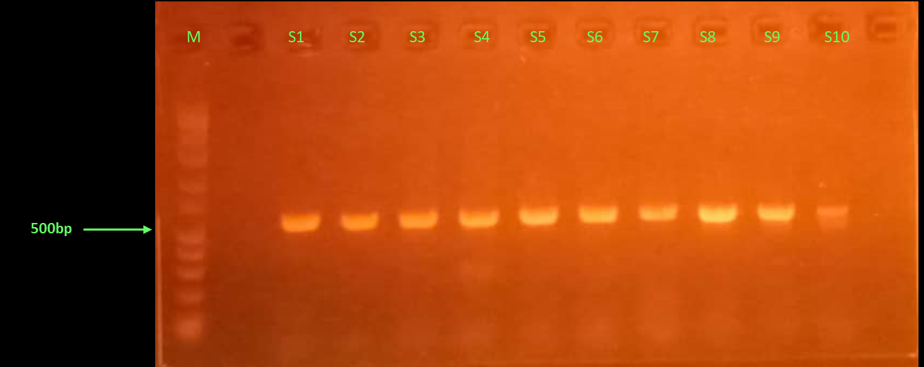
Fig. 5. Bands Positive for bla_{TEM} Antimicrobial Genes.
Lane M is 1 kb Ladder, S1-10 are culture samples amplified with bla_{TEM} primers.

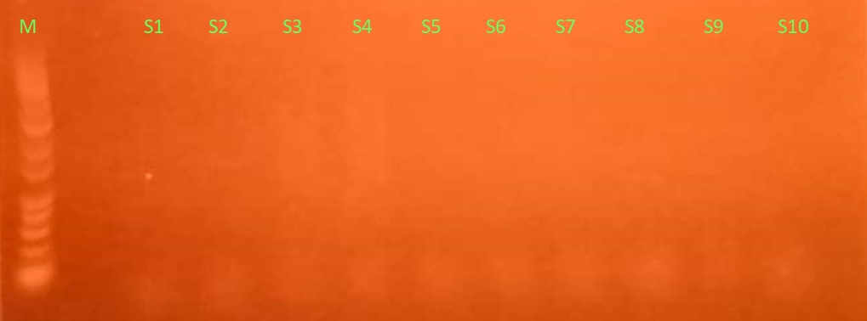
Fig. 6. Culture Samples are Negative for bla_{SHV} Antimicrobial Genes.
Lane M is a 1 kb Ladder, S1-10 are SHV negative culture samples.

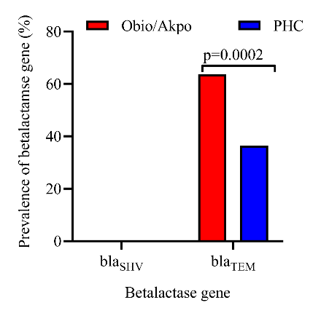
Fig. 7. Comparative Prevalence of Betalactamase Genes in Bacteria Isolates in Obio/Akpor and Port Harcourt City Local Government Area.
The two betalactamase genes investigated were bla_{SHV} and bla_{TEM}. Each bar represents mean ± SD. T-test was used for statistical comparison. Statistical significance was assumed at 95% confidence interval.

4. discussion

Foodborne infection is a common global phenomenon which necessitated this current study to investigate a highly patronized local food, Abacha, for the bacterial prevalence, bacteria load, and presence of multiple antimicrobial resistance in the isolated pathogen. This was done using two LGAs within Port Harcourt Metropolis and a high prevalence of multidrug resistant bacteria were noted with resultant detection of a gene linked to this occurrence.
The first objective of this work was to check for the prevalence of bacteria in Abacha. Our findings showed that there was a high burden of bacteria on the different samples. Proteus mirabilis, Myroides odoratimimus and Kosakonia quasisacchari had the highest prevalence 2 (20.0%) each. Other bacteria isolated found in Abacha, however with the lowest prevalences, were Proteus alimentorum, Citrobacter cronae, Providencia huaxiensis and Flavobacterium tibetense. This shows that various species of bacteria could be found in Abacha. A closely related work showed a 1.2% of Citrobacter species in food handlers (Ifeadike et al., 2014). This shows the presence of this bacteria in the Abacha may have arisen due to cross-contamination from the personnel handling the food. In comparison to the conventional method of isolation, different types of bacteria were detected. This implies that the molecular method has better discriminatory power hence, its ability to detect more specific bacteria.
However, these pathogens have not previously been reported as foodborne pathogens. This is because they differ from the conventional foodborne bacteria (Escherichia coli, non-typhoidal Salmonella spp., and Shigella spp., S. typhi, enteropathogenic E. coli, enterotoxigenic E. coli, Vibrio cholerae, and Campylobacter spp. are the major hazards Listeria monocytogenes, Clostridium botulinum, Brucella spp., Bacillus cereus, Staphylococcus aureus, and Clostridium perfringens) listed by the World Health Organisation (Bintsis et al., 2017). The bacteria isolated from the Abacha could be classified as hazards associated with food. As there is a paucity of data on the prevalence of microbes on this food type used in this work, there will be comparative analyses with other food types.
Most of the isolated bacteria do not naturally colonize food or cause food related infections. However, food could act as a vehicle of spreading them. For instance, Proteus mirabilis is the most common species among the Proteus genus that cause urinary tract infection, with approximately 90% success rate (Chen et al., 2012). Myroides odoratimimus is a rare human pathogen that can lead to soft tissue infection (Maraki et al., 2012) and as opportunistic pathogen in diabetic patients (Endicott-Yazdan et al., 2015). Hence, it would be very useful to perform further research on Abacha and as well as the food handlers to determine the likely source of these pathogens.
Across all the locations sampled, Peter Odili Road had the highest level of bacterial load while Borokiri had the lowest level of bacterial load. Several factors could be attributed to these trends observed with the results. First, Peter Odili Road is located along the largest slaughterhouse in Rivers State (Otto and Simeon, 2022). Another study showing the geospatial mapping of urban flood-prone areas in Port Harcourt Metropolis pointed out that Peter Odili Road is an area characterized by high level of flooding (Wizor and Mpigi, 2020). These factors put together will result in a high burden because of slaughterhouses. For instance, in Imo State of Nigeria, significantly high level of bacterial burden of 3.29 × 10⁹ CFU/cm² total mean viable count (Uzoigwe et al., 2021) in a slaughterhouse. This is higher than our results because of the high surface area samples were collected from. Again, Bacillus cereus (69 × 10⁸ CFU/ml) and Pseudomonas aeruginosa (201 × 10⁷ CFU/ml) have been found in the effluents of the three slaughterhouses in in the city of Ngaoundéré (Cameroon) (Ngouyamnsa et al., 2023). Borokiri on the other hand is located in a well-planned region with good road networks which could be attributed to the low bacterial burden found.
No study has evaluated the MAR indices of bacteria isolated from Abacha, hence, this study used multiple antimicrobial resistance (MAR) indices to evaluate the antibiotic resistance profiles of the bacteria. This MAR indices measure the resistance index of the isolates using the ratio of the number of antibiotics to which an organism is resistant to total the number of antibiotics to which the organism is exposed (Afunwa et al., 2020). Bacteria having MAR index ≥ 0.2 originate from a high-risk source of contamination where several antibiotics are used. In this study, all the isolates in this study where above 0.2 MAR index implies a likelihood of these pathogen being exposed to antibiotics. In fact, the MAR indices range from as high as 0.65 to as low as 0.39 but still above the benchmark of 0.2. This poses a significant question of the phytochemical composition of the mixed Abacha. A new area of exposome noted by Monsi et al. (2017) and Monsi et al. (2018) suggested that the exposure of bacteria to anoxic compounds induce antibiotic resistance. This concept comes from the fact that when bacteria are exposed to stressors, they tend to adapt through the production of factors such as enzymes that enable them to survive.
The antimicrobial resistance (AMR) patterns in this study indicate observable variation among bacterial isolates recovered from Abacha. The MAR indices revealed that Proteus species and Providencia huaxiensis exhibited the highest resistance levels, with indices of 0.80 each. Conversely, Myroides odoratimimus and Citrobacter cronae had the lowest MAR indices of 0.47 each, suggesting a lower resistance burden. These findings align with previous studies that have reported varying resistance patterns across different bacterial species, often influenced by environmental factors and antibiotic usage patterns (Woh et al., 2023; Ghasemian et al., 2022).
One of the objectives of the current study was to determine the presence of factors that could have caused the high MAR indices found in this study. In this direction, our study analyzed the antibiotics susceptibility profiles of the isolates to determine whether they could produce beta-lactamase enzymes. In this current study, it was observed that Proteus mirabilis has the highest MAR index of 0.8 while Myroides odoratimimus and Citrobacter cronae both had the lowest MAR index of 0.47. Similarly, high levels of MAR indices were noted in Mir et al. (2022) which ranged from 0.45 to 0.81 for Salmonella species.
Resistance to different classes of antibiotics has been regarded as one of the most important challenges in public health and food safety. Foods and foodborne pathogens are the main routes of transmission of ARGs to the human gut microbiota, leading to intestinal drug-resistant infections (Pakbin et al., 2022a and Pakbin et al., 2022b). The pattern of antimicrobial resistance noted in this study showed that 2nd and 3rd cephalosporins such as cefotaxime (3rd generation cephalosporin), ceftriaxone sulbactam (3rd generation cephalosporin + sulbactam), cefexime (3rd generation cephalosporin) and cefuroxime (2nd generation cephalosporin) and penicillins antibiotics had the highest levels of resistance. This could be the reason for the presence of beta-lactamase gene detected in the study. This observation is consistent with global trends indicating widespread resistance to cephalosporins, often linked to the overuse and misuse of these antibiotics in clinical and non-clinical settings (WHO, 2021). Interestingly, the drug of last resort in patient management, belonging to the carbapenems groups of antibiotics, showed the highest levels of sensitivity to further reinforce their continued efficacy against multidrug-resistant bacterial strains (Ma et al., 2023).
Foodborne pathogens harboring various virulence factors and producing heat-stable toxins are another threat to food safety. Beta-lactam resistance genes, including bla genes, have been most frequently detected in food samples. In this study, we detected beta-lactam resistance genes, including bla_{TEM} but no bla_{SHV} was detected in any of the samples. Beta-lactamases are the main enzymes responsible for the resistance of Gram-negative bacteria (Wu et al., 2020). There are limited studies concerning the presence of different antimicrobial resistance genes in Abacha food samples. However, several studies reported and investigated the presence of ARGs in food samples such as processed dairy products and sweet foods. For instance, Wu et al. (2020) investigated the prevalences of antimicrobial resistance genes in high-moisture sweet samples, and they found the largest prevalence of the tetW, tetT, and tetA46 genes in these samples are associated with resistance to antibiotics belonging to the class of tetracyclines. They also detected the erm41 and tlrC genes associated with resistance against the antibiotic class of macrolides.
A key significance of this study lies in the fact that bacteria multiply rapidly in the presence of moisture, nutrients and specific temperature for growth usually between 5°C and 63°C (Qui et al., 2022). This temperature specification falls within the actual temperature that the handlers work in. Again, the constituent of the Abacha could also affect the bacteria antibiotics response thereby making some of the pathogens develop antibiotics resistance as pointed out by Monsi et al. (2017). Poor sanitation, unhygienic food handling and improper preservation and packaging of food are considered common causes for food poisoning as the bacteria could be transferred to food and they can grow and produce toxins. This cross-contamination can occur via the respiratory tract by coughing and sneezing and contamination occurs also after heat treatment of the food (Mohammed et al., 2016).
The study used small sample size. The study could have been advanced through the performance of high-performance liquid chromatography technique to determine, quantitatively and qualitatively, the constituents of the entire mixture of Abacha. This could bring out potential compounds that could induce antibiotic resistance to the bacterial isolates found in the food. Sequencing of the antibiotic resistance genes is another area that could be explored to show possible variation in the gene sequence with other known sequences.

5. Conclusion

The findings from this study showed the most prevalent bacteria was Proteus mirabilis with Peter Odili Road as the location with the highest bacterial load while Borokiri had the lowest level of bacteria. The microbial load based on the LGAs showed the Obio/Akpor LGA has a higher microbial load than Port Harcourt City LGA. The bacterial isolated showed the highest MAR indices in Woji and the lowest indices in Ikoku. The average MAR indices of bacteria in Obio/Akpor were marginally higher than those bacteria in Port Harcourt City. Proteus species and Providentia huaxiensis had the highest level of MAR indices ranging from 0.73 to 0.80 for Proteus species and 0.8 for Providentia huaxiensis. There was a significant burden of the bla_{TEM} gene observed in the Obio/Akpor than the PHC. Overall, antibiotic resistance bacteria in Abacha tend to be present in remote towns with high human activities.

COMPETING INTERESTS DISCLAIMER:
Authors have declared that they have no known competing financial interests OR non-financial interests OR personal relationships that could have appeared to influence the work reported in this paper.

References

Eluu S.C., Oko A.O., Uduma E.O., Ohanagorom M.I., Osegbo B.E., Okechukwu S.A., Kalu N.K., Moses I.B., Ugbo E.N., Onyia C.F., Oluwole A.O., Eze G.O., Ekuma O. & Okorie J.M. 2018. Bacteriological quality, consumption value and antibiotics susceptibility pattern of isolates of ready-to-eat African salad sold and consumed in Ebonyi State University, Abakaliki, Nigeria. Archives of Biological Sciences. 14(2), 200–211.
Oranusi, S., Braide, W., Eze, U.C. & Chinakwe, E. 2013. Quality Aspects of African Salad, Journal of Emerging Trends in Engineering and Applied Sciences, (4(2), pp. 287-292.
Osewa, O., 2013. African Salad Food Nairaland. http://www.nairaland.com. (accessed on 22 February 2023).
Issa-Zacharia, A., & Said Seif, M. 2023. Evaluation of Hygienic Practices and Microbiological Quality of Street Vended Fruit Salads in Morogoro, Tanzania. European Journal of Nutrition & Food Safety, 15(10), 73–84. https://doi.org/10.9734/ejnfs/2023/v15i101347
Bintsis, T. 2017. Foodborne pathogens. AIMS microbiology, 3(3), 529.
Ifeadike C.O., Ironkwe O.C, Adogu P.O. & Nnebue C.C. 2014. Journal of Tropical Medicine Assessment of the food hygiene practices of food handlers in the Federal Capital Territory of Nigeria., 17(10-15).
Adley, C. C., & Ryan, M. P. 2016. Antimicrobial Food Packaging, Academic press. 1, 1-10.
Oguwike, F. N., Olisah, M. C., Nwadighoha, A. N., Emenuga, V. N. & Ezekwueme, E. N. 2014. Evaluation of pathogenic bacterial contaminants in road side African salad (Manihot esculenta) and their effect in the gastro intestinal system of subjects in Enugu Nigeria. IOSR Journal of Dental and Medical Sciences, 13, 98-103.
Ire, F. S., Amos, P. C., Ahaotu, I., & Ndukwe, M. 2024. Microbiological and nutritional assessment of ‘ncha iwu’(edible emulsion) vended in selected markets in Umunneochi Lga, Abia State, Nigeria. Scientia Africana, 23(3), 171-184.
Zhou, S. Y., Wei, M. Y., Giles, M., Neilson, R., Zheng, F., Zhang, Q., Zhu, Y. G., & Yang, X. R. 2020. Prevalence of Antibiotic Resistome in Ready-to-Eat Salad. Frontiers in public health, 8, 92. https://doi.org/10.3389/fpubh.2020.00092
Monsi, Tombari Pius, Melford Miller Chinwebudu, and Samuel Douglas Abbey. 2025. “Bioinformatics of BlaTEM-1 and BlaSHV Genes of Herbal Drugs Pretreated-Klebsiella Pneumoniae”. International Journal of Pathogen Research 14 (2):43-57. https://doi.org/10.9734/ijpr/2025/v14i2349.
Laxminarayan, R., Duse, A., Wattal, C., Zaidi, A.K., Wertheim, H.F., Sumpradit, N., Vlieghe, E., Hara, G.L., Gould, I.M., Goossens, H. and Greko, C., 2013. Antibiotic resistance—the need for global solutions. The Lancet infectious diseases, 13(12), pp.1057-1098.
Bhaskar, S. V. (2017). Foodborne diseases—disease burden. Food Safety in the 21st Century, 1–10.
Toko, M.A., Shaibu-Imodagbe, E. M., Okuofu, C. A. & Giwa, A. 2020. Assessment of groundwater quality in Port Harcourt, Nigeria using weighted arithmetic water quality index. 5(2), 894-900.
Cheesbrough, M., 2000. Antimicrobial sensitivity testing. District laboratory practice in tropical countries. Sheck Wah Tong Printing Press Ltd, Hong Kong, pp.133-8.
Clinical and Laboratory Standard Institute (CLSI). 2021. Performance standard for antimicrobial susceptibility testing (31st ed.) CLSI.
Chen, C.Y., Chen, Y.H., Lu, P.L., Lin, W.R., Chen, T.C., & Lin, C.Y. 2012. Proteus mirabilis urinary tract infection and bacteremia: risk factors, clinical presentation, and outcomes. Journal of Microbiology, Immunology and Infection, 45(3), 228-236.
Maraki, S., Sarchianaki, E., & Barbagadakis, S. 2012. Myroides odoratimimus soft tissue infection in an immunocompetent child following a pig bite: case report and literature review. The Brazilian Journal of Infectious Diseases, 16(4), 390-392.
Otto, C. G., & Simeon, B. 2022. Capacity assessment of slaughter rotary intersection. Journal of Newviews in Engineering and Technology (JNET), 4(1).
Wizor, C. H., & Mpigi, G. L. 2020. Geospatial mapping of urban flood-prone areas in Port Harcourt metropolis: implications for effective urban physical planning in Nigeria. World Journal of Innovative Research (WJIR), 8(1), 17-25.
Uzoigwe, N. E., Nwufo, C. R., Nwankwo, C. S., Ibe, S. N., Amadi, C. O., & Udujih, O. G. 2021. Assessment of bacterial contamination of beef in slaughterhouses in Owerri zone, Imo state, Nigeria. Scientific African, 12, e00769.
Ngouyamnsa Ghenmi, E. M., Weldi Gnowe, D., Noubissie, E., Noumi, G. B., & Ahmed, A. 2023. Identification of some microbial flora contained in slaughterhouse effluent and likely to be effective in its treatment by biological process. Journal of Water and Health, 21(10), 1460-1469.
Afunwa, R. A., Ezeanyinka, J., Afunwa, E. C., Udeh, A. S., Oli, A. N., & Unachukwu, M. 2020. Multiple antibiotic resistant index of gram-negative bacteria from bird droppings in two commercial poultries in Enugu, Nigeria. Open Journal of Medical Microbiology, 10(4), 171-181.
Monsi, T.P., Amala, S.E., and Ugoaru, N.F. 2017. Acquisition of Antibiotic Resistance in Escherichia Coli Exposed To a Locally Produced Herbal Drug. Microbiology Research Journal International 22 (2):1-7. https://doi.org/10.9734/MRJI/2017/34812.
Monsi, T.P., Wokem, G.N. & Aleruchi, P.C. 2018. Development of Antibiotic Resistance in Herbal Drug-Sensitized Staphylococcus Aureus Isolate. Journal of Advances in Microbiology 7 (4):1-7. https://doi.org/10.9734/JAMB/2017/37893.
Woh, P. Y., Yeung, M. P. S., & Goggins III, W. B. 2023. Multiple antibiotic resistance index (MARI) of human-isolated Salmonella species: a practical bacterial antibiotic surveillance tool. Journal of Antimicrobial Chemotherapy, 78(5), 1295-1299.
Ghasemian, S. O., Mahmoodipour, H., & Gholami-Ahangaran, M. 2022. Study on antibiotic resistance profile and multiple antibiotic resistance index (MAR Index) in the Campylobacter spp. isolates from domestic animals and water. Pathobiology Research, 25(3), 6-14.
Mir, R., Salari, S., Najimi, M., & Rashki, A. 2022. Determination of frequency, multiple antibiotic resistance index and resistotype of Salmonella spp. in chicken meat collected from southeast of Iran. Veterinary Medicine and Science, 8(1), 229-236.
Pakbin, B., Didban, A., Brück, W. M., & Alizadeh, M. 2022a. Phylogenetic analysis and antibiotic resistance of Shigella sonnei isolates. FEMS microbiology letters, 369(1), 42-45.
Pakbin, B., Brück, W. M., Allahyari, S., Rossen, J. W., & Mahmoudi, R. 2022b. Antibiotic resistance and molecular characterization of Cronobacter sakazakii strains isolated from powdered infant formula milk. Foods, 11(8), 1093.
World Health Organization (2021). Foodborne diseases. [online] www.who.int. Available at: https://www.who.int/health-topics/foodborne-diseases#tab=tab_1 [Accessed 10 Jun. 2024].
Ma, J., Song, X., Li, M., Yu, Z., Cheng, W., Yu, Z., & Li, L. (2023). Global spread of carbapenem-resistant Enterobacteriaceae: Epidemiological features, resistance mechanisms, detection and therapy. Microbiological Research, 266, 127249.
Wu, Z., Luo, Y., Bao, J., Luo, Y., & Yu, Z. 2020. Additives affect the distribution of metabolic profile, microbial communities and antibiotic resistance genes in high-moisture sweet corn kernel silage. Bioresource Technology, 315, 123821.
Qiu, Y., Zhou, Y., Chang, Y., Liang, X., Zhang, H., Lin, X., & Luo, Z. 2022. The effects of ventilation, humidity, and temperature on bacterial growth and bacterial genera distribution. International Journal of Environmental Research and Public Health, 19(22), 15345.
Mohammad, Mohammad, S. El-Sharkaway, Ibrahim A. Samaha, & H. I. A. El-Galil. 2016. Prevalence of pathogenic microorganisms in raw meat products from retail outlets in Alexandria province. Alexandria Journal of Veterinary Sciences, 51(2), 374-380.

