**Evaluation of Trench cum Bund (TcB) as Soil and Water Conservation Measure for Black Cotton Soils in Tribal Watersheds: A Case Study**

**Abstract**

Trench cum Bund (TcB) is taken up as in-situ soil and water conservation measure as a part of watershed development projects to addresses challenges of soil erosion, waterlogging, and drought/dry spells in medium to deep black soil zone of erstwhile Adilabad district of Telangana state of India. This study investigates the efficacy of Trench cum Bund (TcB) in eight watersheds inhabited mainly by tribal community in the erstwhile Adilabad district. The evaluation study revealed that the cross-sectional area of bunds varied from 0.5 to 0.75 m², while the length of TcB varied from 100 m to 300 m per hectare. It was found that the TcB technique improved crop yields on an average by 20% for Cotton and 25% for Soybean, the two major crops in the region. Economic evaluation indicates that TcB is a viable intervention with Benefit-Cost Ratios (BCR) greater than 1, Net Present Worth (NPW) of Rs. 5221 and Rs. 21,808 per acre for Cotton and Soybean-Chickpea cropping patterns respectively. The study concludes that TcB is effective for rainwater conservation, reducing the problem of waterlogging, soil erosion control, and enhancing productivity, and merits promoting the technique under the National Rural Employment Guarantee Programme (NREGP) in a big way for the benefit of small and marginal tribal farmers in the district.

Keywords: Trench cum Bund(TcB), Soil and Water Conservation, Black Cotton Soils, Tribal Watersheds, Rainwater Harvesting, Economic Evaluation

**Introduction**

Black soils, also known as Vertisols, are predominant in central peninsular India, covering approximately 76.4 million hectares. These soils are distributed mainly in Maharashtra, Madhya Pradesh, Gujarat, Andhra Pradesh (including Telangana), Karnataka, Tamil Nadu, Rajasthan, and Odisha. Characterized by high clay content, these soils exhibit significant swelling and shrinking properties, which cause low infiltration rates and high runoff during the monsoon season. This results in problems like soil erosion, waterlogging, and reduced crop productivity (Samra et al., 2002; Verma, 1982; and Mishra, et al., 2010).

A significant portion of India's black soil region experiences moderate to high rainfall, ranging from 750 to 1250 mm. Runoff studies conducted in the high-rainfall areas of the Indore region indicate that approximately 21 to 53 percent of the total rainfall contributes to runoff from medium black soils (Verma, 1982). This highlights a substantial opportunity for harvesting and recycling runoff in the black soil regions of the country (Samra et al., 2002).

The erstwhile Adilabad district of Telangana state with medium to deep black soils and relatively high rainfall, sheet erosion is more common in the cultivated lands leading to loss of fertility of soils and low productivity. In addition, water logging is more common during monsoon and there is water scarcity during post monsoon (rabi and summer seasons). Mishra et al (2010) assessed the scope for rain water harvesting in medium to deep black soil zone of Adilabad district of Telangana state. The study revealed that the average percentage of seasonal runoff to rainfall was 46%, indicating the potential scope for rain water harvesting in vertisols. The land in this region can be classified into four groups namely sloping hillocks (slope >8%), upland (slope of 5-8%), midland (slope of 1-5 %) and lowland/valley land (less than 1%) based on the topography and soil characteristics (Mishra et al., 2010). The upper reaches of in the villages of Adilabad district of Telangana state mainly owned by Gondu tribal community have undulating topography with steep slopes and are subjected severe soil erosion. Further, the uncontrolled runoff from these areas causes extensive damage to the agricultural lands falling below. To address this issue, the sloping hillocks and uplands are usually treated with staggered contour trenches and water absorption trenches as area treatment along with stone gully plugs in the nalas/drainage line (Mishra, et al., 2024).

In the midland and low lands traditional methods of soil and water conservation have been inadequate for dealing with the unique challenges posed by black cotton soils, particularly in regions where rainfall is both heavy and unevenly distributed. Given these conditions, the adoption of improved soil and water conservation techniques such as Trench cum Bunding (TcB) becomes imperative. Simple field bunding as followed in other soils in mid lands and low lands may not suitable in case of black cotton soils because of huge volume of runoff.

Therefore, Trench cum Bunding (TcB) was executed in the cultivated mid and low lands of tribal farmers as a part of watershed development programme in the erstwhile Adilabad district of Telangana state. The present study evaluated TcB as an in-situ soil and water conservation method to combat multiple issues in black cotton soil region of Adilabad district of Telangana state.

**Materials and Methods**

The evaluation study was conducted covering eight micro-watershed development projects falling in erstwhile Adilabad district, Telangana. The study area (erstwhile Adilabad district) is in northern part of Telangana state of India (Fig. 1), falling under Xth Agro-climatic zone (Southern plateau and hills region) inhabited mainly by *Gondu* tribals.

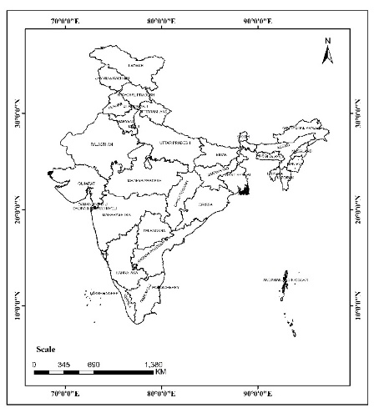 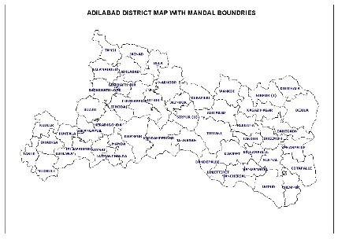

Fig. 1 Location of study area

Though district receives average annual rainfall of 1267 mm, it is faced with paradoxical situation in that there is excess rain water during the monsoon season causing water logging all over the area during *kharif* season whereas in winter and summer months there is acute shortage of good quality water for irrigation purpose. In addition, there are also dry spells in *Kharif* season affecting the crop production. In this area, increasing the food production is possible only through conservation and the judicious use of rainwater (Mishra, et al., 2010).

With a view to control waterlogging during monsoon and conserve soil moisture TcB was taken up across different watershed development projects implemented in the district. The TcB technique consists of constructing conservation trenches across the slope along with bunds fortified with vegetative cover to reduce soil erosion and enhance water percolation. The present study is taken up to evaluate the design specifications and performance of TcB on crop production across eight watersheds in the district. The design details of TcB studied included land slope, trench width, trench depth, bund cross-section, horizontal Interval, presence of outlets/surplus weirs, length per hectare, etc. Fuhrer, the impact of tcB on crop yields was evaluated by comparing pre-treatment and post-treatment data. The crop yield, cost of cultivation and sale price of produce were also obtained. The economic life of TcB was five years. Further, the financial viability of the TcB was assessed by evaluating the Benefit Cost Ratio (BCR), Net Present Value (NPV), and Internal Rate of Return (IRR). The net incremental returns due to introduction of TcB were worked out based on the collected field data. Thereafter, year wise incremental cost and returns (i.e. cash flows) were generated and financial parameters namely BCR, NPW and IRR were determined by using library functions available in MS-Excel (Mishra et al., 2022). Also, for simplicity of calculations it was assumed that the cash inflows and outflows took place at the end of the year (Ravi Babu and Mishra 2001, Dabral and Baithuri 2007 Mishra et al., 2010 and Mishra et al., 2022).

**Results and Discussion**

The study aimed at assessing the effectiveness of the trench-cum-bund system in enhancing crop productivity by controlling soil erosion and waterlogging and improving soil moisture retention and soil health. The findings revealed notable positive effects on soil moisture conservation and overall yield and income improvement. This system proved effective in minimizing water runoff, reducing soil erosion, and promoting sustainable agricultural practices. The results of the study are presented and discussed as below:

**Construction of TcB**

The TcB was found to be executed in mid and low lands of watersheds with slope of fields of 2 to 5%. The technique involved constructing conservation trenches across the slope with bunds fortified with vegetative cover to minimize soil erosion and promote water percolation.

The design specifications of TcB as executed in the fields of eight watersheds are given below (Table1):

**Table 1 Design parameters of TcB**

|  |  |  |
| --- | --- | --- |
| **S.No.** | **Parameter** | **Specifications** |
| 1 | Trench width | 1-1.25 m |
| 2 | Trench depth | 0.5-0.6 m |
| 3 | Bund cross-section | 0.5-0.75 m² |
| 4 | Berm | 0.3 m |
| 5 | Land slope | 2 – 5% |
| 6 | Horizontal Interval between Bunds | 40 – 60 m |
| 7 | Length per hectare | 100 – 300 m |

The bunds were constructed using soil excavated from the trenches, which were then reinforced with vegetation to enhance stability. Additionally, surplus weirs were incorporated to dispose of excess water safely and prevent waterlogging. The cross-section of TcB with design specifications is given in Figure 2:

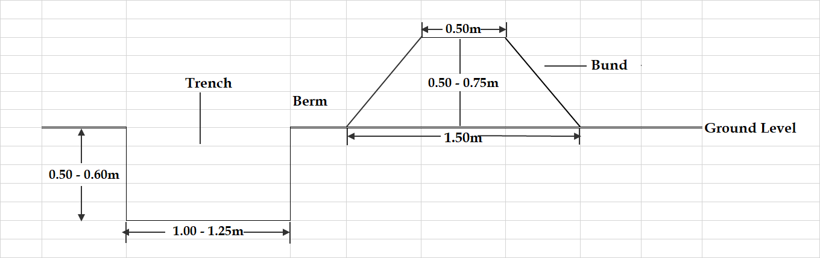

**Fig. 2 Cross-section of TcB with design dimensions**

Under TcB. the width of trench is restricted to 1-1.25 m and depth of excavation is maintained at 0.5-0.6 m (Table 1 and Fig. 2). The cross-section of bund was found to vary from 0.5-0.75 sq.m (Table 1). The conservation trench of rectangular shape with more emphasis on excavation (instead of scraping) with equalizer of about 0.3 m at regular interval was found to be made across the slope just above the location earmarked for the bunding, leaving a berm (space between conservation trench and bund) of about 0.3 m, bund of 0.5-0.75 sq.m was made across the slope.

These conservation TCBs are made at a horizontal interval of 60-40 m (between two successive trench dcum bunds) with slope of 2-5% (Table 1). The bunds were found to be fortified with vegetative cover especially with castor/red gram for stability. Also, outlets are to be placed at appropriate place in the bund to dispose the excess water safely. Properly constructed TcB helped in accommodating about 1 lakh litres of rain water at a time and improved the soil moisture (in 1 ha of area with about 200 r.m of length and 0.5 sq.m cross-section). With the introduction of TcB, the soil moisture was adequate with seepage water from these trenches, creating conducive environment for crop production. In fact, TcB was found to act as a drought proofing measure in the years of low rainfall.

**Crop Yield Improvement**

While Cotton or Soybean crop is grown in the main field after treatment, castor/red gram on the berm/bund was grown to give supplementary income and stabilization of bunds. The study revealed that TcB implementation substantially improved crop yields by effectively conserving rainwater and preventing soil erosion. The impact of Trench Cum Bund (TCB) treatment on crop yield across watersheds for both Soybean and Cottin crops is given in Table 2.

**Table 2 Impact of TcB on crop wise yield across watersheds**

|  |  |  |  |
| --- | --- | --- | --- |
| **Name of Crop** | **Average Yield Before TCB (Qtl/acre)\*** | **Average Yield After TCB (Qtl/acre)\*** | **% Increase in Yield\*** |
| Soybean | 6.5 – 8.2 | 8.7 – 10.9 | 25% – 35% |
| Cotton | 6.2 – 9.5 | 8.2 – 11.7 | 10.3% – 44.6% |

*across eight watersheds

The crop wise average yield before and after TcB and percentage increase for Cotton and Soybean crops across watersheds is presented in Table 3. Thus, the study found that the TcB technique enhanced crop yields by an average of 20% for cotton and 25% for soybean, the region's two primary crops (Table 3).

**Table 3 Average crop yield improvement before and after TcB**

|  |  |  |  |
| --- | --- | --- | --- |
| **Crop** | **Average Yield Before TcB (Qtl/ha)** | **Average Yield After TcB (Qtl/ha)** | **Percentage Increase (%)** |
| Soybean | 9.3 | 11.6 | 25 |
| Cotton | 8.3 | 9.9 | 20 |

Fig. 3 highlights the trends in yield improvement (%) for soybean and cotton across different watersheds. Dharmasagar has the most significant spike for cotton (44.6%), showing the best response to Trench cum Bund. Soybean shows a stable upward trend, maintaining a yield improvement of 25-35% across most watersheds. Cotton showed more fluctuations, with lower level of increase in crop yield in respect of Cotton crop i.e. Indervelly (16.2%) and Kohinoor B (15.8%) among eight watersheds. This may be due to variation in physical and chemical properties of soil. Soybean crop yield increase, outperformed Cotton in Settihadapoor, Sakeda, and Indervelly watersheds, reinforcing the need for crop-specific interventions. Among eight watersheds, Yamaikunta has a balanced performance for both crops (~30% increase in crop yield), making it an ideal location for either soybean or cotton.

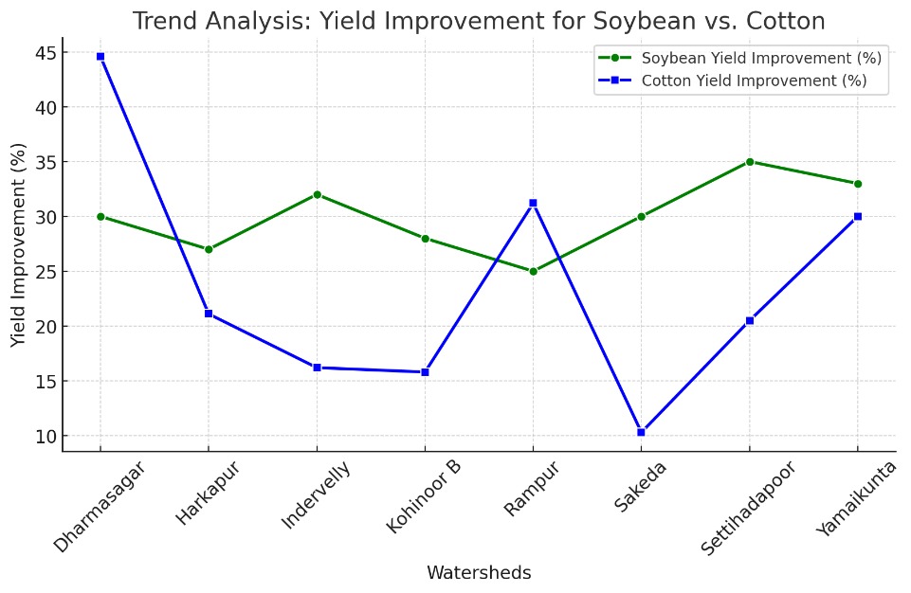

**Fig. 3 Trend Analysis: Yield Improvement for Soybean vs. Cotton**

Thus, overall, the field evaluation demonstrated that TcB implementation significantly improved crop yields by effectively conserving rainwater and preventing soil erosion.

**Financial Evaluation**

The financial feasibility of TcB was assessed by working out metrics such as Net Present Value (NPV), Benefit-Cost Ratio (BCR), and Internal Rate of Return (IRR). To work out these metrics, the season-wise crops grown, area under each crop, yield, cost of cultivation, sale price and income in pre and post treatment of TcB with Soybean (Kharif) with Chickpea in rabi season and Cotton as principal crops are given in Table 4 and 5, respectively.

While Cotton is grown as mono-crop of long duration, the soybean farmers grown chickpea during rabi season with improved soil moisture availability. This cropping sequence was taken into account while performing the financial viability. Further, it is noted that about 3 to 5% of crop area is used for making TcBs. However the farmers used bunds to grow Redgram/Castor and hence the same is taken into account while working out the net incremental income after introduction of TcB (Table 4 and 5).

Table 4 and 5 presents a comparative analysis of crop yield and profitability of crop production with pre and post TcB implementation. As the twin problems of waterlogging and soil erosion are solved with TcB, remarkable increase in crop yield and net incremental income could be noted (Table 4 and 5), both for Cotton and Soybean + Chickpea, cropping systems. The data indicate that the trenches act as efficient rainwater retention structures, allowing for gradual infiltration and seepage into the soil profile rather than rapid surface drainage. This water retention capability ensured prolonged soil moisture availability, supporting crop growth and enhanced crop productivity, thus proving the capability of TcB as a drought proofing measure. The net incremental return post TcB with Cotton stood at Rs. 7422 per acre per year (Table 4), while the same for Soybean+Chickpea cropping system reached to Rs. 12520 per acre per year (Table 5).

|  |  |  |  |  |  |  |  |  |
| --- | --- | --- | --- | --- | --- | --- | --- | --- |
| **Table 4 Details of cost, income and incremental income (pre and post development stage) – Cotton** | | | | | | | | |
|  |  |  |  |  |  |  |  |  |
| **Stage/season/crop** | **Area (acre)** | **Yield (q/acre)** | **Total yield (q)** | **Cost of cultivation (Rs./acre)** | **Sale price (Rs./q)** | **Total income (Rs.)** | **Total cost of cultivation** | **Profit (Rs.)** |
| **Pre-development** |  |  |  |  |  |  |  |  |
| *Kharif* |  |  |  |  |  |  |  |  |
| Cotton | 1 | 8.4 | 8.4 | 25000 | 5000 | 42000 | 25000 | 17000 |
| *Rabi* |  |  |  |  |  |  |  |  |
| No crop |  |  |  |  |  |  |  |  |
| **Sub-Total (A)** |  |  |  |  |  |  |  | **17000** |
| **Post-development** |  |  |  |  |  |  |  |  |
| *Kharif* |  |  |  |  |  |  |  |  |
| Cotton | 0.95 | 10 | 9.5 | 25000 | 5000 | 47500 | 23750 | 23750 |
| Redgram/Castor on bunds | 0.03 | 8 | 0.24 | 8000 | 3800 | 912 | 240 | 672 |
| *Rabi* |  |  |  |  |  |  |  |  |
| No crop |  |  |  |  |  |  |  |  |
| **Sub-Total (B)** |  |  |  |  |  |  |  | **24422** |
| **Net incremental income (B-A)** |  |  |  |  |  |  |  | **7422** |

**Table 5 Details of cost, income and incremental income (pre and post development stage) – Soybean (Kharif) & Chickpea (Rabi)**

|  |  |  |  |  |  |  |  |  |
| --- | --- | --- | --- | --- | --- | --- | --- | --- |
| **Stage/season/crop** | **Area (acre)** | **Yield (q/acre)** | **Total yield (q)** | **Cost of cultivation (Rs./acre)** | **Sale price (Rs./q)** | **Total income (Rs.)** | **Total cost of cultivation** | **Profit (Rs.)** |
| **Pre-development** |  |  |  |  |  |  |  |  |
| *Kharif* |  |  |  |  |  |  |  |  |
| Soybean | 1 | 9.3 | 9.3 | 18000 | 3500 | 32550 | 18000 | 14550 |
| *Rabi* |  |  |  |  |  |  |  |  |
| No crop |  |  |  |  |  |  |  |  |
| **Sub-Total (A)** |  |  |  |  |  |  |  | **14550** |
| **Post-development** |  |  |  |  |  |  |  |  |
| *Kharif* |  |  |  |  |  |  |  |  |
| Soybean | 0.95 | 11.6 | 11.02 | 18000 | 3500 | 38570 | 17100 | 21470 |
| Redgram/Castor on bunds | 0.03 | 8 | 0.24 | 8000 | 3500 | 840 | 240 | 600 |
| *Rabi* |  |  |  |  |  |  |  |  |
| Chickpea | 0.5 | 6 | 3 | 8000 | 3000 | 9000 | 4000 | 5000 |
| **Sub-Total (B)** |  |  |  |  |  |  |  | **27070** |
| **Net incremental income (B-A)** |  |  |  |  |  |  |  | **12520** |

The financial feasibility of TcB was assessed using economic metrics such as Net Present Value (NPV), Benefit-Cost Ratio (BCR), and Internal Rate of Return (IRR) using the year wise cash flows. The economic life of TcB was assumed to be 5 years. During first year only 50% of the yield improvement is considered and second year onwards stability in the yield is assumed as noted from the field data. The results of financial analysis are presented in Table 6 and 7 for Cotton and Soybean (kharif) +Chickpea (rabi) cropping patterns, respectively.

Table 6 and 7 clearly reflect the financial viability of implementing the trench cum bund system in black soils. Although initial investment costs are slightly higher (@Rs. 14700 per acre), the return on investment becomes evident through increased yields, reduced irrigation costs, and enhanced soil fertility (with the control of soil erosion and reduced waterlogging),over time. The profitability metrics calculated for the system suggests a sustainable financial model for farmers, making it an attractive long-term climate resilient agricultural practice.

|  |  |  |  |  |  |
| --- | --- | --- | --- | --- | --- |
| **Table 6 Financial parameters – Cotton** | | | | | |
| **Years** | 1 | 2 | 3 | 4 | 5 |
| Cost (Rs.) | 14700 | 1470 | 1470 | 1470 | 1470 |
| Benefit (Rs.) | 3711 | 7422 | 7422 | 7422 | 7422 |
| Net benefit (Rs.) | -10989 | 5952 | 5952 | 5952 | 5952 |
| DF(15%) | 0.870 | 0.756 | 0.658 | 0.572 | 0.497 |
| Present worth of cost (Rs.) | 12782.61 | 1111.53 | 966.55 | 840.48 | 730.85 |
| Present worth of benefit (Rs.) | 3226.96 | 5612.10 | 4880.09 | 4243.55 | 3690.05 |
| Net Present Worth (NPW) at 15%DF | 5221 |  |  |  |  |
| Benefit Cost Ratio (BCR) | 1.32:1 |  |  |  |  |
| Internal Rate of Return (IRR) | 40% |  |  |  |  |

**Table 7 Financial parameters – Soybean (Kharif) & Chickpea (Rabi)**

|  |  |  |  |  |  |
| --- | --- | --- | --- | --- | --- |
| **Years** | 1 | 2 | 3 | 4 | 5 |
| Cost (Rs.) | 13157 | 1320 | 1320 | 1320 | 1320 |
| Benefit (Rs.) | 6260 | 12520 | 12520 | 12520 | 12520 |
| Net benefit (Rs.) | -6897 | 11200 | 11200 | 11200 | 11200 |
| DF(15%) | 0.870 | 0.756 | 0.658 | 0.572 | 0.497 |
| Present worth of cost (Rs.) | 11440.87 | 998.11 | 867.92 | 754.71 | 656.27 |
| Present worth of benefit (Rs.) | 5443.48 | 9466.92 | 8232.10 | 7158.35 | 6224.65 |
| Net Present Worth (NPW) at 15%DF | 21808 |  |  |  |  |
| Benefit Cost Ratio (BCR) | 2.48:1 |  |  |  |  |
| Internal Rate of Return (IRR) | >50% |  |  |  |  |

The crop wise financial metrics are summarized in Table 8.

**Table 8 Summary of results of financial analysis**

|  |  |  |
| --- | --- | --- |
| **Parameter** | **Cotton (per acre)** | **Soybean-Chickpea (per acre)** |
| NPW | Rs. 5221 | Rs. 21808 |
| BCR | >1.32:1 | 2.48:1 |
| IRR | 48% | >50% |

The NPV of the cash flow over the investment cost at 15 % discounting was Rs. 5221 and Rs. 21808 per acre with Cotton and Soybean-Chickpea cropping pattern, respectively with TcB (Table 8). The BCR and the IRR for Cotton were 1.32 and 48%, respectively (Table 6 and Table 8), while the same are found to be 2.48 and >50%, respectively with Soybean and Chickpea cropping pattern (Table 7 and Table 8). The financial parameters clearly indicate that the TcB has tremendous potential in harvesting runoff, mitigating the problem of waterlogging and soil erosion and improving the income level of the farmers. The above findings are in line with the positive results reported by Tenge *et al* (2011), Sanju and Nitin (2012) and Naveena et al. (2019).

The study confirmed that TcB is an effective method for rainwater conservation, mitigating waterlogging issues, controlling soil erosion, and improving productivity. Given its benefits, the technique should be widely promoted under the National Rural Employment Guarantee Programme (NREGP) to support small and marginal tribal farmers in the district.

**Conclusion**

The TcB technique is a promising soil and water conservation method for the black cotton soil regions of India. The findings indicate that TcB effectively conserves rainwater, mitigates soil erosion and minimizes waterlogging in black soils, enhances soil moisture retention, and improves crop productivity. The economic analysis confirms its profitability and sustainability, indicating its potential for scaling up for adoption for the income and livelihood security of small and marginal tribal farmers in black soil zone.

**References**

Dabral, P. P. and Baithuri. N. Economic evaluation of water harvesting pond under humid condition of Arunachal Pradesh. Journal of Soil and Water Conservation. 2007; 6(1):24-28.

Mishra, P., Venkateswara Rao, B. and Ravi Babu, R. Assessing the scope for rainwater harvesting in vertisols for sustainable agriculture and livelihood security of tribal farmers – a case study. *Journal of Soil and Water Conservation*. 2010; 9(2): 98-108.

Mishra, P., Babu, R.R., Kumar, R.N. and B. Rajaseka. Feasibility assessment of on farm water harvesting structures for livelihood security of small and marginal farmers. *Int. J. Environ. Clim. Change*, vol. 12, no.12, pp. 1880-1885, 2022.

Mishra, P, Venkata Laxmi, K., Navya Swetha, **T., Rajasekar, B. and D. Naga Harshitha.** Design of Farm Pond for Vegetable Cultivation for Livelihood and Nutrition Security of Tribal Farmers in Adilabad District of Telangana. SKV National Conference 2024 (Agriculture in 2050: Technology Development and Dissemination), March 01-03, 2024; Venue: JNKVV, Jabalpur. 4th Abstract Book, Pp: 10.

Naveena, K. P., Shivaraj, S., & Nithin, G. P. Economic and Non-economic Benefits of Trench cum Bunding. Journal of Krishi Vigyan, 2019; 7(2), 125-130.

Ravi Babu. R. and Mishra, P. Farm ponds in coastal saline zone of West Bengal – A Techno-economic feasibility study. *Journal of Agricultural Engineering*. 2001; 38 (4) 17-22.

Samra, J.S., V.N. Sharda and A.K. Sikka. Water harvesting and recycling- Indian experiences. Published by CSWCRTI, Dehradun. 2002; 347 p.

Sanju S. V. & Nitin W. I. Soil and Water Conservation Practices: An Overview. International Journal of Scientific & Engineering Research, 2012; 3(12).

Tenge, A. J., Sterk, G., & Okoba, B. O. Soil and Water Conservation Measures in East African Highlands. Journal of Social Science, 2011; 2(1), 84-100.

Verma, B. N. Water Harvesting and Recycling in Black Soil Region. Indian Journal of Agricultural Sciences, 1982; p. 102.