**Acute, Sub-acute, and Chronic Hepatotoxicity Profiling of Commelina diffusa Aqueous Extract in Wistar Albino Rats: A Comprehensive OECD 425 TG Study"**

ABSTRACT

This study investigated the acute, sub-acute, and chronic hepatotoxicity profiling of Commelina diffusa aqueous extract in Wistar albino rats: a comprehensive OECD 425 TG study. Fourty (40) adult non-pregnant Wistar rats weighing 120 and 170g were purchased from the Biochemistry Animal House, University of Port Harcourt. The rats were divided into ten groups of five rats per group. Group 1 served as normal control while group 2-4, 5-7, and 8-10 were orally administered 166, 250, and 500mg/kg body weight of aqueous extract of the aerial parts of *Commelina diffusa* for 7, 14, and 21 days. All biochemical analysis were carried out based on standard methods. The mean homogenate ALT, AST, and ALP activities of the control were 41.26±0.02U/L, 662.73±0.02U/L, and 38.93±0.04U/L respectively while the extract administered group at 500mg/kg for 21 day were 19.12±0.02U/L, 33.54±0.04U/L, and 21.37±0.03U/L respectively, which were significantly different from the control. The mean homogenate MDA, GSH levels, GPx, CAT, and SOD activities of the control were 29.93±0.02mmol/l, 46.74±0.03μg/mg protein, 59.32±0.03IU/g, 85.45±0.02mg/pro.min, and 27.53±0.02 mg/g respectively while the extract administered at 500mg/kg for 21 days were 17.26±0.03mmol/l, 62.83±0.02μg/mg.protein, 76.81±0.04IU/g, 107.8±60.05mg/pro.min, and 57.86±0.03 mg/g respectively, which were significantly different from the control. The mean plasma total cholesterol, HDL, VLDL, and triglyceride levels of the control were 63.01±0.02 mg/dl, 36.16±0.03 mg/dl, 8.62±0.02 mg/dl, and 28.52±0.02 mg/dl while those of the extract administered at 500mg/kg for 21 days were 72.14±0.03 mg/dl, 52.08±0.02 mg/dl, 14.37±0.05 mg/dl, and 47.43±0.02 mg/dl respectively, which were significantly different from the control. *Commelina diffusa* extract enhanced the metabolism of all the assayed parameters, hence it is less toxic at 500mg/kg.

*Keywords: Commelina diffusa, toxicity, ALT, AST, MDA, SOD, CAT*

1. **INTRODUCTION**

Ethnomedicinal plants have been widely used in humans and animals as therapeutic remedies, treatments, mitigation and prevention of diseases in traditional medicine in both developed and developing countries (Newman and Cragg, 2014). The general view is that medicinal plants are natural products devoid of synthetic preservatives and therefore, safe for discretional uses. Over 85% of disease conditions of humans and animals, ranging from bacterial illnesses to cancer are treated with either natural products or compounds derived from natural products (Newman and Cragg, 2014). Natural medicines are fast becoming mainstay primary health-care alternatives worldwide, with approximately 50% of the USA population using natural medicines for the treatment and prevention of diseases (Harvey *et al.* 2015). The drug discovery process is complicated and interwoven, requiring not only information about pharmacodynamics and pharmacokinetic parameters of the compound but also, more importantly, its safety (Thomford *et al*. 2018).

Drug-induced liver injury and nephrotoxicity are the leading causes of pharmaceutical withdrawals of promising drug candidates in clinical trials (Schnellman, 2008; Weiler *et al.* 2015). Whereas, aminotransferases and to a lesser extent, alkaline phosphatase, sorbitol dehydrogenase, glutamate dehydrogenase, gamma-glutamyltransferase, total bilirubin, total bile acids, and 5′-nucleotidase are the commonly evaluated biomarkers in drug safety assessment of hepatotoxicity. Blood urea nitrogen, serum creatinine, sodium and phosphorous are the common endpoint indicators used to evaluate renal function (Takin *et al*. 2013). Therefore, assessment of at least four serum parameters, involving a minimum of two for each of the hepatocellular and hepatobiliary serum biomarkers has been recommended for a safety study of xenobiotics (Aulbach and Amuzie, 2017).

Acute, sub-acute, and chronic hepatotoxicity profiling of medicinal plants is a very vital area of study, especially as herbal medicines continue to be widely used (Tauheed *et al*. 2020). Administration of a high single dose at 5000 mg/kg of a plant extract to animals and monitoring for any immediate harmful effects. The acute toxicity of medicinal plants is often evaluated by examining liver proteins such as ALT, AST, and ALP, along with non-proteins like bilirubin levels (Tauheed *et al*. 2021; Tauheed *et al.* 2016).

**Sub-acute toxicity** involves repeated dosing over a period of weeks, often at lower doses (2000 mg/kg), to observe more gradual effects on liver function (Tauheed *et al*. 2021; Boone *et al.* 2005). **Chronic toxicity** studies usually involve long-term administration (several weeks or months) of a plant extract to assess any lasting adverse effects on liver function (Tauheed *et al.* 2021; Aulbach and Amuzie *et al.* 2017).

Herbal medicaments are perceived as inherently secured; meanwhile, numerous plants contain bioactive ingridients that can cause liver disorder, when consumed in high doses/over extended periods. Hepatotoxicity profiling helps identify the maximum tolerable doses for therapeutic use, avoiding overexposure that could lead to liver damage. It serves as a cornerstone of herbal medicine research, ensuring these natural treatments are both safe and effective. This study aims to determine the maximum tolerable doses of Commelina diffusa in order to prevent overexposure that could be detrimental to the liver, since the plant is widely used by traditional healers for various illnesses.

1. **MATERIALS AND METHODS**

**2.1 Chemical/Reagents**

All chemical/reagents used for this study were purchased from commercial industries and the manufacturers’ standard methods and procedure were strictly followed with regard to this study.

**2.2 Source and Identification of Plant Material**

The fresh aerial parts of *Commelina diffusa* were harvested from Toru-Orua and Ebedebiri Communities, in Sagbama Local Government Area of Bayelsa State, Nigeria. The plant sample was identified and authenticated at the Herbarium Unit of the Department of Agriculture, University of Africa Toru-Orua. The sample was registered with Voucher Number UAT/A/3011.

**2.3 Source of Experimental Wistar Albino Rats**

Fourty (40) adult non-pregnant Wistar rats weighing 120 and 170g were purchased from the Biochemistry Animal House, University of Port Harcourt and be acclimatized for Fourteen days, giving free access to rat feed and water. The rats were kept in clean plastic cages in well ventilated room, fed with standard animal feeds produced by Grand Cereals and Oil Mills Ltd., Yenagoa, and water *ad libitum*. The rats were handled according to the principles and standard protocols for the use of laboratory animals for experiments.

**2.4 Animals and Approval from Animal Ethical Committee**

Healthy nulliparous and non-pregnant female Wistar albino rats (120-170g) between 8 and 10 weeks were used for all the experiments in this study. The animals were maintained under standard husbandry conditions in the animal house of ‘College of Health Sciences, University of Africa Toru-Orua, Nigeria (temperature 25 ± 2 °C) in a natural light-dark cycle and fed with standard rodent diet and water ad libitum. Ethical committee clearance was obtained from IAEC (Institutional Animal Ethics Committee) of UAT/CEREMAD/REC/MM72/011, Ref. No. UAT20/03/01/1377.

**2.5 Determination of Median Lethal Dose (LD50) of Aqueous Extract of the Aerial Parts of *Commelina diffusa***

The LD50 values of aqueous extract of the aerial parts of *Commelina diffusa* was determined following the up and down method of Organization of Economic Cooperation and Development (UPD/OECD 425) (1998), as modified by Wellington *et al.* (2022). Following this modified method, 20 female, non-pregnant Wistar albino rats were obtained and divided into four groups, five rats per group. The rats in each group were sequentially dosed one at time, using four graded doses (1250, 2500, 3750 and 5000 mg/kg b.wt) of aqueous extract of the aerial parts of *Commelina diffusa*. Rats in group one were first administered the extract at 1250 mg/kg b.wt once and observed for two days for signs of toxicity and mortality.

**2.6 Experimental Design**

Fourty (40) Wistar albino rats weighing between 120 and 170g were used for this study. They were be purchased from the Biochemistry Animal House, University of Port Harcourt Choba and be acclimatized for 14 days, giving free access to rat feed and water. The rats were then be divided on basis of body weight into ten groups five rats per group and treated as shown in the table below.

Table 1 experimental design

|  |  |  |
| --- | --- | --- |
| Groups | Treatment | Duration |
| 1 | Received rat feed H2O only, serving as normal control | 21 days |
| 2 | Received 166mg/kg *C. diffusa*+ rat feed+ H2O only | 7 days |
| 3 | Received 166mg/kg *C. diffusa*+ rat feed+ H2O only | 14 days |
| 4 | Received 166mg/kg *C. diffusa*+ rat feed+ H2O only | 21 days |
| 5 | Received 250 mg/kg *C. diffusa*+ rat feed+ H2O only | 7 days |
| 6 | Received 250 mg/kg *C. diffusa*+ rat feed+ H2O only | 14 days |
| 7 | Received 250 mg/kg *C. diffusa*+ rat feed+ H2O only | 21 days |
| 8 | Received 500 mg/kg *C. diffusa*+ rat feed+ H2O only | 7 days |
| 9 | Received 500 mg/kg *C. diffusa*+ rat feed+ H2O only | 14 days |
| 10 | Received 500 mg/kg *C. diffusa*+ rat feed+ H2O only | 21 days |

Exactly, 24 hours after the last day of oral treatment with the extract, the rats were humanly sacrificed through cervical dislocation, blood sample were be collected for biochemical assays. The liver was harvested and was cut into two equal halves. Half of the organs was homogenized for estimation of liver biomarkers while the other half was used for histological examination.

**i2.7 Biochemical Analysis**

Different biochemical parameters were measured using ELISA and Randox kits in a biochemical analyzer. The parameters observed for liver function parameters observed are aspartate aminotransferase (AST), alanine aminotransferase (ALT), alkaline phosphate, bilirubin, albumin and, and total protein. The oxidative plasma cardiac and kidney homogenate biomarkers determined were malondialdehyde (MDA), glutathione (GSH), glutathione peroxidase (PDx), superoxide dismutase (SOD) and catalase (CAT). Lipid Profile that determined were total cholesterol, triglyceride, high density lipoprotein (HDL), very low density lipoprotein (VLDL), and low density lipoprotein (LDL) were observed.

**2.8 Histopathological Analysis of Heart, Kidney, and Liver Tissues**

The liver isolated from sacrificed non-pregnant Wistar albino rats was fixed in 10% formalin, then after processing embedded in paraffin wax. Paraffin sections were made at 5 mm and stained with hematoxylin and eosin. The slides were studied under a light microscope and captured the magnified images of tissues structure for further study.

**2.9 Statistical Analysis**

All Data are represented as means ± error of mean (M±E) and were analyzed using Statistical Package foe Social Sciences (SPSS) for window version 20.0 USA. Descriptive statistics was done by one way analysis of variance (ANOVA) and multiple comparison was done using Turkey Post hoc at (p≤0.05) confidence interval.

1. **RESULTS**

All biochemical parameters evaluated reported in mean and standard error of mean.

**3.1 Effect of Aqueous Extract of the Aerial Parts of *Commelina Diffusa* on Biomarkers of Liver Homogenate in Normal Non-Pregnant Female Rats**

Table 2 shows the effect ofaqueous extract of the aerial parts of *Commelina diffusa* on biomarkers of liver homogenate in normal non-pregnant female rats.

Table 2 Effect ofaqueous extract of the aerial parts of *Commelina diffusa* on biomarkers of liver homogenate in normal non-pregnant female rats (n=5)

|  |  |  |  |  |  |  |
| --- | --- | --- | --- | --- | --- | --- |
| Treatment | Total protein (g/L) | Albumin  (𝛍m/L) | Bilirubin  (U/L) | ALT  (U/L) | AST  (U/L) | ALP  (U/L) |
| N/Control | 43.25±0.03a | 26.04±0.03 a | 27.62±0.02 a | 41.26±0.02 a | 662.73±0.02 a | 38.93±0.04 a |
| 166mg/kg CD 7 Days | 51.04±0.02ac | 31.14±0.03ac | 23.16±0.03ac | 37.25±0.02ac | 71.85±0.03ac | 21.33±0.03ac |
| 166mg/kg CD 14 Days | 51.28±0.04ac | 31.37±0.03ac | 23.16±0.04ac | 37.52±0.03ac | 62.43±0.03ac | 21.85±0.03 ac |
| 166mg/kg CD 21 Days | 51.36±0.03 ac | 31.56±0.04 ac | 23.02±0.04ac | 37.32±0.02 ac | 62.36±0.03ac | 21.52±0.03 ac |
| 250mg/kg CD 7 Days | 59.15±0.02 bc | 42.05±0.04 bc | 19.95±0.02bc | 30.93±0.04 bc | 47.84±0.03bc | 29.84±0.03ab |
| 250mg/kg CD 14 Days | 59.28±0.01 bc | 42.33±0.02 bc | 19.84±0.02bc | 30.75 ±0.03 bc | 47.64±0.03bc | 29.65±0.03 bc |
| 250mg/kg CD 21 Days | 59.64±0.03 bc | 42.74±0.04 bc | 19.55±0.03bc | 30.54±0.03 bc | 34.35±0.02bc | 29.43±0.03 bc |
| 500mg/kg CD 7 Days | 67.25±0.02 ab | 53.42±0.02 ab | 13.53±0.02 ab | 19.46±0.03 ab | 34.15±0.01 ab | 21.85±0.04 ab |
| 500mg/kg CD 14 Days | 67.44±0.02 ab | 53.66±0.04 ab | 13.24±0.01 ab | 19.25±0.02 ab | 33.85±0.04 ab | 21.55±0.03 ab |
| 500mg/kg CD 21 Days | 67.64±0.03 ab | 53.94±0.05 ab | 13.04±0.01 ab | 19.12±0.02 ab | 33.54±0.04 ab | 21.37±0.03 ab |

Values are reported as mean ± standard error of mean (M±SEM) (n =5). Values bearing superscript (“ac”) were significantly different (p≤ 0.05) from the normal control down the groups. Values with similar superscript (“bc”) were not significantly (p≤ 0.05) different from the normal control and group 2 down the groups. Values bearing superscript (“ac”) were significantly different (p≤ 0.05) from the normal control down the groups. Values with similar superscript (“ab”) were not significantly (p≤ 0.05) different from the normal control, group 2, and group 3 down the groups.

**3.2 Effect of Aqueous Extract of the Aerial Parts of *Commelina Diffusa* on Oxidative Stress Biomarkers 0f Liver Homogenate in Normal Non-Pregnant Female Rats**

Table 3 indicates the effect of aqueous extract of the aerial parts of *Commelina diffusa* on oxidative stress biomarkers of kidney homogenate in normal non-pregnant female rats.

Table 3 Effect of aqueous extract of the aerial parts of *Commelina diffusa* on oxidative stress biomarkers of liver homogenate in normal non-pregnant female rats (n=5)

|  |  |  |  |  |  |
| --- | --- | --- | --- | --- | --- |
| Treatment | MDA  (mmol/l) | GSH  (μg/mg protein) | GPx  (IU/g) | CAT  (mg/pro.min) | SOD  (mg/g) |
| N/Control | 29.93±0.02a | 46.74±0.03 a | 59.32±0.03 a | 85.45±0.02 a | 27.53±0.02 a |
| 166mg/kg CD 7 Days | 29.45±0.02 ac | 49.05±0.02 ac | 65.04±0.03 ac | 89.08±0.03 ac | 31.65±0.03 ac |
| 166mg/kg CD 14 Days | 28.74±0.03 ac | 49.65±0.02 ac | 65.26±0.01 ac | 89.26±0.02 ac | 31.84±0.02 ac |
| 166mg/kg CD 21 Days | 28.35±0.02 ac | 49.94±0.02 ac | 65.44±0.04 ac | 89.43±0.03 ac | 31.94±0.03 ac |
| 250mg/kg CD 7 Days | 22.86±0.03 bc | 56.86±0.02 bc | 70.04±0.03 bc | 96.18±0.03 bc | 43.26±0.01 bc |
| 250mg/kg CD 14 Days | 22.64±0.04 bc | 56.33±0.03 bc | 70.26±0.04 bc | 96.34±0.03 bc | 43.58±0.02 bc |
| 250mg/kg CD 21 Days | 22.16±0.02 bc | 56.78±0.03 bc | 70.44±0.02 bc | 96.53±0.03 bc | 43.85±0.03 bc |
| 500mg/kg CD 7 Days | 17.84±0.03 ab | 62.12±0.03 ab | 76.07±0.04 ab | 107.25±0.03 ab | 57.08±0.03 ab |
| 500mg/kg CD 14 Days | 17.46±0.04 ab | 62.33±0.02 ab | 76.35±0.04 ab | 107.44±0.04 ab | 57.65±0.03 ab |
| 500mg/kg CD 21 Days | 17.26±0.03 ab | 62.83±0.02 ab | 76.81±0.04 ab | 107.8±60.05 ab | 57.86±0.03 ab |

Values are reported as mean ± standard error of mean (M±SEM) (n =5). Values bearing superscript (“ac”) were significantly different (p≤ 0.05) from the normal control down the groups. Values with similar superscript (“bc”) were not significantly (p≤ 0.05) different from the normal control and group 2 down the groups. Values bearing superscript (“ac”) were significantly different (p≤ 0.05) from the normal control down the groups. Values with similar superscript (“ab”) were not significantly (p≤ 0.05) different from the normal control, group 2, and group 3 down the groups

**3.3 Effect of Aqueous Extract of the Aerial Parts of *Commelina Diffusa* on Plasma Lipid Profile in Normal Non-Pregnant Female Rats**

Table 4 shows the effect ofaqueous extract of the aerial parts of *Commelina diffusa* on plasma lipid profile in normal non-pregnant female rats.

Table 4 Effect ofaqueous extract of the aerial parts of *Commelina diffusa* on plasma lipid profile in normal non-pregnant female rats (n=5)

|  |  |  |  |  |  |
| --- | --- | --- | --- | --- | --- |
| Treatment | Total-CHOL  (mg/dl) | HDL-CHOL  (mg/dl) | LDL-CHOL  (mg/dl) | VLDL-CHOL  (mg/dl) | TG  (mg/dl) |
| N/Control | 63.01±0.02a | 36.16±0.03 a | 74.84±0.04 a | 8.62±0.02 a | 28.52±0.02 a |
| 166mg/kg CD 7 Days | 65.01±0.02 ac | 40.05±0.01 ac | 69.03±0.02 ac | 9.53±0.02 ac | 31.07±0.02 ac |
| 166mg/kg CD 14 Days | 65.33±0.02 ac | 40.18±0.03 ac | 69.26±0.04 ac | 9.56±0.03 ac | 31.26±0.03 ac |
| 166mg/kg CD 21 Days | 65.83±0.04 ac | 40.63±0.03 ac | 69.43±0.03 ac | 9.63±0.02 ac | 31.36±0.03 ac |
| 250mg/kg CD 7 Days | 64.03±0.03bc | 44.13±0.03 bc | 58.14±0.02 bc | 11.52±0.02 bc | 41.23±0.03 bc |
| 250mg/kg CD 14 Days | 64.25±0.03 bc | 44.34±0.02 bc | 58.34±0.04 bc | 11.16±0.03 bc | 41.36±0.03 bc |
| 250mg/kg CD 21 Days | 64.43±0.04 bc | 44.75±0.03 bc | 58.43±0.04 bc | 11.33±0.02 bc | 41.56±0.04 bc |
| 500mg/kg CD 7 Days | 72.14±0.03 ab | 52.08±0.02 ab | 32.84±0.04 ab | 14.37±0.05 ab | 47.43±0.03 ab |
| 500mg/kg CD 14 Days | 72.33±0.04 ab | 52.33±0.03 ab | 32.56±0.14 ab | 14.56±0.02 ab | 47.23±0.02 ab |
| 500mg/kg CD 21 Days | 72.14±0.03 ab | 52.08±0.02 ab | 32.84±0.05 ab | 14.37±0.05 ab | 47.43±0.02 ab |

Values are reported as mean ± standard error of mean (M±SEM) (n =5). Values bearing superscript (“ac”) were significantly different (p≤ 0.05) from the normal control down the groups. Values with similar superscript (“bc”) were not significantly (p≤ 0.05) different from the normal control and group 2 down the groups. Values bearing superscript (“ac”) were significantly different (p≤ 0.05) from the normal control down the groups. Values with similar superscript (“ab”) were not significantly (p≤ 0.05) different from the normal control, group 2, and group 3 down the groups.

**3.4** **Effects of aqueous Extract of the Aerial Parts of *Commelina Diffusa* on Liver Tissue of Normal Wistar Rats**

Plate 1-10 shows the effects of *Commelina diffusa* extract at 166, 250, and 500mg/kg body weight for 7, 14, and 21 days.

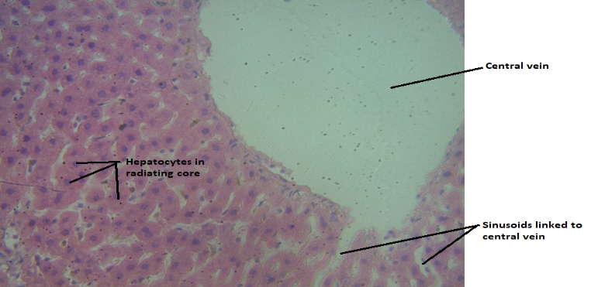

Plate 1. Photomicrograph of control showing normal central vein, hepatocytes and sinusonids

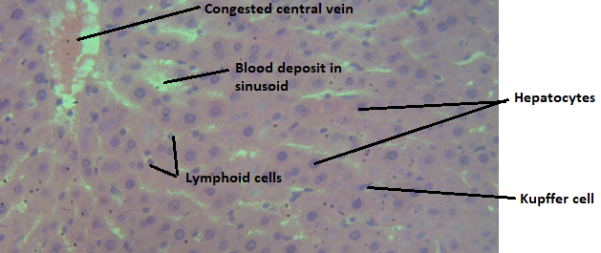

Plate 2. Photomicrograph of normal Wistar albino rats exposed to 166 mg/kg b.wt of aqueous extract of the aerial parts of *Commelina diffusa* for 7 days, congested central vein, moderate lymphoid cells, hepatocytes and kuffer cells

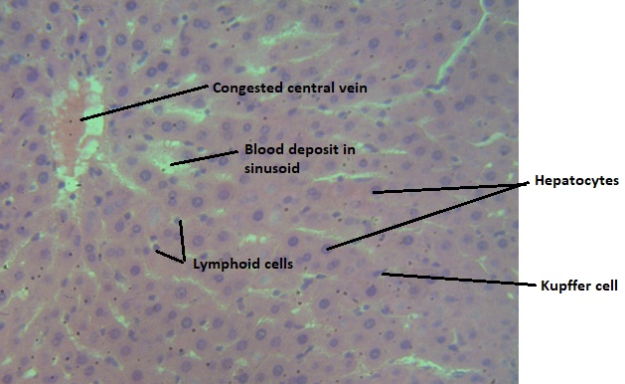

Plate 3. Photomicrograph of normal Wistar albino rats exposed to 166 mg/kg b.wt of aqueous extract of the aerial parts of *Commelina diffusa* for 14 days, miled central vein, moderate lymphoid cells, hepatocytes and kuffer cells

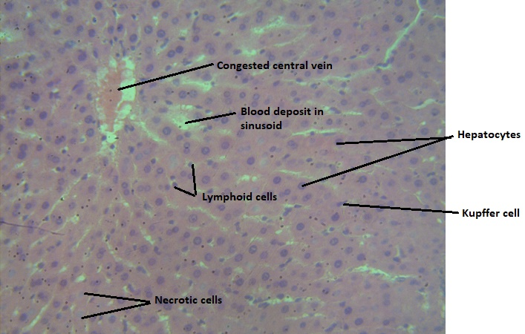

Plate 4. Photomicrograph of normal Wistar albino rats exposed to 166 mg/kg b.wt of aqueous extract of the aerial parts of *Commelina diffusa f*or 21 days, miled necrotic cells, congested central vein, moderate lymphoid cells, hepatocytes and kuffer cells

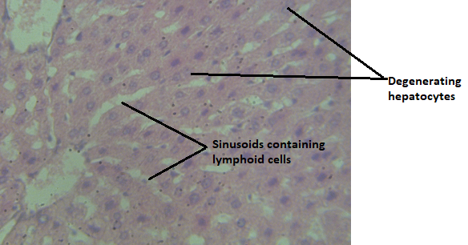

Plate 5. Photomicrograph of normal Wistar albino rats exposed to 250 mg/kg b.wt of aqueous extract of the aerial parts of *Commelina diffusa* for 7 days, showing normal central vein and regenerating hepatocytes

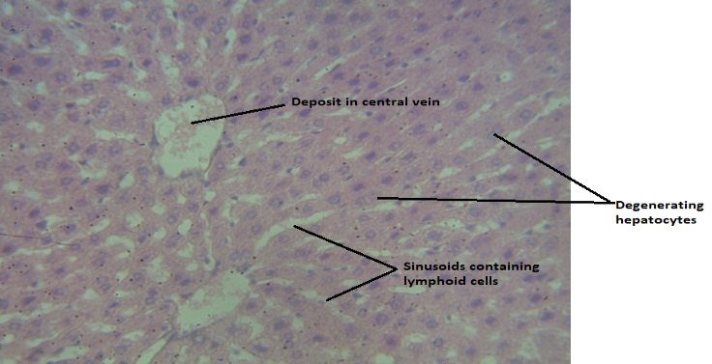

Plate 6. Photomicrograph of normal Wistar albino rats exposed to 250 mg/kg b.wt of aqueous extract of the aerial parts of *Commelina diffusa* for 14 days, showing regenerating hepatocytes, deposit in central vein, and normal sinusoid containing lymphoid cells



Plate 7. Photomicrograph of normal Wistar albino rats exposed to 250 mg/kg b.wt of aqueous extract of the aerial parts of *Commelina diffusa* for 21 days, showing regenerating hepatocytes, and normal sinusoid containing lymphoid cells

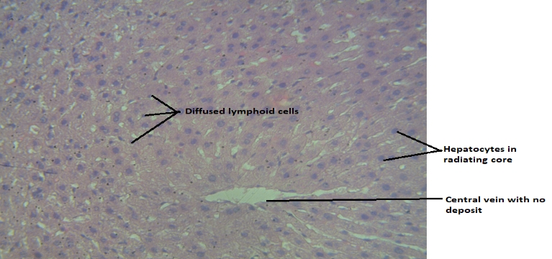

Plate 8. Photomicrograph of normal Wistar albino rats exposed to 500 mg/kg b.wt of aqueous extract of the aerial parts of *Commelina diffusa* for 7 days, showing diffused lymphoid cells, normal kuffer cells, radiating hepatocytes and normal central vein

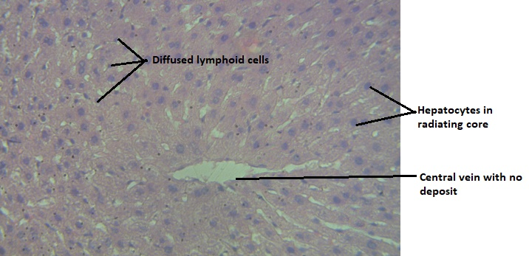

Plate 9. Photomicrograph of normal Wistar albino rats exposed to 500 mg/kg b.wt of aqueous extract of the aerial parts of *Commelina diffusa* for 14 days, showing diffused lymphoid cells, normal kuffer cells, radiating hepatocytes and normal central vein

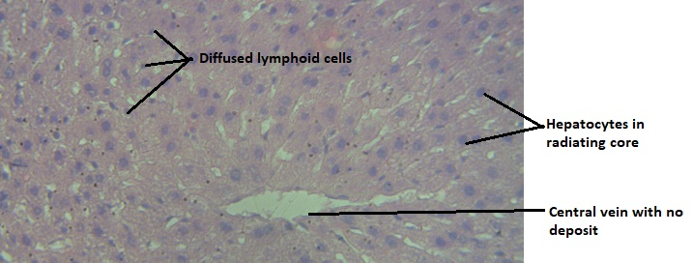

Plate 10. Photomicrograph of normal Wistar albino rats exposed to 500 mg/kg b.wt of aqueous extract of the aerial parts of *Commelina diffusa* for 21 days, showing diffused lymphoid cells, normal kuffer cells, radiating hepatocytes and normal central vein

**4. DISCUSSIOIN OF FINDINGS**

Table 2 shows the effect ofaqueous extract of the aerial parts of *Commelina diffusa* on biomarkers of liver homogenate in normal non-pregnant female rats. Oral administration of aqueous extract of *Commelina diffusa* at 166mg/kg body weight for 7, 14, and 21 days resulted in significant increases on the mean homogenate total protein and albumin levels when compared to the normal control and more significant increases on the mean homogenate total protein and albumin levels were observed in the group treated with the extract at 250 and 500mg/kg body weight for 7, 14, and 21 days in comparison to the control (Table 2). The mean bilirubin level of group 2-4 were significantly decreased after oral treatment with *Commelina diffusa* extract for 7, 14, and 21 days, when compared to the control values and more significant trends occurred with treatment using 250 and 500mg/kg body weight of the extract for 7, 14, and 21 days when compared to the control values (Table 2). Also, the mean homogenate ALT, AST, and ALP activities of rats orally administered with *Commelina diffusa* extract at 166mg/kg for 7, 14, and 21 days were significantly decreased when compared to the control values and more improvements were observed in the rats administered at 250 and 500mg/kg for 7, 14, and 21 days (Table 2). The significantly increased mean homogenate total protein and albumin levels as well as the decreased mean homogenate bilirubin concentration after administration with *Commelina diffusa* at 166, 250, and 500mg/kg body weight of extract for 7, 14, and 21 days in comparison to the normal control is reflective of *Commelina diffusa* ability in enhancing hepatic total protein, albumin, ALT, ALP, and AST biosynthesis. The effect of *Commelina diffusa* extract at 166, 250, and 500mg/kg body weight on the mean homogenate total protein and albumin level as well as the ALT, AST, and ALP activities were similar to the effect elicited by *Euphorbia heterophylla* on the mean plasma total protein and albumin level as well as the ALT, AST, and ALP activities reported by Wellington *et al*. (2020) on acute toxicity study of *euphorbia heterophylla* normal Wistar albino rats.

However, Table 3 indicates the effect of aqueous extract of the aerial parts of *Commelina diffusa* on oxidative stress biomarkers of kidney homogenate in normal non-pregnant female rats. Alqahtani *et al*. (2022) showed that plant extracts were effective in reducing MDA levels, a marker of lipid peroxidation, in the liver of rats exposed to oxidative stressors such as carbon tetrachloride (CCl₄) or high-fat diets. *Silybum marianum* extract elicited protective effect on CCl₄-induced oxidative stress in rats and also increased SOD and GSH levels; reduced MDA levels. Curcumin ameliorates high-fat diet-induced liver damage through antioxidant modulation and restored SOD and GSH activities; reduced lipid peroxidation and ALT/AST levels. Karthik *et al*. (2020)[14] reported that ginger extract conferred hepato-protective on paracetamol-induced oxidative stress in rats, reduced MDA levels and ALT/AST activities, enhanced SOD and CAT enzyme activities. In this study, The mean MDA level was significantly decreased following oral administration of aqueous extract of *Commelina diffusa* at 250mg/kg body weight for 7, 14, and 21 days when compared to the normal control values (Table 3). The mean MDA level was significantly decreased following oral administration of aqueous extract of *Commelina diffusa* at 500mg/kg body weight for 7, 14, and 21 days when compared to the normal control values (Table 3). The significant decreases observed on the mean homogenate MDA level after oral exposure of rats to Commelina diffusa extract at 250 and 500mg/kg body weight is suggestive of the anti-lipid peroxidation potential of the aerial parts of the plant. The mean homogenate GSH levels of rats orally administered with the extract at 250mg/kg for 7, 14, and 21 days were significantly increased in comparison to the normal control and more increased levels were noticed in rats administered with the extract at 500mg/kg body weight for 7, 14, and 21 days, when compared to the control (Table 3). Also, the mean homogenate GPx, CAT, and SOD activities of rats orally administered with *Commelina diffusa* extract at 166, 250, and 500mg/kg body weight for 7, 14, and 21 days were significantly increased when compared to the normal control (Table 3). The significant increases seen on the mean GPx, CAT, and SOD activities of rats orally administered with *Commelina diffusa* extract is expressive of the extract to enhance the synthesis of anti-oxidant enzymes. The enhancement elicited by aqueous extract of *Commelina diffusa* aerial parts on the oxidative stress biomarkers of liver homogenate is similar to the effect produced by aqueous extract of the aerial parts *Leonurus cardiaca* on the mean MDA, GSH, CAT, GPx, and SOD activities reported by Wellington *et al.* (2023) on ameliorative effect of aqueous crude extract of the aerial parts of *Leonurus cardiaca* on doxorubicin-induced cardiovascular damage in Wistar rats.

Meanwhile, Table 4 shows the effect ofaqueous extract of the aerial parts of *Commelina diffusa* on plasma lipid profile in normal non-pregnant female rats. Untreated patients with conditions such as hypertension and acute coronary syndrome exhibited elevated LDL-C (Low-Density Lipoprotein Cholesterol), decreased HDL-C (high-density lipoprotein cholesterol), increased triglycerides and total cholesterol (Martinez *et al.* 2022). Oliveira *et al.* (2020) showed that the lipid abnormalities in patient untreated chronic disease CKD showed hypertriglyceridemia and low HDL-C. According to Silva *et al.* (2022) and **Gupta *et al*. (2021)** hyperlipidemia without treatment is associated with increases in LDL-C and triglycerides decreases in HDL-C. In this study, oral administration of aqueous extract of the aerial parts of *Commelina diffusa* at 166, 250, and 500mg/kg body weight resulted in significant increases on the mean plasma total cholesterol, HDL, VLDL, and triglyceride levels in comparison to the normal control. Administration of the extract at 166, 250, and 500mg/kg body weight significantly caused reduction on the mean plasma LDL-cholesterol when compared to the normal control values (Table 4). The significant increases noticed on the mean plasma total cholesterol, HDL-cholesterol, HDL-cholesterol, VLDL-cholesterol, and triglyceride concentration is suggestive of the ability of the extract to enhance the metabolism of bad cholesterol, hence could serve as herbal anti-lipidemic agent. This results are similar with the report of Ghosh *et al.* (2013) on anti-hyperlipidemic and antioxidant activity of Emblica officinalis fruit extract in hyperlipidemic rats.

Moreso, Plate 1-10 shows the effects of *Commelina diffusa* extract at 166, 250, and 500mg/kg body weight for 7, 14, and 21 days. The liver tissue of rats orally administered aqueous extract of Commelina diffusa at 166mg/kg body weight for 7, 14, and 21 days showed miled improvement on liver architecture when compared to the normal control (Plate 2-4 and 1). Oral exposure of *Commelina diffusa* extract at 250mg/kg for 7, 14, and 21 days showed normal central vein and regenerating hepatocytes when compared to the normal control tissue (Plate 5-7 and 1). Also, the liver tissue of rats administered with *Commelina diffusa* extract at 500mg/kg for 7, 14, and 21 days indicated improved normal kuffer cells, central vein and hepatocytes in comparison to the normal control tissue (Plate 8-10 and 1). The improve effects observed on the liver tissues after exposure to *Commelina diffusa* extract for 7, 14, and 21 days is reflective of less toxic effect of the extract at 166, 250, and 500mg/kg body weight. This findings is similar to the impact of Leonurus cardiaca extract on liver tissues reported by Wellington *et al.* (2022)on acute, sub-acute and chronic toxicity evaluation of aqueous extract of the aerial parts of *Leonurus cardiaca* in normal non-pregnant female Wistar albino rats per OECD 425 TG.

1. **CONCLUSION**

In the light of finding of acute, sub-acute and chronic toxicity studies of aqueous extract of *Commelina diffusa*, as per OECD 425 TG indicated improvement on all assayed liver biomarkers and tissues. The significantly improved effect observed from this study is suggestive that aqueous extract of the aerial parts of *Commelina diffusa* elicited non-toxic effects and the plant extract is safe at 166, 250, and 500 mg/kg.

**REFERENCES**

Newman, D.J., & Cragg, G.M. (2016). Natural products as sources of new drugs from 1981 to

2014. *J Nat Prod, 79*, 629–61.

Harvey, A.L., Edrada-Ebel, R., & Quinn, R.J. (2015). The re-emergence of natural products for

drug discovery in the genomics era. *Nat Rev Drug Disc, 14,*111–29.

Thomford, N.E., Senthebane, D.A., Rowe, A., Munro, D., Seele, P., & Maroyi, A. (2018). Natural

products for drug discovery in the 21st century : innovations for novel drug discovery. *Int J Mol Sci, 19,* 1578–607.

Schnellman, R. (2008). Toxic responses of the kidney. In: Klaassen CD, editor. Casarett and

Doull’s toxicology: the basic science of poisons. New York: McGraw-Hill, 235–72.

Weiler, S., Merz, M., & Kullak-Ublick, G.A. (2015). Drug-induced liver injury: The dawn of

biomarkers. F1000 Prime Reports, 7, 34.

Takin, M.C., Attindehou, S., Sezan, A., Attakpa, S.E., & Baba-Moussa, L. (2013). Bioactivity,

therapeutic utility and toxicological risks of *Khaya senegalensis*. Indian J Pharmaceut Biol Res, 1,122–1229.

Aulbach, A.D., & Amuzie, C.J. (2017). Biomarkers in nonclinical drug development. In: Faqi AS,

editor. A comprehensive guide to toxicology in nonclinical drug development. *London: Academic Press, Elsevier,* 447–71.

Tauheed, A.M., Mamman, M., Ahmed, A., Suleiman, M.M., & Balogun, E.O. (2020). *In*

*vitro* and *in senegalensis* and potash. *J Ethnopharmcol, 258*,112805.

Tauheed, A.M., Mamman, M., & Ahmed, A. (2021). Acute, sub-acute, sub-chronic and chronic

toxicity studies of four important Nigerian ethnomedicinal plants in rats. *Clin Phytosci* **7**,

Tauheed, A.M., Shittu, S.H., Suleiman, M.M., Habibu, B., Kawu, M.U., & Kobo, P.I. (2016). *In*

*vivo* ameliorative effects of methanol leaf extract of *Lawsonia inermis* Linn on experimental *Trypanosoma congolense* infection in Wistar rats. *Int J Vet Sci Med, 4*, 33–40.

Boone, L., Meyer, D., Cusick, P., Ennulat, D., Bolliger, A.P., & Everds, N. (2005). Selection and

interpretation of clinical pathology indicators of hepatic injury in preclinical studies. *Vet Clin Pathol, 34,*182–8

Wellington, E.O., Ogbomade, S.J., & Victor I. (2020). Acute Toxicity Study of Euphorbia

heterophyllain Normal Wistar Albino Rats. *International Journal of Scientific & Engineering Research, 11,* 1.

Alqahtani, M., Alshahrani, M. Y., Al-Sheddi, E. S., Al-Sohaimy, S. A., & Al-Saadi, B. H. (2022).

Protective effects of Silybum marianum extract on CCl₄-induced oxidative stress in rats. Journal of Ethnopharmacology, 285, 114862

**Karthik, R., Srinivasan, M., Kumar, A.,** & **Singh, M.**. (2020). Hepatoprotective effects of ginger

extract on paracetamol-induced oxidative stress in rats. Biomedicine & Pharmacotherapy, 129, 110356.

Wellington, E. O, Otobo, M. B., & Ogbomade, S.J. (2023). Ameliorative Effect of Aqueous Crude

Extract of the Aerial Parts of *Leonurus Cardiaca* on Doxorubicin-Induced Cardiovascular Damage in Wistar Rats. *International Journal of Biochemistry Research & Review, 32*, 6, 22-36.

Martinez, F., Gupta, R., & Lee, S. (2022). Dyslipidemia patterns in patients with acute coronary

syndrome without statin therapy. Cardiovascular Diabetology, *21*(1), 45.

Oliveira, T., Mendes, R .l., & Costa, P. (2020). Comprehensive lipid profiling in untreated chronic

kidney disease patients. Nephrology Dialysis Transplantation, *35*(8), 1405-1413.

Silva, M., Thompson, L., & Garcia, H. (2022). Untreated obesity and its impact on plasma lipid

profiles in adults. Obesity Reviews, *23*(5), e13321.

**Gupta, A., Kumar, R., Thakur, M.,** & **Sharma, S. (2021)**. Curcumin ameliorates high-fat diet-

induced liver damage through antioxidant modulation. Phytomedicine, 91, 153696.

Ghosh, K.S, Bandyopadhyay, N.G., Sinha, S., Chatterjee, M. (2013). Anti-hyperlipidemic and

antioxidant activity of Emblica officinalis fruit extract in hyperlipidemic rats. Pharmacognosy Journal,***5***(3), 179-184.

Wellington, E.O., Onyeike, E.N., Peters, D.E., Otobo, M.B., Felix, D., & Ogbomade, S.J. (2022).

Acute, Sub-acute and Chronic Toxicity Evaluation of Aqueous Extract of the Aerial Parts of *Leonurus cardiaca* in Normal Non-pregnant Female Wistar Albino Rats per OECD 425 TG. *Journal of Applied Life Sciences International, 25*(6), 1-17.