The Effect of Abattoir Waste as an Amendment on the Physiochemical Properties of Household Organic Waste

.

ABSTRACT

|  |
| --- |
| **Aims:** To evaluate the effect of abattoir waste as an amendment on the physiochemical properties (Temperature, PH, EC, MC, VS, and TOC) of household organic waste in windrows composting.  **Study design:** Field and laboratory experiment were employed during the experiment.  Place and duration of study: project laboratory and waste-to-resource project site, department of environmental science, University of Buea, Cameroon from January to April 2025.  **Methodology:** The study used abattoir waste as an amendment in four different ratios; 70:30%, 80:20%, 90:10% and 100:00% in composting household waste. A total of eight treatments in 8 chambers were set up at the waste-to-energy resource project site. The various treatments were monitored twice a week for pH, Temperature, EC, MC, TOC and VS, data collected and the composting process was completed in 100 days.  **Results:** The highest temperature recorded was 51.70c and was experienced from 70:30% treatment and the lowest temperature recorded was 39.10c from household waste 100:00% treatment. The treatments were highly acidic at the beginning with treatment 80:20% being the highest 4.42 and treatment 100:00% being the lowest 3.28. The highest electrical conductivity (EC) was observed in the 70:30% treatment at 2.8 μs/cm, and treatment 100:00% being 0.3 μs/cm, while MC content was highest 83.75 from treatment 100:00% and lowest 82.07 from treatment 70:30%. For vs and TOC, there were no significant differences between the various treatments with a p-value > 0.05 (0.701). The MC, VS and TOC in all the treatments started high and kept decreasing till the end of the experiment.  **Conclusion:** the addition of abattoir waste in a higher proportion of 70:30% enhances the physiochemical properties of the composting material as compared to treatments 80:20%, 90:10% and 100:00%. |

*Keywords: Composting, household organic waste, physicochemical properties, abattoir waste,*

*treatments, amendment*

1. INTRODUCTION

Globally, urbanization as well as steady rise in human population has resulted in the generation of large quantities of abattoir wastes (Onwosi *et al.,* 2017), as global meat consumption has seen a 40% increase in the last decade (Ragasri & Sabumon, 2023). Due to the extensive upsurge in demand for meat, the number of abattoirs is also amassed thereby increasing the production of eco-friendly organic waste. Several management techniques for abattoir waste exist in developed countries, but effective application of abattoir waste management is still absent in developing countries. These abattoir waste streams have led to several challenges (environmental, social and economic) especially in developing countries (Awasthi *et al.,* 2014; Sukholthaman & Sharp, 2016). Large proportions of waste generated are not disposed of properly posing potential environmental threat due to the presence of pathogens and toxic pollutants. Abattoir wastes are a potential reservoir of bacterial, viral prion and parasitic pathogens, capable of infecting both animals and humans if not treated (Murtala, 2014). The increasing human population directly correlates with increased organic and inorganic waste generation. Huge amounts of organic waste are produced in order to meet the ever-increasing global demand for food and other livestock products like beef, pork, milk and eggs (Tiku, 2019).

Waste management concerns have increased in the past decades resulting from large quantities of waste produced from the urban and rural areas, especially from households. Municipal bodies or waste management companies in various cities collect this waste, transport and dispose of it in open dumpsites or landfills. Landfill is problematic as improper management which is the case in most developing countries like Cameroon produces greenhouse gases and leachate that pollutes the air, soil, ground water and affects biodiversity (Martin *et al.,* 2019). Large proportions of waste produced from communities are not disposed of properly, posing a potential threat to humans and the environment due to the presence of pathogens and toxic pollutants (Bakume *et al.,* 2018), emitting ammonia and other greenhouse gases. Therefore, it is necessary to find a suitable alternative to reduce the environmental problems associated with the management of waste. Research works conducted on wastes in developing countries suggested that wastes can be recycled or processed for conversion into useful products such as nutrient input for agricultural production (Tamirat & Tamenech, 2017). Recycling a variety of organic wastes (including abattoir waste, and household organic waste) to form compost is an environment-friendly alternative strategy and technology for waste management (Antoni *et al.,* 2020).

Composting is one of the best-known processes for the biological stabilization of solid organic wastes by transforming them into safer and more stabilized agricultural applications (Yengong *et al.,* 2021). Composting helps to reduce air pollution and greenhouse gas (GHG) emissions, and generates useful products while serving as a waste treatment technology. Among the different types of composting, windrow composting is known for its low capital cost, relatively simple operation and eco-friendliness (Vigneswaran *et al.,* 2016). Much importance was given to the composting of household waste because of its eco-compatibility, availability and easy operational procedure. The composition of the composting materials determines the metabolic processes of various microorganisms during the composting process. Therefore, the individual properties of particular waste materials may have their special characters during composting, though the principles of composting for different kinds of waste are mostly the same (Zhentong *et al.,* 2013). To produce quality compost, it is important to monitor and control the parameters that affect the decomposition process. This process is governed by physiochemical parameters such as; pile temperature, moisture content, volatile solid, total solid, pH, carbon-to-nitrogen ratio, total organic carbon (TOC) and electrical conductivity (Yengong *et al.,* 2021) which greatly influence the composting process. This study was therefore carried out to evaluate the effect of abattoir waste as an amendment on the physiochemical properties of household organic waste in windrows composting.

2. material and methods

2.1. RESEARCH SITE

This research was carried out at the waste-to-energy resource project site and project laboratory of the department of environmental science of the University of Buea, Cameroon between January and April 2024. The facility is made up of 18 composting chambers; each with a dimension of 0.7 × 0.9 × 1 m. Each chamber has 3 closed walls with an open front and top (figure 1). The closed walls are made of cement blocks at a height of 1 m from the ground. The floor of each chamber is fully concreted with a gentle slope that channels leachate outwards. The entire composting facility is roofed at a height of 3 m from the ground (Tiku *et al*., 2023). The projected site is located at 4º10'n, 9º14'e and 400 meters above sea level.

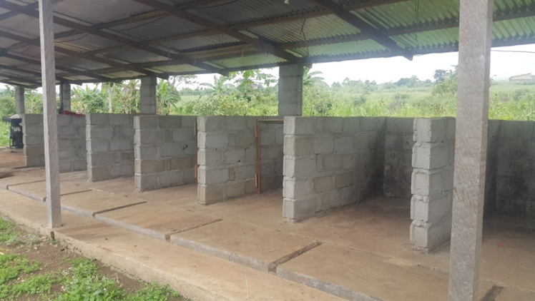

Figure 1: Composting facility at the University of Buea

**2.2 SUBSTRATE COLLECTION**

The main materials used for the composting were abattoir waste (cow dung and stomach waste) and organic household waste (fruit wastes, vegetable wastes, leftover food). The abattoir waste was sourced locally from Buea Town and Mutengene abattoirs; Household organic waste was collected from households in Buea and from Muea Market. All the waste (the different substrates) used for the experiment were collected in empty rice bags and transported by a tricycle to the experimental site at UB a day before the establishment of the experiment.

**2.3 EXPERIMENTAL SET-UP**

**2.3.1 SUBSTRATE PREPARATION**

Household Organic Waste was shredded to particles of 2-5 cm in size with sharpened cutlasses before using in the experiment. This helped to increase the surface area for reaction hence facilitating decomposition process. At the composting site, the weights of the different waste types were obtained using a scale balance (Type: Analog Hanging Scale, Shangzing Quan Heng, China). 250kg of shredded household organic substrate plus abattoir waste as amendment was measured and placed in the chambers in ratios of 70:30, 80:20, 90:10 and 100:00 respectively. The materials were mixed in four treatments with two replications in a randomized complete block design as shown in Table 1. One liter of water was sprinkled on the waste content in each chamber and mixed thoroughly at the beginning of the experiment. This was to maintain the right moisture content in order for microorganisms to live and work to decompose organic waste. The composting was carried out in eight composting rooms of equal dimensions under aerobic conditions. A shovel was used to turn the treatments ones a week, and physiochemical parameters (temperature, volatile solid, electrical conductivity, total organic carbon, pH and moisture content) were taken twice a week for analysis till the end of the experiment which ran for a period of 100 days.

Table 1: Composting Chambers with different Ratios of Household Organic Waste and Abattoir Waste Amendments

|  |  |
| --- | --- |
| **Household Organic Waste: Abattoir Waste** |  |
| Chamber 1. 80:20 |
| Chamber 2. 100:00 |
| Chamber 3. 70:30 |
| Chamber 4. 90:10 |
| **REPLICATES** | |
| **Household Organic Waste: Abattoir Waste** |
| Chamber 5. 100:00 |
| Chamber 6. 80:20 |
| Chamber 7. 90:10 |
| Chamber 8. 70:30 |

**2.3.2 MEASUREMENT OF PHYSIOCHEMICAL PARAMETERS**

Temperature and pH were measured in-situ twice a week (between 10:00am and 12:00 noon) with the use of a compost thermometer (TFA Dostmann, Wertheim, Germany) and an AL10pH portable pH meter (Aqualytic, Dortmund, Germany). They were placed in the compost pile for 5 minutes at 3 different points and depth ranging from 30-40 cm. Three different readings were collected for each of the chambers; the average of these three readings was considered to be the temperature and pH of the pile. The pH probe was cleaned with 70% ethanol between each sample measurement to preclude the build-up of films from sample organic acids, which could reduce accuracy. Samples were collected into duplicate vials for the analyses of EC, moisture content (MC) and VS using method 1648 of the U.S. Environmental Protection Agency (Ngwabie *et al.,* 2018; Ngwabie *et al.,* 2022; USDA, 2020). Total organic carbon (TOC) was calculated according to Zhang *et al.,* (2020).

**2.4 STATISTICAL ANALYSIS**

Statistical analyses of the data were carried out using MINITAB version 21. Analysis of Variance (ANOVA) test was used to assess differences in the various physiochemical parameters in the windrow compost piles at a p-value of 0.05. Where significant differences were observed, a post-hoc analysis was carried out using the Tukey HSD test to assess the various physiochemical parameters of the different treatments in the windrow composting. Student T-test was also used to compare means of the physiochemical properties of the treatments.

3. results and discussion

3.1 Temperature Variation

The temperature trends in the various household organic waste treatments with different ratios of abattoir amendments are shown in fig. 2. All the treatments began with ambient temperatures and experienced a sharp increase within the first seven days of composting. During the first seven days, the highest recorded temperature was 42.20C in the 70:30% treatment and the lowest temperature 36.90C was experienced in the 80:20% treatment. A gradual increase in temperature was noticed in all the treatments from the 8th day to the 14th day after which there was a sharp increase in treatment 70:30% with a temperature of 51.70C from the 14th day to the 18th day. All the treatments experienced a gradual decrease in temperature from the 19th day till the end of the experiment. The sharp increase in temperatures within the first seven days of composting can be ascribed to the direct relationship that exists between microbial activities and temperature during composting as supported by (Paran *et al.,* 2017). Treatment with the highest percentage of abattoir waste 70:30% had the highest temperature (51.70C) because of the high organic load from the abattoir waste resulting to high microbial activities that lead to a rapid increase in temperatures, as compared to the other treatments. The sharp increase in temperature 51.70C from the 14th day to the 18th day in treatment 70:30% shows that the addition of abattoir waste in greater proportion plays a significant role in providing optimal C/N ratio to microorganisms, and this encourages active microbial biomass, organic matter degradation and rise in temperature as compared to the other treatments. The lowest temperature 41.80C from 100:00% treatment indicates a decrease in microbial activities due to the absence of abattoir waste in the treatment. The decrease in temperature till the end of the experiment is an indication that the microbes in the compost treatments have completed the decomposition process in the experiment. The temperature evolution during the experiment followed a similar pattern as those of other reports like; Brito *et al.*, (2012); Bustamante *et al.,* (2008); Tiku, (2019). In Table 2, the Anova results showed that there were no statistical significant differences between the various treatments with a p-value = 0.05 (0.707).

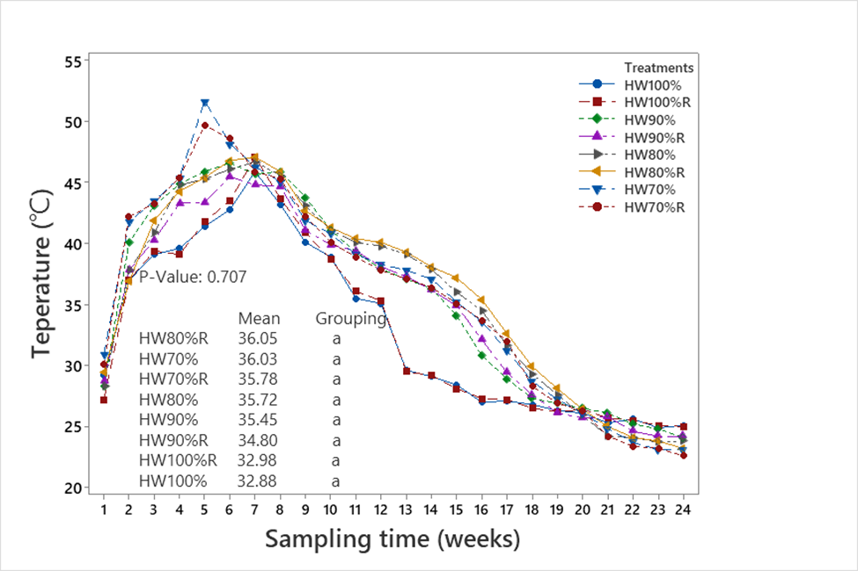

Figure 2: Temperature trend during the experiment.

**3.2 PH VARIATION**

Fig. 3 shows the pH values of the various treatments which were found to be highly acidic at the beginning of the composting process with treatment 100:00% having the lowest value 3.28 and treatment 80:20% having the highest value 4.42. There was a sharp increase in the pH values in all the treatments from the beginning till the tenth day and a sharp decrease from the eleventh day till the fourteenth day, after which there was a sharp increase till the twenty-first day. The pH value was almost constant till the end of the experiment from the twenty-first day. At the beginning of the experiment, the treatment had varying degrees of acidity ranging 3.28 to 4.42. Low pH at the start of composting indicates the development of organic acids, which subsequently became more basic in all the treatments and reached 7.09 in treatment 80:20% by the tenth day. The gradual increases in pH throughout the composting process restrict fungal development that thrives in an acidic environment. Treatment with 100:00% household organic waste had a more acidic pH 3.28 as compared to treatment 70:30% which pH 4.0 was closer to basic condition. This is as a result of the organic content found in the 70:30% treatment. A sharp increase in pH (5.05 to 7.09) within the fourth day and seventh day was recorded by treatment 80:20% during the experiment. This indicates that sufficient air was being supplied to the system, maintaining it at aerobic conditions as supported by Vivienne, (2015). After a decrease in all the treatments between day ten and day fourteen, there was a rapid increase in all the treatments from the fifteenth day to the eighteenth day with the highest basic value being 8.23 in treatment 70:30% and the lowest value being 5.03 in treatment 100:00%. From week three, all the treatments had basic values till the end of the experiment in line with the findings of Nedra *et al.,* (2019). Rise and fall in pH values exhibited by the treatments could be linked to the biodegradation of the organic acids, mineralization of organic compounds and the consequent release of volatile NH3 (Said-Pullicino *et al.,* 2007). The ANOVA results indicated no statistically significant differences between the various treatments with a P-value = 0.05 (0.765) as shown in Table 2.

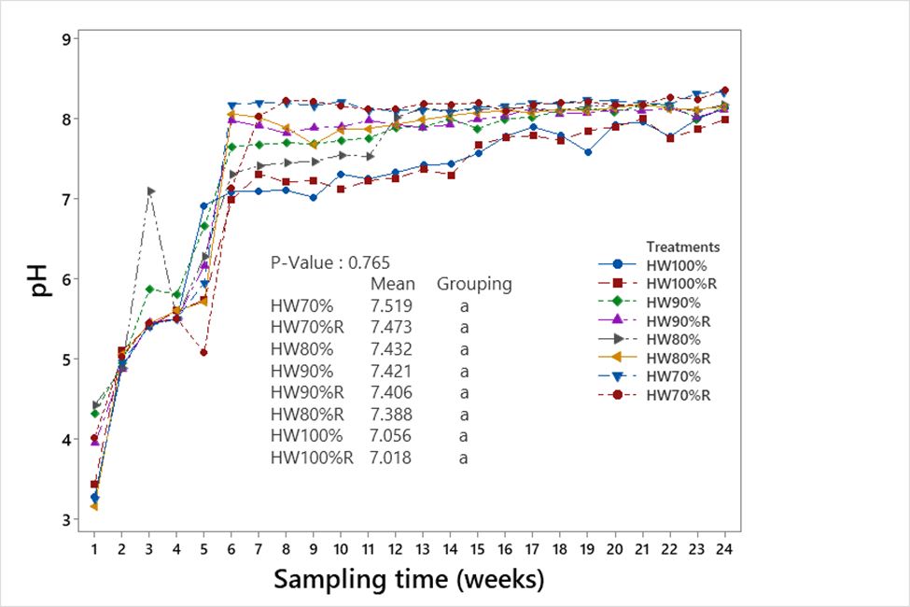

Figure 3: pH trend during the experiment

**5.3 ELECTRICAL CONDUCTIVITY (EC) VARIATION**

All the treatments had low electrical conductivity (EC) values which reduced gradually during the first week of the experiment, increased steadily during the second week and started dropping from the third week till the end of the experiment. The highest EC value was 2.8 μS/cm in the 70:30% treatment, with the lowest value being 0.3 μS/cm in treatment 100:00%.Fig. 4 shows that there was a steady rise in EC value (2.3 μS/cm-2.8 μS/cm) in the 70:30% treatment from the third week to the fourth week of the experiment. This treatment has a high proportion of abattoir waste amendment with high organic matter content whose degradation forms inorganic compounds and the relative concentration of ions increases owing to waste mass loss leading to a high EC value. The 80:20% treatment had the second highest EC value 2.38 μS/cm because of the proportion of the abattoir waste in the treatment. Treatment 100:00% had the lowest EC value 0.3 μS/cm because of the absence of abattoir content in the treatment. The decrease in EC values in all the treatments during the first week is likely due to the leaching of salts from the substrates due to the addition of water, as well as changes in the absorption capacity of the compost piles in the treatments. Similar results were reported by Paredes *et al.,* (2015). Huang *et al.,* (2004) explained that the volatilization of ammonia and the precipitation of mineral salts may cause a decrease in EC at the later stage of composting. The ANOVA results showed that there were statistically significant differences between the various treatments with a P-value = 0.05 (0.000) as shown in Table 2.

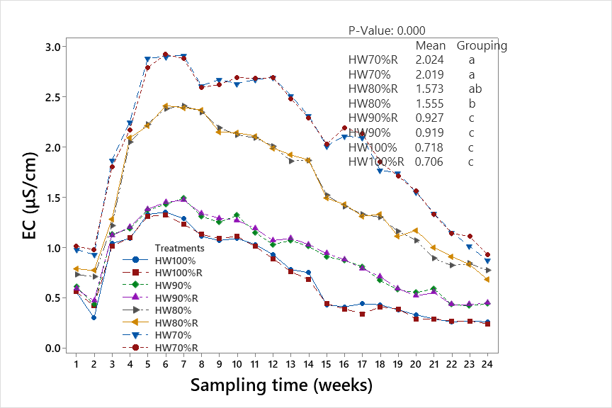

Figure 4: Electrical Conductivity trend during the experiment

**5.4 MOISTURE CONTENT (MC) VARIATION**

At the beginning of the experiment, all the treatments had high moisture content (MC) which kept decreasing till the end of the experiment, with the highest being 83.75 from the 100:00% treatment and the lowest being 82.07 from treatment 70:30% as shown in fig.5. The final moisture content was lower for all the treatments with the highest being 44.26 from treatment 100:00% and the lowest being 32.68 from treatment 70:30%. The presence of high moisture content from treatment 100:00% is because this treatment is made up only of household organic waste with a majority of it being vegetable waste. This finding is supported by Jain *et al.,* (2019) stating that, vegetable waste is one kind of organic waste holding very high moisture. The high proportion of abattoir waste in the 70:30% treatment produces high microbial activities which uses more water producing heat thus reducing the moisture content as compared to the other treatments. The ANOVA results showed that there were no statistically significant differences between the various treatments with a P-value = 0.05 (0.181) as shown in Table 2.

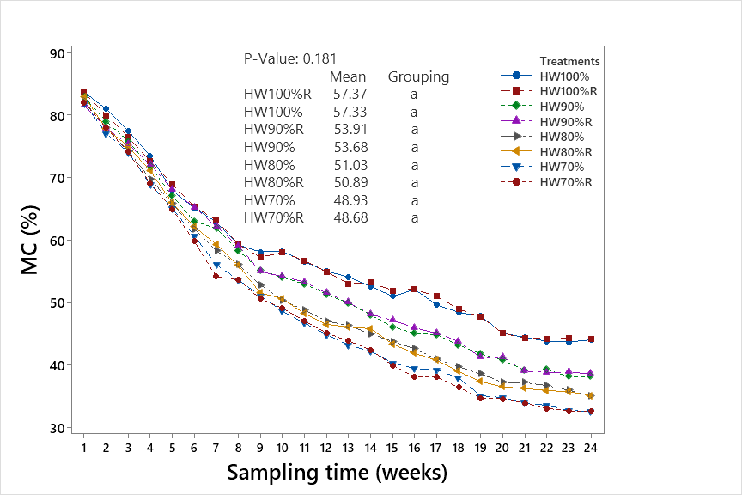

Figure 5: Moisture Content trend during the experiment

**3.5 VOLATILE SOLID (VS) AND TOTAL ORGANIC CARBON (TOC) VARIATIONS**

Fig. 6a and 6b shows that both VS and TOC in all the treatments had very high values at the beginning of the experiment with treatment 70:00% having the highest values within the first two weeks and treatment 100:00% having the lowest values. From the third week till the end of the experiment, treatment 100:00% had the highest values while treatment 70:00% had the lowest values of both VS and TOC in all the treatments. Higher temperatures, within the thermophilic stage (45-700C) accelerate the breakdown of volatile solids and significantly speed up the activity of microorganisms that decompose organic matter. During the experiment, VS and TOC decreased significantly during the composting process with the maximum reduction occurring during the thermophilic stage. There was a great reduction in the VS value in the 70:30% treatment within the first and second week of the experiment as compared to treatments; 100:00%, 80:20% and 90:10% due to the higher degradation of the organic matter, during the active thermophilic and post thermophilic stage of the experiment. This is in support of the findings by Vempalli *et al.,* (2017). Microorganisms break down organic matter by consuming volatile solids thus the continuous reduction in both VS and TOC till the end of the experiment in all the treatments. However, a reduction in VS and TOC is a very good indicator of the decomposition rates of the piles. This experiment had the same trend as the findings of Malwana *et al.,* (2013). The ANOVA results showed that both VS and TOC values were not significantly different along the treatments with P-value = 0.05 (0.701).

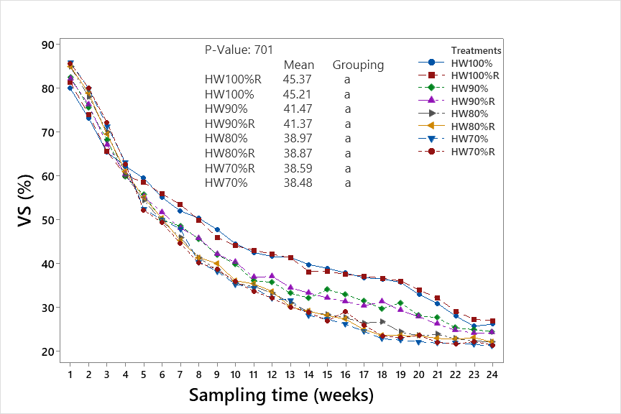

Figure 6a: Volatile Solid trend during the experiment

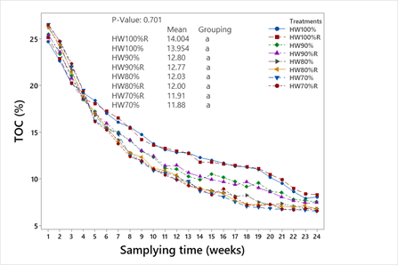

Figure 6b: Total Organic Carbon trend during the experiment

Table 2: T-test results for comparison of means of physiochemical properties between HW and HW when amended with Abattoir Waste

|  |  |  |  |  |  |  |
| --- | --- | --- | --- | --- | --- | --- |
| **Variables** | **Temp** | **pH** | **EC** | **MC** | **VS** | **TOC** |
| HW100 - HW90 | Significant | Significant | Significant | Significant | Significant | Significant |
| HW100 - HW80 | Significant | Significant | Significant | Significant | Significant | Significant |
| HW100 - HW70 | Significant | Significant | Significant | Significant | Significant | Significant |
| HW90 - HW80 | Significant | Significant | Significant | Significant | Significant | Significant |
| HW90 - HW70 | Significant | Significant | Significant | Significant | Significant | Significant |
| HW80 - HW70 | Not Significant | Not Significant | Significant | Significant | Not Significant | Not Significant |

**4 CONCLUSION**

Composting is a simple and useful technique to manage the organic fraction of household waste. The use of abattoir waste as an amendment influences both the efficiency of the composting process and the quality of the compost obtained. While the statistical analysis did not reveal significant differences in temperature and pH between the treatments with varying ratios of abattoir waste to household organic waste, clear trends were observed, suggesting that a higher proportion of abattoir waste may lead to faster initial heating.The results indicate that treatment 70:30% with a higher proportion of abattoir waste is more efficient and degrades faster than treatments 80:20%, 90:10% and 100:00%. The study thus concludes that household organic waste should be amended with higher proportion of abattoir waste and used for the production of compost

References

Antoni Sánchez, Tahseen Sayara, Rezq Basheer-salimia, & Fatina Hawamde. (2020). Recycling of organic wastes through composting: process performance and compost application in agriculture. Agronomy for sustainable development, 10. Https://doi.org/10.3390

Awasthi, M. K., Pandey, A. K., Khan, J., Bundela, P. S., Wong, J. W. C., & Selvam, A. (2014). Evaluation of thermophilic fungal consortium for organic municipal solid waste composting. Bioresource technology, 168, 214–221. Https://doi.org/10.1016/j.biortech.2014.01.048

Bakume, Q. B., Valentine, A. T., & Essia, U. (2018). Abattoir waste management and its potential effects on humans and surface water quality: south west region, Cameroon. 8(8).

Brito, l. M., Mourão, I., Coutinho, J, & Smith, S. R. (2012). Simple technologies for on-farm composting of cattle slurry solid fraction. Waste management, 1332–1340.

Bustamante, M. A., Paredes, C, Marhuenda-Egea, F. C, Pérez-Espinosa, A., Bernal, M. P., & Moral, R. (2008). Co-composting of distillery wastes with animal manures: carbon and nitrogen transformations in the evaluation of com-post stability. Chemosphere, 551–557.

Huang, G. F., Wong, J. W. C., Wu, Q. T., & Nagar, B. B. (2004). Effect of C/N on composting of pig manure with sawdust. Waste manage. 805–813.

Jain, M. S., Daga, M., & Kalamdhad, A. S. (2019). Variation in the key indicators during composting of municipal solid organic wastes. Sustainable environment research, 29(1), 9. Https://doi.org/10.1186/s42834-019-0012-9

Malwana, C., Weerasinghe, T. K., & Pilapitiya, S. (2013). Determination of optimal pile dimensions during thermophillic windrow composting of municipal solid waste (MSW) in sri lanka. International journal of bioscience, biochemistry and bioinformatics, 552–556. Https://doi.org/10.7763/ijbbb.2013.v3.274

Martin Ngwabie, Vanderzaag, A., Nji, P., Tembong, G., & Chenwi, T. (2019). Assessment of gaseous emissions from cattle abattoir wastes in Cameroon. Agriengineering, 1(2), 145–152. Https://doi.org/10.3390/agriengineering1020011

Murtala, U. (2014). Sustainable waste management system in abattoir design. [master]. Ahmadu bello university, zaria.

Nedra Asses, Walid Farhat, Moktar Hamd, Hassib, & Hassib Bouallagui. (2019). Large scale composting of poultry slaughterhouse processing waste: microbial removal and agricultural biofertilizer application. Elsevier, 124, 128–136.

Ngwabie NM, Chungong BN, & Yengong FL. (2018). Characterisation of pig manure for methane emission modelling in sub-saharan africa. Biosystems engineering.

Ngwabie NM, Tiku TD, & yengong lf, (2022). Effect of wood shavings on the temperature profile of livestock waste during composting with daily turning. Agricultural engineering international: cigr journal.

Onwosi, C. O., Igbokwe, V. C., Odimba, J. N., Eke, I E., Nwankwoala, M. O.,Iiroh, I. N., & Ezeogu, l. I. (2017). Composting technology in waste stabilization: on the methods, challenges and future prospects. Journal of environmental management, 190, 140–157. Https://doi.org/10.1016/j.jenvman.2016.12.051

Paran G, Norshuhaila. Ms, Hazel MP, & Aziz al. (2017). Effect of pH and alum dosage on the efficiency. International journal of green energy.

Paredes, C., Pérez-Murcia, M. D., Pérez-Espinosa, A., Bustamante, M, & Moreno-Caselles, J. (2015). Recycling of two-phase olive-mill cake “alperujo” by co-composting with animal manures. Commun. Soil sci. Plant. Anal, 238-247.

Ragasri, S., & Sabumon, P. C. (2023). A critical review on slaughterhouse waste management and framing sustainable practices in managing slaughterhouse waste in India. Journal of environmental management, 327, 116823. Https://doi.org/10.1016/j.jenvman.2022.116823

Said-pullicino, D Erriquens, F, G., & Gigliotti, G. (2007). Changes in the chemical characteristics of water-extractable organic matter during composting and their influence on compost stability and maturity. Bioresource technology, 1822–1831.

Sukholthaman,P., & Sharp, A. (2016). A system dynamics model to evaluate effects of source separation of municipal solid waste management: a case of Bangkok, Thailand. Waste management, 52, 50–61. Https://doi.org/10.1016/j.wasman.2016.03.026

Tamirat Herago, & Tamenech Bandaw. (2017). Review on abattoir waste management. Global veterinaria, 8. Https://doi.org/10.5829/idosi.gv.2017.517.524

Tiku david tabe. (2019). Effect of adding wood shavings on the composting of livestock manure [MSc degree]. University of Buea.

Tiku David Tiku, Ngwa M. Ngwabie, Veronica E. Manga, & Fabrice l. Yengong. (2023). Variability of physiochemical properties of pig manure with added wood shavings during open-air dumping and windrow composting. Int. J. Environ. Clim. Change, 13(8), 851–862. Https://doi.org/10.9734/ijecc/2023/v13i82020

USDA. (2020). Livestock and poultry: world markets and trade. Foreign agricultural service.

Vempalli Sudharsan Varma, Suminakshi Das, Chivukula V. Sastri, & Ajay S. Kalamdhad. (2017). Microbial degradation of lignocellulosic fractions during drum composting of mixed organic waste. Sustainable environment research.

Vigneswaran S, Kandasamy J, & Johir Mah. (2016). Sustainable operation of composting in solid waste management procedia. Environmental sciences, 408–415.

Vivienne Sim Jie Wei. (2015). Physico-chemical changes and kinetics for mineralisation of efb composting [msc.].

Yengong, l. F., Veronica, E. M., Ngwa, M. N., David, T. T., & Esongami, N. E. (2021). Variability of physiochemical properties of livestock manure with added wood shavings during windrow composting. African journal of environmental science and technology, 15(2), 117–123. Https://doi.org/10.5897/ajest2020.2973

Zhang Y, Guo Y, Dong J, Liu H, Yang F, & Cui Z. (2020). Effects of adding wood shavings on the physicochemical properties and microbial community of pig manure during open-air dumping and windrow composting. Waste management.

Zhentong Li, Hongwei Lu, Lixia Ren, & Li He. (2013). Experimental and modeling approaches for food waste composting: a review. Chemosphere, 1247–1257.