**INNOVATIVE APPROACHES IN ENHANCING VALUE-ADDED PRODUCT FROM MUSHROOM**

**ABSTRACT**

Mushrooms are highly nutritious and rich in vitamins, proteins, antioxidants, and amino acids. However, their perishability limits their demand. Value addition on mushrooms enhances their stability, making them more versatile for consumption. This present study explores the development of innovative mushroom-based products aimed at enhancing shelf life, consumer preference, and market potential. Various value-added formulations, including mushroom souffles, brownies, and cookies, were developed by integrating mushrooms into conventional recipes while maintaining their nutritional integrity. Sensory evaluation of these products demonstrated favorable organoleptic properties, with an optimal balance of texture, flavor, and appearance. The incorporation of mushroom powder and extracts into baked and savory items significantly improved their taste. Additionally, these value-added products could provide an opportunity to increase the utilization of mushrooms to create economically viable alternatives for producers. This research highlights the potential of mushroom-based value-added products in promoting sustainable food practices and expanding consumer markets.

**Keywords:** Mushrooms, Nutrients, Vitamins, Value-added product

**1. Introduction**

Mushroom cultivation is expanding rapidly due to its sustainability and relatively simple production process. However, despite this growth, the demand and supply of mushrooms, particularly in India, remain limited due to a lack of consumer awareness about their nutritional value and the challenges of perishability (Royse et al., 2017; Jahan et al., 2019; Seethapathy et al., 2023). Mushrooms are an excellent source of high-quality protein and essential nutrients, such as B vitamins, selenium, copper, and phytonutrients (Barros et al., 2008; Alves et al., 2012; Praveen et al., 2018). They also contain bioactive compounds like β-glucans, which exhibit immunomodulatory, antioxidant, anticancer, and anti-inflammatory properties (Kumar et al.,2021). Additionally, mushrooms serve as a viable meat alternative for vegans due to their rich macro- and micronutrient composition, including potassium (K⁺), phosphorus (P⁺), calcium (Ca²⁺), magnesium (Mg²⁺), and iron (Fe²⁺) (Leema et al., 2023).

However, mushrooms have been extensively utilized as a key component in a variety of value-added products. Recent developments include dried formulations such as the Shanzhen series of mushroom-infused noodles, mushroom black sesame powder, extract-based mushroom flavoring, dried mushroom bean curd, seafood–mushroom nutrient steamed buns, mushroom and vegetable vermicelli, beverages, and edible mushroom-flavored sauces, along with other processed formulations like mushroom sauce, mushroom beef paste, and assorted mushroom sauces. In contrast, earlier product innovations predominantly focused on preserved items, including mushroom jams, pickles, ketchups, preserves, and candies, as well as processed products such as mushroom patties, pakoda, soups, and ready-to-serve curries (Singhal et al., 2019; Shankar et al., 2024).

Hence, the value-added mushroom foods could be a numerous benefit, including improved nutritional intake for children and mothers, increased economic returns for producers, expanded market opportunities, and advancements in packaging and storage technologies that minimize waste and enhance food safety (Devia et al., 2022). The concept of value addition refers to the economic enhancement generated through the production of goods and services and is quantified as the difference between the final output value and the cost of intermediate inputs. Additionally, value-added products contribute to the overall income distribution by compensating labor and capital involved in the production process.

To introduce a new challenge, the focus is on increasing mushroom consumption and shelf life through value-added processing, making them more appealing to a diverse consumer base. Enhancing the production and demand for mushroom-based products can contribute to combating malnutrition, addressing public health concerns, and improving food security while providing economic benefits to cultivators. Developing highly nutritious, palatable, and affordable mushroom-derived products can further promote their integration into everyday diets, ensuring accessibility and acceptance across various consumer groups.

**2. Materials and Methods**

Most mushroom-based products are developed by modifying their physical state through cleaning, oven drying, and grinding. This approach is commonly used in the production of value-added products like biscuits, brownies, candies, instant soup mixes, nuggets, murraba, juices, and papads. However, certain products, including mushroom samosas, kebabs, and paniyaram, do not require grinding and instead incorporate whole or chopped mushrooms. Despite the nutritional and functional benefits of these products, many innovative mushroom-based formulations remain underexplored and have yet to gain widespread consumer acceptance.

**2.1. Mushroom Souffle**

To prepare mushroom souffle, melt two tablespoons of butter in a pan and sauté the mushrooms, lemon juice, and minced garlic for 2–3 minutes. Transfer the sauteed mushrooms to a bowl and season with oregano. In a separate pan, melt the remaining 2 tablespoons of butter, add all-purpose flour, and cook for 2 minutes before removing from heat. Gradually stir in milk and bring the mixture to a boil. Incorporate the mushroom mixture and egg yolks into the sauce. Separately, whisk the egg whites until stiff peaks form and gently fold them into the mixture. Transfer the prepared batter into baking dishes and bake in a preheated oven at 400°F for 8–10 mins or until the soufflé turns golden brown on top with slight modifications as per the procedure by Dietrich et al.(2022).

**2.2. Mushroom Brownie**

Preheat the oven to 180°C. Melt the dark compound chocolate and butter using the double-boiling method until a smooth mixture is obtained. In a separate bowl, thoroughly mix the brown sugar and white sugar to eliminate any lumps. Add the eggs and beat well to achieve a homogenous mixture. Gradually incorporate refined flour (maida), cocoa powder, and the melted chocolate-butter mixture, stirring continuously until a smooth batter is formed. Add a pinch of salt and vanilla essence for enhanced flavor. Pour the prepared batter into a parchment-lined baking pan and bake in the preheated oven for 15–20 mins, or until the surface appears dry and the edges begin to pull away from the pan. Allow the brownies to cool before adding toppings or serving. The procedure was performed as per the protocol by De Abreu at al. (2021) with slight modification instead of using seed flour.

**2.3. Mushroom Cookies**

To prepare the mushroom cookies, four and half cups of maida flour, four teaspoons of baking powder, and two teaspoons of salt were thoroughly combined, followed by the incorporation of one and half cups of butter to create a homogeneous base. Subsequently, one and a half cups of finely chopped mushrooms and one and a halfcups of Swiss cheese were added. In a separate vessel, eggs and cream were vigorously beaten and then gradually introduced into the dry mixture under gentle stirring to ensure uniform integration. The resulting dough was shaped on a floured surface to conform to the desired pan dimensions, cut into the preferred form, and optionally chilled for one hour to stabilize the structure. Finally, the dough was baked in a preheated oven at 350°F for approximately 30 minutes until the top surface achieved a uniform golden-brown coloration as per the protocol described by Chaudhari et al. (2018).

**3. Result and Discussion**

**3.1. Mushroom Souffle**

The prepared mushroom souffle exhibited a light, airy texture with a well-risen structure, indicating proper incorporation of whipped egg whites. The souffle had a golden-brown crust on the surface, enhancing its visual appeal. Sensory evaluation revealed a rich umami flavor from the mushrooms, complemented by the subtle tanginess of lemon juice and the aromatic presence of garlic and oregano. The butter and milk contributed to a creamy feeling in the mouth, while the seasoning balanced the overall taste. The product was well-received for its soft and fluffy consistency, making it an appealing and nutritious mushroom-based dish (Fig. 1A).

**3.2. Mushroom brownie**

The mushroom brownie exhibited a unique integration of traditional brownie attributes with enhanced nutritional benefits from mushroom powder (Fig. 1B). Its texture was characterized by a dense, moist crumb complemented by a subtly crisp exterior, while the earthy nuances from the mushroom powder balanced the rich, dark chocolate flavor. Sensory evaluations indicated a harmonious blend of sweetness, aroma, and mouthfeel, with the baking process yielding a uniformly dry top surface and slightly retracted edges that confirmed optimal heat distribution. Overall, the product successfully merged enhanced functional properties with desirable organoleptic qualities, underscoring its potential as an innovative dessert option.

**3.3. Mushroom Cookies**

The final mushroom cookies exhibited a uniform golden-brown surface with a balanced texture, characterized by a crisp exterior and a tender, buttery interior (Fig. 1C). The homogeneous integration of finely chopped mushrooms and Swiss cheese imparted a subtle, savory nuance, which complemented the overall rich flavor profile. Sensory evaluation indicated that the cookies achieved an optimal balance between moisture and firmness, while the use of egg and cream contributed to a smooth, cohesive mouthfeel. Overall, these cookies demonstrate the successful incorporation of functional ingredients without compromising on the desirable organoleptic properties typical of conventional bakery products. The presented results were in accordance with Sood (2022) and Chaudhari et al. (2018).

**4. Conclusion**

Mushrooms are highly perishable and can begin to deteriorate within a few hours when stored under suboptimal environmental conditions, such as high temperature and humidity. In India, the current value addition to mushrooms is below 7%, primarily due to their rapid spoilage and limited consumer acceptance. However, incorporating mushrooms into value-added products such as cookies, brownies, nuggets, and papads can potentially elevate to approximately 20%, thereby extending shelf life and enhancing both nutritional appeal and marketability.

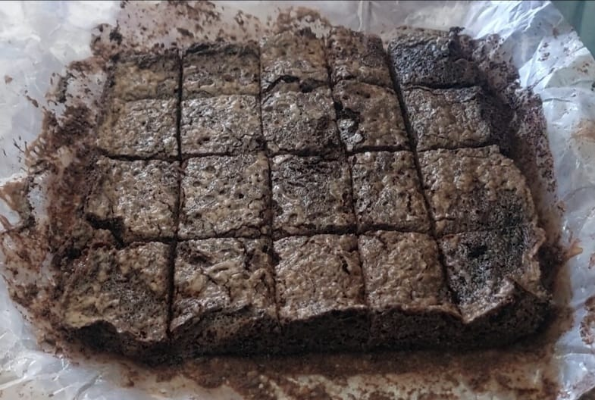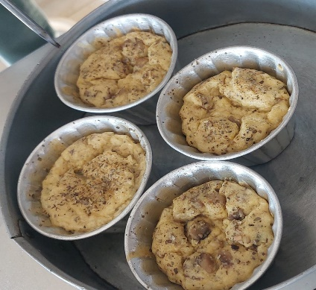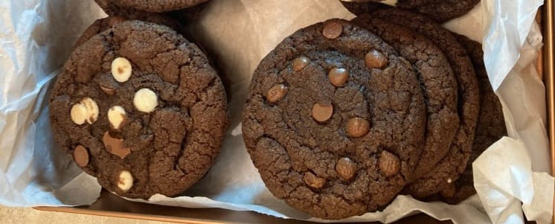

A

B

C

**Fig 1: Value added product of Mushroom. A. Mushroom Souffle; B. Mushroom Brownie and C. Mushroom Cookies**

**REFERENCES**

1. Alves, M.J., Ferreira, I.C., Dias, J., Teixeira, V., Martins, A. and Pintado, M. (2012). A review on antimicrobial activity of mushroom (Basidiomycetes) extracts and isolated compounds. *Planta medica*, *78*(16), pp.1707-1718.
2. Barros, L., Cruz, T., Baptista, P., Estevinho, L.M. and Ferreira, I.C. (2008). Wild and commercial mushrooms as source of nutrients and nutraceuticals. *Food and Chemical Toxicology*, *46*(8), pp.2742-2747.
3. Chaudhari, P.D.N., Wandhekar, S.S., Shaikh, A.A. and Devkatte, A.N. (2018). Preparation and characterization of cookies prepared from wheat flour fortified with mushroom (*Pleurotussajor-caju*) and spiced with cardamom. *Int. J. Res. Anal. Rev*, *5*, pp.386-389.
4. De Abreu, D.J.M., de Moraes, I.A., Asquieri, E.R. and Damiani, C. (2021). Red mombin (*Spondiaspurpurea* L.) seed flour as a functional component in chocolate brownies. *Journal of Food Science and Technology*, *58*, pp.612-620.
5. Devia, P. and Jain, K. (2022). Value-added products and many health benefit of mushroom products. *Int J Home Sci*, pp.73-75.
6. Dietrich, I., Kuzmin, O. and Mikhailenko, V., (2017). Comprehensive evaluation of the hot sweet soufflé dessert quality. *Ukrainian Journal of Food Science*, (5, Iss. 1), pp.92-102.
7. Jahan, A. and Bhoopendra Kumar Singh. (2019). Mushroom value chain and role of value addition. *International Journal of Botany and Research* 9, no. 1 : 5-14.
8. Kumar, K., Mehra, R., Guiné, R.P., Lima, M.J., Kumar, N., Kaushik, R., Ahmed, N., Yadav, A.N. and Kumar, H. (2021). Edible mushrooms: A comprehensive review on bioactive compounds with health benefits and processing aspects. *Foods*, *10*(12), p.2996.
9. Leema and Punetha, H., (2023). Effect of ZnO nanoparticles on macronutrients content of Pleurotussajarcaju (oyster mushroom).
10. Praveen, T., R. Reihana, V.K. Parthiban and Ramamoorthy, V. (2018). Molecular Characterization and Phenotypic Study of New Pleurotusdjamor Isolate KKM 1. Int.J.Curr.Microbiol.App.Sci. 7(08): 3574-3582.
11. Royse, D.J., Baars, J. and Tan, Q. (2017). Current overview of mushroom production in the world. *Edible and medicinal mushrooms: technology and applications*, pp.5-13.
12. Seethapathy, P., Thangaraj, P., Pandita, A., Sankaralingam, S. and Pandita, D. (2023). Oyster Mushroom (Pleurotus ostreatus). In *Mushrooms* (pp. 302-321). CRC Press.
13. Shankar, B.L., Veena, T.R., Pawar, S., Gowda, A. and Kadadevaramath, A.R. (2024). A study on value chain of mushrooms for value addition: challenges, opportunities and prospects of cultivation of mushrooms. *International Journal of Business and Systems Research*, *18*(6), pp.539-554.
14. Singhal, S., Rasane, P., Kaur, S., Garba, U., Singh, J., Raj, N. and Gupta, N. (2019). Mushroom cultivation, processing and value-added products: a patent-based review. *Recent Patents on Food, Nutrition & Agriculture*, *10*(1), pp.3-19.
15. Sood, A. (2022). Studies on preparation and preservation of value-added products from specialty mushrooms (Doctoral dissertation, College of Horticulture and Forestry, Dr YSP UHF, Neri, Hamirpur (HP)).