Case report

Transverse colon volvulus presenting as bowel obstruction: A rare case report

**Abstract**

Volvulus of the transverse colon is a rare cause of large bowel obstruction, with a total of 100 cases reported in the literature. **(The accuracy of this number is unclear, as it may be an estimate or a misrepresentation. Did you review this number of cases?).** The usual sites affected are the sigmoid colon (75%), the caecum (22%) and the transverse colon (2%).

It is a surgical emergency that can lead to bowel infarction, peritonitis, and death.

It is essential to highlight this case and those of the literature, as many gastroenterologists and surgeons may have never seen a case of transverse colon volvulus.

So, through the column of this article, we describe a 52-year-old male to whom the clinical presentation and the radiological findings were that of large bowel obstruction. A subtotal colectomy and colostomies were performed.

Keywords: Transverse colon, Volvulus, Ogilvie’s syndrome

**This Abstract is not well-structured. It should include the**

1. **The background (Introduce the disease being discussed, any uniqueness of the case ?)**
2. **Case Presentation (Summary of the patient’s demography information, clinical findings, imaging, lab results, and risk factors)**
3. **Intervention/Treatment (Management approach used, diagnostic procedures, treatment or surgical interventions)**
4. **Outcome/Results (Patients progress, outcome of treatments, any complications)**
5. **Conclusion ( Summarize key learning points)**

**Introduction**

Colonic volvulus is the axial twisting of the colon on its vascular pedicle. Rare sites of colonic volvulus include the transverse colon (about 2%) and the splenic flexure (1-2%) [1].

To our knowledge, few reports have been published to date, and fewer than 100 patients have been described with such a diagnosis (2).

Such an emergency can lead to infarction, peritonitis, and death [3].

Below, we present a case of a 52-year-old patient presented with acute transverse colon volvulus. (This Introduction is too short. Kindly improve on this with more citations to make a good reading)

**Case Report**

The study reports a case that goes back to 27/07/23 of a 52-year-old man with a one-year history of constipation; there was no other significant past medical history, particularly psychiatric disease or abdominal surgery, starting by the appearance of a sub-occlusive syndrome made of cessation of materials and gas. His last bowel movement had been 3 days ago.

This was followed by the appearance of abdominal pain, the leading cause of nausea without vomiting or ​​progressive aggravation, which motivated a consultation.

The admission examination revealed a conscious patient with a blood pressure of 120/80 mmHg and a heart rate of 88 beats per minute. His respiratory rate was at 23c /min and arterial oxygen saturation at 96% at room air without fever (body temperature at 36°.9C),

The abdominal exam revealed significant distension associated with a tympanitic abdomen on percussion without signs of peritonitis.

The digital rectal exam showed an empty rectal ampulla without any intraluminal mass.

The abdomen without preparation (ASP) that finds one of its good indications showed an aspect of bowel volvulus. The patient was admitted to our gastroenterology unit for further investigations.

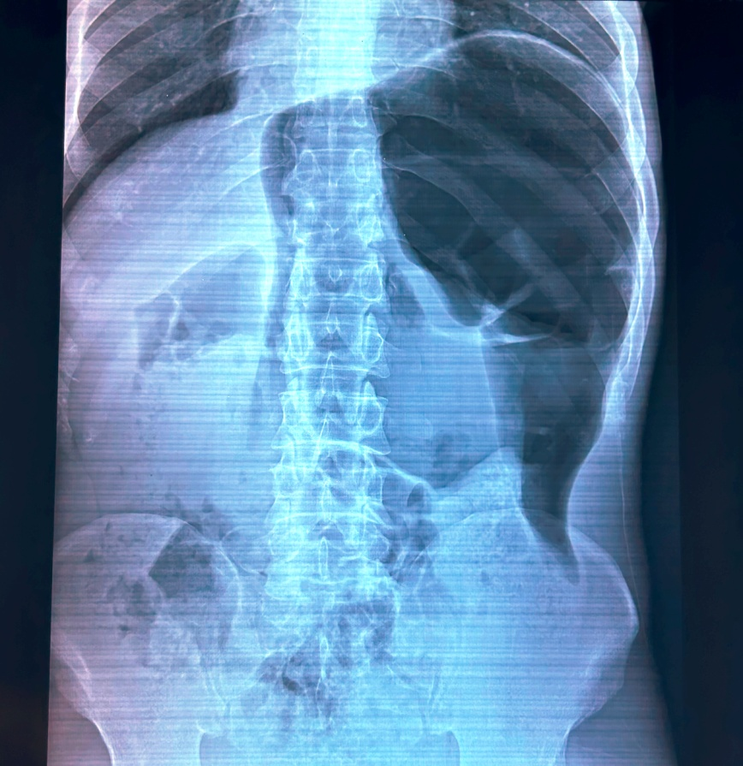

Figure 1: ASP revealing important bowel volvulus

ct scan showed colon distention without obstacle concluding to probable Ogilvie syndrome.

The patient's biological assessment revealed a white blood cell count of 4,820 cells/mm³ (neutrophils 3,040, lymphocytes 1,200), a haemoglobin level of 12.2 g/dl, and a thrombocyte count of 190,000 cells/mm³. Prothrombin time and partial thromboplastin time were normal (TP at 70% and TCA at 26s for a witness of 23s).

Natremia:142 mmol / l, kalemia: 3.9mmol / l, correct liver and renal function (urea: **0.72 g /l and creatinine: 8.9 mg /l, ASAT: 20 IU / L and ALT: 24 IU / L), fasting blood sugar at 1.03 g / l, C-reactive protein at 1 mg /l, albumin 42 g/L (Please check the units of** these analytes. **I will prefer you use the standard units for Urea, Creatinine, Fasting blood sugar and C-reactive protein)**

Therapeutic management included oxygen therapy and medical pain treatment.

A therapeutic colonoscopy was performed, revealing an enlarged colonic lumen without an obstructive cause, consistent with a dolichocolon.

On the second day, the symptomatology worsened by the aggravation of pain and abdominal distention, leading to a surgical exploration.

The surgical exploration revealed a purulent peritoneal effusion and a dolichocolon with a necrotic transverse colon volvulus, resulting in two spire towers.

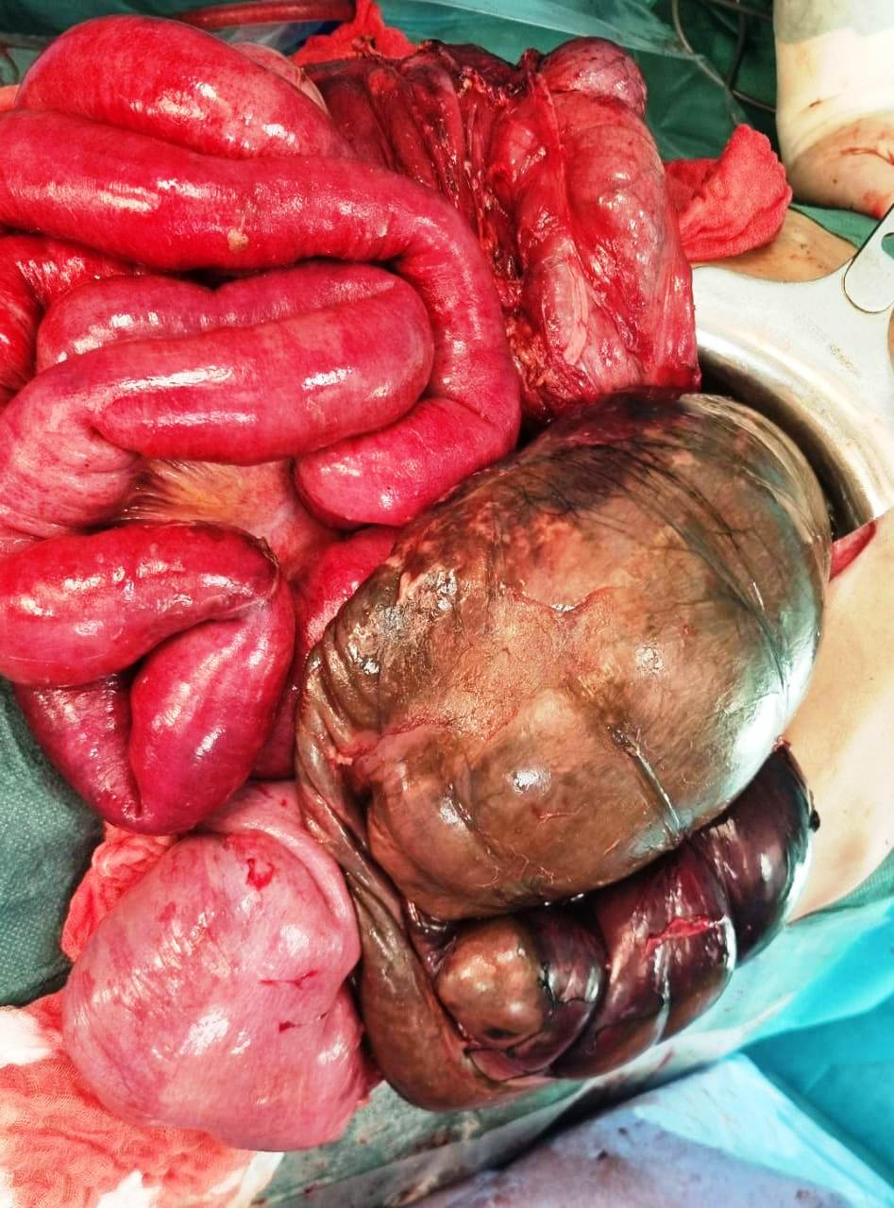

Figure 2: pre-operative image showing necrotic transverse colon volvulus **(Make sure that’s what you mean)**

**Discussion:**

Volvulus of the transverse colon case was first described in 1932 by the Finnish surgeon Kallio [4].

It is an abnormal twisting of the bowel along its mesenteric axis, resulting in a closed-loop obstruction. It stops venous return and compromises arterial supply, leading to ischemia [5].

Volvulus itself is an unusual cause of intestinal obstruction, accounting for 5% of cases of gastrointestinal obstruction and 10-15% of large bowel obstruction.

Moreover, chronic constipation appears to be associated with the occurrence of volvulus in the transverse colon, likely due to its excessive elongation [6].

Given the clinical picture and morphological transformations, the acute volvulus form is characterized by sudden severe abdominal pain, peritoneal signs, nausea, vomiting, and a severe clinical state.

Inadequate implementation of effective treatment can lead to exacerbation and progression to a fulminating form [7, 8].

The diagnosis of this condition is usually made during laparotomy despite a thorough history, examination, and appropriate radiological investigations [9].

In the absence of clinical and radiological signs of necrosis or perforation, the initial management of volvulus involves colonoscopic derotation and decompression, followed by semi-elective resection and anastomosis after optimizing the patient's condition [10, 11].

According to the literature, in contrast to the volvulus of the sigmoid colon and caecum, an attempt at endoscopic decompression and drainage of the colon is not recommended mainly due to the high probability of necrosis in the case of volvulus of the transverse colon [12], the mortality rate is 33%, which is much higher than the mortality rate recorded for the volvulus of the sigmoid colon or cecum, which is 21% and 10% respectively [13].

Our patient had an extensive right hemicolectomy with colostomy. His postoperative

the course was eventful; the symptomatology was worsened by hemodynamic instability; the patient was intubated and passed away within 24 hours after the surgery.

**Conclusion:**

Transverse colon volvulus is a rare cause of bowel obstruction syndrome. Its diagnosis is challenging.

Prompt recognition and emergency intervention constitute the key to a successful outcome and prevent complications.

**References**

1. Lianos G, Ignatiadou E, Lianou E, Anastasiadi Z, Fatouros M. Simultaneous volvulus of the transverse and sigmoid colon: case report. G Chir. 2012;33(10): 324-326.

2. *Ciraldo A, Thomas D, Schmidt S*: Case report: transverse colon volvulus associated with Chilaiditis Syndrome. *Internet J Gastroenterol* 2000; 1: 1.

3. Sana L, Ali G, Kallel H, Amine B, Ahmed S, Ali M, *et al*. Spontaneous transverse

colon volvulus. Pan African Med J. 2013;14:1937–8688.

4. Kallio KB. Uber volvulus transversii. Act Chir Scand. 1932;70:39–58

5. Sparks DA, Dawood MY, Chase DM, Thomas DJ. Ischemic volvulus of the transverse colon: a case report and review of literature. Cases J. 2008;1(1): 174.

6. *Casamayor Franco MC, Gracia Solanas JA, Artigas Marco C* et al.: Intestinal occlusion secondaryto transverse colon volvulus. *Rev Esp Enferm Dig* 2005; 97: 914-15.

7. *Sparks D, Dawood M, Chase D* et al.: Ischemic volvulus of the transverse colon: A case report and review of literature. *Cases J* 2008; 1: 174.

8. *Eisenstat TE, Raneri AJ, Mason GR*: Volvulus of the transverse colon. *Am J Surg* 1977; 134: 396.

9. Islam S, Hosein D, Bheem V, Dan D. Synchronous volvulus of the sigmoid colon and caecum, a very rare cause of large bowel obstruction. Case Reports. 2016; 2016: bcr2016217116.

10.Motsumi MJ, Tlhomelang O. Synchronous volvulus of the sigmoid and transverse colon in a 26-year-old male. J Surg Case Rep. 2018;2018(11): rjy295.

11. Chung YFA, Eu KW, Nyam DCNK, Leong AFPK, Ho YH, Seow-Choen F. Minimizing recurrence after sigmoid volvulus. British Journal of Surgery. 1999;86(2): 231-233.

12.*Echenique M, Amondaraín JA*: Colonic volvulus. *Rev Esp Enferm Dig* 2002; 94: 201-05.

13. *Ciraldo A, Thomas D, Schmidt S*: Case report: transverse colon volvulus associated with Chilaiditis Syndrome. *Internet J Gastroenterol* 2000; 1: 1