**DRYING KINETICS OF DATE FRUITS AND THE EFFECT OF TEMPERATURE ON THE SENSORY AND NUTRITIONAL PROPERTIES**

**ABSTRACT**

The quality of date fruits obtained after processing is essential to the date palm value chain. This study was carried out to evaluate the effect of temperature on the drying characteristics, sensory characteristics and the primary nutritional properties of date fruits. This experiment was conducted at varying drying temperatures of 50, 60, 70, 80, 90 and 100 °C using hot air electrical oven at a relative humidity of 75±5%. The brix index, total carbohydrates, pH and glossiness of the processed dried dates at different temperatures were determined. The drying curves showed that the drying rate decreases as temperature decreases. This trend did not hold for 50 0C as its drying rate was higher than that of 60 and 70 0C. The brix index was within the range of 19 to 29 with the highest at 100oC. There was no significant change or difference in the percentage total carbohydrate as well as the pH in all the drying temperatures. The fruit was glossier at drying temperature of 100 oC and lowest at 80 oC. In all, the date fruits dried at 500C gave the best product based on drying characteristics.

**Keywords:** Date Fruits, Drying Kinetics, Sensory characteristics, Nutritional properties.

**INTRODUCTION**

Date palm fruit (Phoenix dactylifera), naturally grown and popularly cultivated in arid biomes of the world is known as one of the oldest foods with essential medicinal properties. Date palm grows in dry regions, especially Middle Eastern countries, Africa and parts of Central and South America (Oladzad *et al*., 2021). Dates are energy rich fruits due to the high carbohydrate content mainly in the form of sugars. It is also high in dietary fibre content, vitamins and minerals, and, more essentially, harbours high levels of both antioxidants and phenolic compounds (Elwakeel *et al*., 2022).

Date fruits have a myriad of product derivatives. These products include dehydrated date fruits, date bars, date powder, date syrup, date juice concentrate, date jam and date fibre cookies (S. A. Ibrahim *et al*. 2020). The processing of dates into these products involves dehydration.

Dehydration of dates is an indispensable part of date processing as it reduces the moisture content to an appropriate level suitable for proper storage and preservation to give quality date products (Falade and Abbo, 2007).

During the process of drying date fruits, the concentration of sugar increases as the water content decreases. The reduction in water activity decreases enzymatic degradation and limits microbial growth. The process of dehydration therefore increases stability and the shelf life of dried dates, enhancing the quality (Al-Shahib and Marshall, 2002). According to Barreveld 1993, heat treatment of date fruits at a maximum temperature of 60-65°C may have the combined beneficial effect of destroying insect life, reducing the microbial count, and decreasing enzyme activity. All these factors work in tandem, creating products with prolonged shelf life (Elwakeel *et al*. 2022).

Though the primary objective of food drying is preservation, but depending on the mechanism of drying, the raw material may end up completely different with significant variations in product quality (Gunhan *et al*., 2005).

It is therefore imperative to investigate the drying conditions of date fruits in order to determine the optimum temperature that will yield the best dried date fruit product. Thus, the present study seeks to investigate the effect of different drying temperatures on drying rate, appearance, brix index and total carbohydrate of dried date fruits.

**MATERIALS AND METHODS**

**Pre-treatment of date palm fruits**

Dates fruits were obtained from the market in Benin City, Edo state. They were stored in polyethylene bags at room temperature.

The Date fruits were pitted manually, washed in tap water and blanched in boiling water at 99±100C for 10 min and then allowed to cool for another 10mins under room temperature. The weight of each experimental batch of date fruits was recorded before drying.

**Experimental Set up**

The date fruits were dried at temperatures of 500C, 600C, 700C, 800C, 900C, and 1000C in duplicates with uniform sample thickness. Drying process started when steady-state condition was achieved in the dryer. The fruits were placed in petri dishes and allowed to dry in an oven dryer.

In order to determine the drying rate, the samples were taken out and weighed at 30 minutes intervals using a digital electronic balance. The accuracy of the weighing system was 0.1g. Moisture contents of the samples were calculated as (kg water**/** kg wet solid) % monitored every 30 minutes. Drying continued until constant weight was achieved.

At the end of each experiment, the moisture content was calculated and the drying data was expressed as moisture content versus drying time. The formula used in calculating the moisture content and drying rate is shown below in equation (1).

MC (%) = $\frac{M1-M2}{M1} X 100$

Where, *M1* and *M2* are the initial weight and the weight at any given time during the experiment respectively.

**Determination of Brix value:**

The brix value of the dried dates fruits was determined using a refractometer.

To determine the brix value, the dried dates were mashed with small quantity of water enough to form a thick paste. A cheese cloth was used to squeeze out some drops of the dried date sample into the surface of refractometer. Readings were taken and the brix index for the dried date fruits were recorded as % soluble sugar (Adekunle, 2021).

**Total Carbohydrate Estimation**

Estimation of carbohydrate was carried out using the Anthrone method. In this method, carbohydrates were dehydrated by conc.H2SO4 to form furfural derivative. Anthranol, which is the active form of anthrone, reacts by condensing with the carbohydrate furfural derivative. This produces a green coloration in dilute solutions and a blue coloration in concentrated solutions. The blue - green solution was read at 620 nm (David, 1990).

**Determination of pH**

pH of the dried date fruits was determined using a pH meter (PHS-3C). Ten percent of the date fruit solution was prepared using pulverised date fruits. The electrode of the pH meter was inserted into the solution. The pH was recorded as described by Umar (2002).

**Glossiness**

The glossiness was measured by sensory observation of the eyes and recorded on a scale of 1 to 5. Where, 1 = very poor. 2 = poor. 3 = good 4 = very good 5 = excellent

**RESULTS AND DISCUSSION**

**Drying Rate and Drying Characteristics**

The relationship between the moisture content and the drying time in minutes for all test samples is shown in Figure 1. It is observed from these plots that moisture content decreased continuously with drying time. The increase in the drying temperature resulted in a decrease in drying time. The drying time required to obtain three consecutive constant weights for 500C, 600C, 700C, 800C, 900C, and 1000C were about 4-9 hours.

**Figure 1a:** Moisture content against time at 500 C

**Figure 1b:** Moisture content against time at 600 C

**Figure 1c:** Moisture content against time at 700 C

**Figure 1d:** Moisture content against time at 800 C

**Figure 1e:** Moisture content against time at 900 C

**Figure 1f :** Moisture content against time at 1000 C

**Figure 2:** Moisture content against time for temperatures 500 C – 1000 C

Series 1 = 1000C, Series 2 = 900C, Series 3 = 800C,

Series 4 = 700C, Series 5 = 600C, Series 6 = 500C

**Figure 3:** Graph of drying time against temperature

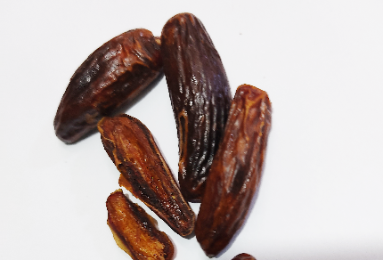 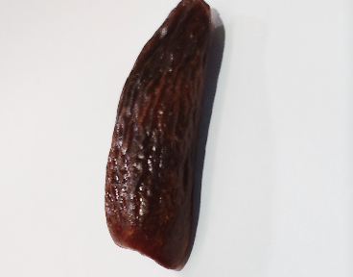 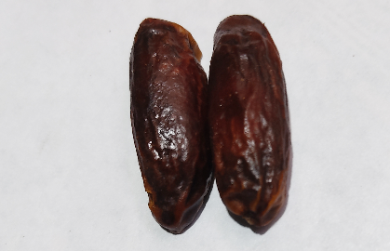

800C

900C

1000C

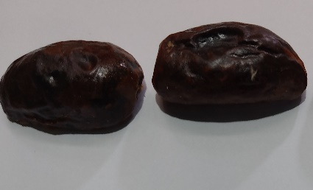 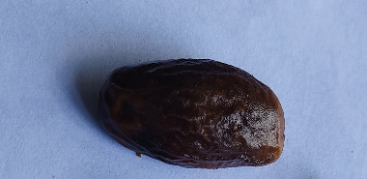 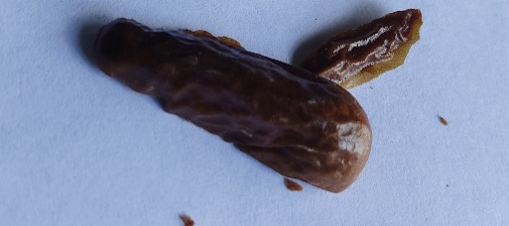

600C

500C

700C

**Figure 4**: Glossy appearance of date fruits after drying under different temperatures.

|  |  |  |  |  |  |  |
| --- | --- | --- | --- | --- | --- | --- |
| T (0C) | 50 | 60 | 70 | 80 | 90 | 100 |
| Brix Index | 26 | 21 | 24 | 26 | 19 | **29** |
| Total Carbohydrate (%) | 65.31 | 64.87 | **65.97** | 65.53 | 64.65 | 64.21 |
| PH | 6.8 | 6.8 | 6.9 | 6.5 | 6.8 | **6.9** |
| Glossiness | 4 | 3 | 3 | 4.5 | 4.5 | **5** |

**Table 1:** Brix Index, Total Carbohydrate, PH and glossiness of dried dates at different experimental temperature

**Effect of Temperature on Moisture Content of Blanched Date Fruits**

Figure 1a, 1b, 1c, 1d, 1e and 1f show**ed** the plot of the moisture content against drying time. From the plots, it can be observed that the entire drying process was done for 240, 300, 480, 510, 540 and 420 minutes for oven drying temperatures of 100, 90, 80, 70, 60 and 50 °C respectively. The date fruit samples were dried at specific temperatures till they attain constant moisture content (Abodunrin *et al*, 2022).

**Effect of Temperature on Drying Rate of Blanched Date Fruits**

Figure 3 show**ed** the plot of the drying temperature against the drying time for oven dried date samples respectively. It can be observed that the drying rate for samples 100, 90, 80, 70, and 60 °C exhibited an inverse trend of increasing drying time with decreasing drying temperature (Sagarika *et al*, 2019). However, there was a break in the observed trend as drying temperature of 50 °C exhibited a faster drying rate compared to 80, 70, and 60 °C.

**Effect of Temperature on Brix index, Total carbohydrate and pH of Blanched Date Fruits**

From Table 1, the dried date fruit samples of drying temperatures 100, 90, 80, 70, 60 and 50 °C have mean total carbohydrate value of 65.09% and range of 1.76, mean brix index value of 24.7 and range value of 10, mean pH value of 6.8 and range value of 0.4. The mean and small range values of the estimated total carbohydrate and pH of the experimental samples suggest that there is no significant variability and therefore drying temperature has negligible effect on the total carbohydrate and pH of dried date fruits. However the mean and range brix value of 24.7 and 10 for the various experimental temperatures shows that there is significant disparity. The brix value provides an objective measurement of the sugar concentration in a product and hence gives idea of the level of sweetness of the product (foodscience-avenue, 2013). 1000C and 500C had the highest brix value of 29. Temperatures 80, 70, and 60 °C have brix values of 26, 24 and 21 respectively while 900C has the lowest brix value of 19.

**Effect of Temperature on Glossiness of Blanched Date Fruits**

At first glance, the glossiness as shown in table 1 improves with increasing temperature. Temperature 500C ironically has better glossy appearance when compared to 70 and 60 °C. The pictogram showing the glossiness of the different dried date samples is shown in figure 4.

**CONCLUSION**

**Drying of date palm fruits is an essential aspect of date fruit processing. It helps in extending the shelf life of date palm fruits, preserving it till off-season. During the study, date palm fruits were dried at temperatures 500C, 600C, 700C, 800C, 900C, and 1000C. The drying kinetics of date palm fruits in the various temperatures were compared.** Overall, the appropriate drying temperature of blanched date fruits was 500C. This in comparison to other drying temperatures gives the best date fruit product when considering drying time/drying rate, total carbohydrate, brix value and glossiness.

**REFERENCES**

Abdallah E. Elwakeel, Aml A. Tantawy, Mohamed M. Alsebiey, Abdallah K. Elliby. (2022). The date fruit drying systems: acritical over review. *Al-Azhar Journal of Agricultural Engineering.* 3: 26-36

Abodunrin, David & Oyebola, Olabinjo & Adefidipe, Ebenezer & Oladebeye, Dayo & Akinyoola, James. (2022). Drying Kinetic of Oven and Cabinet Dried Red Date Fruit. International Journal of Innovative Technology and Exploring Engineering. 11. 43-48. 10.35940/ijitee.G9228.09111022.

Adeoye, Adekunle. (2021). Re: Brix determination. Retrieved from: <https://www.researchgate.net/post/brix_determination/61c7846a7ced1914af101e11/citation/download>

Ayivi, Raphael & Ibrahim, Salam & Ayad, Amira & Williams, Leonard & Gyawali, Rabin & Krastanov, Albert & Aljaloud, Sulaiman. (2020). Date fruit: A review of the chemical and nutritional compounds, functional effects and food application in nutrition bars for athletes. 10.1111/ijfs.14783.

Ashraf, Z. Hamidi-Esfahani, and M. A. Sahari. (2012). Evaluation and Characterization of Vacuum Drying of Date Paste. *J. Agr. Sci. Tech*. Vol. 14: 565-575

Barreveld, Y.H., 1993. Date-Palm Products. Bulletin NO 101. Rome, Italy: Food and Agriculture Organization of the United Nations

David T. Plummer (1990) An Introduction to Practical Biochemistry,179 Third Edition

Falade, K. O. and Abbo, E. S. 2007. Airdrying and Rehydration Characteristics of Date Palm (Phoenix dactylifera L.) Fruits. J. Food Eng., 79: 724–730.

Gunhan, T., Demir, V., Hancioglu, E. and Hepbasli, A. 2005. Mathematical Modeling of Drying of Bay Leaves. J. Food Eng., 46: 1667–1679.

https://www.foodscience-avenue.com/2013/09/definition-of-brix.html

Layne, E. (1975) Methods in Enzymology,3:447

Oladzad S., Narges F., Amir M., Neda A., and Mohammad J. T. (2021). Date fruit processing waste and approaches to its valorization: A review. *Bioresource Technology 340: 125625*.

Sagarika N. & Kapdi, Shyam & Sutar, Roy & Patil, Ghanshyam & Akbari, Sanjay. (2019). Study on drying kinetics of date palm fruits in greenhouse dryer. 8. 2074-2079.

Umar, M. A. Cosmetics, Soaps, Detergents and NAFDAC’s Regulatory Requirements. A paper presented at training workshop for small and medium scale enterprises organized by UNDP/JCSL and Ministry of Commerce and Industry, Maiduguri, Borno State, Nigeria. Nigeria (2002).