Journal Name: | Asian Journal of Research and Reviews in Physics
Manuscript Number: | Ms_AJR2P_132461
Title of the Manuscript: | Are Luminosities of Radio Galaxies affected by Dark Energy?
Type of the Article

PART 1: Comments

 | Reviewer’s comment  Artificial Intelligence (AI) generated or assisted review comments are strictly prohibited during peer review. | Author’s Feedback (Please correct the manuscript and highlight that part in the manuscript. It is mandatory that authors should write his/her feedback here)
Please write a few sentences regarding the importance of this manuscript for the scientific community. A minimum of 3-4 sentences may be required for this part. | Despite accomplished advanced progress regarding the knowledge of dark energy, dark matter, the rapid expansion of space-time (universe) and the availability of observational data, numerous aspects and questions still remain to be addressed. According to the two main results derived in this work, the investigated effect (of dark energy on the luminosities of radio-galaxies) is estimated to be more important by about 10 times on the luminosities of large radio galaxies than on those of the smaller, compact radio-galaxies. This information (probably needing confirmation by other studies) is of importance for the scientific community.  Using analytical and statistical methods (specifically, linear regression analyses), the authors of this work investigate possible effects of Dark energy (assumed to be behind the accelerated expansion of the universe) on the Luminosities of two classes of Radio Galaxies (small, compact galaxies in one  hand and more extended, larger ones in the other hand).They found two correlated results obeying power-law functions: a direct power-law function in case of compact galaxies and an inverse such function fitted to the larger galaxies, connected to the respective ambient environments of these two  subclasses of astronomical objects. While the compact radio galaxies are sub-galactic and are then more affected by their denser ambient gases and interstellar gravitational attraction, the larger radio galaxies are, in contrast, located in the intergalactic media (where dark energy is mostly prevalent)  featured by insufficient gravitational pull and few amounts of dust particles, which causes their luminosities to be naturally affected under the space-time expansion as shown by the derived results for the galaxies luminosities versus their recession velocities (i.e., for the large radio galaxies,  and for the smaller, more compact radio galaxies).
Is the title of the article suitable?  (If not please suggest an alternative title) | The title of the article seems to be suitable.
Is the abstract of the article comprehensive? Do you suggest the addition (or deletion) of some points in this section? Please write your suggestions here. | The abstract of the article is enough comprehensive.

Is the manuscript scientifically, correct? Please write here.
Are the references sufficient and recent? If you have suggestions of additional references, please mention them in the review form.
Is the language/English quality of the article suitable for scholarly communications? | The article is written in overall good quality English. However, the language could be improved by the authors upon reading again their manuscript with further application. As an example, I have retouched paragraph 1.1 section 1 (Introduction) with suggesting underlined text propositions written in italics’ form. That paragraph is reproduced below, i.e.:  1. INTRODUCTION  1.1 Dark energy  The universe expansion was first pointed out by Edwin Hubble in 1929. He discovered that when he found a direct linear relationship between velocities of the galaxies and distances to the galaxies. The equation is as follows:  Here, represents velocity of a galaxy; which is generally referred to as velocity of recession of the galaxy. is Hubble’s parameter, and is the distance to the galaxy. The physical significance of this equation may be seen from what follows:  Equation (1) suggests that if the velocity of a galaxy at distance is at time , then at distance (greater than ) at time (greater than ), the new velocity, , will be greater than . Therefore, we obtain  where is recognized as acceleration. This implies that Hubble’s law predicts accelerating expansion of the universe.  Moreover, by observation of type 1A supernovae, it was found that the galaxies are receding and accelerating relative to each other; which shows that the universe is suffering from rapid expansion. Observation of the cosmic microwave background anisotropy has supported this phenomenon. Another independent method which supports this expansion entails the use of voids and super-voids as standard rulers for measuring cosmic distances [1-4].  Many authors have suggested, with some observational supports, that recession of galaxies is not brought about by the individual galactic kinematics/dynamics; rather, the recession is the result of creation of more spaces in the fabric of the space-time. This means that when the volume of space increases, the distances between the galaxies embedded in the space increases too. The name ‘dark energy’ has been introduced to account for the energy in the space-time that generates more spaces, thereby triggering off the observed accelerated expansion. This energy is believed to be an intrinsic characteristic of the space-time. Since its effect is seen only at astronomical distances, only little is known about it. [1-4].  Some authors have suggested models for explaining dark energy. The most important models are the ‘Cosmological Constant ’ and the ‘Quintessence’. The former was introduced by Albert Einstein in 1917, when he attached a constant, , without any mathematical proof to his mathematical model for a static universe. Although he has regretted ever doing that, scientists found later that the constant was needed to account for the observed accelerating expansion of the universe. Since dark energy density is found to be constant everywhere, the cosmological constant is used by many authors to explain it.  Figure 1: Schematics (not to scale) comparing dark energy density, and the energy density contributed by baryonic matter, dark matter, and electromagnetic radiant energy. Dashed horizontal line represents dark energy; while dotted curved line represents total energy density contributed by other entities.  Energy density of the universe  Time  Figure1 is a schematic diagram that shows how dark energy density compares with the energy densities contributed by the baryonic matter, dark matter, and electromagnetic radiation as cosmic time increases. It can be seen that the dark energy density remains constant, while the total energy density from other the sources decays exponentially. At earlier time, dark energy density was overwhelmed by the other energy densities; while at latter time dark energy density is more prevalent and overshadows the other energy densities. This shows that dark energy will continue to increase even beyond as time goes on; while the other energy densities will continue to decrease below . For the present epoch, observations have shown that dark energy density lies between and of the total energy density; while the other energy density lies between and . This simply implies that at infinite time, the universe will be ‘completely empty’ (i.e. with infinitesimal amount of matter or electromagnetic radiation) [1-4]. Figure 2 is a column chart for the total energy density of the universe. Blue column represents dark energy density , Brick-red column represents dark matter , and green column represents baryonic matter/atoms ; while the remaining represents the density contribution by other entities not mentioned in the column chart.  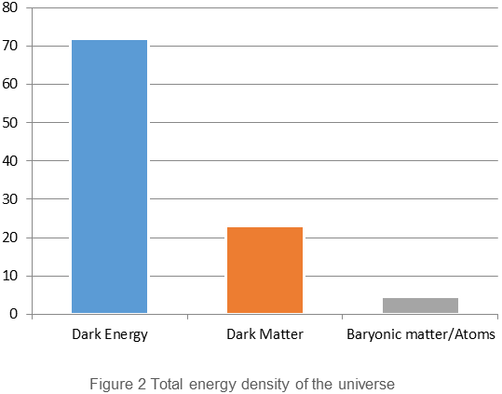  Quintessence, on the other hand, is a theoretical framework in which some dynamic field is believed to drive the observed accelerated expansion of the universe. It varies in space and time, and must be light. It was first introduced in 1998, and has been proposed by some authors to be a fifth fundamental force. It is not constant but it dynamically changes with time [1-5].

Optional/General comments

PART 2:

 | Reviewer’s comment | Author’s comment (if agreed with reviewer, correct the manuscript and highlight that part in the manuscript. It is mandatory that authors should write his/her feedback here)
Are there ethical issues in this manuscript? | (If yes, Kindly please write down the ethical issues here in details)

Reviewer Details:

Saad Ouichaoui, University of Sciences and Technology Houari Boumediene (USTHB), Algeria

