Comments:

1. In line # 20: it would be interesting to make a correlation with dataset population of Benghazi, because it is referred the issue of the prevalence.

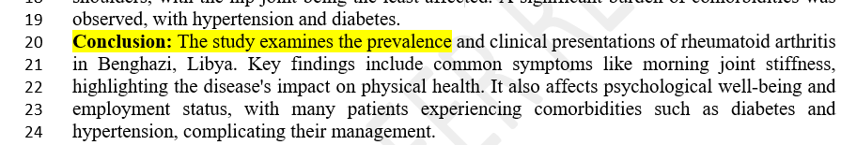

1. Age distribution of examined population is not showed.
2. To run orthograph tool, to adjust some items, like these: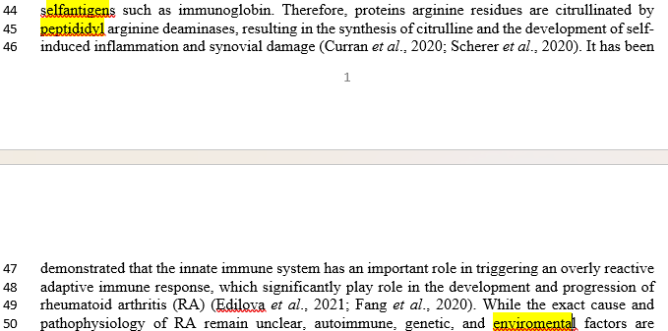
3. It should be interesting to account with the questionnaire as an Annex to article, in order to let know the instrument to an hypothetical reader. This is referred in the Materials and methods´ section.

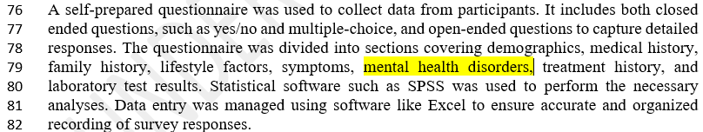

1. To include kg in the title of figure: Weights in kg

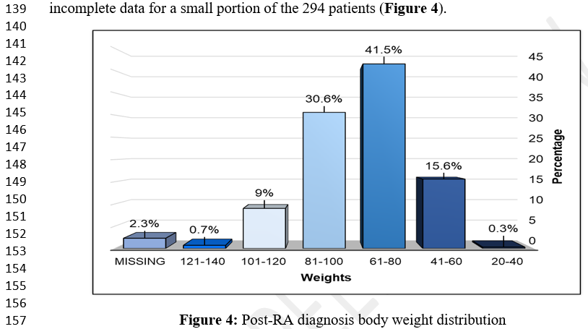

1. If this is the graphic to show mental health disorders, it should better describe i.e. depression, sadness, anxiety, as referred in line #189. To adjust emotinal.

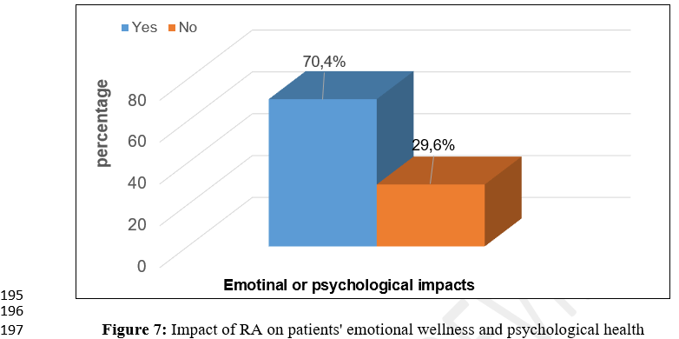

1. It should be more informative to include in the Figure 7, data related to depression, sadness, anxiety, etc, as referred in this section

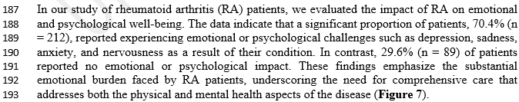

1. The Discussion section is worth to make a more extensive correlation of the findings of the population, with that of the reported by literature, maybe including a comparative table.
2. According to aims, it is no mention of stiffness and severity of joint pain in conclusions.



(…)

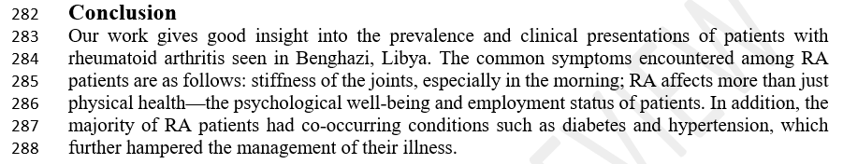

1. The emotional impact is not detailed in terms of sadness, anxiety or depression, as it is in Discussion section, printscreen below.

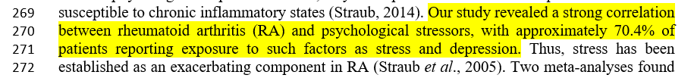

General impression

The article should be published after adjjustments.