**ESTIMATION OF SERUM TRACE ELEMENT LEVELS OF NEWLY DIAGNOSED DRUG-SENSITIVE AND DRUG-RESISTANT PULMONARY TUBERCULOSIS PATIENTS IN OYO STATE, NIGERIA**

**ABSTRACT**

**Objective:** This study investigates the interplay between specific trace elements particularly —zinc (Zn), copper (Cu), iron (Fe), and selenium (Se)—in newly diagnosed drug-sensitive tuberculosis (DSTB) and drug-resistant tuberculosis (DRTB) patients compared to a control group without tuberculosis admitted in selected health facilities in Oyo State, Nigeria.

**Methodology:** Serum samples of study participants who were categorized as DRTB, DSTB and non-TB were analyzed for selenium, copper, iron and zinc levels using atomic absorption spectrometry. Using structured questionnaire, information on the socio-demography (e.g. age, gender, access to potable water, food etc.) of the participants were also analyzed to see the relationship with trace elements. Descriptive (frequency, mean, standard deviation) and inferential (analysis of variance Turkey’s HSD post hoc, Pearson’s correlation coefficient) analysis was performed to compare variation of trace elements in different health conditions . Significant level was considered at P<0.05.

**Result:** Zn, Fe, Se and Cu concentrations of Control group and tuberculosis patients were statistically significant P<0.001 and extremely weak correction existed in elements within the study groups with no statistical significant P>0.05 except in iron and copper of DRTB P<0.05. **Conclusion:** The study reveals that, compared to non-TB, low levels of serum zinc, iron, copper and selenium are linked to DSTB with more deficiencies are associated for drug-resistant tuberculosis (DRTB). This study highlighting that the mentioned micronutrients might act as valuable biomarkers for assessing a patient’s response to tuberculosis treatment with distinguishing betweenDSTB and DRTB at the diagnostic stage.

**Keywords: trace elements; Drug-resistant tuberculosis; drug-sensitive tuberculosis, Atomic absorption spectrophotometry; Oyo**

1. **INTRODUCTION**

Eliminating tuberculosis (TB) globally has been quite challenging. Despite the many preventive and control actions that are now being implemented, tuberculosis persists in certain populations and no environment is completely immune to it (Orgeur *et al.,* 2024). Being one of the most easily transmissible diseases with no specific symptoms, early diagnosis and treatment have been very difficult.

Regretfully, TB claims the lives of approximately 245,000 Nigerians yearly, and an estimated 590,000 new cases are reported. Globally, an estimated 4.1% and 19% of new and retreatment tuberculosis cases respectively are believed to have rifampicin resistance and started on second-line anti-TB treatment (Salari *et al.,* 2023). According to Akinyemi (2022) and Oguntola (2023), Oyo State in Nigeria has been classified as having a very high tuberculosis burden. Of the 136,222 presumed cases of tuberculosis, the state reported 11,934 confirmed cases in 2022 (Oguntola, 2022).

Several diseases have been linked with shortages or imbalances in vital trace elements (Islam *et al*. 2023). Such trace elements named as micronutrients has diverse interactions thus might potentially be used as a foundation for the pathophysiology and etiology of a number of diseases, related to nutritional deficiencies (Kawahara *et al.,* 2023). While these elements constitute a very small fraction of the overall body weight, these trace elements play a significant role in various life processes especially in growth and development (Jomova *et al.,* 2022). According to Feng *et al.* (2024), “Micronutrient environments are key contributors to immune function and cytokine kinetics”. Thus, such environments have been increasingly suggested to play an indispensible role in individual’s response to infectious diseases. In severe form tuberculosis such as drug resistant tuberculosis , the elevated metabolic requirement is causing malnutrition with decreased nutrient intake leading to more nutritional deficiency which may delay tuberculosis treatment response or worsen the disease state by inhibiting important immune functions (Aanandhi *et al.,* 2023).

Trace elements possess great immunomodulatory function as such deficiency leads to decreased immunity and impacts greatly on clinical outcomes (Surana *et al.,* 2024). Once tuberculosis is diagnosed, treatment is commenced which could yield a positive outcome for non-drug resistant tuberculosis or a negative treatment outcome which could develop drug resistance such as mono, poly or multi-drug resistant (MDR) tuberculosis or death. Drug resistance is manifested when there is selective growth and proliferation of resistant mutants among the actively multiplying population in presence of drug (Tiberi *et al.,* 2022).

Acquired drug resistance is the term used to describe *Mycobacterium tuberculosis* drug resistance found in patient isolates who have received treatment with anti-TB drugs for one month or more. In contrast, people who have never had treatment before or treated for less than 1 month are called “primary drug resistance. Resistance to one specific medication is referred to as "mono resistance." and resistance to two or more drugs is defined as “poly resistance.” or at least resistance to isoniazid plus rifampicin is termed as multi-drug resistant “MDR” (Alemu *et al.,* 2023).

Modified trace element profiles have been found in several populations of tuberculosis patients according to research investigations (Feng *et al.,* 2024). Surprisingly, host physiology, pathogen physiology, and host nutrition are considered to have an effect on trace element patterns. However, the extent to which Oyo state's multidrug-resistant strain of tuberculosis is impacted by changes in trace elements remains unknown. It becomes vital to investigate further underlying abnormalities such as trace element variations that may lead to treatment resistance in tuberculosis patients. Therefore, this study examines the interplay between specific trace elements—zinc (Zn), copper (Cu), iron (Fe), and selenium (Se)—in newly diagnosed drug-sensitive tuberculosis (DSTB) and drug-resistant tuberculosis (DRTB) patients compared to a control group without tuberculosis admitted in selected health facilities in Oyo State, Nigeria.

1. **METHODOLOGY**

**2.1 Study Area**

This study was conducted in Oyo central senatorial district of Oyo state, south-west, Nigeria

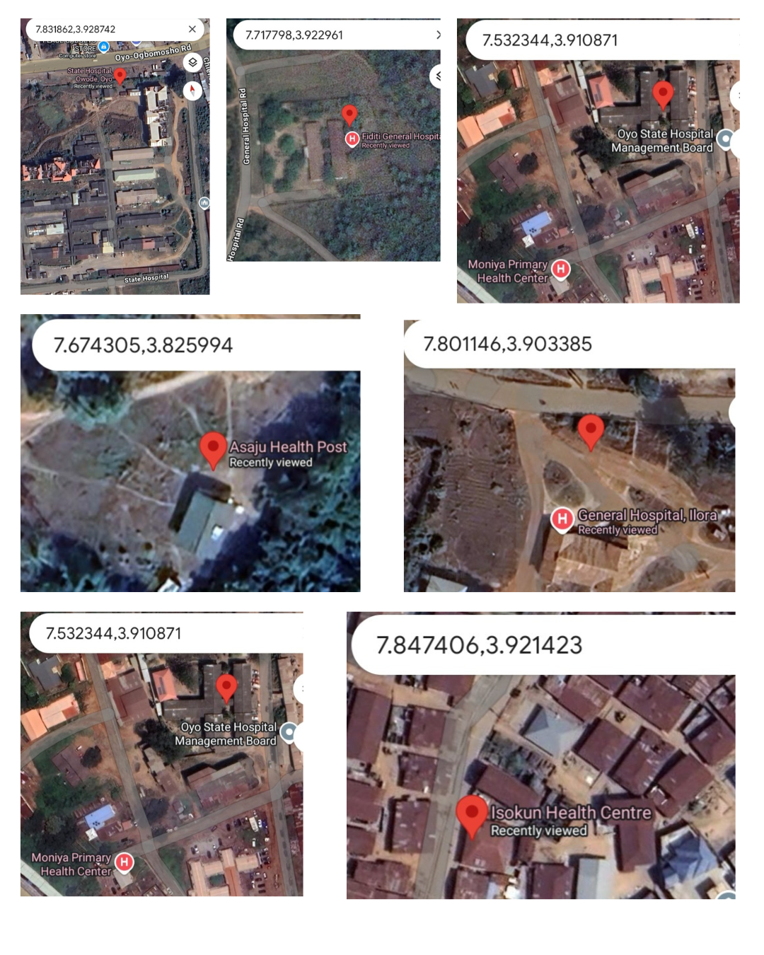

**Fig. 1a: Sampling site with geo-point**

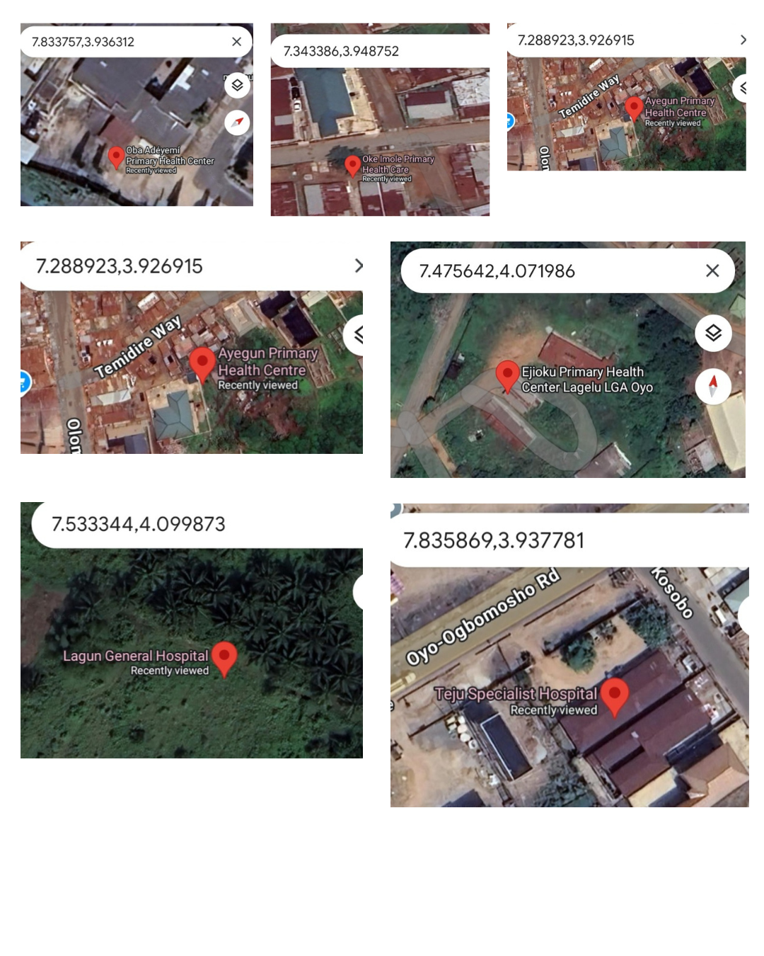

**Fig. 1b: Sampling site with geo-point**

**2.2 Study Population**

A multi-stage sampling technique as outlined by Kamalu *et al.,* (2021) was employed using a random sample approach. Between March to June 2024, appropriate participants from different health facilities in Oyo state were chosen from the centers using a table of random numbers.

**2.2.1 Sample size determination**

Sample size was determined using the formula;

N = z2pq/d2

Where, n = the minimum required sample size in population

z = the standard normal deviation (1.96) at 95% confidence interval (CI),

p = the proportion in the target population (3.042%=0.0342),

q = the failure proportion (1-0.03),

d = the required level of precision, tolerable margin of error, expected difference (5%=0.05).

DRTB prevalence =4.1% (Salari *et al.,* 2023). DRTB/HIV co-infection prevalence = 25.8% of total DRTB prevalence (Reward *et al.,* 2021). Based on this Cochran 1977 formula, minimum number of 45 was calculated. Therefore a minimum number of 52 samples were examined from each study groups making a total of 156 samples examined.

**2.3.1 Exclusion Criteria**

The study's participants were not included if they took immune-suppressive medications, were pregnant or breastfeeding babies, had other co-occurring chronic or acute illnesses, had worked in a profession or led a lifestyle that could change how the body metabolized trace elements. In addition, living in an area (like a landfill or an industrial area) where heavy/toxic metals were present was considered an exclusion criterion, due to adverse characteristic of interaction between essential trace elements (like Zn, Cu, Fe, Se) and toxic metals.

For healthy participants or the controls without tuberculosis, the requirements for inclusion were as given by Nizamani *et al.,* (2019). These include the following: no prior tuberculosis illness diagnosis; no known or suspected household contact with pulmonary tuberculosis throughout the preceding two years; and no fever, no cough, or other signs of pulmonary illness when they were enrolled.

**2.3.2 Questionnaire**

Pre-tested questionnaire was used to gather bio-data and other demographic information which includes age, sex, medical conditions, general treatment history, lifestyle factors (drug abuse, alcohol use, and smoking), water source, housing condition as well as feeding pattern.

**2.4.1 Sample Collection and processing**

After confirmation of tuberculosis as DRTB, DSTB and negative based of WHO recommended standard (WHO, 2024), a tourniquet is applied lightly above the median cubital vein, after sterilization with alcohol, venipuncture using the needle, and the first mL of blood was used to rinse the vial and discarded. Then 5mL of blood was collected into the prepared vial and transported to the laboratory. Samples are allowed to clot and separated within 2 hours after 20 minutes of centrifugation at 1500 g/min, the serum was decanted into a fresh, clean tube and stored at -20oC before estimation with atomic absorption spectrometry.

**2.4.2 Sample Analysis**

**Wet digestion techniques for determination of metals or mineral elements in blood samples for atomic absorption spectrometry (AAS)**

Onto a 50 ml digestion tube, 1 ml of well-homogenized blood sample, which had been measured using a 5 ml pipette, 5 ml of concentrated HNO3, 10 ml of concentrated H2SO4, and 5 ml of HClO4 was added. The sample combination was broken down in a fume cupboard with a fume hood using a Gallenkamp Hot plate that was heated to 3000C. Until the fluid was colorless, the digesting process was continued. This made sure that every single HNO3 was gone. After cool, 20 cm3 of deionized water was introduced, and carefully swirled in. A Whatman filter paper No. 42 was used to filter the solution after it had been diluted with deionized water to the proper amount in a 50 cm3 volumetric flask. Analysis of the sample digest was done to determine the levels of zinc, copper, iron and selenium using a Buck 211VGP Atomic Absorption Spectrophotometer and a UV/V Spectrophotometer (Subramanian, 1996).

**Se, Cu, Fe, and Zn determination utilizing (BUCK) 11 AAS (AOAC, 975.23)**

Via the suction tube, the diluted digested solution was sucked into the Buck 211VGP Atomic Absorption Spectrophotometer (AAS), where the atom absorb light or energy and the electron in the atom move from the ground state to an excited state. Every trace element was read at its distinct wavelengths using the proper fuel and oxidant mixture in each individual hollow cathode lamps. Wavelength emitted by the analyte corresponds to the energy difference between the excited and ground state of the analyte atom. As the atomized sample is exposed to light, some photons are absorbed by the excited analyte atoms, causing them to return to their ground state. A detector measures the light difference that passes through the sample. The difference in intensity is directly proportional to the analyte's concentration in the sample. Detection limit for each trace element on Buck 211VGP Atomic Absorption Spectrophotometer (AAS) are Cu= 0.1 µg/ml; Fe=0.1 µg/ml; Zn=0.03 µg/ml; Se= 0.1 µg/ml with absorption sensitivity of 1% or 0.0044 absorbance unit (Visser, 2021).

**2.5 Statistical Analysis**

IBM Corporation, Armonk, NY, USA, provided the statistical software package SPSS version 27, which was used to analyze the data. The frequency distributions for each category variable were produced. For quantitative factors, such as zinc, copper, iron, and selenium levels, the location measurements were established. The mean ± standard deviation of the data was calculated using descriptive statistics. To ascertain if two means were statistically significant, the Student T test (also known as the independent t test) was utilized. Trace element levels of categories of tuberculosis patients and controls were compared using analysis of variance (ANOVA) with Turkey’s HSD post hoc. Relationships between different trace elements were established using Pearson's correlation coefficient. The statistical results were considered significant at P<0.05.

1. **RESULT**

**Table 1: The socio-demography of each group**

|  |  |  |  |
| --- | --- | --- | --- |
| DRTB(%) DSTB(%) CONTROL (%) | | | |
| Age- (18-27 years) | 13.2 | 11.5 | 9.6 |
| Age- (28-37 years) | 41.5 | 40.4 | 38.5 |
| Age (38-47 years) | 30.2 | 26.9 | 34.6 |
| Age (≥48 years) | 15.1 | 21.2 | 17.3 |
| Housing- (inadequate) | 59.6 | 70.4 | 61.1 |
| Housing- (adequate) | 40.4 | 29.6 | 38.9 |
| Water source- (portable) | 59.6 | 51.9 | 67.3 |
| Water source- (non-portable) | 40.4 | 48.1 | 37.2 |
| Family size- (1-4) | 42.3 | 44.2 | 50.0 |
| Family size-(5-8) | 23.1 | 28.8 | 21.2 |
| Family size- (≥ 9)) | 34.6 | 26.9 | 28.8 |
| Feeding pattern- (inadequately nourished) | 65.4 | 34.6 | 34.6 |
| Feeding pattern- (adequately nourished) | 34.6 | 65.4 | 65.4 |
| Marital status- (single) | 28.8 | 32.7 | 28.8 |
| Marital status (married) | 63.5 | 63.5 | 67.3 |
| Marital status- (divorce/separated) | 7.7 | 3.8 | 3.8 |

**Table 2: Zinc, Iron, Selenium and copper concentrations of Control group and study group**

|  |  |  |  |  |  |
| --- | --- | --- | --- | --- | --- |
|  | N | Mean | Standard deviation | F-value | P-value |
| Zn (µg/dl) control  DRTB†  DSTB†§  Total | 52  52  52  156 | 102.04  64.18  79.87  82.03 | 14.41  17.26  9.59  13.75 | 94.47 | < 0.001* |
| Fe (µg/dl) Control  DRTB†  DSTB†  Total | 52  52  52  156 | 148.12  83.60  119.70  117.14 | 13.46  37.19  27.67  26.11 | 70.02 | < 0.001* |
| Se (µg/dl) Control  DRTB†  DSTB†§  Total | 52  52  52  156 | 4.87  1.19  2.23  2.76 | 13.09  0.42  0.86  4.79 | 3.25 | < 0.001* |
| Cu (µg/dl) Control    DRTB†    DSTB†§  Total | 52  52  52  156 | 77.49  150.9  103.12  95.50 | 6.33  13.87  11.87  52.33 | 11.14 | < 0.001* |

**Key:* Statistical difference at P <0.05; DRTB- drug resistant tuberculosis; DSTB- drug sensitive tuberculosis; † - denotes significant difference when DRTB or DSTB was compared with control. § denotes significant difference when DRTB and DSTB were compared.**

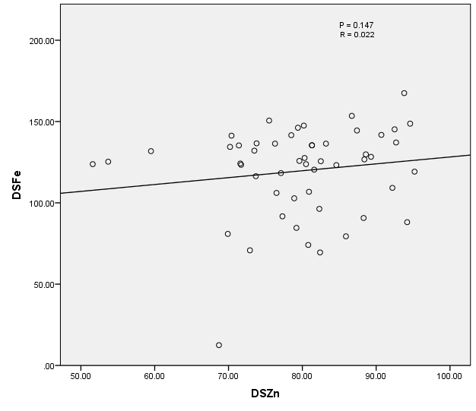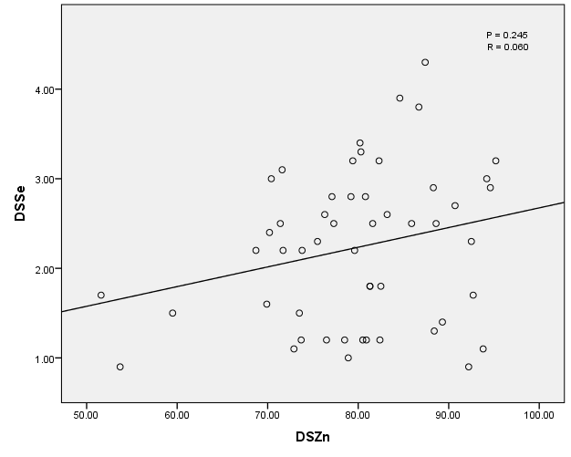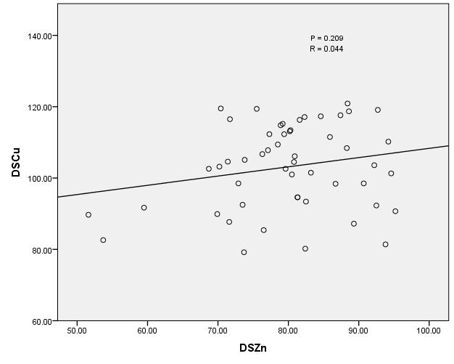

**Figure 2, 3 and 4 Scatter plot of Pearson’s correlation of drug sensitive tuberculosis subjects between zinc and iron (figure 2), zinc and selenium (figure 3), and zinc and copper (figure 4)**

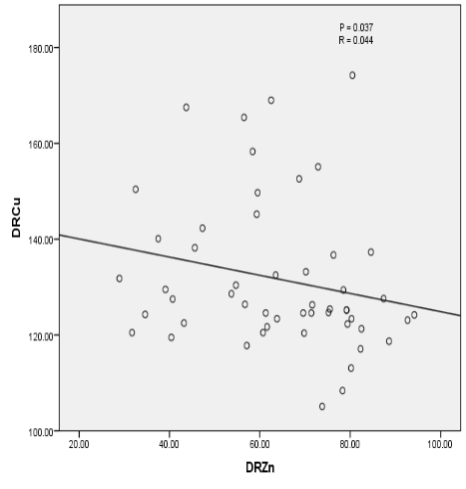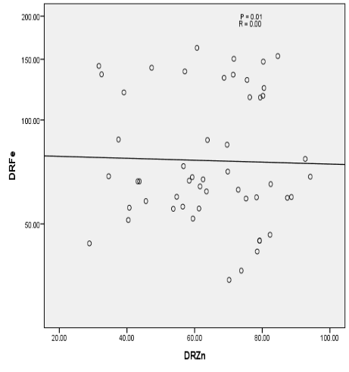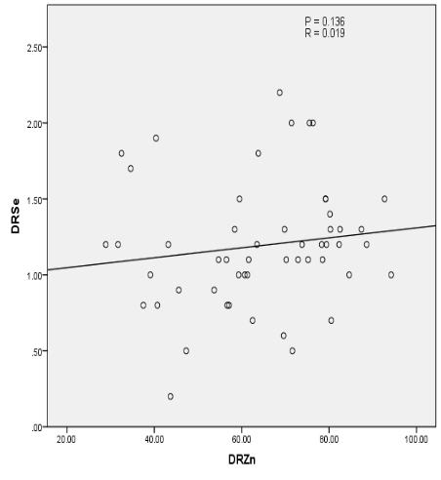**Figure 5, 6 and 7 Scatter plot of Pearson’s correlation of drug resistant tuberculosis subjects between zinc and iron (figure 5), zinc and selenium (figure 6), and zinc and copper (figure 7)**

1. **DISCUSSION**

The demographic data of participation in percentage according to the various study groups is shown in table 1. Out of the four stated age groups, age range 28 – 37 had the highest number of participants across all groups 41.5%, 40.4% and 38.5%. This is an important, physically active, engaging and economically productive age group. Emorinken *et al.,* (2023) revealed a higher prevalence of tuberculosis in similar age group which is consistent with this stidy. . Among the DRTB and DSTB, participants that were married possessed the greatest occurrence, at 63.5% and 63.5%, respectively. The large proportion of married individuals in each category is consistent with other study (Long *et al.*2022). This is because active tuberculosis is most likely to spread among people who spend daily time together (i.e. degree of exposure and duration of contact), including family members. Among the risk variables that might make it easier for tuberculosis to spread is overcrowding. 57.7% (DRTB) and 55.7% (DSTB) were five inhabitants or more living together, inadequate housing, inadequate feeding and consumption of non-portable water also recorded significant percentage in this study and demonstrated its contribution to tuberculosis and its drug resistant strain (Lord *et al.,* 2021; Isukuru *et al.,* 2024).

The tuberculosis groups against the control and also represented the comparison of the two tuberculosis groups as noted in the keys below the table 2. It was demonstrated that the average levels of zinc, iron, and selenium were greater in the control group (102.4, 148.12 and 4.87), compared to drug-resistant (64.18, 83.60 and 1.19) and drug-sensitive (79.87, 119.70 and 2.23) tuberculosis patients. A statistically significant difference in the zinc levels between drug-sensitive, drug-resistant tuberculosis and control (tuberculosis negative) subjects was demonstrated by analysis of variance (f-value = 94.47 and p-value < 0.05). DRTB patients exhibited more immune function disruption than DSTB patients, as suggested by Barman *et al*. (2021).

They claimed that in contrast to DSTB sufferers, those with DRTB had a poorer T-helper cell response and generated higher concentrations of the inflammatory cytokines IL-4, IL-6, and TNF-α. The mean blood iron levels for DRTB, DSTB, and control patients in the study were statistically significant with an F-value of 70.02 and a P-value < 0.05 (Table .3). This decrease in iron levels maybe as a result of more hemoptysis-related blood loss in tuberculosis patients or the body's defense mechanism of establishing an iron-scarce environment that limits the growth and development related to *Mycobacterium tuberculosis*. Alteration could have also evolved as a cytokine-mediated defense against microbial infections to effectively prevent bacteria from obtaining iron, according to Gebremicael *et al*. (2019). Additionally, people who have low hemoglobin levels are more vulnerable to recurrent tuberculosis infections (Dasaradhan *et al.,* 2022).

Table 2 further indicates that the selenium concentrations of the control, DRTB, and DSTB individuals differed statistically significantly (F = 3.25; P = < 0.001). Selenium is vital to human health because it regulates antioxidant defense, enzyme function, and immunological response. It was found to be deficient in the tuberculosis participants especially among DRTB group. This was also supported by Barchielli *et al*. (2022), who found selenium shortage in TB patients, and he further suggested that it may be because of fewer glutathione peroxidases. Additionally, Matvyeyeva, (2021) discovered that DRTB had lower selenium levels.

Statistically significant higher copper levels for DRTB and DSTB compared with control (F = 11.14, P < 0.01) was presented in this study. Research has demonstrated that maintaining copper homeostasis, which involves mobilization and redistribution, is necessary for the body's defense against tuberculosis infection. Although the copper levels of almost all participants were within the normal range, this is different from previous study by Yang *et al.* (2024) that observed low copper level in tuberculosis subjects and suggested that low copper levels in TB patients may be caused by increased copper ingestion by Mycobacterium tuberculosis and macrophages. However, this study's higher copper levels are consistent with Nizamani *et al*. (2019) findings, which looked at copper, zinc, and iron among smokers' biological samples for those with pulmonary tuberculosis.

In the above figures 2, 3, and 4, zinc was modeled as the independent variable while iron, selenium, and copper as the dependent variables in the drug sensitive tuberculosis group when comparing the trace elements that have a high immunological function and aid in the fight against tuberculosis with the trace elements that are thought to aid in the growth of *Mycobacterium tuberculosis*. With a coefficient of variation (R) that tends towards 0.0, the drug-sensitive group, as shown in the scatter plots of Figures 2, 3, and 4 exhibits no statistical significance and a very weak correlation between copper and zinc (p value > 0.05, R = 0.044), selenium and zinc (p value > 0.05 and R = 0.060), and iron and zinc (p > 0.05, R = 0.022). This suggests that trace element interaction did not play a role in the significantly lower level of zinc, Fe, and Se that coexisted with significantly higher Cu levels in the TB group compared with the control.

The correlation of the drug-resistant research group was depicted by the scatter plots in figures 5, 6 and 7. Based on the graph, there was a significant difference between copper or iron and zinc (P = 0.053 and 0.01) respectively, with little to no correlation between the variables {coefficient of variation (R)=0.04 and 0.00} respectively, yet the p-value was significant. The implication of this is a picture of a significant non-linear relationship. But in Figure 7, There was no noticeable distinction between zinc and selenium (P > 0.05, R = 0.01). The incredibly weak associations seen in the research between iron, selenium, or copper and zinc may be the result of these elements' separate metabolic regulation.

1. **CONCLUSION**

When compared to the control participants that were tuberculosis negative, a low level of serum zinc, iron, and selenium was substantially linked to tuberculosis subjects. When compared to drug-sensitive subjects, drug-resistant tuberculosis patients had noticeably reduced levels of zinc, iron, and selenium. Zinc and selenium exhibited a negative link with *Mycobacterium tuberculosis* development, but iron, an element that aids in its growth, showed a positive and significant correlation both in DRTB and DSTB. A lack of zinc, iron, and selenium might exacerbate tuberculosis, based on how trace elements influence the immune system. In addition, higher level of copper can cause lung fibrosis, cytokine imbalance, and immunosuppression, which makes tuberculosis more difficult to treat. Therefore, several immune system characteristics, including antibody responses, cell-mediated immunity, and natural killer (NK) cell activity, are susceptible to both deficits and excess levels of trace elements. Overall, the host's capacity to avoid or reduce infections depends on a healthy immune system. Future studies are required to conclusively determine whether these trace element concentrations affect clinical outcomes and to ascertain whether regularly administering supplements might result in improving quality of life with treatment for TB. Also epigenetic research is required to analyze the impact of trace elements on gene expression in tuberculosis especially the resistant strain.

**Significance of the study:** This work has contributed to the understanding of trace element imbalances in TB patients, both in drug-resistant and drug-sensitive cases, emphasizing on the Role of Trace Elements in the Immune Response, indicating that a lack of zinc, iron, and selenium might increase the severity of tuberculosis.

**DISCLAIMER (ARTIFICIAL INTELLIGENT)**

We hereby declare that no generative artificial intelligence technologies and the likes was used in the curse of writing and editing of this manuscript.

**CONSENT**

Confidentiality of the data derived from the study was maintained. Informed written consent was obtained from the tuberculosis patients and participants in the control group.

**ETHICAL CONSIDERATION**

Ethical approval for the study was obtained from the Oyo State Ministry of Health, Ibadan, Oyo state (NHREC/OYOSHRIEC/11/12/23).

**Institution review board**

Not applicable

**References**

Aanandhi Muthukumar, V., Devanandan, P., and Chowdary Puvvada, R. (2023). Role of Micronutrients in Tuberculosis Management. In *Tuberculosis: Integrated Studies for a Complex Disease* (pp. 321-329). Cham, Springer International Publishing.

Akinyemi B. (2022). Tuberculosis: Nigeria ranks first in Africa as Oyo recorded 11,817 cases in 2021. Nigeria Tribune. Available at: <https://tribuneonlineng.com/tuberculosis-nigeria-ranks-first-in-africa-as-oyo-recorded-11817-cases-in-2021/> (Accessed January 13, 2024).

Alemu, A., Bitew, Z. W., Diriba, G., Seid, G., Moga, S., Abdella, S., and Gumi, B. (2023). Poor treatment outcome and associated risk factors among patients with isoniazid mono-resistant tuberculosis: A systematic review and meta-analysis. *Public Laboratory of Science One*, ***18***(7), e0286194.

Barchielli, G., Capperucci, A., and Tanini, D. (2022). The role of selenium in pathologies: an updated review. *Antioxidants*, ***11***(2), 251.

Barman, N., Khan, M. M. H., Ghosh, D., Towhid, M. I. I., Uddin, M. N., Paul, D., and Haque, M. A. (2021). Serum zinc level and its association with multidrug-resistant tuberculosis. *The International Journal of Mycobacteriology*, ***10***(2), 177-181.

Cochran, W. G. (1977). Sampling techniques (3rd ed.). *New York*: John Wiley & Sons.

Dasaradhan, T., Koneti, J., Kalluru, R., Gadde, S., priya Cherukuri, S., and Chikatimalla, R. (2022). Tuberculosis-associated anemia: A narrative review. *Cureus*, ***14***(8).

Emorinken, A., Ugheoke, A. J., Agbadaola, O. R., Dic-Ijiewere, M. O., Atiri, A., Olugbemide, O., and Eifediyi, R. A. (2023). Prevalence and clinical profile of tuberculosis patients in a rural teaching hospital in South-South Nigeria: A ten-year retrospective study. *International Journal of Tropical Diseases and Health*, ***44***(8), 33-42.

Feng, Q., Lin, Q., Yao, F., Liao, Y., Zhang, H., Sun, Y., and Xu, Y. (2024). Discovering novel biomarkers for diagnosis and treatment monitoring of active pulmonary tuberculosis by ion metabolism analysis. *Microbiological Research*, ***283***, 127670.

Gebremicael, G., Alemayehu, M., Sileshi, M., Geto, Z., Gebreegziabxier, A., Tefera, H., and Kassa, D. (2019). The serum concentration of vitamin B12 as a biomarker of therapeutic response in tuberculosis patients with and without human immunodeficiency virus (HIV) infection. *International journal of general medicine*, 353-361.

Islam, M. R., Akash, S., Jony, M. H., Alam, M. N., Nowrin, F. T., Rahman, M. M., and Thiruvengadam, M. (2023). Exploring the potential function of trace elements in human health: a therapeutic perspective. *Molecular and Cellular Biochemistry*, ***478***(10), 2141-2171.

Isukuru, E. J., Opha, J. O., Isaiah, O. W., Orovwighose, B., & Emmanuel, S. S. (2024). Nigeria's water crisis: Abundant water, polluted reality. *Cleaner Water*, 100026.

Jomova, K., Makova, M., Alomar, S. Y., Alwasel, S. H., Nepovimova, E., Kuca, K., and Valko, M. (2022). Essential metals in health and disease. *Chemico-biological interactions*, ***367***, 110173.

Kamalu, I., Niyomwungere, F., and Etikan, İ. (2024). A Comprehensive Analysis of Cluster Sampling versus Multi-Stage Sampling Techniques: Methodologies, Applications, and Comparative Insights. *Pioneer Journal of Biostatistics and Medical Research,****2***(1), 21-30.

Kawahara, M., Kato-Negishi, M., and Tanaka, K. I. (2023). Dietary trace elements and the pathogenesis of neurodegenerative diseases. *Nutrients*, ***15***(9), 2067.

Long, R., Divangahi, M., and Schwartzman, K. (2022). Chapter 2: Transmission and pathogenesis of tuberculosis. *Canadian Journal of Respiratory, Critical Care, and Sleep Medicine*, *6*(sup1), 22-32.

Lord, J., Thomas, A., Treat, N., Forkin, M., Bain, R., Dulac, P., and Schmaelzle, P. H. (2021). Global potential for harvesting drinking water from air using solar energy. *Nature*, *598*(7882), 611-617.

Matvyeyeva, S. (2021). Influence of compensation of selenium deficiency on immunological parameters of patients with multidrugresistant tuberculosis at the background of subclinical hypothyroidism. Buletinul Academiei de Ştiinţe a Moldovei. Ştiinţe Medicale, **71**(3), 242-244.

Nizamani, P., Afridi, H. I., Kazi, T. G., Talpur, F. N., and Baig, J. A. (2019). Essential trace elemental levels (zinc, iron and copper) in the biological samples of smoker referent and pulmonary tuberculosis patients. *Toxicology reports*, ***6*,** 1230-1239.

Oguntola S. (2022) Oyo records 11,934 TB cases in one year, says official*.* *Nigeria Tribune.* 2022 march 24. Availableat: <https://tribuneonlineng.com/oyo-records-11934-tb-cases-in-one-year-says-official/>.

Orgeur, M., Sous, C., Madacki, J., and Brosch, R. (2024). Evolution and emergence of Mycobacterium tuberculosis. *FEMS Microbiology Reviews*, ***48***(2), 6.

Reward, E. E., Ike, A. C., Muo, S. O., Soga-Oke, B. F., and, Mbaawuaga, E. M. (2021). Coinfection of Tuberculosis and HIV in Nigeria: A Systematic Review and Meta-analysis. *AIDS reviews*, ***23***(2).

Salari, N., Kanjoori, A. H., Hosseinian-Far, A., Hasheminezhad, R., Mansouri, K., and Mohammadi, M. (2023). Global prevalence of drug-resistant tuberculosis: a systematic review and meta-analysis. *Infectious Diseases of Poverty*, ***12***(1), 57.

Subramanian, K. S. (1996). Determination of metals in biofluids and tissues: sample preparation methods for atomic spectroscopic techniques. *Spectrochimica Acta Part B: Atomic Spectroscopy*, ***51*(**3), 291-319.

Surana, K. R., Ahire, E. D., Mahajan, S. K., Patil, D. M., and Khairnar, S. J. (2024). Nutrition, Malnutrition, Infection, And Immunity. In *Immune-Boosting Nutraceuticals for Better Human Health* (pp. 355-367). Apple Academic Press.

Tiberi, S., Utjesanovic, N., Galvin, J., Centis, R., D'Ambrosio, L., van den Boom, M., and Migliori, G. B. (2022). Drug resistant TB–latest developments in epidemiology, diagnostics and management. *International Journal of Infectious Diseases*, ***124****,* S20-S25.

Visser, D. (2021). Atomic absorption spectroscopy, principles and applications. *Technol Networks Anal Sep Available https://www/Technolcom/analysis/articles/atomic-absorption-spectroscopy-principles-and-applications-356829 (accessed 28 December 2022)*.

World Health Organization. (2024). WHO consolidated guidelines on tuberculosis. *Module 3: diagnosis–rapid diagnostics for tuberculosis detection*. World Health Organization.

Yang, Z., Zhang, L., Wang, Y., Pi, J., Peng, D., Yao, Y., and Zhao, Y. (2024). Iron, Copper, and Zinc Homeostasis in the Battle between Macrophage and Mycobacterium Tuberculosis. *Current Medicinal Chemistry*.