**Case report**

**Hemoadsorption with CytoSorb in a patient of sepsis, AKI and acute fulminant hepatitis**

**Abstract**

Sepsis, a life-threatening condition characterized by dysregulated immune responses and multi-organ dysfunction, remains a significant therapeutic challenge. This case report highlights the successful use of hemoadsorption therapy (CytoSorb) in a 35-year-old female with sepsis, acute fulminant hepatitis, and multi-organ failure. The patient initially presented with fever, jaundice, and oliguria, progressing to respiratory distress and worsening renal and hepatic function. Despite initial antibiotic therapy and haemodialysis, her condition deteriorated, prompting the initiation of CytoSorb hemoadsorption integrated with renal replacement therapy (RRT). Two 12-hour hemoadsorption sessions over 48 hours led to marked clinical and biochemical improvement, including a reduction in serum bilirubin from 24.1 mg/dl to 5.6 mg/dl, ALT from 335 U/L to 59 U/L, and procalcitonin from 23.2 μg/L to 9.54 μg/L. The patient’s respiratory distress resolved, and she achieved haemodynamic stability, allowing transfer to the general ward and subsequent discharge without complications. This case underscores the potential of hemoadsorption therapy in modulating the inflammatory response and supporting organ recovery in complex sepsis cases. CytoSorb’s efficacy in reducing cytokine load and improving hepatic and renal function highlights its role as a valuable adjunct in sepsis management. Further studies are warranted to establish long-term outcomes and cost-effectiveness compared to other extracorporeal therapies.

**Key Words:** CytoSorb, Cytokines, Hemoadsorption, Sepsis, Septic shock.

**Introduction**

Sepsis, a life-threatening organ dysfunction caused by a dysregulated host response to infection, is often complicated by multi-organ failure, including acute kidney injury (AKI) and liver dysfunction [3,4]. Managing sepsis remains challenging due to the complex interplay of inflammation, immune dysregulation, and organ impairment. Cytokine adsorption therapy, such as hemoadsorption using CytoSorb, has emerged as a promising adjunct to conventional treatments in sepsis [2]. Hemoadsorption works by removing excess cytokines, bilirubin, and other inflammatory mediators from circulation using porous polymer beads. This mechanism helps modulate the immune response, reduce inflammation, and support organ recovery.

In particular, CytoSorb has shown utility in patients with AKI and liver dysfunction, where its adsorptive capacity aids in decreasing inflammatory markers and improving excretory liver function [1]. This case report illustrates the effectiveness of hemoadsorption therapy in the rapid stabilization and organ recovery of a patient with sepsis, acute fulminant hepatitis, and multi-organ failure.

**Case Presentation**

On January 4, 2024, a 35-year-old female presented to a peripheral hospital with a 7-day history of fever, yellowish discoloration of the skin, sclera, and urine, and severe pruritus. She disclosed that she had previously utilized herbal medications and nonsteroidal anti-inflammatory drugs. Her symptoms evolved to encompass oliguria as time progressed. Hyperbilirubinemia (15.2 mg/dl), leukocytosis (44.80 K/μl), elevated erythrocyte sedimentation rate (41 mm/hour), and altered liver enzymes (SGPT/ALT 450 U/L, ALP 902 U/L) were all identified during the initial laboratory investigations. Intravenous ceftriaxone was administered as initial therapy.

Her condition worsened with a rise in serum creatinine to 7.1 mg/dl, necessitating haemodialysis on January 6. Subsequently, she developed respiratory distress and somnolence and was referred to BIRDEM General Hospital, Dhaka, on January 8. Upon admission, she was conscious but somnolent and required oxygen supplementation via nasal cannula. Bilateral pulmonary crepitations were noted on auscultation. Laboratory findings included serum bilirubin 24.1 mg/dl, procalcitonin (PCT) 23.2 μg/l, serum creatinine 9.7 mg/dl, ferritin 2268 ng/ml, and serum potassium 6.3 mEq/L. A chest X-ray revealed bilateral pulmonary oedema. Hepatitis serologies were negative, but ANA was positive, suggesting an autoimmune component. Given her complex presentation involving sepsis, AKI, and acute fulminant hepatitis, the medical team initiated hemoadsorption therapy using CytoSorb in conjunction with renal replacement therapy (RRT).

**Treatment**

Two 12-hour sessions of hemoadsorption therapy were performed over 48 hours with a 24-hour interval between sessions. CytoSorb was integrated with RRT [5] without anticoagulation, given the elevated risk of bleeding in the setting of liver dysfunction. The hemoadsorber was positioned pre-hemofilter, with blood flow and dialysate flow rates set at 150 ml/min and 2000 ml/min, respectively. Concurrent antibiotic therapy with meropenem and moxifloxacin was administered.

**Measurements**

Clinical and laboratory parameters, including bilirubin, liver enzymes (ALT/SGPT, AST/SGOT), PCT, and consciousness levels, were closely monitored. A timeline of key lab parameter trends is provided in Table 1 and Figure 1.

**Results**

Following hemoadsorption sessions, significant clinical and biochemical improvement was observed: serum bilirubin levels decreased from 24.1 mg/dl to 5.6 mg/dl and remained stable, with further spontaneous reduction in subsequent days. ALT/SGPT decreased from 335 U/L to 59 U/L. AST/SGOT decreased from 183 U/L to 92 U/L. PCT levels declined from 23.2 μg/l to 9.54 μg/l.

The patient’s respiratory distress resolved, and she became fully conscious and orientated. Haemodynamic stability was achieved, and she was transferred to the general ward on January 13.

The chart above illustrates the rapid improvement in bilirubin, ALT/SGPT, AST/SGOT, and PCT levels over the 5-day course of hemoadsorption therapy. Notable decreases in bilirubin and inflammatory markers highlight the efficacy of the treatment.

**Patient Follow-Up**

The patient experienced a complication-free hospital course and was discharged home on January 26, 2024. Although long-term follow-up data were not available, the prognosis appeared favourable given the significant improvements observed during hospitalization. Discussions on relapse risks and the need for continued vigilance were communicated to the patient and her family.

**Discussion**

Cytokine adsorption therapy played a pivotal role in this patient’s recovery by rapidly reducing inflammatory markers and bilirubin levels, thereby mitigating the cytokine storm associated with sepsis (Schädler et al., 2017). The absence of anticoagulation during RRT minimized bleeding risks without causing complications. The synergistic effects of antibiotics and supportive care also contributed to the positive outcome, highlighting the importance of a multimodal treatment approach. Comparative studies have demonstrated the efficacy of hemoadsorption in sepsis management, particularly in reducing cytokine load, improving haemodynamics, and supporting organ recovery. However, limitations such as cost implications and the need for long-term efficacy data warrant further investigation. Future studies should explore the comparative effectiveness of hemoadsorption versus other therapies, such as high-volume hemofiltration and extracorporeal membrane oxygenation (ECMO).

**Conclusions**

In this patient with sepsis, AKI, and acute fulminant hepatitis, hemoadsorption therapy combined with standard care led to rapid clinical improvement and stabilization of inflammatory markers. This case underscores the safety, ease of use, and efficacy of hemoadsorption as a valuable adjunct in managing complex sepsis cases.

**References**

1. Friesecke, S., Träger, K., Schittek, G. A., Molnar, Z., Bach, F., Kogelmann, K., Bogdanski, R., Weyland, A., Nierhaus, A., Nestler, F., Olboeter, D., Tomescu, D., Jacob, D., Haake, H., Grigoryev, E., Nitsch, M., Baumann, A., Quintel, M., Schott, M., … Brunkhorst, F. M. (2019). International registry on the use of the CytoSorb® adsorber in ICU patients: Study protocol and preliminary results. *Medizinische Klinik - Intensivmedizin Und Notfallmedizin*, *114*(8), 699–707. https://doi.org/10.1007/s00063-017-0342-5
2. Kogelmann, K., Jarczak, D., Scheller, M., & Drüner, M. (2017). Hemoadsorption by CytoSorb in septic patients: A case series. *Critical Care*, *21*(1). https://doi.org/10.1186/s13054-017-1662-9
3. Schädler, D., Pausch, C., Heise, D., Meier-Hellmann, A., Brederlau, J., Weiler, N., Marx, G., Putensen, C., Spies, C., Jörres, A., Quintel, M., Engel, C., Kellum, J. A., & Kuhlmann, M. K. (2017). The effect of a novel extracorporeal cytokine hemoadsorption device on IL-6 elimination in septic patients: A randomized controlled trial. *PLoS ONE*, *12*(10). https://doi.org/10.1371/journal.pone.0187015
4. Singer, M., Deutschman, C. S., Seymour, C., Shankar-Hari, M., Annane, D., Bauer, M., Bellomo, R., Bernard, G. R., Chiche, J. D., Coopersmith, C. M., Hotchkiss, R. S., Levy, M. M., Marshall, J. C., Martin, G. S., Opal, S. M., Rubenfeld, G. D., Poll, T. Der, Vincent, J. L., & Angus, D. C. (2016). The third international consensus definitions for sepsis and septic shock (sepsis-3). In *JAMA - Journal of the American Medical Association* (Vol. 315, Issue 8, pp. 801–810). American Medical Association. https://doi.org/10.1001/jama.2016.0287
5. White, J. A. (2007). *Pre-pump arterial pressure = what is going on with the patient’s access. Post-pump arterial pressure = what is going on inside the dialyzer. Why is PBE an important tool? PBE Pressure of Blood Entry Another way of illustrating post-pump arterial pressure*.

**Table**

**Table 1:** Laboratory parameters from Day 01- Day 05 following Hemoadsorption sessions.

|  |  |  |  |  |
| --- | --- | --- | --- | --- |
| **Day** | **Bilirubin (mg/dl)** | **ALT/SGPT (U/L)** | **AST/SGOT (U/L)** | **PCT (µg/L)** |
| 1 | 24.1 | 335 | 183 | 23.20 |
| 2 | 15.0 | 200 | 140 | 18.00 |
| 3 | 9.0 | 150 | 120 | 12.00 |
| 4 | 7.2 | 100 | 100 | 10.50 |
| 5 | 5.6 | 59 | 92 | 9.54 |

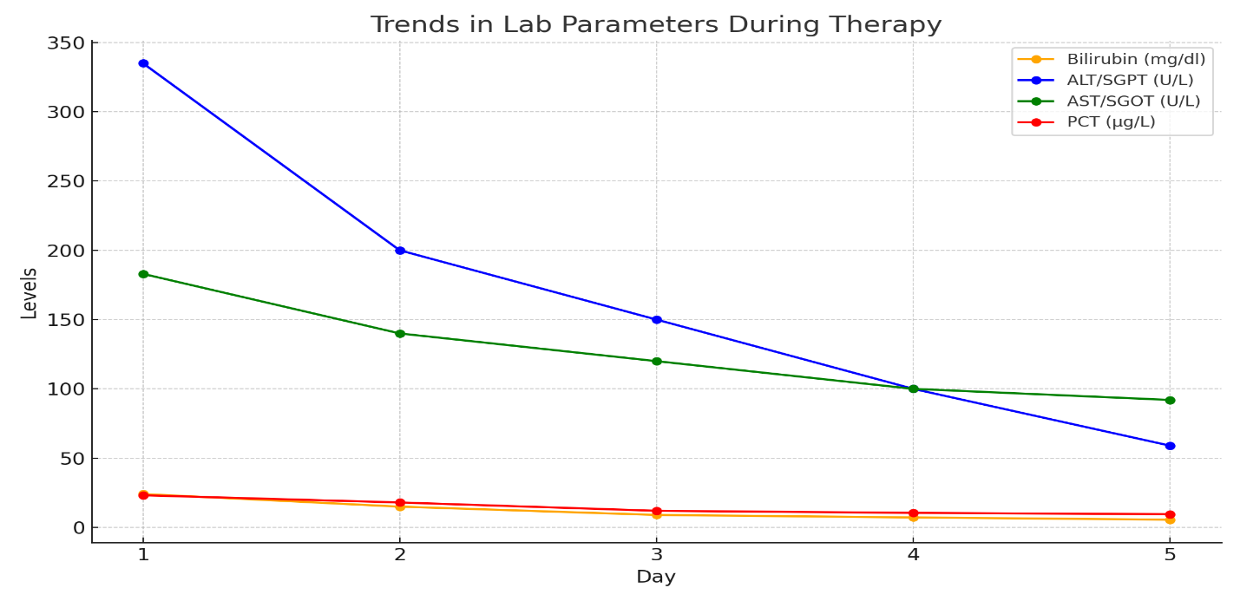**Figure**

**Figure 1:** Laboratory parameters from Day 01- Day 05 following Hemoadsorption sessions.