A Correlation between Dietary Patterns and Anaemia among Adolescent Girls of Kolam Tribe

Abstract
Anaemia is a significant public health issue, particularly among adolescent girls, due to inadequate dietary intake and increased iron requirements. Objective: This study aims to assess the correlation between dietary patterns and anaemia among adolescent girls. Methods & Methodology: A cross-sectional study was conducted from December 2023 to January 2024, involving 60 adolescent girls aged 17–18 years from government higher secondary schools. Participants were randomly selected, and informed written consent was obtained. A semi-structured questionnaire collected data on sociodemographic details, dietary intake, and anaemia-related knowledge. Haemoglobin levels were measured using a hemoglobinometer, classifying anaemia as mild (11.0–11.9 mg/dl), moderate (8.0–10.9 mg/dl), or severe (<8.0 mg/dl). Socioeconomic status was determined using the modified Kuppuswamy classification. Data analysis was conducted using SPSS software, applying descriptive statistics and Pearson’s chi-square test for associations. Results: Anaemia was prevalent among 75% of the participants, with 5% classified as severe cases. The mean BMI was 20.1, height 146.6 cm, and weight 43.0 kg. Dietary analysis revealed that 70% maintained regular meal timings, with daily consumption of cereals, milk, and occasional buttermilk. Leafy vegetables were consumed twice a week (95%), fruits once a week (86%), and meat twice a week. Eggs were consumed daily by 21 participants, while 63% consumed millets twice a month. The findings highlight a significant correlation between dietary patterns and anaemia prevalence, suggesting the need for improved nutritional interventions.
Keywords: Adolescent girls, Kolam tribe, anaemia, nutritional status
Introduction
30% of people worldwide have IDA—of which more than 80–90% live in developing nations—may seem astonishing. Even more surprising is the realization that in India, an estimated 80% of infants and toddlers, adolescents, expectant moms, and nursing mothers are iron deficient. (Chaturvedi et al., 2017)
Anaemia is a worldwide concern that is more prevalent in adolescents. According to NFHS 4 and NFHS 5, anaemia prevalence in adolescents in India is 59.1% and 54.1%. (National Family Health Survey (NFHS-5), n.d.) Adolescent girls are more susceptible to anaemia due to poor food choices, socioeconomic disparities, and increased iron requirements during menstruation and puberty. Iron deficiency anaemia, which can significantly impact physical and cognitive development, future productivity, and health, remains a significant public health concern. (Bharti,jha, et al.,2023)
In Mexico, it is found that anaemia in girls aged 12-19 was positively correlated with Western dietary patterns, such as sugary drinks, salty snacks, and fast food. Few publications explicitly discuss the features of Cantonese cuisine in South China, a typical example of Eastern healthy dietary patterns, despite studies exploring the relationship between dietary patterns and anaemia. (Ma et al., 2023)
Inadequate nutrition in adolescents can lead to chronic health issues like diabetes, obesity, high blood pressure, cardiovascular disease, and cancer. Understanding teenage girls' eating habits is crucial for effective care planning and treatment. (Twara et al., 2015)
Proper nutrition is required to provide essential nutrients and micronutrients, reducing the risk of anaemia. The WHO is committed to a 50% global reduction in anaemia by 2025.One major contributing factor to nutritional anaemia in females is the unequal distribution of health resources within households and society.2. Iron deficiency anaemia is the most frequent cause of anaemia, according to the WHO. (Ramya et al., 2020)
Reducing its prevalence has the potential to significantly benefit the general public's health, particularly for adolescent girls. This includes improving their physical development, cognitive function, academic achievement, productivity at work, and quality of life. (Singhal & Agarwal, 2015)
Tribe people make up 8% of India's population and live in unique environments. Their food intake is influenced by nature and seasonal variations. Inadequate healthcare facilities and ecological degradation worsen their situation. The Indian government has implemented programs to develop tribal communities, including Integrated Tribal Development Projects (ITDP) and a Modified Area Development Approach (MADA). There are 194 ITDPs and 259 MADA pockets in India, and 75 micro projects for primitive tribal groups. Adolescent girls are also vulnerable to undernutrition, as they face high nutrient requirements during rapid growth and maturation. (Rao et al., 2006)
Materials and methods
The present study was carried out from December 2023 to January 2024 at the higher secondary schools in the Telangana state district of Komuram Bheem Asifabad. The study's participants were adolescent girls, ages 17 to 18, enrolled at government colleges. From a list of adolescent girls who attended every upper secondary school in the area of interest, study participants were randomly selected using a random number technique. The NFHS-5 fact sheet states that the prevalence of anaemia in Telangana among teenage girls in the Asifabad district was 74.5%, the statical method used in this study was simple random sampling. Whereas the prevalence of anaemia in adolescent girls as per NFHS-5 i.e.=74.5% and q was taken as (1-p) i.e. q =25.5 and the permissible level of error is taken 15% i.e. e= 11.25 and the confidence level taken was 99%, 57 sample size was obtained out of which 60 sample size was taken.
The study involved 60 adolescents who were randomly selected and provided informed written consent before participating. Participants were interviewed using a pre-formed, semi-structured questionnaire, which included questions on demographic details, family composition, socioeconomic status, anthropometric assessment, clinical methods for anaemia, self-assessment, dietary assessment, and knowledge of various aspects of anaemia. Haemoglobin was measured using a hemoglobinometer with aseptic precautions. Anaemia among adolescent girls is classified into three degrees: 11.0-11.9 mg/dl is mild, 8.0-10.9 mg/dl is moderate, and <8.0 mg/dl is severe.
The modified kuppuswamy classification for socioeconomic status was used.
Data collection was processed using SPSS Windows software version 20. Descriptive statistics using proportions were used for sociodemographic variables, and Pearson's chi-square test was conducted to establish an association between anaemia and knowledge of signs and symptoms of anaemia as dependent variables and various determinants as independent variables.

Results

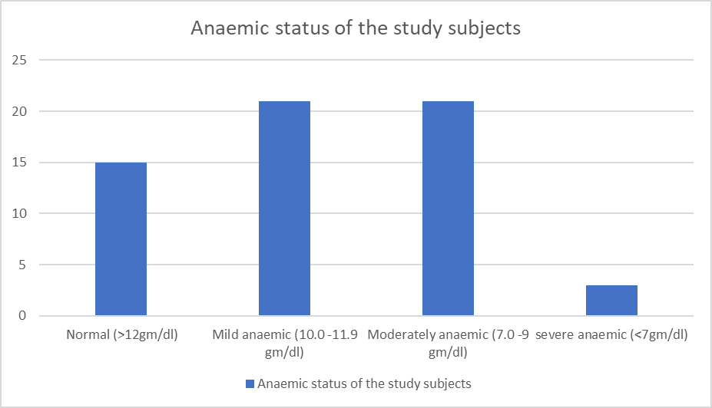
Figure 1: Anaemic status of the study subjects
In the current study, the prevalence of anaemia was found to be 75% among the participants. Among those affected, 5% were classified as severely anaemic, while 25% of the total population were identified as non-anaemic, as depicted in Figure 1.

Table 1: Anthropometric measurements and mean values
Among 60 participants, the mean height was 146.6 + 7.42 cm. The mean weight was 43.0 + 5.23 kg and the BMI was 20.1 + 2.68.
Participant | Height (cm) | Weight (kg) | BMI (kg/m²)
Mean value | 146.6 + 7.42 | 43.0 + 5.23 | 20.1 + 2.68

the study assessed a total of 60 participants, analysing their anthropometric measurements, including height, weight, and Body Mass Index (BMI). The results revealed the following key findings:
Mean Height: The average height of the participants was 146.6 cm, with a standard deviation of ±7.42 cm. This indicates that the height of most participants ranged between 139.18 cm and 154.02 cm (assuming a normal distribution, covering approximately 68% of the population within one standard deviation). MeanWeight: The participants had an average body weight of 43.0 kg, with a standard deviation of ±5.23 kg. This suggests that the majority of the participants had weights ranging from 37.77 kg to 48.23 kg.Mean Body Mass Index (BMI): The average BMI was recorded at 20.1 kg/m², with a standard deviation of ±2.68. This indicates that most participants had BMI values within the range of 17.42 kg/m² to 22.78 kg/m², placing them within the normal BMI range.

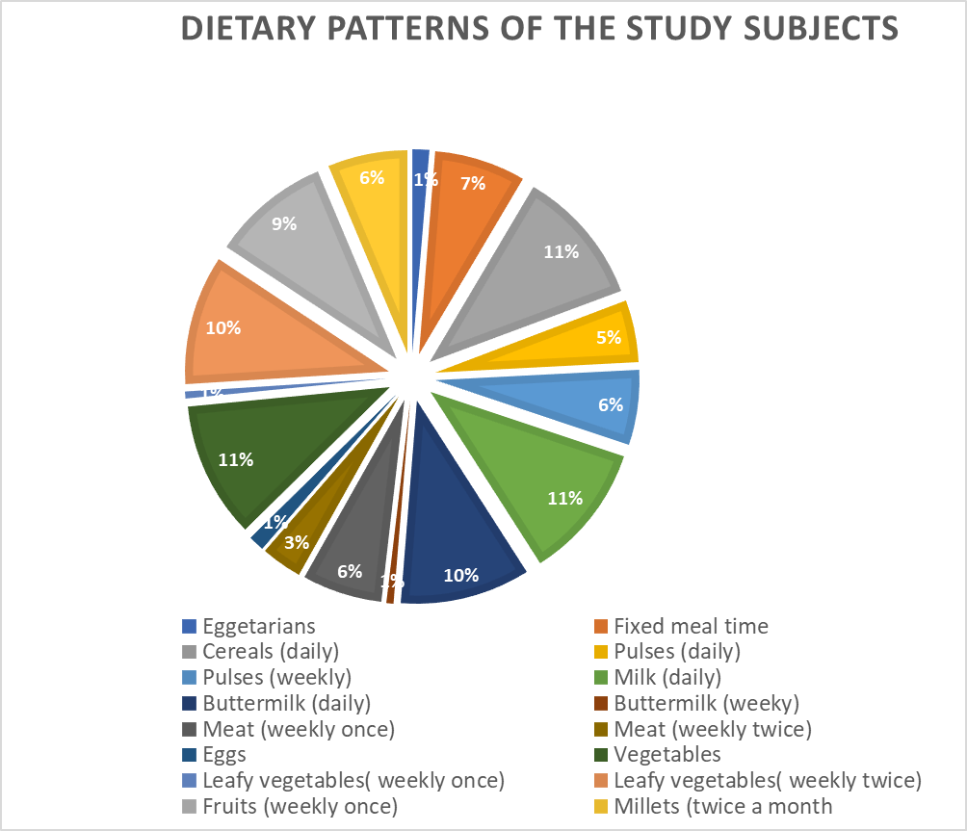
Figure 2: Dietary patterns of the study subjects
The analysis of dietary patterns among the participants revealed notable trends in food consumption habits. The majority of individuals were non-vegetarians, while a smaller proportion identified as eggetarians.
A structured meal routine was observed among the participants, with 70% reporting that they consume their meals at fixed times. The dietary intake of various food groups was also examined, highlighting key findings:
Cereal Consumption: All participants included cereals in their daily diet, making it a staple component of their meals. Dairy Intake: Participants reported daily milk consumption in the morning, and buttermilk was consumed three times a week, indicating a moderate intake of dairy products. Vegetables and Fruits: Leafy vegetables were consumed twice a week by 95% of the participants, reflecting a fairly regular intake of iron-rich greens. Fruit consumption, however, was comparatively lower, with 86% of participants consuming fruits only once a week. Protein Sources – Meat and Eggs: Meat and meat products were included in the diet twice a week by the participants. Egg consumption varied among individuals. Out of the 60 participants, 21 individuals consumed eggs daily, whereas the remaining participants ate eggs twice a week. Millet Consumption: Millets, known for their nutritional benefits, were incorporated into the diet at varying frequencies:63% of the participants consumed millets twice a month.33% consumed them once a month, suggesting a moderate intake of these nutrient-dense grains.

Discussion
In the present study showed that 75% of participants had anaemia, with 5% having severe symptoms. which suggests us the dietary adjustments are necessary.
The average body mass index (BMI) was 20.1, height was 146.6 cm, and weight was 43.0 kg. The majority were non-vegetarians, with 70% eating within regular hours.
Cereals were consumed daily, milk in the morning, and buttermilk three times each week. 95% consumed leafy vegetables twice a week, with 86% eating fruit once a week. Meat was consumed twice a week; twenty-one individuals ate eggs every day, while others did so twice a week. Millets were included in 63% of diets twice a month, and 33% once a month.
Increased consumption of fruits and grains may enhance nutrition and health outcomes. (Utami et al., 2022) in their study have shown a high prevalence of anaemia among adolescent girls in Islamic boarding schools and those living with family. This study found a 17.3% prevalence at Islamic boarding schools, similar to Jakarta (19.6%) and lower than Kediri City (29.93%). The findings suggest no significant difference in anaemia prevalence between these groups.
(Kabir et al., 2010) This study found 23% of girl’s anaemic (Hb <12 g/dl), comparable to 22% in urban schoolgirls but lower than peri-urban (27%) and garment factory workers (44%). High anaemia rates in urban college girls studying Food and Nutrition may result from limited knowledge and inadequate iron intake. Anaemia prevalence was 17.3% in Islamic boarding schools, similar to Jakarta (19.6%) and lower than Kediri City (29.93%), showing no major difference from girls living with family. Anaemia prevalence was 17.3% in Islamic boarding schools, similar to Jakarta (19.6%) and lower than Kediri City (29.93%), showing no major difference from girls living with family.
(Sulistiyanti et al., 2022) This study found 23% of girls anaemic, comparable to 22% in urban schoolgirls but lower than peri-urban (27%) and garment factory workers (44%). High anaemia rates in urban college girls may result from limited knowledge and inadequate iron intake. Nutritional status was assessed using BMI, with 33.1% underweight, 55.6% normal weight, and 11.3% overweight. BMI reflects dietary intake and nutrient use, highlighting the link between proper nutrition, malnutrition, and anaemia.
(Sathyavathi et al., 2025) The present study revealed that the prevalence of anaemia is higher (75%) among the adolescents in the Kolam tribe. This depicts that anaemia is a major public health concern among adolescent girls and an age group of 17-18 years in the growing phase is more prone to anaemia. This study does not show any relation with knowledge of anaemia in general, its signs and symptoms and the consequences and its prevention. The overall knowledge is quite low ranging from 20-50%.

Conclusion
This study reveals a high prevalence of anaemia (75%) among adolescent girls in the Kolam tribe, underscoring the urgent need for dietary modifications and nutritional interventions. Despite consuming cereals, dairy, and meat regularly, the insufficient intake of fruits and iron-rich foods highlights a significant nutritional gap contributing to anaemia. These findings align with previous research, reinforcing the impact of dietary habits on anaemia prevalence. Addressing these deficiencies through improved access to iron-rich foods, supplementation programs, and increased dietary awareness could play a crucial role in reducing anaemia rates and enhancing the overall health and well-being of adolescent girls in tribal communities.

The study highlights a critical public health concern regarding anaemia among adolescent girls in tribal communities. While the current research provides valuable insights, a comprehensive, multi-faceted approach—including nutritional education, dietary modifications, and government intervention programs—is essential to reduce anaemia prevalence. Future studies should focus on long-term dietary interventions, socioeconomic influences, and educational initiatives to improve adolescent health outcomes in this region.

References
Bharti, S. K., Jha, A. K., & Perween, G. (2023). EXPLORING THE RELATIONSHIP BETWEEN ANAEMIA AND DIETARY PATTERNS IN ADOLESCENT GIRLS. Int J Acad Med Pharm, 5(5), 1395-1397.
Chaturvedi, D., Chaudhuri, P. K., Priyanka, & Chaudhary, A. K. (2017). Study of correlation between dietary habits and anemia among adolescent girls in Ranchi and its surronding area. International Journal of Contemporary Pediatrics, 4(4), 1165. https://doi.org/10.18203/2349-3291.ijcp20172022
Kabir, Y., Shahjalal, H. M., Saleh, F., & Obaid, W. (2010). Dietary pattern, nutritional status, anaemia and anaemia-related knowledge in urban adolescent college girls of Bangladesh. PubMed, 60(8), 633–638. https://pubmed.ncbi.nlm.nih.gov/20726192/
Ma, J., Huang, J., Zeng, C., Zhong, X., Zhang, W., Zhang, B., & Liu, Y. (2023). Dietary Patterns and Association with Anemia in Children Aged 9–16 Years in Guangzhou, China: A Cross-Sectional Study. Nutrients, 15(19), 4133. https://doi.org/10.3390/nu15194133
National Family Health Survey (NFHS-5). (n.d.). https://rchiips.org/nfhs/factsheet_NFHS-5.shtml
Ramya, N., Shankar, S., & Arvind, J. (2020). A study of magnitude of anemia and its association with diet pattern in young females. Panacea Journal of Medical Sciences, 10(1), 43–46. https://doi.org/10.18231/j.pjms.2020.011
Rao, K. M., Balakrishna, N., Laxmaiah, A., Venkaiah, K., & Brahmam, G. N. V. (2006). Diet and nutritional status of adolescent tribal population in nine states of India. PubMed, 15(1), 64–71. https://pubmed.ncbi.nlm.nih.gov/16500880
Sathyavathi, P., Singh, N., & Singh, A. (2025). Knowledge regarding anaemia and its impact on adolescent girls of the Kolam Tribe: A Cross-Sectional Study. Journal of Complementary and Alternative Medical Research, 26(2), 27–32. https://doi.org/10.9734/jocamr/2025/v26i2622
Singhal, P., & Agarwal, V. (2015). Dietary Habits in Adolescents Girls and their Association with Anaemia. International Journal of Contemporary Pathology, 1(1), 64. https://doi.org/10.5958/2395-1184.2015.00016.9
Sulistiyanti, A., Widodo, N. S., & Sari, D. N. (2022b). CORRELATION OF NUTRITIONAL STATUS AND DIETARY HABIT WITH THE INCIDENCE OF ANEMIA IN ADOLESCENT GIRLS. Proceeding of International Conference on Science Health and Technology, 469–475. https://ojs.udb.ac.id/index.php/icohetech/article/view/2244
Twara, T., Dubey, R., Singh, M., Agrawal, A., & Dubey, G. P. (2015). Evaluation of dietary intake and food patterns of adolescent girls from Motihari town, Bihar. Asian Pacific Journal of Health Sciences, 2(4S), 27–31. https://doi.org/10.21276/apjhs.2015.2.2s.5
Utami, A., Margawati, A., Pramono, D., & Wulandari, D. R. (2022). Prevalence of Anemia and Correlation with Knowledge, Nutritional Status, Dietary Habits among Adolescent Girls at Islamic Boarding School. Jurnal Gizi Indonesia (the Indonesian Journal of Nutrition), 10(2), 114–121. https://ejournal.undip.ac.id/index.php/jgi/article/view/40297

