Analysis of Coral Reef Community Structure And Coral Cover In Tanjung Seloka Village, Pulau Laut Selatan District, Kotabaru District, South Kalimantan Province

.
ABSTRACT
Involvement of local communities in conservation efforts is one of the keys to the success of preserving marine biological resources. The research aims to analyze the structure of coral reef communities and coral cover in Tanjung Seloka Village, Pulau Laut Selatan District, Kotabaru Regency, South Kalimantan Province. The research was carried out in the waters of Tanjung Seloka village, Pulau Laut Selatan District, Kotabaru Regency, South Kalimantan Province. Environmental parameters include bioecological aspects consisting of live coral cover and coral lifeforms, physical aspects consisting of Temperature (°C), Brightness (m), Current (m/s) and chemical aspects consisting of Salinity (‰), Degree of Acidity (pH) and Dissolved Oxygen (DO). Coral reef data collection uses the Line Intercept Transect (LIT) method. The coral reef ecosystem around the waters of Tanjung Seloka Village, Pulau Laut Selatan District, Kotabaru Regency, only found 2 types of Acropora coral lifeforms. The range of live coral reef cover ranges from 26.76% at station 3 to 52.76% at station 1. The condition of coral reefs around the waters of Tanjung Seloka village, Pulau Laut Selatan District, Kotabaru Regency ranges from medium to good. The water quality parameters measured are: temperature, brightness, current speed, salinity, pH and DO are still within the tolerance limits of water quality standards, except for brightness which is below the quality standard threshold and salinity which is above the quality standard threshold based on Minister of Environment Decree No. 51 of 2004.

Keywords: Coral Reef; Coral Cover;Tanjung Seloka Waters; Marine Ecosystem Health

1. INTRODUCTION

Tanjung Seloka Village, which is located in Pulau Laut Selatan District, Kotabaru Regency, South Kalimantan Province, has abundant marine resource potential, especially in the coral reef ecosystem. The community in this village is highly dependent on marine products as their main source of livelihood. Understanding the condition of the marine ecosystem as a whole to ensure sustainable use of resources and protect its existence from various threats (Coralwatch, 2011).
Coral reefs are a marine ecosystem that has very high biodiversity. In Indonesia, coral reefs provide important habitats for various species of fish and other marine organisms. Its ecological functions include protecting the coast from abrasion, supporting the fisheries sector, and playing an important role in supporting marine tourism (Hamner et al, 2007). The existence of coral reefs is increasingly under threat due to climate change, marine pollution, and environmentally unfriendly marine exploitation practices.
Research focused on identifying the types and structures of coral reef communities is needed, especially in areas with high marine ecosystem potential such as Tanjung Seloka Village. This study aims to identify the types of coral reefs and analyze their community structures as a basis for information in conservation efforts. Accurate data on the distribution and health conditions of coral reefs in the area.
The methods used in this study include Line Intercept Transect (LIT) and satellite image data processing using Landsat-8 imagery (Sarbini et al, 2016). This combined approach allows for a more comprehensive analysis of coral cover and community structure found on the seabed. The results of this method will strengthen the understanding of the dynamics of coral reef ecosystems, as well as become the basis for designing management policies based on scientific data (Oktarina et al, 2014).
In the context of coral reef conservation and rehabilitation technology, the use of Bioreef_Block has become one of the promising innovations. Bioree_Block technology is a modification of Bioreeftek which combines natural materials such as coconut shells with a hollow cubic concrete block structure. Function is as a medium for attaching coral planula larvae and a shelter for reef fish, thus supporting the natural and sustainable recovery process of coral reef ecosystems (Tony et al., 2021).
Previous research in Sungai Cuka Village, Kintap District, Tanah Laut Regency showed that the use of Bioreef_Block can gradually increase the diversity and abundance of reef fish. The physicochemical parameters of the water are mostly within the standard quality limits, although salinity tends to be low due to high rainfall. The increase in the uniformity index of coral fish communities after the installation of Bioreef_Block indicates that this technology is able to improve the condition of biotic communities in waters (Tony et al., 2021).
The LIT method successfully identified various forms of coral life, algae, other fauna, and abiotic components. Coral cover conditions ranging from moderate to good indicate that continuous monitoring is necessary to ensure the sustainability of marine ecosystems (Tony et al., 2025). This research is expected to make a real contribution to the development of marine and fisheries science, as well as support sustainable conservation measures in Kotabaru Regency.
The results of this study are expected to increase local community awareness of the importance of preserving coral reef ecosystems. This is because the involvement of local communities in conservation efforts is one of the keys to the success of preserving marine biological resources. The research aims to analyze the structure of coral reef communities and coral cover in Tanjung Seloka Village, Pulau Laut Selatan District, Kotabaru Regency, South Kalimantan Province.

2. material and methods

The research was carried out in the waters of Tanjung Seloka village, Pulau Laut Selatan District, Kotabaru Regency, South Kalimantan Province, the observation point can be seen in Figure 1 below:
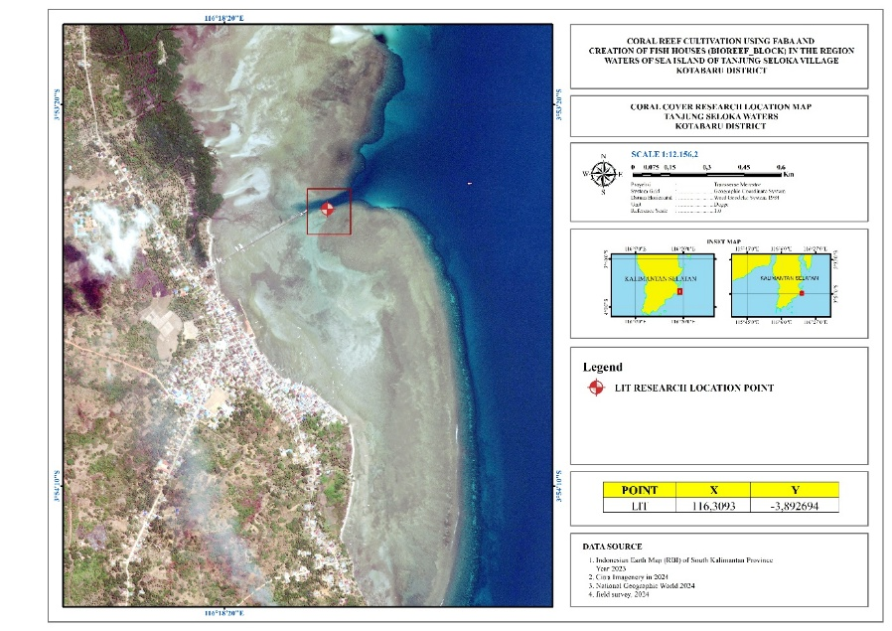
Figure 1. Map of research location

Environmental parameters include bioecological aspects consisting of live coral cover and coral lifeforms, physical aspects consisting of Temperature (°C), Brightness (m), Current (m/s) and chemical aspects consisting of Salinity (‰), Degree of Acidity (pH) and Dissolved Oxygen (DO).
Coral reef data collection uses the Line Intercept Transect (LIT) method based on English et. al., (1994). The LIT method is a method used to estimate coral cover and cover of benthic communities that live with coral.
Table 1. Lifeform categories and codes for the LIT method (English et. al., 1994)
Lifeform |  | Code
Hard Coral (Acropora) | Digitate | ACD
Hard Coral (Acropora) | Branching | ACB
Hard Coral (Acropora) | Tabulate | ACT
Hard Coral (Acropora) | Encrusting | ACE
Hard Coral (Acropora) | Sub Massive | ACS
Hard Coral (Non Acropora) | Branching | CB
Hard Coral (Non Acropora) | Massive | CM
Hard Coral (Non Acropora) | Encrusting | CE
Hard Coral (Non Acropora) | Sub Massive | CS
Hard Coral (Non Acropora) | Foliose | CF
Hard Coral (Non Acropora) | Mushroom | CMR
Hard Coral (Non Acropora) | Meliopora | CME
Hard Coral (Non Acropora) | Heliopora | CHL
Dead Scleractinia | Dead coral | DC
Dead Scleractinia | DC with algae | DCA
Algae | Macro | MA
Algae | Turf | TA
Algae | Corralline | CA
Algae | Halimidae | HA
Algae | Alga Assemblage | AA
Other Fauna | Soft Coral | SC
Other Fauna | Spoonge | SP
Other Fauna | Zoanthids | ZO
Other Fauna | Others | OT
Abiotic | Sand | S
Abiotic | Rubble | R
Abiotic | Silt | SI
Abiotic | Water | WA
Abiotic | Rock | RCK

3. results and discussion

3.1 Results
Types and Conditions of Coral Reef Cover
The research results show that there are 2 types of Acropora coral lifeforms in the sea waters of Sei Village. Vinegar, namely Acropora branching (ACB) and Acropora tabulate (ACT), and 6 types of non-Acropora, namely Coral branching (CB), Coral massive (CM), Coral encrusting (CE), Coral foliose (CF), Coral Mushroom (CMR) and Coral heliopora (CHL). The range of live coral reef cover ranges from 26.76% found at station 3 to 52.76% found at station 1. Therefore, the condition of coral reefs around the waters of Tanjung Seloka village, Pulau Laut Selatan District, Kotabaru Regency ranges from MEDIUM to GOOD. The percentage of live coral coverage can be seen in Table 2 below.

Table. 2. Percentage of live coral cover in the waters of Tanjung Seloka village
Station | 1 | 2 | 3
Percentage (%) | 52,76 | 36,23 | 26,76

Station 1, hard coral (Acropora) cover, namely Coral Branching (ACB) 8.78% and Coral Tabulate (ACT) 10.26% with a total cover of 19.04%, while hard coral (Non Acropora) namely Coral branching (CB) 4.26%, Coral massive (CM) 22.4%, Coral encrusting (CE) 1.26%, Coral foliose (CF) 0.78%, Coral Mushroom (CMR) 2.26%, and Coral heliopora (CHL) 2.76% with a total cover of 33.27%, The percentage of coral cover at station I can be seen in Figure 2 below:

Figure 2. Percentage of Coral Cover Station 1
The percentage of lifeform cover at Station 1 consists of Acropora Branching Tabulate, Branching, Massive, Encrusting, Foliose, Mushroom, Heliopora, DC With Algae, Sponge, Other fauna, Sand and Rubble.
The percentage of station I lifeform cover in Figure 3 is as follows:

Figure 3. Percentage of Lifeform Coverage at Station 1
Station 2, hard coral (Acropora) cover was found, namely Coral Branching (ACB) 8.26% and Coral Tabulate (ACT) 2.8% with a total cover of 11.06%, while hard coral (Non Acropora) namely Coral branching (CB) 9.02%, Coral massive (CM) 2.92%, Coral encrusting (CE) 5.06%, Coral foliose (CF) 7.78%, and Coral Mushroom (CMR) 0.48%, with a total cover of 25.26%. The percentage of coral cover at station 2 can be seen in Figure 4 below:

Figure 4. Percentage of Coral Cover Station 2
The percentage of lifeform cover at Station 2 was found to be 15 types, namely Tabulate, Branching, Massive, Encrusting, Foliose, DC With Algae, Halimidae, Sponge and Sand, while on transect 2 5 types were found, namely Foliose, DC With Algae, Halimidae, Sponge and Sand. The percentage of lifeform cover at Station 2 transects 1 and 2 can be seen in Figure 5 below:
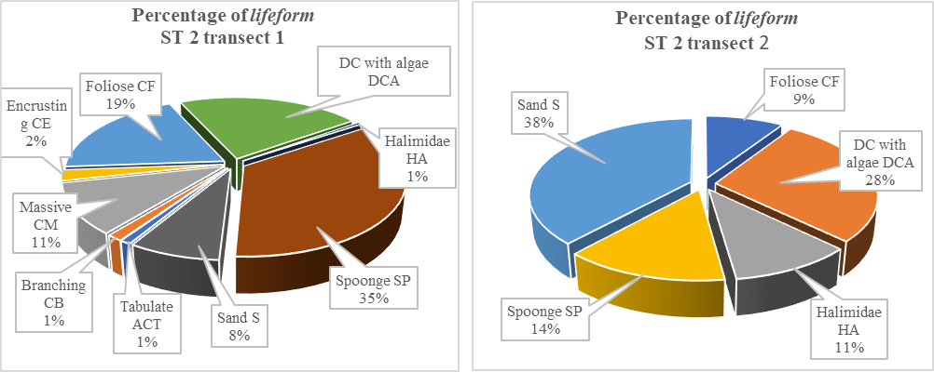
Figure 5. Percentage of Lifeform Cover Station 2 transects 1 and 2
At station 3, transect 1 and transect 2, no hard coral (Acropora) cover was found, while hard coral (Non Acropora) was only found on transect 1, namely Massive and Foliose with a cover percentage of 14.14%. The percentage of coral cover at Station 3 can be seen in Figure 6 below:
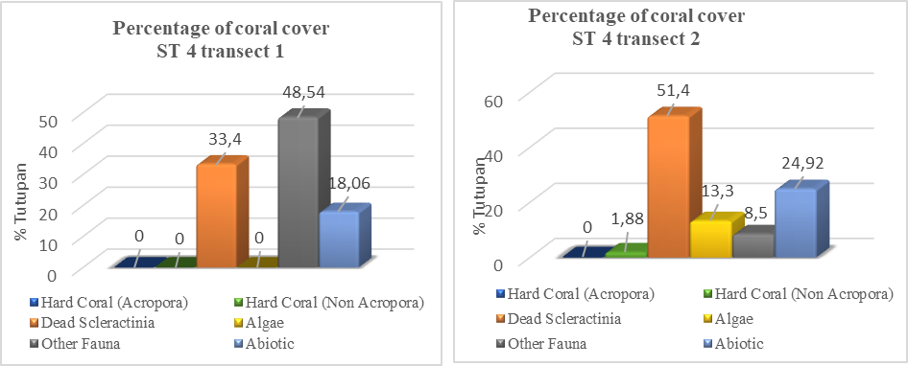
Figure 6. Percentage of Coral Cover Station 4 transects 1 and 2.
The percentage of lifeform cover at Station 4 on transect 1 was found to be 4 types, namely DC With Algae, Sponge, Others and Sand, while on transect 2, 6 types were found, namely Encrusting, DC With Algae, Halimidae, Sponge, Others and Sand. The percentage of lifeform cover for Station 4 transects 1 and 2 can be seen in Figure 7 below:

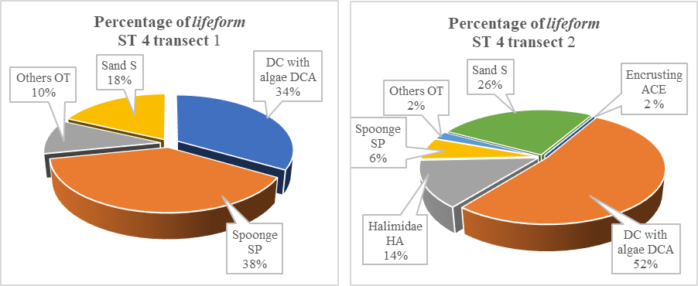
Figure 7. Percentage of lifeform cover for Station 4 transects 1 and 2
Table 3. Coral Reef Assessment Criteria according to Minister of Environment Decree No. 4 of 2011
Category | Live Coral Cover (%)
Very Good | 75 – 100
Good | 50 – 74,9
Average | 25 – 49,9
Bad | 0 – 24,9

Water quality parameter
The results of research on water quality parameters which are physical and chemical factors of sea waters in Tanjung Seloka Village, South Island Island District, Kotabaru Regency can be seen in table 4 below:

Table 4. Water quality parameter measurement results.
Parameter |  | Station |  |  | Minister of Environment Decree No. 51 of 2004
 |  | 1 | 2 | 3 | Minister of Environment Decree No. 51 of 2004
Pickup Time |  | 17.04 | 17.18 | 17.34 | Minister of Environment Decree No. 51 of 2004
Physical Factors | Temperature (°C) | 29,3 | 28 | 28,2 | 28 -30 °C
Physical Factors | Brightness (m) | 5,2 | 5,3 | 5,2 | > 5
Physical Factors | Current (m/s) | 0,04 | 0,06 | 0,08
Chemical Factors | Salinity (‰) | 31.5 | 30,4 | 30,8 | 33 - 34
Chemical Factors | pH | 7.77 | 7,94 | 7,76 | 7 - 8,5
Chemical Factors | DO (mg/l) | 6,6 | 7,1 | 6,4 | > 5

3.2 Discussion

The results of the research activities can be concluded that the coral reefs in the waters of Tanjung Seloka Village, Pulau Laut Selatan District, Kotabaru Regency are the type of fringing coral reefs, because the coral reefs in the research location can be found along the coast with a water depth that is not too far towards the open sea which can be found at a depth of less than 8 meters. This is in line with the literature of Nybakken (2000) which states that Fringing Reefs, namely coral reefs found along the coast and no more than 40 meters deep. These reefs grow to the surface and towards the open sea.
The research location is in the waters of Tanjung Seloka Village, Pulau Laut Selatan District, Kotabaru Regency, the coral reef flats at this location are generally found to be sloping coral reef flats at each station. At a depth of more than 8 meters, coral is rarely found, this is because the sand substrate mixed with mud seems to be more dominant at the research location. In the sea waters of Tanjung Seloka Village, Pulau Laut Selatan District, Kotabaru Regency, it is known that the percentage of live coral cover is 46.38% which is in the moderate category. The types of coral found are from the Coral Massive and Coral Encrusting types.
Hard coral cover as an indicator of coral reef health appears to be low at each station, so the coral reefs are in a damaged condition. Coral reefs are heavily dominated by soft coral communities, hard corals are generally from the Massive coral group and the growth of Halimeda algae. Other biota from the sponge group associated with other reefs are often seen reaching 71%. Iskandar et al (2020) the presence of algae will become a competitor for coral, making it difficult for coral to survive. The quality of coral cover in the Kotabaru area shows better conditions compared to the waters of Sungai Cuka Village, Kintap District, Tanah Laut Regency, South Kalimantan which is reported to vary between damaged to moderate (Tony et al., 2021). The characteristics of the coral reef ecosystem in the waters of Tanjung Seloka Village, Pulau Laut Selatan District, Kotabaru Regency show the type of fringing reef or edge reef.
The low coral cover is also influenced by water quality, including salinity which has exceeded the quality standard threshold based on Minister of Environment Decree No. 51 of 2004 with a salinity tolerance of 33-34‰, whereas at the time of collecting research data at all stations it ranged between 35-40‰, while parameters such as temperature, pH and Do were still within the quality standard threshold tolerance. In addition, brightness parameters also greatly determine coral growth.
Sedimentation or deposition that occurs due to various kinds of human activities in the form of mining, construction along the coast, logging of tropical forests, or agriculture. These activities cause soil erosion that is carried to the sea. Where the research location is in the waters of Tanjung Seloka Village, Pulau Laut Selatan District, Kotabaru Regency, right at the mouth of the Cuka River, as a result the level of water turbidity can also result in higher levels and threaten the life of existing coral reefs because the water quality is dirty and murky. This can be seen from the data obtained that the brightness parameter only reaches 3 - 3.5 meters, only at station 3 has a brightness of 5.2 meters. It can be concluded that the lower the level of brightness of water, the more it can disrupt coral growth.
The average current speed is 0.07 m/s with the highest value at station 3 of 0.10 m/s in Table 5. The current speed value in Table 5 shows that the results are greater than the current speed in the coastal waters of Angsana Kab. Tanah Bumbu between 0.01 - 0.05 m/s with an average of 0.03 m/s, (Rina & Tony, 2013). Currents play a role in the growth process, supplying food in the form of plankton, oxygen and are needed in the cleaning process of materials stuck in coral polyps (Dahuri, 2003). Condition of the coral will be better if it is in an area with moderate currents because it does not make the coral easily broken and helps clean the material on the coral. In addition, the current can also reduce sedimentation that covers the surface of the coral. Based on the data above, the range of current speeds also affects the growth of coral reefs. This is in line with the condition of clam coral cover in the Kima coral waters area in Bunati village, Kec. Angsana District. Tanah Bumbu is categorized as moderate to good. (Jainuddin, 2015), while in the research area it is categorized as damaged to moderate.
The number of algae living on coral reefs is not a good indication. Algae that grows due to the amount of pollution that occurs will gradually die. Fish that prey on algae are caught excessively, then it is certain that algae will grow rapidly because fish that eat algae are decreasing. All stations at the research location found Halimidae Algae. The dominance of soft coral and algae cover causes competition for space with hard corals and inhibits the coral recruitment process, namely preventing the attachment of larvae and development of coral saplings (Loya et al., 2004). Hard corals and soft corals are important reef benthic communities, both of which are often present together as sessile benthic that compete with each other for space. The dominance of soft corals benefits from waters with high nutrient waves and strong currents as well as low temperatures, which occur regularly and continuously (Rustam et al., 2016)

4. Conclusion

The coral reef ecosystem around the waters of Tanjung Seloka Village, Pulau Laut Selatan District, Kotabaru Regency, only found 2 types of Acropora coral lifeforms. The range of live coral reef cover ranges from 26.76% at station 3 to 52.76% at station 1. The condition of coral reefs around the waters of Tanjung Seloka village, Pulau Laut Selatan District, Kotabaru Regency ranges from medium to good. The water quality parameters measured are: temperature, brightness, current speed, salinity, pH and DO are still within the tolerance limits of water quality standards, except for brightness which is below the quality standard threshold and salinity which is above the quality standard threshold based on Minister of Environment Decree No. 51 of 2004.

References

Coralwatch. 2011. Coral Reefs and Climate Change. A Guide to Education and Awareness Building. The University of Queensland. Australia, 272 pages.
Dahuri, R. 2003. Marine Biodiversity Sustainable Development of Indonesia. Jakarta: Gramedia Pustaka Utama
English S., C. Wilkinson & V. Baker, 1997. Survey Manual for Tropical Marine Resources, 2nd Edition. (Townsville: Australian Institute of Marine Science).
English, S., Wilkinson, C., Baker, V,. 1994. Survey Manual For Tropical Marine Resources. ASEAN – Australia Marine Science Project Living CoastalResources. Australia.
Hamner PP. 2007. Export-import dynamics of zooplankton on a coral reef in Palau. Mar Ecol Prog Ser 334: 83-92.
Iskandar, R., Soemarno, Kusuma, Z., Wiadnya, D, G, R. 2020., Association between Coral Community Coverage with Coral Reef Fish Communities at Samber Gelap Island, South Kalimantan, Indonesia., Egyptian Journal of Aquatic Biology & Fisheries Zoology Department, Faculty of Science, Ain Shams University, Cairo, Egypt. ISSN 1110 – 6131 Vol. 25(3): 861 – 881 (2021)
Iskandar, R., Tony. F., 2013. Sedimentation Study at the Angsana River Estuary, Angsana District, Tanah Bumbu Regency, South Kalimantan, Enviro Scienteae 9 (2013) 106-111, ISSN 1978-8096.
Loya Y, Lubinevsk H, Rosenfeld M, Kramarsky-Winter E. 2004. Nutrient enrichment caused by in situ fish farms at Eilat, Red Sea is detrimental to coral reproduction. Mar Pollut Bull. 49(4):344–353.
Nybakken, J.W. 2000. Marine Biology: An Ecological Approach. PT. Gramedia. Jakarta
Oktarina, A., E. Kamal and Soeparno. 2014. Study of Coral Reef Condition and Management Strategy in Panjang Island, Air Bangis, West Pasaman Regency. Postgraduate Program, Bung Hatta University.
Rustam A, Yulius A, Heriati, Salim HL, Ramdhan M. 2016. Study of water quality in Central Lombok waters as a regional marine conservation area. Taslim Arifin et al (eds). Anthology: Coastal Resources Science and Technology for the Development of Blue Economy in Lombok Island. IPB Press. Bogor.
Sarbini, R., Kuslani, H., Nugraha, Y. 2016. Coral Reef Cover Observation Technique Using Line Intercept Transect on Kumbang Island, Karimun Jawa Islands. Litkayasa Engineering Bulletin, 14(1): 33-42.
Tony F., Iskandar Rina., Rifa’I M. Ahsin., Khasanah R. I. 2021., Effectiveness of Bioreef_Block Technology on Reef Fish Diversity In Marine Waters Of Sungai Cuka Village At Kintap District, Tanah Laut Regency of South Kalimantan, Indonesia. DOI 10.18551/rjoas.2021-07.24
Tony, F., Bijaksana, U., Fitriliyani, I., Mahmud, A., Widiyanto, D., Hutomo, M., & Iskandar, R. (2025). Coral reef coverage in the 17 Islands Marine Natural Tourism Park, Riung District, Ngada Regency, East Nusa Tenggara Province. International Journal of Research and Reviews, 12(2):89-101

