GENETIC DIVERSITY OF SOME DECAPODS IN NIGERIAN NIGER DELTA RIVERS USING DNA BARCODING

**Abstrac**t

Shellfish are those aquatic animals with exoskeleton covering as chitin. Crabs one of the

shellfish present in Akor and Itu rivers with average number of 14.97±11.93 and weight of

33.73±11.258g were obtained in higher number in both rivers during the dry seasons than in the

rainy season and non were obtained in the rainy season period of Akor river. The crabs obtained

from Akor river were 6.42±2.37 and Itu 23.53±11.52 but the weight 35.64±11.67g and

31.81±10.71g respectively. Females caught from the rivers were 15.22±12.48 and the males

14.72±11.54. The PCR showed availability of the DNA samples available in the content as they

moved in the electrolyte medium. The crabs after sequencing showed 95% similarity with

*Sudanonates floweri* after blasting and more than 90% pair-wise sequence alignment. The

phylogentoc tree further expressed their close relationships with other species along the lines of

identification and genera.

Key words; biotechnology, genetics, pcr, dna, biodiversity, dna barcodes, taxonomy, Akor river, Itu River, Itu Head Bridge, Itunta Ibere Ikwuano Local Government Area Abia State, Itu Local Government Area Akwa Ibom State, Niger Delta and Nigeria.

**Introduction**

Aquatic organisms have some characteristics of remarkable morphological characters which could be challenging in identification using morphological features (George *et al.,* 2020). Therefore, identification, characterization and assessment of biodiversity are very important in fishery investigations and assessment of natural reserves (Vartak *et al.,* 2015)

DNA barcoding is one of the new and reliable methods of species identification which is based on ectraction of gene from tissues of an organism (Nwakanma *et al.,* 2015). It is essential in identification of organisms down t species level which traces the history of such organism addressing fundamental ecological issues (Kress *et al.,* 2009). DNA barcoding process involves matching of the unknown sample with the known barcode library or binding the unknown sample with the barcode library of the known species all for the identification of the unknown sample which were amplified using PCR (Nwakanma *et al.,* 2015).this method if well utilized would eradicate the mis-identification, and the mimicries that makes compromise even in conservation (George *et al.,* 2020). The similar characteristics may lead to changes in morphological similarities and not evidence on the gene (Dunsin *et al.,* 2023)

COI in DNA barcoding of animals has gained reputable grounds as a suitable or reliable marker and extensively applied in various dimensions including ecological discrimination (Berry *et al.,* 2017)

With biodiversity as the variety or diversity of organisms in a particular region, genetic diversity refers to the variety of organisms having corresponding genetic identity regardless of location as migration etc could cause dispersal among them. Advancements may occur in a species as a result of any kind of mutation but that does not delete the genetic foundation of such organism (Nwakanma *et al.,* 2015)

Shellfish are aquatic invertebrates with thick shells, they include molluscs, and crustaceans. Shellfish culture is gradually increasing and is becoming area of interest even as they serve as biological indicators (Moruf and Adekoya, 2018). **Crabs:** are decapods in which the abdomen is vestigial; the five pairs of thoracic legs are well developed and used for capturing prey, walking and swimming. Crabs inhabit a wide variety of habitats like mud flats, rock crevices, under stones, in gravel and sand and constructed burrows etc. They prefer to hide in places where they can get shelter during the day because they are primarily nocturnal.

**a. Freshwater Crabs**: Freshwater crabs are adapted to semi-terrestrial or terrestrial mode of life and known for their ability to complete the life-cycle independent of marine environment. They are generally omnivorous, feeding on plant material, live or dead animals such as fish, prawns, molluscs, etc., and sometimes cannibalism is also seen.

**b. Brackish water/Marine Crab:** Marine crabs are one of the valuable seafood items that are in great demand both in the domestic and export markets. There are about 600 species of marine crabs recorded from Indian waters. The crab fishery in India is dominated by a few species such as *Scylla serrata, S. tranquebarica, Portunus pelagicus, P. sanguinolentus, Charybdis feriata, C. lucifera and C. truncata*. Commercial-scale crab culture is undertaken along the coastal areas of Andhra Pradesh, Tamil Nadu, Kerala and Karnataka. Grow-out culture (‘Crab Fattening’) is generally pond based wherein crabs juveniles are held in pens or cages. Production of ‘Soft-Shelled Crabs’ is done using floating boxes held in tidal ponds.

**Materials And Methods**

**Study Area**

The study was carried out in two areas, Itu river head bridge region Itu, Akwa Ibom state and Akor river Itunta Ibere Ikwuano, Abia state. Akor river has the coordinates of latitudes 05.34829°N and Longitude 007°.34468' E with elevation of 77m located within the rainforest zone of Eastern Nigeria and between longitudes 7oN and 8oE and latitude 4o 45o E and 6o17o N. Itu a river in Itu local government in Akwaibo State which bears the Itu river and this shares a boundary with the Cross river State. Itu river is a tributary of Niger river with coordinates latitude 5.765N and longitude 8.941E. The both areas are deeply involved in fishing activities, crop farming including rice, cocoa, etc and timber dealing activities in large scales.

**Collection of Samples**

Each of the sites was divided into three stations such that samples could be collected proficiently. These stations were different positions at the rivers giving rise to different points for exploitation.

Sampling was carried out monthly for twelve (6) months comprising the peak of the raining season and the dry seasons. The physicochemical parameters were taken in the morning hours.

**Molecular Identification**

**DNA Extraction,**

Deoxyribonucleic Acid (DNA) was extracted from the sample using the Quick-DNA Miniprepplus Kit (Zymo-Research Laboratory, California, USA) by following the manufacturer’s protocol.The protocol followed is highlighted below:

Up to 25mg of the sample was added to a microcentrifuge tube and 95µl of Solid Tissue Buffer (Blue) was added, followed by 10µl of Proteinase K, and then 95µl of DNA elution buffer. The tube was mixed thoroughly by pipetting in and out, vortexed for 15 seconds and then incubated at 55˚C for 3hrs. After incubation, 1 volume (200µl) of Genomic Binding Buffer was added to the tube and mixed thoroughly by vortexing for 15 seconds. The mixture was transferred to a Zymo-Spin™ IIC-XLR Column in a Collection Tube and centrifuged at 13,000rpm for 1 minute. The flow through was discarded and 400µl DNA Pre-Wash Buffer was added to the spin column in a new Collection Tube and centrifuged at 13,000rpm for 1 minute. The Collection Tube was emptied and 700µl g-DNA Wash Buffer was added to the spin column and centrifuged at 13,000rpm for 1 minute. The Collection Tube was emptied and 200µl g-DNA Wash Buffer was added to the spin column and centrifuged at 13,000rpm for 1 minute. The Collection Tube with the flow through was discarded and the spin column was transferred to a clean microcentrifuge tube, while 100µl DNA Elution Buffer was added directly on the column matrix. The tube with the column was incubated for 5 minutes at room temperature, and then centrifuged at 14,700rpm for 1 minute to elute the DNA. The eluted DNA was stored -20ºC for future use.

**Agarose Gel Electrophoresis of Genomic DNA**

The DNA samples were separated on 1% agarose at 100V for 45mins. The gel wasprepared with 1X TAE and stained with ethidium bromide (4µl).The samples were loaded in the gel as follows: 10µl of each sample was mixed with 2µl of DNA loading dye. The mixture was vortexed, while 10µl of the mixture was loaded in the gel with micropipette. After separation, the gel was examined with a UV Trans-illuminator (TVD-1000R/FB).

**DNA Quantification**

The quality and quantity of the extracted DNA was measured using a nanodrop (Thermo Scientific™ NanoDrop™ One Microvolume UV-Vis Spectrophotometer). The system was blanked using 1µl of DNA Elution Buffer. Afterwards 1ul of the DNA was placed on the pedestal and measured. The concentration (ng/µl), A260/280 ratio and A260/230 ratio of the sample were subsequently recorded.

**Polymerase Chain Reaction (PCR): Amplification of Crustacean Cytochrome Oxidase Gene**

The target region was amplified with a cytochrome oxidase primer pair using [OneTaq® Quick-Load® 2X Master Mix](https://international.neb.com/protocols/2012/09/11/protocol-for-onetaq-quick-load-2x-master-mix-with-standard-buffer-m0486) (NEB, Catalogue No. M0486) following the conditions presented in the Table below.Details of the primers are contained in the table below.

The reaction mixture contained 12.5μl of OneTaq 2X MasterMix with Standard Buffer (NEB, Catalogue No. M0482S), 3μl Genomic DNA (10-30ng/μl), 0.5μl Forward primer (10μM), 0.5μl Reverse primer (10μM), and 8.5μl Nuclease free water (Catalogue No. E476).

https://international.neb.com/products/m0482-onetaq-2x-master-mix-with-standard buffer#Product%20Information

The samples were amplifiedusing EppendorfMastercycler Nexus gradient 230, under the following conditions: initial denaturation at 94°C for 10mins, followed by 35 cycles of denaturation at 94°C for 30sec, annealing at 50°C for 1min, and extension at 68°C for 90sec, and then a cycle of final extension at 72°C for 10mins.

**Table 1. .Details of Primers Used**

|  |  |  |
| --- | --- | --- |
| **Primer name** | **Sequence(5’-3’)** | **Amplicon size** |
| LCO1490 | **GGTCAACAAATCATAAAGATATTGG** | **600bp** |
| HCO2198 | **TAAACTTCAGGGTGACCAAAAAATCA** |  |

**Agarose Gel Electrophoresis of Amplified DNA**

After PCR amplification, 2ul of the PCR product was run on 1% agarose gel, stained with SafeView Red (5ul) and photographed using a gel documentation system (E-BOX, VilberLourmat,Italy).

**Post-PCR Purification**

PCR products were cleaned using an enzymatic method (ExoSAP) as follows:

1. The ExoSAP master mix was prepared by adding the following to a 0.6ml micro-centrifuge tube:
   1. 50µl of 20U/µl Exonuclease I (Catalogue No. NEB M0293L)
   2. 200µl of 1U/µl of Prawn Alkaline Phosphatase (Catalogue No. NEB M0371)
2. The reaction mixture was prepared by mixing the following and incubating the resulting mix at 37℃ for 30mins and at 95℃ for 5mins.
   1. Amplified PCR Product 10 µl
   2. ExoSAP Mix (step 1) 2.5 µl

 http://mvz.berkeley.edu/egl/inserts/Big_Dye_v3.1_Protocol_Manual.pdf

https://www.thermofisher.com/order/catalog/product/4406016

**Sequencing**

The fragments were sequenced using the Nimagen, Brilliant Dye™ Terminator Cycle Sequencing Kit V3.1, BRD3-100/1000 according to manufacturer’s instructions:

<https://www.nimagen.com/products/Sequencing/Capillary-Electrophoresis/BrilliantDye-Terminator-Cycle-Sequencing-Kit/> .

The labelled products were then cleaned with the ZR-96 DNA Sequencing Clean-up Kit (Catalogue No. D4053): <http://www.zymoresearch.com/downloads/dl/file/id/52/d4052i.pdf>

The cleaned products were injected on the Applied Biosystems ABI 3500XL Genetic Analyzer (Serial number 22309-040) with a 50cm array, using POP7:<https://www.thermofisher.com/order/catalog/product/4406016> , and sequence data collected.

The sequences were obtained in PDF and FASTA formats and then searched on the NCBI website.

**Phylogenetic Analysis**

Analyses were conducted using the Maximum Composite Likelihood model . The differences in the composition bias among sequences were considered in evolutionary comparisons. The analysis involved 14 nucleotide sequences. Codon positions included were 1st+2nd+3rd+Noncoding. All ambiguous positions were removed for each sequence pair (pairwise deletion option). Evolutionary analyses were conductedin MEGA11 (Saitou and Nei, 1987)

**Pair-wise Sequence Alignments of The Samples**

The sequences obtained were aligned using Needle (Embos) Pairwise Alignment Tool (Needleman and Wunsch, 1970).The nucleotide sequences were aligned to determine the nucleotide variations.

**Results**

*Sudanonautes floweri* formed the dominant specie of crab prevalent at Akor and Itu River River. *S. floweri* were rampantly occurring at high frequency range of 25 – 8 for both sexes, throughout the period of research. The months of highest frequency of occurrence were February 25.50±22.90 and December 24.25±24.31. There was higher frequency of occurrence at Itu River 23.53±11.52, compared to that of Akor River 6.42±2.37. The morphometric analysis of the crab is shown in Table 2.

**Table 2. The morphometric parameters of fresh water crabs found in Akor and Itu Rivers**

|  |  |  |  |  |
| --- | --- | --- | --- | --- |
| **Month** | **Frequency** | **Weight (g)** | **Dorsal length(cm)** | **Dorsal width (cm)** |
| May 2023 | 11.25±4.35 | 32.30±9.42 | 5.15±0.54 | 4.28±0.56 |
| June | 8.75±2.99 | 28.96±9.34 | 5.38±0.64 | 4.13±0.50 |
| July | 8.75±1.26 | 38.76±15.59 | 6.35±1.33 | 4.48±0.75 |
| Aug | 9.50±1.91 | 33.60±6.76 | 5.65±0.44 | 4.33±0.49 |
| Sept | 12.50±7.05 | 26.78±11.52 | 4.73±0.28 | 3.98±0.62 |
| Oct | 14.75±10.21 | 27.53±5.87 | 5.38±0.43 | 3.73±0.25 |
| Nov | 16.00±13.44 | 35.11±15.13 | 5.38±1.25 | 4.30±0.81 |
| Dec | 24.25±24.31 | 33.98±9.30 | 5.36±0.61 | 4.40±0.36 |
| Jan 2024 | 21.75±21.08 | 34.90±16.32 | 5.37±1.25 | 4.33±0.74 |
| Feb | 25.50±22.90 | 31.11±10.66 | 5.08±0.68 | 4.13±0.64 |
| March | 17.25±12.04 | 41.13±13.66 | 5.36±1.43 | 4.58±0.67 |
| April | 16.25±13.18 | 48.00±4.85 | 5.95±1.79 | 5.00±0.12 |
| May | 10.00±8.91 | 34.45±13.08 | 6.00±1.04 | 4.33±0.63 |
| June2 | 11.75±4.99 | 32.05±10.21 | 5.15±0.66 | 4.18±0.68 |
| July2 | 11.00±1.83 | 28.96±9.34 | 5.38±0.64 | 4.13±0.50 |
| Aug2 | 14.00±2.58 | 36.66±13.61 | 5.58±1.34 | 4.43±0.70 |
| Sept2 | 16.75±11.94 | 30.97±11.96 | 5.04±0.65 | 4.10±0.60 |
| Oct2 | 19.50±16.22 | 31.82±13.63 | 5.95±1.06 | 4.23±0.63 |
| **Site** |  |  |  |  |
| Akor | 6.42±2.37 | 35.64±11.67 | 5.64±1.04 | 4.34±0.61 |
| Itu | 23.53±11.52 | 31.81±10.71 | 5.27±0.80 | 4.21±0.55 |
| **Sex** |  |  |  |  |
| male | 14.72±11.54 | 32.29±10.84 | 5.27±0.80 | 4.21±0.58 |
| female | 15.22±12.48 | 35.16±11.70 | 5.64±1.04 | 4.35±0.58 |

From table 2 the number of crabs caught within the period of this research started with a low catch within the initial months of May, June, July and august 2023 with 11.25±4.35, 8.75±2.99, 8.75±1.26 and 9.50±1.91 respectively. The number of catch increased over the months and declined. It was also observed that the low catch months such as May, June, July and august 2023 with 11.25±4.35, 8.75±2.99, 8.75±1.26 and 9.50±1.91 respectively even of the upper year were during the rainy seasons while the higher catches such as September 2023 –February 2024 were dry seasons. The highest number of catch occurred in the month of February 2024 with 25.50±22.90 and the lowest was in the month of June and July 2023 with 8.75±1.26.

The weight of the crabs caught in the rivers at the different month varied. The weight of the crabs caught on the month of April was the largest with 16.25±13.18 g while the smallest in weight was in the month of September 2023 with 12.50±7.05g the weight of the crabs caught during the rainy seasons are more than the ones caught during the dry seasons. As seen in table 2

The dorsal length being a measure of the dorsal view of the crabs were obtained and the crabs obtained in the month of July 2023 with 6.35±1.33 cm recorded the highest in centimeters while the crabs caught in the month of September 2023 with 4.73±0.28 cm recorded the lowest as seen in the table 2

As seen in table 2 the dorsal widths of the crabs decreased deeply in the month of October 2023 with 3.73±0.25cm making the lowest value during the experiment after which increased to the highest at the month of April 2024 with 5.00±0.12 cm. The low was observed to have occurred during the dry season while the high occurred during the rainy season.

Akor River was 6.42±2.37 cm and the ones caught at Itu River was 23.53±11.52 cm, this implied that the number of catches made at Itu river was higher than the catches made at Akor river. The weight of the crabs also recorded 35.64±11.67 g for Akor site and 31.81±10.71 g for Itu site explaining that the weight of crabs obtained at Akor site was higher than that of Itu river. The dorsal length and width of the crabs also were 5.64±1.04 cm and 5.27±0.80 cm and 4.34±0.61 cm and 4.21±0.55 cm for Akor river and Itu river respectively, also explained that the dorsal length and width o the crabs of Akor river were higher than the ones obtained from Itu river.

According to table 2 the number of males caught at Akor river Itu river were 14.72±11.54 average and 15.22±12.48 females and this implied that the number of females caught was more than the males caught during the experiment. The weight of males caught were less than the weight of females caught with 32.29±10.84 g and 35.16±11.70 g respectively as well as the dorsal length and width with 5.27±0.80 cm and 5.64±1.04 cm for dorsal length and 4.21±0.58 cm and 4.35±0.58 cm for the dorsal width respectively as seen in table 2.

There was a significance difference among the weight, dorsal length, dorsal width and number of catch of crabs made at the Akor and Itu rivers at p≤0.05, therefore was no change in any month as a result of change in another month this also implied at the sites and sexes

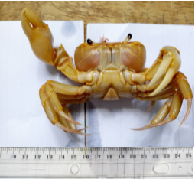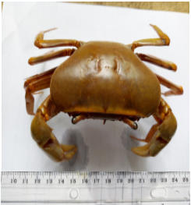

**Plate 2: *Sudanonautesfloweri* ventral view obtained from Akor river Abia State**

**Plate 1: *Sudanonautes floweri* dorsal view obtained from Akor river Abia State**

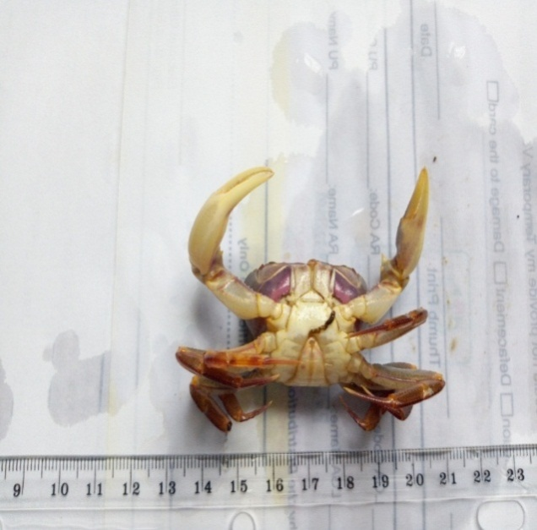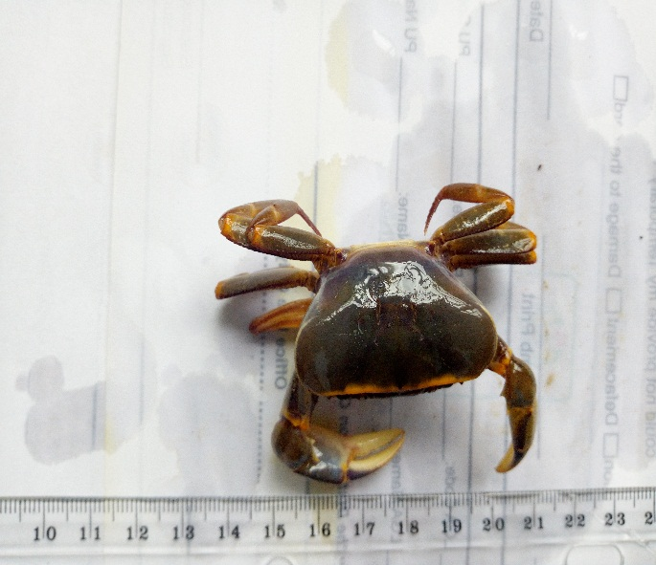

**Plate 4: *Sudanonautes floweri* ventral view obtained from Itu River Akwa Ibom**

**Plate 3: *Sudanonautes floweri* dorsal view obtained from Itu river Akwa Ibom**

**PCR Amplification**

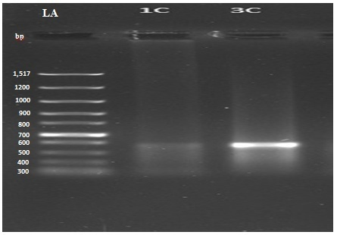

**Fig. 1 PCR Gel Image For The Samples.(LA=DNA Ladder, while 1C and 3C are the samples)**

**Table 3 Summary of Blast Prediction (Sequencing)**

|  |  |  |  |  |  |
| --- | --- | --- | --- | --- | --- |
| **Sequence id** | **Matched organism** | **E-value** | **Querry cover** | **% identity** | **Accession number** |
| 1C | *Sudanonautes floweri* | 0.0 | 84% | 94.76% | OR887119.1 |
| 3C | *Sudanonautes floweri* | 0.0 | 92% | 93.99% | KY069939.1 |

**Table 4 : Summary of Pairwise Sequence Alignments of Samples 1c (Akor) And 3c (Itu) crabs**

|  |  |
| --- | --- |
| **Parameter** | **Value** |
| Length | 679 |
| Identity | 605/679(89.1%) |
| Similarity | 621/679(91.5%) |
| Gaps | 3/679 |
| Score | 2820 |

**Phylogenetic Analyses**



**Fig. 2 : Evolutionary Relationships of Taxa – Bootstrap Consensus Tree.**

The tree formed two clades with samples 1c and 3c being sister taxa. It could be inferred that the samples evolved from *Potamonautes margaritarius s*pecies which existed thousands of years ago.

**Maximum Likelihood Estimate Of Transition/Transversion Bias**  
The estimated Transition/Transversion bias (*R*) is 1.33. Substitution pattern and rates were estimated under the Kimura (1980) 2-parameter model. The nucleotide frequencies are A = 25.00%, T/U = 25.00%, C = 25.00%, and G = 25.00%. For estimating ML values, a tree topology was automatically computed. The maximum Log likelihood for this computation was -5181.208. This analysis involved 14 nucleotide sequences. Codon positions included were 1st+2nd+3rd+Noncoding. There were a total of 718 positions in the final dataset. Evolutionary analyses were conducted in MEGA11 (Tamura *et al.,* 2021).

DiscussionsFisheries science and aquaculture management rely on fundamental parameters such as fish growth, body composition, and reproductive performance to ensure sustainable production and ecological balance. Understanding these biological traits is essential for assessing fish health, optimizing breeding strategies, and improving aquaculture productivity. The weight-length relationship and condition factor are widely used indicators of growth efficiency and overall well-being in fish populations, contributing to effective stock assessment and management practices (Javed *et al*., 1992; Naeem *et al*., 2010a, 2011). Additionally, variations in composition, influenced by body size and physiological status, play a significant role in determining the value of fish (Naeem et al., 2010b; Ashraf *et al*., 2011; Yusaf *et al*., 2011).The high prevalence of *S. floweri* was noted in this research. This is inline with Cumberlidge 1995, who noted prevalence of *Sudanonautes floweri* in South Eastern Nigeria, parts of Cameroon and Bioko Equtorial Guinea. The use of DNA barcoding with COI gene for species identification is a well known and accepted approach in fisheries (Knebelsberger *et al.,* 2014). It had also been proven to be efficient in species identification. There are different success rates recorded in this approach as more researches and finding are in progress for better performance in the industry. The molecular identification of crabs had 100% success rate and this corroborates with other reports on DNA barcoding of fishes (Shen *et al.,* 2016; George *et al.,* 2020) while other studies revealed different levels of success rates ranging from 90 to 95.60% (Iyiola *et al.,* 2018). The different species clustered demonstrated the unambiguous resolution and diagnostic utility of COI gene which was also in the work of Shen *et al.* 2016, DNA barcoding for identification of fish species from freshwater in Enugu and Anambra States of Nigeria. The congeneric and confamilial species were well resolved by the phylogeny. Ward *et al.* (2009) had also shown that the COI gene delineates boundaries of different species, and that there was an indication of distinct phylogeny resolution in COI sequences that was linked to the clustering of congeneric and confamilial species in his work the campaign to DNA barcode all fishes. Generally, all the sequences pertaining to all species were correctly grouped together, thereby, demonstrating the potential of COI gene in DNA barcoding for fishery identification and management as also in the work of George *et al., (*2020), DNA barcoding for identification of fish species from freshwater in Enugu and Anambra States of Nigeria. Many of the identified shellfish species in this study have been previously reported in Nigeria (Ukagwu 2015).

Phylogenetic diversity assesses the community phylogenetic richness, this which was gotten through the summation of the lengths of tree branch lengths or distances that are members of the corresponding minimum traversing species or the sum of branch lengths of the evolutionary trees connecting a set of taxa or individuals, is a crucial diversity index (George *et al.,* 2020).

**References**

Dunsin Abimbola Bolaji a,∗ , Aderonke O. Lawal-Are b , Minasu P. Kuton (2023). DNA barcoding and misidentification of some marine fish species in Nigerian industrial trawl fishery. Scientific Africa 20. 2468-2276

Moruf, Rasheed Olatunji and ADEKOYA, Khalid Olajide (2018). Molluscan And Crustacean Genetic And Biotechnology Interventions: A Review. *Animal Research International* 15(1): 2906 – 2917

Kress, W. J., Erickson, D. L., Jones, F. A., Swenson, N.G., Perez, R., Sanjun, O., Bermingham, E. (2009). Plant DNA barcodes and community phylogeny of a tropical forest dynamics plot in panama. Proc Natl ACad Sci USA 106: 18621 -18626.

Berry O, Sarre SD, Farrington L, Aitken N (2017) Faecal DNA detection of invasive species: the case of feral foxes in Tasmania. Wildlife Res 34:1–7

Vartak VR, Narasimmalu R, Annam PK, Singh DP, Lakra WS (2015) DNA barcoding detected improper labelling and supersession of crab food served by restaurants in India. J Sci Food Agric 95(2):359–366

George N. Ude1  · David O. Igwe1,4 · Chrysten Brown1  · Myron Jackson1  · Alusine Bangura1  · Onyinye Ozokonkwo‑Alor2  · Onyinye C. Ihearahu1  · Obih Chosen2  · Michael Okoro2,3 · Christabel Ene2  · Venatus Chieze2  · Mariam Unachukwu2  · Christie Onyia2  · George Acquaah2  · James Ogbonna2,5 · Aditi Das (2020). DNA barcoding for identifcation of fish species from freshwater in Enugu and Anambra States of Nigeria. Conservation Genetics Resources (2020) 12:643–65

Ashraf, M., Naeem, M., & Zafar, A. (2011). Comparative studies on the seasonal variations in the nutritional values of three carnivorous fish species. International Journal of Agriculture and Biology, 13(5), 701-706.

Naeem, M., Ishtiaq, A., & Shafique, S. (2010). Length-weight and condition factor relationship of farmed hybrid (Catla catla ♂ × Labeo rohita ♀) from Multan, Pakistan. Sindh University Research Journal (Science Series), 42(2), 35-38.

Naeem, M., Salam, A., & Ishtiaq, A. (2011a). Length-weight relationships of wild and farmed Tor putitora from Pakistan. Journal of Applied Ichthyology, 27(4), 1133-1134.

Yusaf, M., Salam, A., & Naeem, M. (2011). Body composition of freshwater Wallago attu in relation to body size, condition factor, and sex from southern Punjab, Pakistan. African Journal of Biotechnology, 10(20), 4265-4268.

Naeem, M., A. Salam, S.S. Tahir and N. Rauf. (2010b). Assessment of the essential element and toxic heavy metals in hatchery reared *Oncorhynchus mykiss*. Int. J. Agric. Biol., 12: 935–938.

Javed, M. Y., Salam, A., Khan, M. N., & Naeem, M. (1992). Weight-length and condition factor relationship of a freshwater wild mahseer, Tor putitora from Islamabad, Pakistan. Proceedings of the Pakistan Congress of Zoology, 12, 335-340.