**A COMPARATIVE STUDY OF THE HEALTH STATUS OF REBA CARP (*Cirrhinus reba*) FROM DHEPA AND ATRAI RIVER OF DINAJPUR DISTRICT**

.

ABSTRACT

|  |
| --- |
| **Aims:** Investigation on the health condition of *Cirrhinus reba* in Dhepa and Atrai river of Dinajpur district was carried out by evaluating the water quality parameters, body indices and haematological parameters.  **Study design:** Nine fishes were randomly collected from each source for determining the body indices (hepatosomatic index, intraperitoneal fat and viscerosomatic index) and haematological parameters analysis (haemoglobin, red blood cell, white blood cell count, total platelet count, differential leucocyte count and erythrocyte sedimentation rate).  **Place and Duration of Study:** In the Dhepa river near Hajee Mohammad Danesh Science and Technology University, Dinajpur and Atrai river near Mohanpur bridge, Dinajpur for six months from October 2019 to March 2020.  **Methodology:** Fish sampling and water quality parameters (air and water temperature, depth, transparency, pH, dissolved oxygen, alkalinity and hardness) were monitored monthly.  **Results:** The highest air and water temperature were recorded in October, while the lowest was found in December in Dhepa and Atrai river. Highest transparency and pH were observed in January in Dhepa and Atrai river, while the lowest was recorded in October and November respectively. The body indices result revealed that HSI (0.04-0.09%), IPF (0.17-1.47%) and VSI (14.25-20.38%) of *C. reba* observed in both Dhepa and Atrai river. The lowest WBC, lymphocyte and monocyte count were found in the blood of *C. reba* collected from both sources in December; while the highest total platelet count and ESR were recorded from the fish collected from the Dhepa river only in October. The highest level of Hb, WBC and lymphocyte count were observed in between February and March 2020 in both Dhepa and Atrai river.  **Conclusion:** It can be said that the health condition of *C. reba* collected from both sources are apparently healthy and better haematological parameters were observed in the months of February and March 2020. |

*Keywords: Body indices; Cirrhinus reba; haematological parameters; health status; water quality parameters*

1. INTRODUCTION

Fisheries is one of the rich probability sector of agriculture and over the last three decades aquaculture has developed to become the fastest growing food producing sector in the world as well as in Bangladesh. Bangladesh is enriched with a huge water bodies which are considered as the gold mines fisheries sector as well as national economy. The main rivers of Dinajpur districts are: Dhepa, Punarbhaba and Atrai. This resource has substantial impact on the ecology, biodiversity and socio economy of the surrounding localities in Dinajpur district. But at present the status of Dhepa and Atrai river ecosystem is not very supporting due to unplanned urban and agricultural developments, the involved anthropogenic disturbances, predominantly throwing of garbage, discharge of sewage and municipal wastes into water body, unload of sand and overexploitation of aquatic resources. Moreover, some parts of the river are fully dried up during winter season which setting the ecosystem for aquatic life under threat. Among them *C. reba* (Hamilton, 1822) commonly known as ‘Rikhor’ or ‘Raik’ is a noticeable one. Although the fish is hardly available in the eastern part of the country, but it is profusely available in the western and north western part of Bangladesh.

*C. reba* (Reba carp) is a species of ray-finned fish in the genus *Cirrhinus* (Gupta, 1975). This commercially significant freshwater minor carp fish found in large streams, rivers, lakes, reservoirs and native to Bangladesh, India, Nepal, Pakistan. It is a desired table size fish as having high nutritional value with good amount of protein, calcium and low fatty acid content. Its flesh contains not much bone and has a good flavor. It is a great target species for small and large-scale fishers of Bangladesh who use different types of traditional fishing gears such as conical trap, square lift net and cast net to collect it.

Once reba is obtainable in almost all freshwater areas of the country, in recent days the availability of these fishes has drastically declined in open water bodies such as rivers, beels, haors and baors. One of the most important reasons of reducing these species is the outbreak of various types of diseases in open water bodies (Rahman & Chowdhury, 1999). Billions of dollars have been destroyed annually because of disease outbreak, which has been recognized as a major threat to the sustainability of the fisheries sector. Fish production has failed to remain pace with its demand due to increase in population which can be tackled by proper utilization of all thewater bodies for the culture of fishes by using scientific method.

The water quality, body indices and haematological parameters play a significant role in disease diagnosis. Knowledge on the disease pattern in reba fish is key for maintaining their availability. In Bangladesh, studies on water quality parameters, body indices and haematological parameters (Akter *et al*., 2009) are scares particularly in reba fish. Considering the above fact, the current study was carried out to determine the current health status of commercially important reba minor carp in the Dhepa and Atrai river of Dinajpur district based on the water quality, body indices and haematological parameters.

2. material and methods

**2.1 Experimental site**

The study area of the experiment was the Dhepa river near Hajee Mohammad Danesh Science and Technology University, Dinajpur and Atrai river near Mohanpur bridge, Dinajpur (Figure 1) and was conducted for a period of six months from October 2019 to March 2020.

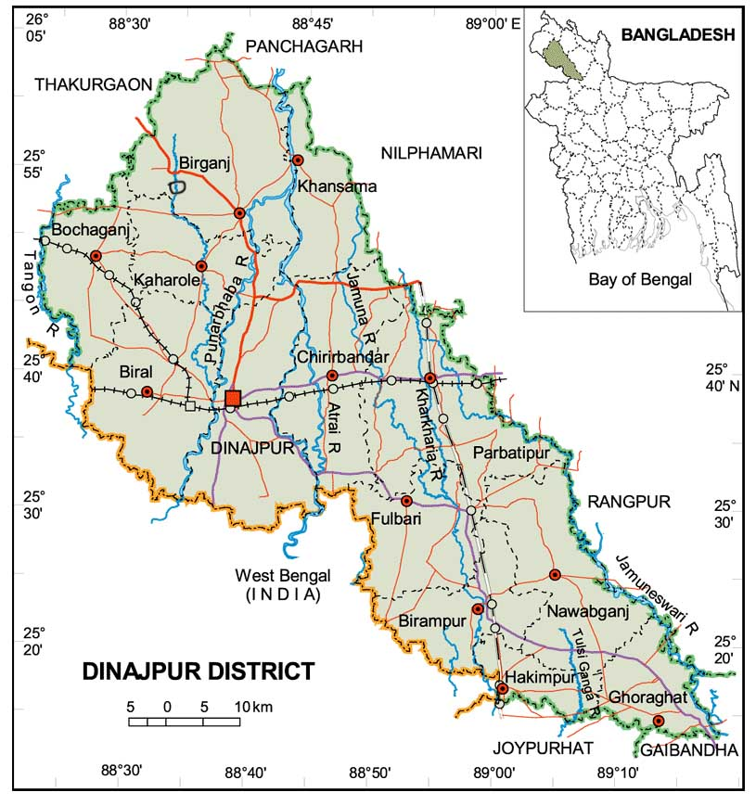

**Fig. 1.** Map showing the study area.

**2.2 Experimental design**

Nine live fishes of reba carp (*C. reba*) were collected from the Dhepa and Atrai river once in month and transported in separate plastic buckets filled with fresh water during experimental period and immediately carried to the laboratory of aquaculture, Faculty of Fisheries, Hajee Mohammad Danesh Science and Technology University, Dinajpur for investigation purposes.

**2.3 Water quality assessment**

Water quality parameters were determined once in a month. Temperature, transparency and pH were recorded by a standard mercury thermometer, secchi disc and a digital pH meter, respectively. DO, alkalinity and total hardness were measured by using a digital DO meter, an alkalinity test kit (HI 3811) and hardness test kit (HI 3812), respectively.

**2.4 Determination of body indices**

At the end of the experiment, body indices of *C.reba* such as Hepatosomatic index (HSI), intraperitoneal fat (IPF) and viscerosomatic index (VSI) were determined by using the following formulae as previously used by Akter *et al*., (2019, 2021):

$Hepatosomatic index (HPI \%)=\left\{{Liver weight (g)}/{Body weight (g)}\right\}×100$

$Intraperitoneal fat \left(IPF \%\right)=\left\{{Intraperitoneal fat weight (g)}/{Body weight (g)}\right\}×100$

$Viscerosomatic index \left(VSI \%\right)=\left\{{Viscera weight (g)}/{Body weight gain (g}\right\}×100$

**2.5 Determination of haematological parameters**

To determine the haematological parameters, the experimental fish were starved for 24 hours. Nine fish from each river were randomly selected and immediately stabilized to reduce stress during handling. Then blood was collected by inserting a 21 gauge needle attached to a 1 mL syringe and transferred to a heparinized tube to prevent the blood sample from clotting for determining the haemoglobin (Hb), red blood cells (RBC), white blood cells (WBC), total platelet count, differential leucocyte count and erythrocyte sedimentation rate (ESR) as previously described by Akter *et al*., (2019).

**2.6 Data analysis**

All data were tested using two-way analysis of variance (ANOVA). Significant results (*P* = .05) were further tested using two-way ANOVA followed by Post Hoc Test to identify significant difference between means. The data were expressed as mean±SD and statistical analysis was performed using SPSS version 22 and Microsoft Office EXCEL for window.

3. results and discussion

The water quality parameters, body indices and haematological parameters of fishes are used to diagnose various fish disease. The suitable water quality parameters are prerequisite for healthy aquatic environment and for the production of sufficient fish food organisms (Rahman, 1992). Water quality provides information on the health of water bodies and help for developing strategies that facilitates better management of catchment and changes in nature of freshwater habitats can cause rapid changes in biodiversity composition (De Pauw & Vanhooren, 1983).

**3.1 Water quality parameters**

Water quality parameters of Dhepa and Atrai river such as water temperature, air temperature, depth, pH, DO, transparency, alkalinity and hardness were studied from October 2019 to March 2020 and ranged between 21.23 to 31.62 ºC and 20.67 to 30.34 ºC, 5.67 to 11.17 ft and 5.83 to 10.50 ft, 7.25 to 7.53 and 7.40 to 7.57, 6.58 to 8.00 mg/L and 6.68 to 8.46 mg/L, 23.15 to 30.33 cm and 18.13 to 31.17 cm, 41.33 to 54.67 mg/L and 35.67 to 54.67 mg/L, 73.00 to 90.67 and 68.50 to 84.50 mg/L, respectively (Table 1).

**Table 1. Water quality parameters in Dhepa and Atrai river of Dinajpur district from October 2019 to March 2020 (mean±SD)**

|  |  |  |  |  |  |  |  |  |  |
| --- | --- | --- | --- | --- | --- | --- | --- | --- | --- |
| **Rivers** | **Months** | **Air Temperature (ºC)** | **Water Temperature (ºC)** | **Depth (ft)** | **pH** | **Dissolved Oxygen(mg/L)** | **Transparency (cm)** | **Alkalinity**  **(mg/L)** | **Hardness(mg/L)** |
| **M±SD** | **M±SD** | **M±SD** | **M±SD** | **M±SD** | **M±SD** | **M±SD** | **M±SD** |
| Dhepa | October | 31.62± 1.65 | 29.42±0.69 | 11.17±3.66 | 7.25±0.27 | 7.15±0.95 | 23.15±2.81 | 41.33±2.73 | 73.00±12.82 |
| November | 27.45± 2.73 | 23.22±0.64 | 6.83±3.06 | 7.43±0.23 | 7.82±0.89 | 23.33±6.06 | 41.33±1.63 | 78.50±16.48 |
| December | 21.23± 2.31 | 18.30±1.16 | 6.42±3.32 | 7.30±0.22 | 9.53±0.78 | 25.67±9.77 | 44.00±1.26 | 90.67±14.75 |
| January | 27.79±2.02 | 24.62±2.28 | 5.67±2.73 | 7.53±0.23 | 7.73±1.21 | 30.33±2.93 | 47.67±3.44 | 79.17±7.88 |
| February | 25.23±0.99 | 22.88±1.77 | 5.80±1.72 | 7.27±0.23 | 8.00±0.63 | 23.58±2.11 | 54.67±6.25 | 86.50±18.34 |
| March | 27.70±1.21 | 25.87±2.29 | 5.98±1.98 | 7.38±0.34 | 6.58±0.49 | 23.31±2.76 | 51.50±3.56 | 74.50±10.29 |
| Atrai | October | 30.34±2.08 | 27.77±1.05 | 10.17±3.66 | 7.40±0.11 | 6.68±0.43 | 19.60±2.82 | 43.33±3.01 | 78.67±9.05 |
| November | 25.15±2.49 | 22.58±1.86 | 7.67±3.44 | 7.49±0.22 | 8.46±0.76 | 18.13±3.30 | 54.67±6.25 | 79.00±9.80 |
| December | 20.67±1.78 | 18.83±1.53 | 5.83±3.06 | 7.55±0.27 | 7.19±0.74 | 27.40±5.69 | 47.67±3.44 | 68.50±6.12 |
| January | 21.80±1.89 | 19.42±1.38 | 9.37±3.52 | 7.57±0.16 | 7.53±0.86 | 31.17±3.55 | 44.67±1.63 | 76.50±12.11 |
| February | 27.13±1.56 | 26.03±1.52 | 10.50±4.51 | 7.45±0.24 | 7.98±0.80 | 24.70±7.17 | 51.50±3.56 | 84.50±12.50 |
| March | 28.87±0.69 | 26.07±1.11 | 9.78±3.75 | 7.42±0.25 | 7.60±0.36 | 28.75±0.82 | 35.67±3.44 | 80.00±9.03 |

In the present study, the average water temperature of Dhepa river were noted as 18.30±1.16 to 29.42±0.69 ºC, while in Atrai river 18.83±1.3 to 27.77±1.05 ºC respectively which coincides with the study of Begum *et al*., 2019 (19.1 to 19.6 ºC); Rahman *et al*., 2020 (22.8 to 30 ºC); Amin *et al*., 2021 (21.67 to 32.03 ºC). From this context, it can be said that the experimental river water temperatures were suitable for health condition of fishes.

In addition, the highest depth in Dhepa river was observed in October and lowest water level was noted in January, while highest depth in Atrai river was observed in February and lowest water depth was observed in December. Similarly, Singh *et al.*, (2010) observed the highest water depth in monsoon and lowest in summer season in Manipur River.

The DO content at Dhepa river was 6.58±0.49 to 9.53±0.78 mg/L, on the other hand, the range of DO at Atrai river was 6.68±0.43 to 8.46±0.76 mg/L in October and November respectively. Adequate DO is necessary for good water quality, survival of aquatic organism and decomposition of waste by microorganisms (Islam *et al*., 2010). The lower DO concentrations indicate higher level of organic pollutants and lower level of oxygen concentration in water (Islam *et al.*,2012). Therefore, the DO content in the present study was acceptable for health condition of fishes.

In the current study, pH values ranged from 7.25±0.27 to 7.53±0.23 for Dhepa river, while in Atrai river 7.40±0.11 to 7.57±0.16, respectively that agrees well with the study of Roy *et al*., (2002) 5 to 9.03 for carp SIS; Shariful *et al.*,(2009) 6.5 to 8.1 for benthic fauna and Rahman & Marimuthu (2010) 7.40 to 8.50 for endangered native fishes. From this context, it can be said that the experimental rivers were appropriate for health condition of fishes.

In the present study, transparency was found to vary from 23.15 to 30.33 cm for Dhepa river, while in Atrai river 18.13 to 31.17 cm. The minimum values were observed 23.15±2.81 to 18.13±3.30 cm in October and November and maximum values were observed 30.33±2.93 to 31.17±3.55 cm in January Dhepa and Atrai river respectively. According to Khan *et al.*,(2007) transparency was 22.99 cm, while inMouri river the average value was 37.25 cm.

In Dhepa river, the minimum alkalinity 41.33±1.63 mg/L was recorded in November and maximum 54.67±6.25 mg/L in February, while in Atrai river, the minimum alkalinity 43.33±3.01 mg/L in October and maximum 54.67±6.25 mg/L in November. Islam *et al*., (2014) found more alkalinity in water of Brahmaputra River during dry season and seasonal fluctuation in total alkalinity in Talar river. The mean alkalinity of the Korotoa river water was 122.05 mg/L which was within the standard limit 150 mg/L (DoE, 2016).

The minimum hardness of Dhepa river was 73.00±12.82 mg/L in October and maximum was 90.67±14.75 mg/L in December, while in Atrai river, the minimum hardness 68.50±6.12 mg/L in December and maximum 84.50±12.50 mg/L in February which coincides with the study of Huq & Alam (2005) who recorded the mean content of hardness 75.59 mg/L in the river water. From this context, it can be said that all the water quality parameters were within acceptable range for fishes.

**3.2 Body indices**

Among, the body indices non statistically significant *(P* = *0.05)* was exist for HSI, IPF and VSI (Table 2, Figure 2).

**Table 2. Body indices of *C. reba* collected from Dhepa and Atrai river from October 2019 to March 2020 (mean±SD)**

|  |  |  |  |  |
| --- | --- | --- | --- | --- |
| **Rivers** | **Months** | **HSI (%)** | **IPF (%)** | **VSI (%)** |
| **M±SD** | **M±SD** | **M±SD** |
| Dhepa | October | 0.09±0.02 | 0.18±0.13 | 14.25±5.84 |
| November | 0.08±0.01 | 0.16±0.13 | 20.38±2.70 |
| December | 0.09±0.05 | 0.93±0.47 | 15.32±1.51 |
| January | 0.08±0.01 | 0.17±0.14 | 19.01±1.47 |
| February | 0.06±0.05 | 1.28±0.11 | 14.58±0.18 |
| March | 0.06±0.05 | 1.47±0.34 | 16.00±1.28 |
| Atrai | October | 0.07±0.03 | 0.19±0.18 | 17.78±4.55 |
| November | 0.04±0.01 | 0.73±0.63 | 17.99±2.74 |
| December | 0.06±0.03 | 1.03±0.91 | 17.85±0.56 |
| January | 0.08±0.02 | 0.17±0.15 | 18.50±5.28 |
| February | 0.06±0.03 | 0.92±0.75 | 17.65±2.30 |
| March | 0.04±0.00 | 1.29±0.77 | 17.04±0.43 |

**3.3 Haematological parameters**

The health status of fish was reflected through its haematological parameters. Therefore, understanding of the haematological parameters used as an effective index in evaluating physiological and pathological abnormalities in fish to verify its health status (De Pedro *et al*., 2005). Among the haematological parameters statistically significant *(**P = .05)* were exist for monocyte (%), eosinophil (%) and no statistically significant *(P = .05)* observed for Hb (g/dL), RBC (m/µL), WBC (cu.mm), total platelet count, neutrophil (%), lymphocyte (%), basophil (%) and ESR (mm/hr.) of *C*. *reba* were determined from Dhepa and Atrai river in different months (Table 3).

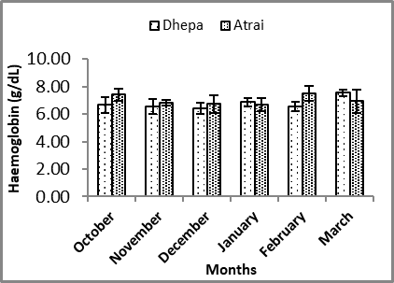

**A**

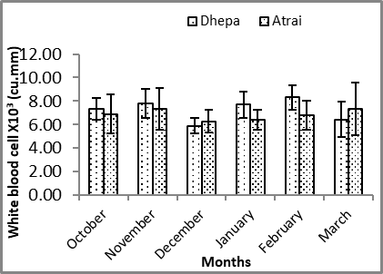

**B**

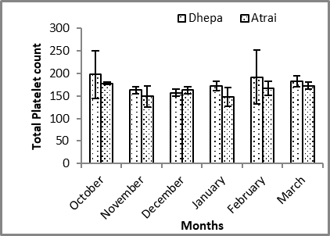

**D**

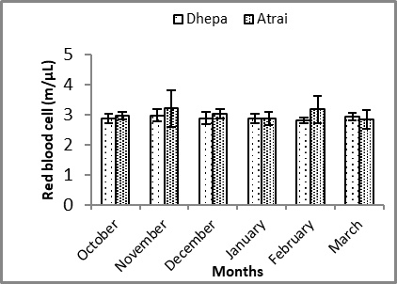

**C**

|  |  |
| --- | --- |
|  |  |

E

F

G

**Fig. 2.** A) Hb (g/dL), B) WBCX10³ (cu.mm), C) RBC (m/µL), D) total platelet count, E) neutrophil(%), F) lymphocyte (%), G) monocyte (%), H) eosinophil (%) and I)ESR (mm/hr.) of *C. reba* collected from Dhepa and Atrai river of Dinajpur district.

Fish are sensitive and very vulnerable to alterations of water quality, which possibly reflected in their blood parameters (Blaxhall, 1972; Reddy & Baghel, 2012; Reddy & Rawat, 2013). Haematological parameters reflected the poor condition of fish more quickly than other commonly measured parameters and they respond quickly to changes in environmental conditions (Alkinson & Judd, 1978) and they have been widely used for the description of healthy fish for monitoring stress responses (Soivio & Oikari, 1976; Kocabatmaz & Ekingen, 1984) and the physiological adaptations of fishes. In the current study, the outcome of most of the body indices including HSI, IPF and VSI were not significantly changed in the *C. reba* in the both river. The study on the changes of haematological parameters of fish provided valuable information in the identification of stress, environmental contamination and pathology (Elahee & Bhagwant, 2007) and changes in these indices from reference give an indication of disease.

**Table 3. The haematological parameters of *C. reba* collected from Dhepa and Atrai river from October 2019 to March 2020 (mean±SD)**

|  |  |  |  |  |  |  |  |  |  |  |  |
| --- | --- | --- | --- | --- | --- | --- | --- | --- | --- | --- | --- |
| **Rivers** | **Months** | **Hb**  **(g/dL)** | **WBC**  **X10³(cu.mm)** | **RBC**  **(m/µL)** | **Total platelet count** | **Neutrophil**  **(%)** | **Lymphocyte**  **(%)** | **Monocyte**  **(%)** | **Eosinophil**  **(%)** | **Basophil**  **(%)** | **ESR**  **(mm/hr)** |
| **M±SD** | **M±SD** | **M±SD** | **M±SD** | **M±SD** | **M±SD** | **M±SD** | **M±SD** | **M±SD** | **M±SD** |
| Dhepa | October | 6.67±0.57 | 7.33±0.91 | 2.87±0.15 | 198.00±53.00 | 19.00±4.00 | 71.00±3.00 | 4.00±1.00 | 5.00±2.00 | 0±0 | 16.00±5.00 |
|  | November | 6.53±0.55 | 7.80±1.22 | 2.97±0.21 | 163.00±8.00 | 24.00±5.00 | 69.00±6.00 | 4.00±1.00 | 3.00±2.00 | 0±0 | 13.00±5.00 |
|  | December | 6.43±0.42 | 5.90±0.66 | 2.88±0.21 | 157.00±8.00 | 25.00±3.00 | 67.00±1.00 | 4.00±2.00 | 5.00±2.00 | 0±0 | 15.00±4.00 |
|  | January | 6.87±0.31 | 7.70±1.14 | 2.87±0.15 | 172.00±11.00 | 23.00±6.00 | 69.00±7.00 | 4.00±1.00 | 5.00±2.00 | 0±0 | 10.00±2.00 |
|  | February | 6.53±0.35 | 8.33±1.04 | 2.80±0.10 | 192.00±60.00 | 21.00±2.00 | 71.00±2.00 | 4.00±1.00 | 4.00.±2.00 | 0±0 | 17.00±2.00 |
|  | March | 7.53±0.25 | 6.43±1.50 | 2.93±0.12 | 183.00±12.00 | 18.00±3.00 | 72.00±3.00 | 4.00±0.00 | 6.00.±2.00 | 0±0 | 10.00±1.00 |
| Atrai | October | 7.40±0.46 | 6.90±1.68 | 2.97±0.12 | 178.00±3.00 | 19.00±3.00 | 74.00±3.00 | 4.00±1.00 | 3.00±1.00 | 0±0 | 13.00±5.00 |
|  | November | 6.80±0.20 | 7.33±1.80 | 3.20±0.61 | 149.00±23.00 | 25.00±6.00 | 68.00±7.00 | 2.00±1.00 | 4.00±2.00 | 0±0 | 14.00±6.00 |
|  | December | 6.73±0.64 | 6.27±0.97 | 3.03±0.15 | 163.00±8.00 | 25.00±4.00 | 68.00±6.00 | 2.00±1.00 | 4.00.±2.00 | 0±0 | 10.00±0.00 |
|  | January | 6.67±0.49 | 6.40±0.85 | 2.87±0.21 | 148.00±21.00 | 25.00±4.00 | 68.00±7.00 | 3.00±2.00 | 4.00±2.00 | 0±0 | 11.00±3.00 |
|  | February | 7.47±0.55 | 6.77±1.24 | 3.17±0.46 | 167.00±15.00 | 18.00±3.00 | 76.00±4.00 | 4.00±2.00 | 3.00±2.00 | 0±0 | 12.00±7.00 |
|  | March | 6.93±0.85 | 7.33±2.25 | 2.83±0.31 | 173.00±8.00 | 17.00±4.00 | 76.00±3.00 | 3.00±0.00 | 4.00±2.00 | 0±0 | 15.00±6.00 |

The highest Hb content 7.53±0.25 g/dL was observed in the month of March 2020 and lowest 6.43±0.42 g/dL in December 2019 in Dhepa river and the highest Hb content 7.47±0.55 g/dL was observed in the month of February 2020 and lowest 6.67±0.49 g/dL in January 2020 in Atrai river respectively. Previously, different studies reported the level of Hb standard of Tilapia is 5.05 to 8.33 g/dL (Salasia *et al*., 2001) and 7.14 to 8 g/dL (Arfiati *et al.*,2020) which are mostly similar to the present study and the average level of Hb concentrations.

In the current study the value of WBC count at Dhepa river was 5.90 to 8.33 cu.mm in December and February. On the other hand, the range of WBC at Atrai river was 6.27 and 7.33 cu.mm in December and March respectively. Singh & Tandon (2009) observed WBC 8.40 and 9.30 cu.mm. WBC plays a major role in the defense mechanism of the fish and consists of granulocytes, monocytes and lymphocytes. Granulocytes and monocytes function as phagocytes to salvage debris from injured tissue and lymphocytes produce antibodies (Ellis *et al.*, 1978). From this context, it can be said that the experimental rivers were appropriate for health condition of fishes.

In this study, the RBC content of *C*. *reba* collected from the Dhepa river was 2.80± 0.10 m/µL in February and 2.97± 0.12 m/µL in November. On the other hand, the range of RBC at Atrai river was 2.83± 0.31 m/µL and 3.20± 0.61 m/µL in March and November respectively. A significant difference was found between the fishes of these two rivers that agrees with the findings of Adedeji *et al.*, (2000).

The value of the total platelet content of Dhepa river ranged from 157 to 198, while in Atrai river 148 to 178 and has more ability to maintain heamostasis during blood lost (Srivastava, 1969). There was no significant difference in the amount of platelet between the fishes of these two rivers. The lymphocyte percentage of Dhepa river ranged from 67 to 72 %, while in Atrai river 68 to 76 %. According to Adedeji *et al*., (2011) the lymphocyte count ranges between 37 to 72 % with the mean value of 63.45±1.93 % in *C. gariepinus* while *C. nigrodigitatus* lymphocyte ranges between 34 to 78 % with a mean value of 52.35±3.01 %. This finding was similar to the finding of the present study and the haematological parameters showed a statistical significance for the monocyte and eosinophil content.

In the current study, in the Dhepa river, the minimum ESR 10±1mm/hr was recorded in March and maximum 16±5 mm/hr was recorded in October, while in Atrai river, the minimum ESR 10±0 mm/hr in December and maximum 15±6 mm/hr in March 2020. From this context, it can be said that the ESR of fishes from these two experimental rivers were suitable for health condition of fishes. However, the parameters were within the satisfactory range for healthy condition of fish (Jhingran, 1991).

4. Conclusion

The health status of *C. reba* collected from the Dhepa and Atrai river of Dinajpur district was evaluated and the results indicated that *C. reba* collected from both sources are apparently healthy. The better water quality parameters such as temperature, depth, pH and a higher concentration of Hb, WBC and lymphocyte were found in the blood of *C. reba* collected from both sources particularly in the months of February and March 2020.

**REFERENCES**

Adedeji, O. B., & Adegbile, A. F. (2011). Comparative haematological parameters of the bagrid catfish (*Chrysichthysnig rodigitatus)* and the African catfish (*Clarias gariepinus*) from Asejire Dam in southwestern Nigeria. Journal of Applied Sciences Research, 7(7), 1042-1046.

Adedeji, O. B., Taiwo, V. O., & Agbede, S. A. (2000). Comparative haematology of five Nigerian freshwater fish species. Nigerian Veterinary Journal, 21, 75-84.

Akter, M. N., Ahmed, G. U., & Hossain, M. S. (2009). Seasonal variation of gill pathology of a climbing perch in lake fisheries of Bangladesh. International Journal of Animal and Fisheries Science, 2(3), 208-213.

Akter, M. N., Hashim, R., Sutriana, A., & Nor, S. A. M. (2019). Influence of mannan oligosaccharide supplementation on haematological and immunological responses and disease resistance of striped catfish (*Pangasianodon hypopthalmus* Sauvage,1878) juveniles. Aquaculture International, 27, 1535-1551.

Akter, M. N., Zahan, K., Zafar, M. A., Khatun, N., Rana, M. S., & Mursalin, M. I. (2021). Effects of dietary mannan oligosaccharide on growth performance, feed utilization, body composition and haemotoligical parameters in Asian catfish (*Clarias batrachus*) juveniles. Turkish Journal of Fisheries and Aquatic Science, 21(11), 559-567. DOI: 10.4194/1303-2712-v21_11_04.

Alkinson, J. & Judd, F. W. (1978). Haematological parameters reflected the poor condition of fish more quickly than other commonly measured parameters. Copeia, 12, 230.

Amin, A. R., Zafar, M. A., Abbus, M. S., Badruzzaman, M., & Hoshan, I. (2021). An assessment of vital water quality parameters of Teesta River closest to barrage region in Lalmonirhat district of Bangladesh. International Journal of Fisheries and Aquatic Studies, 8, 92-95.

Arfiati, D., Hertika, A. M. S., Lukito, D. A., & Puspitasari, A. W. (2020). Haematology Profile in Silver Barb (*Barbonymus gonionotus*) Caught from Jagir River, Surabaya City, East Java, Indonesia. In IOP Conference Series: Earth and Environmental Science. 416(1), 12008.

Begum, S., Islam, M. S., Rehnuma, M., Kabir, M. H., & Tusher, T. R. (2019). Water quality and fish diversity status in Meghna River at Narsingdi in Bangladesh. Journal of Environmental Science and Resources, 37, 25-31.

Blaxhall, P. C. (1972). Haematological parameters reflected the poor condition of fish more quickly than other commonly measured parameters and they have been widely used for the description of healthy fish. Journal of Fish Biology, 4, 593-604.

De Pauw, N., & Vanhooren, G. (1983). Method for biological quality assessment of watercourses in Belgium. Hydrobiologia, 100(1), 153-168.

De Pedro, N., Guijarro, A. I., López‐Patiño, M. A., Martínez‐Álvarez, R., & Delgado, M. J., (2005). Daily and seasonal variations in haematological and blood biochemical parameters in the tench, Tincatinca Linnaeus, 1758. Aquaculture Research, 36(12), 1185-1196.

DoE (Department of Environment). (2016). River water quality report 2015, Environmental Quality Standard, Natural Resource Management Section (pp.64). Department of Environment, Ministry of Environment and Forests, Government of the People's Republic of Bangladesh, Dhaka, Bangladesh..

Elahee, K. B., & Bhagwant, S. (2007). Hematological and gill histopathological parameters of three tropical fish species from a polluted lagoon on the west coast of Mauritius. Ecotoxicology and Environmental Safety, 68(3), 361-371.

Ellis, A. E., Rodger, H. D., Hardy, R. W., Secombes, C. J., Munro, E. S., Smail, D. A., Robert, R. J., & Wotten, R. (1978). Fish Pathology. (pp. 318).Bailliere Tindall, London.**.**

Gupta, S. (1975). Some observations on the biology of *C.reba* (Cuvier). Journal of Fish Biology, 7(1), 71-76.

Hamilton, F. (1822). An account of the fishes found in the river Ganges and its branches. (pp.1-405).Archibald Constable and Co, Edinburgh, UK..

Huq, S. M. I., & Alam, M. D. (2005). A handbook on analysis of soil, plant and water. (pp. 265).BACER-DU, University of Dhaka, Bangladesh.**.**

Islam, M. S., Kabir, M. H., Sifat, S. A., Meghla, N. T., & Tusher, T. R. (2014). Status of water quality from the Padma River at Bheramara point of Kushtia in Bangladesh. Bangladesh Journal of Environmental Science, 27,110-115.

Islam, M. S., Meghla, N. T., Suravi, Islam, M., & Sultana, N. (2012). Status of water quality in the Dhaleswari River and its effect on aquatic organisms. Bangladesh Journal of Environmental Science, 23, 131-138.

Islam, M. S., Suravi, & Meghla, N. T. (2010). Investigation on water quality in Ashulia Beel, Dhaka. Bangladesh Journal Environment Science Natural Resources, 14(1-2), 55-64.

Jhingran, V. G. (1991). Fish and Fishes of India. (pp. 727). Hindustan Publication of Corporation, New Delhi.**.**

Khan, A. N., Rahman, M. A., & Ahamed, F. (2007). Study on the physico chemical properties of water of Mouri River, Khulna, Bangladesh. Pakistan journal of biological sciences, 10(5**), 710-7**.

Kocabatmaz, M., & Ekingen, G. (1984). Haematological parameters reflected the poor condition of fish more quickly than other commonly measured parameters for monitoring stress responses. Doga Bilim Dergisi, 8,149.

Rahman, M. B., Islam, M. M., Ruma, M., & Rahman, M. M. (2020). Effects of environmental condition on spatial-temporal changes of fish diversity and morphology of Shitalakshya River. Ecologia, 10(1), 38-49.

Rahman, M. A., & Marimuthu, K. (2010). Effect of different stocking density on growth, survival and production of endangered native fish climbing perch (*Anabas testudineus*, Bloch) fingerlings in nursery ponds. Advances in Environmental Biology, 4(2), 78-187.

Rahman, M. M., & Chowdhury, M. B. R., (1999). Isolation of bacterial pathogen causing an ulcer disease in farmed carp fishes of Mymensingh. Bangladesh Journal of Fisheries, 19, 103-110.

Rahman, M. S. (1992). Water quality management in aquaculture. BRAC Prokashana,

Reddy, P. B., & Baghel, B. S. (2012). Impact of Industrial waste water on the Chambal River and Biomarker responses in fish due to pollution at Nagda. MP India. DAV International Journal of Science, 1(1), 86-91.

Reddy, P.B., & Rawat, S. S. (2013). Assessment of aquatic pollution using histopathology in fish as a protocol. International Journal of Environmental Science, 2(8), 79-82.

Roy, N. C., Kohinoor, A. H., Wahab, M. A., & Thilsted, S. H. (2002). Evaluation of performance of carp-SIS polyculture technology in the rural farmers' pond. Asian Fisheries Science, 15(1), 41-50.

Salasia, S. I. O., Sulanjari, D., & Ratnawati, A. (2001). Studi hematologiikan air tawar. BerkalaIlmiah Biologi, (pp. 2).

Shariful, M. E., Ali, H., Alam, M. S., Hossain, M. M., & Rahman, M. O. (2009). Depth wise abundance of benthic fauna in a selected pond of Mymensingh district. Bangladesh Journal of Agriculturist, 2(1), 29-34.

Singh, M. R., Gupta, Asha, & Beeteswari, K. (2010). Physico-chemical properties of water samples from Manipur River system, India. Journal of Applied Science Environment and Management, 14(4), 85-89.

Singh, B.P., & Tandon, P. K. (2009). Effect of river water pollution on hematological parameters of fish, *Wallago attu.* Research in Environment and Life Sciences, 2(4), 211-214.

Soivio, A., & Oikari, A. (1976). Haematological parameters reflected the poor condition of fish more quickly than other commonly measured parameters for monitoring stress responses. Journal of Fish Biology, 8, 397.

Srivastava, A. K., (1969). Studies on heamatology of certain freshwater teleosts-v thrombocytes and the clotting of blood. Bangladesh Journal of Anatomy, 124, 368-374.