**Impact Assessment of Precipitation and Temperature Variability on Land Suitability for Surface Irrigation in Kilosa district, Morogoro-Tanzania**

**ABSTRACT**

This study focused on assessing the impacts of precipitation and temperature variability on land suitability in relation to surface irrigation in Kilosa district, Tanzania, utilized a multidisciplinary approach integrating remote sensing, geographical information systems (GIS), and multiple-criteria decision-making (MCDA) methods. The study evaluated various factors including precipitation, temperature, soil texture, soil depth, soil drainage, slope, altitude, distance from water source (river proximity) and land use/land cover to determine land suitability classes. The land suitability was analyzed by considering the baseline period (1981-2005) and climate scenarios. Precipitation and temperature data for the baseline period were downloaded from CHIRPS and ERA5 Ag datasets while the future climate scenarios (2011-2035) were projected using statistical downscaling methods based on Representative Concentration Pathways (RCPs). By incorporating the factors, the land suitability for surface irrigation was analyzed for both baseline periods and climatic scenarios. The suitability analysis employed the Analytical Hierarchy Process (AHP) to assign weights to the contributing factors. Results indicated that approximately 796,024.48(53.36%) hectares of the study area were recommended for surface irrigation within a baseline period while for projected period under RCPs, the recommended areas were reduced significantly. The study underscored the importance of considering climate factors specifically precipitation and temperature in irrigation land planning and emphasized the need for adaptive management strategies to ensure sustainable surface irrigation practices.

***Key words***: Land Suitability, Surface Irrigation, Spatial Information Technology, Kilosa District, Tanzania.

1. **INTRODUCTION**

Climate change is the most influential factor to a global challenge by impacting natural and human systems (Bandh *et al.,* 2021). The increase in global temperatures and shifting of precipitation patterns causes a variation in water availability and distribution (Konapala *et al.,* 2020). Agriculture sector which heavily dependent on climate conditions, is vulnerable in Africa specifically southern Sahara (Nhemachena *et al.,* 2020). Irrigation as a critical component of agricultural production, is directly influenced by changes in climate variables such as temperature and precipitation (Hatfield *et al.,* 2020).

Africa is susceptible to the impacts of climate change due to its high dependence on rain-fed agriculture (Pickson & Boateng, 2022). Many African countries, including Tanzania, are experiencing variation in rainfall patterns and increased frequency of droughts and floods, which significantly affect agricultural productivity (Ibe & Amikuzuno, 2019).

Agriculture is the backbone of Tanzania's economy, employing more than 65% of the people, either formally or informally (Mpogole *et al.,* 2020). This sector accounts for around 33% of the GDP and has a considerable impact on export revenues (Mpogole *et al.,* 2020). Despite the constant expansion of the agricultural sector (Wineman *et al.,* 2020), the country is still not reaching the maximum production to become surplus for export espite the presence of substantial markets in East African nations such as Kenya and South Sudan (John, 2024). A high reliance on rainfed agriculture is one of the main reasons. It is estimated that irrigated output accounts for less than 2.3% of Tanzania's total cultivable area (Uisso & Tanrıvermiş, 2021).

Expanding irrigation infrastructure in Tanzania could boost agricultural output and lessen dependency on unpredictable rainfall (Gwambene & Mung'ong'o, 2023). The government's policy focuses on the transition from rainfed to irrigation-based agriculture in order to improve surplus production for export. The goal is to increase irrigated land from 0.2 million hectares in 2004 to 1.0 million hectares by 2035 (NIMP, 2018). The planning for this development should prioritize evaluating land suitability for irrigation, focusing particularly on the surface irrigation method due to its effective cost, as well as its vulnerability to the effects of climate change (Worqlul *et al.,* 2019). Consequently, it is essential to understand how future hydrological processes are influenced by current climatic trends, particularly changes in precipitation and temperature. The National Irrigation Master Plan (NIMP 2018) emphasizes the potential of land by making regional climate variability the lowest unit of consideration (Oates *et al.,* 2023). However, following this strategy may produce average findings that are not always appropriate for planning reasons. Several studies show that focusing on smaller geographic areas rather than regional scales could produce more accurate estimates of climatic variability (Luhunga & Kahimba*,* 2016). Understanding how climate change impacts the suitability of land for surface irrigation, particularly at the local level, would help to plan the review of the future Tanzania's National Irrigation Master Plan (NIMP).

Thus, the primary goal of this study was to assess the impact of precipitation and temperature variability, on land suitability for surface irrigation in Kilosa district. The specific objectives of this study were to (1) Calibrate and validate the GCM models (2) Assess the suitability of physical land features, land use/cover and river proximity (3) Weight the overall factors suitability. In the assessment, this study considered 25 years duration, from 1981 to 2005 as a baseline period while 2011 to 2035 was the projected period.

The findings of this study will provide useful recommendation for future irrigation planning, particularly when reviewing Tanzania's National Irrigation Master Plan (NIMP). Furthermore, the findings provide valuable insight into the impact of climate change specifically precipitation and temperature variability on surface irrigated agriculture, as well as recommendations for reducing these effects.

1. **METHODOLOGY**
   1. **Description of the study area**

Kilosa district is located in Morogoro region of Tanzania with latitude -6.8525 (approximately 6°51'9"S) and longitude 36.9916 (approximately 36°59'30"E) covering an area of approximately 14,918 square kilometers (John & Manyong, 2019). Geographically the district combines plains and hills terrains, which create a perfect environment for varied ecosystems to succeed (Quail, 2020). The local economy is primarily driven by agriculture, with a substantial portion of the population engaged in farming activities (Luanda, 2020), this is due to its potential in fertile land and favorable climate which both contribute to the cultivation of various crops, consequently making the district a vital hub for food production in the region.

The district has huge potential for paddy production, contributing significantly to Morogoro's agricultural output (Mkubya & Mahoo, 2023). The rainfall in the district varies spatially and seasonally (dry and wet), resulting in uneven distribution patterns (Kitasho *et al.,* 2020). The dry season spans from May to October with little or no rain, while the wet season is from November to April, generally, the rainfall regime is described as unimodal (Wilson & Ouedraogo, 2017). The variations are influenced by factors such as latitude, altitude, and prevailing wind patterns. This shows that with adequate planning and management, surface irrigation systems might make efficient use of these different precipitation patterns.

The district is confronted with environmental challenges that pose significant implications for the well-being of its residents (Liwenga & Silangwa, 2020). Challenges such as deforestation, soil erosion, and inadequate water management practices have raised concerns about the sustainability of the district (Quail, 2020). Sustainable development practices, reforestation initiatives, and community engagement programs are essential components of any comprehensive strategy aimed at preserving the district's natural resources and ensuring the prosperity of its residents.

The chosen study area has been designated as one of the districts for the National Irrigation Master Plan (NIMP 2018) aimed at strategic irrigation potential planning.

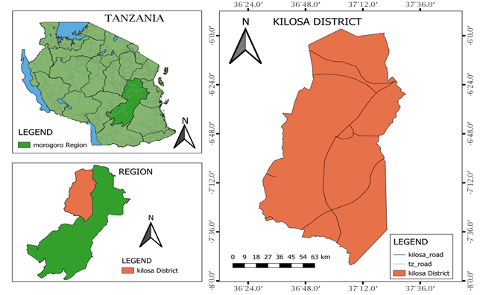

Figure 1: Maps illustrating Tanzania, Morogoro Region, and Kilosa District.

* 1. **Calibration and Validation of GCM models**

Based on the area coverage of the district (14,918 km2), 35 grids were generated, each covering an area of 500 km2. The choice of such a large number of grids was driven by the geographical significance of the precipitation pattern of the study area, which varies geographically and seasonally (Biasutti, 2019). In contrast, the analysis of temperature adopted only nine grids . This decision was informed by the understanding that temperature is influenced by global factors rather than localized geography (Erb *et al.,* 2017). These grids were used as representative rainfall stations for data gathering.

The precipitation data used were downloaded from the CHIRPS dataset (1981-2005) while temperature from the ERA5 Ag (1981-2005) dataset, both as an alternative to observed data as recommended by Solomon *et al.,* (2017).

The historical/baseline data of the district, and large-scale climatic variables from the NCEP (National Centers for Environmental Prediction) reanalysis data, were used as predictands and predictors, respectively (Liu *et al.,* 2021). Using the multilinear regressions model and stochastic bias correction techniques, the Statistical Downscaling Method (SDSM) calibrated the models by establishing the relationships between the predictands and predictors (Baghanam *et al.,* 2024).

The calibrated models then reprojected the baseline/historical data to validate their performance (Figure 2) (Mendez *et al.,* 2020). The outputs were compared with the existing historical data from some of the grids. The SDSM incorporated multiple model evaluation techniques, including statistical and graphical methods, to assess the performance of the calibrated models in reproducing the observed data (San *et al.,* 2023). Different formulas have been used for the statistical analysis (Equation i, ii and iii).

$CC=\frac{\sum_{i=1}^{N}{\left(P_{i}-P\right).(O_{i}-O)}}{\sqrt{\sum_{i=1}^{N}{{(P_{i}-P)}^{2}}}.\sqrt{\sum_{i=1}^{N}{(O_{I}-O)^{2}}}}$.....................................................................i

.......................................................................................ii

................................................................................iii

* 1. **Precipitation and Temperature**

The assessment was conducted for the baseline (1981-2005) period and projected climate scenarios (2011-35) (Faggian, 2021). The two scenarios were utilized for the projected period which are Representative Concentration Pathway (RCP 4.5) as a moderately optimistic, and Representative Concentration Pathway (RCP 8.5), which assumes no mitigation (Lee *et al.,* 2024). Using the Q-GIS package, the Inverse Distance Weighting (IDW) interpolation method was used to convert the point data to area data for the baseline period and projected period, into spatial representations in the forms of suitability maps.

* 1. **Physical land features, Land use/cover and River proximity**

**2.4.1 Soil properties**

Key soil properties crucial for land suitability evaluation for surface irrigation included texture, drainage, and soil depth (Hagos *et al*., 2022). In the study area, these properties were analyzed and classified into four suitability categories: highly suitable, moderately suitable, marginally suitable, and not suitable.

**2.4.2 Topographic factors**

Slopes and altitudes played a critical role in determining land suitability for surface irrigation (Girma *et al.,* 2020). Utilizing a 30-meter resolution Digital Elevation Model (DEM) from the freely accessible Shuttle Radar Topography Mission (SRTM), slope and altitude data were reclassified using the QGIS software. Slopes were categorized into four groups: 0–2%, 2–5%, 5–8%, and >8% as per FAO, 1993). Similarly, altitudes were divided into four classes: 0–1000 m, 1000–2000 m, 2000–3000 m, and above 3000 m, as shown in Table 2.

**2.4.3 Land use/cover (LU/LC)**

The 2023 Land Use/Land Cover (LULC) assessment for Kilosa district was assessed using the QGIS package. The study area was classified into ten categories: cultivated land, grassland, bushland, natural forest, plantation forest, woodland, permanent swamp, urban areas, water bodies, and bare soil. Based on land suitability evaluation for surface irrigation, the district was then grouped into four classes: highly suitable (S1), moderately suitable (S2), marginally suitable (S3), and not suitable (N) (Mazahreh *et al.,* 2019).

**2.4.4 River proximity**

Proximity to water sources was a crucial criterion in assessing land suitability for surface irrigation in the study area (Balew *et al.,* 2021). The river proximity was analyzed and categorized into four groups using QGIS, as detailed in Table 2.

* 1. **Overall Land Suitability**

The land suitability assessment method involved assigning ratings from highly suitable to not suitable based on how well the land's characteristics met the requirements of surface irrigation practice (FAO, 1976). Surface irrigation land suitability maps categorized areas into four classes: highly suitable (S1), moderately suitable (S2), marginally suitable (S3), and not suitable (N) (Yao *et al.,* 2021), as shown in Table 1. The overall conceptual methodology adopted in this study is illustrated in Figure 2, while Table 2 outlines the weights assigned to each contributing parameter and its respective classes.

**Table 1:** Land suitability classification (FAO, 1976)

|  |  |
| --- | --- |
| **Class Suitability** | **Description** |
| S1 Highly suitable | Land without any major limitations |
| S2 Moderately suitable | Moderate limitations that reduce productivity, or increase the required inputs |
| S3 Marginally suitable | Significant limitations, making land use only marginally justifiable. |
| N Not suitable | Limitations that cannot currently be overcome with existing knowledge at an acceptable cost. |

**Table 2:** Suitability criteria established for the studied parameters.

|  |  |  |  |  |  |  |
| --- | --- | --- | --- | --- | --- | --- |
| **Main factor** | **Sub factor** | **Factor rating** | | | | **Source** |
| S1 | S2 | S3 | N |
| Topography | Slope (%) | 0-2 | 2-5 | 5-8 | >8 | FAO, (1984) |
| Altitude (m) | 2000-3000 | 1500-2000 or | 3300-3800 | <1500 or >3800 | FAO, (1984) |
| 3000-3300 |
| Soil | Drainage class | Well | Moderately well | Imperfectly | Poor | Adem, A. F., & Danbara, J. H. (2022) |
| Depth (cm) | >100 (Very deep) | 50-100 (Moderately deep) | 10-50 (Shallow) | <10 (Very shallow) | Mandal et al. 2018 |
| Texture | Loam, Clay-Loam | Clay, Sand-Clay-Loam | Sand-Loam | N/A | Kilosa DC (2020). |
| Distance from water source | Euclidian distance (m) | 1000 | 1000-3000 | 3000-5000 | >5000 | Han *et al.,* 2021. |
| LU/LC | LU/LC | Cultivated land | Grassland | Bushland | Constraints (Forest, Build-up, water, ponds) | Barman, J., & Das, P. (2023) |
| Precipitation | Precipitation (mm) | 1200 | 800-1200 | 600-800 | <600 | Angelakιs *et al.,* (2020). |
| Temperature | Temperature (0C) | <20 | 20-23 | 23-25 | >25 | NIMP, (2018) |

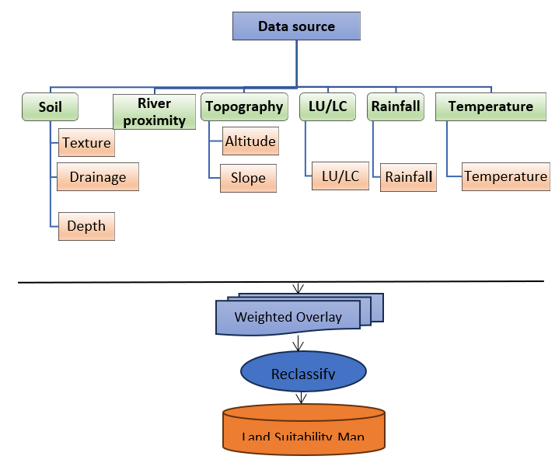

**Figure 2:** The Overall conceptual framework utilized in the study.

The Analytical Hierarchy Process (AHP) assigned weights to each contributing criterion. AHP was used to identify and classify criteria for assessing spatial planning decisions (Aidinidou *et al*., 2023). The three key principles which are decomposition, comparative judgment, and synthesis of priorities were used to guide the method (Gyani *et al.*, 2022). A pairwise comparison matrix was constructed for the parameters influencing land suitability in relation to surface irrigation. The scale from 1 to 9 was applied to indicate the relative importance of the two factors. The prioritization of the factors in the study area was informed by Tanzania's experiences as recommended by NIMP (2018). Reciprocal values ranging from 1/1 to 1/9 represented the relative significance between the criteria (Table 3). Criteria weights were determined by calculating eigenvalues through pairwise comparisons and then normalizing the results (Odu, 2019). The consistency ratio (CR) was calculated using the random consistency indices (RI) established by Saaty (1980) to assess the consistency of the pairwise comparisons (Table 4).

**Table 3**: Saaty’s scale in AHP (Saaty 1980)

|  |  |  |
| --- | --- | --- |
| **Definition** | **Index** | **Definition Index** |
| Equally important | 1 | Equally important 1/1 |
| Equally or slightly more important | 2 | Equally or slightly less important 1/2 |
| Moderately/Slightly more important | 3 | Moderately/Slightly less important: Experience and judgment slightly favor one option over the other (with a ratio of 1/3). |
| Slightly to much more important | 4 | Slightly to weigh less important 1/4 |
| Strongly more important / Much more important | 5 | Way less important: Experience and judgment strongly favor one option over the other. 1/5 |
| Much to far more important | 6 | Way to far less important 1/6 |
| Very much more important/Far more important | 7 | Far less important: Experience and judgment strongly favor one option over the other. 1/7 |
| Far more important to extremely more important | 8 | Far less important to extremely less important 1/8 |
| Absolutely more important / Extremely more important | 9 | Extremely less important: The evidence supporting one option over the other (with a ratio of 1/9) is of the highest possible validity. |

**Table 4:** Values of random index (RI)

|  |  |  |  |  |  |  |  |  |  |  |
| --- | --- | --- | --- | --- | --- | --- | --- | --- | --- | --- |
| n | 1 | 2 | 3 | 4 | 5 | 6 | 7 | 8 | 9 | 10 |
| RI | 0.00 | 0.00 | 0.58 | 0.90 | 1.12 | 1.24 | 1.32 | 1.41 | 1.45 | 1.49 |

The consistency index (CI) was calculated using the formula provided below.

$CI=\frac{λ_{max}-n}{n-1}$……………………………………………………iv

Where λmax is the largest eigenvalue of the pairwise comparison matrix and n is the number of classes.

The consistency ratio is defined as

$CR=\frac{CI}{RI}$………………………………………………………v

where RI is ratio index/average value of CI for random matrices using Saaty scale.

The consistency index (CI) (equation i) was compared to a random index (RI) (Table 4) to assess the reliability of the pairwise comparisons (Pant, 2022). The RI reflected the average CI of randomly generated reciprocal matrices using a scale from 1/9 to 9/1 (Peláez *et al.,* 2018). Saaty (1980) generated random matrices of varying sizes (n) and calculated their mean CI values (Table 4). For matrices with n≥5, a consistency ratio (CR) of lower than 0.1 was accepted, indicating a reasonable level of consistency (Saaty, 1979). To evaluate overall land suitability spatially, the QGIS weighted overlay analysis tool (Figure 2) was employed, generating a suitability map by combining the outputs from AHP (Salifu *et al.,* 2022).

1. **RESULTS** 
   1. **Calibration and Validation of GCM models**

The outcome for validation were produced in graphical and statistical (Figure 3 and Table 5).

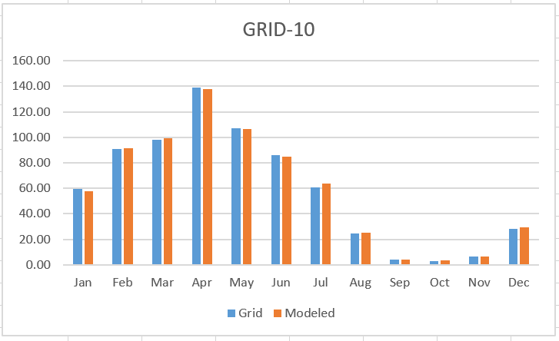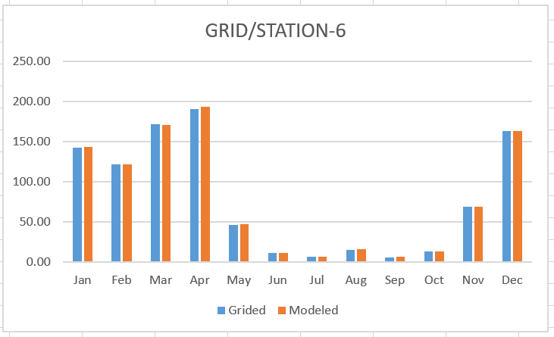

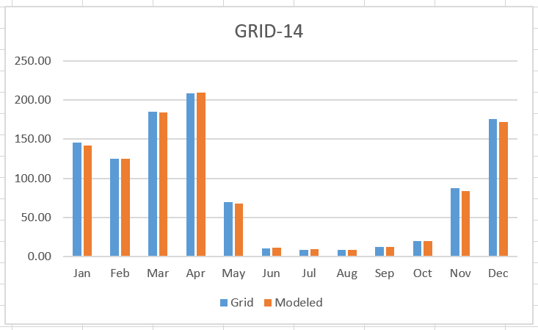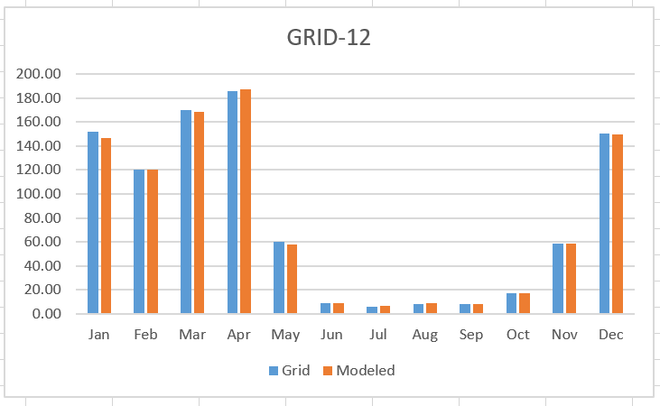

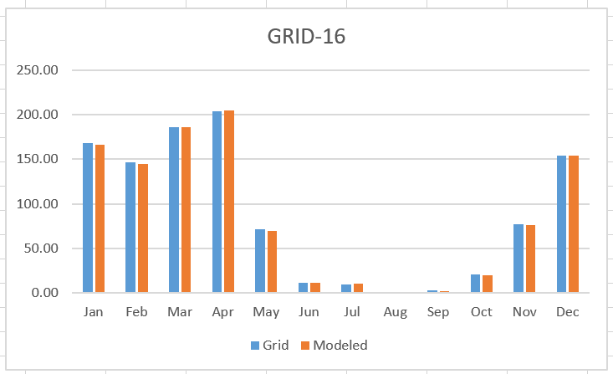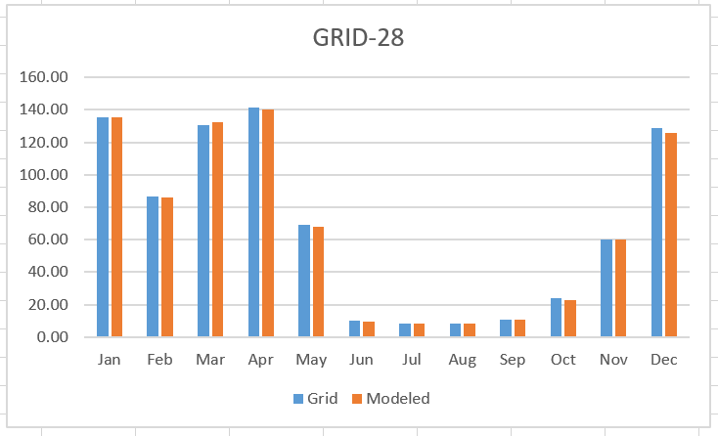

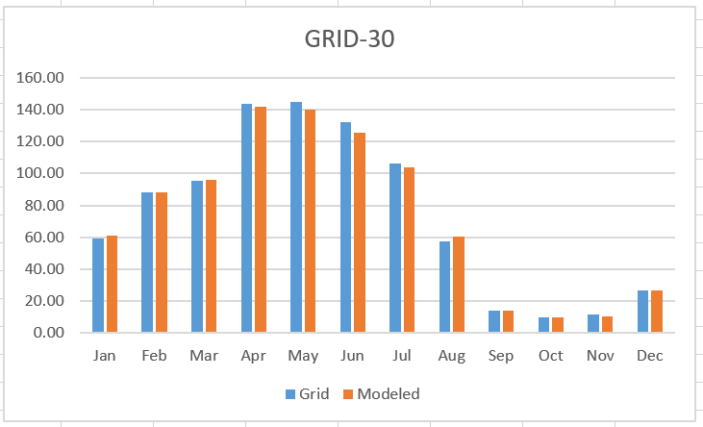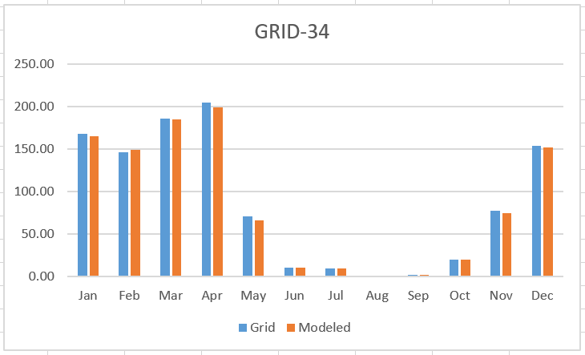

**Figure 3:** The performance of the models by comparing the modeled results to the observed (grid) monthly precipitation using the graph method.

**Table 5**: The performance of the models by comparing the modeled results to the observed (grid) monthly precipitation and temperature using the statistical method

|  |  |  |  |  |  |  |  |  |  |
| --- | --- | --- | --- | --- | --- | --- | --- | --- | --- |
| PRECIPITATION | 6 | 10 | 12 | 14 | 16 | 28 | 30 | 32 | 34 |
| MAE | 0.72 | 0.74 | 0.69 | 0.77 | 0.73 | 0.74 | 0.79 | 0.71 | 0.71 |
| RMSE | 1.16 | 1.23 | 1.03 | 1.11 | 1.03 | 1.18 | 1.12 | 1.01 | 1.04 |
| CC | 1.00 | 1.00 | 1.00 | 1.00 | 1.00 | 1.00 | 1.00 | 1.00 | 1.00 |

|  |  |  |  |  |  |  |  |  |  |
| --- | --- | --- | --- | --- | --- | --- | --- | --- | --- |
| TEMPERATURE | 6 | 10 | 12 | 14 | 16 | 28 | 30 | 32 | 34 |
| MAE | 0.00 | 0.00 | 0.00 | 0.00 | 0.00 | 0.00 | 0.00 | 0.01 | 0.01 |
| RMSE | 0.00 | 0.00 | 0.01 | 0.01 | 0.01 | 0.01 | 0.01 | 0.01 | 0.01 |
| CC | 1.00 | 1.00 | 1.00 | 1.00 | 1.00 | 1.00 | 1.00 | 1.00 | 1.00 |

* 1. **Precipitation and Temperature**

The analysis of average annual rainfall revealed that the study area was predominantly characterized by moderately suitable. During the baseline period, it covered 1,320,988.90(88.55%) hectares (Table 6). Under the RCP 4.5 scenario, this area slightly decreased to 1,258,930.02(84.39%) hectares, and further declined to 1,229,094.02(82.39%) hectares, under the more extreme RCP 8.5 scenario.

Highly suitable areas were observed only during the baseline period, covering 50,721.20(3.40%) hectares (Table 6).

In contrast, marginally suitable areas accounted for 120,089.90(8.05%) hectares during the baseline period (Table 6). The area increased significantly to 230,930.64(15.48%) hectares under RCP 4.5 and 260,617.46(17.47%) hectares under RCP 8.5.

Finally, the areas classified as not suitable were only observed under RCP 4.5 as 1,939.34 (0.13%) hectares and remained unchanged at 2,088.52(0.14%) hectares under RCP 8.5.

Temperature analysis showed the area was dominated by moderately suitable. During the baseline period, covering 1,013,976.46(67.97%) hectares (Table 6), under scenario RCP 4.5, the analysis indicated that 998,610.92(66.94%) hectares, while under scenario RCP 8.5, the analysis indicated that 995,925.68(66.76%) hectares. Under marginal suitable, the baseline presented 300,597.70(20.15%) hectares (Table 6), under scenario RCP 4.5 indicated 181,999.6(19.20%) hectares, while under scenario RCP 8.5 indicated 289,260.02(19.39%) hectares. Where the remaining area was assigned under highly suitable for surface irrigation, During the baseline period the area indicated 177,225.84(11.88%) hectares (Table 6), under scenario RCP 4.5 was 206,763.48(13.86%) hectares, while under scenario RCP 8.5 was 206,614.30(13.85%) hectares.

* 1. **Physical land features****, Land use/cover and River proximity**

The study also highlighted other critical factors influencing land suitability in relation to surface irrigation. The highly suitable areas of the district were characterized by loam and clay-loam soils, excellent drainage, deep soil profiles, proximity to water sources within 1000 meters, gentle slopes below 2%, and altitudes of 2000–3000 meters (Table 6). Moderately suitable regions, including areas with sand-loam or sand-clay-loam soils, imperfect drainage, moderate slopes (2–5%), altitudes of 1500–2000 meters, and distances of 1000–3000 meters from water sources (Table 6). Marginally suitable areas faced greater constraints, such as poor drainage, shallow soils, steep slopes (5–8%), lower altitudes below 1500 meters, and distances of 3000–5000 meters from water sources (Table 6). Not suitable regions, including those with very poor drainage, excessive slopes, distances beyond 5000 meters from water sources, and conflicting land uses like urbanization (Table 6).

* 1. **Overall Suitability/Weighting of factors using AHP**

The overall spatial suitability for surface irrigation based on overlaid individual factors for the baseline period indicated that 242,119.14 (16.23%) hectares of the study area were potentially highly suitable, 553,905.34(37.13%) hectares were moderately suitable, 652,214.96(43.72%) hectares was marginal suitable, whereas 43,560.56(2.92 %) of the district was accounted for not suitable (Figure 4a, Table 7).

Under the RCP 4.5 scenario, the suitability analysis for surface irrigation in the study area revealed significant changes compared to the baseline period. The highly suitable area decreased to 223,173.28(14.96%) hectares, a reduction of 1.27%. The moderately suitable area also decreased to 450,076.06(30.17%) hectares, a decline of 6.96%. Conversely, the marginally suitable area increased to 754,701.62(50.59%) hectares, a rise of 6.87%, and the area not suitable for surface irrigation increased to 63,849.04(4.28%) hectares, a rise of 1.36% (Figure 4b, Table 7).

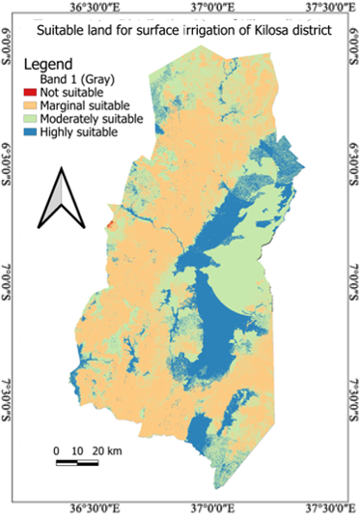 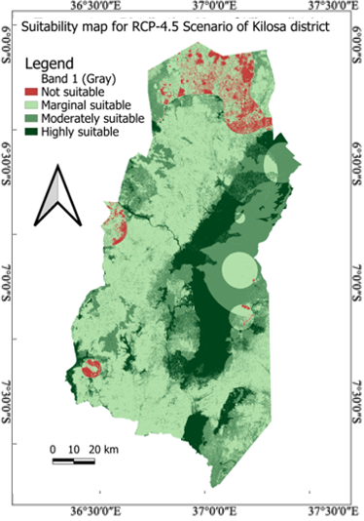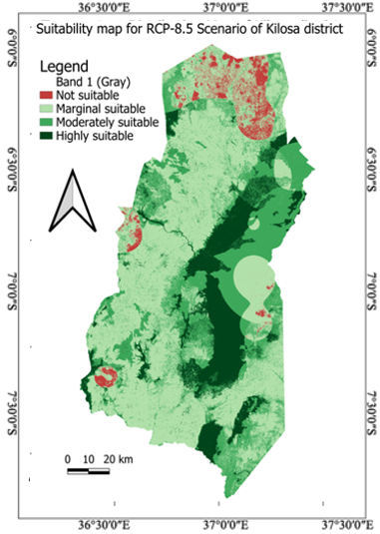

**Figure 4(a)**: Overall baseline suitability map **(b)** RCP-4.5 scenario map **(c)** RCP-8.5 scenario map

Under the RCP 8.5 scenario, the suitability analysis for surface irrigation in the study area also revealed significant changes compared to the baseline period. The highly suitable area decreased to 201,393.00(13.50%) hectares, a reduction of 2.73%. The moderately suitable area also decreased to 448,733.44(30.08%) hectares, a decline of 7.05%. Conversely, the marginally suitable area increased to 760,370.46(50.97%) hectares, a rise of 7.25%, and the area not suitable increased to 81,303.10(5.45%) hectares, a rise of 2.53%. These results indicate a shift in suitability, with a notable increase in both marginally suitable and unsuitable areas (Figure 4c, Table 7).

1. **DISCUSSION**

In determining the performance level of the GCM model based on Mean Absolute Error (MAE) and Root Mean Squared Error (RMSE), the level of predictive accuracy of performance was good. The MAE, which varied from 0.69 to 0.79, showed that the model predictions were slightly different from actual values. Likewise, the RMSE, which varied from 1.01 to 1.23, showed significant error, supporting the validity of the model. The Pearson Correlation Coefficient (CC) of 1.0, as anticipated, reflected a linear correlation between the observed and predicted values, validating the strength of the model. The findings concur with Pham et al. (2020), whose high accuracy also resulted when predictive models were used in comparative hydrological and climatic evaluations.

Land suitability analysis for surface irrigation under a changing climate was extremely spatially variable. Nine most important factors (temperature, rainfall, soil type, slope, drainage, land use/cover, distance from rivers, altitude, and topography) were utilized to compute suitability by the application of a weighted approach. The findings revealed that the eastern region of Kilosa district was the most suitable place for surface irrigation. The climatic conditions of the area, such as high precipitation and proximity to large water bodies (Mkondoa and Wami rivers), played a major role in enhancing its irrigation potential. These are in line with earlier research in East Africa by Gebrechorkos *et al.* (2019b), which had similar factors among the main determinants of irrigation suitability.

But, future projected climates (RCP 4.5 and RCP 8.5) showed a reduction in highly suitable regions, which means that climate change is increasingly eroding irrigation potential. Both scenarios showed a significant reduction in highly and moderately suitable regions and increasing marginally suitable and unsuitable regions. This change was most experienced in the western and northern regions of the district, where the hilly landscapes, drainage, and additional distances from the water sources lowered the potential for irrigation. Rubeho and Ukaguru mountains, with their rough lands and poorly drained soils, progressively became less favorable, driven by decreasing rainfalls and a rise in temperature. These results are consistent with larger scale climate change projections, where enhanced temperature extremes and changed regimes of precipitation are likely to further exacerbate water shortage in semi-arid areas.

Apart from climatic conditions, human activities also impacted land suitability. Land degradation resulting from deforestation within the Ukaguru and Rubeho forest reserves, as a result of charcoal production and agriculture expansion, has caused land degradation and disturbance to local water catchments. Urbanization in fast-growing towns like Gairo, Kilosa, Mikumi, Kimamba, and Dumila has changed land use patterns, indorsed soil erosion and diminished arable land for irrigation. Permanent water bodies expansion and protected forest reserves have also limited the extent of irrigable land. These socio-environmental processes show that climate change is not the only driving factor behind irrigation issues, but that human activities and land use changes also play important roles.

The implications of the findings above highlight the paramount importance of climate-resilient irrigation practices. With climatically stressed locations reducing due to lower suitability, sustainable land and water management practices should be accorded topmost priority. Adaptation measures likewise utilization of water using rainwater harvesting, better irrigation facilities, afforestation and land reclamation to avoid further degradation in marginally suitable locations, and climate-smart agriculture practices like drought-tolerant crops and conservation agriculture to enhance productivity under change.

Overall, the study points out that climatic and human-induced factors together impact land suitability for surface irrigation in Kilosa district. The trends that have been observed emphasize the necessity of integrated management of water resources and forward-looking policy measures for ensuring the sustainability of irrigation agriculture under changing climatic scenarios.

**Table 7:** Overall suitability class for-Kilosa district

|  |  |  |  |  |  |
| --- | --- | --- | --- | --- | --- |
| Main Factor | Suitability | Description | Percentage (%) | Area (ha) | Variability (%) |
| Baseline | S1 | Highly Suitable | 16.23 | 242,119.14 | 0 |
| S2 | Moderately Suitable | 37.13 | 553,905.34 | 0 |
| S3 | Marginal Suitable | 43.72 | 652,214.96 | 0 |
| N | Not Suitable | 2.92 | 43,560.56 | 0 |
| RCP 4.5 | S1 | Highly Suitable | 14.96 | 223,173.28 | 1.27 |
| S2 | Moderately Suitable | 30.17 | 450,076.06 | 6.96 |
| S3 | Marginal Suitable | 50.59 | 754,701.62 | -6.87 |
| N | Not Suitable | 4.28 | 63,849.04 | -1.36 |
| RCP 8.5 | S1 | Highly Suitable | 13.5 | 201,393.00 | -2.73 |
| S2 | Moderately Suitable | 30.08 | 448,733.44 | -7.05 |
| S3 | Marginal Suitable | 50.97 | 760,370.46 | 7.25 |
| N | Not Suitable | 5.45 | 81,303.10 | 2.53 |

**Table 6;** Results of individual factors which influence the efficient surface irrigation land suitability.

|  |  |  |  |  |  |  |
| --- | --- | --- | --- | --- | --- | --- |
| Main factor | Criteria | Classes | Suitability | Area coverage (%) | Global weight (%) | Area coverage (ha) |
| Topography | Slope (%) | 0-2 | S1 | 40.67 | 24.86 | 606,715.06 |
| 2-5 | S2 | 13.34 | 199,006.12 |
| 5-8 | S3 | 24.56 | 366,386.08 |
| >8 | N | 21.43 | 319,692.74 |
| Altitude (m) | 2000-3000 | S1 | 73.14 | 14.65 | 1,091,102.52 |
| 1500-2000 | S2 | 17.11 | 255,246.98 |
| <1500 | N | 9.75 | 145,450.50 |
| Soil | Drainage | Somewhat excessive, well | S1 | 74.67 | 11.93 | 1,113,927.06 |
| Imperfect, moderately well | S2 | 4.91 | 73,247.38 |
| Poor | S3 | 13.23 | 197,365.14 |
| Very poor | N | 7.19 | 107,260.42 |
| Depth (cm) | >100 | S1 | 23.87 | 10.41 | 356,092.66 |
| 75-100 | S2 | 76.13 | 1,135,707.34 |
| Texture | Clay, sandy-clay-loam | S1 | 68.34 | 9.16 | 1,019,496.12 |
| Loam, clay-loam | S2 | 22.60 | 337,146.80 |
| sand-loam | S3 | 9.06 | 135,157.08 |
| Distance from water | Euclidian distance (m) | 0-1000 | S1 | 17.19 | 2.88 | 256,440.42 |
| 1000-3000 | S2 | 0.73 | 10,890.14 |
| 3000-5000 | S3 | 15.07 | 224,814.26 |
| >5000 | N | 67.01 | 999,655.18 |
| Land user/cover  (LU/LC) | Land user/cover  (LU/LC) | Cultivated land | S1 | 9.59 | 3.39 | 143,063.62 |
| Grassland | S2 | 20.19 | 301,194.42 |
| Bushland | S3 | 10.84 | 161,711.12 |
| Forest land, Pond, Buildings | N | 59.38 | 885,830.84 |
| Precipitation | Precipitation (mm) | >1200 | S1 | 3.4 | 19.68 | 50,721.20 |
| 800-1200 | S2 | 88.55 | 1,320,988.90 |
| 600-800 | S3 | 8.05 | 120,089.90 |
| Temperature | Temperature (0C) | 0-20 | S1 | 11.88 | 3.03 | 177,225.84 |
| 20-23 | S2 | 67.97 | 1,013,976.46 |
| 23-25 | S3 | 20.15 | 300,597.70 |

1. **CONCLUSIONS**

Comprehending the climate factors variability specifically precipitation and temperature is essential in determining the impact of climate change on land suitability for surface irrigation. This is essential in irrigation planning for areas that facing erratic rainfall like Kilosa district in Morogoro Tanzania. The findings revealed a significant variation influenced by different climate scenarios. During the baseline period, about 796,024.48(53.36%) hectares of the area were recommended for surface irrigation while the remaining 695,775.52(46.64%) hectares of the area were not recommended. Under the mitigation scenario RCP 4.5 (2011-2035), the recommended area was reduced to 673,249.34(45.13%) hectares while the area which was not recommended was increased to 818,550.66(54.87%) hectares. In the business-as-usual scenario RCP 8.5 (2011-2035), the recommended area was reduced to 650,126.44(43.58%) hectares while the area which was not recommended was increased to 841,673.56(56.42%) hectares. These assessments revealed that precipitation and temperature variability significantly affected the suitability of land for surface irrigation.

**COMPETING INTERESTS DISCLAIMER:**

Authors have declared that they have no known competing financial interests OR non-financial interests OR personal relationships that could have appeared to influence the work reported in this paper.

**REFERENCES**

1. Adem, A. F., & Danbara, J. H. (2022). "Land Suitability Mapping for Surface Irrigation Using GIS-Based Techniques in Ethiopia." Water Resources Management, 36(2), 101-123. DOI: 10.1007/s11269-022-03177-3.
2. Baghanam, A. H., Nourani, V., Bejani, M., Pourali, H., Kantoush, S. A., & Zhang, Y. (2024). A systematic review of predictor screening methods for downscaling of numerical climate models. Earth-Science Reviews, 104773.
3. Bandh, S. A., Shafi, S., Peerzada, M., Rehman, T., Bashir, S., Wani, S. A., & Dar, R. (2021). Multidimensional analysis of global climate change: a review. Environmental Science and Pollution Research, 28(20), 24872-24888.
4. Barman, J., & Das, P. (2023). A multi-criteria decision-making approach for land suitability assessment for tea cultivation in Hilly Aizawl district in Mizoram, India. In Advancement of GI-Science and Sustainable Agriculture: A Multi-dimensional Approach (pp. 135-147). Cham: Springer Nature Switzerland.
5. Biasutti, M. (2019). Rainfall trends in the African Sahel: Characteristics, processes, and causes. Wiley Interdisciplinary Reviews: Climate Change, 10(4), e591.
6. Erb, K. H., Luyssaert, S., Meyfroidt, P., Pongratz, J., Don, A., Kloster, S., & Dolman, A. J. (2017). Land management: data availability and process understanding for global change studies. *Global Change Biology,* 23(2), 512-533.
7. Faggian, P. (2021). Future precipitation scenarios over Italy. Water, 13(10), 1335.
8. Food and Agriculture Organization (FAO). (1976). A framework for land evaluation. FAO Soils Bulletin, 32.
9. Food and Agriculture Organization (FAO). (1984). *Agroclimatological data for Africa*. Food and Agriculture Organization of the United Nations, Rome.
10. Food and Agriculture Organization (FAO). (1993). Land evaluation for irrigated agriculture: FAO Soils Bulletin 55. Food and Agriculture Organization of the United Nations.
11. Gebrechorkos, S. H., Hülsmann, S., & Bernhofer, C. (2019). Statistical downscaling of climate projections in East Africa: Assessing their performance and implications for climate change adaptation. Climate Dynamics, 52(3-4), 1513–1535.
12. Gwambene, B., Liwenga, E., & Mung’ong’o, C. (2023). Climate change and variability impacts on agricultural production and food security for the smallholder farmers in Rungwe, Tanzania. *Environmental Management,* 71(1), 3-14.
13. Gyani, J., Ahmed, A., & Haq, M. A. (2022). MCDM and various prioritization methods in AHP for CSS: A comprehensive review. IEEE Access, 10, 33492-33511.
14. Hagos, Y. G., Mengie, M. A., Andualem, T. G., Yibeltal, M., Linh, N. T. T., Tenagashaw, D. Y., & Hewa, G. (2022). Land suitability assessment for surface irrigation development at Ethiopian highlands using geospatial technology. Applied Water Science, 12(5), 98.
15. Han, C., Chen, S., Yu, Y., Xu, Z., Zhu, B., Xu, X., & Wang, Z. (2021). Evaluation of agricultural land suitability based on RS, AHP, and MEA: A case study in Jilin Province, China. Agriculture, 11(4), 370.
16. Hatfield, J. L., Antle, J., Garrett, K. A., Izaurralde, R. C., Mader, T., Marshall, E., ... & Ziska, L. (2020). Indicators of climate change in agricultural systems. Climatic Change, 163, 1719-1732.
17. John, I., & Manyong, V. (2019). Building Livelihoods: Young People and Agricultural Commercialisation. Tanzania Country Study. APRA Working Paper, 24.
18. John, M. (2024). Climate Change, Food Insecurity, Peace and Sustainable Development in East Africa: Case Study of South Sudan, Sudan, Ethiopia and Kenya. In Climate Change and Socio-political Violence in Sub-Saharan Africa in the Anthropocene: Perspectives from Peace Ecology and Sustainable Development (pp. 141-165). Cham: Springer Nature Switzerland.
19. Kilosa District Council, Agricultural Development Plan Report, Morogoro, Tanzania, 2020
20. Kitasho, N., Abdallah, J. M., & Zakayo, R. (2020). Adaptive capacity to climate change of pastoralists in Kilosa District, Tanzania. *Tanzania Journal of Forestry and Nature Conservation,*89(1), 25-46.
21. Konapala, G., Mishra, A. K., Wada, Y., & Mann, M. E. (2020). Climate change will affect global water availability through compounding changes in seasonal precipitation and evaporation. Nature communications, 11(1), 3044.
22. Lee, M., Stock, C. A., Shevliakova, E., Malyshev, S., Beaudor, M., & Vuichard, N. (2024). Uneven consequences of global climate mitigation pathways on regional water quality in the 21st century. Nature Communications, 15(1), 5464.
23. Liu, L., Gu, H., Xie, J., & Xu, Y. P. (2021). How well do the ERA Interim, ERA 5, GLDAS 2.1 and NCEP R2 reanalysis datasets represent daily air temperature over the Tibetan Plateau? International Journal of Climatology, 41(2), 1484-1505.
24. Liwenga, E. T., & Silangwa, F. (2020). Natural resource use conflicts in a changing climate: The case of the wetlands of Kilombero and Kilosa districts in Tanzania. In Climate change impacts and sustainability: ecosystems of Tanzania (pp. 153-168). Wallingford UK: CABI.
25. Luanda, H. S. (2020). The impact of land use conflicts on agricultural production; A case study of Kilosa District Morogoro Region (Doctoral dissertation, The Open University of Tanzania).
26. Luhunga, P., Botai, J., & Kahimba, F. (2016). Evaluation of the performance of CORDEX regional climate models in simulating present climate conditions of Tanzania. Journal of Southern Hemisphere Earth Systems Science, 66(1), 32-54.
27. Mandal, D., Majumdar, K., & Singh, S. K. (2018). "Evaluation of Land Suitability for Surface Irrigation Based on Soil Depth and Other Physical Parameters." Agricultural Water Management, 202(4), 94-104. DOI: 10.1016/j.agwat.2018.02.013.
28. Mendez, M., Maathuis, B., Hein-Griggs, D., & Alvarado-Gamboa, L. F. (2020). Performance evaluation of bias correction methods for climate change monthly precipitation projections over Costa Rica. *Water,* 12(2), 482.
29. Mkubya, R. W., Damas, P., & Mahoo, H. F. (2023). Socio-Economic Factors Influencing the Adoption of SRI among Smallholder Rice Irrigation Farmers in Morogoro Region, Tanzania. *Tanzania Journal of Agricultural Sciences,* 22(1), 169-183.
30. Mpogole, H., Dimoso, P., & Mayaya, H. (2020). Agriculture for Rural Development in Tanzania. TEMA Publishers Co. Limited, Dar es Salaam.
31. National Irrigation Master Plan (NIMP). (2018). Ministry of Water and Irrigation, Tanzania.
32. Nhemachena, C., Nhamo, L., Matchaya, G., Nhemachena, C. R., Muchara, B., Karuaihe, S. T., & Mpandeli, S. (2020). Climate change impacts on water and agriculture sectors in Southern Africa: Threats and opportunities for sustainable development. Water, 12(10), 2673.
33. Oates, N., Mossello, B., & Jobbins, G. (2017). Pathways for irrigation development: policies and irrigation performance in Tanzania.
34. Pham, B. T., Le, L. M., Le, T. T., Bui, K. T. T., Le, V. M., Ly, H. B., & Prakash, I. (2020). Development of advanced artificial intelligence models for daily rainfall prediction. *Atmospheric Research,* 237, 104845.
35. Pickson, R. B., & Boateng, E. (2022). Climate change: a friend or foe to food security in Africa? Environment, Development and Sustainability, 1-26.
36. Quail, S. E. (2020). Climate Smart Agriculture to Constrain Deforestation, Land-Cover Change Modeling, and Leakage: Analyzing Tradeoffs and Synergies at a REDD+ Pilot Project in Kilosa District, Tanzania (Doctoral dissertation, University of Florida).
37. Quail, S. E. (2020). Climate Smart Agriculture to Constrain Deforestation, Land-Cover Change Modeling, and Leakage: Analyzing Tradeoffs and Synergies at a REDD+ Pilot Project in Kilosa District, Tanzania (Doctoral dissertation, University of Florida).
38. Saaty, T. L. (1979). Fundamentals of decision making and priority theory with the analytic hierarchy process. RWS Publications.
39. Saaty, T. L. (1980). The Analytic Hierarchy Process: Planning, Priority Setting, Resource Allocation (Vol. 2). McGraw-Hill.
40. Şan, M., Nacar, S., Kankal, M., & Bayram, A. (2023). Daily precipitation performances of regression-based statistical downscaling models in a basin with mountain and semi-arid climates. Stochastic Environmental Research and Risk Assessment, 37(4), 1431-1455.
41. Solomon, H., Flores, A., Herold, N., & Nikulin, G. (2017). Assessment of Climate Data Sources for Land Use and Environmental Studies in East Africa. *Environmental Modelling & Assessment,* 22(1), 61-74.
42. Thornton, P. K., Ericksen, P. J., Herrero, M., & Challinor, A. J. (2014). Climate variability and vulnerability to climate change: a review. Global change biology, 20(11), 3313-3328.
43. Uisso, A. M., & Tanrıvermiş, H. (2021). Driving factors and assessment of changes in the use of arable land in Tanzania. *Land Use Policy*, *104*, 105359.
44. Wilson, E., McInnes, R., Mbaga, D. P., & Ouedraogo, P. (2017). Kilombero Valley, United Republic of Tanzania. Ramsar Site, (1173).
45. Wineman, A., Jayne, T. S., Isinika Modamba, E., & Kray, H. (2020). The changing face of agriculture in Tanzania: Indicators of transformation. *Development Policy Review*, 38(6), 685-709.
46. Worqlul, A. W., Dile, Y. T., Jeong, J., Adimassu, Z., Lefore, N., Gerik, T., & Clarke, N. (2019). Effect of climate change on land suitability for surface irrigation and irrigation potential of the shallow groundwater in Ghana. *Computers and electronics in agriculture*, 157, 110-125.
47. Yao, M., Shao, D., Lv, C., An, R., Gu, W., & Zhou, C. (2021). Evaluation of arable land suitability based on the suitability function-A case study of the Qinghai-Tibet Plateau. *Science of the Total Environment,* 787, 147414.