**Assessment of Precipitation and Temperature trends in Kilosa district, Morogoro-Tanzania**

**Abstract**

Global climate change presents challenges in characterizing regional impacts, particularly on rainfall patterns, crucial for socio-economic activities like agriculture in vulnerable regions such as Africa. Sub-Saharan Africa, with its erratic rainfall, limited data, and reliance on agriculture, faces significant climate-related challenges, particularly drought. Understanding rainfall characteristics is vital for water resources management particularly agriculture, prompting the study of precipitation and temperature trends in Kilosa District, Tanzania. Using CHIRPS precipitation data and ERA 5 Ag-9.6 km temperature data from 1981 to 2022, this study analysed annual and seasonal trends. The Mann-Kendall test was employed to assess statistical significance. The findings show an increasing trend in annual precipitation, with wet years exceeding 900 mm/year and dry years dropping below 400 mm/year. While the dry season exhibits mixed trends, the wet season consistently shows increasing trends, albeit with variations across grids. Spatial analysis indicates a clear spatial distribution of precipitation patterns. Temperature trends reveal a consistent upward trajectory in mean, maximum, and minimum temperatures. Annual mean temperatures rise by 0.017°C per year, with December recording the highest (17.94°C) and July the lowest (13.43°C) temperatures. All grids/stations exhibit significant increases in both wet and dry season temperatures. Spatially, areas near urban centers experience the most significant temperature rise, while higher elevations witness slight decreases. These findings underscore the importance of comprehending local climate variations for effective water resource and agricultural management. Future research should focus on the impacts of these trends on surface irrigation, water availability, agricultural productivity, and ecosystem health, especially in the context of growing urbanization and environmental degradation. Efforts to mitigate climate change impacts should prioritize sustainable land use and water management practices in vulnerable district areas like Kilosa.

**Key words**: Rainfall Variability, Rainfall characteristics, Trend analysis, Water resources management.

1. **Introduction**

Global climate change is a visible and identifiable phenomenon, but its presence at regional and local scales, especially in precipitation records, is difficult to characterise because of the high variability (IPCC, 2007b). The fourth Intergovernmental Panel on Climate Change (IPCC) assessment report provides compelling evidence that the global climate has changed significantly over the last century (Solomon et al., 2007). Africa is considered to be particularly vulnerable to climate change, mainly due to its dependence on climate, and in particular rainfall, for various socio-economic activities, particularly agriculture (FAO, 2004). Several studies have been conducted worldwide and in Sub-Saharan Africa, specifically Tanzania (Kulyakwave et al., 2023) to understand this effect. The majority of investigations, however, have focused on a general perspective rather than local scale leading to more generalized results. So, for this study, it scaled down to district level as a smallest unit.

Interpretation of variations in meteorological analysis, usually expressed as monthly or seasonal averages, is crucial to understanding the impact on agriculture (Silungwe, *et al.,* 2019a). Understanding changes in rainfall patterns, particularly those affecting planting dates and the growth cycle of crops, is essential for the agricultural sector, which is the main source of income for most regions and local populations (Silungwe *et al*., 2019b). Precipitation and temperature are among the most important climatic variables in hydrology, water management and climate, due to their significant influence on the timing and geography of water availability (Raneesh, 2014). Precipitation is key to the relationship between rainfall and runoff, mitigation strategies and the assessment of floods and droughts, while temperature is important for water availability, respiration and evaporation (Qiu *et al.,* 2021). Long-term variations in rainfall and temperature are essential to understand the impacts of climate change (Jones & Briffa, 2001). Valuable information on past and future changes in climate regimes can be obtained from the assessment of meteorological indicators such as precipitation and temperature (Tošić *et al.,* 2015).

Although the trend towards global warming is clear, precipitation varies from place to place because of its higher geographical and seasonal variability relative to the increase in temperature (Dore, 2005). In hydrological studies, precipitation is an important factor in agriculture, disaster preparedness and water management and plays a key role in resource planning and management (Sivakumar, 2011). Recent emphasis in climate change research has been on regional and temporal precipitation distribution (Trenberth, 2011).

Acquisition of data from rain gauges faces challenges in many areas because of issues related to administration and technology (Silungwe *et al.,* 2019a). Limited rain gauges in many river basins with limited data records make the distribution of observed precipitation for regional and temporal being imprecise (Tapiador *et al.,* 2017). To address these challenges, alternative datasets have been developed in the previous two decades, including GPCP, TMPA, APHRODITE, CSFR, PERSIANN-CDR, ERA5 Ag and CHIRPS (Solomon *et al.,* 2017). Several research efforts have compared these datasets to ground observations to assess their relevance in hydrological researches (Musuuza *et al.,* 2023). The results of comprehensive assessment of several climate data sources for East Africa were used to guide this study on the use of the gridded satellite datasets with higher spatial and temporal resolutions (Gebrechorkos *et al.,* 2018).

The policy of the Government of Tanzania is to shift from rain-fed to irrigated agriculture to improve food security (Patel et al., 2014). The objective is to increase irrigated land from 0.2 million ha in 2004 to 1.0 million ha in 2035 (NIMH, 2018). For effective development planning, understanding long-term trends in climatic factors, especially precipitation and temperature, over the last 25 years is essential. Focusing on the district level, taking 1981-2005 as a reference period will help to simplify the planning strategies up to 2035 as foreseen in the NIMPL.

Kilosa district is confronted with environmental challenges that pose significant implications for the well-being of its residents (Liwenga & Silangwa, 2020). Deforestation, soil erosion, inadequate water management practices, and depletion of natural resources have raised concerns about the sustainability of the district (Mugasha & Katani, 2016). The consequences of these challenges extend beyond the environment, affecting the well-being of the local population and the overall socio-economic fabric of the district. The district experienced variability in seasonal rainfall, resulting in an unreliable water supply for paddy crops. This unreliability stems from a reduction in both rainfall and river water, affecting the effectiveness of surface irrigation systems. Additionally, urbanization in the district has contributed to a rise in temperature (Sumari *et al.,* 2022). Consequently, it is essential to understand the historical climatic trends, particularly those related to precipitation and temperature for the future review of National Irrigation Master Plan (NIMP). Therefore, the goal of the study was to assesses precipitation and temperature trends in Kilosa district. The specific objectives of the study included (1) To validate the climatic datasets (2) To generate gridded climatic data and (3) To analyze precipitation and temperature trends.

1. **Materials and Methods**
   1. **Description of the Study Area**

The study was conducted in Kilosa district due to its potential in paddy cultivation among several districts in Tanzania and its prone to climate change impact. The district is located in Morogoro region in Eastern Tanzania between 36°30'E and 37°30'E easting, and 6°00'S and 7°00'S northing (Figure 1). The altitudes are ranging 300 and 600 meters above sea level and is about 138 kilometers from Morogoro Municipality (Boku, 2014). The main crops grown is paddy by surface irrigation and rain-fed methods.

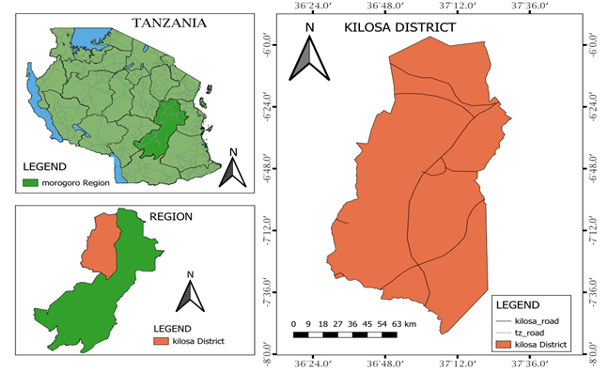

Figure 1: Location of the study area.

The district is one among the six districts of Morogoro Region in Tanzania, covers 14,918 square kilometers and is known for its significance in agriculture, contributing significantly to Tanzania's food production (Boku, 2014). It is characterized by strategic location offering a mix of plains and hills, favoring diverse ecosystems (Kilosa, 2015). The district is categorized by a dry season spanning from May to October with little or no rains while wet season is from November to April, which describe the rainfall regime as unimodal (Wilson & Ouedraogo, 2017). The surface irrigation is enforced by the presence of several Rivers such as Wami, Mkondoa, Ruaha and Mkata, supplementing precipitation to meet the crop water requirements (Kisoza, 2007). The local economy is primarily driven by agriculture, with a substantial portion of the population involved in farming activities (Luanda, 2020), this is due to its potential in fertile soil and favorable climate which both donate to the cultivation of several crops, consequently making Kilosa District a vital hub for food production in the region (Ntumva, 2020).

* 1. **Validation of climatic datasets**

The precipitation data used in this research comes from CHIRPS (1981-2005), which is a satellite-based rainfall estimation system (Paredes *et al.,* 2017). It integrates daily infrared cold cloud duration (CCD) observations with ground data to provide accurate measurements (Sulugodu & Deka, 2019). CHIRPS offer gridded rainfall data at a spatial resolution of 0.05 degrees (around 4.8 kilometers) and covers the period from 1981 to date (Ntawukuriryayo, 2022). CHIRPS dataset is primarily utilized to evaluate long-term climate variability and trends, serving as a substitute for observed data (Wiwoho *et al.,* 2021). For temperature data, including maximum, minimum, and mean temperatures, the study relied on ERA5 Ag (1981-2005) as an alternative to observed data (Velikou *et al.,* 2022). ERA5 Ag offers high spatial resolution with grid cells of 0.1 degrees (approximately 9.6 km) (He *et al.,* 2023). Research using ERA5 Ag has effectively investigated temperature anomalies and extremes, offering valuable insights into regional climate variability (Huang *et al.,* 2021).

In this study, the methodology which involves point-to-area grid cell averaging to assess the accuracy of two specific products which are CHIRPS and ERA 5 Ag was used due to its efficiency in yielding accurate results compared to other methods (Kimani *et al.,* 2017). Consequently, the comparison was conducted by matching the station averages with the area grid cell averages of these products, utilizing various statistical techniques (Dembélé & Zwart, 2016).

The validation area is Ukaguru forest meteorological station owned by Ruvu basin Tanzania, positioned at Latitude -6.333 and Longitude 36.95 within Kilosa district (Ido, 2008). The observed rainfall data, as well as minimum and maximum temperatures from 1981 to 2005 from the ground station (Ukaguru), were compared with gridded data of rainfall using CHIRPS and temperature using ERA5 Ag with the same period of length (Frank *et al.,*2022).

This study utilized statistical methods, comprises of Pearson correlation coefficient (CC), Mean Absolute Error (MAE) and Root Mean Squared Error (RMSE) (Shabani *et al*., 2020) for comparative analysis with the help of statistical package RStudio (Sarmento & Costa, 2017). Additionally, the findings have been compared with prior research on the assessment of several climate data sources used for management of environmental resources in East Africa (Solomon *et al*., 2017).

$CC=\frac{\sum_{i=1}^{N}{\left(P_{i}-P\right).(O_{i}-O)}}{\sqrt{\sum_{i=1}^{N}{{(P_{i}-P)}^{2}}}.\sqrt{\sum_{i=1}^{N}{(O_{I}-O)^{2}}}}$................................................................i

...................................................................................ii

...........................................................................iii

* 1. **Generation of gridded climatic data**

The analysis of annual and seasonal precipitation trends covers a vast area of Kilosa district, spanning 14,918 square kilometers. This comprehensive study involves 35 grids, each covering an area of 500 square kilometers due to standard rain gauge sparse density (Frei & Schär, 1998). The choice of such a large number of grids is driven by the geographical significance of precipitation trends, which vary spatially each year and season across the district (New, 2001). In contrast, the analysis of temperature trends adopts only nine grids for this aspect of the study. This decision is informed by the understanding that temperature trends are influenced by global factors rather than localized geography (Easterling, 1997).

The grids which are representative of stations executed using the developed shape file of Kilosa district border, collected from Tanzania Agricultural Research Institution (TARI)-Mlingano with the help of Q-GIS software (Mbwambo *et al.,* 2024). Precipitation and temperature data of 25 years for historical period (1981-2005) were gathered from the generated grids (Serbin & Kucharik, 2009).

* 1. **The Analyses of precipitation and temperature trends within a baseline period (1981-2005)**

Various statistical approaches can be employed for trend detection (Kundzewicz & Radziejewski, 2006). In this study, the nonparametric Mann–Kendall test was utilized for this purpose (Alashan, 2024). It is non-parametric tools which assumes observations are dependent (Karpouzos, 2010), not normally distributed, and effectively identifying the presence of trends. Based on this test, the null hypothesis H0 assumes no trend in the data (i.e., it is independent and randomly ordered) and tests this assumption in relation to the alternative hypothesis H1, which assumes that there is a trend (Tabari *et al.,* 2011). Evaluation was conducted at a 95 percent confidence level, considering serial autocorrelation (Bence, 1995). Mann-Kendall test is presented by equation (iv):

$S=\sum_{k=1}^{n-1}{\sum_{j=k+1}^{n}{sign(x_{j}+x_{k})}}$..........................................................iv

Where, S = Mann-Kendall test value

Xj and Xk = Sequential data values

J, k and n = Length of the data

The presence of a statistically signiﬁcant trend is assessed using the Z value, as defined by the equation (v):

$Z=\left\{\begin{aligned}S-1/{\sqrt{VAR(S)}} if S>0 \\ 0 if S=0 \\ S+1/{VAR(S)} if S<0\end{aligned}\right.$.......................................................v

Where, Z = Normalized test statistics

S = Mann-Kendall statistical value

VAR(S) = Mann-Kendall variance.

A positive and negative values of Z indicate an upward and downward trend respectively (Kabanda, 2018). To test whether there is either an upward or downward monotone trend (a two-tailed test) at α signiﬁcance level, H0 is rejected if |Z| > Z1-α/2, H0 is rejected if the p value is less than the significance level α (alpha) = 0.05 (Limbu, & Makula, 2023). Rejecting H0 shows that there is a trend in the time series, while acceptance of H0 shows no trend was detected. When rejecting the null hypothesis, the result is said to be statistically significant (Kavishe & Limbu, 2020). The analysis was executed by using a statistical package of RStudio.

1. **Results**
   1. **Validation of the climatic data sets**

The statistical evaluation of the CHIRPS and ERA5 Ag datasets, as presented in Table 1, highlights their predictive accuracy and reliability for climatic data.

The Mean Absolute Error (MAE) suggests a high level of precision, indicating minimal average error in predictions. Similarly, the Root Mean Squared Error (RMSE) implies a moderate degree of error. The unbiased RMSE (ubRMSE) values show a slight improvement over RMSE, suggesting minor adjustments to reduce bias in the data. Additionally, the Pearson Correlation Coefficient (CC) for both datasets confirm the almost perfect linear relationship between observed and predicted values, underscoring the dataset’s reliability.

Overall, both of the datasets provide accurate and dependable representations of climatic variables with higher correlation, lower errors and minor biases in the validation area. These findings align closely with validation studies conducted in Ethiopia, Kenya, and Tanzania, as documented by Gebrechorkos *et al.* (2018). In these countries, the CHIRPS dataset for precipitation and the ERA5 Ag dataset for temperature have consistently shown stronger correlations and lower biases with station data than other satellite sources. This validation highlights their reliability in representing the stations data within the study area.

The analysis of physical land features, environmental factors, and climatic data trends in Kilosa District reveals intricate interactions influenced by geographical and climatic variability. Kilosa's landscape is characterized by contrasting terrains, with the mountainous southern region receiving higher annual precipitation (up to 1313.15 mm) compared to the moderately flat northern region, which receives as little as 573.62 mm.

**Table 1:** Validation of the climatic data sets

|  |  |  |  |
| --- | --- | --- | --- |
| Statistic test | CHIRPS | | ERA 5 Ag |
| MAE | | 0.81 | 0.71 |
| RMSE | | 1.16 | 1.14 |
| ubRMSE | | 1.11 | 1.10 |
| CC | | 1.00 | 1.00 |

* 1. **Generation of gridded climatic data**

Using Q-GIS package, 35 grided point were generated each with a 500 square kilometer as a maximum coverage area for an area with flat area the same as Kilosa district (Figure 2).

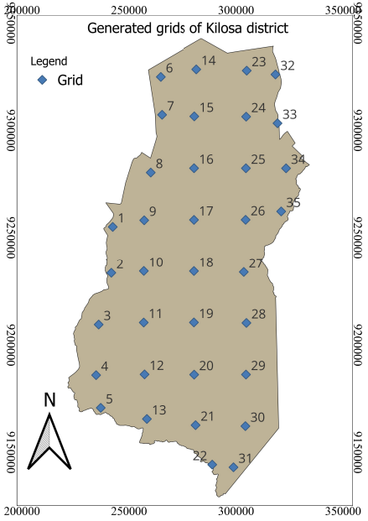

Figure 2: Maps showing generated grids with approximately coverage area of 500 km2

* 1. **Distribution and Trends Analysis**
     1. **Precipitation**

Generally, the average annual precipitation in Kilosa district is between 573.62 mm in the moderately flat north to 1313.15 mm in the mountainous south (Figure 3). The wet season lasts from November to a third week of April, whereas the remaining months are dry. The peak rainfall occurs in March, while the lowest occurs in June (Fig. 4 and Table 2). More than 90% of whole precipitation occurs in the wet season (November-April). IDW (Inverse Distance Weighting) interpolation analysis was used to execute the spatial analysis of precipitation from generated point data (Chen *et al.,*2012).

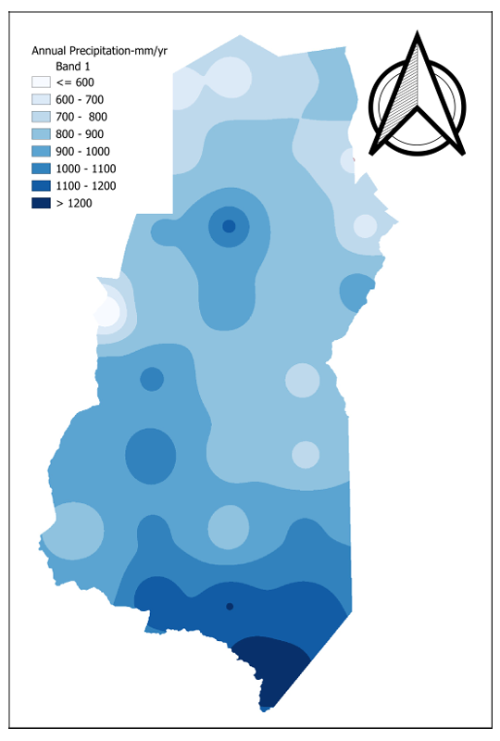

Figure 3: The spatial distribution of Kilosa District Precipitation

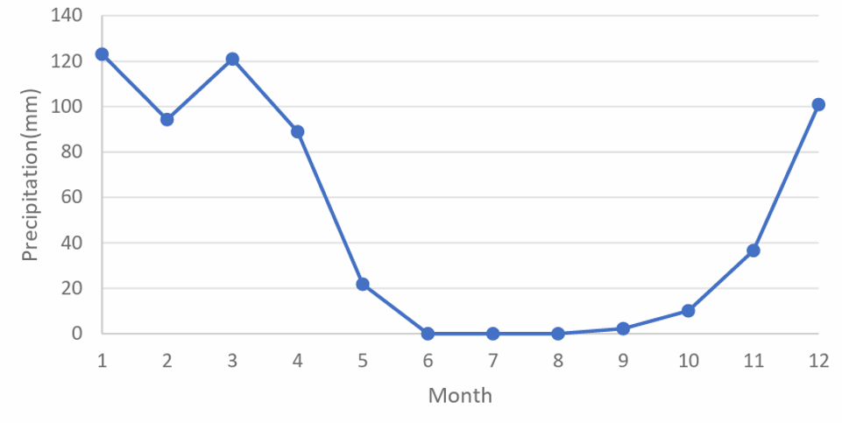

Figure 4: Monthly average of Kilosa district Precipitation

Table 2:

|  |  |  |  |  |  |  |  |  |  |  |  |  |
| --- | --- | --- | --- | --- | --- | --- | --- | --- | --- | --- | --- | --- |
| Month | Jan | Feb | Mar | Apr | May | Jun | Jul | Aug | Sept | Oct | Nov | Dec |
| Temp | 123.11 | 94.30 | 120.98 | 88.94 | 21.78 | 0.04 | 0.04 | 0.02 | 2.28 | 10.14 | 36.59 | 100.95 |

The annual precipitation in Kilosa district from 1981 to 2005 indicates decreasing trend with a magnitude of -6.810 (Figure 5). Dry years occurred in 2005 with precipitation not exceeding 600 mm/year. In contrast, wet years appeared in 1989 with annual precipitation exceeding 1200 mm/year.

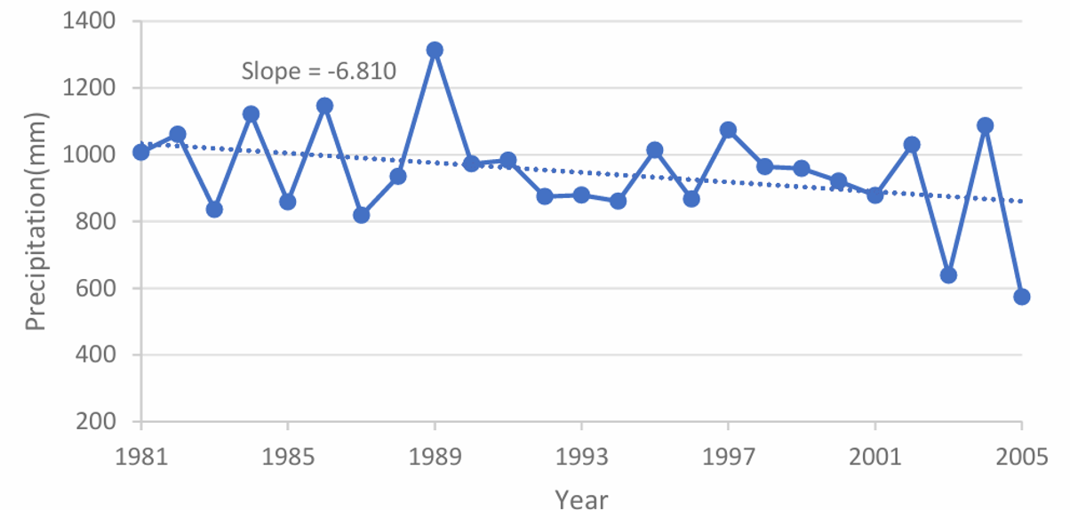

Figure 5: Variation of Annual Precipitation for Kilosa district

The MK test was applied to assess the annual precipitation time series through RStudio statistical package, which showed that 14.29% (5 grids) had a positive trend while 85.71% (30 grids) with a negative trend (Gupta & Chavan, 2021). The Z value revealed that, four (4) grids with an insignificant increase (I) while one grid with significant increase (SI), twenty-six (26) with an insignificant decrease (D) while four (4) grids with significant decrease (SD) (Table 3 & 4), The magnitude of the trend varies from -16.87 mm/year to 5.38 mm/year. (Figure 6a). This aligns with the findings of Luganda *et al.,* (2019), who observed a significant shift in rainfall patterns across several areas in Kilosa from 1972 to 2004, resulting in an increased distance to grazing lands.

Table 3: MK Trend Analysis of 17 grids for precipitation in Kilosa District

|  |  |  |  |  |  |  |  |  |  |
| --- | --- | --- | --- | --- | --- | --- | --- | --- | --- |
| Grid |  | Wet |  |  | Dry |  |  | Annual |  |
| Z | Slope | Trend | Z | Slope | Trend | Z | Slope | Trend |
| 1 | 0.58 | 2.28 | I | -2.45 | -0.59 | SD | 2.32 | 2.40 | SI |
| 2 | -0.63 | -2.89 | D | -2.50 | -1.83 | SD | -0.63 | -3.95 | D |
| 3 | -1.00 | -6.60 | D | -1.99 | -1.13 | SD | -1.10 | -6.84 | D |
| 4 | -0.86 | 4.57 | D | -2.41 | -1.04 | SD | -1.14 | 5.38 | D |
| 5 | -1.05 | -5.32 | D | -2.45 | -0.74 | SD | 0.12 | 1.41 | I |
| 6 | 0.21 | 1.62 | I | -1.94 | 0.24 | SD | 1.86 | 4.00 | I |
| 7 | 0.16 | 0.58 | I | -2.79 | -1.11 | SD | 0.00 | -0.08 | D |
| 8 | 0.58 | 2.23 | I | -2.45 | -1.55 | SD | 0.26 | 1.28 | I |
| 9 | 0.35 | 1.76 | I | -2.97 | -1.67 | SD | -0.02 | -0.11 | D |
| 10 | -0.12 | -0.55 | D | -2.69 | -2.36 | SD | -0.44 | -4.47 | D |
| 11 | -0.49 | -2.67 | D | -3.06 | -2.58 | SD | -0.86 | -10.18 | D |
| 12 | -1.42 | -8.53 | D | -3.62 | -2.54 | SD | -1.80 | 1.45 | I |
| 13 | -1.05 | -7.41 | D | -3.01 | -1.96 | SD | -1.52 | -9.07 | D |
| 14 | 0.12 | 0.58 | I | -1.80 | -0.94 | D | -0.26 | -0.78 | D |
| 15 | -0.30 | -1.18 | D | -2.64 | -2.17 | SD | -0.35 | -1.47 | D |
| 16 | -0.30 | -2.14 | D | -2.73 | -2.84 | SD | -0.82 | -5.30 | D |
| 17 | 0.35 | 0.89 | I | -3.11 | -2.24 | SD | -0.16 | -1.14 | D |

Table 4. MK Trend Analysis of 18 grids for precipitation in Kilosa District

|  |  |  |  |  |  |  |  |  |  |
| --- | --- | --- | --- | --- | --- | --- | --- | --- | --- |
| Grid |  | Wet |  |  | Dry |  |  | Annual |  |
| Z | Slope | Trend | Z | Slope | Trend | Z | Slope | Trend |
| 18 | -0.21 | -0.84 | D | -2.55 | -1.89 | SD | -0.68 | -3.21 | D |
| 19 | -0.72 | -2.18 | D | -3.62 | -2.57 | SD | 1.19 | -5.44 | D |
| 20 | -1.28 | -6.05 | D | -3.06 | -1.84 | SD | -1.66 | -8.88 | D |
| 21 | -1.38 | -9.14 | D | -3.67 | -3.64 | SD | -1.99 | -13.98 | SD |
| 22 | -1.52 | -10.91 | D | -4.41 | -4.51 | SD | -2.13 | -16.87 | SD |
| 23 | -0.16 | -0.26 | D | 0.00 | 0.004 | I | -0.58 | -2.09 | D |
| 24 | -0.44 | -2.64 | D | -2.50 | -2.08 | SD | -1.19 | -4.02 | D |
| 25 | 0.00 | -0.01 | D | -3.34 | -2.80 | SD | -0.58 | -2.29 | D |
| 26 | -0.68 | -1.66 | D | -3.62 | -2.67 | SD | -0.96 | -5.18 | D |
| 27 | -1.10 | -2.43 | D | -2.92 | -2.13 | SD | -1.47 | -4.70 | D |
| 28 | -0.40 | -2.83 | D | -4.23 | -2.27 | SD | -1.10 | -5.40 | D |
| 29 | -1.42 | -8.53 | D | -3.62 | -2.54 | SD | -1.80 | -10.18 | D |
| 30 | -1.61 | -8.22 | D | -3.76 | -3.82 | SD | -2.13 | -13.85 | SD |
| 31 | -1.80 | -10.77 | D | -4.27 | -4.33 | SD | -2.45 | -15.87 | SD |
| 32 | -0.54 | -2.33 | D | -1.94 | -2.01 | SD | -0.77 | -3.30 | D |
| 33 | -0.86 | -3.22 | D | -2.78 | -1.80 | SD | -1.52 | -4.36 | D |
| 34 | -0.54 | -1.86 | D | -2.97 | -2.13 | SD | -1.28 | -4.78 | D |
| 35 | 0.35 | 0.89 | I | -3.11 | -2.24 | SD | -0.16 | -1.14 | D |

Despite the annual trend, in dry season the MK trend found that 22.86 % (1 grid) with a positive trend while 77.14 % (34 grids) with a negative trend. The Z value revealed that, thirty-three grids (33) with significant decrease (SD), one grid with an insignificant decrease (D), and one grid with insignificant increase (I) (Table 3 & 4), The magnitude of trends varies from -4.51 mm/year to 0.24 mm/year, with a small part of the southern area of the district showing the maximum decreasing trend while the northern part showing the highest increasing trend (Figure 6c).

Again, in the wet season, the MK test found 22.86 percent of grids (8) with a positive trend while 77.14 percent with a negative trend (27 grids). The Z value showed that, eight (8) grids and twenty-seven (27) grids, with insignificant increase (SI) and decrease (SD) respectively (Table 3 & 4). The magnitude of trends varies from -10.91 mm/year to 4.57 mm/year, with the northern part showing the increasing trend while southern part of the district showing the maximum decreasing trend (Figure 6b).

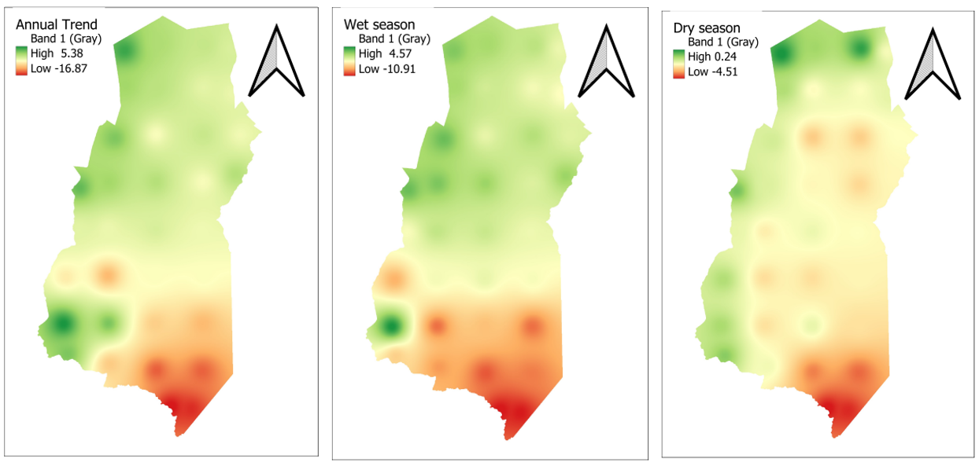

Figure 6: a, b, c. The Annual and Seasonal Spatial trend of Precipitation in Kilosa district

* + 1. **Temperature**

Based on the analysis from 1981 to 2005, the mean temperature of Kilosa district has shown variability ranging from 18.33°C to 22.71°C across nine (9) monitoring grids. On monthly bases, December recorded the highest temperature at 17.77°C, whereas July marked the lowest at 13.29°C (Figure 7 and Table 5). Based on the spatial distribution map of mean annual temperature from 1981 to 2005, the eastern part which is fairly flat experiences the highest temperatures, peaking at 24.83°C, while the western part, characterized by higher elevations, records the lowest temperatures, averaging at 16.15°C (Figure 8).

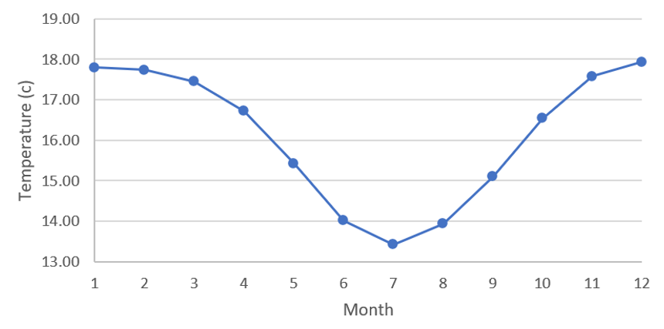

Figure 7: The monthly average temperature of Kilosa district

Table 5:

|  |  |  |  |  |  |  |  |  |  |  |  |  |
| --- | --- | --- | --- | --- | --- | --- | --- | --- | --- | --- | --- | --- |
| Month | Jan | Feb | Mar | Apr | May | Jun | Jul | Aug | Sept | Oct | Nov | Dec |
| Temp | 22.59 | 22.56 | 21.96 | 20.93 | 19.88 | 18.72 | 18.33 | 18.94 | 20.19 | 21.40 | 22.34 | 22.71 |

The findings obtained for seasonal and annual data of minimum, maximum, and mean temperatures are presented in Table 6, 7 and 8 respectively. In annual minimum temperature, the analysis reveals decreasing trend from 1981 to 2005. This trend is quantified by a magnitude of -0.0059°C (Figure 8). The lowest minimum temperature was recorded in 1996 at 12.53°C, while the highest occurred in 1982 at 13.20°C. The results indicate that 100 percent of grids (9) had a positive trend in wet season in which 2 of the grids are significant (SI), while in dry season 100 percent are insignificant negative trend (D). In annual trends 66.67% of the grids (6) had insignificant positive trend (I) and 33.33% of the grids (3) had insignificant negative trend (D). The Z value reveals a notable increase across all grids during the wet season in which 2 grids with significant increase (SI). and insignificant decrease (D) across all grids during the dry season. Furthermore, it signifies annual insignificant increase (I) across 6 grids and annual insignificant decease (D) across the remaining 3 grids.

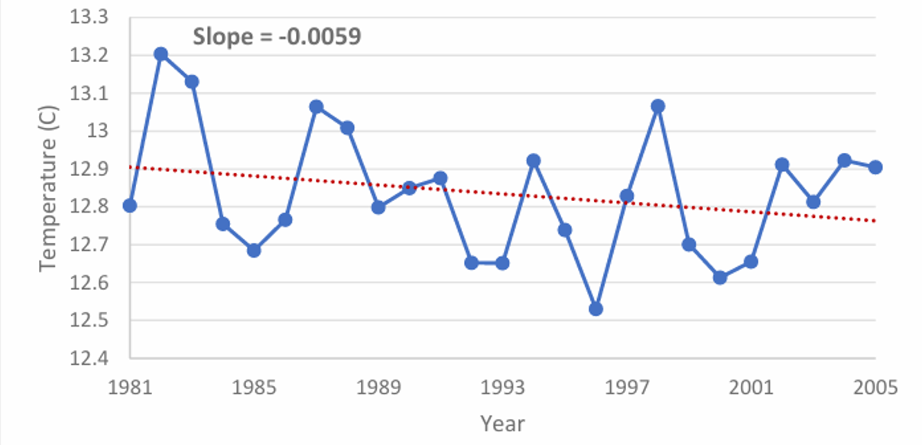

Figure 8: Minimum temperature trend of Kilosa district

Table 6: MK Trend Analysis of minimum temperature in Kilosa district

|  |  |  |  |  |  |  |  |  |  |
| --- | --- | --- | --- | --- | --- | --- | --- | --- | --- |
| Grid |  | Wet |  |  | Dry |  |  | Annual |  |
| Z | Slope | Trend | Z | Slope | Trend | Z | Slope | Trend |
| 6 | 0.257 | 0.001 | I | 1.658 | -0.014 | D | -0.817 | -0.005 | D |
| 10 | 0.958 | 0.005 | I | -1.191 | -0.009 | D | 0.000 | 0.00001 | I |
| 12 | 0.911 | 0.005 | I | -1.238 | 0.008 | D | -0.117 | -0.0004 | D |
| 14 | 1.705 | 0.012 | I | -1.004 | 0.006 | D | 0.631 | 0.005 | I |
| 16 | 1.798 | 0.014 | I | -0.072 | 0.001 | D | 0.631 | 0.006 | I |
| 28 | 1.425 | 0.007 | I | -1.238 | 0.011 | D | -0.304 | 0.002 | D |
| 30 | 1.752 | 0.007 | I | -0.911 | -0.005 | D | 0.210 | 0.001 | I |
| 32 | 2.265 | 0.013 | SI | -0.235 | -0.210 | D | 0.724 | 0.006 | I |
| 34 | 2.125 | 0.010 | SI | -0.490 | -0.004 | D | 0.584 | 0.003 | I |

The annual maximum temperature has shown a consistent upward trend from 1981 to 2005, with an increase of 0.0199°C (Figure 9). The lowest recorded maximum temperature was in 1989 at 18.80°C, while the highest was observed in 1998 at 19.78°C. The findings reveal that all grids display rising trends in both wet and dry seasons, as well as annually. Moreover, statistical analysis indicates that these trends are significant (SI) at a 95% confidence level for all grids (Table 7).

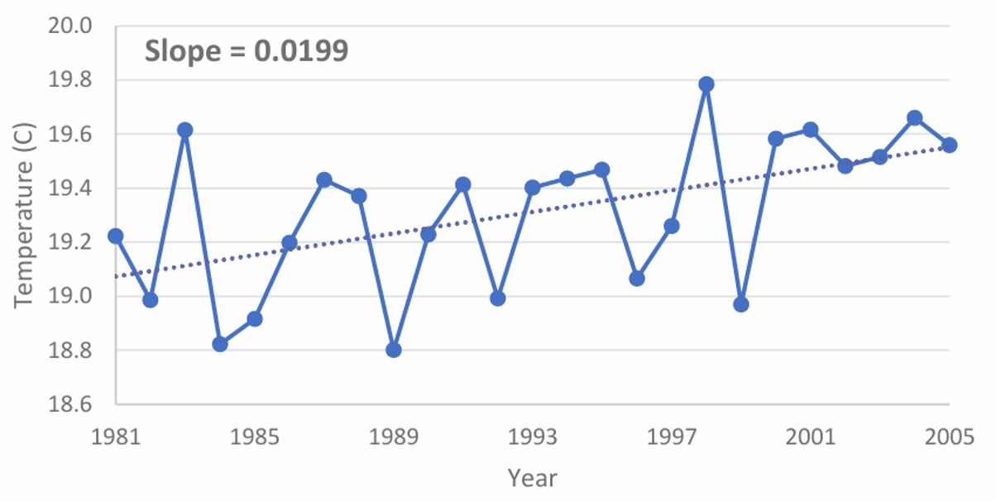

Figure 9: Maximum temperature trend of Kilosa district

Table 7. MK Trend Analysis of maximum temperature in Kilosa district

|  |  |  |  |  |  |  |  |  |  |
| --- | --- | --- | --- | --- | --- | --- | --- | --- | --- |
| Grid |  | Wet |  |  | Dry |  |  | Annual |  |
| Z | Slope | Trend | Z | Slope | Trend | Z | Slope | Trend |
| 6 | 4.036 | 0.012 | SI | 4.865 | 0.017 | SI | 4.602 | 0.014 | SI |
| 10 | 3.307 | 0.017 | SI | 4.602 | 0.021 | SI | 4.359 | 0.019 | SI |
| 12 | 4.157 | 0.017 | SI | 4.622 | 0.020 | SI | 4.926 | 0.018 | SI |
| 14 | 3.631 | 0.021 | SI | 4.258 | 0.023 | SI | 4.460 | 0.022 | SI |
| 16 | 4.036 | 0.019 | SI | 4.562 | 0.019 | SI | 4.784 | 0.018 | SI |
| 28 | 4.076 | 0.025 | SI | 4.683 | 0.025 | SI | 4.683 | 0.023 | SI |
| 30 | 3.934 | 0.031 | SI | 4.703 | 0.034 | SI | 4.804 | 0.029 | SI |
| 32 | 2.357 | 0.019 | SI | 3.752 | 0.019 | SI | 3.125 | 0.017 | SI |
| 34 | 3.226 | 0.023 | SI | 4.642 | 0.020 | SI | 4.056 | 0.020 | SI |

The annual mean temperature in Kilosa district exhibited a consistent upward trend from 1981 to 2005 (Figure 10). The magnitude of increase was measured at 0.0112°C. The lowest mean temperature was 15.61°C found in 1984, while the highest mean temperature of 16.37°C was observed in 2005. The findings reveal that all grids displayed increase in both wet and dry season temperatures, as well as annually. Additionally, statistical analysis indicates that all grids exhibited a significant upward trend (SI) at a confidence level of 95% for both wet and dry seasons, as well as annually (Table 8).

Table 8. MK Trend Analysis of mean temperature in Kilosa district

|  |  |  |  |  |  |  |  |  |  |
| --- | --- | --- | --- | --- | --- | --- | --- | --- | --- |
| Grid |  | Wet |  |  | Dry |  |  | Annual |  |
| Z | Slope | Trend | Z | Slope | Trend | Z | Slope | Trend |
| 6 | 5.836 | 0.018 | SI | 4.946 | 0.015 | SI | 5.836 | 0.017 | SI |
| 10 | 6.000 | 0.020 | SI | 5.650 | 0.020 | SI | 5.730 | 0.020 | SI |
| 12 | 5.800 | 3.650 | SI | 5.760 | 0.020 | SI | 6.020 | 0.020 | SI |
| 14 | 5.270 | 0.030 | SI | 5.290 | 0.020 | SI | 5.610 | 0.020 | SI |
| 16 | 5.650 | 0.030 | SI | 5.390 | 0.020 | SI | 5.730 | 0.020 | SI |
| 28 | 5.710 | 0.020 | SI | 5.610 | 0.020 | SI | 5.920 | 0.020 | SI |
| 30 | 5.530 | 0.030 | SI | 5.920 | 0.030 | SI | 5.920 | 0.030 | SI |
| 32 | 4.600 | 0.030 | SI | 5.290 | 0.030 | SI | 5.190 | 0.030 | SI |
| 34 | 5.050 | 0.030 | SI | 5.610 | 0.020 | SI | 5.450 | 0.030 | SI |

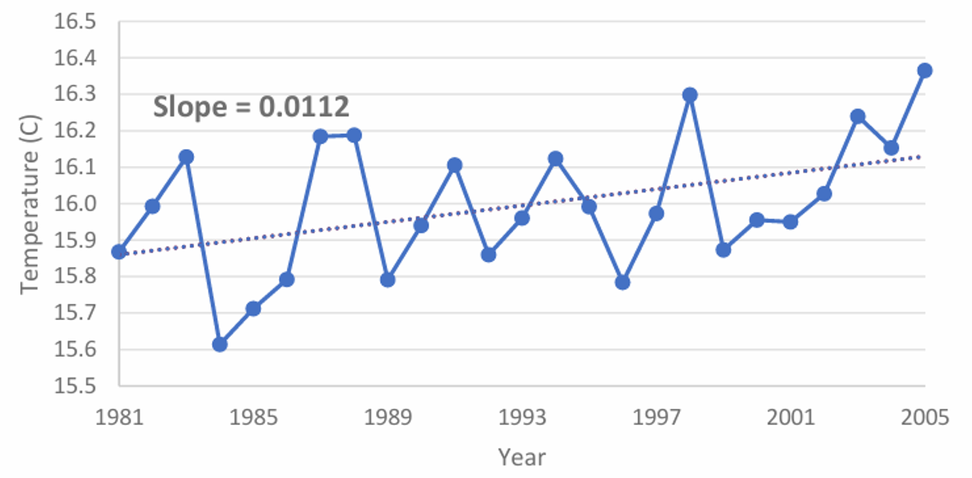

Figure 10: Mean temperature trend of Kilosa district.

The Inverse Distance Weighted (IDW) interpolation method is utilized to spatial interpolation of confidence levels and slopes of trend tests, ultimately producing a raster surface.

1. **Discussion**

The climate trends in Kilosa District are shaped by a combination of geographical, environmental, and human factors, greatly influencing its ecological and climatic stability. Rubeho mountains located in the southwestern to western part of the district and Ukaguru ranges in northeastern part. play a critical role in rainfall distribution through orographic effects, where moist air rises and cools, resulting in higher precipitation in the mountainous southern regions compared to the northern areas. These highlands also host vital forest reserves that enhance local precipitation pattern through evapotranspiration and act as natural water catchments. The rivers originating from these mountains are essential for agriculture, biodiversity, and local livelihoods. However, increasing climatic variability and human-induced changes, such as deforestation, threaten these water resources and ecosystems.

Deforestation, particularly in Rubeho, Ukaguru and Kilangali Forest Reserves, has disrupted natural hydrological cycles, reduced soil moisture retention and exacerbating rainfall variability. This aligns with observed declines in rainfall trends, which have significant implications for water availability and ecological stability. Conservation areas, including Mikumi Game Reserve and natural forests in the mountainous regions, are under pressure from human encroachment and climate-induced changes, which threaten their sustainability. Urbanization has further contributed to climatic changes, especially in the eastern regions characterized by flat terrain and expanding urban settlements. Rising temperatures in these areas are driven by the urban heat island effect, caused by increased infrastructure development and reduced vegetation cover. Urban expansion has heightened water demand and diminished natural recharge areas, compounding the district's water management challenges in the context of declining precipitation.

The interplay of declining rainfall, rising temperatures, and urban expansion poses significant risks to agricultural productivity, particularly for rain-fed farming systems that are highly sensitive to climatic fluctuations. Seasonal disparities in rainfall patterns highlight the urgent need for adaptive water management strategies, such as surface irrigation systems, to ensure consistent water availability. Protecting critical forest reserves and conservation areas through reforestation and sustainable land-use practices is crucial for restoring disrupted hydrological cycles and mitigating the adverse effects of climate variability. Urban planning in Kilosa must also integrate climate-resilient strategies, including expanding green spaces, adopting sustainable infrastructure designs, and improving water resource management systems. These measures can help counteract the urban heat island effect, enhance natural cooling, and bolster the district’s capacity to adapt to changing climatic conditions.

In conclusion, addressing climate challenges in Kilosa District requires a holistic and integrated approach that considers the interconnectedness of its physical features, environmental resources, and socio-economic activities. Proactive strategies in conservation, urban planning, and water resource management are essential for building resilience and ensuring sustainable development in this region.

1. **Conclusions**

The findings revealed that most of the grids showed a decreasing trend with more decline in dry season followed by the annual trend. In contrast, all grids within the district exhibited a positive trend in temperature. The most substantial increase was observed in the eastern region, adjacent to Morogoro urban and Mvomero town, areas known for high rates of urbanization.

**REFERENCES**

1. Bence, J. R. (1995). Analysis of short time series: Correcting for autocorrelation. *Ecology*, 76(2), 628-639.
2. Boku, E. J. (2014). Climate change, migration and conflict: a case study of Kilosa district, Tanzania (Master's thesis, Universitetet i Agder; University of Agder).
3. Chen, Y., Guo, H., & Chen, Z. (2012). Trend analysis of temperature and precipitation in the Yellow River Basin from 1951 to 2009. *Stochastic Environmental Research and Risk Assessment,* 26, 1059-1072.
4. Dembélé, M., & Zwart, S. J. (2016). Evaluation and comparison of satellite-based rainfall products in Burkina Faso, West Africa. *International Journal of Remote Sensing,* 37(17), 3995-4014.
5. Dembélé, M., Schaefli, B., Van De Giesen, N., & Mariéthoz, G. (2020). Suitability of 17 rainfall and temperature gridded datasets for largescale hydrological modelling in West Africa. *Hydrology and Earth System Sciences Discussions,*2020, 1-39.
6. Dore, M. H. (2005). Climate change and changes in global precipitation patterns: what do we know? *Environment International,* 31(8), 1167-1181.
7. Easterling, W. E. (1997). Why regional studies are needed in the development of full-scale integrated assessment modelling of global change processes. *Global Environmental Change,* 7(4), 337-356.
8. FAO (2004). Drought impact mitigation and prevention in the Limpopo River Basin: A situation analysis. Food and Agriculture Organization of the United Nations.
9. Frei, C., & Schär, C. (1998). A precipitation climatology of the Alps from high resolution rain‐gauge observations. *International Journal of Climatology: A Journal of the Royal Meteorological Society*, 18(8), 873-900.
10. Gebrechorkos, S. H., Hülsmann, S., & Bernhofer, C. (2018). Regional climate projections for impact assessment studies in East Africa. *Environmental Research Letters*, 13(5), 055013.
11. He, L., Fang, G., Wang, Y., Sun, Z., Zhang, X., & Xu, X. (2023). Evaluating the performance of reanalysis and satellite-based precipitation products in the Luanhe River Basin, North China. *Atmospheric Research,* 282, 106399.
12. Huang, J., Yu, H., Dai, A., Wei, Y., & Kang, L. (2021). Drylands face potential threat under 2°C global warming target. *Nature Climate Change*, 7, 417-422.
13. IPCC (2007b). Climate Change 2007: The Physical Science Basis. Contribution of Working Group I to the Fourth Assessment Report of the Intergovernmental Panel on Climate Change.
14. Jones, P. D., Osborn, T. J., & Briffa, K. R. (2001). The evolution of climate over the last millennium. *Science,*292(5517), 662-667.
15. Kabanda, T. (2018). Long-term rainfall trends over the Tanzania coast. Atmosphere, 9(4), 155.
16. Karpouzos, D. K., Kavalieratou, S., & Babajimopoulos, C. (2010). Trend analysis of precipitation data in Pieria Region (Greece). *European Water*, 30, 31-40.
17. Kavishe, G. M., & Limbu, P. T. S. (2020). Variation of October to December rainfall in Tanzania and its association with sea surface temperature. *Arabian Journal of Geosciences,* 13(13), 534.
18. Kimani, M. W., Forkuor, G., & Lautenbach, S. (2017). Mapping precipitation distribution in data-scarce regions: Comparison of multiple precipitation products over East Africa. *International Journal of Climatology,* 37(6), 3389-3401.
19. Kulyakwave, P. D., Wen, Y., & Shiwei, X. (2023). Overcoming climate change challenges: The role of irrigation in enhancing rice yield in Tanzania.*Economics, Management and Sustainability,*8(1), 58-71.
20. Liwenga, E. T., & Silangwa, E. L. (2020). The role of indigenous knowledge in climate change adaptation: Insights from rural Tanzania. *Climate and Development*, 12(4), 1-10.
21. Luanda, P. (2020). Climate change and agricultural practices in Kilosa district, Tanzania. *Journal of Agricultural and Environmental Sciences,* 9(2), 45-56.
22. Mbwambo, L., Moshi, N., & Msanya, B. (2024). Soil characterization for agricultural suitability in Kilosa District, Tanzania. *Soil Science Society of America Journal,* 88(1), 125-136.
23. Mugasha, A. G., & Katani, J. Z. (2016). Addressing environmental challenges in Kilosa district through community-based approaches. *International Journal of Environmental Studies,* 73(5), 678-694.
24. New, M., Todd, M., Hulme, M., & Jones, P. (2001). Precipitation measurements and trends in the twentieth century. International Journal of Climatology. *A Journal of the Royal Meteorological Society,* 21(15), 1889-1922.
25. NIMP (2018). National Irrigation Master Plan. Dar es Salaam: Ministry of Agriculture.
26. Ntawukuriryayo, E. (2022). Applicability of satellite-based rainfall estimates and inundation extent for flood modeling in the Sebeya catchment, Rwanda (Master's thesis, University of Twente).
27. Paredes-Trejo, F. J., Barbosa, H. A., & Kumar, T. L. (2017). Validating CHIRPS-based satellite precipitation estimates in Northeast Brazil*. Journal of arid environments,* 139, 26-40.
28. Patel, S., Vedeld, P., & Tarimo, A. (2014). Irrigation management, institutions and local livelihood adaptation on Usangu plains, Tanzania.
29. Qiu, J., Shen, Z., Leng, G., & Wei, G. (2021). Synergistic effect of drought and rainfall events of different patterns on watershed systems. *Scientific reports,* 11(1), 18957.
30. Raneesh, K. Y. (2014). Impact of climate change on water resources. *Journal of Earth Science & Climatic Change,* 5(3), 1.
31. Sarmento, R., & Costa, V. (Eds.). (2017). Comparative approaches to using R and Python for statistical data analysis. IGI Global.
32. Serbin, S. P., & Kucharik, C. J. (2009). Spatiotemporal mapping of temperature and precipitation for the development of a multidecadal climatic dataset for Wisconsin. *Journal of Applied Meteorology and Climatology,* 48(4), 742-757.
33. Shabani, F., & Kumar, L. (2020). Investigating the trend and variability of drought using SPI and SPEI: Case study in Iran*. Theoretical and Applied Climatology*, 139, 1711-1730.
34. Silungwe, F.R, Graef, F, Bellingrat-Kimura, S. D. Tumbo, S.D. Kahimba, F.C, and Lana, M.A. (2019b). The management strategies of pearl millet farmers to cope with seasonal rainfall variability in a semi-arid agroclimate. *Agronomy* 9, 400.
35. Silungwe, F.R, Graef, F, Bellingrat-Kimura, S. D. Tumbo, S.D. Kahimba, F.C, and Lana, M.A. (2019a). Analysis of Intra and Interseasonal Rainfall Variability and Its Effects on Pearly Millet Yield in a Semiarid Agroclimate; Significance of Scattered Fields and Tied Ridges. *Water* 11, 578.
36. Sivakumar, B. (2011). Global climate change and its impacts on water resources planning and management: assessment and challenges. *Stochastic Environmental Research and Risk Assessment,* 25, 583-600.
37. Solomon, H. S., Tekleab, S., & Araya, T. (2017). Evaluation of satellite rainfall estimates and rainfall products for hydrological applications in East Africa. *Hydrology and Earth System Sciences*, 21(6), 3661-3680.
38. Solomon, S., Qin, D., Manning, M., Chen, Z., Marquis, M., Averyt, K., & Miller, H. (2007). IPCC fourth assessment report (AR4). *Climate Change,* 374.
39. Sulugodu, B., & Deka, P. C. (2019). Evaluating the performance of CHIRPS satellite rainfall data for streamflow forecasting. *Water Resources Management*, 33, 3913-3927.
40. Sumari, N. S., Mandela, P. J., & Swai, C. S. (2022). Impact of urban expansion on land surface temperature in Dodoma and Morogoro metropolises, Tanzania. *Tanzania Journal of Agricultural Sciences,* 21(1), 263-276.
41. Tabari, H., Marofi, S., & Talaee, P. H. (2011). Detection of aridity trend in arid and semi-arid regions of Iran. *Water Resources Management,* 25(5), 1327-1348.
42. Tošić, I., Unkašević, M., & Trajkovic, S. (2015). Analysis of precipitation and temperature time series in Serbia. *Global and Planetary Change,* 122, 10-19.
43. Trenberth, K. E. (2011). Changes in precipitation with climate change. *Climate Research,* 47(1-2), 123-138.
44. Velikou, K., Lazoglou, G., Tolika, K., & Anagnostopoulou, C. (2022). Reliability of the ERA5 in replicating mean and extreme temperatures across Europe. *Water*, 14(4), 543.
45. Wilson, R. T., & Ouedraogo, M. (2017). Rainfall and agriculture in sub-Saharan Africa: Growing season, seasonal rainfall, and annual rainfall variability. *Journal of Applied Meteorology and Climatology*, 56(7), 1953-1963.
46. Wiwoho, B. S., Astuti, I. S., Alfarizi, I. A. G., & Sucahyo, H. R. (2021). Validation of three daily satellite rainfall products in a humid tropic watershed, Brantas, Indonesia: implications to land characteristics and hydrological modelling. *Hydrology*, 8(4), 154.