Case report

Syncope Revealing an Arrhythmogenic Mitral Valve Prolapse: A Case of Severe Mitral Regurgitation Complicated by Ventricular Tachycardia

Abstract
Mitral valve prolapse is the most common mitral valve disease in Western countries. Its two main etiologies are myxomatous degeneration (Barlow’s disease) and fibroelastic degeneration. Although generally benign, this prolapse can be associated with an increased risk of ventricular arrhythmias, ranging from simple asymptomatic extrasystoles to sudden cardiac death. Its management remains a challenge for clinicians.
We report the case of a 56-year-old man with no significant medical history, admitted for a sudden syncope without prodrome, preceded by progressive dyspnea over a week. Clinical examination revealed an intense holosystolic murmur (try to mention the grade) at the mitral focus. (area) The electrocardiogram showed ventricular extrasystoles likely originating from the posterior papillary muscle, with negative QRS complexes in inferior leads, a (remove it) qR pattern in V1, and an R wave smaller than S in V5-V6. Echocardiography revealed severe mitral regurgitation due to a prolapse of the P1-P2 leaflets with chordal rupture.
Given the severity of the valvular damage, an emergency surgical mitral valve repair was performed. Postoperatively, the patient experienced an episode of sustained ventricular tachycardia, requiring the implantation of an implantable cardioverter-defibrillator (ICD) for secondary prevention. This case highlights the importance of screening for arrhythmogenic mitral valve prolapse, which may present with an inaugural syncope and severe ventricular arrhythmias. Close monitoring and a multidisciplinary approach are essential to prevent severe complications, including sudden cardiac death.
Keywords: Mitral valve prolapse, syncope, mitral regurgitation, ventricular arrhythmias, ventricular tachycardia, implantable cardioverter-defibrillator.

Introduction
Mitral valve prolapse is a common valvular anomaly affecting approximately 2–3% of the general population(1). Often asymptomatic or responsible for mild manifestations, it can, however, lead to severe complications such as significant mitral regurgitation, ventricular arrhythmias, and, in rare cases, sudden cardiac death(2). These so-called "arrhythmogenic" forms are increasingly recognized, posing a real diagnostic and therapeutic challenge(3).
The association between mitral valve prolapse and malignant ventricular arrhythmias appears to be linked to structural changes in the left ventricle, involvement of the mitral papillary muscles, and electrophysiological abnormalities (4). We report here the case of a patient whose inaugural syncope revealed an arrhythmogenic mitral valve prolapse, complicated by severe mitral regurgitation and ventricular tachycardia, necessitating mitral valve repair followed by the implantation of an implantable cardioverter-defibrillator.
Case Presentation:
A 56-year-old patient with no notable medical history was admitted to the emergency department for a sudden syncope without prodrome, in a context of increasing dyspnea evolving over a week.
On admission, his vital signs were as follows: blood pressure = 112/72 mmHg, heart rate = 75 bpm, and SpO₂ = 98% on room air.(try to write in a sentence)
Clinical examination revealed an intense holosystolic murmur at the mitral focus. There were no signs of right (?left) heart failure or other significant clinical abnormalities.
The electrocardiogram showed frequent ventricular extrasystoles, likely originating from the posterior papillary muscle, characterized by negative QRS complexes in inferior leads, a qR pattern in V1, and an R wave smaller than S in V5-V6 (Figure 1). Transthoracic and transesophageal echocardiography revealed severe mitral regurgitation (Figures 2-3) due to a prolapse of the posterior leaflets P1-P2 with chordal rupture (Figure 4), along with an increase in left ventricular end-diastolic volume. The preoperative coronary angiography was normal.
Given the severity of mitral regurgitation and the presence of ventricular rhythm disturbances, an emergency cardiac surgery was decided upon. A mitral valve repair was successfully performed, restoring normal valvular function. However, postoperatively, despite the effective correction of mitral regurgitation, the patient experienced a symptomatic episode of sustained ventricular tachycardia, requiring an external electric shock (cardioversion or defibrillation) to restore normal rhythm. The analysis of the arrhythmogenic substrate revealed a persistent risk, justifying the implantation of an implantable cardioverter-defibrillator for secondary prevention. The subsequent evolution was favorable, with good tolerance of the device and no recurrence of syncope. (remove the sentence)

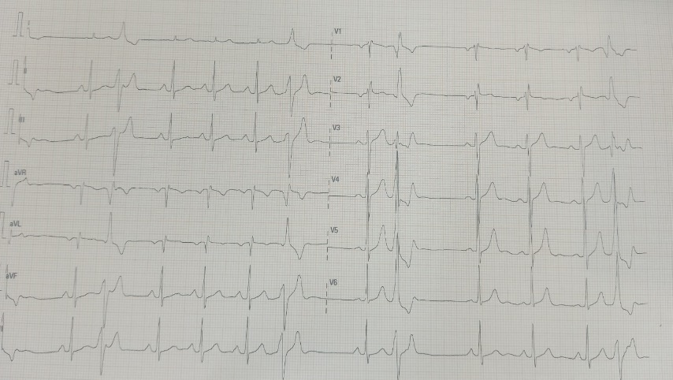
Figure 1: ECG: Sinus rhythm with right bundle branch block-type premature ventricular contractions with superior axis.
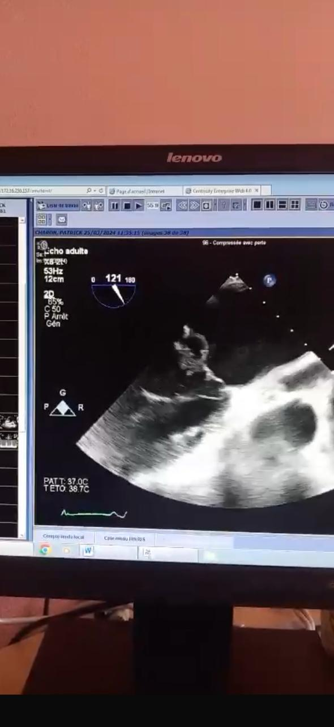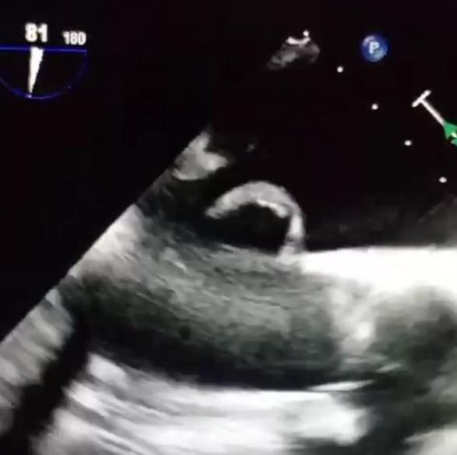
Figures 2-3: P1-P2 prolapse with chordal rupture.
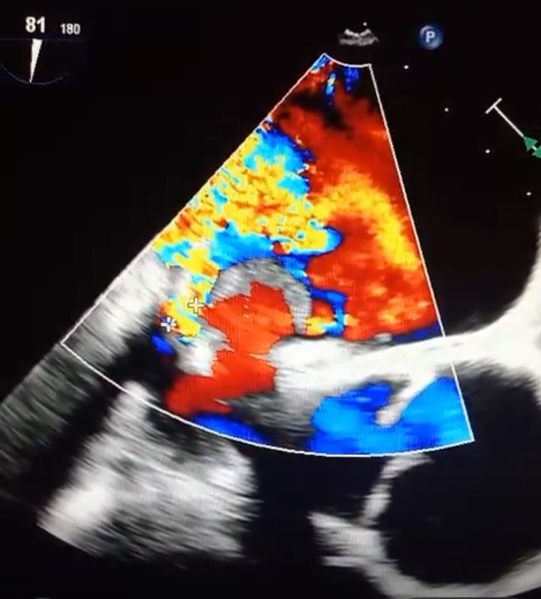
Figure 4: Severe mitral regurgitation due to P1-P2 prolapse.

Discussion
Arrhythmogenic mitral valve prolapse is an increasingly recognized entity, combining mitral valve prolapse with an increased risk of malignant ventricular arrhythmias in the absence of other clear etiologies (5). Several criteria help identify at-risk patients, including bilateral prolapse with severe valvular myxomatous degeneration, inverted T waves in inferior leads, and papillary muscle-originated ventricular extrasystoles. These electrical abnormalities are often associated with structural modifications of the left ventricle and the papillary muscle, favoring electrical instability and promoting ventricular arrhythmias.
Among the highest-risk phenotypes are severe mitral regurgitation, which doubles the incidence of sudden death in this population, and mitral annular disjunction, which frequently occurs in advanced forms of myxomatous disease with bileaflet prolapse, long, thick, redundant leaflets, and an enlarged mitral annulus (6). The link between this disjunction and the occurrence of ventricular arrhythmias is well established, with a doubled risk of arrhythmia in this subpopulation. Arrhythmogenic events tend to progress over the years, affecting one-third of patients after five years and two-thirds after ten years.
The underlying pathophysiological mechanisms include fibrosis of the papillary muscle and the posterior wall of the left ventricle, increasing susceptibility to ventricular tachycardia episodes. The hyperstimulation of mechanosensitive receptors, associated with shear forces on the mitral valve and papillary muscles, may also contribute to rhythm disorders (7).
Various imaging modalities can be used to identify markers associated with increased risk of SCD and VA in patients with MVP; however, many need further validation in larger cohorts(8)
Muthukumar et al. reported the observation of a spiked tissue Doppler velocity profile, termed the Pickelhaube sign, in keeping with a hypercontractile state of the basal to mid-lateral myocardium(9) Further, LGE was not present in any patients without the Pickelhaube sign (versus 33% with)These systolic velocities are generally much greater in patients with Ventricular arrhythmias associated with mitral valve prolapse than in those with non-Ventricular arrhythmias associated with mitral valve prolapse or the control population and are thought to represent myocardial stretch secondary to the sharp tugging of prolapsing leaflets.
CMR is a useful imaging modality to detect localized fibrosis (LGE) in the papillary muscle and inferolateral LV region, indicative of substrate for VA. Groeneveld et al. recently reported in their 2022 retrospective multicenter cohort study that MAD in the inferolateral wall was more prevalent in 72 patients with idiopathic VF than in 72 healthy controls (7 [11%] versus 1 [1%], p=0.024) With MAD observed almost equally in patients both with and without MVP, these CMR imaging findings support MAD at the inferolateral region being a distinctive imaging data point able to identify patients predisposed to idiopathic VF(10).
Regarding the determinants of high ventricular arrhythmia risk, such as palpitations, syncope, mitral annular disjunction, and bileaflet prolapse, prolonged rhythm monitoring is recommended. A seven-day Holter or an implantable cardiac monitor allows for assessing arrhythmic burden and risk stratification, particularly in cases of ventricular tachycardia exceeding 180 bpm. Prevention of sudden death relies on implantable cardioverter-defibrillator placement only in cases of documented sudden cardiac death from atrial fibrillation or ventricular tachycardia without a reversible factor, in the presence of symptomatic sustained ventricular tachycardia above 180 bpm, or in the case of hemodynamically tolerated non-sustained ventricular tachycardia with at least two high-risk phenotypic criteria(11). ICD may be reasonable based on expert consensus (in the EHRA consensus statement) in those with a combination of two phenotypic risk factors (T wave inversion in the inferior leads, repetitive documented polymorphic PVCs, MAD phenotype, redundant MV leaflets, enlarged LA, LVEF ≤50% or mitral apparatus LGE) and one high-risk feature (hemodynamically tolerated sustained VT, NSVT or unexplained syncope)(12)
Indications for ablations of PVCs or VAs, regardless of underlying arrhythmogenic substrate and relating not only to an Ventricular arrhythmias associated with mitral valve prolapsecohort, include patients with symptoms refractory to medical therapy, when medical therapy is not tolerated, when ablation is preferred over long-term pharmacotherapy or when there is associated impairment of LV function(13)(14)
In a cohort of 152 patients who underwent 170 consecutive procedures for ablation of focal VA, 25 of whom had MVP diagnosed by echocardiography, the association between LV papillary muscle VA and reported MVP did not adversely affect the acute or medium-term outcomes of ablation(15)MVP was present in 9 of 23 (39%) patients who underwent ablation of the LV PM, compared with none of 129 (0%) patients at other sites
implantable loop recorders may offer a useful alternative for detecting arrhythmias in those patients not initially fulfilling primary prevention ICD criteria but with high-risk features of Ventricular arrhythmias associated with mitral valve prolapse and previously inconclusive shorter-duration Holter monitoring, and for those with intermediate risk factors and phenotypic features including LGE on CMR (12)
Data on the efficacy of MV surgery in treating VA burden in patients with MVP and degenerative MR remain limited, with risk stratification remaining difficult and the indication for surgery not absolute(15)(16).The timing of the operation (e.g. prior to malignant substrate formation), the technique used (repair, replacement, annuloplasty, cryoablation) and whether the degree of MR before and after surgery impact the risk of SCD are questions that remain unanswered.
In our case, management was guided by the severity of mitral regurgitation and the presence of a documented arrhythmogenic substrate. Mitral valve repair corrected valvular regurgitation, but the persistence of rhythm disorders required the implantation of an implantable cardioverter-defibrillator to prevent any recurrence of ventricular tachycardia and sudden death.
Conclusion:
Arrhythmogenic mitral valve prolapse is an underestimated cause of syncope and potentially fatal ventricular arrhythmias. In patients with unexplained syncope associated with papillary muscle-originated ventricular extrasystoles or electrical abnormalities in inferior leads, a thorough evaluation of mitral valve prolapse is essential. Early and multidisciplinary management, including valvular correction and prevention of rhythmic complications, is crucial to reducing the risk of sudden death and improving patient prognosis.
References:
(1) LA Freed, D Levy, RA Levine. Prevalence and clinical course of mitral valve prolapse. N Engl J Med, 341 (1999), pp. 1–7

(2) Liu PY, Tsai KZ, Lin YP, et al. Prevalence and characteristics of mitral valve prolapse in young adult military personnel in Taiwan from the CHIEF Heart Study. Sci Rep 2021;11:2719.
(3) Devereux RB, Jones EC, Roman MJ, et al. Prevalence and correlates of mitral valve prolapse in a Native American population sample: the Strong Heart Study. Am J Med 2001;111:679–85
(4) Han HC, Ha FJ, Teh AW, et al. Mitral valve prolapse and sudden cardiac death: a systematic review. J Am Heart Assoc 2018;7:e010584.

(5) Sabbag, A., Essayagh, B., Barrera, J.D.R., Basso, C., Berni, A., Cosyns, B. et al. EHRA expert consensus statement on arrhythmic mitral valve prolapse and mitral annular disjunction complex in collaboration with the ESC Council on valvular heart disease and the European Association of Cardiovascular Imaging, endorsed by the Heart Rhythm Society, by the Asia Pacific Heart Rhythm Society, and by the Latin American Heart Rhythm Society. Europace, 2022, 24 (12), 1981-2003.
(6) Nalliah, C.J., Mahajan, R., Elliott, A.D., Haqqani, H., Lau, D.H., Vohra, J.K. et al. Mitral valve prolapse and sudden cardiac death: a systematic review and meta-analysis. Heart, 2019, 105 (2), 144-151.
(7) Essayagh B et al. Arrhythmic mitral valve prolapse and mitral annular disjunction: pathophysiology, risk stratification, and management. Eur Heart J 2023; ehad491
(8) Muthukumar L, Jahangir A, Jan MF, et al. Association between malignant mitral valve prolapse and sudden cardiac death: a review. JAMA Cardiol 2020;5:1053–61.
(9) Muthukumar L, Rahman F, Jan MF, et al. The Pickelhaube sign: novel echocardiographic risk marker for malignant mitral valve prolapse syndrome. JACC Cardiovasc Imaging 2017;10:1078–80.
(10) Groeneveld SA, Kirkels FP, Cramer MJ, et al. Prevalence of mitral annulus disjunction and mitral valve prolapse in patients with idiopathic ventricular fibrillation. J Am Heart Assoc 2022;11:e025364.
(11) Chahal NS, Lim TK, Jain P, et al. Normative reference values ​​for the tissue Doppler imaging parameters of left ventricular function: a population-based study. Eur J Echocardiogr 2010;11:51–6.
(12) Sabbag A, Essayagh B, Barrera JDR, et al. EHRA expert consensus statement on arrhythmic mitral valve prolapse and mitral annular disjunction complex in collaboration with the ESC Council on valvular heart disease and the European Association of Cardiovascular Imaging endorsed by the Heart Rhythm Society, by the Asia Pacific Heart Rhythm Society, and by the Latin American Heart Rhythm Society. Europace 2022;24:1981–2003.
(13) Zeppenfeld K, Tfelt-Hansen J, de Riva M, et al. 2022 ESC guidelines for the management of patients with ventricular arrhythmias and the prevention of sudden cardiac death: developed by the task force for the management of patients with ventricular arrhythmias and the prevention of sudden cardiac death of the European Society of Cardiology (ESC) endorsed by the Association for European Pediatric and Congenital Cardiology (AEPC). Eur Heart J 2022;43:3997–4126
(14) Cronin EM, Bogun FM, Maury P, et al. 2019 HRS/EHRA/APHRS/LAHRS expert consensus statement on catheter ablation of ventricular arrhythmias. Europace 2019;21:1143–
(15) Naksuk N, Syed FF, Krittanawong C, et al. Effect of mitral valve surgery on ventricular arrhythmia in patients with bicuspid mitral valve prolapse. Indian Pacing Electrophysiol J 2016;16:187–91.
(16) Vaidya VR, DeSimone CV, Damle N, et al. Reduction of malignant ventricular arrhythmia and appropriate shocks after surgical correction of bicuspid mitral valve prolapse. J Interv Card Electrophysiol 2016;

