**A COMMON CLINICAL PRESENTATION AND AN UNCOMMON DIAGNOSIS, ‘GANGLIOCYTIC PARAGANGLIOMA’: CASE REPORT**

**ABSTRACT**:Can start your abstract as Duodenal gangliocytic Paraganglioma is an uncommon tumour with a common clinical presentation . Mention pathological characteristics and IHC used in the diagnosis. Mention whether it has potential for metastasis or malignant transformation .Mention in short of your case as in mention age , gender of your patient Presenting to you a case of malena, headache, dizziness, fatigue. Patient can never present with a diagnostic dilemma it’s the clinician who has the diagnostic dilemma !.. The histopathological examination showed spindle cells, epitheloid cells and ganglion cells, thereby clinching the diagnosis of ‘Duodenal Gangliocytic Paraganglioma’. The first case was reported in 1957, however only a few hundred cases are available in the literature mostly in the form of case reports.. Because of the rarity of the case, it is important to report thereby adding to the existing literature.

**KEYWORDS: Duodenum, Gangliocytic Paraganglioma, Case Report, Excision**

**INTRODUCTION**

Gangliocytic Paraganglioma (GP) was first described in 1957 as duodenal ganglioneuroma by Dahl et al.1 In 1971, Kepes and Zacharias first described these tumors as GP because of the presence of both ganglion cells and epithelioid cells.2 To add the characteristic feature of the tumour that is the presence of **Epitheloid, stromal and ganglion cells** Gangliocytic [paraganglioma](https://www.sciencedirect.com/topics/medicine-and-dentistry/paraganglioma) mainly arises from the second part of the [duodenum](https://www.sciencedirect.com/topics/medicine-and-dentistry/duodenum) in close proximity to the [ampulla of Vater](https://www.sciencedirect.com/topics/medicine-and-dentistry/ampulla-of-vater), although the tumor can be seen throughout the [gastrointestinal tract](https://www.sciencedirect.com/topics/medicine-and-dentistry/gastrointestinal-tract).6 Could you comment on second most common site for this tumour apart from ampulla of Vater.To mention whether this tumour has a tendency to be benign or malignant? To mention common sites of metastasis if malignant. GPs are exceedingly rare tumors, is any incidence or prevalence available for this diagnosis apart from just quoting the number of cases available in literature searchwith approximately 280 cases identified in a MEDLINE search through November 2022.3,4,5  Hence it is important to report this case. Thereby adding to the existing literature.

This case report has been reported in line with the SCARE Criteria 2023.7

**CASE REPORT**

**Patient Information**

A young ( considereing GP can present more often in older age)39yr/Male preferred terminology is ‘Gentleman’ presented to a peripheral hospital with complains of headache, weakness, giddiness, fatigue, malena for a period of 1 week did all occur since1 week or was there any sequence of occurrence. Related to each of the complaints was any negative history elucidated for eg. With headache/ weakness did he have blurring of vision, vomiting. Seizures? etc . Worth mentioning the vital signs if recorded as he had acute presentation.On subsequent evaluation, Hb- 12.6gm/dl, Stool- occult blood positive. Upper GI endoscopy showed hiatal hernia, antral gastritis and duodenal ulcer. Mention what was your clinical diagnosis based on findings .He was given symptomatic treatment mention drugs was it injectable or oral PPI and discharged home in 2 days what was the events when admitted to hospital and recommnedations during discharge . Is there a significant family history of cancers to be mentioned pertaining to the complaints of presentation.

Clinical Findings

After 2 weeks he presented to our hospital with complains of headache, giddiness and malena for how long was he symptom free. He was again subjected to a battery of investigations what was additional tests conducted apart from the first visit, the reports were as follows: mention as significant drop in hemoglobinHb- 9.4gm/dl, Platelets- 2,87,000.

**Diagnostic Assessment**

Upper GI scopy showed bleeding from ampulla, with a bulky ampulla (Fig 1). Are pictures available from 1st scopy as you have clearly mentioned that there was only ulcer or was this neoplasm missed in first scopy as findngs ! Side viewing duodenoscopy was done which showed periampullary neoplasm with ulcerations. Biopsy was taken from it. Lower GI Endoscopy was within normal limits reason for doing this? . Histopathology report: benign ampullary mucosa, lamina propria shows mild inflammatory infiltrate of lymphocytes and plasma cells. No evidence of granulomas, dysplasia or malignancy. CEA: <0.5ng/ml. CA 19-9: 16.77 U/ml is there any microscopic picture available as it can add value to your case report.

It would be good to mention whether he had biochemical or clinical signs of jaundice considering the location of tumour.

Computed Tomography (CT) Scan of abdomen and pelvis with oral+ IV contrast: polypoidal, heterogeneously enhancing lesion of size 2.4*1.5*1.5 cm seen in second part of the duodenum along medial wall just below periampullary region (Fig 2). No dilation of pancreatic duct or common bile duct. Periduodenal fat planes appear normal. Possibility of gastrointestinal stromal tumour (GIST) likely. No significant abdominal lymphadenopathy.

During this was it during repeat scopy procedure or was it during evaluation? his Hb dropped to 8gm/dl in how many days? And was his vitals stable? . He was transfused with 2 pints of packed cell volume (PCV). Whole body PET CT showed small, intraluminal, polypoidal lesion in 2nd part of duodenum, closely abutting ampulla. (SUVmax: 3.6, size: 14*15mm) (Fig 2) Reason for PET when there was no significant abdominal lymphadenopathy in CT?

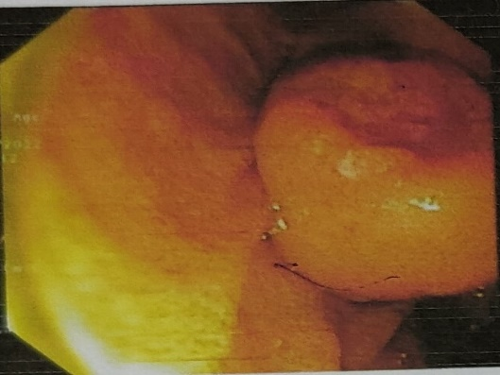

Fig 1. Showing upper GI endoscopy appearance

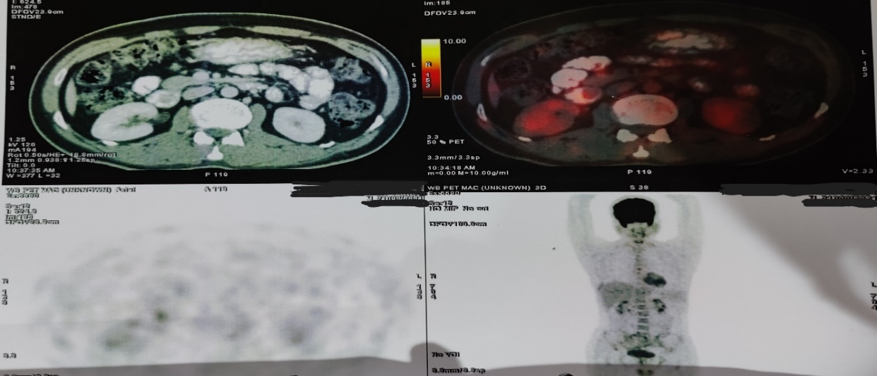 Fig 2. Showing CT Scan and PET CT Appearance

**Therapeutic Intervention**

Now this patient presented a diagnostic dilemma. With no definite diagnosis to the exact nature of the periampullary lesion, further management was contemplated did you consider an option of second biopsy and repeating IHC markers to confirm / rule out GIST in this young individual? . Being in close proximity to the ampulla and owing to ambiguity about the nature of the lesion and its size, gastroenterology opinion did not favour endoscopic management. Hence, we decided to go ahead with surgery.

An upper midline vertical incision was taken. 2nd part of duodenum was opened in right lateral part vertically. Lesion was seen in very close proximity to ampulla. Wide excision of the lesion was done gross margin of excision considered? . Duodenal incision was closed primarily in two layers. Drain kept. Patient did well postoperatively. He was discharged on post-op day 5, tolerating full diet. Histopathology report showed gross size of 1.5*1.2*0.8cm. Submucosal tumor with relatively circumscribed borders composed of spindle cells, small clusters of epitheloid cells and ganglion cells. These features are suggestive of duodenal gangliocytic paraganglioma. Resection margins are free.

Do you have surgical specimen pictures or gross pathological or microscopic pictures ?

**Follow up and Outcome**

On routine subsequent follow up of 20 months, patient is doing well. There is no evidence of local or systemic recurrence of the disease.

**DISCUSSION**

**Can mention your history of GP here( mentioned in your introduction)**

GP (better to mention the full form at the beginning of the sentence) is a rare tumour of the gastro intestinal tract commonly arising in second part of the duodenum close to ampulla of vater. Could you mention common age range of presentation of this tumour ? with a slight male predominance (1.5:1) this cam be commented later and not in your first paragraph of discussion .The most common clinical presentation is gastrointestinal bleeding; other symptoms include abdominal pain, anemia, nausea, weight loss, fatigue, and jaundice .3.NO need to mention this again as you would have described in detail in your case presentation

First mention how upper GI endoscopy with biopsy would help and then describe how radiology imaging will help in the diagnosis. GP is difficult to diagnose could you mention why. Radiologically, GP usually presents a diagnostic dilemma.8 Due to the submucosal location of this tumor, preoperative pathologic diagnosis is difficult based on endoscopic biopsy alone with a diagnostic rate of only 11.4%.9 As Mention the IHC markers that can be used in pre operative endoscopic biopsies / post operative specimen biopsies like Pancreatic Polypeptide and Progesterone markers( kindly read literature) that help in differentiating these tumours from the common others. ( in this case preoperative biopsy was inconclusive showing mild inflammatory infiltrate. Ct scan report suggested it to be tumor of 2.4cm, with possibility of it being GIST. Due to diagnostic uncertainty, a PET Scan was performed. Whole body PET CT showed small, intraluminal, polypoidal lesion in 2nd part of duodenum, closely abutting ampulla (SUVmax: 3.6, size: 14*15mm

A multidisciplinary team decided that surgical resection should be undertaken. Hence open D2 duodenotomy with wide excision of the lesion was done. Postoperative HPE report diagnosed it as GP. )---🡪 all this can be mentioned in your case presentation and not in discussion. Resection of the tumor either via endoscopiuc mucosal resection with local, resectable and non metatstatic disease or surgical resebtion is the only definitive treatment10

Patients with local disease and no malignant features or lymph node metastasis on preoperative workup can be considered for endoscopic mucosal resection .11 Depending on the size and location of the tumor and the expertise available, laparoscopic or robotic or open approach can be undertaken What is the procedure recommended like is it just enucleation or wide local excision or Whipples ? is there any role . Complete resection of the tumor with free margins constitutes adequate treatment. Is there any role of Whipples if so when is it considered On routine follow up of 20 months the patient is doing well with no evidence of recurrence or metastasisAgain this is repeated .

Check literature and comment on recurrence, chances of metastasis , malignant transformation and what is the method to follow up. Is the only clinical or do we need to do Upper GI scopy or any radiological imaging during follow up.

**CONCLUSION**

Duodenal gangliocytic paraganglioma is a rare lesion commonly arising in the 2nd part of duodenum. It is usually benign. Preoperative radiology or histopathology diagnosis is very difficult and requires a high degree of suspicion rather can mention as these two helps in diagnosis but not always. Resection constitutes definitive treatment for GP.

Consent: A written informed consent was taken from the patient for reporting the case and the accompanying images.

**COMPETING INTERESTS DISCLAIMER:**

Authors have declared that they have no known competing financial interests OR non-financial interests OR personal relationships that could have appeared to influence the work reported in this paper.

**REFERENCES**

1. Dahl EV, Waugh JM, Dahlin DC. Gastrointestinal ganglioneuromas; brief review with report of a duodenal ganglioneuroma. Am J Pathol. 1957;33(5):953-965. [PubMed](https://www.ochsnerjournal.org/lookup/external-ref?access_num=13458330&link_type=MED&atom=%2Fochjnl%2Fearly%2F2023%2F07%2F10%2Ftoj.23.0010.atom) [Google Scholar](https://www.ochsnerjournal.org/lookup/google-scholar?link_type=googlescholar&gs_type=article&author%5b0%5d=EV+Dahl&author%5b1%5d=JM+Waugh&author%5b2%5d=DC+Dahlin&title=Gastrointestinal+ganglioneuromas;+brief+review+with+report+of+a+duodenal+ganglioneuroma&publication_year=1957&journal=Am+J+Pathol&volume=33&pages=953-965)
2. Kepes JJ, Zacharias DL. Gangliocytic paragangliomas of the duodenum. A report of two cases with light and electron microscopic examination. Cancer. 1971;27(1):61-67. doi: 10.1002/1097-0142(197101)27:1<61::aid-cncr2820270111>3.0.co;2-I [CrossRef](https://www.ochsnerjournal.org/lookup/external-ref?access_num=10.1002/1097-0142(197101)27:1%3C61::AID-CNCR2820270111%3E3.0.CO;2-I&link_type=DOI) [PubMed](https://www.ochsnerjournal.org/lookup/external-ref?access_num=4099700&link_type=MED&atom=%2Fochjnl%2Fearly%2F2023%2F07%2F10%2Ftoj.23.0010.atom) [Google Scholar](https://www.ochsnerjournal.org/lookup/google-scholar?link_type=googlescholar&gs_type=article&author%5b0%5d=JJ+Kepes&author%5b1%5d=DL+Zacharias&title=Gangliocytic+paragangliomas+of+the+duodenum.+A+report+of+two+cases+with+light+and+electron+microscopic+examination&publication_year=1971&journal=Cancer&volume=27&pages=61-67)
3. Okubo Y, Yoshioka E, Suzuki M, et al. Diagnosis, pathological findings, and clinical management of gangliocytic paraganglioma: a systematic review. Front Oncol. 2018;8:291. doi: 10.3389/fonc.2018.00291 [CrossRef](https://www.ochsnerjournal.org/lookup/external-ref?access_num=10.3389/fonc.2018.00291&link_type=DOI) [Google Scholar](https://www.ochsnerjournal.org/lookup/google-scholar?link_type=googlescholar&gs_type=article&author%5b0%5d=Y+Okubo&author%5b1%5d=E+Yoshioka&author%5b2%5d=M+Suzuki&title=Diagnosis,+pathological+findings,+and+clinical+management+of+gangliocytic+paraganglioma:+a+systematic+review&publication_year=2018&journal=Front+Oncol&volume=8)
4. Nguyen BD, Guo R. Multimodality imaging of multiple duodenal gangliocytic paragangliomas with post-surgical recurrence. Dig Liver Dis. 2021;53(1):122-124. doi: 10.1016/j.dld.2020.06.001 [CrossRef](https://www.ochsnerjournal.org/lookup/external-ref?access_num=10.1016/j.dld.2020.06.001&link_type=DOI) [Google Scholar](https://www.ochsnerjournal.org/lookup/google-scholar?link_type=googlescholar&gs_type=article&author%5b0%5d=BD+Nguyen&author%5b1%5d=R+Guo&title=Multimodality+imaging+of+multiple+duodenal+gangliocytic+paragangliomas+with+post-surgical+recurrence&publication_year=2021&journal=Dig+Liver+Dis&volume=53&pages=122-124)
5. Reis D, Damião F, Noronha Ferreira C, et al. Duodenal gangliocytic paraganglioma: a unique cause of abdominal pain. ACG Case Rep J. 2019;7(1):e00272. doi: 10.14309/crj.0000000000000272 [CrossRef](https://www.ochsnerjournal.org/lookup/external-ref?access_num=10.14309/crj.0000000000000272&link_type=DOI) [Google Scholar](https://www.ochsnerjournal.org/lookup/google-scholar?link_type=googlescholar&gs_type=article&author%5b0%5d=D+Reis&author%5b1%5d=F+Dami%C3%A3o&author%5b2%5d=C+Noronha%20Ferreira&title=Duodenal+gangliocytic+paraganglioma:+a+unique+cause+of+abdominal+pain&publication_year=2019&journal=ACG+Case+Rep+J&volume=7)
6. B. Wang, Y. Zou, H. Zhang, L. Xu, X. Jiang, K. Sun Duodenal gangliocytic paraganglioma: report of two cases and review of literature Int. J. Clin. Exp. Pathol., 8 (9) (2015), p. 9752 [Scopus](https://www.scopus.com/inward/record.url?eid=2-s2.0-85012977571&partnerID=10&rel=R3.0.0) [Google Scholar](https://scholar.google.com/scholar_lookup?title=Duodenal%20gangliocytic%20paraganglioma%3A%20report%20of%20two%20cases%20and%20review%20of%20literature&publication_year=2015&author=B.%20Wang&author=Y.%20Zou&author=H.%20Zhang&author=L.%20Xu&author=X.%20Jiang&author=K.%20Sun)
7. Sohrabi, Catrin BSc, PhD, MBBSa; Mathew, Ginimol BSc, MBBSb; Maria, Nicola MD, MRCSc; Kerwan, Ahmed MBBS, MScd; Franchi, Thomas MBChB, MSc, FHEA, MAcadMEde; Agha, Riaz A MBBS, MSc (Oxon), DPhil (Oxon), MRCS Eng, FHEA, FRSA, FRSPH, FRCS Glasg (Plast), FRCS (Ed), FRCS (Plast), FEBOPRASf; Collaborators. The SCARE 2023 guideline: updating consensus Surgical CAse REport (SCARE) guidelines. International Journal of Surgery 109(5):p 1136-1140, May 2023. | DOI: 10.1097/JS9.0000000000000373
8. Jain V, Selvakumar B, Varshney VK, Vishwajeet V, Taywade S, Agarwal L, Yadav T, Pandey R. Gangliocytic Paraganglioma of the Duodenum: A Masquerader. Ochsner J. 2023 Fall;23(3):251-256. doi: 10.31486/toj.23.0010. PMID: 37711472; PMCID: PMC10498948.
9. Okubo Y, Wakayama M, Nemoto T, Kitahara K, Nakayama H, Shibuya K, et al Literature survey on epidemiology and pathology of gangliocytic paraganglioma BMC Cancer. 2011;11:187[Cited Here](https://journals.lww.com/ijpm/fulltext/2018/61040/duodenal_gangliocytic_paraganglioma__a_rare_cause.25.aspx#O3-25-2) [Google Scholar](https://scholar.google.com/scholar_lookup?title=Literature+survey+on+epidemiology+and+pathology+of+gangliocytic+paraganglioma&publication_year=2011&author=Y+Okubo&author=M+Wakayama&author=T+Nemoto&author=K+Kitahara&author=H+Nakayama&author=K+Shibuya)
10. Okubo Y, Nemoto T, Wakayama M, et al. Gangliocytic paraganglioma: a multi-institutional retrospective study in Japan. BMC Cancer. 2015;15:269. [PubMed](http://www.ncbi.nlm.nih.gov/pubmed/25886293)  [Google Scholar](https://scholar.google.com/scholar_lookup?title=Gangliocytic+paraganglioma%3a+a+multi-institutional+retrospective+study+in+Japan.&publication_year=2015&author=Y+Okubo&author=T+Nemoto&author=M+Wakayama)
11. Loftus TJ, Kresak JL, Gonzalo DH, Sarosi GA Jr, Behrns KE. Duodenal gangliocytic paraganglioma: a case report and literature review. *Int J Surg Case Rep*. 2015;8C:5-8. doi:  10.1016/j.ijscr.2015.01.003 [PMC free article](https://www.ncbi.nlm.nih.gov/pmc/articles/PMC4353939/) [PubMed](https://pubmed.ncbi.nlm.nih.gov/25600615) [CrossRef](https://doi.org/10.1016%2Fj.ijscr.2015.01.003) [Google Scholar](https://scholar.google.com/scholar_lookup?journal=Int+J+Surg+Case+Rep&title=Duodenal+gangliocytic+paraganglioma:+a+case+report+and+literature+review&author=TJ+Loftus&author=JL+Kresak&author=DH+Gonzalo&author=GA+Sarosi&author=KE+Behrns&volume=8C&publication_year=2015&pages=5-8&pmid=25600615&doi=10.1016/j.ijscr.2015.01.003&)