**Case report**

**CHOROIDAL MELANOMA WITH CEREBRAL EXTENSION: A CASE REPORT**

**Abstract**

Choroidal melanoma is a rare and aggressive form of primary eye cancer originating from melanocytes in the choroid. Although the disease is infrequent, it can metastasize to distant organs, particularly the liver, lungs, and brain, with cerebral extension significantly worsening the prognosis. This article reviews the pathophysiology, clinical presentation, diagnosis, and treatment options for choroidal melanoma with cerebral metastasis. We report the case of a 30-year-old male who underwent enucleation for right eye choroidal melanoma five years ago, later developing brain metastasis, which was successfully treated with neurosurgery. Treatment strategies for choroidal melanoma with cerebral extension are multifaceted, including local treatment of ocular tumors and systemic approaches such as surgery, radiotherapy, chemotherapy, and immunotherapy. Despite treatment advances, the prognosis remains poor, underscoring the need for early detection and personalized, multidisciplinary management.

**Introduction**

Choroidal melanoma is a rare and aggressive form of primary eye cancer, originating in the choroid, a vascular layer located between the retina and the sclera [1-4]. Although this type of eye cancer is relatively rare, it is often diagnosed too late, when metastases have already developed, notably in the brain. Cerebral extension of choroidal melanoma is a dreaded complication, as it seriously compromises the prognosis of the disease and requires multidisciplinary management [5]. This article explores the mechanisms, diagnosis and therapeutic options associated with this phenomenon.

**Pathophysiology of Choroidal Melanoma**

Choroidal melanoma is a cancer that results from the malignant transformation of pigmented cells in the choroid, known as melanocytes. Although this cancer is initially localized in the eye, its ability to metastasize is significant, particularly to the liver, lungs and brain [6,7]. Cerebral extension usually occurs from hematogenous metastases, via the bloodstream. The central nervous system is a frequent target, due to its rich vascularization and the presence of the blood-brain barrier, which allows cancer cells to infiltrate without being immediately attacked by the immune system [8-10].

**Clinical case:**

We report the observation late metastatic extension of a choroidal melanoma,

30-year-old man

History: Enucleation for choroidal melanoma of the right eye 5 years ago.

HTIC syndrome: Ocular pain with headache and vomiting 24 hours prior to admission

Exaemen of right eye: Prosthesis in place

Examination of left eye: Visual acuity: 10/10, eye tone: 14mmhg, normal anterior segment, fundus: -Peri-papillary flaming hemorrhage, arteriovenous crossings, infero-temporal papillary pallor, flat retina, normal macula

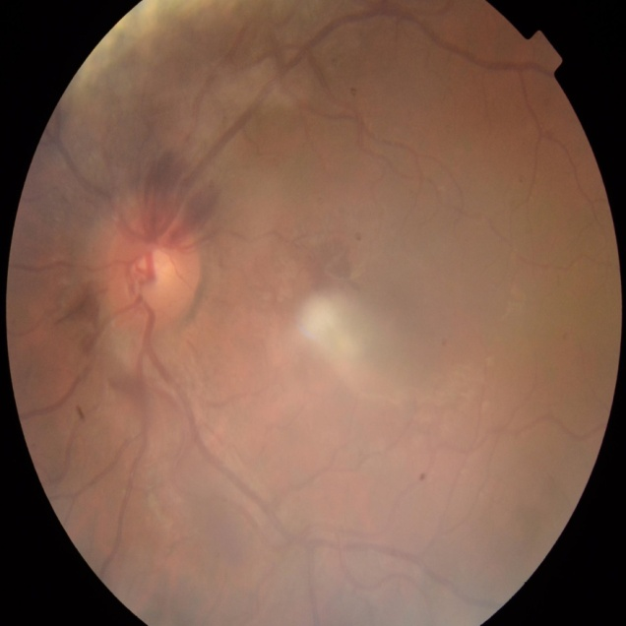

**Assessment:**

General examination: no extraocular signs

Cerebral MRI: intra-axial tumoral process in left prieto-occipital, T1 hyper signal, T2 intermediate signal, mass effect with subfalcoral involvement

Extension workup: no other secondary localizations

Postoperative histopathological examination:

Extension to sclera, healthy optic nerve resection margins

IHC: melanin markers MELAN A HMB45

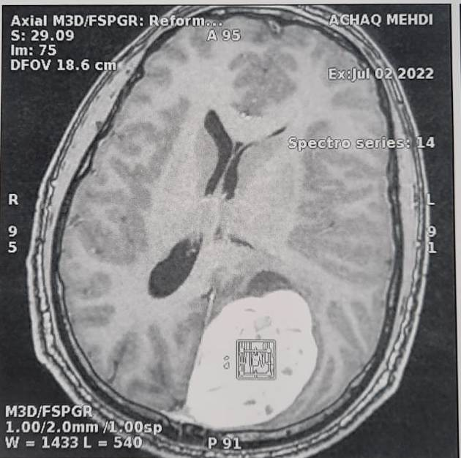

**Course of action:**

Transfer to neurosurgery: multidisciplinary consultation, removal of tumour mass

Progression after neurosurgical intervention

**Clinical :**

No HTIC syndrome, AV =10/10, papillary OCT: RNFL normal

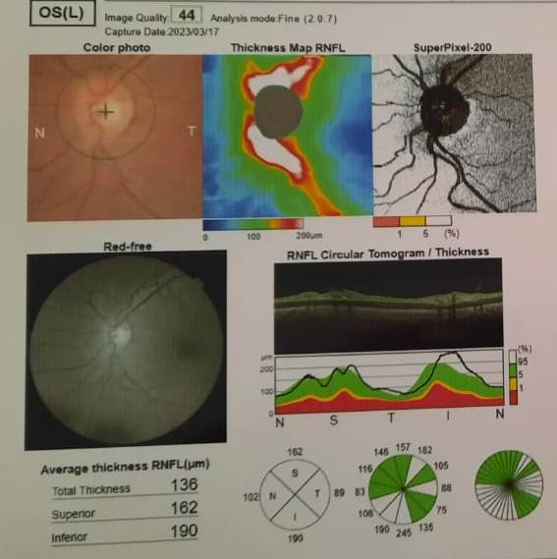

Visual field:

Upper quadanopsia, Scotoma arciformis



Annual monitoring by F.O., biannual liver monitoring by abdominal ultrasound

**Clinical features**

Choroidal melanoma is often asymptomatic in its initial stages. When symptoms do appear, they can be varied: reduced visual acuity, distortion of objects, or the appearance of blind spots in the visual field. These signs are usually detected during an ophthalmological examination, where a pigmented neoplasm is observed in the choroid, often accompanied by deformation of the adjacent retina.

When choroidal melanoma spreads to the brain, neurological signs become evident. Patients may experience symptoms such as headaches, balance disorders, motor or sensory deficits, cognitive impairment, seizures or loss of consciousness. These symptoms depend on the location and size of the brain metastases

**Diagnosis**

The diagnosis of choroidal melanoma is based on a combination of clinical examination, imaging tests and biopsy. The ophthalmological examination, which includes fundus photography, optical coherence tomography (OCT) and ocular ultrasound, allows the characteristics of the primary melanoma to be visualized. If there is any doubt about the nature of the tumour, a biopsy may be performed.

Detection of cerebral extension requires cerebral imaging examinations, in particular MRI (Magnetic Resonance Imaging), which is the tool of choice for identifying cerebral metastases. MRI can also differentiate brain metastases from other primary or benign lesions. Computed tomography (CT) is also sometimes used, although MRI is more accurate in this context.

Confirmation of the diagnosis of brain metastases can also be obtained by brain biopsy, but in many cases, clinical examination and imaging are sufficient to make the diagnosis

Treatment of Choroidal Melanoma with Cerebral Extension

The treatment of choroidal melanoma with cerebral extension is complex and requires a multimodal approach, involving both local and systemic treatments.

Local treatment of ocular tumors

In the early stages, choroidal melanoma can be treated locally by radiotherapy (external radiotherapy or proton therapy) or surgery, depending on the size and location of the tumour. Enucleation (removal of the eye) may be considered in advanced cases where the tumor is large or threatens the integrity of the eyeball. However, in the presence of cerebral metastases, the importance of local treatment for the eye becomes secondary to that of cerebral extension

**Treatment of brain metastases**

Treatment of brain metastases from choroidal melanoma requires a multidisciplinary approach involving neurology, oncology and neurosurgery. Several therapeutic options may be considered:

1-Surgery: If brain metastases are accessible and limited to one or a few lesions, surgery can be performed to remove them.

2-Radiotherapy: Stereotactic body radiotherapy (SRS) is commonly used to treat single or multiple brain metastases. Conventional radiotherapy or proton beam radiotherapy can also be effective options.

3-Chemotherapy: Systemic treatment of choroidal melanoma with cerebral extension remains a field under development. Melanoma is notoriously resistant to chemotherapy, but targeted therapies and immunotherapy, such as immune checkpoint inhibitors (e.g. pembrolizumab and nivolumab), have shown promising efficacy in some cases

4-Targeted therapies and immunotherapy: Immunotherapy has emerged as a new therapeutic strategy for treating melanoma metastases. The use of immune checkpoint inhibitors, particularly in brain metastases, is under constant evaluation. Treatments specifically targeting signaling pathways involved in melanoma progression may also offer new options for patients

**Prognosis**

The prognosis for choroidal melanoma with cerebral extension remains guarded, with median survival after diagnosis of cerebral metastases generally between 6 and 12 months, depending on disease stage and response to treatment. However, advances in immunotherapy and targeted therapy have improved survival prospects for some patients. Clinical and radiological follow-up remains essential to detect recurrence and adjust therapeutic strategies

**Discussion**

Choroidal melanoma, while rare, poses a significant threat due to its potential for metastasis, particularly to the brain. In the presented case, the patient had a history of enucleation for choroidal melanoma and presented with symptoms suggestive of intracranial pressure, including ocular pain, headache, and vomiting. This late presentation highlights the importance of regular monitoring in patients who have undergone treatment for choroidal melanoma, even after the tumor appears to have been removed.

Cerebral metastasis in choroidal melanoma occurs through hematogenous spread, and its development significantly worsens the prognosis. Neuroimaging, particularly MRI, plays a crucial role in diagnosing brain metastases, providing vital information for treatment planning. In the case described, the patient's cerebral MRI showed intra-axial tumoral involvement in the left prieto-occipital region, confirming the presence of metastases.

Treatment of choroidal melanoma with cerebral extension is complex and requires a multidisciplinary approach. The local treatment of the ocular tumor may involve radiotherapy or enucleation in advanced cases, but once cerebral metastases are detected, systemic treatments take precedence. Surgical resection of accessible brain lesions, coupled with stereotactic radiotherapy, has shown to offer significant benefit in select patients. Chemotherapy remains less effective for melanoma due to its resistance, but targeted therapies and immunotherapies have shown promising results. Immunotherapy, particularly immune checkpoint inhibitors, represents a new frontier in treatment and has been incorporated into the management of metastatic melanoma, including brain metastases.

The prognosis for choroidal melanoma with cerebral extension remains poor, with a median survival of approximately 6 to 12 months after the diagnosis of brain metastasis. However, with the advent of immunotherapies and targeted therapies, some patients may experience prolonged survival and improved quality of life. Ongoing clinical trials and research into biomarkers and novel treatment modalities offer hope for more effective management strategies in the future. Regular follow-up, including imaging and clinical monitoring, remains essential for early detection of recurrence and adjustment of therapeutic approaches.

**Conclusion**

Choroidal melanoma with cerebral extension is an aggressive form of ocular cancer whose prognosis remains dismal, particularly when cerebral metastases are present. Advances in immunotherapy and targeted therapies offer new treatment options and improved survival prospects for patients. Early, multidisciplinary management is crucial to improving patients' quality of life and prolonging their survival. The development of new treatments and the identification of specific biomarkers remain research priorities for this rare but devastating pathology

1. **References:** Kaliki, S., & Shields, C. L. (2017). Uveal melanoma: relatively rare but deadly cancer. Eye, 31(2), 241-257.
2. Shukla, S., Acharya, S., & Dulani, M. (2015). Choroid melanoma–a rare case report. Journal of Clinical and Diagnostic Research: JCDR, 9(5), ED09.
3. Everett, L., Damato, B. E., Bloomer, M. M., Palmer, J. D., Kao, A. A., Stewart, J. M., & Afshar, A. R. (2019). Metastatic cutaneous melanoma presenting with choroidal metastasis simulating primary uveal melanoma. Ocular Oncology and Pathology, 5(2), 135-138.
4. Shields, C. L., & Shields, J. A. (2009). Ocular melanoma: relatively rare but requiring respect. Clinics in dermatology, 27(1), 122-133.
5. McCartney, A. C. E. (1995). Pathology of ocular melanomas. British medical bulletin, 51(3), 678-693.
6. Broggi, G., Russo, A., Reibaldi, M., Russo, D., Varricchio, S., Bonfiglio, V., ... & Caltabiano, R. (2020). Histopathology and genetic biomarkers of choroidal melanoma. Applied Sciences, 10(22), 8081.
7. Bourguet, A., Piccicuto, V., Donzel, E., Carlus, M., & Chahory, S. (2015). A case of primary choroidal malignant melanoma in a cat. Veterinary Ophthalmology, 18(4), 345-349.
8. Finger, P. T. (2015). Eye: Choroidal melanoma, retinoblastoma, ocular adnexal lymphoma and eyelid cancers. UICC manual of clinical oncology, 726-744.
9. Tarlan, B., & Kıratlı, H. (2016). Uveal melanoma: current trends in diagnosis and management. Turkish journal of ophthalmology, 46(3), 123.
10. Lemaître, S., Zmuda, M., Jacomet, P. V., Lévy-Gabriel, C., Dendale, R., Berges, O., ... & Cassoux, N. (2017). Small choroidal melanoma revealed by a large extrascleral extension. Ocular Oncology and Pathology, 3(3), 240-246.

.