Original Research Article
Socio-Economic Profile and Fisheries Management Practices of Fisheries Co-operative Societies in Niwas block, Madhya Pradesh, India

.
ABSTRACT

Aims: The present study aim to assess the socio-economic status of fishery cooperative societies in Niwas Block, Madhya Pradesh, India.
Study design: The study covered all the six fisheries cooperative societies existing in the Niwas Block namely, Gouri Shakti, Maa Durga, Maa Narmada Adiwasi, Maa Narmada, Adiwasi, and Maa Reva Fisheries Cooperative Societies with 171 members in total.
Place and Duration of Study: The study was conducted in the Niwas Block, Mandla district, Madhya Pradesh, India during the month of June-August, 2023.
Methodology: The socio-economic status of the fishery cooperative societies was studied through a structured questionnaire. The collected data were analyzed using descriptive statistical techniques.
Results: The study finds that most members are male (67.25%) and married (90.30%), with the majority in the 31-40 age group (28%). Education levels are low, with 21% illiterate and only 1.5% graduates. Most members belong to Scheduled Tribes (57.50%) and Other Backward Classes (30%). For the year 2021-2022, the average annual income of members was Rs. 28,086. The study also highlights housing conditions, with 35.5% of members living in kachcha houses, 38.18% in semi-pucca houses, and 26.32% in pucca houses. Regarding insurance coverage of the members, 32.17% of members are insured under a government policy, while 67.83% are not covered by any insurance. Nearly, 95.33% of the members are supported through Kishan Credit Cards. The societies produced approximately 2,100 kgs of fish annually. The government supports the societies by providing boats, nets, vehicles, and fish seed. A lack of interest in record-keeping, auditing, and maintenance of files was observed among the society members.
Conclusion: The study highlights a need for further education and awareness on financial and organizational management to enhance the overall effectiveness of these societies.

Keywords: Socio-economic, Fisheries cooperative society, Mandla, Niwas, Madhya Pradesh

1. INTRODUCTION

India is the 3rd largest fish producing nation in the world (Ministry of Fisheries, Animal Husbandry & Dairying, 2018). Fisheries sector occupies a very important place in the socio-economic development of the country, as it contributes to economic growth and human welfare (Karuppusamy et al.,2016). Madhya Pradesh, also called the Heart of India, is gifted with vast water bodies in terms of ponds, tanks, rivers, canals, reservoirs and lakes. There are 1.38 lakh ha area of large reservoirs, 1.49 lakh ha medium reservoirs and 1.72 lakh ha small reservoirs (Vass & Sugunan, 2009). Fisheries in the open water resources or common water resources such as village tanks, reservoirs, dams, wetlands etc are generally managed by the local people through cooperative societies with the help of state government. Fisheries cooperative society is a form of occupational organization formed under the society act. It is group voluntary associate persons who use their resources for group welfare. Moreover, cooperatives are considered shield of the weak. In cooperatives, members with limited mean pool their resources and efforts to achieve much, which otherwise they would not have achieved. Members of the cooperative society works collectively for the welfare of the local people while managing the resources efficiently and sustainably. Well managed cooperative not only provide livelihood, but also actively engaged in social activities such as education, health, public distribution system, social reform and charity (Sapovadia, 2004). Fishery cooperatives can increase fish production by adopting professional management practices and being involved in processing, value chains, and value addition. However, in India fishery activities being generally backed by weaker section of the society, the members are generally illiterate and most of the times they are unaware of the modern technology be it in culture systems or machinery used for better utilization of the resources. These communities sometimes lack proper schooling and health facilities in their villages (Beishamayum et al., 2023). Fisheries co-operative societies may resolve most of these challenges and fishermen in various states have chosen the collaborative method of working to enhance their fisheries in general and also their socioeconomic situations (Mahanayak and Panigrahi, 2021). Mandla district, Madhya Pradesh has many water tanks which are built to cater to irrigation needs, domestic water supply, and the generation of hydropower. To our knowledge no information is available on the study undertaken for the socio-economic study of these societies in the Mandla district of Madhya Pradesh. Socio-economic studies provide the data and insights of the income levels and financial stability of fishermen involved in cooperatives, gaps and key need to better fishing gear, infrastructure, or financial support. And devising appropriate solutions to long term growth and sustainability. The outcome will strengthen the policy makers, stakeholders to make interventions for overall well-being of the members and society and the local economy. Therefore, in the present study the socio-economic status and the management strategy of the fishery cooperatives societies in the block-Niwas are carried out.

2. methodology

The socio-economic status of the fishery cooperative societies was studied through a structured questionnaire. The primary data were collected through personal interview and physical observations of members of society (Plate No. 1 and Plate No. 2). The data are collected from the six fishery cooperative societies in the Niwas Block involving 173 members in total. Each cooperative society has one reservoir for doing fishing activities. Secondary data were collected from the records maintained at the societies as well as office of the Fishery department of Mandla, Madhya Pradesh. The collected data were analyzed using descriptive statistical techniques and expressed in percentage. The study was conducted in the month of June-August 2023.

3. results and discussion

3.1 Organizational structure OF THE FISHERIES COOPERATIVE SOCIETIES (FCS)
There are six fishery cooperative societies existing in the Niwas Block of District Mandla, Madhya Pradesh. These societies were producer cooperative society and each society has a reservoir or water tanks under them for performing fishing activities. The particulars of the 6 cooperative societies exist in the Niwas block are given in Table 1. The Adiwasi Fisheries Cooperative Society (AFCS) is the oldest, established in 2010, while the Maa Durga Fisheries Cooperative Society (MDFCS) is the most recent, founded in 2018. In terms of the water area managed, the Maa Narmada Fisheries Cooperative Society (MNFCS) oversees the largest area, with approximately 104.60 hectares of water bodies for fishery activities. On the other hand, MDFCS manages the smallest area, with around 10.56 hectares. GSFCS has the highest members (37 numbers) followed by MNFCS (36 numbers), AFCS (33 numbers), MRFCS (23 numbers), MNAFCS (22 numbers) and MDFCS (20 numbers). Despite having the largest water area, MNFCS operates with only 36 members, similar to the Gouri Shakti Fisheries Cooperative Society (GSFCS), which manages 14.14 hectares of water bodies. The actual size of a cooperative is not prescribed by law or does not depend on the size of water bodies its hold for fishing activities rather it is governed by its activities, social and cultural feasibility (Ben-Yami and Anderson, 1985).

Table 1. Particulars of the cooperative societies existing in the Niwas Block of District Mandla, Madhya Pradesh

Name of the cooperative societies | Location | Reservoir size (Hectare) | Establish year
Gouri Shakti fisheries cooperative society (GSFCS) | Bhatgaon | 14.14 | 2014
Maa Durga fisheries cooperative society (MDFCS) | Jilhati | 10.56 | 2018
Maa Narmada Adiwasi fisheries cooperative society (MNAFCS) | Kohani | 19.93 | 2011
Maa Narmada fisheries cooperative society (MNFCS) | Manjhgaon | 104.60 | 2011
Adiwasi fisheries cooperative society (AFCS) | Mudjhaur | 14.14 | 2010
Maa Reva fisheries cooperative society (MRFCS) | Pondi | 11.30 | 2012

Overall, all the six fishery cooperative societies in the Niwas block have similar organizational structure as per the rule set by the Madhya Pradesh government (Figure 1). The administration is mainly through the board of directors, consisting of a total of 8 members which are elected and directed by the cooperative department and fisheries department. In general, each society has one chairman, two vice chairman’s, one secretary, one treasurer, and three board members. The general meeting of committee members is hold once in a year and discuss on the following matters:
• Allocation of profits and distribution amongst society member
• Fixing the maximum credit limit of each member of the society
• Framing rules for collection
• Marketing of fish and fish seed
• Audit report and other letter received from the co-operative department

Fig. 1. Generalised committee members and their role in the fishery cooperative society of Madhya Pradesh

3.2 Socio-economic profile
3.2.1 Gender and marital status of the FCS members
The gender profile and marital status of the members of fisheries cooperative societies of Niwas block is given in Table 2. A gender disparity was observed in the membership of fishery cooperative societies, with males representing 67.25% and females 32.75% of the total membership. Within individual societies, the proportion of male members is higher than that of female members. Among these, GSFCS has the highest percentage of female members at 45.95%, while MNFCS has the lowest at 16.66%. In fishing related occupations, men generally outnumber women. A study on fish farmers in Lohit district, Arunachal Pradesh, found that 93% of the fish farmers were male, while only 8.5% were female (Nath, 2014). Although women represent a small portion of the workforce, their contributions are invaluable. Women are often involved in numerous unpaid tasks, such as fixing nets, preparing food for fishermen, managing accounts, and removing fish from gear (Siason et al., 2002). Majority of the members in all the societies are married and share family responsibilities. Out of total 171 members, 154 (90.30 %) are married and 5 (2.40 %) are unmarried.

Table 2. Gender profile and marital status of members of fisheries cooperative societies of Niwas Block
Name of Society | Total Members | Gender |  | Marital Status
 |  | Male  (%) | Female (%) | Married (%) | Unmarried (%) | Widow (%)
GSFCS | 37 | 20 (54.04%) | 17(45.95%) | 33 (89.19 %) | 4 (10.81) | 0
MDFCS | 20 | 12 (60%) | 8 (40%) | 19 (95 %) | 0 | 1 (5%)
MNAFCS | 22 | 13 (59.10%) | 9 (40.90%) | 19 (95 %) | 0 | 3 (5 %)
MNFCS | 36 | 30 (83.33 %) | 6 (16.66%) | 35 (97.22 %) | 1 (2.8 %) | 0
AFCS | 33 | 25 (75.75%) | 8 (24.24%) | 28 (84.85 %) | 0 | 5 (15.15 %)
MRFCS | 23 | 15 (65.21%) | 8 (34.78%) | 20 (86.96 %) | 0 | 3 (13.04 %)
Total | 171 | 115 (67.25 %) | 56 (32.75 %) | 154 (90.30%) | 5 (2.40%) | 12 (7.30%)

3.2.2 Age distribution of the FCS members

In the present study, the age composition of society members showed that the majority are in the 31-40 years age group (28%), followed by 26% in the 41-50 years group and 26% in the 51-60 years group (Table 3). Both GSFCS and MNFCS have an equal number of members in the 31-40 years age group. The age of members significantly impacts the governance, management, and profitability of societies. Similar studies of FCS of other states in India were also dominated by middle age group members. In fishery cooperative societies of Karnataka, majority of the fishermen (43.33%) were aged 30-40 years followed by 41.67 % in the age group of more than 40 years (Vijayakumar et al., 2019).

Table 3. Age Group of members of fisheries cooperative societies of Niwas Block
Name of Society | Member | Age Group
 |  | 21-30 year | 31-40 year | 41-50 year | 51-60 year | 60-70 year
GSFCS | 37 | 6 | 10 | 8 | 9 | 4
MDFCS | 20 | 0 | 8 | 2 | 3 | 7
MNAFCS | 22 | 0 | 3 | 7 | 5 | 7
MNFCS | 36 | 6 | 10 | 8 | 8 | 4
AFCS | 33 | 0 | 9 | 13 | 11 | 0
MRFCS | 23 | 0 | 7 | 7 | 8 | 1
Total | 171 | 12 | 47 | 45 | 44 | 23
Percentage | 100% | 7% | 28% | 26% | 26% | 13%

3.2.3 Educational status of the FCS members
The educational status of the fishermen in the study was categorized into two main levels: illiterate and literate, with the literate group further divided into five sub-levels: 5th class, 8th class, 10th class, 12th class, and graduation (Table 4). The study found that the majority of society members have completed 8th grade (31%), followed by 27% who have completed 5th grade, 16% who have completed 10th grade, 3.5% who have completed 12th grade, and 1.5% who have graduated. Among the societies, AFCS had the highest proportion of literate members, followed by MNFCS, MNAFCS, with GSFCS having the lowest number of literate members. Education is an important factor for growth and management of a society. File work in the society including accounting, record keeping and all other basic finance or non-finance related works depends on educated members of society. Educated members can easily comprehend to any developmental program for the society such as scientific training program, conflict management etc (Chandra et al., 2022).
Earlier studies also found lower education among the fish farmers of Andhra Pradesh and West Bengal. Abraham et al. (2010) and Goswami et al. (2012) reported that majority of fish farmers in Andhra and West Bengal is educated up to middle school level. Similar finding is reported by Chandra et al. (2022) where members of fishermen´ cooperatives societies in Hardoi district of Uttar Pradesh were 52.43 % illiterate and 8.11% graduate.

Table 4. Education status of members of fisheries cooperative societies of Niwas Block
Name of Society | Member | Illiterate | Literate | Literate
 |  |  |  | Upto 5th | 8th | 10th | 12th | UG
GSFCS | 37 | 16 (43%) | 21 (57%) | 5 | 7 | 8 | 1 | 0
MDFCS | 20 | 4 (20%) | 16 (80%) | 8 | 5 | 3 | 0 | 0
MNAFCS | 22 | 3 (14%) | 19 (86%) | 10 | 7 | 2 | 0 | 0
MNFCS | 36 | 5 (14%) | 31 (86%) | 14 | 11 | 5 | 1 | 0
AFCS | 33 | 3 (9%) | 30 (91%) | 6 | 14 | 9 | 0 | 1
MRFCS | 23 | 5 (22%) | 18 (78%) | 4 | 9 | 0 | 4 | 1
Total | 171 | 36 | 135 | 47 | 53 | 27 | 6 | 2
Percentage |  | 21% | 79% | 27% | 31% | 16% | 3.50% | 1.50%

3.2.4 Caste status of the FCS members
The data revealed that the majority of members belong to Scheduled Tribes (57.50%), followed by the Fisherman community (Other Backward Castes) at 30%, Scheduled Castes at 12%, and General category at 0.50%. GSFCS, MNAFCS, and AFCS societies have a higher proportion of Scheduled Tribe members, while MNFCS and MDFCS societies have a majority of OBC (Fisherman community) members. MRFCS society primarily consists of Scheduled Caste members. The category of society members is an important criterion in allocation of fishing rights for a particular reservoir or water bodies for fishing activities in Madhya Pradesh. The priority for leasing water bodies is given on the order of Fisherman Caste > Scheduled Tribe > Scheduled Caste > Backward Class > General Category.

3.2.5 Income status (salary) of the society members
The source of income for the society members includes fishing activity, agriculture and others (Table 5). The average annual income of the society members ranges from Rs. 24200 to Rs. 34722. From the study it is observed that the net income of society is not proportionate to the water area available for fishing activities. MNFCS with the highest water area of 104.60 ha could earn only 1.00 lakh annual net income while that of MNAFCS having water area of 19.93 ha could earn 3.00 lakh net annual income. This might be due to the fact that small water area is easily manageable and profitable for fisheries by cooperative society. In addition to size of water area, many circumstances affect income generation such as management, work activity, distribution of money, accounting of society records etc. Certain factors like lack of education, lack of acceptability of modern tool and techniques by the members also affect income generation potential of a society. AFCS and GSFCS both are performing low in fishing activities but on other hand they are gaining from agriculture, so these members prefer agriculture over fishing. Low income from fishing activity may be due to inactive member of society. Goswami et al. (2012) revealed that the majority of respondents perceived fish culture as secondary occupation in West Bengal. The annual income of the members is comparatively low when compare with the income of other fisheries society of Karnataka. Vijayakumar et al. (2019) reveals that, 26.66 per cent of the respondents had an annual family income of less than 1,00,000, 45.83 per cent had an family income ranging from 1,00,000-1,50,000 per annum and 27.50 per cent had family income of more than 2,00,000 per annum in Karnataka.

Table 5. Income Profile of members of fisheries cooperative societies of Niwas Block for the year 2021-2022
Name of Society | Leased Water Area (Hectare) | Net Income of Society (Lakh) | Average income (Rs.)/Member/Year |  |  | Average Income (Rs) Year/ Member
 |  |  | Fish Farming | Agriculture | Others
GSFCS | 14.14 | 0.80 | 4250 | 16666 | 6416 | 27333
MDFCS | 10.56 | 1.00 | 6389 | 3333 | 25000 | 34722
MNAFCS | 19.93 | 3.00 | 13111 | 10888 | 444 | 24443
MNFCS | 104.60 | 1.00 | 4891 | 13435 | 10304 | 28630
AFCS | 14.14 | 0.50 | 2700 | 9200 | 12300 | 24200
MRFCS | 11.30 | 1.40 | 4760 | 14000 | 10428 | 29190
Total | 174.67 | 7.70 | 36101 | 67522 | 64892 | 168518
Average | 29.11 | 1.27 | 6017 | 11254 | 10815 | 28086

3.2.6 Housing status of the FCS members

The housing conditions of the members were classified into three types: kaccha, half-pucca, and pucca. The study found that 35.50% of members live in kaccha houses, 38.18% reside in half-pucca houses, and 26.32% live in pucca houses.

3.2.7 Financial and Insurance Coverage Status of FCS Members
All society members (100%) have bank accounts; however, only 32.17% are covered by a government insurance policy, while the remaining 67.83% do not have insurance. On the other hand, 95.33% of members have a Kishan Credit Card (KCC), and 4.67% do not.

3.2.8 Infrastructure of the FCS
Only the Maa Narmada Fisheries Cooperative Society has its own building, which was constructed with government aid. The remaining five societies do not have any dedicated buildings for their activities.

3.3 Fisheries management by the FCS

3.3.1 Fish seed stocking and production during 2021-2022

The societies regularly stock fish seed into the water bodies with the support of the state fisheries department to enhance the production of the reservoirs. However, fish production across all societies in Niwas block is generally recorded low. In the year 2021-2022, MNAFCS stocked the highest number of fry (1.00 lakh), while AFCS released the lowest number (0.30 lakh). In total, all the societies produced 2,100 kg of fish during the same period.

3.3.2 Craft and gear

Craft and gears are essential for effective harvesting of fishes from the water resources. During the study it was recorded that GSFCS and MDFCS have one boat each, and all other societies have two or more boats. MNFCS have highest number of nets (50 Nos.).

3.3.3 Fish marketing
The majority of societies sell their catch in the local market. However, three societies (MNAFCS, MNFCS, MRFCS) sell fish at the inter-district level, with only MNFCS and MRFCS using ice for marketing. MNAFCS, being close to the district border, does not use ice for its sales.

3.4 Constraints and difficulties
The societies face several challenges in their daily activities, which include:
- Inexperienced and uninspired leadership from board members
- Corruption within the society
- Difficulties in collecting funds for fish seed, boats, nets, and other equipment and activities
- Mismanagement of funds and improper distribution
- Unequal distribution of work
- Poaching in ponds/reservoirs by outsiders, and occasionally by society members themselves
- Lack of technical fishing skills
- Limited interest in record-keeping, auditing, and maintenance
3.5 Government´s intervention
The state Fisheries department is working tirelessly for the upliftment of fishermen community through the following initiatives:
- Facilitating the leasing process of water bodies to fishing societies
- Assisting in the establishment, administration, and development of fisheries cooperative societies
- Promoting fish seed stocking
- Organizing awareness and training programs on modern fishing techniques
- Implementing welfare schemes for fishermen, such as KCC and insurance
- Providing boats, nets, and fish seed

4. Conclusion
This study offers insights into the current socio-economic status of the six fisheries cooperative societies operating in the Niwas block of Mandla district, Madhya Pradesh. The majority of members are male, and most have a low level of education. In terms of infrastructure, all except one society lack a proper building, and many are missing basic facilities required for fishing activities in the water bodies such as gear and craft. Improvements could be achieved through targeted training and awareness programs. Government support in the form of basic training, input distribution, and programs aimed at better management practices would enhance fish productivity, ultimately improving the livelihoods of the members.

Consent

All authors declare that ‘written informed consent was obtained from the respondents and preserved by the author(s)”.

References

- Ministry of fisheries animal husbandry and dairying (2018). Handbook on fisheries statistics, government of India, https://dof.gov.in/sites/default/files/2023-08/HandbookFisheriesStatistics19012023.pdf
- Karuppusamy R, & Subramanian A. (2016). A study on socio-economic conditions and financial status of fishermen with special reference to Pudhucherry and Karikkal. International Journal of Management and Development Studies, 5(6), 80-86.
- Vass, K.K. & Sugunan, V.V. (2009). Status of Reservoir Fisheries in India, In De Silva, S.S. and Amarasinghe, U.S. (Ews.), Status of reservoir fisheries in five Asian countries. NACA Monograph No. 2. Network of Aquaculture Centres in Asia-Pacific, Bangkok, Thailand. 113 p.
- Sapovadia, V. K. (2004). Fisherman cooperatives: a tool for socio-economic development. In International Institute of Fisheries Economics & Trade Conference. https://ssrn.com/astract=954986
- Beishamayum, N. D., K, K., Kaiwart, L., Bhaskar, R., & Dhruw, V. (2023). Socio-economic profile and challenges of fishing communities:A Case study of Chhirpani Reservoir in Kabirdham district, Chhattisgarh. Journal of Indian Fisheries Association, 50(2), 52-57.
- Mahanayak B, Panigrahi AK (2021). Sustainable management of the aquatic ecosystem and the fishermen cooperative societies in India: a brief review. Uttar Pradesh Journal of Zoology, 42, 28–35.
- Ben-Yami, M., and Anderson, A. M. (1985). Community Fishery Centres: Guidelines for Establishment and Operation. FAO Fisheries Technical Paper 264. Rome: Food and Agriculture Organization of the United Nations. http://www.fao.org/docrep/003/X6863E/X6863E00.htm#TOC
- Nath K. (2014). Socio-economic Status of Fish Farmers in Arunachal Pradesh: An Analytical Study. Asian Journal of Research in Business Economics and Management, 4(12): 67-76.
- Siason, I., Tech, E., Matics, K. I., Choo, P. S., Shariff, M., Heruwati, E. S., et al. (2002). Women in Asia.
https://digitalarchive.worldfishcenter.org/bitstream/handle/20.500.12348/2227/wifg_asia.pdf?sequence=1&isAllowed=y
- Vijayakumar S., Muttaooa Khavi, Vijay Atnur & Rajanna KB. (2019). Socio-economic status of fishery co-operative societies in the Vijayapur district of Karnataka. Journal of Entomology and Zoology Studies, 7(6), 667-669.
- Chandra P., Kumar, A.& Sulekha, Dana, S.S. (2022). Study on present status of socio-economic condition of fisheries co-operatives societies members of hardoi district in Uttar Pradesh, India, International Journal of Agriculture Sciences, 14(9), 11684-11687.
- Abraham T., Jawahar Sil S.K. & Vineetha P.A. (2010). Comparative study of the aquaculture practices adopted by fish farmers. Indian Journal of Fishery, 57(3), 41-48.
- Goswami B. (2012). Factors Affecting Attitude of Fish Farmers towards Scientific Fish Culture in West Bengal. Indian Research Journal of Extension Education, 12(1), 44-50.

APPENDIX

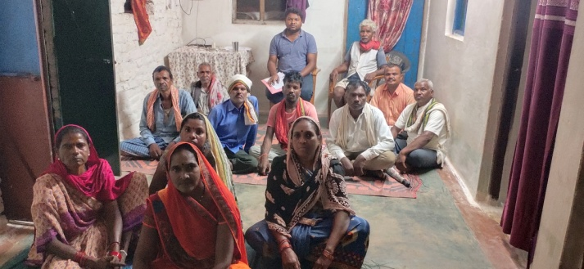  1. Gouri Shakti Fisheries cooperative society Bhatganv, Block - Niwas | 2. Maa Durga Fisheries cooperative society Jilhati, Block – Niwas
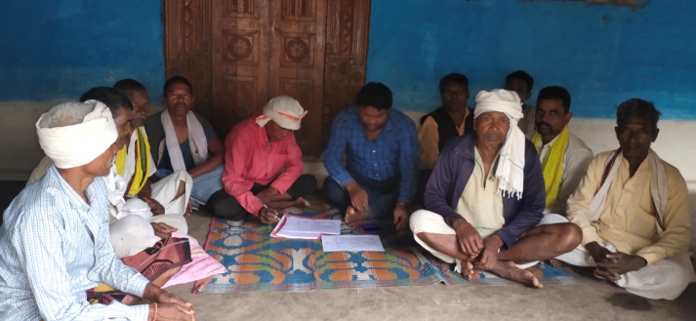  3. Maa Narmada Adiwasi Fisheries cooperative society Kohani, Block – Niwas | 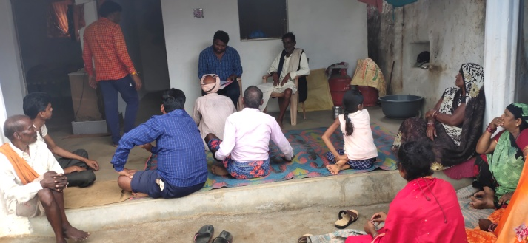  4. Maa Narmada Fisheries cooperative society Jilhata Manjhganv, Block – Niwas
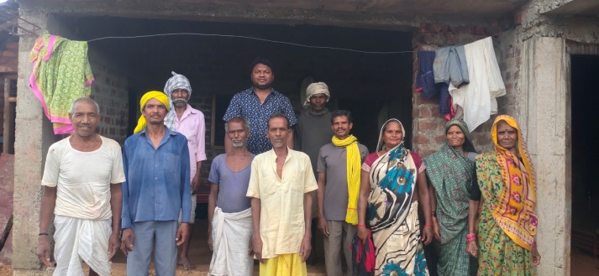5. Adiwasi Fisheries cooperative society Mudjhore, Block – Niwas | 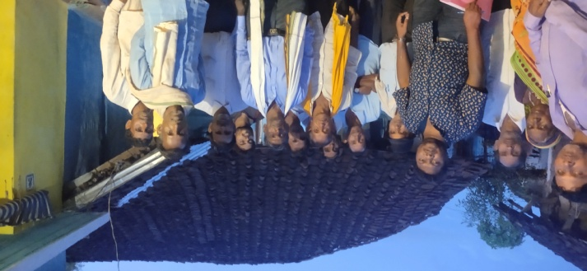6. Maa Reva fisheries cooperative society pondi, Block – Niwas

Plate No. 1: Physical meeting with six Fishery Cooperative Societies members

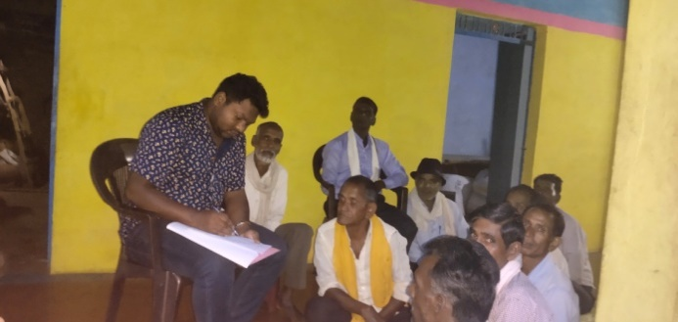  Group discussion with Society | 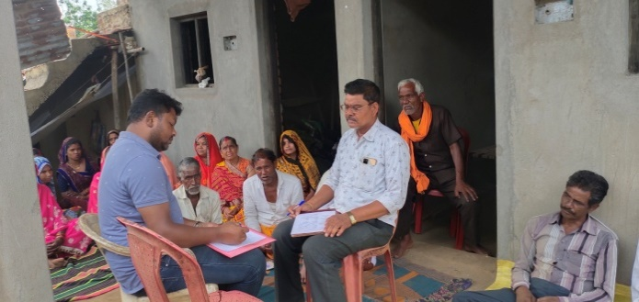  Group discussion with Society Member
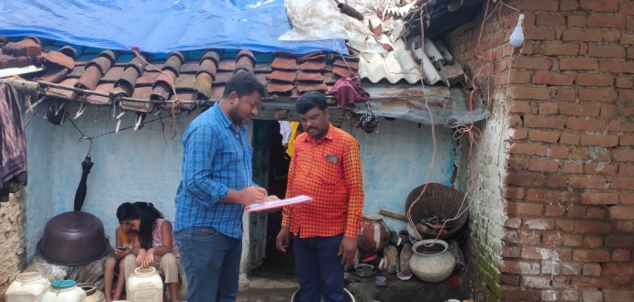  House condition of fisherman | 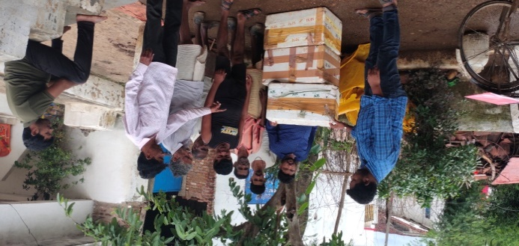  Discussion about Icing box and Market
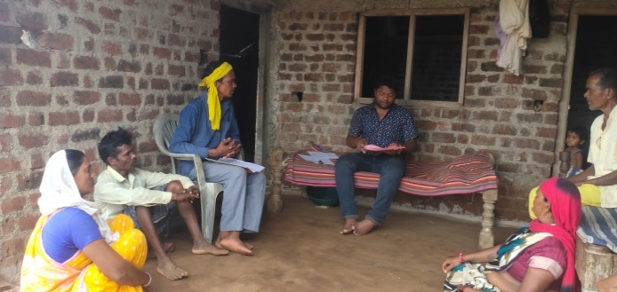  Pakka House Fisherman discussion | 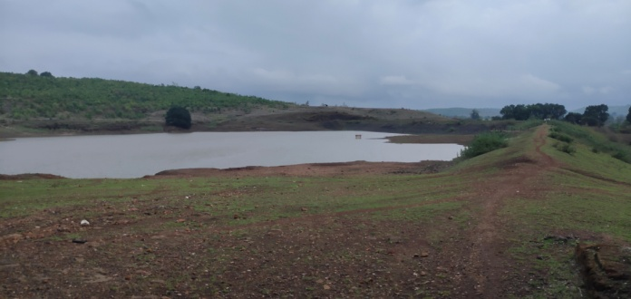  A view of Reservoir in Jilhati
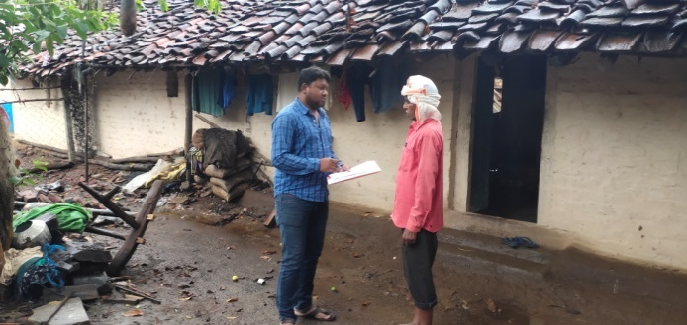  Traditional agriculture equipment of fisherman | 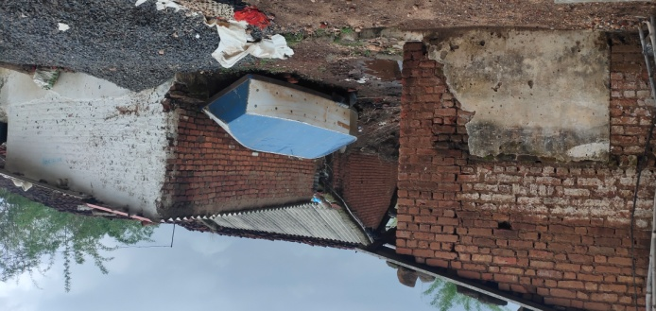  Fishing Boat Keep outside the reservoir

Plate No. 2: Data collection and site visit

