Journal Name: | Advances in Research
Manuscript Number: | Ms_AIR_135054
Title of the Manuscript: | Approaches to ensuring accessibility of web applications for users with disabilities
Type of the Article

PART 1: Comments

 | Reviewer’s comment  Artificial Intelligence (AI) generated or assisted review comments are strictly prohibited during peer review. | Author’s Feedback (It is mandatory that authors should write his/her feedback here)
Please write a few sentences regarding the importance of this manuscript for the scientific community. A minimum of 3-4 sentences may be required for this part. | The importance of this manuscript lies in the fact that the three ways of looking which are theoretical research, technological optimization and targeted application solutions in the main goal are to combine into a single concept that results in effective usability of applications for people with disabilities. The article introduces the basic directions with examples, presents the basic elements to be considered in the design of web applications, the key methods of proper technological integration and the main conclusions based on the results of other studies.  The article is easy to read, the content should be well interpreted even by those outside the IT community. The sentences are not overly elaborate, and the hypothesis posed responds to a real and current problem. Using a specific example of WHO statistics allows the reader to more easily visualize the complexity of the issues discussed in the article. The article is a good introduction to the general topic related to the future and increasingly widespread need for digitalization for people with all types of disabilities.
Is the title of the article suitable?  (If not please suggest an alternative title) | Yes, the title of the article is suitable, but I suggest adding two keywords so that the title directs to the mentioned integration and adaptive approach.  “Integrated adaptive approaches to ensuring accessibility of web applications for users with disabilities”  The change is due to the overly general meaning of the word “approaches.” The words “integrated and adaptive” directly refer to the main topic of the article, so it will be easier for people looking for this particular branch of application design to come across the content of this article.
Is the abstract of the article comprehensive? Do you suggest the addition (or deletion) of some points in this section? Please write your suggestions here. | Yes, the abstract is comprehensive.  The article correctly explains the purpose and describes the hypothesis, lists examples of positions of people for whom the content will be helpful for further development within the application-related topics.  The only suggestion is to add the word “web applications”
Is the manuscript scientifically, correct? Please write here. | Yes, the manuscript is scientifically correct.  It contains a general introduction to the problem, supported by statistical data cited after the WHO, the stated purpose and the hypothesis set, which at the end of the article is confirmed, the methodology of the study is defined, supported by theoretical issues on current sources, the results are discussed along with the general conclusion set.  The only remarks refer to minor corrections of the visual sphere, sentence formation or generalization of some concepts in the field of computer science- specific indications are given in the Optional/General comments
Are the references sufficient and recent? If you have suggestions of additional references, please mention them in the review form. | Yes, the references are sufficient and recent.  I suggest quoting two key terms in the context of the regulatory framework- adding a link to the creator's site which is the W3C- World Wide Web. The mention will enrich the content and support the references contained in the content. A good placement of the footnote is the following sentence from the article:  “The theoretical basis of accessibility is formed on the principles proposed by international standards, including Web Content Accessibility Guidelines (WCAG) and WAI-ARIA (Accessible Rich Internet Applications) specifications”- prepared by W3C- The World Wide Web Consortium.  References: W3C, https://www.w3.org.  I suggest also to correct and place sources under figure no 1 and tables no 1 and 2. Their absence or wrong placement causes in the reader the need to answer the question of whether they are a citation of a book issue, whether they are the result of a conclusion based on someone else's thoughts or whether it is the authorial scheme of the person writing the article. The proposed layout is below, along with commentary on the appropriate description depending on the source used:  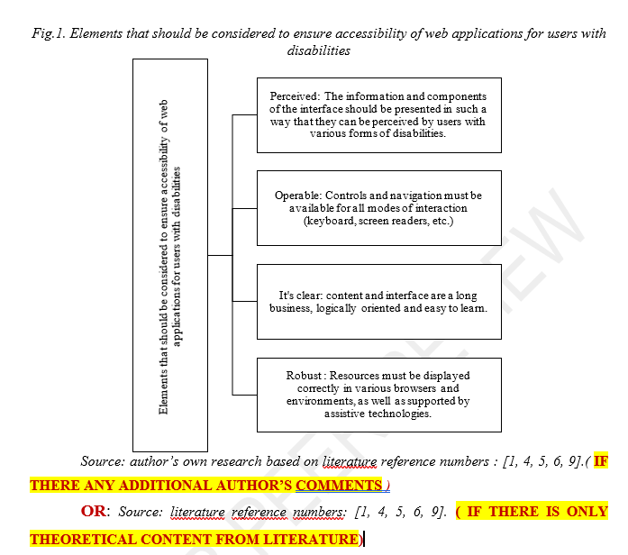  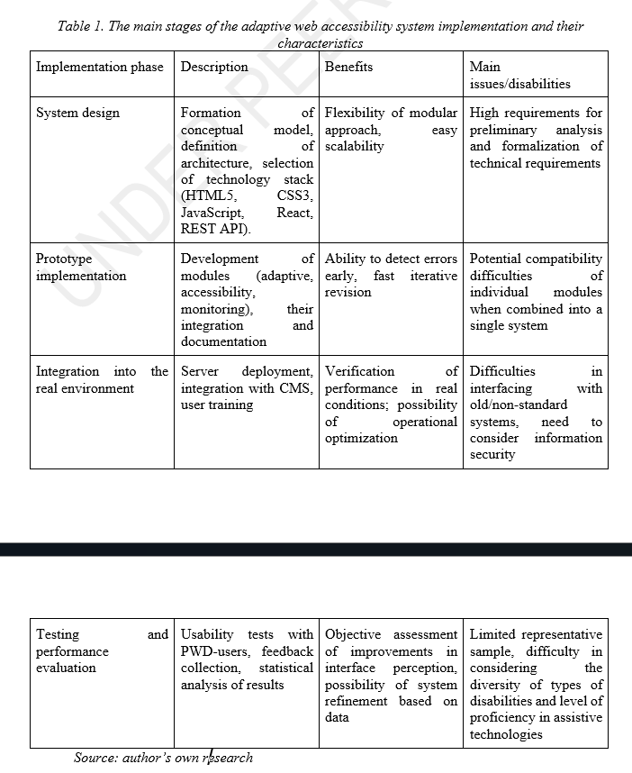
Is the language/English quality of the article suitable for scholarly communications? | Yes, the text reads smoothly and in an understandable way. No detected typos or contextual errors, or translation errors in the translation into another language
Optional/General comments | Comments in demand to the development of definitions within a facilitated description for readers outside the IT community and shortening sentences within a clear view:  - Shortening the sentence below:  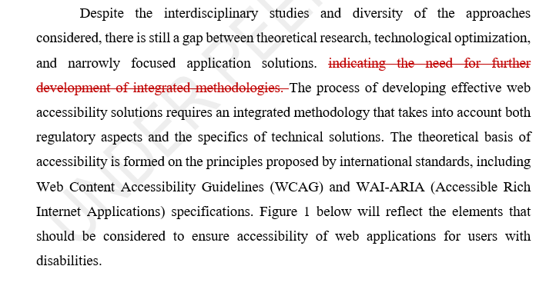  - Expansion of the definition of rendering- a word appearing several times, can make the subject difficult or incomprehensible to those not familiar with IT. A good placement of the correction is the following sentence from the article:  “The second direction focuses on technological optimization of visualization and rendering- which is generating photorealistic images analyzing points of light.”  - Expansion of the definition of semantic labelling- the reason is the same as above. A good placement of the correction is the following sentence from the article:  “In addition to WCAG, WAI-ARIA recommendations are used in the development and evaluation of accessibility, which allow effective semantic labelling (a set of tags that complement the html coding language) of interface elements.”  - Expansion of the definition of DOM- the reason is the same as above. A good placement of the correction is the following sentence from the article:  “Module development. The adaptive module is built on modern CSS3 and JavaScript tools that allow you to dynamically change the DOM structure ( Document Object Model).”

PART 2:

 | Reviewer’s comment | Author’s Feedback (It is mandatory that authors should write his/her feedback here)
Are there ethical issues in this manuscript? | (If yes, Kindly please write down the ethical issues here in detail)

Reviewer details:

Sandra Syc, The School of Banking and Management in Krakow, Poland

