Water Footprint in Agriculture Production System: An Analysis

.
ABSTRACT
The study presents a systematic bibliometric analysis of agricultural water footprint research all over the world. A total of 2,084 journal articles published during the year 2000 to 2024 were collected and catalogued using lens.org platform. Water footprint, blue water, green water, and grey water in the context of agriculture were the terms employed for selecting the articles. The dataset was subjected to advanced filtering and refinement using the processing techniques in R and Office Excel 2019. VOSviewer (v1.6.20) was used for depicting the key research trends, influential academics, and cooperative networks that shaped the field in the bibliometric maps. The results showed that the number of publications has increased at the CAGR of 21.97% since 2010, reflecting growing global concerns about sustainable water management in agriculture. Co-authorship and citation analysis highlight the contributions of Arjen Y. Hoekstra, Mesfin Mekonnen and Johan Rockström, while the co-occurrence mapping of keywords highlights the critical intersections with climate change, life cycle assess-ment, and virtual water. Publishing and funding areas were dominated by major publishers such as Elsevier, MDPI, Springer and supported by a variety of global funding bodies, strengthening collaborative research ecosystems.

Keywords: Water footprint; Green water; Grey water; Blue water; Agriculture; Bibliometric analysis.
1. INTRODUCTION

Worldwide, the largest freshwater consumer is agriculture, consuming more than 70% of the world’s freshwater (Lucrezia et al., 2014). Consumption of agricultural products determines the global water footprint related to consumption (Sarma, 2019, Hoekstra, 2003, Hoekstra et al, 2011, Mekonnen and Hoekstra, 2011). Therefore, proper knowledge on water footprint of agricultural products is quite necessary.
Bibliometrics is a discipline that applies scientific and statistical methods for analysis of publications (Rousseau & Rousseau, 2017; Zuccala, 2016; Zupic & Čater, 2015). Finding research outputs in a specific field enables scholars to determine emerging topics and frontier research which guide them to plan their future line of research. Through bibliometric analysis, researchers can gather a detailed understanding of publications, including authors, keywords, countries, publishing institutions, and cited references. Popular software tools for such analyses include CiteSpace (Chen, 2004, 2006), VOSviewer (van Eck & Waltman, 2010), “bibliometric”, and R package (Aria & Cucurullo, 2017). These visualisation tools have been active in various fields (Fan et al., 2020; Glynatsi & Knight, 2021; Iftikhar et al., 2019; Moustakas, 2022; Rojas-Sánchez et al., 2023; Wu et al., 2023; Moshahary et al., 2024). Of late, there have been numerous bibliometric studies on different subjects. However, to the best of our knowledge, bibliometric studies on water footprint in agriculture have not been conducted so far. Given the importance of the subject for sustainable water management in agricultural practices, a bibliometric analysis was carried out on research papers in the field of water footprint in agriculture published during the period 2000 to 2024.

2. material and methods

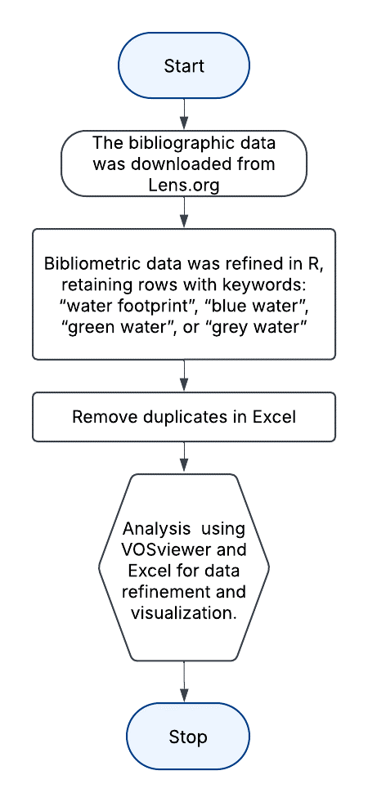
A comprehensive and systematic review of the global academic literature on agricultural water footprint was conducted based on research papers published all over the world during 2000 to 2024 using lens.org platform. The criteria employed for query and filtering the bibliometric data are given below:
• Query: (“water footprint" OR (“blue water" OR (“green water" OR "grey water”))) AND agriculture
• Filter: Year published = (2000-2024), Publication type = (journal article)
The retrieval of the bibliometric data was carried out on March 20, 2025, ensuring the most recent and relevant studies only. R software was used during the data retrieval process for eliminating and filtering the publication to be used for the study. The articles carrying the terms ‘water footprint’, ‘blue water’, ‘green water’, or ‘grey water’ at least once in the title, abstract, or keywords column were only consider for the study. Moreover, we have removed all duplicate articles using lens ID in Office Excel 2019. The working flow diagram used for the study are shown in Figure 1. After refining the data, a total of 2084 documents were considered for the bibliometric analysis which was executed using VOSviewer (Version 1.6.20).
Fig.1. Flowchart of Analysis
3. results and discussion

3.1. Quantitative analysis of publication
After refining the search strategy and eliminating duplicate entries, a total of 2084 unique articles have been identified till December 2024. As depicted in Figure 2, the number of research articles on water footprint in agriculture has grown substantially over the past two decades. A sharp increase was observed from 2010 onwards, reflect-ing a rising global interest in sustainable water management practices. The publica-tions in this field accelerated at an impressive compound annual growth rate (CAGR) of 21.97% during the period from 2000 to 2024
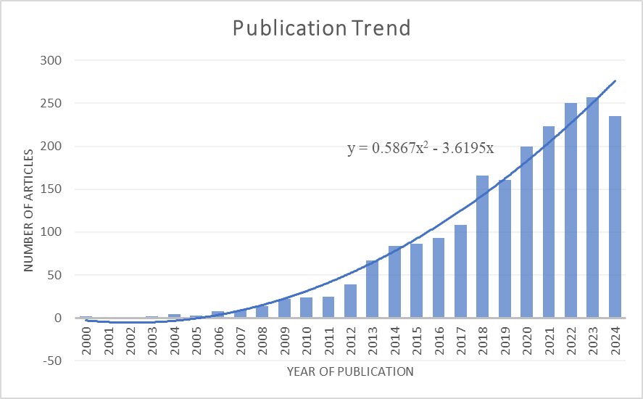

Fig.2. The trend of publications during the study period
3.2 Co-authorship Analysis
For this purpose, authors who have published a minimum of 10 academic articles and received a good number of citations were considered. Scientists like Arjen Y. Hoekstra, Mesfin Mekonnen, and Johan Rockström stood out as the most cited researchers, reflecting the significant impact of their work on the academic community. On the other hand, Pute Wu and Yubao Wang showed notable collaborative strength, as demonstrated by their high total link strengths, which indicate frequent and diverse co-authorships with other researchers. Such collaboration metrics highlighted their pivotal role in the expansion and establishment of research networks. The co-authorship network, as illustrated in Figure 3, visually represents these key contributors and their interconnections, facilitating a deeper understanding of the dissemination of knowledge and the influence in the domain of water footprint analysis in agriculture.
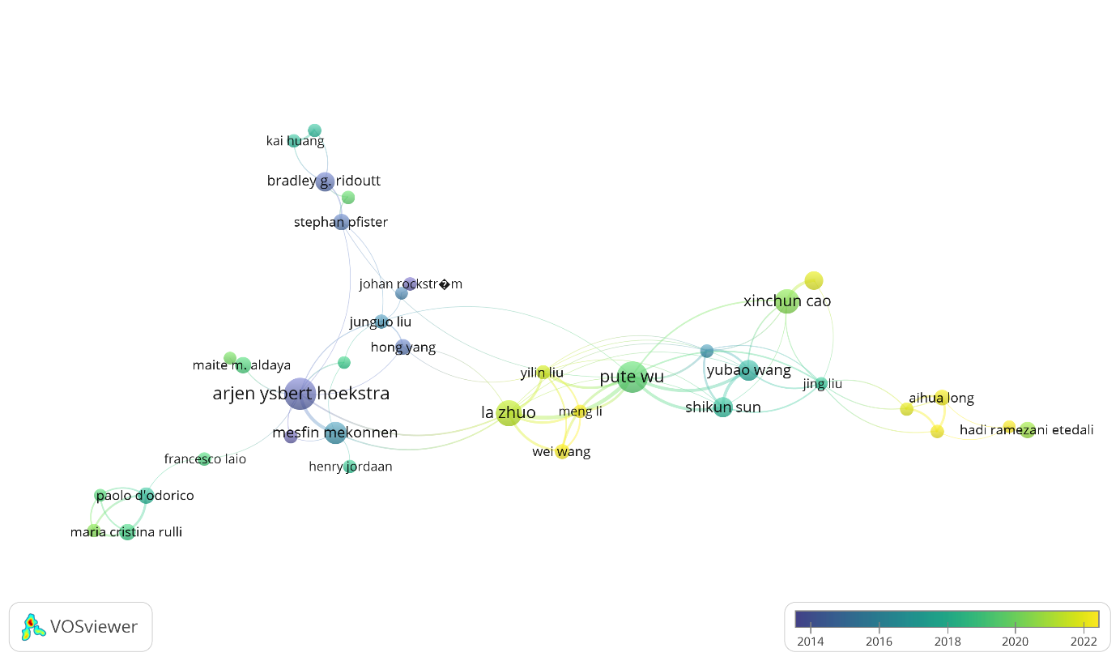

Fig.3. Co-authorship Analysis of Water Footprint in Agriculture
3.3. Citation analysis of articles
A threshold of at least 100 citations was considered to find out the influential publications in this field. Based on this criterion, 123 articles out of 2084 considered in the present study qualified as the most cited research publications. The selected articles were further analysed on their strength of citation links that showed how consistent the publication was within the citation network. The study revealed that the publication by Mesfin Mekonnen (2011) emerged as the most cited document with 1879 citations and a link strength of 119, followed by Arjen Y. Hoekstra (2012b) with 1768 citations and 90 links, and Arjen Y. Hoekstra (2006) with 1303 citations and 56 links. Other key contributions include publications by Tom Gleeson (2012), Mesfin Mekonnen (2012a) and Stefanie Rost (2008), all of whom had received substantial academic attention and exhibited strong connectivity within the research network as shown in Figure 4. These findings formed a critical factor in the study, providing in-formation on trends in knowledge dissemination and collaboration.
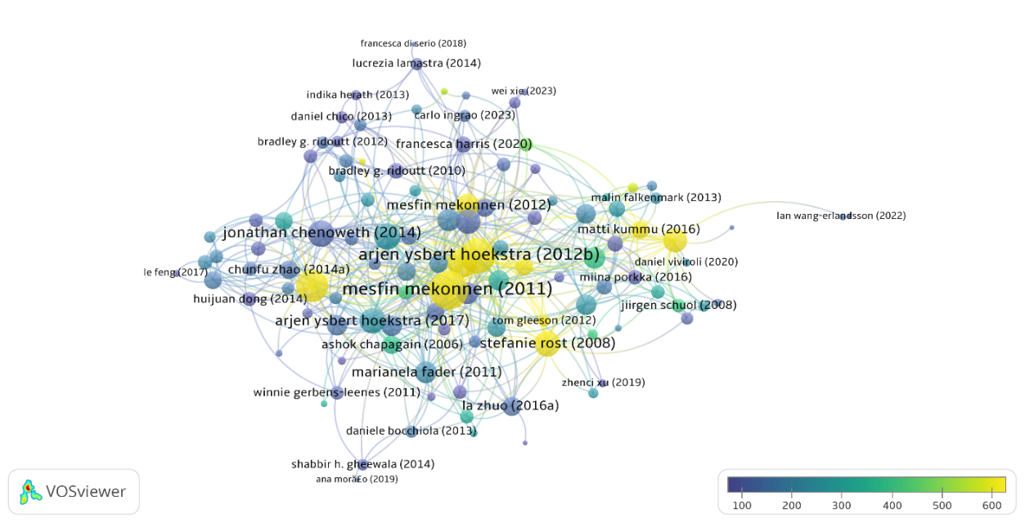
Fig.4. Citations pool and strength link of the publications
3.4. Co-occurrence of Keywords
The analysis uses the co-occurrence method with the author keyword and complete counting, selecting keywords with a minimum occurrence threshold of 5 with VOSviewer. Of the 1,156 keywords, 36 met the threshold and weighed importance in the field. Among them, "water footprints" emerged as the most dominant keyword with 152 mentions and a total link strength of 181, followed by "climate change" (32 mentions), "carbon footprints" (24 mentions), "life cycle assessment" (21 mentions) and "China" (25 mentions). The resulting visualizations revealed a dense network of inter-related themes such as "agriculture", "food security", "virtual water", "sustainable" and "water scarcity", which shows the interdisciplinary nature of water-related research. The map also highlighted the importance of various water components, such as “green water”, “blue water” and “grey water”, in addition to broader issues such as “food consumption”, “environmental impact” and “irrigation”. The analysis of this network provided a comprehensive overview of the evolution of research directions and inter-connections in water resource management, sustainability, and environmental assessment, as shown in Figure 5.
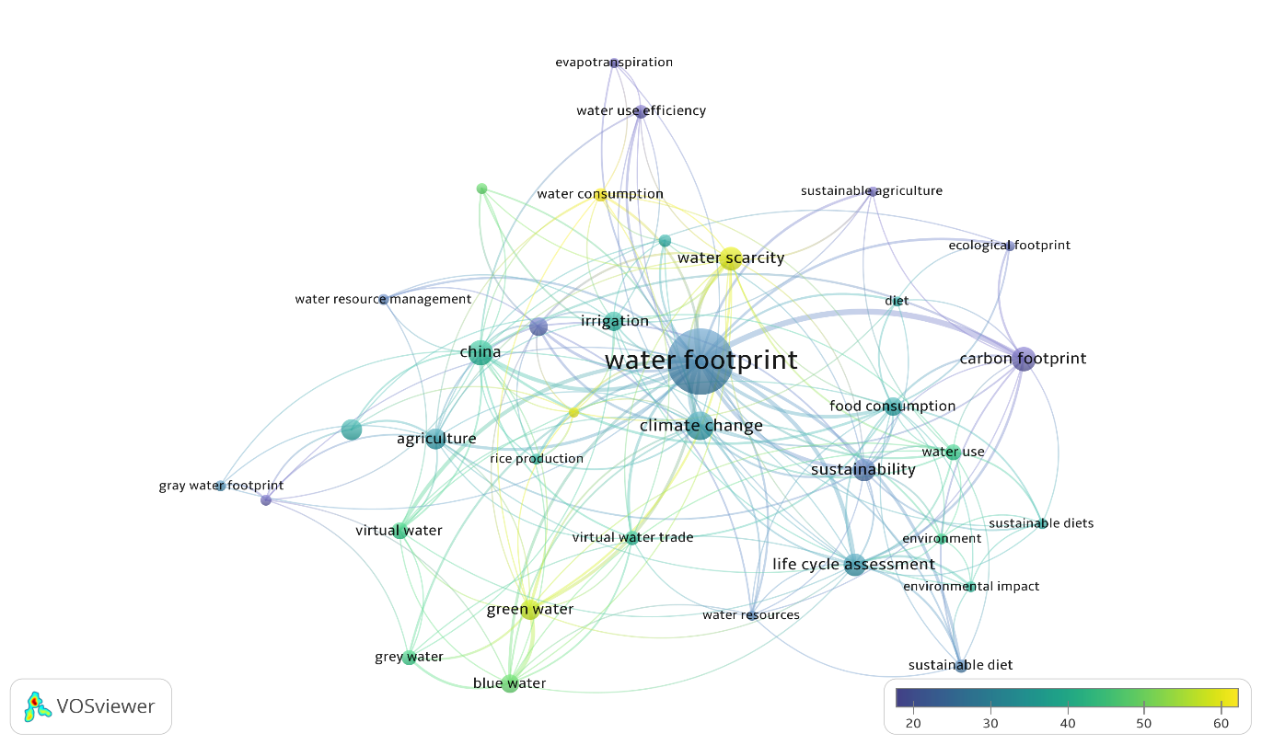
Fig.5. Keyword analysis for water footprint in agriculture
3.5. Bibliometric coupling by authors
Using VOSviewer, a bibliometric coupling analysis was conducted on 6,755 authors in the field of water footprint in agriculture. Employing a filter to retain authors(s) with at least five publications, 158 authors were retained. The nodes in the resulting network represented the authors; edges showed the strength of their biblio-metric coupling (i.e., the similarity of their cited references).
Several key authors (e.g., Pute Wu, Arjen Ysbert Hoekstra) exhibited high link strengths, suggesting strong foundational or widely cited work. The network map clustered the authors into colour-coded groups, each sharing thematic or methodological similarities such as global virtual water trade, life cycle assessment approaches, or regional case studies. These groups revealed distinct ‘schools of thought’ in the field, highlighting both established research communities and potential areas for interdisciplinary collaboration. This bibliometric overview helps in identifying influential scholars, tracing collaborative patterns, and pinpointing emerging topics relevant to water footprint in the agriculture domain as shown in Figure 6.
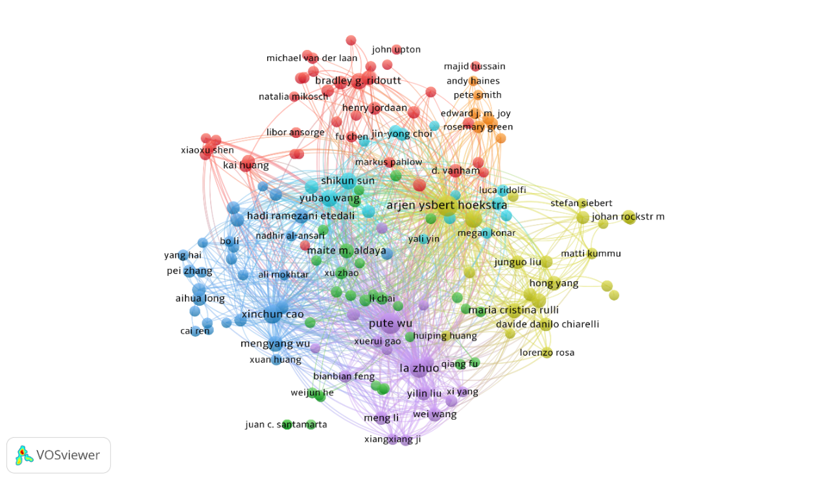
Fig. 6. Bibliometric coupling by author’s contributions
3.6. Publication and Funding Sources
The water footprint in the agriculture research domain demonstrated both a concentrated publisher landscape and a diverse range of funding sources. Among 2,084 articles in our dataset, nearly 23.12% were published by Elsevier BV, followed by MDPI AG (15.06%) and Springer Science and Business Media LLC (14.11%). These three publishers collectively represented more than half of the total articles, highlighting their central role in the dissemination of research in this field. Other prominent publishers included Elsevier (as a separate entity), Wiley, IWA Publishing, IOP Publishing, Copernicus GmbH, and Informa UK Limited, reflecting a mix of both specialized and broad-based outlets contributing to the scholarly dialogue.
With respect to funding agencies, the National Natural Science Foundation of China (NNSFC) emerged as the leading contributor, supporting 31 publications. Other significant funding sources included the National Science Foundation (USA), the Water Research Commission (South Africa), and various European funding bodies such as the European Commission and the Horizon 2020 Framework Programme. Additionally, specialized grants, such as those from the China Scholarship Council and the Bun-des ministerium für Bildung und Forschung (Germany), indicated targeted regional or thematic support. Although most of the research was clearly linked to recognizable institutions, a notable portion was funded by ‘unknown’ sources, suggesting gaps in acknowledged support or reporting.
Together, these insights underlined the global and interdisciplinary nature of the water footprint in agricultural research. The presence of dominant publishers, combined with funding from various regional and international agencies, suggests a broad and collaborative ecosystem. While the major publishers offered widespread visibility and potentially high impact on the one hand, funding from multiple regions drives a variety of methodological and geographical perspectives on the other hand. As such, understanding these patterns will help researchers and policy makers pinpoint collaboration opportunities, and to identify influential research hubs, and recognize potential gaps or biases in the literature.
3.7. Forecast Analysis of Publication Trends
Based on the data for 2000 to 2024 and using Excel 2019, projected publication has been forecasted till 2031 (Figure 7). The forecast (blue line) suggested a continued increase in articles on the water footprint in agriculture, underscoring its growing im-portance. The upper and lower confidence bounds (orange lines) showed a 95% confidence interval, illustrating potential variation based on factors like funding and policy shifts. In general, the forecast indicated that interest in sustainable water use in agriculture is likely to remain strong, providing guidance to researchers and policy makers in planning future initiatives.

Fig.7. Forecasting publications till 2031

4. Conclusion

The comprehensive bibliometric exploration of the water footprint research in agriculture underscored the dynamic growth and interdisciplinary reach of the field. The substantial increase in publications since 2010 reflected a greater global awareness of sustainable water management in agricultural practices. Co-authorship and citation analyses point to the pivotal contributions of leading scholars such as Arjen Y. Hoeks-tra, Mesfin Mekonnen, and Johan Rockström, whose influential works continue to shape academic discourse. Meanwhile, collaborative strength, exemplified by re-searchers like Pute Wu and Yubao Wang, highlighted the importance of network building for advancement of knowledge.
Keyword co-occurrence mapping confirmed the interwoven nature of topics such as climate change, life cycle assessment, and virtual water, illustrating how water foot-print research connects environmental, social, and economic dimensions. Bibliometric coupling analysis further revealed distinct thematic clusters, signaling both well-established research trajectories and emerging areas ripe for exploration.
The publishing and funding landscape demonstrated a focused publishing environment led by major outlets such as Elsevier BV, MDPI AG, and Springer alongside a diverse array of funding agencies around the world. This combination suggested a global collaborative ecosystem that can simplify impactful cross-border research initiatives. Finally, forecasting was performed, and the findings of this bibliometric assessment can help researchers, funding agencies, and policy makers identify key research centers, foster interdisciplinary partnerships, and address current research gaps in the field of water footprint in agriculture.

Data Availability Statement

Data supporting this study are available with the authors and can be freely provided upon request or can be download from lens.org.

References

Aria, M., & Cuccurullo, C. (2017). bibliometrix : An R-tool for comprehensive science mapping analysis. Journal of Informetrics, 11(4), 959–975. https://doi.org/10.1016/j.joi.2017.08.007
Sarma, B., Kotoky, U. and Bora, S. S. (2019). Water footprint in horticultural crops. International Journal of Chemical Studies, 7(4), 725-732.
Chen, C. (2004). Searching for intellectual turning points: Progressive visualisation of the knowledge domain. Proceedings of the National Academy of Sciences, 101(suppl_1), 5303–5310. https://doi.org/10.1073/pnas.0307513100
Chen, C. (2006). CiteSpace II: Detecting and visualising emerging trends and transient patterns in the scientific literature. Journal of the American Society for Information Science and Technology, 57(3), 359–377. https://doi.org/10.1002/asi.20317
Fan, J., Gao, Y., Zhao, N., Dai, R., et al. (2020). Bibliometric Analysis on COVID-19: A Comparison of Research Between English and Chinese Studies. Frontiers in Public Health, 8. https://doi.org/10.3389/fpubh.2020.00477
Glynatsi, N. E., & Knight, V. A. (2021). A bibliometric study of research topics, collaboration, and centrality in the iterated prisoner’s dilemma. Humanities and Social Sciences Communications, 8(1), 45. https://doi.org/10.1057/s41599-021-00718-9
Hoekstra, A. Y. (2003). The water footprint of food : Water for Food. Twente Water Centre, Univ. of Twente, The Netherlands.
Hoekstra, A. Y., Chapagain, A. K., Aldaya, M. M. and Mekonnen, M. M. (2011). The Water Footprint Assessment Manual: Setting the Global Standard. Earth Scan, London
Iftikhar, P. M., Ali, F., Faisaluddin, M., Khayyat, A., De Gouvia De Sa, M., et al. (2019). A Bibliometric Analysis of the Top 30 Most-cited Articles in Gestational Diabetes Mellitus Literature (1946-2019). Cureus. https://doi.org/10.7759/cureus.4131
Lucrezia, L., Nicoleta, A. S., Elisa, N., and Marco, T. (2014). A new approach to assessing the water footprint of wine: An Italian case study. Science of the Total Environment, 490, 748–756.
Mekonnen, M. M. and Hoekstra, A. Y. (2011). The green, blue and grey water footprint of crops and derived crop products. Hydrology and Earth System Sciences, 15, 1577–1600.
Moshahary, J., Choudhury, M., Ahmed, P., Sarma, B., et al. (2024). A bibliometric analysis of biochar in sustainable agriculture. International Journal of Research in Agronomy, 7(1S), 173–179. doi:10.33545/2618060x.2024.v7.i1sc.255
Moustakas, L. (2022). A Bibliometric Analysis of Research on Social Cohesion from 1994–2020. Publications, 10(1), 5. https://doi.org/10.3390/publications10010005
Rojas-Sánchez, M. A., Palos-Sánchez, P. R., & Folgado-Fernández, J. A. (2023). Systematic literature review and bibliometric analysis on virtual reality and education. Education and Information Technologies, 28(1), 155–192. https://doi.org/10.1007/s10639-022-11167-5
Rousseau, S., & Rousseau, R. (2017). Being metric-wise: Heterogeneity in bibliometric knowledge. El Profesional de La Información, 26(3), 480. https://doi.org/10.3145/epi.2017.may.14
Van Eck, N. J., & Waltman, L. (2010). Software survey: VOSviewer, a computer program for bibliometric mapping. Scientometrics, 84(2), 523–538. https://doi.org/10.1007/s11192-009-0146-3
Wu, Y., Meng, S., Liu, C., Gao, W., et al. (2023). A bibliometric analysis of research for climate impact on agriculture. Frontiers in Sustainable Food Systems, 7. https://doi.org/10.3389/fsufs.2023.1191305
Zuccala, A. (2016). Inciting the metric-oriented humanist: Teaching bibliometrics in a faculty of humanities. Education for Information, 32(2), 149–164. https://doi.org/10.3233/EFI-150969
Zupic, I., & Čater, T. (2015). Bibliometric Methods in Management and Organization. Organizational Research Methods, 18(3), 429–472.

