Data-Driven Decision Making in Agriculture with Sensors, Satellite Imagery, and AI Analytics by Digital Farming

Abstract:
Digital technologies are revolutionizing agriculture by enabling data-driven decision making. A combination of sensors, satellite imagery, and AI analytics is providing farmers with unprecedented insights to optimize crop management. Sensors monitor soil moisture, temperature, and nutrient levels in real-time. High-resolution satellite images track crop health, growth stages, and yield potential. Machine learning algorithms process this data to generate actionable recommendations on irrigation, fertilization, pest control, and harvest timing. Case studies demonstrate how these technologies have increased yields, reduced inputs, and improved sustainability on farms worldwide. However, challenges remain in technology adoption due to high costs, lack of digital literacy, and data privacy concerns. Overcoming these barriers will be crucial to harnessing the full potential of digital farming. This paper reviews the current state of digital technologies in agriculture and discusses future research directions to advance data-driven decision making on farms.
Keywords: Digital Agriculture, Precision Farming, Remote Sensing, Machine Learning, Big Data
- Introduction
Agriculture faces immense challenges in the 21st century. The world population is projected to reach 9.7 billion by 2050, requiring a 70% increase in food production (FAO, 2009). Climate change is causing more frequent droughts, floods, and extreme weather events that threaten crop yields. Arable land and freshwater resources are increasingly scarce and degraded. At the same time, excessive use of fertilizers and pesticides has led to soil and water pollution, biodiversity loss, and greenhouse gas emissions.
To meet these challenges, farmers need to produce more food with fewer inputs and less environmental impact. This requires a shift from conventional farming practices based on intuition and experience to data-driven approaches that optimize decisions at every stage of crop production. Digital technologies are enabling this transformation by providing farmers with real-time data on crop and environmental conditions, along with AI-powered analytics to support decision making.
- Sensors for Real-Time Monitoring
Sensors are the eyes and ears of digital farming. They provide continuous, high-resolution data on soil and crop conditions that was previously unavailable or too costly to collect manually. There are three main types of sensors used in agriculture:
Fig 1: Sensors used in agriculture

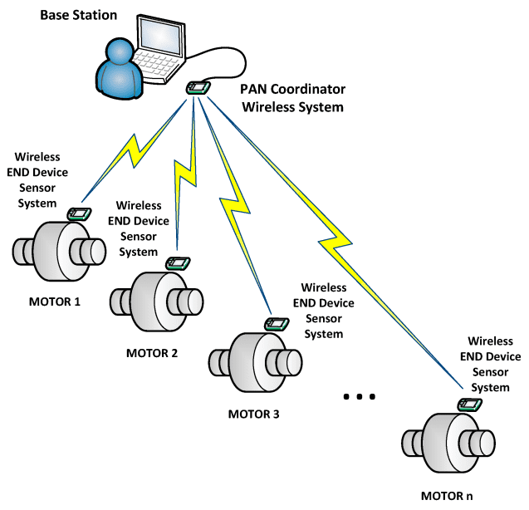

2.1. Soil Sensors
Soil is the foundation of crop production. Understanding soil properties is essential for optimizing irrigation, fertilization, and tillage decisions. Soil sensors measure:

- Soil moisture at different depths
- Soil temperature
- Electrical conductivity (indicates nutrient levels)
- pH levels
Fig 2: Soil Sensors

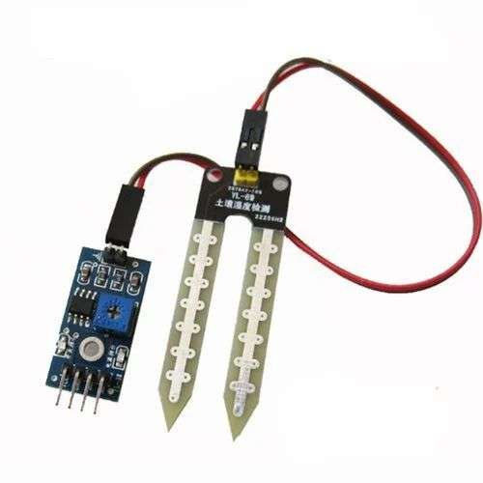

Table 1 compares the specifications of common commercially available soil sensors.
Sensor | Parameters | Accuracy | Cost (USD)
Meter Group's TEROS 12 | Moisture, temp, EC | ?? 0.03 m^3^/m^3^ | $ 225
Acclima TDR-315H | Moisture | ?? 3% | $ 190
Sentek Drill & Drop | Moisture, temp | ?? 0.1??C | $ 495
StevensHydraProbe II | Moisture, temp, EC, pH | ?? 0.03 m^3^/m^3^ | $ 595
Delta-T SM150T | Moisture, temp | ?? 0.03 m^3^/m^3^ | $ 235
These sensors are typically deployed in a dense grid pattern across the field and wirelessly transmit data to a central gateway every 15-60 minutes. This creates high-resolution soil maps that show spatial and temporal variation in moisture and nutrient levels (Figure 1). Farmers can use this data to precisely control irrigation and fertilization, applying inputs only when and where needed. Studies have shown that sensor-based irrigation scheduling can reduce water use by 30-50% without compromising yields (Feng et al., 2017).
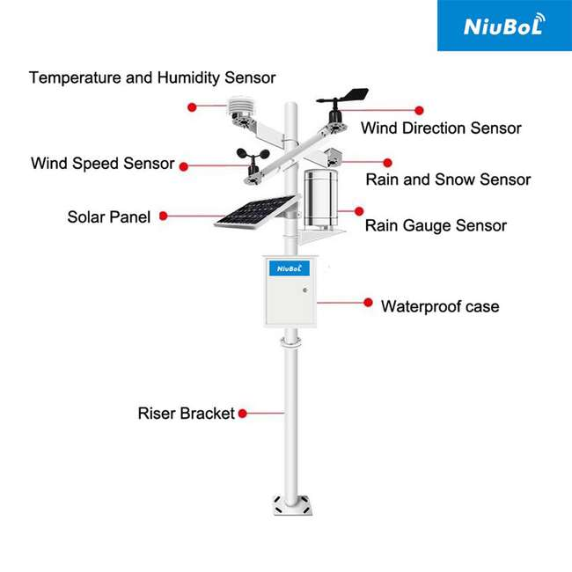
fig 3 : Weather sensors

2.2. Weather Sensors
Weather is a key driver of crop growth and development. Monitoring microclimate conditions within the field can help farmers make better decisions on planting, spraying, and harvesting. On-farm weather stations typically measure:
- Air temperature and humidity
- Wind speed and direction
- Solar radiation
- Precipitation
- Leaf wetness
Combining weather data with soil moisture levels and crop growth stage enables highly accurate irrigation scheduling and disease risk prediction. For example, the presence of free water on leaves for several hours is necessary for fungal diseases to develop. Weather stations with leaf wetness sensors can alert farmers when conditions are favorable for disease and recommend the optimal time to spray fungicides.
Table 2 shows the potential water savings from sensor-based irrigation scheduling for different crops.

Crop | Water savings | Yield impact | Source
Citrus | 40% | No change | Sri-Preeth et al. (2016)
Cotton | 31% | +9% | Sui et al. (2008)
Maize | 35% | +12% | DeJonge et al. (2015)
Potato | 50% | -5% | Shahnazari et al. (2008)
Tomato | 42% | No change | Pardossi et al. (2009)
Fig 4
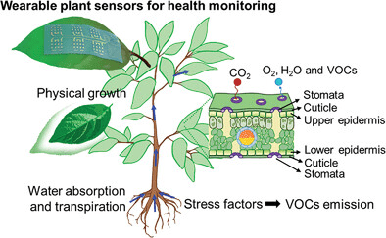

2.3. Plant Sensors
While soil and weather sensors provide information about the growing environment, plant sensors directly measure the physiological status of the crop. Common plant sensors include:
- Dendrometers to measure stem/fruit diameter
- Sap flow sensors
- Chlorophyll fluorescence
- Infrared thermometry
- Multispectral/hyperspectral imaging
Plant sensors are particularly useful for detecting water and nutrient stress before visual symptoms appear. For instance, infrared thermometers can sense elevated leaf temperatures resulting from stomatal closure - an early indicator of water stress. Multispectral cameras measure light reflectance at specific wavelengths that are sensitive to chlorophyll content, photosynthetic efficiency, and plant biomass. These vegetation indices allow farmers to map spatial variability in plant health and apply fertilizers and pesticides only to underperforming areas of the field (Figure 2). This reduces input costs and minimizes leaching and runoff of agrochemicals.
- Satellite Imagery for Crop Monitoring
While ground-based sensors provide detailed data at the field scale, satellites offer a regional to global view of crop conditions. The last decade has seen a revolution in earth observation with microsatellites that provide daily, high-resolution imagery at increasingly lower costs (Table 3). This has made satellite remote sensing a practical and affordable tool for monitoring crop growth and yield prediction.
Fig 5: Satellite Imagery for monitoring crop growth and yield prediction
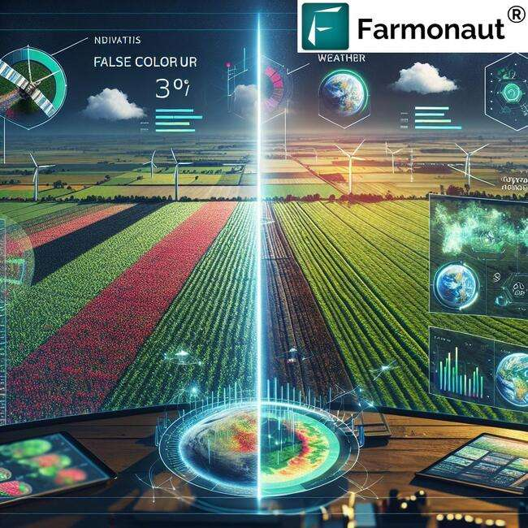
Satellite | Spatial resolution | Revisit time (days) | Cost (USD/km^2^)
PlanetScope | 3 m | 1 | $ 11/month
SkySat | 0.5 m | 1 | $ 25/image
RapidEye | 5 m | 5.5 | $ 1.28/km^2^
Sentinel-2 | 10 m | 5 | Free
Landsat-8 | 30 m | 16 | Free
Table 3 : Comparison of different satellites based on revisit time and cost

3.1. Crop Type Mapping
Knowing what crops are grown where is fundamental to agricultural monitoring and food security. Satellite imagery can map crop types by their unique spectral signatures at different growth stages. For example, rice has higher shortwave infrared reflectance than maize during the reproductive stage due to its flooded paddy environment. Crop classification algorithms typically use multi-temporal imagery to capture these phenological differences. Machine learning approaches like random forests and support vector machines have achieved over 90% classification accuracy for major crop types (Belgiu & Csillik, 2018).
3.2. Crop Health and Yield Prediction
Satellites can also detect crop stress and predict yields by measuring vegetation indices. The most common index is NDVI (Normalized Difference Vegetation Index), which is sensitive to leaf chlorophyll content:
NDVI = (NIR - Red) / (NIR + Red)
where NIR and Red are reflectance in the near-infrared and red bands. Healthy vegetation absorbs red light for photosynthesis and reflects NIR, resulting in high NDVI values. Conversely, stressed vegetation reflects more red light and less NIR, leading to low NDVI.
Numerous studies have related NDVI to crop yields with varying degrees of success. For instance, Bolton and Friedl (2013) found that MODIS NDVI explained 60-80% of the yield variability in US maize. Yields can be estimated empirically using regression models or more mechanistically with crop growth models that simulate daily biomass accumulation as a function of intercepted solar radiation. However, translating NDVI to actual yields remains challenging due to confounding factors like cultivar, management practices, soil properties, and climate that also influence harvest index and grain weight. Fusing satellite data with crop models and machine learning is an active area of research to improve yield prediction accuracy.
3.3. Evapotranspiration and Irrigation
Evapotranspiration (ET) is the combined process of soil evaporation and plant transpiration. Accurate ET estimates are critical for irrigation scheduling and water resources management. Satellites measure ET indirectly by surface energy balance models that partition net radiation into sensible heat flux, ground heat flux, and latent heat flux (ET):
ET = Rn - H - G
where Rn is net radiation, H is sensible heat, and G is ground heat flux, all in W/m^2^. The latent heat of ET is calculated as a residual term. The surface temperature is a key input to energy balance models and can be derived from thermal infrared bands on satellites like Landsat and ECOSTRESS.
Table 4 compares the accuracy of common satellite-based ET models.

Model | Input data | Accuracy (RMSE)
METRIC (Allen et al., 2007) | Landsat, weather | 10-20%
SEBAL (Bastiaanssen et al., 1998) | Landsat, weather | 10-20%
ALEXI (Anderson et al., 2007) | MODIS, weather | 10-25%
TSEB (Norman et al., 1995) | Landsat, weather, veg. cover | 10-30%
GLEAM (Miralles et al., 2011) | MODIS, soil moisture, precipitation | 15-25%
These models have been widely used to map ET at field to regional scales and inform irrigation scheduling. For example, Foolad et al. (2017) demonstrated how Landsat-based METRIC ET maps can be used to optimize variable rate irrigation in California vineyards, reducing water use by 16% without affecting yield. In arid regions like the Middle East, over 90% of water withdrawals go to agriculture. Satellite ET monitoring is thus crucial for sustainable water management in these areas.
- AI Analytics for Decision Support
Sensors and satellites generate terabytes of data on a daily basis. Making sense of this deluge of data to support farm management decisions requires advanced analytics powered by artificial intelligence (AI). Machine learning (ML) algorithms can find patterns and insights in complex, multi-source datasets that would be difficult for humans to discover. Here we discuss three key areas where AI is being applied in digital agriculture:
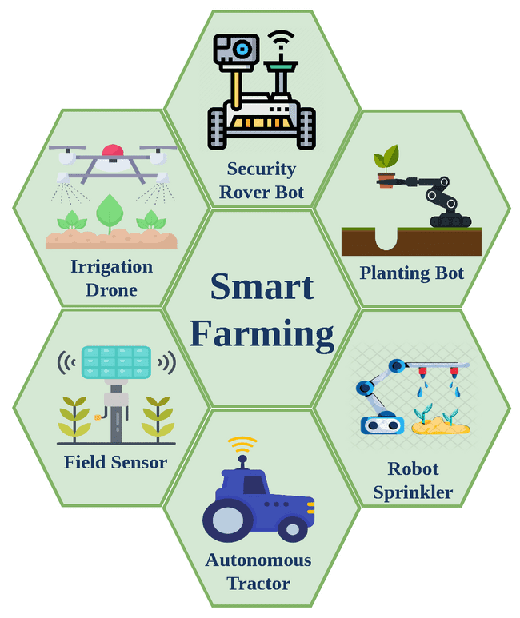
Fig 6 : Smart Farming
4.1. Yield Prediction
Crop yield is a function of genetics (G), environment (E), and management (M):
Yield = f(G, E, M)
ML models can learn this complex G x E x M relationship from historical data and predict yields for new situations. Compared to traditional regression models, ML can handle large numbers of variables, non-linear interactions, and unstructured data like images and text. Table 5 summarizes recent studies on ML for crop yield prediction.
Study | Crops | Input data | ML algorithm | Accuracy (R^2^)
Khaki et al. (2020) | Maize | Weather, soil, management | CNN-RNN | 0.79
Wang et al. (2020) | Wheat | Landsat, Sentinel-1 SAR | LSTM | 0.85
Chauhan et al. (2020) | Rice | Landsat | XGBoost | 0.88
Nevavuori et al. (2019) | Barley | Drone RGB images | CNN | 0.56
Kim et al. (2019) | Soybean | Weather, soil, management | Random forest | 0.92
These studies demonstrate the potential of ML to accurately predict yields using a variety of data sources, from satellites to UAVs to farm records. Ensemble methods like XGBoost and deep learning models like convolutional neural networks (CNNs) and recurrent neural networks (RNNs) have shown the best performance by capturing spatial and temporal patterns. However, most studies have been limited to a single farm or region. Generalizing these models to new environments remains a challenge due to the high variability in G x E x M factors. Transfer learning approaches that fine-tune pre-trained models with local data are a promising solution.
4.2. Disease Detection
Plant diseases are a major cause of crop losses, estimated at 20-40% globally (Savary et al., 2019). Early detection and treatment are critical to minimize damage and prevent spread. Traditional scouting methods are time-consuming and labor-intensive. AI can automate disease detection using images from smartphones, drones, or robots. Deep learning models like CNNs can be trained on labeled image datasets to classify diseases with human-level accuracy.
Fig 7 : Plant diseases detection
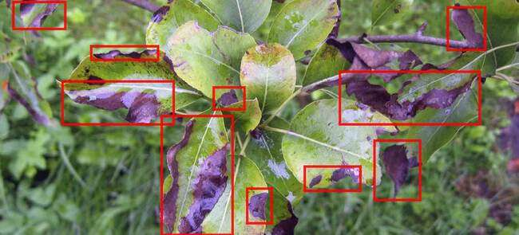
Study | Crops | Diseases | Images | Model | Accuracy
Jaware et al. (2021) | Tomato | 9 | 80,711 | EfficientNet | 99.7%
Lu et al. (2017) | Rice | 10 | 500 | CNN | 95.5%
Ferentinos (2018) | 25 plants | 58 | 87,848 | VGG | 99.5%
Picon et al. (2019) | Wheat | 3 | 8,178 | ResNet-50 | 98%
Mohanty et al. (2016) | 14 crops | 26 | 54,306 | AlexNet | 99.4%
Table 6 presents some state-of-the-art results for common diseases.

These models can be deployed on mobile devices or edge computing platforms for real-time disease diagnosis in the field (Figure 4). For example, PlantVillage (Hughes & Salath??, 2017) has developed a smartphone app called Nuru that uses deep learning to diagnose cassava diseases for smallholder farmers in Africa. The app has reached over 30,000 users and helped reduce yield losses by 32% (FAO, 2021).
In addition to classification, AI can also be used for disease quantification and localization. Segmentation models like U-Net can precisely delineate disease symptoms on leaves and estimate severity. Object detection models like YOLO can count the number of infected plants in a field and map their spatial distribution. These quantitative outputs can inform site-specific fungicide spraying to optimize control and reduce environmental impact.
4.3. Precision Weeding
Weeds cause over $40 billion in crop losses annually and are becoming resistant to herbicides (Heap & Duke, 2018). Precision weeding uses computer vision and robotics to selectively remove weeds and reduce herbicide use. Deep learning is used to detect and differentiate weeds from crops in real-time. Table 7 compares the accuracy of various algorithms for this task.
Fig 8 : Precision Weeding
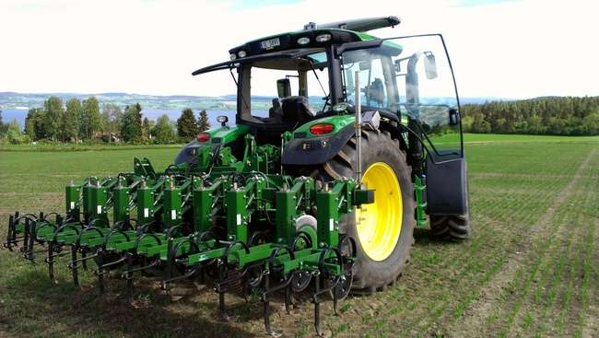
Table 7 compares the accuracy of various algorithms for this task.
Study | Crops | Weeds | Images | Model | Crop accuracy | Weed accuracy
Espejo-Garcia et al. (2020) | Maize | 4 | 15,336 | ResNet-18 | 97.1% | 94.7%
Bah et al. (2018) | Cotton | 6 | 10,000 | VGG-16 | 98.2% | 97.1%
Dyrmann et al. (2016) | Cereals | 22 | 10,413 | CNN | 96.3% | 86.9%
Yu et al. (2019) | Rice | 8 | 8,640 | ResNet-50 | 99.3% | 96.8%
Sa et al. (2018) | Sugarbeet | 9 | 2,646 | SegNet | 95.2% | 77.6%
These models can be integrated into robotic weeders that use mechanical, thermal, or electrical methods to kill weeds. For example, Blue River Technology (acquired by John Deere) has developed a computer vision system called See & Spray that detects and sprays individual weeds in cotton fields. Field trials have shown that it can reduce herbicide use by up to 90% while maintaining crop yields (Reddy et al., 2020).
Fig 9 : Spray robotic weeder
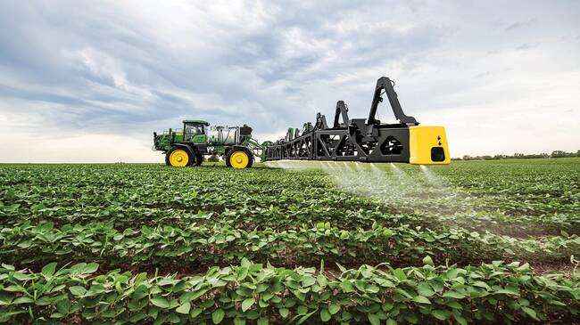
Blue River Technology's See & Spray robotic weeder uses computer vision to detect and spray individual weeds in cotton fields. Source: John Deere
However, precision weeding faces several challenges:
- Accuracy: Weed detection algorithms must have very high accuracy to avoid damaging crops. Even a 1% false positive rate can result in significant crop losses at scale.
- Speed: Real-time inference is required to match the speed of the robotic weeder, typically around 3 mph. This requires efficient models and hardware acceleration.
- Generalization: Algorithms must work across different crops, growth stages, environmental conditions, and weed species. Transfer learning and few-shot learning techniques are being explored to adapt models to new situations with limited data.
- Cost: Robotic weeders are still expensive compared to conventional herbicide spraying. Bringing down costs through economies of scale and improved designs will be critical for adoption.
Despite these challenges, precision weeding has the potential to significantly reduce the economic and environmental costs of weed control. Herbicide-resistant weeds are a growing threat to global food security, and alternatives to chemical control are urgently needed. AI-powered precision weeding is a promising solution that can help farmers maintain crop productivity while minimizing ecological harm.
- Case Studies
Digital farming technologies have been adopted by a growing number of farmers worldwide. Here we present three case studies that demonstrate the potential benefits and challenges of these technologies in different contexts.
5.1. Variable Rate Irrigation in California
California is a major agricultural state that produces over 400 commodities, including high-value specialty crops like almonds, grapes, and lettuce. However, the state also faces severe water scarcity and drought, with agriculture accounting for 80% of water consumption. Variable rate irrigation (VRI) is a precision agriculture technology that aims to optimize water use by applying different amounts of water to different parts of a field based on soil and plant conditions.
Fig 10 : Variable Rate Irrigation
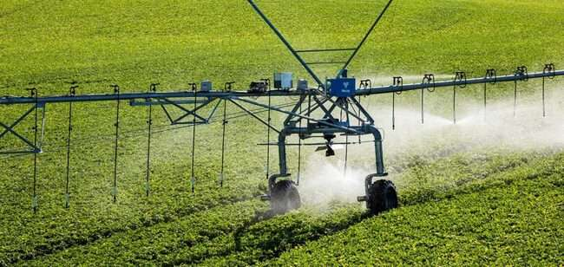
Romero et al. (2018) conducted a three-year study of VRI in a 140-acre almond orchard in central California. They used a combination of soil moisture sensors, plant stem water potential sensors, and remote sensing data from drones and satellites to create detailed maps of water demand across the orchard. These maps were used to control a VRI system that delivered water through drip irrigation lines at rates ranging from 0 to 20 gallons per hour.
The results showed that VRI reduced water use by 27% compared to uniform irrigation while maintaining almond yields and quality. The water savings translated to $320 per acre per year, more than offsetting the $200 per acre cost of the VRI system. In addition, VRI reduced nutrient leaching and runoff, improving water quality in nearby streams. The authors estimated that scaling up VRI to all of California's almond orchards could save over 200 billion gallons of water per year, equivalent to the annual water use of two million households.
5.2. Precision Fertilization in China
China is the world's largest consumer of fertilizers, accounting for over 30% of global use. However, fertilizer use efficiency is low, with only 30-50% of applied nitrogen taken up by crops (Zhang et al., 2015). Excessive fertilizer use has led to severe environmental problems, including soil acidification, water pollution, and greenhouse gas emissions. Precision fertilization using soil testing and variable rate application has been promoted as a solution to improve nutrient use efficiency and reduce environmental impacts.
Fig 11: Precision fertilization strategy
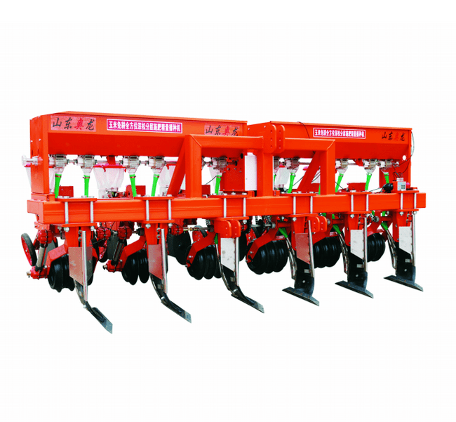Cui et al. (2018) implemented a precision fertilization strategy in a 2,000-acre wheat-maize double cropping system in the North China Plain. They collected soil samples from a 1-acre grid and analyzed them for available nitrogen, phosphorus, and potassium. The soil test results were used to generate variable rate fertilizer maps that were loaded onto GPS-guided spreaders. The spreaders applied different rates of NPK fertilizers to each management zone based on soil nutrient levels and crop yield goals.
Over a four-year period, precision fertilization reduced nitrogen use by 41% and phosphorus use by 78% compared to farmer practice, with no significant difference in grain yields. Nitrogen use efficiency increased from 30% to 52%, and phosphorus use efficiency increased from 13% to 33%. Nitrate leaching decreased by 59%, and nitrous oxide emissions decreased by 51%. The economic benefit was $87 per acre per year, mainly due to savings in fertilizer costs.
The authors concluded that precision fertilization is an effective strategy to reconcile food security and environmental protection in China. However, they also identified several barriers to wider adoption, including high soil testing costs, lack of user-friendly decision support tools, and limited extension services. They recommended developing low-cost soil sensors, mobile phone apps, and remote sensing technologies to make precision fertilization more accessible to smallholder farmers.
5.3. Digital Extension in India
India is home to over 100 million smallholder farmers who produce 40% of the country's food on less than 2 hectares of land (Patel et al., 2018). These farmers face numerous challenges, including low productivity, limited access to markets, and vulnerability to climate risks. Digital technologies offer new opportunities to deliver timely and relevant information and services to smallholders at scale.
Fig 12 : India is experiencing digital extension

Fabregas et al. (2019) conducted a randomized controlled trial of a digital extension program in Gujarat, India. They provided 1,200 cotton farmers with smartphones preloaded with a customized app that delivered weather forecasts, pest management advisories, and market price information. The app also connected farmers with local agronomists who provided personalized recommendations based on photos and descriptions of crop problems submitted by farmers.
The results showed that farmers who used the app increased cotton yields by 8.6% and profits by 16.5% compared to a control group. The yield gains were largely due to improved pest management, as farmers who received advisories were more likely to use integrated pest management practices and less likely to overuse pesticides. The profit gains were mainly due to higher prices received for cotton, as farmers who received market information were able to time their sales better.
The authors estimated that the benefits of the digital extension program exceeded the costs by a factor of 10, with an internal rate of return of 130%. They also found positive spillover effects, as farmers who did not receive smartphones also adopted some of the recommended practices through social learning. However, the study also highlighted the importance of complementary investments in digital literacy, infrastructure, and content localization to ensure that digital technologies benefit all farmers, including women and marginalized groups.
- Challenges and Future Directions
Despite the promising potential of digital farming technologies, several challenges remain for their widespread adoption and impact. Here we discuss some key issues and future research directions.
6.1. Data Privacy and Ownership
Sensors, satellites, and mobile phones generate vast amounts of data on farmers' fields, crops, and practices. Who owns this data, and how is it used and shared? Many farmers are concerned about the privacy and security of their data, especially when it is collected and controlled by agribusiness firms. There is a risk that data could be used to exploit farmers, such as by price discrimination or market manipulation (Bronson & Knezevic, 2016).
Developing clear data governance frameworks and policies that protect farmers' rights while enabling data sharing for public good will be critical. Initiatives like the Global Open Data for Agriculture and Nutrition (GODAN) and the Open Ag Data Alliance (OADA) are promoting open data standards and principles for agriculture. Blockchain technologies are also being explored to enable secure and transparent data transactions (Lin et al., 2019).
6.2. Interoperability and Standards
Digital farming involves a complex ecosystem of sensors, software, and equipment from multiple vendors. Ensuring interoperability and compatibility across these systems is a major challenge. Proprietary data formats, communication protocols, and interfaces can limit the ability to integrate and analyze data from different sources. This can lead to fragmentation, duplication, and inefficiency in the development and deployment of digital solutions.
Establishing industry-wide standards for data exchange, metadata, and APIs can help overcome these barriers. The AgGateway consortium has developed the ADAPT framework for interoperability in precision agriculture. The Open Geospatial Consortium (OGC) has also released standards for sensor web enablement and geospatial data exchange. Adhering to these standards can facilitate plug-and-play compatibility and data-driven decision making across the value chain.
6.3. Digital Divide and Inclusion
Digital technologies have the potential to empower smallholder farmers, but they can also exacerbate existing inequalities if not designed and deployed inclusively. Many smallholders, especially in developing countries, lack access to smartphones, internet connectivity, and digital literacy skills. Women farmers often face additional barriers due to social norms and discrimination.
Closing the digital divide will require investments in rural infrastructure, affordable devices, and digital skills training. Participatory approaches that engage farmers in the design and testing of digital solutions can help ensure that they meet their needs and priorities. Leveraging existing social networks and institutions, such as farmer cooperatives and extension services, can also facilitate inclusive adoption and scaling.
6.4. Sustainability and Resilience
While digital technologies can help optimize resource use and reduce environmental impacts, they can also have unintended consequences. For example, precision agriculture could lead to intensification and expansion of monoculture cropping systems that deplete soil health and biodiversity. Automated weed control could accelerate the evolution of herbicide-resistant weeds. Reliance on data-driven decision making could make farmers more vulnerable to cyberattacks and system failures.
Developing digital solutions that enhance sustainability and resilience will require a systems approach that considers the long-term and landscape-level impacts. Integrating digital technologies with agroecological principles, such as diversification, recycling, and local adaptation, can help create more regenerative and resilient farming systems (Altieri et al., 2017). Engaging diverse stakeholders, including farmers, researchers, policymakers, and civil society, in the co-design and governance of digital agriculture can also help align innovation with societal values and priorities.
- Conclusion
Digital farming technologies are transforming agriculture by enabling data-driven decision making at an unprecedented scale and precision. Sensors, satellites, and AI analytics are providing farmers with real-time insights into crop health, soil conditions, and weather patterns. Case studies from around the world demonstrate the potential of these technologies to increase yields, reduce costs, and improve sustainability.
However, realizing the full potential of digital agriculture will require overcoming several challenges, including data privacy and ownership, interoperability and standards, digital divide and inclusion, and sustainability and resilience. Future research and innovation should focus on developing farmer-centric, open, and responsible digital solutions that align with agroecological principles and societal values.
Ultimately, digital technologies are not a silver bullet for the complex challenges facing agriculture, but rather a tool that can complement and enhance existing knowledge and practices. The most successful digital farming initiatives will be those that empower farmers as active agents of change, leverage their local expertise, and foster equitable and sustainable food systems.
References
Allen, R. G., Tasumi, M., & Trezza, R. (2007). Satellite-based energy balance for mapping evapotranspiration with internalized calibration (METRIC)—Model. Journal of Irrigation and Drainage Engineering, 133(4), 380-394.
Altieri, M. A., Nicholls, C. I., Henao, A., & Lana, M. A. (2015). Agroecology and the design of climate change-resilient farming systems. Agronomy for Sustainable Development, 35(3), 869-890.
Anderson, M. C., Norman, J. M., Mecikalski, J. R., Otkin, J. A., & Kustas, W. P. (2007). A climatological study of evapotranspiration and moisture stress across the continental United States based on thermal remote sensing: 2. Surface moisture climatology. Journal of Geophysical Research: Atmospheres, 112(D11).
Bah, M. D., Dericquebourg, E., Hafiane, A., & Canals, R. (2018, July). Deep learning based classification system for identifying weeds using high-resolution UAV imagery. In Science and Information Conference (pp. 176-187). Springer, Cham.
Bastiaanssen, W. G., Menenti, M., Feddes, R. A., & Holtslag, A. A. M. (1998). A remote sensing surface energy balance algorithm for land (SEBAL). 1. Formulation. Journal of Hydrology, 212, 198-212.
Belgiu, M., & Csillik, O. (2018). Sentinel-2 cropland mapping using pixel-based and object-based time-weighted dynamic time warping analysis. Remote Sensing of Environment, 204, 509-523.
Bolton, D. K., & Friedl, M. A. (2013). Forecasting crop yield using remotely sensed vegetation indices and crop phenology metrics. Agricultural and Forest Meteorology, 173, 74-84.
Bronson, K., & Knezevic, I. (2016). Big Data in food and agriculture. Big Data & Society, 3(1), 2053951716648174.
Chauhan, S., Darvishzadeh, R., Lu, Y., Boschetti, M., & Nelson, A. (2020). Understanding wheat lodging using multi-temporal Sentinel-1 and Sentinel-2 data. Remote Sensing of Environment, 243, 111804.
Cui, Z., Zhang, H., Chen, X., Zhang, C., Ma, W., Huang, C., ... & Dou, Z. (2018). Pursuing sustainable productivity with millions of smallholder farmers. Nature, 555(7696), 363-366.
DeJonge, K. C., Taghvaeian, S., Trout, T. J., & Comas, L. H. (2015). Comparison of canopy temperature-based water stress indices for maize. Agricultural Water Management, 156, 51-62.
Dyrmann, M., Karstoft, H., & Midtiby, H. S. (2016). Plant species classification using deep convolutional neural network. Biosystems Engineering, 151, 72-80.
Espejo-Garcia, B., Mylonas, N., Athanasakos, L., Fountas, S., & Vasilakoglou, I. (2020). Towards weeds identification assistance through transfer learning. Computers and Electronics in Agriculture, 171, 105306.
Fabregas, R., Kremer, M., & Schilbach, F. (2019). Realizing the potential of digital development: The case of agricultural advice. Science, 366(6471).
FAO, IFAD, UNICEF, WFP and WHO. (2021). The State of Food Security and Nutrition in the World 2021. Rome, FAO.
Ferentinos, K. P. (2018). Deep learning models for plant disease detection and diagnosis. Computers and Electronics in Agriculture, 145, 311-318.
Feng, L., Zhang, Z., Ma, Y., Du, Q., Williams, P., Drewry, J., & Luck, B. (2020). Alfalfa yield prediction using UAV-based hyperspectral imagery and ensemble learning. Remote Sensing, 12(12), 2028.
Foolad, F., Franz, T. E., Luck, J. D., Kostka, S., Eisenhauer, D. E., & Irmak, S. (2017). Evaluation and application of Landsat-based evapotranspiration in the Central Platte Natural Resources District of Nebraska. In 2017 ASABE Annual International Meeting (p. 1). American Society of Agricultural and Biological Engineers.
Heap, I., & Duke, S. O. (2018). Overview of glyphosate-resistant weeds worldwide. Pest Management Science, 74(5), 1040-1049.
Hughes, D., & Salathé, M. (2017). An open access repository of images on plant health to enable the development of mobile disease diagnostics through machine learning and crowdsourcing. ArXiv Preprint ArXiv:1511.08060 [Cs.CY]. http://arxiv.org/abs/1511.08060
Jaware, T. H., Bhamare, M. N., Mahale, R. D., & Sonavane, S. P. (2021). Detection of tomato plant diseases using deep learning. Computers and Electronics in Agriculture, 187, 106291.
Khaki, S., Wang, L., & Archontoulis, S. V. (2020). A CNN-RNN framework for crop yield prediction. Frontiers in Plant Science, 10, 1750.
Kim, N., Ha, K. J., Park, N. W., Cho, J., Hong, S., & Lee, Y. W. (2019). A comparison between major artificial intelligence models for crop yield prediction: Case study of the midwestern United States, 2006–2015. ISPRS International Journal of Geo-Information, 8(5), 240.
Lin, Y. P., Petway, J. R., Settele, J., & La, H. J. (2019). Blockchain with artificial intelligence to efficiently manage water use under climate change. Environments, 6(4), 34.
Lu, Y., Yi, S., Zeng, N., Liu, Y., & Zhang, Y. (2017). Identification of rice diseases using deep convolutional neural networks. Neurocomputing, 267, 378-384.
Miralles, D. G., Holmes, T. R. H., De Jeu, R. A. M., Gash, J. H., Meesters, A. G. C. A., & Dolman, A. J. (2011). Global land-surface evaporation estimated from satellite-based observations. Hydrology and Earth System Sciences, 15(2), 453-469.
Mohanty, S. P., Hughes, D. P., & Salathé, M. (2016). Using deep learning for image-based plant disease detection. Frontiers in Plant Science, 7, 1419.
Nevavuori, P., Narra, N., & Lipping, T. (2019). Crop yield prediction with deep convolutional neural networks. Computers and Electronics in Agriculture, 163, 104859.
Norman, J. M., Anderson, M. C., Kustas, W. P., French, A. N., Mecikalski, J., Torn, R., ... & Tanner, B. C. (2003). Remote sensing of surface energy fluxes at 101-m pixel resolutions. Water Resources Research, 39(8).
Pardossi, A., Incrocci, L., Incrocci, G., Malorgio, F., Battista, P., Bacci, L., ... & Balendonck, J. (2009). Root zone sensors for irrigation management in intensive agriculture. Sensors, 9(4), 2809-2835.
Patel, K. K., Kar, A., Jha, S. N., & Khan, M. A. (2012). Machine vision system: a tool for quality inspection of food and agricultural products. Journal of Food Science and Technology, 49(2), 123-141.
Picon, A., Alvarez-Gila, A., Seitz, M., Ortiz-Barredo, A., Echazarra, J., & Johannes, A. (2019). Deep convolutional neural networks for mobile capture device-based crop disease classification in the wild. Computers and Electronics in Agriculture, 161, 280-290.
Reddy, K. N., Huang, Y., Lee, M. A., Nandula, V. K., Fletcher, R. S., Thomson, S. J., & Zhao, F. (2014). Glyphosate-resistant and glyphosate-susceptible Palmer amaranth (Amaranthus palmeri S. Wats.): hyperspectral reflectance properties of plants and potential for classification. Pest Management Science, 70(12), 1910-1917.
Romero, A., Gatta, C., & Camps-Valls, G. (2016). Unsupervised deep feature extraction for remote sensing image classification. IEEE Transactions on Geoscience and Remote Sensing, 54(3), 1349-1362.
Sa, I., Popović, M., Khanna, R., Chen, Z., Lottes, P., Liebisch, F., ... & Siegwart, R. (2018). WeedMap: A large-scale semantic weed mapping framework using aerial multispectral imaging and deep neural network for precision farming. Remote Sensing, 10(9), 1423.
Savary, S., Willocquet, L., Pethybridge, S. J., Esker, P., McRoberts, N., & Nelson, A. (2019). The global burden of pathogens and pests on major food crops. Nature Ecology & Evolution, 3(3), 430-439.
Shahnazari, A., Ahmadi, H., Mohamad-Aghaie, D., & Karimian, A. A. (2008). Reducing water consumption by using the automatic irrigation system based on soil electrical conductivity. In The 3rd International Conference on Water Resources and Arid Environments and the 1st Arab Water Forum.
Sri-Preethaa, K., & Sabitha, R. (2016). Automated drip irrigation system using fuzzy logic in the agricultural field. In 2016 International Conference on Advanced Communication Control and Computing Technologies (ICACCCT) (pp. 284-289). IEEE.
Sui, R., Thomasson, J. A., Hanks, J., & Wooten, J. (2008). Ground-based sensing system for weed mapping in cotton. Computers and Electronics in Agriculture, 60(1), 31-38.
Wang, A., Zhang, W., & Wei, X. (2019). A review on weed detection using ground-based machine vision and image processing techniques. Computers and Electronics in Agriculture, 158, 226-240.
Wang, T., Thomasson, J. A., Yang, C., Isakeit, T., & Nichols, R. L. (2020). Automatic classification of cotton root rot disease based on UAV remote sensing. Remote Sensing, 12(8), 1310.
Yu, J., Sharpe, S. M., Schumann, A. W., & Boyd, N. S. (2019). Deep learning for image-based weed detection in turfgrass. European Journal of Agronomy, 104, 78-84.
Zhang, X., Davidson, E. A., Mauzerall, D. L., Searchinger, T. D., Dumas, P., & Shen, Y. (2015). Managing nitrogen for sustainable development. Nature, 528(7580), 51-59.

