**Ecological diversity of marine copepods of Mandapam region, Southeast coast of India**

**Abstract:**

Presently, an evaluation was made on the spatiotemporal variation of physio-chemical characteristics of sea water, and biodiversity of the copepod was studied at the Gulf of Mannar Region, Southeast coast of India. The monthly surface water and copepod samples were collected from February 2021 to January 2022. The physicochemical characteristics of water were analysed. The collected copepods were identified based on morphological characters, and the diversity indices of copepods were estimated. The findings of the study inferred that the rainfall ranged between 0.4 and 351.1 mm and chlorophyll “a” varied from 0.01 to 1.42 mg/cm3. Atmospheric and surface water temperatures were found to range between 26.64 and 30.34ºC and 26.0 and 30.83ºC, respectively. The chemical parameters, including pH, salinity, and DO, were varied from 5.33–8.47, 25.33–38.17%, and 0.05–5.43 mg/L, respectively. The inorganic nutrients such as ammonia, nitrite, nitrate, phosphate, and reactive silicate were 2-10.82 µmol/L, 0.11-1.95 µmol/L, 0.07-1.816 µmol/L, 0.31-9.27 µmol/L, and 2.04-61.56 µmol/L, respectively. A total of 34 copepod species were recorded; among them, calanoid contributed 12 species, while both cyclopoid and harpacticoid contributed 11 species, respectively. The Mandapam coastal areas with an abundant diversity of copepods denote the main role of ecological connection in Palk Bay, Indian Ocean, and Gulf of Mannar, India. Our study favours a continuous analysis with further investigation of the distribution and diversity of open ocean and benthic copepods and their ecological importance in the Gulf of Mannar coastal region, Southeast coast of India.

**Keywords:** *Physico-chemical parameters, Marine copepods, species composition, Gulf of Mannar, Diversity*.

**1. INTRODUCTION**

The marine biodiversity of Tamil Nadu is extremely high and is supported by a variety of ecological variables. The coastline of Tamil Nadu is an intertidal zone that is home to rocky and sand beaches, coastal marshes, and lagoons with an increased salinity and brackish water. Along with plenty of fishing harbors and coastal enterprises like sea food companies and thermal power plants, three major ports, seven government ports, and sixteen tiny ports are located along the Tamil Nadu coastal area of India. The Gulf of Mannar Biosphere Reserve (GOMBR), which is home to twenty-one small islands and coral reefs, is an important protected area of India. It is situated between one and ten kilometers southeast of the same area. The copepods represent the largest and most diverse group among crustaceans. They comprise 14,485 species, 2,400 genera, and 210 families, an undoubtedly underestimated count. Globally copepods inhabit various environments, including marine and freshwater bodies, semiterrestrial habitats, and symbiotic relationships with other organisms. About 2,800 species are found in freshwater habitats (Castonguay et al., 2008). Tiny marine organisms termed copepods are drifting or suspended in open or pelagic waters since they have minor interaction to currents. Although some types of copepods migrate vertically, their horizontal location is largely influenced by the current flows of the body of water they live in. Copepods have a significant link in the energy transformation in the aquatic environment and their ecology is of great relevance in evaluating ocean production potential. Major members of the zooplankton community in freshwater and marine environments include copepods (Santhanam et al., 2012). In coastal and marine environments, they are most important secondary producers that provide a necessary link between phytoplankton, micro-zooplankton and higher tropic levels including fish (Kavitha et al., 2019; Santhanam et al., 2019). Physico-chemical parameters of water significantly contribute to zooplankton dynamics. Copepod succession is mainly regulated by temperature, pH and salinity (Krebs et al., 2015). They have variations in their morphology according to their environment. The calanoid copepods are the predominant sub-group in the coastal waters, the cyclopoids abound in freshwater and the harpacticoids predominate in the meiobenthic ecosystem. The occurrence of worldwide warming of the temperature, eutrophication, and overuse of natural resources are causing deleterious effect on biodiversity of the Earth's ecosystem. The secondary producer that is most significant in the water, copepods, is extremely sensitive to changes in its surroundings. To effectively evolve conservation strategies in aquatic habitats, it is imperative to comprehend the effect of copepod diversity on ecosystem functioning.

The major environmental characteristics such as salinity, oxygen, temperature, pH and nutrients which characterize particular water mass also determine the composition of its flora and fauna (Kavitha et al., 2018). Located between Rameswaram and Kanyakumari, the Gulf of Mannar (GoM) consists of a chain of 21 islands (each island area ranging from 0.95 to 130 Hectares) 140 km between Thoothukudi and Rameswaram at 08°55'- 09°15'N lat. and 78°0'- 79°16'E longitude, with rich biodiversity. Several studies have been conducted on the seasonal distribution of copepods in the Indian coastal water (Kasturirangan et al., 1963; Kumar et al., 2014; Sugumaran et al., 2016; Kavitha et al., 2019; Morales et al., 2019; Saroj et al., 2020). In the present study, the spatial variation of seawater's physicochemical properties and copepods' biodiversity were studied in the Gulf of Mannar region off the southeast coast of India to analyze their ecological diversity significance. From the conclusion of this study, we can easily know the physicochemical nature of water and the production of fishes with a diversity of copepods.

**2. MATERIALS AND METHODS**

**2.1. Description of the study area**

The current study was carried out in Tamil Nadu-coast of India, specifically along the Mandapam coast and Maraikayarpattinam, in the GoM Region. The Indian government has declared the Gulf of Mannar as a Biosphere Reserve due to its great ecological value. The target of this designation is to protect and maintain the special and varied biodiversity of the area. Sampling sites are shown in Fig.1. There are three sampling stations viz; ST-1 (Lat 9°26'08.90"N; Long 79°12'86.00"E), ST-2 (Lat 9°24'64.67"N Long 79°13'83.43" E) and ST-3 (Lat 9°22'87.35"N Long 79°13'06.49" E) were fixed and monthly samplings were carried out from February 2021 to January 2022.

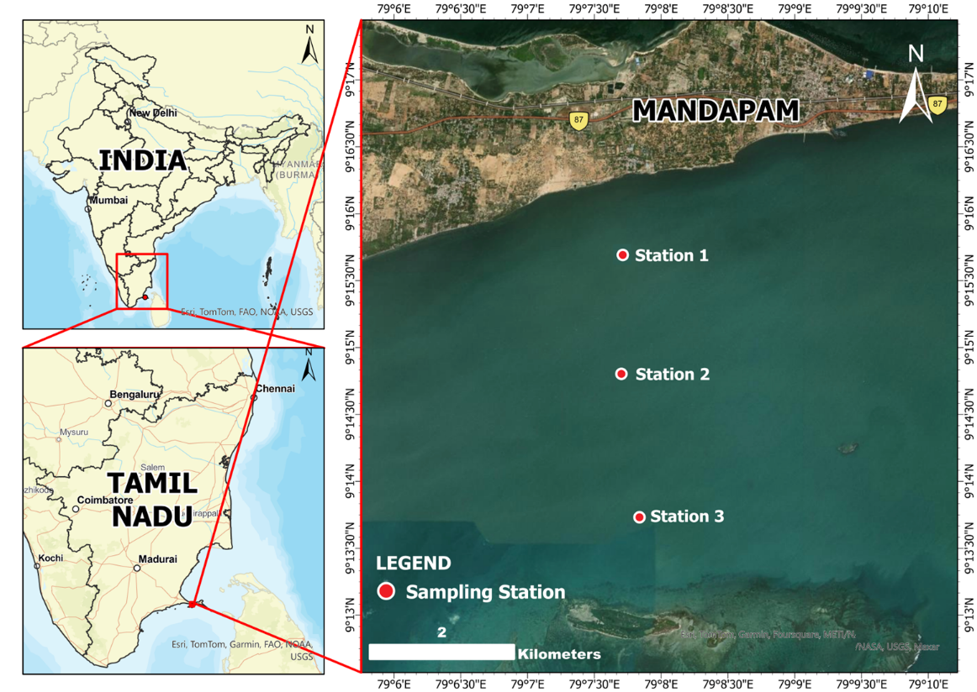

**Fig. 1. Map showing the sampling area of Gulf of Mannar Region.**

**2.2. Analysis of water quality parameters**

The monthly water sampling was made from February 2021 to January 2022 at three points along the GoM region for analysis of physico-chemical properties. The surface water and atmospheric temperatures were restrained using a standard mercury-filled centigrade thermometer. Dissolved oxygen was estimated by adopting modified Winkler’s method. Salinity was estimated using a hand Refractometer (ERMA, Japan) and pH was measured using an ELICO pH meter. The water samples collected in clean polyethene bottles were preserved in a temperature-controlled ice box and then transported to the laboratory. Then the water samples were used for the analysis of nutrients (ammonia, nitrite, nitrate, inorganic phosphate, silicate) and biological characteristics (chlorophyll “a”) analysis. The Millipore filtering system (MFS) was used to filter the water sample before going for analysis. The entire nutrient and biological characteristics were followed as per the standard methods described (Santhanam et al., 2012).

**2.3. Evaluation of Composition and Community Structure of Copepod**

Copepod samples were obtained from surface waters using horizontal towing of a zooplankton net (35 cm diameter, fastening silk mesh with a size of 158 μm) for a duration of 20 minutes. The plankton net was towed for 20 minutes, contingent upon the abundance of plankton at each sampling location. The specimens were preserved in 5 % neutralized formalin and sent to the laboratory for identification and additional investigation. Copepod species were identified according to the established methodologies of (Jeyaraj et al., 2014). The quantitative examination of copepods was conducted on samples filtered via a bag net (158 μm), and the numerical plankton analysis was performed using an inverted microscope (Micros, Austria). Biodiversity indices were computed in accordance with the standard formula outlined by: Biodiversity: H’ = -S Pi log Pi; 1=1; richness: D = 1-C; C = SPi²; Pi = ni/N; evenness: J’ = H’/log2S (Forouhar et al., 2018).

**Statistics Analysis**

The diversity indices of copepods analysed using Past 4.03 was performed to test significant seasonal differences in copepod abundance, diversity and water quality factors. The correlation analyses were performed using SPSS version 18.0.

**3. RESULTS AND DISCUSSION**

**3.1. Physio-Chemical Characteristics of Seawater**

Presently, the meteorological and physicochemical parameters such as rainfall, atmospheric and surface water temperature, chlorophyll, pH, salinity, dissolved oxygen, ammonia, nitrite, nitrate, phosphate and silicate contents in the GoM, were recorded for a period of one year from (February 2021 to January 2022). A total of 831.5 mm of rainfall was recorded throughout the year, with the lowest rainfall (0.4 mm) reported during February 2021 and the highest rainfall (351.1 mm) recorded during November 2021. This annual variation of rainfall can significantly impact on the hydrographical changes in marine environmental characteristics. The rainfall plays a crucial role in shaping these changes in surface water temperature, salinity, chlorophyll and species evenness. Moreover, the Southeast coast of India is particularly influenced by the northeast monsoon rainfall. This suggests that the timing and amount of rainfall during the Northeast rainy season can have significant effects on the hydrology and ecology of the study region (Kavitha et al., 2019).

The recorded atmospheric temperature during the study period was from 26.64 ℃ to 30.34 ℃. The lowest value was observed in January and the highest in March (post-monsoon). High solar radiation and evaporation are major causes of the increase in atmospheric temperature. In the present study the surface water temperature was ranged from 26 to 34.83 ℃ in S1, 26.5 to 34.5 ℃ in S2 and 26.5 to 34.83 ℃ in S3. In all the stations, the lowest surface water temperature was recorded in August and the highest surface water temperature was recorded between May and June 2021. The recorded low temperature in August might be due to the cloudy sky of monsoon season in the study area. The high temperature also correlates with other observations (Kavitha et al., 2019). The salinity was ranged between 25.3 and 38 % in S1, 25.3 and 38.17 % in S2 and 25.67 and 38.5 % in S3. In all stations, the lowest salinity was recorded in February and the maximum was recorded in May and October 2021. The recorded high salinity may be due to low rainfall and elevated evaporation. Among the salinity recorded period only the month of August had shown low salinity due to rainfall in that particular month. Due to the influence of freshwater through rainfall and low temperature, the salinity was low in months. Salinity is one of the important factors in determining the distribution of organisms across the environment (Kavitha et al., 2018; Nandy et al., 2020). It also influences the biological activity of the animals in the ecosystem. The dissolved oxygen concentration was ranged from 0.05 to 5.43 mL/L in S1, 0.06 to 4.83 mL/L in S2 and 0.05 to 4.97 mL/L in S3. Considering the values from all three stations recorded for 12 months, the lowest DO concentration was observed in August 2021 and the highest was recorded in January 2022. The low concentration of DO in August was due to the occurrence of *Noctiluca sp*., bloom in the study area. The DO has a negative relationship with temperature and salinity. The hydrogen ion concentration (pH) values ranged from 5.63 to 8.44 in S1, 5.33 to 8.47 in S2 and 5.46 to 8.4 in S2. In 12 months, the highest pH value was recorded during November 2021 and the lowest pH value was recorded in August 2021. The recorded minimum value of pH was due to the presence of algal bloom the constant respiration of algae at night which releases carbon dioxide and decreases pH. The pH remained alkaline throughout the study period except August 2021. The nitrate (NO3) concentration varied from 0.07 to 8.12 of all three stations from Feb 2021 to Jan 2022. Station 2 had the lowest value during December 2021 and station 3 had the highest value during March 2021. The nitrite (NO3) concentration varied from 0.14 to 7.95. Station 2 had the lowest value during November 2021 and station 3 highest value during March 2021. The ammonia (NH3) concentration varied from 2.01 µmol/L to 10.82 µmol/L in all three stations during the study period. Station 1 shows the lowest value during June 2021 and the highest value was recorded in station 1 during September 2021. The nitrite (NO2) concentration ranged from 0.11 µmol/L to 1.95 µmol/L during the study period. The lowest value was recorded during August 2021 in station I and the highest value was recorded during May 2021 in station 3. The phosphate (PO43-) concentration ranged from 0.36 µmol/L to 9.27 µmol/L during the study period. The lowest value was recorded during June 2021 in station 1 and the highest value was recorded during April 2021 in station 3. The reactive silicate (SiO2) concentration ranged from 2.04 µmol/L to 61.56 µmol/L during the study period. The lowest value was recorded during July 2021 in station 3 and the highest value was recorded during August 2021 in station 3. The chlorophyll “a” concentration ranged from 0.01 to 1.42 mg/L during the study period. The lowest value was observed during August 2021 in station 1 and the highest value was observed during September 2021 in station 3.

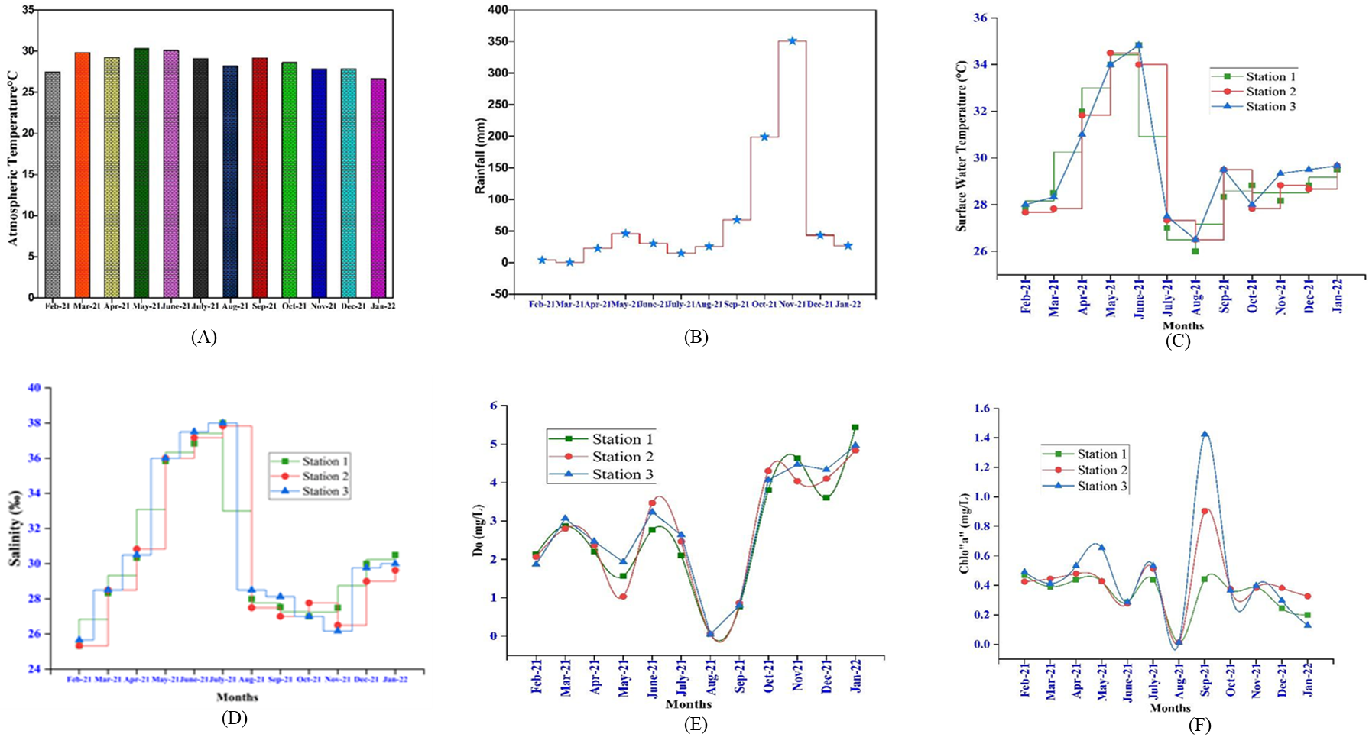

**Fig. 2. Seasonal Variation in Atmospheric temperature (A), Rainfall (B), Surface water temperature (C), Salinity (D), Dissolved oxygen (E), Chlorophyll “a” (F) in Gulf of Mannar Coastal Water during February 2021 to January 2022.**

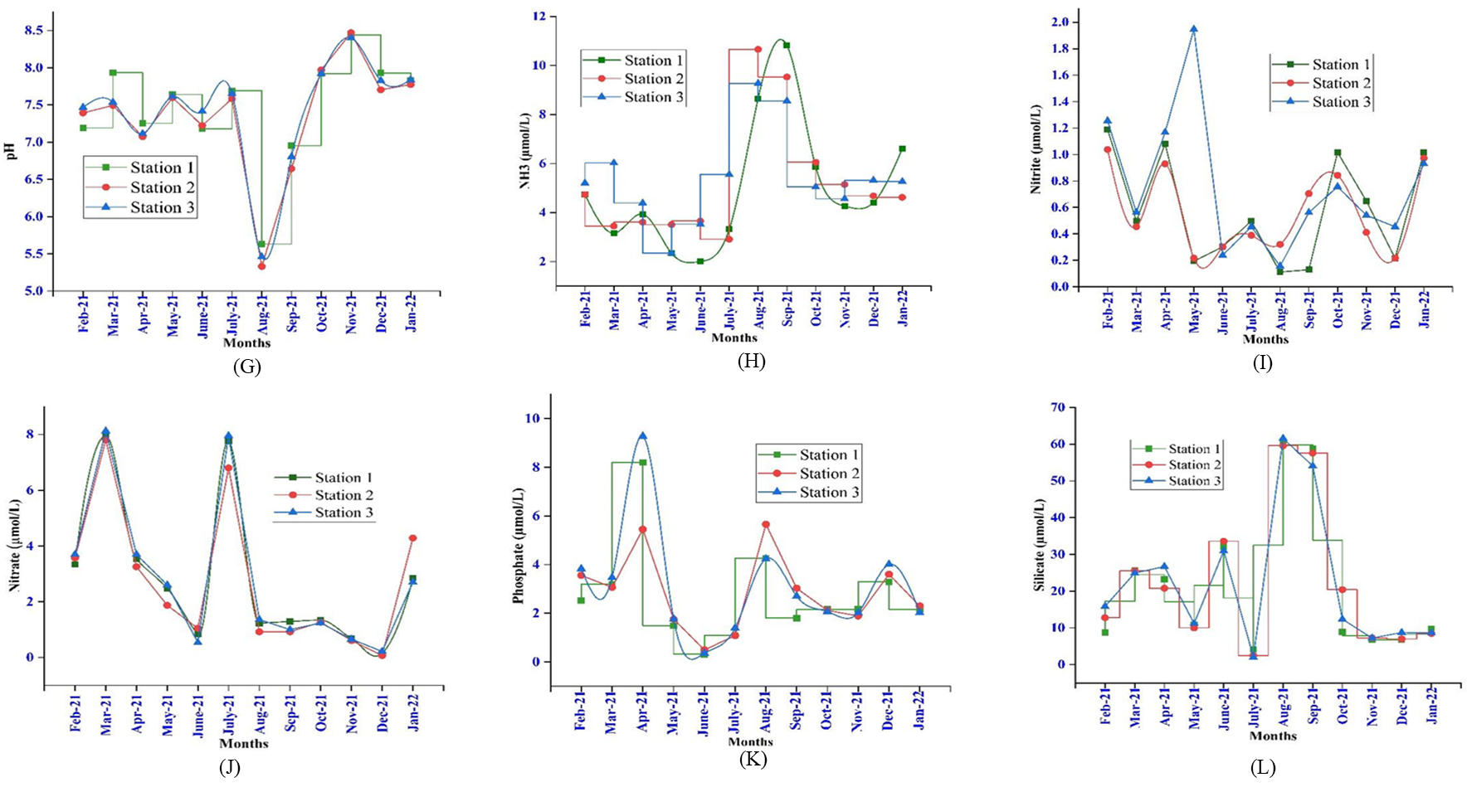

**Fig. 3.** **Seasonal Variation in pH (G), Ammonia (H), Nitrite (I), Nitrate (J), Phosphate (K), Silicate (L) in Gulf of Mannar Coastal Water during February 2021 to January 2022.**

**3.2. Distribution and Occurrence of Copepods**

In this study, a total of 34 species of copepods were recorded in Gulf of Mannar coastal region and among these calanoid-group was the most dominant one in twelve numbers followed by both cyclopoid and harpacticoid groups having each of the eleven number of species. Copepod population density ranged between 4000 ind./l and 723,000 ind./l. The maximum population density was recorded in S3 in May and the minimum population density was recorded in same sampling station (S3) in August 2021. Copepod species diversity was varied from 0.56 to 3.38. Maximum species diversity was recorded in S3 in February 2021 whereas the minimum species diversity was recorded in same station (S3) in August 2021. The species richness was ranged from 0.72-5.11 with maximum species richness was recorded in S1 during February 2021 and the minimum was recorded in S3 during August 2021. Species evenness was ranged from 0.82-0.98. Maximum species evenness was recorded in S1 in August 2021 and the minimum was recorded in same sampling site (S1) in May 2022. The recorded low species diversity in August may be due to the recurring rainfall during the period.

**Table 1. Occurrence of copepod species along the Mandapam coast, the Southeast coast of India.**

|  |  |  |  |  |
| --- | --- | --- | --- | --- |
| **Orders** | **Copepods species** | **Station 1** | **Station 2** | **Station 3** |
| **Calanoid copepod** | *Labidocera minuta*  *Rhincalanus* sp.  *Eurytemora capsica*  *Centropages furcatus*  *Paracalanus crassirostris*  *Paracalanus indicus*  *Calanopia elliptica*  *Acartia pacifica*  *Labidocera pavo*  *Nannoclanus minor*  *Acartia tonsa*  *Pontella fera* | -  +  +  -  +  -  +  +  +  +  +  - | +  -  +  +  +  +  +  +  +  +  +  + | +  +  +  -  +  +  -  +  -  +  +  + |
| **Cyclopoid copepod** | *Oithona dissimilis*  *Dioithona rigida*  *Oithona parvi*  *Oithona nana*  *Apocyclops royi*  *Paracyclops poppei*  *Triconia dentipes*  *Oncaea* sp.  *Thermocyclops crassus*  *Apocyclops* sp.  *Oithona* sp. | +  +  +  +  +  +  +  +  +  +  + | +  +  +  +  +  +  +  +  +  +  + | +  +  +  +  +  +  +  +  +  +  + |
| **Harpacticoid copepod** | *Onychocamptus mohammed*  *Nitokra spinipes*  *Nitokra affinis*  *Metis jousseaumei*  *Macrosetella gracilis*  *Corycaeus anglicus*  *Tisbe* sp.  *Clytemnestra scutellata*  *Euterpina acutifrons*  *Microsetella norvegica*  *Nitokra* sp. | +  +  +  -  +  +  +  +  +  +  + | +  +  +  -  -  +  +  -  +  +  + | +  +  +  +  -  +  +  -  +  +  + |

In the present investigation, *Nanocalanus parvi, Acartia pacifica, Oithona rigida* and *Oithona parvi* were present throughout the year even during unfavorable conditions. (Montagna et al., 2018) also reported that *Acartia sp*. and *Oithona rigida* were found predominantly throughout the year as they exhibit prominent adaptation to extreme and changing environmental conditions. (Kavitha et al., 2019) have reported that calanoid to be the most dominant group of copepods from the Offshore Region of Tuticorin, Southeast coast of India. Reported that the most abundant (36 species belonging to 3 orders) among the zooplankton population from the river Matla in the Sundarbans estuarine system, India. (Deepika et al., 2019) have also reported copepods constituting about 46 % of the total zooplankton community in the seagrass habitat of Mandapam coast. Stated that calanoid copepods were found to be dominant (63.52 %) in Vellar estuary, Parangipettai coast. The lesser density of copepods recorded during August may be due to low salinity induced by rainfall (Kumar et al., 2014).

**3.3. Diversity Indices**

The obtained vales of Copepod diversity indices were shown in Table 2. The diversity at station S1 varied from 1.079 to 3.377. The months of February and August 2021 the highest and lowest diversity index readings, respectively. Similarly, the range of species evenness was 0.837-0.980. August 2021 recorded the highest evenness value, while March 2021 showed the lowest evenness. In a similar vein, the range of species richness was 4.176-5.112. February 2021 had the highest values recorded, while August 2021 showed the lowest values. The range of copepod diversity indices in Station S2 was 1.33 to 3.344. The lowest value was recorded in August 2021, while the greatest values were reported on February 21. The range of the species evenness was 0.833 to 0.944. August 2021 recorded the highest value, while Feb-21 recorded the lowest. The estimates of species richness varied between 1.674 and 5.068. The periods of Feb-21 and Aug-21 was recorded as having the greatest and lowest species richness, respectively. Overall observations showed that species richness and diversity were higher in the post-monsoon season, whereas the highest species evenness was noted during the monsoon season due to the fall in species richness and diversity caused by algal bloom. The similar trend was observed in station S3. The highest diversity indices values were reported during August 21 and lowest values reported during September 21. Similarly, the highest species evenness was reported in October 2021 and lowest values was reported during Feb-21.

In the Gulf of Mannar region, (Krishna et al., 1971) also reported on the evenness and diversity indices of zooplankton that are examined in the vicinity of the study site. The average diversity was 3.21±0.43, with a range of 2.51 to 3.97 bits/individual (Table 1). Station 5 showed the least amount of diversity, whereas Station 4 showed the most. According to the high copepod density at station 4, which suggests consistent hydrological conditions and phytoplankton density, may be the cause of the high species diversity values there. One species dominance at station 5 may be the cause of the low species diversity there. The evenness ranged from 0.83 to 0.96, with an average of 0.92±0.04. Station 5 had the lowest evenness due to an uneven distribution of the zooplankton species. Nonetheless, station 4 had the highest evenness ratings, indicating that the species were dispersed equally.

**Table 2. Diversity indices of copepod species along the Mandapam coastal waters, Southeast coast of India**

|  |  |  |  |  |  |  |  |  |  |  |  |  |
| --- | --- | --- | --- | --- | --- | --- | --- | --- | --- | --- | --- | --- |
| **Indices** | **Feb-21** | **Mar-21** | **Apr-21** | **May-21** | **Jun-21** | **Jul-21** | **Aug-21** | **Sep-21** | **Oct-21** | **Nov-21** | **Dec-21** | **Jan-22** |
| **Station 1** | | | | | | | | | | | | |
| **Shannon_H** | 3.377 | 3.289 | 3.23 | 3.329 | 3.301 | 3.19 | 1.079 | 3.192 | 3.278 | 3.291 | 3.275 | 3.191 |
| **Evenness_e^H/S** | 0.861 | 0.837 | 0.903 | 0.872 | 0.848 | 0.867 | 0.980 | 0.901 | 0.914 | 0.895 | 0.911 | 0.900 |
| **Margalef** | 5.112 | 4.868 | 4.222 | 4.752 | 4.935 | 4.399 | 1.028 | 4.594 | 4.514 | 4.571 | 4.382 | 4.176 |
| **Station 2** | | | | | | | | | | | | |
| **Shannon_H** | 3.344 | 3.282 | 3.257 | 3.274 | 3.293 | 3.154 | 1.33 | 3.17 | 3.265 | 3.27 | 3.274 | 3.184 |
| **Evenness_e^H/S** | 0.833 | 0.887 | 0.927 | 0.825 | 0.868 | 0.867 | 0.944 | 0.850 | 0.902 | 0.907 | 0.910 | 0.894 |
| **Margalef** | 5.068 | 4.416 | 4.181 | 4.751 | 4.726 | 4.159 | 1.674 | 4.623 | 4.437 | 4.41 | 4.347 | 4.125 |
| **Station 3** | | | | | | | | | | | | |
| **Shannon_H** | 3.382 | 3.335 | 3.24 | 3.312 | 3.319 | 3.225 | 0.5623 | 3.178 | 3.314 | 3.302 | 3.262 | 3.192 |
| **Evenness_e^H/S** | 0.866 | 0.877 | 0.880 | 0.885 | 0.863 | 0.897 | 0.877 | 0.889 | 0.916 | 0.905 | 0.899 | 0.869 |
| **Margalef** | 5.028 | 4.763 | 4.313 | 4.557 | 4.937 | 4.281 | 0.7213 | 4.419 | 4.583 | 4.491 | 4.368 | 4.247 |

According to the (Kavitha et al., 2019) Species richness (D), species diversity (H) and species evenness (J) Copepod species richness index (D) values varied from 0.48 to 2.72. At station IV, the highest value was recorded in March, and at station III, the lowest value was recorded in December. Between 0.87 to 1.98 was the range of the zooplankton species diversity index (H). At stations IV and III, the highest species diversity was noted in March, while the lowest species diversity was noted in December. The species evenness in stations III and I ranged from 0.24 to 0.51. December and October had the lowest and highest values, respectively. In the summer, the highest range of species richness, species diversity, and species evenness was seen. Species richness, diversity, and evenness minimum values observed in December among all four locations. Salinity fluctuations and rainfall inflow may be the cause of this lowest figure during the monsoon season.

The diversity of copepod species ranged from 0.92 to 0.97. In May of 2016, Station 1 reported the highest species diversity, while in November of the same year, Station 3 recorded the lowest species diversity. The range of species richness was determined to be 0.43 to 0.98. Station 3 recorded the lowest species richness in February 2016, whereas Station 1 had the highest species richness in May 2016. The species' evenness ranged from 0.78 to 0.98. In September of 2016, Station 1 recorded the highest evenness, while in March of the same year, Station 3 recorded the lowest data document by (Kavitha et al., 2019).

**3.4. Correlation Analysis of Environmental and Biological Matrix**

Presently, Pearson correlation analysis of physico-chemical attributes shown in Tables 3-6.) Strongly favorable connections between air temperature, rainfall, surface water temperature, salinity, dissolved oxygen, chlorophyll "a," pH, ammonia, nitrite, nitrate, phosphate and silicate revealed. The species diversity and richness of copepod was formed to be favorably influenced at station as supported by Pearson as supported by correlation study of rainfall and surface temperature. The pH of seawater revealed a positive link (p< 0.01) in species richness and diversity. Negative link in rainfall, seawater temperature, pH and DO was also shown in species evenness. Strong influence (p<0.01) of NH3 revealed the positive link between the species distribution during the monsoon season. In species evenness and richness, similarly station S2, atmospheric temperature was negatively correlated; in species diversity of copepod, it was positively correlated. pH was clearly affecting species richness and environmental quality as well as p<0.01. The similar trend was observed in station S3 shown the pH has greatly affected environmental features of DO, NH3, PO43-, SiO2 and copepods species diversity and richness.

**Table 3. Correlation of water quality properties with abundance and biodiversity indices of copepods occurring at Station 1 in Mandapam coastal reigon, Southeast coast of India**

|  |  |  |  |  |  |  |  |  |  |  |  |  |  |  |  |  |  |  |  |
| --- | --- | --- | --- | --- | --- | --- | --- | --- | --- | --- | --- | --- | --- | --- | --- | --- | --- | --- | --- |
| Station 1 | AT | RF | | SST | | S | | pH | | DO | CHL | NH3 | NO2 | NO3 | PO43+ | SIO2 | Shannon_H | Evenness | Margalef |
| AT | 1 | |  | |  | |  | |  |  |  |  |  |  |  |  |  |  |  |
| RF | -0.196 | | 1 | |  | |  | |  |  |  |  |  |  |  |  |  |  |  |
| SST | 0.564 | | -0.131 | | 1 | |  | |  |  |  |  |  |  |  |  |  |  |  |
| S | 0.520 | | -0.307 | | 0.545 | | 1 | |  |  |  |  |  |  |  |  |  |  |  |
| pH | -0.068 | | 0.465 | | 0.153 | | 0.080 | | 1 |  |  |  |  |  |  |  |  |  |  |
| DO | -0.475 | | 0.441 | | 0.085 | | -0.073 | | 0.794** | 1 |  |  |  |  |  |  |  |  |  |
| CHL | 0.366 | | 0.117 | | 0.213 | | 0.065 | | 0.504 | 0.025 | 1 |  |  |  |  |  |  |  |  |
| NH3 | -0.394 | | 0.050 | | -0.550 | | -0.559 | | -0.499 | -0.301 | -0.326 | 1 |  |  |  |  |  |  |  |
| NO2 | -0.453 | | 0.120 | | -0.059 | | -0.352 | | 0.325 | 0.504 | 0.327 | -0.139 | 1 |  |  |  |  |  |  |
| NO3 | 0.257 | | -0.427 | | -0.203 | | 0.251 | | 0.167 | -0.078 | 0.375 | -0.329 | 0.186 | 1 |  |  |  |  |  |
| PO43+ | -0.093 | | -0.154 | | -0.072 | | -0.353 | | -0.245 | -0.156 | -0.073 | 0.096 | 0.314 | 0.049 | 1 |  |  |  |  |
| SIO2 | 0.244 | | -0.241 | | -0.117 | | -0.192 | | -0.804** | -0.690* | -0.394 | 0.645* | -0.522 | -0.206 | 0.157 | 1 |  |  |  |
| Shannon_H | 0.154 | | 0.141 | | 0.423 | | 0.164 | | 0.806** | 0.525 | 0.783** | -0.478 | 0.368 | 0.171 | -0.250 | -0.640* | 1 |  |  |
| Evenness | -0.427 | | 0.182 | | -0.425 | | -0.366 | | -0.526 | -0.224 | -0.676* | 0.659* | -0.154 | -0.518 | 0.391 | 0.415 | -0.765** | 1 | 1 |
| Margalef | 0.231 | | 0.100 | | 0.426 | | 0.152 | | 0.735** | 0.427 | 0.807** | -0.487 | 0.311 | 0.196 | -0.339 | -0.563 | 0.979** | -0.846** | 1 |
|  | | | | | | | | | | | | | | | | | | | | |

*\*: Correlation is significant at the 0.05 level (2-tailed).**: Correlation is significant at the 0.01 level (2-tailed).*

**Table 4. Correlation of water quality properties with abundance and biodiversity indices of copepods occurring at Station 2 in Mandapam coastal reigon, Southeast coast of India**

|  |  |  |  |  |  |  |  |  |  |  |  |  |  |  |  |  |  |  |  |  |  |  |  |  |  |  |  |  |  |  |
| --- | --- | --- | --- | --- | --- | --- | --- | --- | --- | --- | --- | --- | --- | --- | --- | --- | --- | --- | --- | --- | --- | --- | --- | --- | --- | --- | --- | --- | --- | --- |
| Station 2 | AT | | RF | | SST | | S | | pH | | DO | | CHL | | NH3 | | NO2 | | NO3 | | PO43+ | | SIO2 | | Shannon_H | | Evenness | | Margalef | |
| AT | | 1 | |  | |  | |  | |  | |  | |  | |  | |  | |  | |  | |  | |  | |  | |  |
| RF | | -0.196 | | 1 | |  | |  | |  | |  | |  | |  | |  | |  | |  | |  | |  | |  | |  |
| SST | | 0.558 | | -0.104 | | 1 | |  | |  | |  | |  | |  | |  | |  | |  | |  | |  | |  | |  |
| S | | 0.588* | | -0.325 | | 0.571 | | 1 | |  | |  | |  | |  | |  | |  | |  | |  | |  | |  | |  |
| pH | | -0.122 | | 0.502 | | 0.129 | | 0.083 | | 1 | |  | |  | |  | |  | |  | |  | |  | |  | |  | |  |
| DO | | -0.398 | | 0.376 | | -0.035 | | -0.029 | | 0.769** | | 1 | |  | |  | |  | |  | |  | |  | |  | |  | |  |
| CHL | | 0.245 | | 0.005 | | 0.149 | | -0.040 | | 0.221 | | -0.105 | | 1 | |  | |  | |  | |  | |  | |  | |  | |  |
| NH3 | | -0.233 | | 0.122 | | -0.365 | | -0.543 | | -0.692* | | -0.496 | | -0.042 | | 1 | |  | |  | |  | |  | |  | |  | |  |
| NO2 | | -0.451 | | -0.051 | | -0.175 | | -0.460 | | 0.092 | | 0.190 | | 0.263 | | 0.033 | | 1 | |  | |  | |  | |  | |  | |  |
| NO3 | | 0.122 | | -0.445 | | -0.258 | | 0.220 | | 0.134 | | 0.036 | | 0.132 | | -0.497 | | 0.198 | | 1 | |  | |  | |  | |  | |  |
| PO43+ | | -0.253 | | -0.253 | | -0.331 | | -0.556 | | -0.612* | | -0.426 | | -0.182 | | 0.473 | | 0.255 | | -0.100 | | 1 | |  | |  | |  | |  |
| SIO2 | | 0.231 | | -0.173 | | -0.054 | | -0.253 | | -0.834** | | -0.615* | | 0.019 | | 0.812** | | -0.050 | | -0.299 | | 0.404 | | 1 | |  | |  | |  |
| Shannon_H | | 0.150 | | 0.139 | | 0.380 | | 0.175 | | 0.819** | | 0.552 | | 0.582* | | -0.716** | | 0.247 | | 0.201 | | -0.545 | | -0.621* | | 1 | |  | |  |
| Evenness | | -0.322 | | 0.217 | | -0.381 | | -0.299 | | -0.246 | | 0.208 | | -0.516 | | 0.290 | | -0.042 | | -0.170 | | 0.548 | | 0.186 | | -0.516 | | 1 | |  |
| Margalef | | 0.203 | | 0.100 | | 0.420 | | 0.145 | | 0.723** | | 0.392 | | 0.609* | | -0.616* | | 0.236 | | 0.119 | | -0.564 | | -0.506 | | 0.961** | | -0.692* | | 1 |
|  | | | | | | | | | | | | | | | | | | | | | | | | | | | | | | |

*\*: Correlation is significant at the 0.05 level (2-tailed).**: Correlation is significant at the 0.01 level (2-tailed).*

**Table 5. Correlation of water quality properties with abundance and biodiversity indices of copepods occurring at Station 3 in Mandapam coastal region, Southeast coast of India**

|  |  |  |  |  |  |  |  |  |  |  |  |  |  |  |  |  |  |  |  |  |  |  |  |  |  |  |  |  |  |
| --- | --- | --- | --- | --- | --- | --- | --- | --- | --- | --- | --- | --- | --- | --- | --- | --- | --- | --- | --- | --- | --- | --- | --- | --- | --- | --- | --- | --- | --- |
| Station 3 | AT | | RF | | SST | | S | | pH | | DO | | CHL | | NH3 | | NO2 | | NO3 | | PO43+ | | SIO2 | | Shannon_H | | Evenness | | Margalef |
| AT | 1 |  | |  | |  | |  | |  | |  | |  | |  | |  | |  | |  | |  | |  | |
| RF | -0.196 | | 1 | |  | |  | |  | |  | |  | |  | |  | |  | |  | |  | |  | |  | |  |
| SST | 0.551 | | -0.104 | | 1 | |  | |  | |  | |  | |  | |  | |  | |  | |  | |  | |  | |  |
| S | 0.570 | | -0.389 | | 0.569 | | 1 | |  | |  | |  | |  | |  | |  | |  | |  | |  | |  | |  |
| pH | -0.122 | | 0.502 | | 0.145 | | -0.001 | | 1 | |  | |  | |  | |  | |  | |  | |  | |  | |  | |  |
| DO | -0.398 | | 0.376 | | -0.014 | | -0.091 | | 0.769** | | 1 | |  | |  | |  | |  | |  | |  | |  | |  | |  |
| CHL | 0.243 | | 0.005 | | 0.114 | | -0.028 | | 0.228 | | -0.099 | | 1 | |  | |  | |  | |  | |  | |  | |  | |  |
| NH3 | -0.233 | | 0.122 | | -0.396 | | -0.472 | | -0.692* | | -0.496 | | -0.048 | | 1 | |  | |  | |  | |  | |  | |  | |  |
| NO2 | -0.451 | | -0.051 | | -0.184 | | -0.492 | | 0.092 | | 0.190 | | 0.271 | | 0.033 | | 1 | |  | |  | |  | |  | |  | |  |
| NO3 | 0.122 | | -0.445 | | -0.246 | | 0.194 | | 0.135 | | 0.036 | | 0.129 | | -0.497 | | 0.198 | | 1 | |  | |  | |  | |  | |  |
| PO43+ | -0.253 | | -0.253 | | -0.333 | | -0.524 | | -0.613* | | -0.426 | | -0.188 | | 0.474 | | 0.256 | | -0.102 | | 1 | |  | |  | |  | |  |
| SIO2 | 0.231 | | -0.173 | | -0.086 | | -0.183 | | -0.834** | | -0.615* | | 0.013 | | 0.812** | | -0.050 | | -0.299 | | 0.405 | | 1 | |  | |  | |  |
| Shannon_H | 0.159 | | 0.140 | | 0.364 | | 0.133 | | 0.823** | | 0.548 | | 0.601* | | -0.718** | | 0.241 | | 0.226 | | -0.569 | | -0.624* | | 1 | |  | |  |
| Evenness | -0.053 | | 0.682* | | -0.340 | | -0.225 | | 0.415 | | 0.211 | | 0.189 | | 0.090 | | -0.161 | | -0.222 | | -0.133 | | -0.262 | | 0.127 | | 1 | |  |
| Margalef | 0.194 | | 0.106 | | 0.377 | | 0.118 | | 0.779** | | 0.509 | | 0.572 | | -0.698* | | 0.244 | | 0.215 | | -0.583* | | -0.560 | | 0.987** | | 0.040 | | 1 |
|  | | | | | | | | | | | | | | | | | | | | | | | | | | | | | |

*\*: Correlation is significant at the 0.05 level (2-tailed).**: Correlation is significant at the 0.01 level (2-tailed).*

A thorough understanding of the internal and external biogeochemical processes occurring in the coastal lagoon has been made possible by the correlation between several physico-chemical parameters. The ecological characteristic of ciliate function groups may serve as a bio-indicator of water quality, found a substantial association between ciliates and nitrate (NO3-) (Balcer et al., 1984). The species diversity of copepods was between 0.92 and 0.97. Station 1 reported the highest species diversity in May 2016, while Station 3 recorded the lowest species diversity in November of the same year. A range of 0.43 to 0.98 was found for species richness. Station 1 recorded the highest species richness in May 2016, while Station 3 recorded the lowest in February of the same year. The species' evenness ranged from 0.78 to 0.98.

In September 2016, Station 1 had the highest evenness, while in March 2016, Station 3 recorded the lowest value was reported by (Jeyaraj et al 2014). The study (Kavitha et al., 2019) of the physico-chemical and copepod correlation maximum results were displayed in Tables 2, 3, and 4. Based on data from Station 1, there was a large negative association between rainfall and dissolved oxygen, while there was a substantial positive correlation between rainfall and pH, atmospheric temperature, phosphate, nitrate, and salinity (Table 2). At Station 2, copepod population density, copepod variety, copepod richness, and copepod evenness have all been favourably connected with the temperature of the atmosphere and surface water (Table 3). According to Table 4, Station 3 has likewise shown the similar pattern. At Station 3, phosphate, an inorganic nutrient, had a negative correlation with both dissolved oxygen and nitrate.

The effects of seasonal variation on the diversity and ecological abundance of marine copepods require more thorough long-term monitoring and assessment studies. To priorities future studies, this work focuses on the ecology, taxonomy, richness, and conservation of copepod species in the water of the Mandapam Coastal Region.

**4. CONCLUSIONS**

The present study was conducted in the Gulf of Mannar region for one year (from February 2021 to January 2022) to assess the physio-chemical changes and copepod diversity and it revealed significant relationships between the parameters. Notably, high temperatures and salinity were observed during the post-monsoon season, correlating with increased evaporation and low rainfall, while low dissolved oxygen levels were associated with algal blooms, particularly in August 2021. Copepod diversity, richness, and evenness fluctuated throughout the year, with species richness and diversity peaking in the post-monsoon season and species evenness reaching its maximum during the monsoon. The study confirmed that copepods, particularly calanoid species, adapted well to changing environmental conditions, with certain species like *Nanocalanus parvi, Acartia pacifica,* and *Oithona rigida* remaining dominant year-round despite adverse conditions. The obtained results emphasize the complex and dynamic interactions between environmental variables and marine biodiversity in the Gulf of Mannar. Understanding these relationships is essential for predicting ecosystem responses to climatic and anthropogenic changes, as well as for the sustainable management of marine resources.

**References**

Antony, S., Dev, V. V., Kaliraj, S., Ambili, M. S., & Krishnan, K. A. (2020). Seasonal variability of groundwater quality in coastal aquifers of Kavaratti Island, Lakshadweep Archipelago, India. *Groundwater for Sustainable Development*, *11*, 100377.

Balcer, M. D., Korda, N. L., & Dodson, S. I. (1984). *Zooplankton of the Great Lakes: a guide to the identification and ecology of the common crustacean species*. Univ of Wisconsin Press.

Boxshall, G. A., & Defaye, D. (2008). Global diversity of copepods (Crustacea: Copepoda) in freshwater. *Freshwater animal diversity assessment*, 195-207. https://doi.org/10.1007/978-1-4020-8259-7_21

Castonguay, M., Plourde, S., Robert, D., Runge, J. A., & Fortier, L. (2008). Copepod production drives recruitment in a marine fish. *Canadian Journal of Fisheries and Aquatic Sciences*, *65*(8), 1528-1531. https://doi.org/10.1139/F08-126

Deepika, S., Srinivasan, A., Padmavathy, P., & Jawahar, P. (2019). Diversity of zooplankton in seagrass ecosystem of Mandapam coast in Gulf of Mannar. *International Journal of Current Microbiology and Applied Sciences*, *8*(7), 2034-2042. https://doi.org/10.20546/ijcmas.2019.807.244

Fernandes, V., & Ramaiah, N. (2019). Spatial structuring of zooplankton communities through partitioning of habitat and resources in the Bay of Bengal during spring intermonsoon. *Turkish Journal of Zoology*, *43*(1), 68-93. https://doi.org/10.3906/zoo-1805-6

Forouhar Vajargah, M., Mohamadi Yalsuyi, A., Hedayati, A., & Faggio, C. (2018). Histopathological lesions and toxicity in common carp (Cyprinus carpio L. 1758) induced by copper nanoparticles. *Microscopy research and technique*, *81*(7), 724-729. https://doi.org/10.1002/jemt.23028

Jeyaraj, N., Santhanam, P., Raju, P., Ananth, S., & Jothiraj, K. (2014). Alternative methods for marine harpacticoid copepod, Macrosetella gracilis production in marine fish larviculture. *International Journal of Zoological Research*, *10*(1), 1.

Kasturirangan, L. R. (1963). *A key for the identification of the more common planktonic copepoda: of Indian coastal waters* (No. 2). Delhi: Council of scientific & industrial research.

Kavitha, K., Ebanasar, J., & Sheeja, B. D. 2019. Checklist of Plankton Diversity in Upper and Lower Tiger Hills Reservoir of Upper Nilgiris, Tamil Nadu, India. J. Sci, 13(1), 1-5. <https://doi.org/10.56343/STET.116.013.001.001>

Kavitha, M., Padmavathy, P., Srinivasan, A., Jawahar, P., Ranjith, L., & Linga Prabu, D. (2018). Copepod abundance and Diversity from offshore region of Tuticorin, south east coast of India. *International Journal of Current Microbiology and Applied Sciences*, *7*(4), 2767-2792.

Kaviyarasan, M., Santhanam, P., Balakrishnan, S., Kumar, S. D., Ananth, S., & Kandan, S. (2019). Seasonal variations in copepods diversity along the Vettar coastal waters, South Eastern India.

Krebs, J., Göcking, K., Kissling‐Niggli, M., & Pannek, J. (2015). Cross‐sectional study of the sperm quality in semen samples from spinal cord injured men after long‐term cryopreservation. *Andrology*, *3*(2), 213-219. https://doi.org/10.1111/andr.12017

Krishna Pillay, K., & Nair, N. B. (1971). The annual reproductive cycles of Uca annulipes, Portunus pelagicus and Metapenaeus affinis (Decapoda: Crustacea) from the South-west coast of India. *Marine Biology*, *11*, 152-166. https://doi.org/10.1007/BF00348765

Kumar, K. S., Siva, I., Jeyaraj, P., Jappes, J. W., Amico, S. C., & Rajini, N. (2014). Synergy of fiber length and content on free vibration and damping behavior of natural fiber reinforced polyester composite beams. *Materials & Design (1980-2015)*, *56*, 379-386. https://doi.org/10.1016/j.matdes.2013.11.039

Madhupratap, M. (1999). Free-living copepods of the Arabian Sea: Distributions and research perspectives. http://drs.nio.org/drs/handle/2264/1845

Madhupratap, M., Achuthankutty, C. T., Nair, S. R., & Nair, V. R. (1981). Zooplankton abundance of the Andaman Sea. http://drs.nio.org/drs/handle/2264/6781

Montagna, P. A., Hu, X., Palmer, T. A., & Wetz, M. (2018). Effect of hydrological variability on the biogeochemistry of estuaries across a regional climatic gradient. *Limnology and Oceanography*, *63*(6), 2465-2478. https://doi.org/10.1002/lno.10953

Morales-Marín, L. A., Rokaya, P., Sanyal, P. R., Sereda, J., & Lindenschmidt, K. E. (2019). Changes in streamflow and water temperature affect fish habitat in the Athabasca River basin in the context of climate change. *Ecological Modelling*, *407*, 108718. https://doi.org/10.1016/j.ecolmodel.2019.108718

Nandy, T., & Mandal, S. (2020). Unravelling the spatio-temporal variation of zooplankton community from the river Matla in the Sundarbans Estuarine System, India. *Oceanologia*, *62*(3), 326-346. ttps://doi.org/10.1016/j.oceano.2020.03.005

Santhanam, P., & Perumal, P. (2012). Effect of temperature, salinity and algal food concentration on population density, growth and survival of marine copepod Oithona rigida Giesbrecht.

Santhanam, P., Jeyaraj, N., Jothiraj, K., Ananth, S., Dinesh Kumar, S., & Pachiappan, P. (2019). Assessing the efficacy of marine copepods as an alternative first feed for larval production of tiger shrimp Penaeus monodon. *Basic and applied zooplankton biology*, 293-303. https://doi.org/10.1007/978-981-10-7953-5_12

Santhanam, P., Perumal, P., Ananth, S., & Devi, A. S. (2012). Copepod population in Vellar estuary, Parangipettai coast in relation to environmental conditions. *Journal of Environmental Biology*, *33*(6), 1003.

Saroj, J., Jawahar, P., Srinivasan, A., Neethiselvan, N., Jayakumar, N., & Deepika, S. (2020). Composition, diversity and seasonal distribution of zooplankton in the nearshore waters of Gulf of Mannar, Tamil Nadu. http://www.entomoljournal.com

Strickland, J. D. H., & Parsons, T. R. (1972). A practical handbook of seawater analysis. http://dx.doi.org/10.25607/OBP-1791

Sugumaran, J. (2016). Influence of Seasons on Copepods of Agniyar Estuary, Palk Strait, Tamil Nadu, India. *International Journal of Zoology and Applied Biosciences*, *1*(1), 40-45. http://www.ijzab.com

Zar, J. H. (1984). Statistical significance of mutation frequencies, and the power of statistical testing, using the Poisson distribution. *Biometrical journal*, *26*(1), 83-88. https://doi.org/10.1002/bimj.4710260116