Short communication
Analysis of Gut Microbiome Changes with Eurycoma longifolia (Physta®) Supplementation Using Precision Microbiome Profiling (PMP™): A Case Study

Abstract
The gut microbiome plays a critical role in maintaining human health particularly via the gut-brain axis by regulating metabolic, immune, and neuroendocrine functions. Supplementation of pro and pre-biotics along with certain nutrition may benefit gut microbial diversity. Early clinical research of Eurycoma longifolia supplementation demonstrated physical and mental benefits. Subsequently, animal studies demonstrated improvement in gut of a single gut microbe and related improvement in stress and sleep among farmed livestock. This preliminary case study evaluated the effect of a standardized water extract of Eurycoma longifolia ( Physta® in improving gut microbiome by evaluating faecal microbiota analysed with Precision Microbiome Profiling (PMP™) which quantified 108 bacteria species categorized into five groups ie: Short-chain fatty acid (SCFA)-producing bacteria, Firmicutes-to-Bacteroidetes ratio, Bifidobacteria and Lactobacilli, pathogenic bacteria, including Proteobacteria. The supplementation of Physta® demonstrated improvement in diversity and beneficial bacteria while reducing pathogenic microbe. The supplentation of Physta® may be beneficial for gut health and should be evalauted in a larger population.
Keywords: Eurycoma longifolia, microbiome, gut
Introduction
The gut microbiome, a complex community of trillions of microorganisms, plays a critical role in maintaining human health by regulating metabolic, immune, and neuroendocrine functions. This intricate microbial ecosystem influences physiological processes such as digestion, nutrient absorption, immune modulation, and communication along the gut-brain axis. Emerging research underscores the importance of microbial diversity and the production of short-chain fatty acids (SCFAs) in maintaining gut homeostasis and overall health [1,2].
Kuroki et al. [3] demonstrated the beneficial effects of Physta®, a standardized water extract of Eurycoma longifolia, on the gut microbiota of pigs, indicating its potential to enhance microbial diversity and reduce stress. Given that microbial diversity, often assessed through richness and evenness, is a critical indicator of gut health in humans, the use of Physta® may exert similar positive effects on human gut health. Reduced microbial diversity is consistently associated with gut dysbiosis, a condition linked to metabolic disorders such as obesity, type 2 diabetes, and cardiovascular diseases, as well as inflammatory conditions like inflammatory bowel disease (IBD) [4,5]. Conversely, increased microbial diversity is associated with enhanced resilience to pathogenic invasions, improved immune function, and favorable metabolic outcomes.
Short chain fatty acids (SCFA), including acetate, propionate, and butyrate, are vital metabolites produced by gut bacteria through the fermentation of dietary fibers. Key SCFA-producing microbial species, such as Faecalibacterium prausnitzii and Roseburia inulinivorans, contribute to gut barrier integrity, immune modulation, and inflammatory regulation. SCFAs also mediate gut-brain axis communication, influencing brain function and behavior through neuro-immunoendocrine pathways [2,5]. The gut microbiota plays an important role in the various stages of a a woman’s life from childhood right up to menopause. The study of the gut microbiota may be useful in the treatment of autoimmune disease which appear to plague the female population more than than males and metabolic diseases [6].
This study serves as a preliminary investigation into the effects of Physta®, a standardized water extract of Eurycoma longifolia (Tongkat Ali), on the female gut microbiome. Physta® is derived from the roots of Eurycoma longifolia and is standardized to contain 0.8–1.5% eurycomanone, no less than 22% total protein, no less than 30% total polysaccharide, and no less than 40% glycosaponin. The purpose of this case study is to assess changes in the gut microbiome, including microbial diversity, and key bacterial group dynamics, before and after a four-week supplementation of Physta® using Precision Microbiome Profiling (PMP™) [7].

Methodology and Materials
Gut Microbiota Analysis
Subject was a 55 years old healthy female who was required to consume 100 mg standardized water extract of Eurycoma longifolia trademarked as Physta® after meals for 30 days. Physta® is standardised to contain 0.8–1.5% eurycomanone, no less than 22% total protein, no less than 30% total polysaccharide, and no less than 40% glycosaponin. It is available in a capsule form whereby the product is registered with the Ministry of Health Malaysia with registration number MAL09051452T.
Stool collection was done prior and post treatment. Stool collection, DNA extraction, and microbiome analysis were conducted following previously established protocols [7,8]. Briefly, stool samples were collected on filter papers at the study center and subsequently shipped to Bio-Me (Oslo, Norway) for analysis. From each filter card, three 6 mm discs were excised and placed into designated wells of MagMAX™ 96 Deep Well Plates (Thermo Fisher Scientific, Waltham, USA). Microbial cell walls were lysed through bead-beating, and DNA was extracted using the Microbiome MagMAX Ultra Kit (Thermo Fisher Scientific) according to the manufacturer’s protocol on the KingFisher™ Flex platform (Thermo Fisher Scientific). DNA concentration was quantified using the Quant-iT™ PicoGreen™ dsDNA Reagent (Thermo Fisher Scientific).
Microbiome composition was subsequently assessed using a validated quantitative polymerase chain reaction (qPCR) approach, Bio-Me’s Precision Microbiome Profiling (PMP™), which utilizes TaqMan™ technology in an OpenArray® format (Thermo Fisher Scientific). This method targets 108 well-characterized taxa representative of the human gut microbiome categorized into 4 groups ie: SCFA-producing bacteria, Firmicutes-to-Bacteroidetes ratio, Bifidobacteria and Lactobacilli, pathogenic bacteria, including Proteobacteria. Standard curves for qPCR assays were generated using reference materials quantified via fluorescence (Quant-iT™ PicoGreen™ dsDNA Reagent, Thermo Fisher Scientific). The absolute quantification of each target, expressed as the number of genomic copies per microliter (µL), was interpolated from the standard curves and subsequently normalized to the total DNA concentration of each sample, resulting in a standardized absolute quantification (number of genomic copies per nanogram of purified DNA). All assays were subjected to in silico and in vitro validation to confirm specificity and sensitivity, as well as in vitro assessment for dynamic range and standard curve precision.

Diversity Metrics and Quantification of Target Bacteria Group
The analysis was performed for two major endpoints: bacterial diversity and the quantification of target bacterial groups. The diversity was evaluated using richness and Shannon Index. Richness (number of detected species) and evenness (distribution of bacterial quantities) were analyzed as indicators of microbial diversity. Richness reflects the fraction of species detected above the threshold, while evenness, measured by the Shannon index, represents the uniformity of species distribution. Higher diversity generally indicates a robust microbiome associated with improved health outcomes, assuming pathogenic microorganisms are not contributing to this diversity [9].
For target bacteria group quantification, the total sum of measured quantities within each group was reported. For the ratio between two bacterial groups, the ratio of their respective sums was plotted. Additionally, the measured quantities for each bacterial group were presented. Bacteria with measured values below the detection threshold were reported as 'below detection threshold. All results are compared against a reference population established by Bio-Me and consist of healthy or self-proclaimed healthy individuals. The results are presented in a boxplot in comparison with this reference population, and at which fraction of the reference population is above or below the threshold (Fig.1).


Fig.1 A boxplot in comparison with reference population
Target Bacterial Groups and Health Implications
The analysis focused on the following:
- SCFA-producing bacteria (Faecalibacterium prausnitzii and Roseburia inulinivorans). Insufficient SCFA production compromises gut barrier integrity and contributes to inflammation [2,4].
- Firmicutes-to-Bacteroidetes ratio whereby low ratio suggests suboptimal metabolic function and an increased risk of metabolic conditions [10].
- Beneficial bacteria such as Bifidobacteria and Lactobacilli are considered health promoting bacteria, due to contributing to digestive mechanisms by transforming foods into beneficial metabolites, as well as supporting a well-functioning immune system and creating a barrier against the establishment of potential pathogenic bacteria in the gut [11].
- Pathogenic bacteria, including Proteobacteria, are linked to inflammatory conditions [12].

Results
1. Microbial Diversity
- Pre-Treatment: The baseline sample exhibited reduced diversity, characterized by fewer species detected and uneven species distribution. Reduced microbial diversity is associated with gut dysbiosis, metabolic disorders, and chronic inflammation (Fig.2)
- Post-Treatment: The sample showed increased richness and evenness, indicating improved microbial diversity. Enhanced diversity correlates with metabolic stability, immune support, and reduced inflammation (Fig.3).

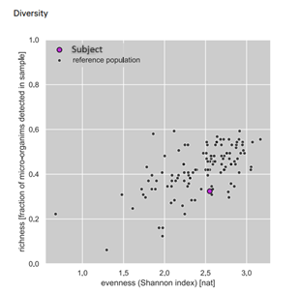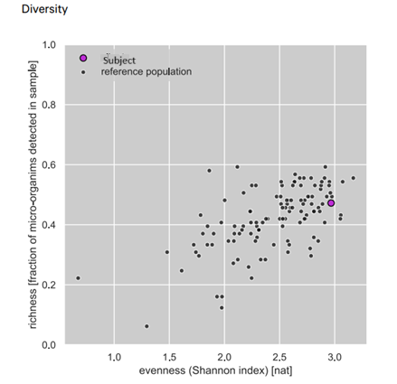

Figure 2 - Diversity of microbes before treatment Figure 3 - Diversity of microbes after treatment

2. Target Bacterial Group
Sum of bacterial groups on the PMP Gut comprehensive panel in the subject versus the known reference population at Bio-Me were observed (Table 1). Low levels of SCFA-producing bacteria, including F. prausnitzii and R. inulinivorans, were detected pre-treatment. Insufficient SCFA production compromises gut barrier integrity and contributes to inflammation. Sum of total short-chain fatty acid producing bacteria on the PMP Gut comprehensive panel in the subject vs the known reference population at Bio-Me showed an increase in SCFA-producing bacteria post-treatment, particularly F. prausnitzii, which is known for its anti-inflammatory properties. Elevated SCFA levels support gut-brain communication, metabolic health, and immune modulation. The F/B ratio was low pre-treatment, suggesting suboptimal metabolic function and an increased risk of metabolic conditions. Post-treatment saw a slight increase in the F/B ratio, reflecting improved metabolic efficiency and gut health. Low levels of Bifidobacterium and Lactobacilli beneficial bacteria which are essential for digestion, immune regulation, and protection against pathogens were observed pre-treatment. At post-treatment, significant increases in Bifidobacteria and Lactobacilli levels were noted, promoting gut health and potentially enhancing immune responses. At pre-treatment elevated Proteobacteria levels linked to inflammatory conditions and metabolic dysfunction were observed. At post-treatment a marked reduction in Proteobacteria levels was observed, indicating a decrease in gut inflammation and improved overall health. This is mainly due to the elimination of E. coli levels after treatment.
Table 1: Microbial Diversity of Gut Pre and Post treatment with Physta extract after 1 month supplementation
 | Microbial Diversity | Pre-treatment | Post-treatment
a. | SCFA Producing bacteria (total) | 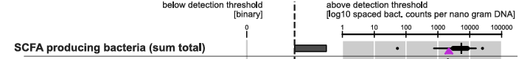 | 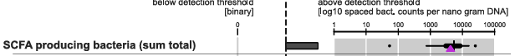
b. | Fermicutes to Bacteriodetes ratio | 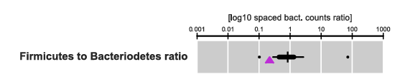 | 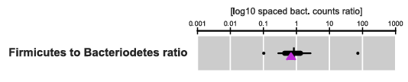
c. | Bifidobacteria and Lactobacilli (total) | 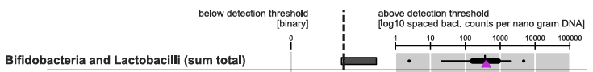 | 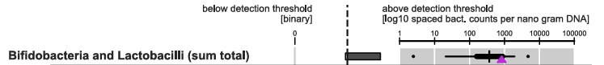
d. | Proteobacteria (total)  - Sutterella wadsworthensis  - Escherichia coli  - Heamophilus parainfluenzae | 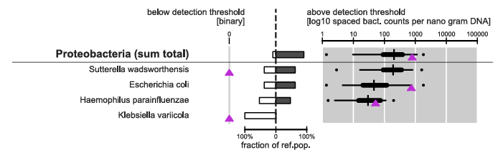 | 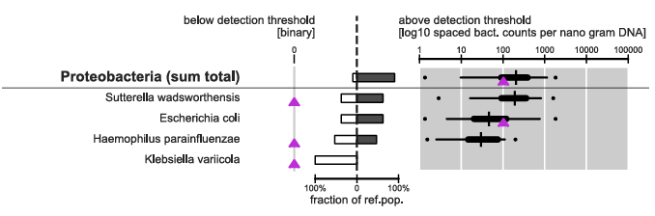

Discussion
The post-treatment changes observed in the gut microbiome indicate significant improvements in gut health, metabolic function, and immune regulation. Notably, the observed increase in microbial diversity and enhanced levels of SCFA-producing bacteria are critical for reducing inflammation, strengthening gut barrier function, and supporting mental health through the gut-brain axis.
The increased abundance of beneficial bacteria such as Bifidobacteria and Lactobacilli, coupled with a reduction in Proteobacteria, underscores a shift towards a healthier gut environment. High microbial diversity is a well-established marker of gut health, as it correlates with increased resilience against infections, enhanced metabolic stability, and reduced risks of chronic diseases such as obesity, diabetes, and autoimmune disorders. Conversely, low diversity is often linked to gut dysbiosis, which can predispose individuals to inflammatory diseases like inflammatory bowel disease (IBD) and other immune-mediated conditions. In this study, the post-treatment increase in microbial diversity aligns with prior evidence highlighting the health benefits of a robust and diverse gut microbiome.
The slight increase in the F/B ratio observed post-treatment is noteworthy, as this ratio is a recognized indicator of metabolic health. Earlier research showed that a higher F/B ratio was associated with obesity, while a lower ratio was linked to leanness and healthier metabolic profiles. However, the relationship between the F/B ratio and obesity is complex and not consistently observed across all studies. Some research has reported conflicting findings, indicating that the F/B ratio alone may not be a definitive marker of obesity [13]. Therefore, while the F/B ratio provides valuable insights into gut microbiota composition, it should be interpreted cautiously and in conjunction with other clinical parameters when assessing gut health and its implications for metabolic diseases [13-15].
Furthermore, one must consider the aim of the specific study in which the F/B ratio is being evaluated. Optimizing this ratio has been shown to enhance energy metabolism and aid in managing metabolic syndrome. The observed improvement supports the hypothesis that Physta® supplementation can contribute to a balanced gut ecosystem, potentially linked to improved health and strength. Previous studies have demonstrated that Physta® increases testosterone levels, resulting in enhanced muscle strength [16]. Peri and menopause also affect microbiome’s composition, affecting oral, intestinal, and urogenital communities, potentially leading to disease. The changes in sex hormones highlights the bidirectional relationship between hormones and the microbiome [17]. A clinical study on peri and post menopausal women supplemented with Physta® demonstrated improved reproductive hormone levels of testosterone and estrodiol suggesting a multi-directional involving hypothalamus-pituitary axis inlving the endocrine [18] and currentlly gastrointestinal tract in the improvement of menopausal quality of life of women.
The observed increase in SCFA-producing bacteria, such as Faecalibacterium prausnitzii and Roseburia inulinivorans, is particularly important. SCFAs—including acetate, propionate, and butyrate—are critical for maintaining gut barrier integrity, modulating immune responses, and reducing inflammation. These metabolites also play a key role in the gut-brain axis, influencing cognitive function and behavior through neuro-immunoendocrine pathways. The positive modulation of SCFA-producing bacteria following Physta® supplementation aligns with prior findings showing its immunomodulatory effects in middle-aged adults [19].
Additionally, the reduction in Proteobacteria post-treatment is highly significant. Elevated levels of Proteobacteria are often linked to inflammatory conditions such as Crohn’s disease and ulcerative colitis, as well as systemic inflammation that can exacerbate insulin resistance and cardiovascular risks [20-22]. These findings underscore the critical role of gut microbiota composition in modulating inflammatory responses and metabolic health. The proliferation of Proteobacteria not only serves as a marker for intestinal inflammation but also as a potential contributor to systemic inflammatory states, influencing the pathogenesis of metabolic disorders and cardiovascular diseases. The root extract of E. longifolia has demonstrated anti-inflammatory and anti-hyperglycaemic effect [23,24]. Hence, why the observed decline in Proteobacteria suggests a shift toward a less inflammatory gut microbiome, contributing to improved long-term health outcomes. However, a more comprehensive study would be needed to verify this for Physta® supplementation.
The increase seen in Bifidobacteria and Lactobacilli post-treatment further emphasizes the potential health benefits of Physta® supplementation. Beneficial bacteria such as Bifidobacteria and Lactobacilli are considered health promoting bacteria, due to contributing to digestive mechanisms by transforming foods into beneficial metabolites, as well as supporting a well-functioning immune system and creating a barrier against the establishment of potential pathogenic bacteria in the gut (Saez Lara 2015). These bacterial genera are well-documented for their roles in enhancing immune function, fermenting dietary fibers into SCFAs, and inhibiting harmful pathogens. [25,26]. Their presence strengthens the gut barrier, reduces inflammation, and supports overall digestive health, thereby reducing the likelihood of gastrointestinal disorders and infections. Physta® in addition, has been reported to possess immunomodulating properties in a clinical study among stressed adults [19].
Conclusion
The results of this study show that Physta® supplementation can lead to favorable changes in the gut microbial diversity, higher SCFA production, and an improved balance of beneficial bacterial groups. These changes are known to be associated with enhanced metabolic health, reduced inflammation, and strengthened immune function. The findings highlight the therapeutic potential of microbiome-focused interventions in improving long-term health outcomes. However, this is only a preliminary study, and a more comprehensive study would be needed to validate these initial findings.

COMPETING INTERESTS DISCLAIMER:
Authors have declared that they have no known competing financial interests OR non-financial interests OR personal relationships that could have appeared to influence the work reported in this paper.

Ethical Approval
Ethical review and approval were waived for this study due to a preliminary internal case study aimed at exploring the potential effects of Physta®, hence the formal ethical approval was not sought. Informed consent was obtained from the subject to participate and disclose findings to provide for pre-liminary data and justification for future studies. Full ethical approval will be obtained prior to conducting the planned comprehensive clinical study to ensure compliance with ethical research standards.
Future studies with larger sample sizes and extended follow-up periods are recommended to validate these findings and further explore the potential of microbiome-targeted therapies in managing chronic diseases and promoting overall health.
Reference:
- Peterson CT, Santiago JP, Lablokov SN, Chopra D, Rodionov DA, Petersen SN. Short-Chain Fatty Acids Modulate Healthy Gut Microbiota Composition and Functional Potential. Curr Microbiol 2022;79(5):128. doi: 10.1007/s00284-022-02825-5.
- Silva YP, Bernardi A, Frozza RL. The Role of Short-Chain Fatty Acids from Gut Microbiota in Gut-Brain Communication. Front Endocrinol (Lausanne). 2020;(11):25. doi: 10.3389/fendo.2020.00025.
- Kuroki Y, Tsuda F, Tawara F, Tsumagari S. Inhibitory Effects of Tongkat Ali (Eurycoma longifolia) extract on lighting stress induced sleep disorders in pigs. J Vet Malaysia 2022; 34(1): x - x
- Fusco W, Lorenzo MB, Cintoni M, Porcari S, Rinninella E, Kaitsa F, et al. Short-Chain Fatty-Acid-Producing Bacteria: Key Components of the Human Gut Microbiota Nutr 2023;15(9):2211. doi: 10.3390/nu15092211.
- Meyers GR, Samauda H, Bohn T. Short Chain Fatty Acid Metabolism in Relation to Gut Microbiota and Genetic Variability. Nutr 2022; 14(24), 5361. doi:10.3390/nu14245361
- Marano G, Traversi G, Gaetani E, Gasbarrini A, Mazza M. Gut microbiota in women: The secret of psychological and physical well-being. World J Gastroenterol 2023;29(45):5945–5952. doi: 10.3748/wjg.v29.i45.5945.
- Farup PG, Maseng MG. Are Faecal Microbiota Analyses on Species-Level Suitable Clinical Biomarkers? A Pilot Study in Subjects with Morbid Obesity. Microorganisms. 2021;9(3):664. doi: 10.3390/microorganisms9030664.
- Grahnemo L, Nethander M, Coward E, Gabrielsen ME, Sree S, Billod JM, et al. Cross-sectional associations between the gut microbe Ruminococcus gnavus and features of the metabolic syndrome. Lancet Diabetes Endo. 2022(10):481–483.
- Mosca A, Leclerc M, Hugot JP. Gut Microbiota Diversity and Human Diseases: Should We Reintroduce Key Predators in Our Ecosystem? Front Microbiol 2016;7:455. doi: 10.3389/fmicb.2016.00455. eCollection 2016
- Houtman TA, Eckermann HA, Smidt H, de Weerth C. Gut microbiota and BMI throughout childhood: the role of firmicutes, bacteroidetes, and short-chain fatty acid producers. Sci Rep. 2022;12(1):3140. doi: 10.1038/s41598-022-07176-6.
- Saez-Lara MJ, Gomez-Lorente C, Plaza-Diaz J, Gil A. The role of probiotic lactic acid bacteria and bifidobacteria in the prevention and treatment of inflammatory bowel disease and other related diseases: a systematic review of randomized human clinical trials. Biomed Res Int. 2015;(2015):505878. doi: 10.1155/2015/505878.
- Vester-Andersen MK, Mirsepasi-Lauridsen HC, Prosberg MV, Mortensen CO, Träger C, Skovsen K et al. Increased abundance of proteobacteria in aggressive Crohn's disease seven years after diagnosis. Sci Rep 2019;9(1):13473. doi: 10.1038/s41598-019-49833-3.
- Pillai SS, Gagnon CA, Foster C, Ashraf AP. Exploring the Gut Microbiota: Key Insights into Its Role in Obesity, Metabolic Syndrome, and Type 2 Diabetes. J Clin Endocrinol & Met 2024;109(11):2709–2719.
- Karasic A, Ranko I, Krznaric Z, Klobucar S, Prso AL. The Association between the Firmicutes/Bacteroidetes Ratio and Body Mass among European Population with the Highest Proportion of Adults with Obesity: An Observational Follow-Up Study from Croatia. Biomed 2024;12(10):2263 doi:10.3390/biomedicines12102263.
- Magne F, Gotteland M, Gauthier L, Zazueta A, Pesoa S, Navarrete P. The Firmicutes/Bacteroidetes Ratio: A Relevant Marker of Gut Dysbiosis in Obese Patients? Nutr 2020;12(5): 1474.
- Henkel RR, Wang R, Bassett SH, Chen T, Liu N, Zhu Y, Tambi MI.Tongkat Ali as a Potential Herbal Supplement for Physically Active Male and Female Seniors—A Pilot Study 2014;28(14). doi:10.1002/ptr.5017
- Nieto ML, Rus MJ, Areal-Quecuty V, Lubián-López DM, Simon-Soro A. Menopausal shift on women’s health and microbial niches. npj Women's Health 2025;3(3)
- Chinnappan SM, George A, Evans M, Anthony J. Efficacy of Labisia pumila and Eurycoma longifolia standardised extracts on hot flushes, quality of life, hormone and lipid profile of peri-menopausal and menopausal women: a randomised, placebo-controlled study. Food Nutr Res 2020;64. doi: 10.29219/fnr.v64.3665.
- George A, Suzuki N, Abas A, Mohri K, Utsuyama M, Hirokawa K, Takara T. Immunomodulation in Middle-aged humans via the ingestion of Physta® Standardized Root Water Extract of Eurycoma longifolia Jack – A Randomized, double blind, placebo-Controlled parallel study. Phytother Res 2016;30(4):627-35. doi: 10.1002/ptr.5571
- Hansen JJ, Sartor RB. Therapeutic Manipulation of the Microbiome in IBD: Current Results and Future Approaches. Curr Treat Options Gastro 2015(13):105–120. doi:10.1007/s11938-014-0042-7
- Vester-Andersen MK, Mirsepasi-Lauridsen HC, Prosberg MV, Mortensen CO, C Träger C, Skovsen K et al. Increased abundance of proteobacteria in aggressive Crohn’s disease seven years after diagnosis. Sci Rep 2019;9(1):13473.
- Puetz A and Kappel BA. Gut Microbiome in Dyslipidemia and Atherosclerosis. In: Federici M, Menghini R (eds). Gut Microbiome, Microbial Metabolites and Cardiometabolic Risk. Endocrinology. 2024.Springer, Cham. doi:10.1007/978-3-031-35064-1_10
- Chaingam J, Choonongv R, Juengwatanatrakul T, Kanchanapoom T, Putalun W, Yusakul G. Evaluation of anti-inflammatory properties of Eurycoma longifolia Jack and Eurycoma harmandiana Pierre in vitro cultures and their constituents. Food and Agricul Immnunol 2022(33)1. doi:10.1080/09540105.2022.2100324.
- Tsai CH, Fang TC, Liao PL, Liao JW, Chan YJ, Cheng YW, Li CH. The Powdered Root of Eurycoma longifolia Jack Improves Beta-Cell Number and Pancreatic Islet Performance through PDX1 Induction and Shows Antihyperglycemic Activity in db/db Mice. Nutr 2020; 12(7):2111. doi: 10.3390/nu12072111.
- Tan JK, Macia L, Mackay CR. Dietary fiber and SCFAs in the regulation of mucosal immunity. J Allergy Clin Immunol 2023;151(2):361-370.
- Venegas DP, Fuente MKD, Landskron G, González MJ, Quera R, Dijkstra G. Short Chain Fatty Accids (SCFAs) – Mediated Gut Epithelial and Immune Regulation and its relevance for Inflammatory Bowel Disease. Front Immunol;2019(10):277. doi: 10.3389/fimmu.2019.00277.

