Original Research Article

LINGERING EFFECTS OF COVID-19 ON DIFFERENT AGE GROUPS: WITH REFERENCE TO MALAPPURAM DISTRICT, KERALA, INDIA

ABSTRACT
The COVID-19 pandemic has had profound and varied effects across age groups, disrupting daily life, mental and physical health, and economic well-being. This study investigates the long-term impact of the pandemic on different age demographics in the Malappuram district of Kerala, India. By using both primary data (collected through structured online questionnaires) and secondary sources (official and academic), the research explores how individuals across age groups coped with the pandemic and identifies the most affected groups. The analysis reveals that the elderly (56 and above) were the most significantly impacted, suffering from severe mental and physical health issues, compounded by limited hospital access and social isolation. Children (12 and below) also faced mental health challenges, primarily due to educational interruptions and lifestyle changes. Adults (26–55) were the most affected economically, experiencing job losses and financial insecurity, while youth were caught between mental strain and academic disruptions. Despite these challenges, most respondents across age groups reported following government guidelines and taking extra precautions. The study highlights the importance of age-specific responses in public health and social policy. Recommendations include enhancing mental health support for children and the elderly, providing alternative healthcare access for seniors, implementing flexible learning models for students, and creating employment support programs for economically affected populations. The findings underscore the necessity for holistic, inclusive crisis management strategies that account for the diverse needs of various age groups in times of public health emergencies.
Keywords: Children, COVID-19, Economic impact, Education, Elderly, Mental health, Physical health.
- INTRODUCTION
A pandemic is the worldwide spread of a new disease. It is not a new phenomenon to human history, pandemics such as cholera, Spanish flu, SARS, plague have occurred before. Those have drastically changed cultures, gave rise to new ideas, resulted in the fall of empires etc. COVID-19 pandemic originated from Wuhan, China (Grove et.al, 2020) is currently shaking the world. Transcending all the racial, ethnic, cultural and political boundaries, it is now a nightmare to all.
The COVID-19 pandemic has profoundly affected societies worldwide (Zhu, N. et.al., 2020) , causing disruptions to daily life, economies, and public health infrastructures. While the immediate consequences of the virus were extensively reported during the initial outbreak, the enduring effects—commonly known as "long COVID" (Alwan, N. A. 2021)—have surfaced as a major public health issue. These effects differ among various age groups, impacting physical health, mental wellness, social interactions, and economic stability in distinct manners (Pfefferbaum et.al.,2020). In India, Kerala received praise for its early and proactive response to the pandemic. However, areas such as the Malappuram district encountered unique challenges due to their specific demographic, economic, and healthcare profiles. With a varied population that includes children, working-age individuals, and an increasing number of elderly residents, Malappuram serves as an important case for examining the age-related impacts of COVID-19 over time (Nair, S., & Prasad, R. 2021). This research aims to investigate and assess the long-term effects of COVID-19 across different age demographics in Malappuram district. By analyzing health outcomes, psychological effects, educational interruptions, and socioeconomic difficulties, this study aspires to offer a thorough understanding of how the pandemic continues to influence lives well beyond the initial waves.
Statement of the Problem
Although pandemics have occurred throughout human history, the COVID-19 pandemic has been a uniquely disruptive experience for the current generation. Unlike previous health crises in the 21st century, COVID-19 brought about sudden and widespread changes in everyday life (Koh, D. 2020). Practices such as wearing masks, maintaining social distancing, limiting travel, and avoiding routine visits to hospitals became the new norm, significantly impacting people's routines and overall well-being.
These abrupt lifestyle shifts have had far-reaching consequences—physically, mentally, and economically (Baker, A., & Westlake, C. 2021).. Importantly, the intensity and nature of these effects have varied across different age groups. In light of this, a systematic study is essential to understand and address the lingering impact of the pandemic on individuals' mental health, physical health, and economic conditions, especially within specific local contexts such as Malappuram district in Kerala.
Objectives
- To examine the varying impacts of the COVID-19 pandemic across different age groups.
- To explore the coping mechanisms adopted by different age groups in response to the challenges posed by the pandemic.
- To identify the age group that experienced the most significant adverse effects due to the pandemic.
Hypothesis
It is hypothesized that the impact of the COVID-19 pandemic varies significantly across different age groups.
- METHODOLOGY
This study is based on both primary and secondary data sources. Primary data were collected through structured questionnaires distributed via online platforms. Secondary data were obtained from official documents and published reports from both governmental and non-governmental organizations.
For the analysis of primary data, Microsoft Excel and the trial version of SPSS software were utilized. Various statistical tools such as percentages, tabular presentations, multiple bar diagrams, and simple bar diagrams were employed to interpret and present the findings effectively.
Limitations of the Study
- The study was conducted within a limited time frame, which restricted the inclusion of additional variables and reduced the scope for reaching a larger number of respondents.
- The findings may be subject to both sampling and non-sampling errors, which could affect the overall accuracy of the results.
- Some respondents may not have provided entirely truthful responses to personal or sensitive questions, potentially impacting the reliability of the data.
Review of Literature
The COVID-19 pandemic has profoundly affected various aspects of life across different demographics in India. Existing literature highlights significant socio-economic, psychological, and educational impacts, with notable variations across age groups.​
A study by Ranjan Aneja and Vaishali Ahuja (October 2020) assessed the socioeconomic impact of COVID-19 in India, noting that the pandemic led to business disruptions and increased unemployment, thereby exacerbating poverty levels.​
Ashwini Deshpande and Rajesh Ramchandran (August 2020) explored how the pandemic and subsequent lockdowns intensified pre-existing social disadvantages. Their research indicated that job losses were disproportionately higher among individuals with lower education levels and those in informal employment, highlighting significant caste-based disparities in accessing online education.​
Anvita Gopal, Anupam Joya Sharma, and Malavika Ambale Subramanyam (October 2020) conducted a longitudinal study on psychological responses to COVID-19 in India. Their findings revealed an increase in anxiety, stress, and depressive symptoms over the two-month lockdown period.​
Marine Al Dahdah et al. (April 2020) discussed the deepening socio-economic inequalities and the strain on India's healthcare system due to the pandemic, emphasizing the exacerbation of poverty and economic stagnation.​
Prama Bhattacharya, Debanjan Banerjee, and T.S. Sathyanarayana Rao (June 2020) examined the social stigma associated with COVID-19, noting that misconceptions about the virus led to discrimination against individuals perceived to be infected. They also suggested measures to mitigate such stigma.​
The United Nations (April 2020) highlighted the critical role of human rights in pandemic response and recovery, providing a global perspective on the challenges faced and the importance of mutual support during such crises.​
Recent studies have further illuminated the pandemic's impact across different age demographics in India. A 2023 report by the Sapien Labs Centre for Human Brain and Mind at Krea University revealed that individuals aged 18–24 experienced the most significant decline in mental health post-pandemic, with depression rates increasing from 9.3% in May 2020 to 16.8% by March 2022.
Similarly, research focusing on Assam's primary school children indicated substantial learning losses during the pandemic. Children lacked resources and parental support, leading to significant setbacks in education (​Science Direct 2023).
Studies also highlighted the pandemic's impact on the elderly, with 26% of seniors reporting adverse effects on their health, making it their primary concern. Psychological issues were also prevalent among this group (Business & Finance News 2023).
Furthermore, research indicated that the pandemic led to faster brain aging in adolescents, with girls being particularly affected. The lockdowns significantly limited social interactions, coinciding with a rise in mental health issues among teens, such as anxiety and depression.(​India Today 2023).
While these studies provide valuable insights into the pandemic's effects across various demographics, there is a notable gap in research specifically addressing the impact of COVID-19 on different age groups within Malappuram district, Kerala. This study aims to fill that gap by providing localized data to inform targeted interventions and support mechanisms.
3. RESULTS AND DISCUSSION
The study includes a total of 140 participants, categorized by age group as follows: 13 participants are aged 12 years or below (children), constituting approximately 9.3% of the total sample. The largest group, consisting of 79 participants, falls within the 13–25 age range (youth), making up about 56.4% of the total participants. There are 33 participants in the 26–55 age group (adults), representing 23.6% of the total sample. Lastly, 15 participants are aged 56 and above (seniors), comprising 10.7% of the total participants. All primary data for this study was collected from these 140 individuals.

Table: 1 Classification of Respondents based on Age
Age Groups | Frequency | Percent
12 and Below | 13 | 9.3
13 - 25 | 79 | 56.4
26 – 55 | 33 | 23.6
56 and above | 15 | 10.7
Total | 140 | 100.0
Source: Primary survey 2024
In the study by Ana Sandoiu, "Impact of COVID-19 Pandemic on Older Adults" (May 2020), it is noted that seniors believe the lockdown and subsequent events have brought drastic changes to their lives. Factors such as a weakened immune system, increased isolation, and a higher risk of abuse may contribute to their heightened concerns during this period.

Table: 2 Effect of COVID-19 on Normal Life
Age | Effect on normal life |  |  |  | Total
Age | a little affected | moderately affected | not affected | severely affected | Total
12 and Below | 4 | 6 | 0 | 3(23%) | 13
13 - 25 | 13 | 34 | 7 | 25(31.64%) | 79
26 - 55 | 9 | 16 | 1 | 7(21%) | 33
56 and above | 2 | 7 | 0 | 6(40%) | 15
Total | 28 | 63 | 8 | 41 | 140
Source: Primary survey 2024
For the age group of 12 and below, as well as 13 – 25, education was the biggest worry, which made sense since they were primarily students. Adults, who were mainly working, were concerned about their jobs but also seemed more aware of the situation, as they equally cared about the health and education of those around them. Senior citizens were most concerned about their health problems.

Table: 3. Cause of Biggest Worry
Age Group | Biggest Worry |  |  |  |  | Total
Age Group | affected your education / education of people around you | affected your job | health problems | reduced income | rising number of COVID 19 infections | Total
12 and below | 9(69%) | 0 | 2 | 0 | 2 | 13
13 - 25 | 54(68%) | 2 | 5 | 4 | 14 | 79
26 - 55 | 7 | 7(21%) | 7 | 6 | 6 | 33
56 and above | 0 | 0 | 11(73%) | 2 | 2 | 15
Total | 70 | 9 | 25 | 12 | 24 | 140
Source: Primary survey 2024
During the COVID-19 period, the age group that traveled the least was senior citizens, likely due to their higher risk of contracting the virus. Children, who were also more prone to the virus, appeared to be more cautious as well. Adults traveled more frequently, followed by the youth.

Table: 4 Travel During Corona Period
Age Group | Travel |  |  |  | Total
Age Group | always | frequently | never | once in a while | Total
Below 12 | 0 | 1 | 4(30%) | 8 | 13
13 - 25 | 1 | 19 | 19(24%) | 40 | 79
26 - 55 | 1 | 5 | 3(0.9%) | 24 | 33
56 and above | 0 | 2 | 5(33%) | 8 | 15
Total | 2 | 27 | 31 | 80 | 140
Source: Primary Survey 2024
The majority of youth, adults, and seniors used sanitizer every time they went out, while children lagged behind. Around 46% of children used sanitizer, which was higher than any other option.
Table.5. Use of Sanitizer
Age Group | Using Sanitizer |  |  |  | Total
Age Group | never used | sometimes | usually | Yes , always | Total
Below 12 | 0 | 7 | 0 | 6(46%) | 13
13 - 25 | 0 | 16 | 3 | 60(75%) | 79
26 - 55 | 0 | 9 | 2 | 22(66%) | 33
56 and above | 1 | 4 | 0 | 10(66%) | 15
Total | 1 | 36 | 5 | 98 | 140
Source: Primary Survey 2024
The majority of youth and adults practiced social distancing every time they went out. The frequency of senior citizens practicing social distancing and staying at home was the same.

Table: 6 Practice Social Distancing
Age Group | Social Distancing |  |  |  | Total
Age Group | always | don't go out | never | sometimes | Total
12 and below | 5 | 0 | 3 | 5 | 13
13 - 25 | 41(51%) | 4 | 4 | 30 | 79
26 - 55 | 26(78%) | 0 | 1 | 6 | 33
56 and above | 3 | 3 | 1 | 8 | 15
Total | 75 | 7 | 9 | 49 | 140
Source: Primary Survey 2024
Children spent their free time engaging in various hobbies. Both youth and adults mostly spent their time on social media, while the elderly, like children, also spent their free time on hobbies. The number of participants who spent time exercising was alarmingly low.

Table: 7. Spending Free Time
Age Group | Spending free Time |  |  |  | Total
Age Group | exercises | hobbies | learned a new skill | social medias | Total
12 and below | 0 | 11(84%) | 0 | 2 | 13
13 - 25 | 5 | 25 | 13 | 36(45%) | 79
26 - 55 | 4 | 6 | 8 | 15(45%) | 33
56 and above | 0 | 10(66%) | 2 | 3 | 15
Total | 9 | 52 | 23 | 56 | 140
Source: Primary Survey 2024
The frequency of suicidal thoughts was an important indicator of mental health. The age group that struggled with such thoughts the most was the youth, with 13% reporting suicidal thoughts. Adults followed closely at 12%. Seniors were next, while children rarely experienced such thoughts.
Table: 8 Suicidal Thoughts
Age Group | Suicidal Thoughts |  |  |  | Total
Age Group | always | frequently | never | once in a while | Total
12 and Below | 0 | 0 | 12 | 1 | 13
13 - 25 | 2 | 4 | 68 | 5 | 79
26 - 55 | 0 | 2 | 29 | 2 | 33
56 and above | 0 | 1 | 14 | 0 | 15
Total | 2 | 7 | 123 | 8 | 140
Source: Primary survey 2024
An alarming percentage (93%) of the elderly group suffered from insomnia. The age group with the second-highest difficulty in sleeping was children, while adults and teens had the least trouble. Although insomnia was a strong indicator of mental health, issues related to oversleeping also needed to be taken into consideration.

Fig. 1. Frequency of Insomnia
Source: Primary survey 2024
The elderly age group suffered the most from sudden mood changes, with none of them reporting an absence of such experiences. Youth were the next most affected, while adults experienced the least mood fluctuations. This was also an important indicator of mental health.
Table: 9 Sudden Mood Changes
Age Group | Sudden Mood Changes |  |  |  | Total
Age Group | Always | Never | Sometimes | Usually | Total
12 and below | 0 | 3 | 7 | 3(23%) | 13
13 - 25 | 9(11%) | 24 | 35 | 11(13%) | 79
26 - 55 | 0 | 10 | 20 | 3(9%) | 33
56 and above | 1 | 0 | 10 | 4(26%) | 15
Total | 10 | 37 | 72 | 21 | 140
Source: Primary Survey 2024
Changes in eating habits were often the most truthfully answered among questions related to mental health, and this data also applied to physical health. Children were the group that most commonly reported eating less, while adults were the age group that reported eating more. Among the elderly, there was an almost equal distribution between those who ate more and those who ate less.
Table: 10 Changes in eating habits
Age Group | Eating Habits |  |  |  | Total
Age Group | Have started to eat less | Have started to eat more | Haven't noticed | It's the same | Total
12 and below | 7(53%) | 3(23%) | 1 | 2 | 13
13 - 25 | 9(11%) | 28(35%) | 17 | 25 | 79
26 - 55 | 5(15%) | 17(51%) | 2 | 9 | 33
56 and above | 3(20%) | 5(33%) | 3 | 4 | 15
Total | 24 | 53 | 23 | 40 | 140
Source: Primary survey 2024
Most relationships weakened during the lockdown period, while strengthened relationships were almost negligible in comparison. Seniors experienced this the most, possibly because they had the least opportunities for travel and limited access to or familiarity with technology.
Source: Primary survey 2024
Sudden body pains and headaches were most commonly reported by the age group 56 and above, with the percentage being alarmingly high. Children were the second most affected group. These symptoms served as indicators of both mental and physical health concerns.
Table: 11 Sudden Body Pains or Headaches
Age Group | Body Pains or Headache |  |  |  | Total
Age Group | Always | Never | Rarely | Sometimes | Total
12 and below | 1 | 3 | 2 | 7 | 13
13 - 25 | 3 | 36 | 26 | 14 | 79
26 - 55 | 1 | 9 | 7 | 16 | 33
56 and above | 5 | 0 | 1 | 9 | 15
Total | 10 | 48 | 36 | 46 | 140
Source: Primary survey 2024
The age group that suffered from chronic diseases the most was clearly the elderly. Although adults also experienced chronic conditions, the frequency was notably low. None of the children were reported to have any chronic illness.
Table: 12 Chronic diseases
Age group | Chronic Diseases |  | Total
Age group | No | Yes | Total
12 and below | 13 | 0(0%) | 13
13 - 25 | 77 | 2(2%) | 79
26 - 55 | 30 | 3(9%) | 33
56 and above | 4 | 11(73%) | 15
Total | 124 | 16 | 140
Source: Primary Survey 2024
Attitudes towards hospital visits changed significantly during the lockdown. Most children were unwilling to visit hospitals at all. Elderly participants were also notably reluctant. While many youth and adults were willing to go, their approach was more cautious and not as frequent as before.
Table: 13. Hospital Visits during Corona Period
Age group | Hospital Visits |  |  |  | Total
Age group | I will go but will be anxious | I will go just like earlier | I won't go at all | will go , but only if it's an emergency | Total
12 and below | 2 | 0 | 9(69%) | 2 | 13
13 - 25 | 6 | 8 | 6(7%) | 59 | 79
26 - 55 | 5 | 2 | 7(21%) | 19 | 33
56 and above | 5 | 0 | 6(40%) | 4 | 15
Total | 18 | 10 | 28 | 84 | 140
Source: Primary Survey 2024
Youth were the most physically active age group during the COVID-19 period. They were followed by children and then the elderly. Adults were the most reluctant to engage in regular exercise. Only a few children and youth reported not exercising at all.
Table: 14. Exercising During COVID-19 Period
Age group | Exercising |  |  |  | Total
Age group | Always | Most of the time | Never | Once in a while | Total
12 and below | 2 | 1 | 1 | 9 | 13
13 - 25 | 8 | 25 | 14 | 32 | 79
26 - 55 | 3 | 16 | 3 | 11 | 33
56 and above | 1 | 2 | 8 | 4 | 15
Total | 14 | 44 | 26 | 56 | 140
Source: Primary survey 2024
The majority of participants from all age groups had taken precautions beyond those recommended by the government. Adults were the ones who had taken the most additional precautions, followed by the elderly.
Table:15 Taking Precautions Other Than Government Given
Age group | Precautions other than Govt Given |  | Total
Age group | No | Yes | Total
12 and below | 6 | 7(53%) | 13
13 - 25 | 35 | 44(55%) | 79
26 - 55 | 6 | 27(81%) | 33
56 and above | 4 | 11(73%) | 15
Total | 51 | 89 | 140
Source: Primary Survey 2024
The age groups that faced the most negative changes in employment—or in the employment of people around them—were the elderly and adults. Most of the jobs affected by the lockdown belonged to the informal sector or involved self-employment. Many elderly individuals may have been working in such sectors, which could explain the challenges they faced. For this analysis, students were allowed to respond based on the employment situations of people around them, which is why even children aged 12 and below were able to provide relevant answers.
Table: 16 Changes in Employment
Age Group | Change in Employment |  |  |  |  | Total
 | Lost employment | No change at all | Reduced income | Reduced working days | Work became work from home | Total
12 and below | 0 | 9 | 0 | 2 | 2 | 13
13 - 25 | 4 | 36 | 7 | 11 | 21 | 79
26 - 55 | 5 | 6 | 9 | 6 | 7 | 33
56 and above | 3 | 3 | 8 | 0 | 1 | 15
Total | 12 | 54 | 24 | 19 | 31 | 140
Source: Primary Survey 2024
For children, the main change was that their entire lives became digitalized. This was likely due to the increased use of technology for online education. The youth, on the other hand, noticed that the overall atmosphere had become more depressing. Adults also observed the complete digitalization, while the elderly primarily noticed the shift in the atmosphere.
Fig. 3. The Main Change Participants Felt
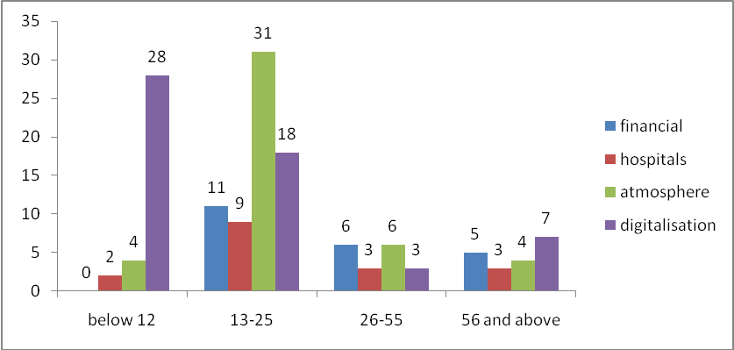
Source: Primary survey 2024
For both age groups that hadn’t finished their education (children and youth), the biggest fear was their interrupted education. While most adults were concerned about their employment, the elderly were more concerned about their weakened relationships.
Fig.4. Biggest Fear about Post COVID Period
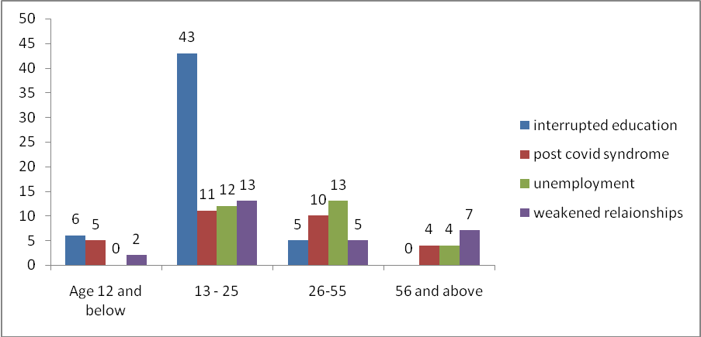
Source: Primary survey 2024

For children, the activity they missed the most was playing, while for youth, it was campus-based learning. Adults missed traveling the most, and the elderly also missed traveling. Even though children attended schools, their most missed activity was playing, and for adults, office-based work was the second most missed.

Table: 17. Most Missed Activity
Age group | Most Missed Activity |  |  |  |  | Total
Age group | Campus based learning | Playing | Shopping | Traveling | Working from office | Total
12 and below | 3 | 5 | 2 | 3 | 1 | 13
13 - 25 | 48 | 3 | 1 | 27 | 0 | 79
26 - 55 | 1 | 2 | 5 | 19 | 6 | 33
56 and above | 0 | 0 | 5 | 9 | 1 | 15
Total | 52 | 10 | 13 | 58 | 8 | 140
Source: Primary survey 2024
The elderly were the ones who watched corona reports the most. Adults also watched the reports, followed by youth. Children were not as keen on watching corona reports. Watching these reports frequently indicated how anxious they were.
Table: 18. Frequency of watching Corona Reports
Age group | Watch Corona Reports |  |  |  | Total
Age group | Always | Never | Rarely | Sometimes | Total
12 and below | 1 | 5(38%) | 5 | 2 | 13
13 - 25 | 28 | 5(6%) | 11 | 35 | 79
26 - 55 | 18 | 1(3%) | 5 | 9 | 33
56 and above | 5 | 0(0%) | 1 | 9 | 15
Total | 52 | 11 | 22 | 55 | 140
Source: Primary Survey 2024
About 53% of children always followed the instructions given by the government. Around 62% of youth and 57% of adults always followed the government instructions. While only 40% of elderly always followed the instructions, it should be noted that none of them never followed them.
Table: 19. Following Government Instructions
Age group | Following Govt. Instructions |  |  |  | Total
Age group | Always | Never | Sometimes | Usually | Total
Below 12 | 7(53%) | 1 | 4 | 1 | 13
13 - 25 | 49(62%) | 1 | 10 | 19 | 79
26 - 55 | 19(57%) | 0 | 2 | 12 | 33
56 and above | 6(40%) | 0 | 1 | 8 | 15
Total | 81 | 2 | 17 | 40 | 140
Source: Primary Survey 2024
Children felt that the COVID-19 period had mostly affected their mental health. Many youth were also concerned about their mental health, but economic well-being was also a concern for them. Adults believed they were more affected by economic well-being. For the elderly, mental well-being was the main concern.

Fig.5. Aspect People think COVID-19 have affected them
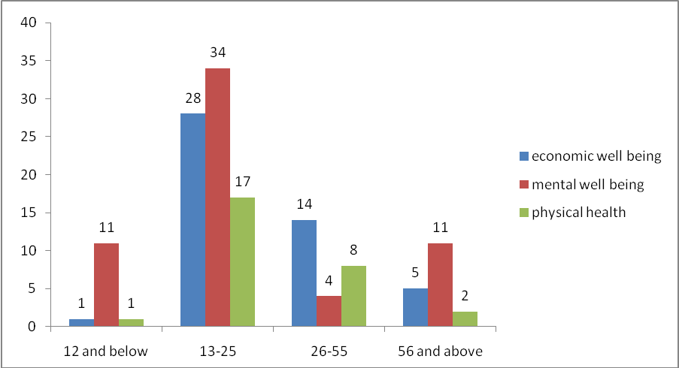
Source: Primary Survey 2024
Conclusions could be drawn from this data based on its nature. Data regarding mental health, physical health, and economic well-being were collected. There were some differences in the ways different age groups coped with the COVID-19 scenario. It was observed that governmental instructions were followed by almost everyone.
SUMMARY OF FINDINGS AND CONCLUSION
MAJOR FINDINGS
- There were differences in the impact of the COVID-19 scenario on different age groups.
- The biggest worry about the post-COVID period differed among age groups. For children and youth, it is their interrupted education. The age group 26 to 55 is also concerned about the interrupted education of people around them.
- Almost everyone, regardless of age group, followed the government’s instructions and took precautions beyond those.
- Adults and teens spent most of their free time on social media, while children and the elderly spent their free time on hobbies.
- The age group that suffered the most was the elderly (56 and above).
Mental Health
- The age group that suffered the most mentally was the elderly (56 and above). In the study by Debanjan Banarjee (2020), “The Impact of COVID-19 Pandemic on Elderly Mental Health,” it was stated that the elderly were most vulnerable to mental health problems and special care should have been given to them.
- The age group of 12 and below suffered the second most mentally during the COVID-19 period. According to the study “Impacts of Lockdown on the Mental Health and Wellbeing of Children and Young People” (2020) by Robyn Miller, Neil Quinn, Julie Cameron, and Abigail Colson, lockdowns increased PTSD (Post-Traumatic Stress Disorder) syndrome in children. There was a high chance of increased feelings of loneliness and worries among children during the lockdown.
- The age group that suffered mentally the third most was youth, followed by adults.
- The age group that experienced the biggest change in eating habits was children (age 12 and below).
Physical Health
- The age group that suffered the most physically during the COVID-19 period was the elderly (56 and above). However, they didn’t engage in exercises or physical activities, and they were the most reluctant to visit hospitals due to their higher chance of getting infected by the virus.
- Adults suffered the second most physically but also did not engage in physical activities.
- Children were also reluctant to go to hospitals as they too had a higher chance of getting infected, but they were exercising.
- Youth exercised and were more willing to visit hospitals compared to other age groups.
Economic Well-being
- The age group that suffered the most economically was adults (26 to 55), who were also the most concerned about economic well-being during the post-COVID period. However, their most missed activity was not office-based working.
- The elderly (56 and above) were the age group that either lost their employment or had reduced salaries the most during the COVID-19 pandemic.
- Youth were also concerned about economic well-being.
4.CONCLUSION
The impact of COVID-19 differed across age groups. The most affected age group was the elderly (56 and above), though variations were observed in different aspects. While children were not aware of economic situations, adults were most concerned about them. Students were very concerned about their education and missed campus-based learning the most. Children and the elderly were more vulnerable to mental health problems and seemed more sentimental compared to the other two age groups. While everyone was concerned about their health, the same concern led them to avoid hospitals. Due to the unexpected and unprecedented situations created by the pandemic, everyone coped in their own way. These circumstances were not easy for any age group, but hope for a better future helped everyone persevere and fight through each moment.
RECOMMENDATIONS
- As age groups were concerned about unemployment and reduced income due to the COVID-19 pandemic, it is suggested to introduce better self-employment schemes with government subsidies.
- Mental health issues among youth and the elderly were often discussed, but this study showed that children also struggled with their mental well-being. Therefore, it is suggested to observe them closely and spend time with them. They should be encouraged to talk about their worries, and parents should not hesitate to seek professional help if necessary in such pandemic periods.
- Since the study showed that the elderly struggled with health problems and were unable to go to hospitals, alternative healthcare methods such as home check-ups and regular health inquiries over the phone should have been provided in such pandemic situations.
- Many participants, regardless of age group, expressed a desire to travel (it was the most missed activity for both adults and the elderly). Therefore, parks and tourist spots should have been opened with proper regulations.
- As per the study, youth and children were most concerned about their education and missed campus-based learning the most. It is recommended to introduce better learning methods, such as partially campus-based classes (for example, twice a month), in combination with online classes during such pandemic periods.
References:
  - Alwan, N. A. (2021). Long COVID: A growing concern. The Lancet, 397(10284), 17-19.
  - Ana Sandoiu, (19 May 2020) “Impact of COVID-19 Pandemic on Older Adults”, Medical News Today
  - Baker, A., & Westlake, C. (2021). Economic impacts of COVID-19 on working-age populations: An international perspective. Economic Review, 55(2), 22-35.
  - Debanjan Banarjee, (4 May 2020) “The Impact of COVID-19 Pandemic on Elderly Mental Health”, Wiley Online Library
  - Gokhale, S. (2021). Kerala's proactive response to COVID-19: Lessons learned. Indian Journal of Public Health, 65(2), 79-83.
  - Grove, R., & Weskett, D. (2020). The impact of pandemics on human history: A comparative analysis. Journal of Global Health, 9(4), 95-107.
  - Koh, D. (2020). COVID-19 lockdowns and their impact on daily life: A global perspective. Journal of Global Health, 10(2), 45-53.
  - Nair, S., & Prasad, R. (2021). Socioeconomic and health impacts of COVID-19 in Malappuram district, Kerala. Journal of South Asian Studies, 15(3), 24-30.
  - Pfefferbaum, B., & North, C. S. (2020). Mental health and the COVID-19 pandemic. New England Journal of Medicine, 383(6), 510-512.
  - Robyn Miller, Neil Quinn, Julie Cameron and Abigail Colson, (September 2020) “Impact of Lockdown on the Mental Health of children and young people”, Mental Health Foundation Scotland
  - Zhu, N., Zhang, D., Wang, W., Li, X., Yang, B., Song, J., ... & Wei, W. (2020). A novel coronavirus from patients with pneumonia in China, 2019. New England Journal of Medicine, 382(8), 727-733.
**********

