Original Research Article

PHYTOCHEMICAL, ANTIOXIDANT, ANTIMICROBIAL AND ANTICANCER PROPERTIES OF BIMETAL NANOPARTICLES SYNTHESIZED FROM STUDY OF LEUCAS ASPERA FLOWER

ABSTRACT
Aims: This study focuses on the biosynthesis of titanium dioxide (TiO₂) and zinc oxide (ZnO) nanoparticles using Leucas aspera flower extract and their evaluation for antioxidant and antimicrobial properties.
Study Design: This study follows an experimental laboratory-based design focusing on the green synthesis, characterization, and bioactivity evaluation of TiO₂/ZnO nanoparticles using Leucas aspera flower extract, with assessments including UV-Vis, FTIR, SEM, antioxidant, antimicrobial, and MIC assays.
Place and Duration of Study: The study was conducted at CBNR Institute, Coimbatore, over a period of January to March 2025
Methodology: Fresh Leucas aspera flowers were collected from Kallakurichi, Tamil Nadu, India, and processed for aqueous extraction. The extract was used for the green synthesis of TiO₂/ZnO nanoparticles by reacting with 1M solutions of zinc acetate and titanium dioxide under continuous stirring, followed by overnight incubation and drying. The synthesized nanoparticles were characterized using UV-Vis spectroscopy, FTIR, and SEM analysis. The antioxidant activity of both the plant extract and nanoparticles was assessed using the Phosphomolybdenum method. Antibacterial and antifungal activities were evaluated using the well diffusion method against S. aureus, K. pneumoniae, P. aeruginosa, A. niger, A. terreus, and A. flavus. Minimum inhibitory concentration (MIC) was determined using a biofilm assay with S. aureus.
Results: The UV-Vis spectroscopic analysis confirmed the synthesis of TiO₂/ZnO nanoparticles with an absorption peak at 315 nm. The total antioxidant activity of the aqueous flower extract shows efficient activity while the nanoparticle extract showed a reduced activity. The antibacterial results revealed that nanoparticles exhibited significant inhibition against S. aureus (26 mm), K. pneumoniae (21 mm), and P. aeruginosa (22 mm), whereas the flower extract showed minimal activity. The antifungal study indicated that A. niger and A. terreus were susceptible to nanoparticles, while A. flavus was resistant. MIC analysis demonstrated a dose-dependent inhibition of S. aureus, with a maximum cell death of 54.45% at 10 µg/ml.
Conclusion: The biosynthesized TiO₂/ZnO nanoparticles exhibited superior antibacterial and antifungal properties compared to the flower extract. The study highlights the potential of Leucas aspera extract-mediated nanoparticles as effective antimicrobial agents for biomedical applications.
Keywords: Leucas aspera, Bimetallic Nanoparticles, Antioxidant Activity, Antimicrobial Properties, MIC

- INTRODUCTION

Medicinal plants have been an integral part of traditional healing systems for centuries, offering a natural source of bioactive compounds with therapeutic potential. Leucas aspera, commonly known as "Thumbai," belongs to the Lamiaceae family and is widely distributed across India, from the Himalayas to Sri Lanka. This plant is well known for its medicinal properties and has been extensively used in Ayurvedic and Siddha medicine (Shalini et al., 2025). Various parts of the plant, including its roots, stems, leaves, flowers, fruits, and seeds, contain bioactive compounds responsible for diverse pharmacological activities. Traditionally, Leucas aspera has been employed as an antidote for snakebites, particularly cobra venom poisoning, as well as in the treatment of gastrointestinal disorders, tooth infections, respiratory ailments, and inflammatory conditions (Joselin et al., 2024; Islam et al., 2012). Additionally, it possesses insecticidal properties and has been used as a mosquito repellent, highlighting its importance as a versatile medicinal herb (Joselin et al., 2024).
The phytochemical constituents of Leucas aspera contribute significantly to its medicinal properties. It is rich in alkaloids, flavonoids, tannins, terpenoids, steroids, saponins, glycosides, and essential oils, which are known for their antioxidant, anti-inflammatory, antimicrobial, and anticancer activities (Indira et al., 2023). The flowers of Leucas aspera are traditionally mixed with honey to treat colds in children, while the leaves are applied topically to reduce swelling and inflammation (Indira et al., 2023). Furthermore, the plant has hepatoprotective activity and plays a crucial role in detoxifying harmful substances and maintaining homeostasis, thereby boosting the immune system and protecting against infections (Hiremath et al., 2025). These medicinal applications make Leucas aspera a promising candidate for the development of novel therapeutic agents.
The increasing concern over the toxicity and environmental impact of chemically synthesized nanoparticles has led researchers to explore green synthesis approaches using plant-based reducing agents. Green nanotechnology is an eco-friendly alternative that utilizes phytochemicals present in plant extracts to synthesize nanoparticles in a non-toxic and sustainable manner. Leucas aspera has gained attention for its potential in nanoparticle synthesis due to its high phytochemical content, which acts as a natural reducing and stabilizing agent. Nanotechnology has revolutionized various scientific fields, particularly in biomedical, pharmaceutical, and environmental applications. The green synthesis of nanoparticles is considered advantageous over conventional chemical methods due to its cost-effectiveness, minimal toxicity, and biocompatibility (Afzal et al., 2023). Among different metallic nanoparticles, bimetallic nanoparticles have shown superior biological and catalytic properties compared to monometallic nanoparticles. The combination of two different metal nanoparticles results in improved stability, bioactivity, and synergistic therapeutic effects (Al Masoudi et al., 2023). Titanium dioxide (TiO₂) and zinc oxide (ZnO) nanoparticles are widely recognized for their potent antioxidant and antimicrobial properties. TiO₂ nanoparticles exhibit excellent photocatalytic activity, making them suitable for applications in antimicrobial coatings, drug delivery, and environmental remediation (Al Masoudi et al., 2023). On the other hand, ZnO nanoparticles possess broad-spectrum antimicrobial activity against drug-resistant bacteria and fungi, along with notable wound-healing properties (Kaviyarasu et al., 2025).
The synthesis of TiO₂/ZnO bimetallic nanoparticles using Leucas aspera flower extract is expected to enhance their biological activities. The phytochemicals present in the flower extract serve as natural capping agents, preventing nanoparticle aggregation and improving stability (Shalini et al., 2025). The antioxidant activity of these nanoparticles plays a crucial role in neutralizing free radicals, reducing oxidative stress, and preventing cellular damage. This property is particularly beneficial in treating diseases associated with oxidative stress, such as cancer, cardiovascular disorders, and neurodegenerative diseases (Fazeela et al., 2024). Additionally, TiO₂/ZnO bimetallic nanoparticles synthesized using Leucas aspera flower extract exhibit strong antimicrobial properties. Several studies have demonstrated that metal oxide nanoparticles possess antibacterial activity against a wide range of pathogens, including Staphylococcus aureus, Klebsiella pneumoniae, Salmonella typhi, and Pseudomonas aeruginosa (Al Masoudi et al., 2023). The antimicrobial mechanism of these nanoparticles involves the generation of reactive oxygen species (ROS), disruption of bacterial cell membranes, and inhibition of microbial enzyme activity and DNA replication (Afzal et al., 2023). Such properties make these nanoparticles valuable candidates for developing alternative antimicrobial agents to combat antibiotic-resistant pathogens.
Apart from their antimicrobial and antioxidant properties, TiO₂/ZnO nanoparticles have potential applications in pharmaceuticals, cosmetics, and environmental remediation. These nanoparticles have been widely utilized in sunscreen formulations due to their UV-blocking capabilities (Al Masoudi et al., 2023). They are also employed in wastewater treatment processes to degrade organic pollutants and in wound dressings for their antimicrobial and wound-healing properties (Kaviyarasu et al., 2025). The integration of Leucas aspera with nanotechnology provides a sustainable and eco-friendly approach to developing multifunctional nanoparticles with diverse applications. The World Health Organization (WHO) recognizes the significance of medicinal plants in drug development, reporting that over 80% of the global population relies on traditional medicine for primary healthcare needs (Sungar et al., 2024). This has driven increased research into plant-derived bioactive compounds for pharmaceutical applications. By incorporating Leucas aspera flower extract into nanoparticle synthesis, researchers aim to develop novel therapeutic agents with enhanced efficacy and minimal toxicity (Shalini et al., 2025).
This study aims to evaluate the phytochemical composition, antioxidant potential, and antimicrobial activity of TiO₂/ZnO bimetallic nanoparticles synthesized using Leucas aspera flower extract. The research focuses on identifying the bioactive compounds in the plant extract, assessing its ability to enhance nanoparticle properties, and exploring its biomedical and pharmaceutical applications. By merging traditional herbal medicine with modern nanotechnology, this study contributes to the development of innovative, sustainable, and effective therapeutic solutions.
- MATERIALS AND METHODS

  - Collection of Flowers
Leucas aspera flowers were collected from Kallakurichi, Tamil Nadu, India. The freshly gathered flowers were transported to the laboratory for subsequent extraction and characterization procedures.
  - Preparation of Flower Extract
The collected Leucas aspera flowers were sun-dried for 20 minutes and finely ground using a pestle and mortar. A total of 1.5 grams of the crushed flowers was soaked in 30 mL of distilled water. The mixture was subjected to continuous agitation using an orbital shaker at 70 RPM for 1 hour at 40°C. After incubation, the aqueous extract was filtered using Whatman No.1 filter paper to obtain a clear filtrate, which was further used for characterization.
  - Synthesis of Titanium and Zinc Nanoparticles
For the synthesis of bimetallic nanoparticles, 2.194 g of zinc acetate (1M) was dissolved in 10 mL of distilled water, and 0.79 g of titanium dioxide (1M) was dissolved in another 10 mL of distilled water. Subsequently, 20 mL of the filtered flower extract was added to the zinc acetate solution and stirred magnetically for 1 hour. After this, 10 mL of the titanium dioxide solution was introduced into the mixture, followed by continuous stirring for another hour. The reaction mixture was left for overnight incubation to facilitate nanoparticle formation (Panhwaret al., 2021).
  - Determination of Total Antioxidant Activity
The total antioxidant activity of both the plant extract and synthesized nanoparticles was evaluated using the phosphomolybdenum method (Prieto et al., 1999). A 0.5 mL aliquot of the sample was mixed with 0.5 mL of a reaction mixture containing 0.6 mM sulphuric acid, 28 mM sodium phosphate, and 4 mM ammonium molybdate. The reaction was incubated in a water bath at 50°C for 90 minutes.After incubation the tubes were normalised into room temperature and the absorbance was read at 695nm using spectrophotometer (LT 291 Labtronics microprocessor).
  - Characterization of Nanoparticles

    - UV-Vis Spectroscopy
The optical properties of the synthesized TiO₂/ZnO nanoparticles were analysed using a UV-Visible spectrophotometer (Begum et al., 2018). A 2 mL aliquot of the sample was placed in a quartz cuvette and scanned in the 200–800 nm wavelength range. The resulting spectrum was recorded, and the absorption peaks were analysed.
    - Fourier Transform Infrared Spectroscopy (FTIR)
The functional groups present in the synthesized nanoparticles were identified using FTIR spectroscopy (Leon et al., 2017). The samples were scanned over a spectral range of 4000–400 cm⁻¹, and the obtained spectra were analysed for characteristic peaks corresponding to functional groups involved in nanoparticle formation.
    - Scanning Electron Microscopy (SEM)
The morphological characteristics of the synthesized nanoparticles were examined using SEM. The samples were coated with a thin layer of metal, and images were captured at various magnifications to analyze the surface morphology and particle size (Hossain and Islam, 2013).
  - Antimicrobial Studies

    - Antibacterial Activity
The antibacterial activity of the synthesized nanoparticles was evaluated using the well diffusion method against three bacterial strains: one Gram-positive (Staphylococcus aureus) and two Gram-negative (Klebsiella pneumoniae and Pseudomonas aeruginosa). The bacterial cultures were obtained from the Centre for Bioscience and Nanoscience Research (CBNR), Coimbatore, Tamil Nadu. Nutrient agar was prepared by dissolving 28g/L of nutrient agar in 50ml of distilled water, followed by autoclave sterilization. After solidification of the agar in Petri plates, bacterial cultures were swabbed using a sterile cotton swab. Wells were created using a sterile well puncher, and corresponding nanoparticle samples were added. The plates were incubated at 37°C for 24 hours, after which the zone of inhibition was measured in millimeters using a ruler (Jesteenaet al., 2016).
    - Antifungal Activity
The antifungal activity of the synthesized nanoparticles was tested against Aspergillus niger, Aspergillus terreus, and Aspergillus flavus using the well diffusion method. The fungal cultures were obtained from CBNR, Coimbatore, Tamil Nadu. Sterile distilled water was used to prepare a spore suspension. Potato dextrose agar (PDA) medium was prepared by dissolving 0.24 g of PDA and 1 g of agar-agar in 50 mL of distilled water, followed by autoclave sterilization. The sterile PDA was poured into Petri plates and allowed to solidify. The fungal cultures were swabbed on the agar surface, and wells were created. Nanoparticle samples were added to the wells, and the plates were incubated at room temperature for 3–4 days. The zone of inhibition was measured in millimeter using a ruler (Gaber et al., 2024).
  - Antibiofilm Activity of the Bimetal Nanoparticle
The antibiofilm activity of the synthesized nanoparticles was determined using 96 well plate assay method. A fresh 24–48-hour culture of S. aureus was used. A 96-well ELISA plate was prepared by adding 50 μl of broth, 10 μl of bacterial culture, and varying concentrations of the nanoparticle sample to each well. The plate was incubated at 37°C for 24 hours. After incubation, 100 μl of 1% crystal violet solution was added to each well and gently shaken for 10–15 minutes. The wells were rinsed with 200 μl of sterile distilled water multiple times and air-dried. After air drying, 50 μl of 90% ethanol was added to each well and allowed to evaporate at room temperature for 30–45 minutes. The optical density (OD) was measured at 570 nm using a microplate reader to determine the percentage of biofilm inhibition and was calculated according to Wiegand et sl., (2008).
- RESULTS AND DISCUSSION
Nanotechnology has gained immense attention in recent years due to its vast applications in medicine, agriculture, and environmental sciences. Leucas aspera, a medicinal plant known for its antimicrobial, antioxidant, and anti-inflammatory properties, serves as an excellent candidate for green nanoparticle synthesis. The phytochemicals present in Leucas aspera extract, such as flavonoids, phenolics, and alkaloids, play a crucial role in reducing metal ions and stabilizing nanoparticles, enhancing their bioactivity. In this study, TiO₂/ZnO nanoparticles were synthesized using Leucas aspera flower extract, and their antioxidant and antimicrobial properties were evaluated. The results provide insight into the potential biomedical applications of these green-synthesized nanoparticles, particularly in combating microbial infections and oxidative stress-related diseases.
  - Collection and Preparation of Extract
The collection of plant material is the first step in the development of plant-based therapeutics. The bioefficacy of medicinal plants depends not only on their phytochemical composition but also on the extraction method used. Factors such as solvent choice, temperature, and drying conditions play a role in optimizing the yield and effectiveness of bioactive compounds (Priya et al., 2018). Ensuring the proper identification and authentication of Leucas aspera is also critical, as the presence of adulterants or other plant species may lead to variations in results.
The collected Leucas aspera flowers were subjected to sun drying, a common method used to remove moisture while retaining the integrity of bioactive compounds. Drying the plant material at controlled temperatures ensures the stability of flavonoids and phenolics, which are known to degrade under extreme conditions (Sasidharan et al., 2011). The dried flowers were then finely ground to increase the surface area for extraction. The aqueous extract was prepared by dissolving the ground material in distilled water, followed by incubation in an orbital shaker. This process enhances the solubilization of bioactive components and facilitates their release into the solvent. The extract was then filtered to remove plant residues, ensuring a purified solution suitable for characterization and further applications. Aqueous extraction is widely used in medicinal plant studies because it preserves hydrophilic compounds such as polyphenols and flavonoids, which contribute to antioxidant and antimicrobial activities (Priya et al., 2018). The extract was stored under controlled conditions to prevent microbial contamination and oxidation, which could compromise its stability. This standardized extraction process ensures consistency and reproducibility in subsequent experiments.
  - Biosynthesis of Titanium and Zinc Nanoparticles
The biosynthesis of titanium and zinc nanoparticles was performed using a green synthesis approach, where Leucas aspera flower extract served as both a reducing and stabilizing agent. The use of plant extracts in nanoparticle synthesis is gaining prominence due to its eco-friendly nature and the avoidance of toxic chemical reducing agents (Ahmed et al., 2016). In this study, zinc acetate and titanium dioxide were separately suspended in distilled water, and the filtered flower extract was gradually introduced into the zinc acetate solution while being continuously stirred. The addition of titanium dioxide followed the same procedure. The solution was incubated overnight, after which it was subjected to heating on a hot plate until a powdered nanoparticle form was obtained.
Green synthesis methods are advantageous due to the presence of plant-derived biomolecules that act as capping agents, preventing aggregation and stabilizing nanoparticles (Khan et al., 2019). The phytochemicals, such as flavonoids and phenolic acids, play a dual role in reducing metal ions and providing stability to the nanoparticles. The success of the synthesis process was indicated by the color change of the reaction mixture, a common visual confirmation of nanoparticle formation. The biosynthesis of TiO₂/ZnO nanoparticles has significant biomedical and environmental applications, as these nanoparticles exhibit antimicrobial, antioxidant, and photocatalytic properties (Mazhar et al., 2017). The synthesized nanoparticles can be used in drug delivery, wound healing, and as antimicrobial coatings for medical devices. The study highlights the potential of Leucas aspera in facilitating the green synthesis of metal nanoparticles, paving the way for sustainable nanotechnology.
  - Total Antioxidant Activity by Phosphomolybdenum Method
The antioxidant potential of the aqueous Leucas aspera flower extract was determined using the phosphomolybdenum method, a widely used assay for evaluating the reducing ability of plant-based compounds. This method is based on the reduction of Mo (VI) to Mo(V) in the presence of antioxidants, leading to the formation of a green phosphomolybdenum complex, which can be quantitatively measured at 695 nm (Prieto et al., 1999). The results indicated that the aqueous extract exhibited strong antioxidant potential, confirming the presence of active phytochemicals capable of scavenging free radicals and preventing oxidative damage.
The significant antioxidant activity observed in the extract is attributed to the presence of phenolic compounds and flavonoids, which are known for their ability to neutralize reactive oxygen species (ROS) (Kaur and Kumar, 2016). These compounds donate electrons to free radicals, stabilizing them and preventing cellular damage. Compared to the synthesized nanoparticles, the aqueous extract showed higher antioxidant potential, suggesting that the phytochemicals in their natural form are more effective at reducing oxidative stress. Several studies have reported similar findings, emphasizing the role of phenolic and flavonoid compounds in plant extracts as primary contributors to antioxidant activity (Bhalodia & Shukla, 2011). The antioxidant potential of Leucas aspera positions it as a potential candidate for therapeutic applications, particularly in combating oxidative stress-related diseases such as cancer, cardiovascular disorders, and neurodegenerative conditions.
  - Characterization of Nanoparticles
    - UV-Vis Spectroscopy
UV Vis analysis of TiO₂/ZnO nanoparticles performed in from wavelength of 200-800nm. From the UV analysis it was observed that for bimetal nano extract UV peaks were observed at 310 nm. From this analysis it was understood that the UV peaks indicate the presence of some bioactive compounds in the extract. The peak conformed that the titanium is formed.

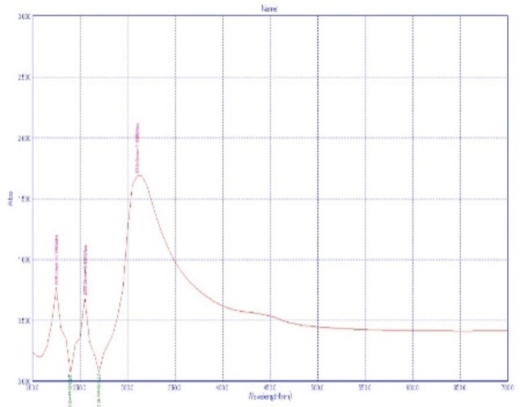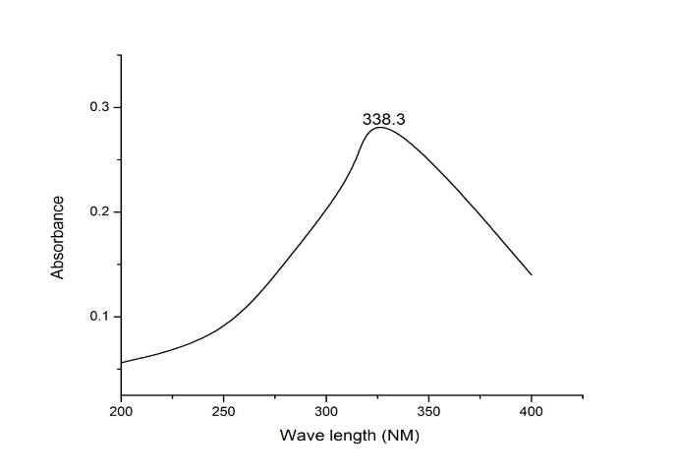
    - Fourier Transform Infrared Spectroscopy (FTIR)
The Fourier Transform Infrared (FTIR) spectrum provided exhibits characteristic absorption peaks that indicate the presence of specific functional groups within the analysed material. The spectrum, recorded using a ZnSe ATR accessory, shows notable peaks at approximately 3986 cm⁻¹, 3865 cm⁻¹, 3610 cm⁻¹, 3394 cm⁻¹, and 3286 cm⁻¹, which may correspond to O-H or N-H stretching vibrations. Additionally, a distinct absorption at 1550 cm⁻¹ suggests the presence of C=C or N-H bending vibrations. The peaks observed in the fingerprint region, particularly at 686 cm⁻¹, 601 cm⁻¹, 501 cm⁻¹, 429 cm⁻¹, and 432 cm⁻¹, could be indicative of metal-oxygen or metal-sulfur bonding, suggesting the presence of inorganic components. These spectral features contribute to the identification and characterization of the material, supporting its structural and compositional analysis within the scope of the thesis.

    - Scanning Electron Microscopy (SEM)
The scanning electron microscope (SEM) image provided shows a high-magnification (2.50KX) view of a material surface, likely composed of small, densely packed crystalline structures. The image was captured using a secondary electron (SE1) signal at an accelerating voltage of 10.00 kV and a working distance of 16.5 mm. The morphology indicates a rough texture with a transition from a more aggregated upper region to a more distinct, granular lower region.

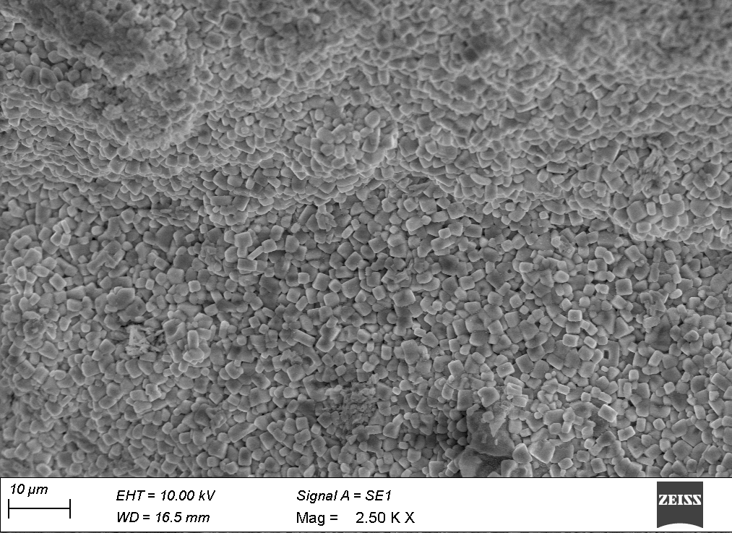
  - Antimicrobial Studies
Microbial infections are a growing concern in the medical field due to the emergence of antibiotic-resistant pathogens. The development of alternative antimicrobial agents, such as nanoparticles, offers a promising strategy to combat bacterial and fungal infections. Titanium dioxide (TiO₂) and zinc oxide (ZnO) nanoparticles have demonstrated potent antimicrobial properties due to their ability to generate reactive oxygen species (ROS) and disrupt microbial cell membranes (Sharma et al., 2021). The antimicrobial activity of the biosynthesized TiO₂/ZnO nanoparticles was evaluated against bacterial and fungal strains using the well diffusion method. The results indicate that the nanoparticles exhibit significant antimicrobial properties, surpassing the efficacy of the crude flower extract, which suggests their potential application in biomedical and pharmaceutical fields. The antibacterial activity of the bimetallic nanoparticles synthesized using Leucas aspera extract was evaluated against Staphylococcus aureus, Klebsiella pneumoniae, and Pseudomonas aeruginosa using the well diffusion method. The results revealed that the nanoparticles exhibited a significantly higher zone of inhibition compared to the crude flower extract, indicating their superior antibacterial efficacy. The highest zone of inhibition (26 mm) was observed against S. aureus, while moderate inhibition was recorded for K. pneumoniae (21 mm) and P. aeruginosa (22 mm). The flower extract, in contrast, showed minimal inhibition against S. aureus (12 mm) and K. pneumoniae (11 mm), while no inhibition was observed against P. aeruginosa.
These findings suggest that the synthesized nanoparticles exhibit broad-spectrum antibacterial activity, particularly against Gram-positive bacteria, which is consistent with previous studies (More et al., 2023). The superior antibacterial activity of TiO₂/ZnO nanoparticles can be attributed to their ability to generate ROS, leading to oxidative stress and disruption of bacterial cell membranes (Huang et al., 2018). The nanoparticles interact with bacterial surfaces, leading to cell membrane damage and leakage of intracellular contents. Additionally, ZnO nanoparticles are known to penetrate bacterial cells, interfering with essential enzymatic and metabolic pathways, ultimately leading to cell death (Mazhar et al., 2017). The observed resistance of P. aeruginosa to the flower extract but susceptibility to nanoparticles suggests that the nanoparticles have a more potent antibacterial mechanism, making them potential candidates for developing new antimicrobial agents. Gram-positive bacteria, such as S. aureus, were found to be more susceptible to TiO₂/ZnO nanoparticles compared to Gram-negative bacteria. This may be due to structural differences in their cell walls; Gram-negative bacteria possess an outer membrane that limits nanoparticle penetration (Khan et al., 2019). However, the nanoparticles still demonstrated significant inhibition against K. pneumoniae and P. aeruginosa, indicating their broad antibacterial spectrum. These findings highlight the potential use of green-synthesized nanoparticles as an alternative to conventional antibiotics, particularly in addressing multidrug-resistant bacterial infections. Further investigation into the exact mechanism of action is necessary to optimize the antibacterial efficacy of TiO₂/ZnO nanoparticles. The incorporation of nanoparticles into wound dressings, coatings, and antimicrobial formulations could enhance their effectiveness against bacterial infections. Additionally, increasing the concentration of nanoparticles may further improve their bactericidal activity, as seen in previous studies where higher doses resulted in enhanced microbial inhibition (Sivaramakrishnan et al., 2019).
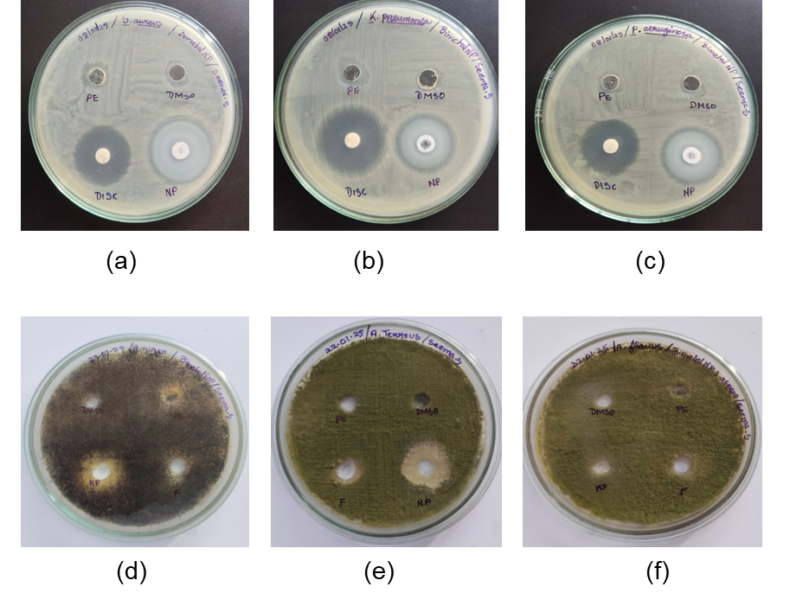
Fig. 1. Antimicrobial Studies of the Synthesized Bimetal Nanoparticle against (a) S.aureus; (b) K.pneumoniae; (c) P.aeruginosa; (d) A.niger; (e) A.terreusand (f) A.flavus
Fungal infections pose a significant health risk, particularly in immunocompromised individuals. The antifungal activity of TiO₂/ZnO nanoparticles was evaluated against Aspergillus niger, Aspergillus terreus, and Aspergillus flavus using the well diffusion method. The results demonstrated that the nanoparticles exhibited substantial antifungal activity, with the highest zone of inhibition observed against A. niger (20 mm) and moderate inhibition against A. terreus (12 mm). In contrast, A. flavus showed complete resistance to both nanoparticles and flower extract, indicating its higher tolerance. The antifungal mechanism of TiO₂/ZnO nanoparticles involves the generation of ROS, which disrupt fungal cell membranes and interfere with metabolic activities, leading to cell death (Ahmed et al., 2016). The significant inhibition of A. niger and A. terreus suggests that the nanoparticles effectively interact with fungal spores, preventing their growth and proliferation. The observed resistance of A. flavus indicates that certain fungal species may require higher nanoparticle concentrations for effective inhibition. This aligns with previous findings, where nanoparticle efficiency was dependent on dosage and fungal strain susceptibility (Balaji et al., 2020). Compared to the flower extract, the nanoparticles exhibited superior antifungal activity, highlighting the enhanced efficacy of the synthesized nanomaterials. The presence of bioactive phytochemicals in the flower extract may contribute to some degree of antifungal activity, but the mechanism of action is less effective compared to nanoparticles. The increased surface area of nanoparticles allows for better interaction with fungal cells, leading to enhanced antimicrobial properties (Priya et al., 2018). To improve antifungal activity, future studies should focus on optimizing the nanoparticle synthesis process, including adjusting particle size, concentration, and surface functionalization. The potential application of TiO₂/ZnO nanoparticles in antifungal coatings, agriculture, and pharmaceutical formulations could be explored further, as they offer a sustainable and effective alternative to chemical fungicides (Kulandaiswami and Marimuthu, 2018).
  - Antibiofilm Activity of Nanoparticles
The Biofilm inhibitory capability of the TiO₂/ZnO nanoparticles was determined against S. aureus using a 96 well plate assay. The results revealed a concentration-dependent inhibition of bacterial growth, with higher nanoparticle concentrations leading to increased bacterial cell death. At the highest concentration (10 µg/mL), bacterial viability was reduced by 54.45%, indicating a strong antibacterial effect. These results align with previous studies demonstrating that ZnO and TiO₂ nanoparticles effectively inhibit bacterial growth at low concentrations (Sharma et al., 2021).
The ability of nanoparticles to penetrate and disrupt biofilms is particularly significant, as biofilms contribute to antibiotic resistance and chronic infections. The disruption of biofilm formation by TiO₂/ZnO nanoparticles suggests their potential application in preventing biofilm-associated infections, such as those found in medical implants and wound infections (Huang et al., 2018). The ROS generation by nanoparticles plays a crucial role in biofilm disruption, as oxidative stress leads to bacterial membrane damage and inhibition of quorum sensing pathways, which are essential for biofilm development (Sivaramakrishnan et al., 2019). These findings suggest that TiO₂/ZnO nanoparticles can be effectively used as antibiofilm agents at low concentrations, reducing the likelihood of toxicity to human cells. Further studies should focus on evaluating the cytotoxic effects of these nanoparticles to ensure their safety in biomedical applications. Additionally, optimizing nanoparticle formulations and exploring their synergistic effects with conventional antibiotics could enhance their antimicrobial efficacy.
- CONCLUSION
The present study successfully demonstrated the biosynthesis of titanium and zinc nanoparticles using Leucas aspera flower extract, highlighting its potential as a green and eco-friendly approach for nanoparticle synthesis. The characterization of the synthesized nanoparticles through UV-Vis, FTIR, and SEM analyses confirmed their stability, functionalization by phytochemicals, and nanoscale morphology. The antioxidant activity of the flower extract was found to be significantly higher than that of the nanoparticles, suggesting that certain bioactive compounds present in the crude extract play a vital role in free radical scavenging. Furthermore, the antimicrobial activity of the biosynthesized nanoparticles exhibited strong antibacterial effects, particularly against Staphylococcus aureus, while moderate inhibition was observed against Klebsiella pneumoniae and Pseudomonas aeruginosa. The antifungal activity revealed promising inhibition of Aspergillus niger and Aspergillus terreus, while Aspergillus flavus demonstrated resistance, indicating that a higher nanoparticle concentration may be required for effective antifungal action. The Antibiofilm study confirmed a dose-dependent antibacterial effect, with a maximum biofilm inhibition of 54.45% at the highest tested concentration. These findings suggest that Leucas aspera-mediated TiO₂/ZnO nanoparticles hold significant promise as natural antimicrobial agents, which could be applied in the pharmaceutical, agricultural, and biomedical sectors. Future studies should focus on optimizing nanoparticle concentration, evaluating cytotoxicity, and exploring potential applications in drug delivery and wound healing. The integration of green nanotechnology in antimicrobial research provides an innovative and sustainable alternative to synthetic chemical approaches, addressing the growing concerns of microbial resistance and environmental toxicity.
References

- Afzal, M. A., Javed, M., Aroob, S., Javed, T., Alnoman, M. M., Alelwani, W., Bibi, I., et al. (2023). The biogenic synthesis of bimetallic Ag/ZnO nanoparticles: A multifunctional approach for methyl violet photocatalytic degradation and the assessment of antibacterial, antioxidant, and cytotoxicity properties. Nanomaterials, 13(14), 2079.
https://doi.org/10.3390/nano13142079.

- Ahmed, S., Ahmad, M., Swami, B. L., & Ikram, S. 2016. A review on plants extracts mediated synthesis of silver nanoparticles for antimicrobial applications: a green expertise. Journal of Advanced Research, 7(1): 17-28.
https://doi.org/10.1016/j.jare.2015.02.007.

- Al Masoudi, L. M., Alqurashi, A. S., Abu Zaid, A., & Hamdi, H. (2023). Characterization and biological studies of synthesized titanium dioxide nanoparticles from leaf extract of Juniperus phoenicea (L.) growing in Taif Region, Saudi Arabia. Processes, 11(1), 272.

- Balaji, D. S., Basavaraja, S., Deshpande, R., Mahesh, D. B., Prabhakar, B. K., & Venkataraman, A. (2009). Extracellular biosynthesis of functionalized silver nanoparticles by strains of Cladosporium cladosporioides fungus. Colloids and surfaces B: biointerfaces, 68(1), 88-92.

- Begum, M. S. M. F., & Sankarram, M. (2024). Phytochemical characterization by GC-MS and in vitro evaluation of antiproliferative and antimigratory studies of Leucas aspera leaf extracts on MDA-MB-231 cell line. Biotechnologia, 105(1), 55-68.

- Dlamini, N. G., Basson, A. K., &Pullabhotla, V. S. R. (2023). Synthesis and characterization of various bimetallic nanoparticles and their application. Applied Nano, 4(1), 1-24. https://doi.org/10.3390/applnano4010001

- Fazeela, M., & Sankarram, M. (2024). Phytochemical characterization by GC-MS and in vitro evaluation of antiproliferative and antimigratory studies of Leucas aspera leaf extracts on MDA-MB-231 cell line. Biotechnologia, 105(1), 55-68.

- Gaber, S. E., Hashem, A. H., El-Sayyad, G. S., & Attia, M. S. (2024). Antifungal activity of myco-synthesized bimetallic ZnO-CuO nanoparticles against fungal plant pathogen Fusarium oxysporum. Biomass Conversion and Biorefinery, 14(20), 25395-25409.
https://doi.org/10.1007/s13399-023-04550-w

- Hiremath, S., & Kumar, K. S. (2025). Hepatoprotective effect of whole plant powder Leucas aspera Spreng. Journal of Young Pharmacists, 17(1), 105.
- Hossain, M. A., & Islam, S. (2013). Synthesis of carbon nanoparticles from kerosene and their characterization by SEM/EDX, XRD and FTIR. American Journal of Nanoscience and Nanotechnology, 1(2), 52-56.

- Huang, Y., He, L., Liu, W., Fan, C., Zheng, W., Wong, Y. S., & Chen, T. (2013). Selective cellular uptake and induction of apoptosis of cancer-targeted selenium nanoparticles. Biomaterials, 34(29), 7106-7116.

- Islam, A. K., & Kato-Noguchi, H. (2012). Allelopathic potentiality of medicinal plant Leucas aspera. International Journal of Sustainable Agriculture, 4(1), 1-7.

- Joselin, J., Benila, B. S., Shynin Brintha, T. S., & Jeeva, S. (2024). Phytochemical profiling, FT-IR spectroscopy, and antioxidant evaluation of select Lamiaceae species. Intelligent Pharmacy.

- Jesteena Johney, E., Kannanan, K. A. N. N. A. N., & Ragunathan, R. R. (2016). Microbial extraction of chitin and chitosan from Pleurotus spp., its characterization and antimicrobial activity. International Journal of Current Pharmaceutical Research, 9(1), 88-93.
https://doi.org/10.22159/ijcpr.2017v9i1.16623

- Kaur, R., & Kumar, N. (2016). Phytochemical composition and in vitro antioxidant activity of Leucas aspera leaves. Research Journal of Pharmacy and Technology, 9(12), 2217-2221.
https://doi.org/10.5958/0974-360X.2016.00448.0.

- Kaviyarasu, K. (2025). Investigation of structural, optical, photocatalytic, and antibacterial properties of ZnO doped GO nanoparticles for environment applications. Microscopy Research and Technique, 88(1), 73-91.
https://doi.org/10.1002/jemt.24672.

- Khan, I., Saeed, K., & Khan, I. 2019. Nanoparticles: Properties, applications and toxicities. Arabian Journal of Chemistry, 12(7): 908-931.
https://doi.org/10.1016/j.arabjc.2017.05.011

- Kulandaisamy, A. N., & Marimuthu, K. (2018). Leucas aspera–A Review of its Biological activity

- León, A., Reuquen, P., Garín, C., Segura, R., Vargas, P., Zapata, P., & Orihuela, P. A. 2017. FTIR and Raman characterization of TiO₂ nanoparticles coated with polyethylene glycol as carrier for 2-methoxyestradiol. Applied Sciences, 7(1): 49.
https://doi.org/10.3390/app7010049

- Mazhar, T., Shrivastava, V., & Tomar, R. S. 2017. Green synthesis of bimetallic nanoparticles and its applications: a review. Journal of Pharmaceutical Sciences and Research, 9(2): 102.

- More, P. R., Pandit, S., Filippis, A. D., Franci, G., Mijakovic, I., &Galdiero, M. 2023. Silver nanoparticles: bactericidal and mechanistic approach against drug-resistant pathogens. Microorganisms, 11(2): 369.
https://doi.org/10.3390/microorganisms11020369

- Panhwar, S., Buledi, J. A., Mal, D., Solangi, A. R., Balouch, A., & Hyder, A. 2021. Importance and analytical perspective of green synthetic strategies of copper, zinc, and titanium oxide nanoparticles and their applications in pathogens and environmental remediation. Current Analytical Chemistry, 17(8): 1169-1181.
https://doi.org/10.2174/1573411017666201001161833

- Prieto, P., Pineda, M., & Aguilar, M. 1999. Spectrophotometric quantitation of antioxidant capacity through the formation of a phosphomolybdenum complex: specific application to the determination of vitamin E. Analytical Biochemistry, 269(2): 337-341.
https://doi.org/10.1006/abio.1999.4019

- Priya, R., Nirmala, M., Shankar, T., & Malarvizhi, A. 2018. Phytochemical compounds of Leucas aspera L. Pharmacological Benefits of Natural Products, 1: 19-35.
- S. Indira, & Mahalakshmi, V. 2023. In-vitro anti-cancer effects of ethanolic extract of Leucas aspera (Willd.) Link whole plant against HeLa, Hep G2, and MCF-7 cell lines. International Journal of Pharmacognosy, 10(12): 562-570.
https://doi.org/10.74358/ijpj.2023.1012562

- Shalini, T. S., Prathiviraj, R., &Senthilraja, P. 2025. Exploring the antimicrobial and antioxidative potential of Leucas aspera (Willd.) Link: Phytochemical screening, molecular docking, and HR-LC/MS profiling against SARS-CoV-2 protein 3CLPro, Spike, and RDB. Phytomedicine Plus, 5(1): 100700. https://doi.org/10.1016/j.phyplu.2024.100700

- Sivaramakrishnan, M., Sharavanan, V. J., Govindarajan, D. K., Meganathan, Y., Devaraj, B. S., Natesan, S., & Kandaswamy, K. 2019. Green synthesized silver nanoparticles using aqueous leaf extracts of Leucas aspera exhibit antimicrobial and catalytic dye degradation properties. SN Applied Sciences, 1: 1-8.
https://doi.org/10.1007/s42452-019-1561-2

- Sungar, S., Toragall, M. M., Mujeeb, M. A., Puranik, S. I., Aladkatti, R., &Ghagane, S. C. 2024. Phytochemical analysis, antimicrobial and anti-inflammatory efficacy of Leucas aspera leaf extracts. Archives of Razi Institute, 79(4): 761-768.
https://doi.org/10.1007/s12250-023-01012-3

- Wiegand, I., Hilpert, K., & Hancock, R. E. 2008. Agar and broth dilution methods to determine the minimal inhibitory concentration (MIC) of antimicrobial substances. Nature Protocols, 3(2): 163-175. https://doi.org/10.1038/nprot.2007.521

