**Phytochemical Compounds Effective Against Malarial Parasites**

**ABSTRACT**

The aim of the present review was to enlist most effective antimalarial phytochemical compounds of some selected plant species of Jharkhand, India. Malaria is still a big problem in the tribal and remote areas in Jharkhand. A large number of poor and malnourished people of the state including women and children are suffering from the disease. The topography and environment of rural Jharkhand indeed create conditions that are conducive to the rapid growth of malaria vectors and the propagation of *P. Falciparum and P. Vivax,* the parasite responsible for the most severe and fatal form of malaria. The yearly average slide positivity rate (SPR) in Jharkhand is 10.4% for symptomatic individuals indicates that malaria continues to be a significant public health issue in the state. This highlights the urgent need for effective preventive measures and treatment strategies, especially for vulnerable populations. The increasing resistance of malarial parasites to commonly used synthetic drugs like chloroquine has raised significant concerns in the fight against malaria. The World Health Organization also supports the use of medicinal plants effective and safe against the malarial parasites. There are a large number medicinal plants constitute effective bioactive phytochemicals compounds, which can play important role in the control of malaria. In the present study six plant species have been reviewed as an effective antimalarial plant species.

***Keywords:*** *Malaria, Plasmodium spp., Medicinal Plants, Antimalarial Phytochemicals, Jharkhand*

**1. INTRODUCTION**

Malaria is predominantly found in the tropical and subtropical areas of Africa, South America as well as Asia. Malaria is a vector-borne disease that changes in haematological structures response of the human body to the infection. These changes depend on various factors such as nutritional condition, demographic factors and haematological background. It is a life-threatening disease caused by Plasmodium parasites, transmitted to humans through the bites of infected female Anopheles mosquitoes. Malaria continues to create a major global health challenge with increasing mortality rates. Malaria is also a big challenge in the developing nations including India. It has been reported that around 95% population in India resides in malaria endemic areas and 80% of malaria reported in the country is confined to areas consisting 20% of population residing in tribal, hilly, difficult and inaccessible areas (NVBDCP). Globally, Malaria cases rose to 263 million in 2023, with an incidence of 60.4 per 1000 population at risk, up from 58.6 in 2022. Malaria mortality stood at 597,000 deaths globally, showing a decline compared to 622,000 deaths in 2020. In India, from 2015 to 2023, Malaria cases fell from 11,69,261 to 2,27,564, and deaths dropped from 384 to 83, representing an80% reduction. In 2024, India exited [WHO](https://www.drishtiias.com/important-institutions/drishti-specials-important-institutions-international-institution/world-health-organization-who)'s High Burden to High Impact (HBHI) group, marking a key milestone. Mizoram and Tripura are the two states of India have decreased high-burden from 10 to 2. Odisha, Chhattisgarh, Jharkhand, and Meghalaya transitioned to medium-burden. The topography and environment of Jharkhand indeed create conditions that are favourable to the rapid growth of female Anopheles mosquitoes, the malaria vector and the proliferation of *Plasmodium* parasites, transmitted to humans through the bites of infected Anopheles and responsible for the malaria. This favourable condition has created some of the regions of the state vulnerable to high rates of transmission of malaria among the rural and tribal communities (Singh et al., 1996; WMR 2024). The HBHI was initiated in West Bengal, Jharkhand, Chhattisgarh, and Madhya Pradesh in 2019. Jharkhand is one of the malaria prone state in India where yearly average slide positivity rate (SPR) is 10.4% for symptomatic individuals indicates that malaria continues to be a significant public health issue in the state. The SPR reflects the percentage of individuals with fever who test positive for malaria, and a 10.4% rate suggests a moderate level of malaria transmission within the population. This highlights the urgent need for effective preventive measures and treatment strategies, especially for vulnerable populations**.** The increasing resistance of malarial parasites, particularly *Plasmodium falciparum*, to commonly used synthetic drugs like chloroquine has raised significant concerns in the fight against malaria (Trape, 2002).This resistance undermines the effectiveness of treatment strategies, making it more challenging to control and eliminate malaria, especially in endemic regions. The World Health Organization (WHO) supports the use of medicinal plants effective and safe against the malarial parasites (WHO, 1985; Willcox and Bodeker, 2004). There are a large number medicinal plants constitute effective bioactive phytochemicals such as alkaloids, tannins, flavonoids and phenolic compounds, which play key role in the eradication of malaria. These medicinal plants are most important sources for discovering new potential antimalaria drugs using traditional knowledge system (Willcox and Bodeker 2004). These plants are valuable resource in traditional and modern medicines contributing to the development of wide range of diseases other than malaria (Schippmann et al., 2006; Ramawat and Goyal, 2008). Many medicinal plants contain bioactive compounds, including secondary metabolites and essential oils, which have been shown to have potential antimalarial effects. These compounds are not only important for traditional medicine but also provide alternative or complementary treatments to conventional drugs, especially in malaria-endemic regions. The phytochemical compounds isolated from the plant species are valuable raw materials which are used in the development of medicines for various diseases including malarial fever. Two notable examples of such compounds that have significantly contributed to reducing malaria diseases worldwide are quinine, isolated from the stem and bark of *Cinchona* species, and artemisinin, derived from the Chinese medicinal plant *Artemisia annua* (Schwikkard and Heerden 2002; Chiyaka et al., 2009). The present study is focused to review the most effective antimalarial phytochemicals derived from the medicinal plants found in Jharkhand. The review can be a valuable source for further research and development of antimalarial drugs.

**2. SELECTED ANTIMALARIAL PLANT SPECIES**

The antimalarial plant species were particularly selected from East Singhbhum district of Jharkhand with the help of local tribal healers. The area is rich in plant biodiversity and ethnobotanically important medicinal plants. These medicinally important plant species are mostly used by the ethnic or tribal communities of the area. The traditional healers or *vaidyas* of the area are familiar about the uses of the locally available plants which are generally used in the treatment of various ailments including malaria. Some of the antimalaria plant species selected for the present study was *Swertia chirayita, Solanum nigrum, Pongamia pinnata, Cyperus rotundus, Artemesia indica* and *Andrographis paniculata.* Traditional methods of uses of the antimalarial plants were also documented during the field study.

**2.1 *Swerita chirayita***: *Swertia chirayita*, commonly known as chirayita or chirata, is an important medicinal herb belongs to family Gentianaceae. This herb is native to the Himalayan region, but it is widely found in various parts of India, including Jharkhand, where it is also used by local communities to treat fever and malaria. The herb has a long history of use in traditional medicines, particularly in the treatment of ailments such as intermittent fever, diabetes, liver problems, worm-killing, skin diseases and digestive disorders. *Swertia chirayita* is particularly known for its antimalarial and liver-protective properties. The herb is commonly administered in various forms, including decoctions, powders, and herbal supplements. The decoction of the whole plant parts are traditionally used as an antimalarial and antihepatitis remedy (Sankar et al. 2017; Kumar and Van Staden 2015; Bhatt et al. 2006; Chen et al. 2011).

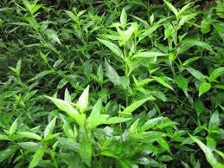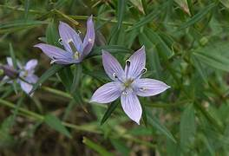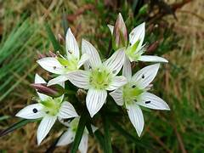

Photo 1: *Swertia chirayita*

**2.2** ***Solanum nigrum***: *Solanum nigrum*, commonly known as black nightshade, is a species of flowering plant in the family [Solanaceae](https://en.wikipedia.org/wiki/Solanaceae). It is an annual herb or short-lived perennial shrub, typically reaching heights of 30 cm to 1.2 meters. The plant is found in many parts of the world and is especially prevalent in tropical and subtropical regions, including Jharkhand and other parts of India. It has long been valued in folk medicine for its therapeutic properties. There are two varieties of *S. nigrum*, i.e., black colour fruit and reddish-brown colour fruit. Both of the varieties have been used traditionally to treat various ailments. Traditionally *S. nigrum* is used in the treatment of fever, inflammation, liver disorders, menstrual cramps, diarrhoea, dizziness, eye infections and other diseases. *S. nigrum* is an important ingredient in traditional Indian medicines. Infusions of the plant are used in malarial fever. In addition to the claimed traditional use, the 80% hydromethanolic fruit extract of *S. nigrum* has promising antimalarial activity, in vitro (IC50 = 10.29 μg/ml) and in vivo with a percentage parasitemia inhibition of 60.68% (P < 0.05). Additionally, in the in vitro test, the 50% cytotoxic concentration (CC50) of the fruit extract of the plant was 66.3 ug/ml on the Raji cell line (B lymphocyte cell line), showing that the plant is potentially toxic at much higher doses (Grubb et al. 2012; Venkateswarlu and Krishna 1971; Jain 1968; 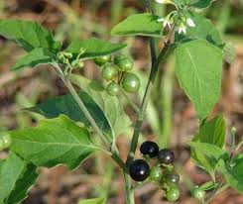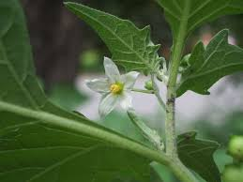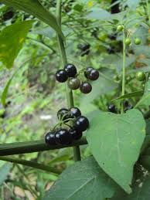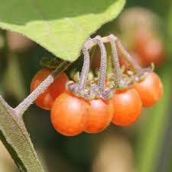Acharya and Pokhrel 1970; Busse and Tefera 2013; Haddad et al. 2017).

Photo 2: *Solanum nigrum*

**2.3 *Pongamia pinnata*:** *Pongamia pinnata* also known as Karanja is a valuable medicinal tree belongs to family Fabaceae. *P. pinnata* is a medium-sized evergreen or briefly deciduous, glabrous tree 15-25 m high native to humid and sub-tropic environments of Indian subcontinent and Southeast Asia. In traditional medicine, various parts of this tree have been used to treat a variety of ailments. The fruits and sprouts are used in folk remedies for abdominal tumours, skin diseases and rheumatism. Leaves juice is used for cold, coughs, diarrhoea, dyspepsia, gonorrhoea and leprosy. Roots are used for cleaning gums, teeth, and ulcers. Bark is used internally for bleeding piles. In the traditional medical practices like Unani and Ayurveda, parts of *P. pinnata* are used for antiplasmodial ailment. The bark of *P. pinnata* is mostly used as an antimalarial cure. The methanolic extract of the bark exhibits potent in vitro antimalarial activity against *Plasmodium falciparum*. Moreover the bark of the tree is used orally as a decoction or steam therapy for malaria (Hocking 1993; Al Muqarrabun et al. 2013; Yadav et al. 2004; Yadav 2011; Shameel et al. 1996; Sangawan et al. 2010; Satish and Sunita 2017).

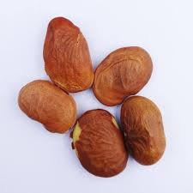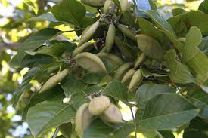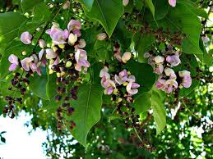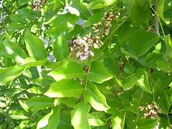

Photo 3: *Pongamia pinnata*

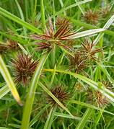**2.4 *Cyperus rotundus*:** *Cyperus rotundus*, commonly known as nut-grass belongs to family Cyperaceae. This monocotyledonous perennial flowering herb is native to India, mostly found in tropical, subtropical, and even some temperate regions. In traditional system of medicine, *C. rotundus* has been used for fever, malaria, coughs, bronchitis, urinary issues, skin problems, wound, cancer, vomiting, indigestion, infertility and menstrual disorders. Aromatic oils of the rhizome are used in the preparation of perfumes and splash. Ethnomedicinally the rhizome of the herb is used in malarial fever (Sri Ranjani and Prince 2012; Talukdar et al. 2011; Sivapalan 2013; Sharma et al. 2001).

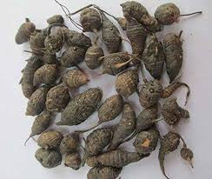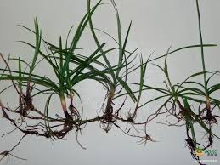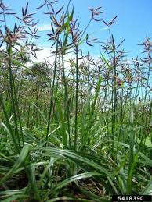

Photo 4: *Cyperus rotundus*

**2.5 *Artemisia indica*:** *Artemisia indica*, a plant belonging to the Asteraceae family, also known as Indian wormwood. The plant is native to the Indian Subcontinent, Southeast Asia and some other parts of the world. Generally the plant is grown along roadsides, forest edges and in scrublands. It is an herbaceous perennial plant characterized by its silvery-gray foliage, divided leaves, and small yellow flowers, typically reaches heights of 80 to 150 cm. The herb has antimalarial, anti-inflammatory properties, and traditionally used in the treatment of asthma, dysentery, and diarrhea. The herb also exhibits antioxidant, antibacterial, antifungal, and antidiabetic activities. Ethnomedicinally the herb is used as antimalarial drug as it contains antimalarial compounds like maackiain and potentially artemisinin. The fresh stem extract of *A. indica* exhibits high potency against *Plasmodium falciparum* (Chatterjee and Pakraoshi 1997; Chanphen et al. 1998).

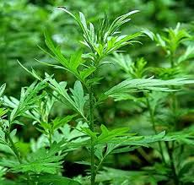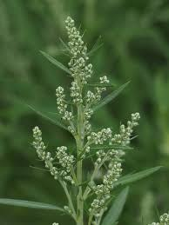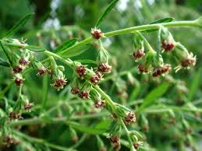

**Photo 5:** *Artemisia indica*

**2.6** ***Andrographis paniculata****:* *Andrographis paniculata*, commonly known as Kalmegh or Indian Echinacea, is an annual [herbaceous](https://en.wikipedia.org/wiki/Herbaceous) plant in the family [Acanthaceae](https://en.wikipedia.org/wiki/Acanthaceae" \o "Acanthaceae), native to India and Sri Lanka. The herb is traditionally used in the treatment of various ailments such as malaria, fever, [rheumatoid arthritis](https://www.sciencedirect.com/topics/pharmacology-toxicology-and-pharmaceutical-science/rheumatoid-arthritis), [respiratory infection](https://www.sciencedirect.com/topics/pharmacology-toxicology-and-pharmaceutical-science/upper-respiratory-tract-infection), diarrhea, and cancer. Herbal extract of *A. paniculata* has been used as fever-reducing drug since ancient time. Methanolic extract of the herb was tested in vitro on choloroquine sensitive (MRC-pf-20) and resistant (MRC-pf-303) strains of *Plasmodium falciparum* for their anti-malarial activity. The aerial parts of the herb are crushed in liquid N2 to fine powder to derive crude extracts.

(Dai et al. 2018; Mishra et al. 2009;

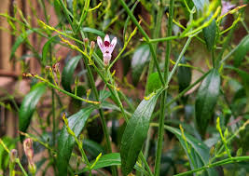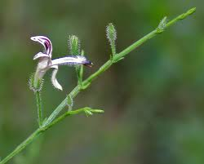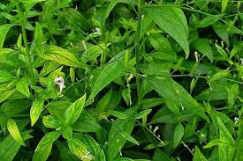

**Photo 6:** *Andrographis paniculata*

**3. ANTIMALARIAL PHYTOCHEMICAL COMPOUNDS**

**3.1 *Swertia chirayita*:** *Swertia chirayita* contains a wide-range bioactive or phytochemical compounds. The antimalarial bioactive compounds found in *S. chirayita* are Gentianine, Xanthones (1-Hydroxy-3,5,8 Trimethoxyxanthone), Flavonoids, Alkaloids, Terpenoids, Iridoids and Secoiridoids glycoside (swertiamarin, amarogentin). These compounds are also effective in liver detoxification and reduce inflammation (Bhargava et al. 2009; Saha et al. 2006; Bhatt et al. 2006). Different pre-clinical trials have investigated the antimalarial efficacy of *S. chirayita* extracts and isolated phytochemical compounds. The investigations have revealed that the bioactive constituents of the herb exert inhibitory effects against Plasmodium parasites at various stages of their life cycle. For example, swertiamarin has been reported to disrupt parasite growth by inhibiting crucial enzymes involved in their survival and proliferation. In the same, way amarogentin exhibits potent anti-plasmodial activity by interfering with parasite metabolism and inducing apoptotic cell death (Abdul et al. 2011).

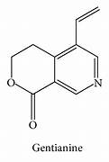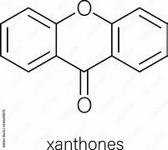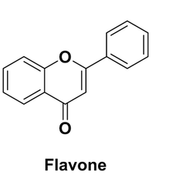

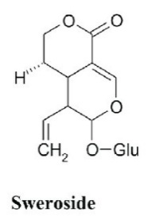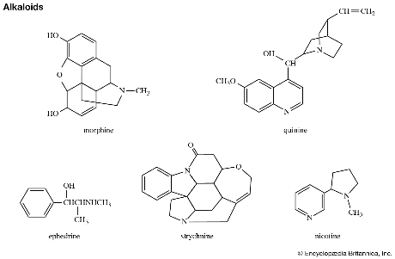

**Figure 1:** *Swertia chirayita*

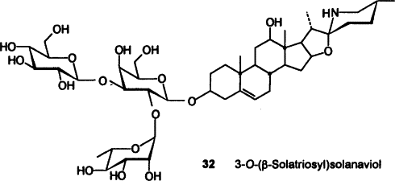**3.2 *Solanum nigrum*:** *Solanum nigrum* contains different phytochemical compounds with potential antimalarial activity. These include steroidal saponins, steroidal alkaloids, flavonoids and coumarin. The chloroform and ethyl acetate fractions extractions of *S. nigrum* reveal significant suppressive activity against malaria parasites. The crude hydromethanolic extract and solvent fractions of leaves of *S. nigrum* exhibited significant dose-dependent anti-plasmodial activity against chloroquine-sensitive *P. Berghei* infected Swiss albino mice (Fidock et al. 2004; Oliveira et al. 2009).

Figure 2: Chemical structure

**3.3 *Pongamia pinnata*:** The methanol extract of the bark of *Pongamia pinnata* had shown an IC50 value of 11.67 μg/mL with potent in vitro antimalarial activity and cytotoxicity. It was found that this extract was not toxic against Brine shrimp and THP-1 cells. The methanolic bark extract had shown promisingly high ((P < 0.05) and dose-dependent chemo-suppression. The phytochemical screening of the crude extracts of bark and latex had shown the presence of alkaloids, flavonoids, glycosides, triterpenes, anthraquinones, tannins, carbohydrates, phenols, coumarins, saponins, phlobatannins and steroids. The antimalarial bioactive compounds found in *P. pinnata* included karanjin, pongamol, and pongagalabrone (Satish and Sunita 2017).

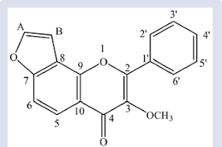

Figure 3: Karanjin

**3.4 *Cyperus rotundus*:** The plant exhibits significant antimalarial properties, particularly in vitro against *P. falciparum*. The extracts from its tubers, particularly crude hexane extracts, demonstrate high potency against this parasite. Specifically, the compound 10,12-peroxycalamenene, a sesquiterpene endoperoxide, has been identified as a strong anti-malarial agent. The antimalarial activities of these compounds were in the range of EC50 10‑4 to10‑6 M, with the novel endoperoxide sesquiterpene, 10,12-peroxycalamenene, exhibiting the strongest effect at EC50 2.33 × 10-6 M (Thebtaranonth et al. 1995).

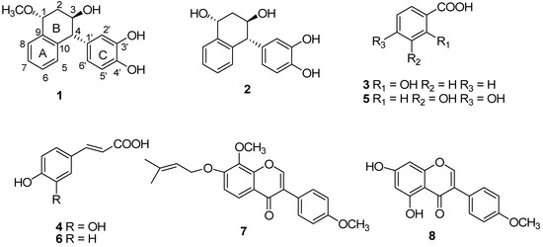

Figure 4: Chemical structure of compound 10,12-peroxycalamenene

**3.5 *Artemisia indica*:** Maackiain is the primary antimalarial phytochemical compound found in *Artemisia indica*. While the herb also contains other antimalarial compounds such as exiguaflavones A and B. Activity-guided investigation of *A. indica* has led to isolation of exiguaflavone A, exiguaflavone B, maackiain, and 2-(2, 4-dihydroxyphenyl)-5,6-methylenedioxybenzofuran. Exiguaflavones A and B exhibit in vitro antimalarial activities of 4.60 x 10(-6) and 7.05 x 10(-6) g/mL, respectively, against *Plasmodium falciparum* (Chanphen et al. 1998).

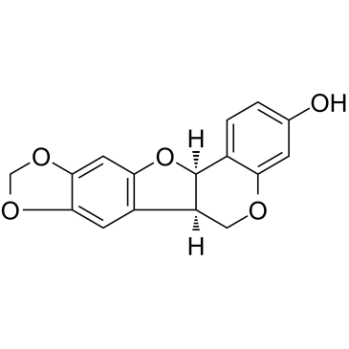

Figure 5: Maackiain

**3.6 *Andrographis paniculata****: A. paniculata* contains different antimalarial bioactive compounds. Diterpenoid lactone andrographolide is the most effective antimalarial compound inhibits parasite growth, reduces inflammatory responses, and may interfere with parasite invasion mechanisms. Other phytochemical compounds such as flavonoids and polyphenols also play key role to its antimalarial activity (John et al. 2024; Chao and Lin 2010).

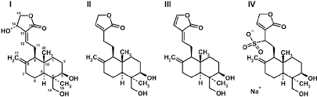

*Figure 6:* Diterpenoid lactone andrographolide

**4. CONCLUSION**

Various types of phytochemical compounds of medicinal plants stand as a demonstration to proficiency of natural healings that also offer a ray of hope in the battle against malaria. Some of the medicinal plants have high anti-malarial potential and favourable safety profile as an alternative remedy for malaria. By leveraging the valuable wealth of traditional knowledge and scientific advancements, the potential of antimalarial plants can be unlocked and open the way towards a malaria-free world. The anti-malarial potential of *Swertia chirayita*, *Solanum nigrum, Pongamia pinnata, Cyperus rotundus, Artemisia indica and Andrographis paniculata* as mentioned in the present review hold great promise to control malaria. Further research is needed to explain its mechanisms of action, optimize dosage schedule, and evaluate long-term safety and efficacy of the plants. Collaborative efforts between scientists, healthcare providers, and traditional healers are essential to harnessing the full therapeutic potential of these medicinal plants. Moreover, initiatives required at sustainable cultivation and conservation of effective antimalarial plants will ensure its availability for future generations and contribute to national and international efforts to combat malaria and improve public health outcomes.

**REFERENCES**

Abdul, L., Rehman, S., Ahmad, S., & Khan, AU. (2011). In vitro antibacterial screening of the extracts of *Swertia chirata* Linn. against MRSA (Methicillin Resistant Staphylococcus aureus). Int. J Curr. Res. Rev., 3(6), 98-104.

Acharya, S. E., & Pokhrel, B. (1970). Ethno-medicinal plants used by bantar of bhaudaha, morang, Nepal. Our Nature, 1, 96–103.

Al Muqarrabun, L.M.R., Ahmat, N., Ruzaina, S.A.S., Ismail, N.H., & Sahidin, I. (2013). Medicinal uses, phytochemistry and pharmacology of *Pongamia pinnata* (L.) Pierre: A review. J. Ethnopharmacol., 150(2), 395-420.

Bhargava, S., Rao, P., Bhargava, P., & Shukla, S. (2009). Antipyretic potential of *Swertia chirata* Buch-Ham. Sci. Pharm., 77:617-623.

Bhatt, A., Rawal, R. S., & Dhar, U. (2006). Ecological features of a critically rare medicinal plant, Swertia chirayita, in Himalaya. Plant Species Biol., 21, 49–52.

Busse, H. & Tefera, G., Handbook of Sidama Traditional Medicinal Plants. (2013). University of Wiscons in School of Medicine and Public Health, Madison, WI, USA.

Chatterjee, A., & Pakraoshi, S.C. (1997). The treatise on Indian medicinal plants. New Delhi: National Institute of Science Communication CSIR, 142-143.

Chanphen, R., Thebtaranonth, Y., Wanauppathamkul, S., & Yuthavong, Y. (1998). Antimalarial principles from *Artemisia indica*. J Nat Prod. 61(9):1146-7.

Chao, WW., & Lin, BF. (2010). Isolation and identification of bioactive compounds in *Andrographis paniculata* (*Chuanxinlian*). *Chin Med* **5**, 17.

Chen, Y., Huang, B., He, J., Han, L., Zhan, Y., & Wang, Y. (2011). In vitro and in vivo antioxidant effects of the ethanolic extract of Swertia chirayita. J. Ethnopharmacol. 136, 309–315.

Dai, Y., Chen, S.R., Chai, L., Zhao, J., Wang, Y., & Wang, Y. (2018). Overview of pharmacological activities of *Andrographis paniculata* and its major compound andrographolide, Crit. Rev. Food Sci. Nutr., 10:1–13.

Fidock, D., A., Rosenthal, P. J., Croft, S. L., Brun, R., & Nwaka, S. 2004. Antimalarial drug discovery: efficacy models for compound screening. Nature Reviews Drug Discovery. 3(6):509–520.

Grubb, A., Raser-Rowland, & Annie (2012). The Weed Forager's Handbook. Australia: Hyland House Publishing Pty Ltd., p. 35.

Haddad, M. H. F., Mahbodfar, H. R., Zamani, Z., & Ramazani, A. (2017). Antimalarial evaluation of selected medicinal plant extracts used in Iranian traditional medicine, Iranian Journal of Basic Medical Science. 20(4), 415–422.

Hocking, D. (1993). Trees for Drylands. Oxford & IBH Publishing Co. New Delhi.

Jain, S.K. (1968). *Medicinal Plants*. Thomson Press (India) Ltd. pp. 133–134.

John, O. O., Adesola, Bunmi O., Aminat, O., Solomon, O., O., Olusola, B., Paul, S., Neil, A., K., & Olufunso, O. O. (2024). Mechanism of antimalarial action and mitigation of infection-mediated mitochondrial dysfunction by phyto-constituents of Andrographis paniculata ((Burm f.) Wall. ex Nees) in Plasmodium berghei-infected mice, Journal of Ethnopharmacology, Volume 331.

Kumar, V., & Van S. J. (2015). A review of *Swertia chirayita* (Gentianaceae) as a traditional medicinal plant. Phytochem., 6,PMCID, PMC, 4709473.

Mishra, K., Dash, A.P., Swain, B.K., & Dey N. (2009). Anti-malarial activities of *Andrographis paniculata* and *Hedyotis corymbosa* extracts and their combination with curcumin. Malar J., 12;8:26.

Oliveira, A. B., Dolabela, M. F., Braga, F. C., Jácome, R. L. R. P., Varotti, F. P., & Póvoa, M. M. (2009). Plant-derived antimalarial agents: new leads and efficient phythomedicines. Part I. Alkaloids. Anais da Academia Brasileira de Ciencias, 81(4), 715–740.

Saha, P., Mandal, S., Das, A., & Das, S. (2006). Amarogentin can reduce hyperproliferation by downregulation of Cox-II and upregulation of apoptosis in mouse skin carcinogenesis model. Cancer Lett., 244, 252-259.

Sangawan, S., Rao, D.V., & Sharma, R.A. (2010). A review on *Pongamia pinnata* (L.) Pierre: a great versatile leguminous plant. Nat Sci., (11), 130–139.

Sankar, A.S.S., Sugathan, N.V., & Mohan, M. (2017). A review on synergistic and Hormetic action of *Swertia chirata* from homoeopathic perspective. International Journal of AYUSH Medicine & Research, 2456-6209.

Shameel, S., Usmanghani, K., & Ali, M.S. (1996). Chemical constituents from seeds of *Pongamia pinnata* (L.) Pierre. Pak. J. Pharm. Sci., 9, 11-20.

Sivapalan, S.R. (2013). Medicinal uses and pharmacological activities of *Cyperus rotundus* Linn – a review. International Journal of Scientific and Research Publications, 3(5): 1-8.

Sharma, P.C., Yelne, M.B., & Dennis, T.J. (2001). Database on medicinal plants used in Ayurveda, CCRAS, Govt of India, New Delhi, 3, 404-408.

Satish, P.V.V., & Sunita, K. (2017). Antimalarial efficacy of *Pongamia pinnata* (L) Pierre against *Plasmodium falciparum* (3D7 strain) and *Plasmodium berghei* (ANKA). BMC Complement. Altern. Med.,11, 17(1), 458.

Sri Ranjani, S., & Prince, J. (2012). Physico-chemical and Phyto-chemical study of rhizome of *Cyperus rotundus* Linn. International Journal of Pharmacology and Pharmaceutical Technology (IJPPT), ISSN: 2277–3436, 1, 2, 42-46.

Talukdar, A.D., Tarafdar, R.G., Choudhury, M.D., Nath, D., & Choudhury, S. (2011). A review on pteridophyte antioxidants and their potential role in discovery of new drugs. Sci and Tech 7(1), 151-155.

Thebtaranonth, C., Thebtaranonth, Y., Wanauppathamkul, S., & Yuthavong, Y. (1995). Antimalarial sesquiterpenes from tubers of *Cyperus rotundus*: structure of 10,12-peroxycalamenene, a sesquiterpene endoperoxide. Phytochemistry, 40, 125-128.

Venkateswarlu, J., & Krishna, R. M. (1971). Inheritance of fruit colour in the *Solanum nigrum*complex. Proceedings of the Indian Academy of Sciences, Section B. 74 (3): 137–141.

World Health Organization (2024). World Malaria Report (WMR).

Yadav, P.P., Ahmad, G., & Maurya, R. (2004). Furanoflavonoids from *Pongamia pinnata* fruits. Phytochemistry, 65(4), 439-443.

Yadav, R., Jain, S., Alok, D.S. & Prajapati, S.K. (2011). *Pongamia pinnata*: An overview. J. Pharm. Sci. Res., 3, 494-500.