**Altitudinal refractivity and refractivity gradient alterations by weather parameters in some selected locations in Nigeria**

**Abstract**

Weather parameters such as pressure, temperature and humidity significantly affect the altitudinal refractivity and refractivity gradients which in return impact the propagation of the radio wave. The alteration in these parameters changes the atmospheric refractive index. Radio refractivity expresses the degree at which a radio signal bends when it travels through the atmosphere. This study examines weather parameters effects on the altitudinal refractivity and refractivity in some selected locations in Nigeria using existing mathematical models relating them with some meteorological parameters from the ground surface to altitude of 12 Km. Higher Refractivity at the ground surface was observed than at elevated altitudes. Decrease in the weather parameters was continuously noticed up to the tropopause as the altitude was increasing. Refractivity gradient was observed to be greater than -40 N up to a height of 4 Km and less than -40 N above 4 Km. In conclusion, the weather parameters have great influence on the altitudinal refractivity and refractivity in the examined locations.

**Keywords:** Altitudinal refractivity, Refractivity gradient, South-Western Nigeria, Air Temperature, Weather parameters

**1.0 Introduction**

The electromagnetic radio waves’ terrestrial propagation is significantly affected by the tropospheric refraction at microwave frequency and ultra-high frequency (UHF) [1]. The minute change in the radio waves’ propagation medium is connected with the communication links impair. This effect is attached to the refractive index which fluctuates with atmospheric altitude as a result of the atmospheric parameters’ non-uniform condition [2]. Radio waves originated from terrestrial-based in the troposphere may deflect away from or towards the surface called anomalous propagation as a result of the different meteorological effects existence such as high evaporation and temperature inversion. The vertical component of atmospheric refractivity determines the radio ducting. The change in this component within the troposphere is exponential with geometric height above 1 km and linear in the lowest 1 km [3].

The atmospheric refractivity gradient profile ranging between 1 km altitudes above the ground surface is crucial in examining the anomalous propagation. The information gotten from the refractivity variability in determining the communication garget performance can be useful for the design engineers in remote sensing [4]. It is vital to examine and document the meteorological link of atmospheric refractivity distribution at troposphere in order to reduce anomalous condition effects on microwave propagation. The various components of the atmosphere are major determinants to the propagating efficiency of the electromagnetic waves in the troposphere due to the alterations of some key atmospheric weather parameters such as atmospheric pressure, atmospheric temperature and relative humidity in the troposphere [5]. The fluctuations of these atmospheric weather variables result in air refractive index of the atmosphere (troposphere) to change from place to place. The variation in refractivity in the troposphere is a function of weather variables [6 - 10].

The variation in the atmospheric refractivity in time and space is due to the physical processes occurring in the atmosphere which are usually difficult to explain in a deterministic manner. Also, consideration must be given to them in most cases as random with its probabilistic characteristics [11 - 14]. The different phenomena in the wave propagation such as scintillation, ducting, refraction, electromagnetic waves fading and elevation errors in radar acquisition resulted from refractivity. Refractive attributes are very vital in designing and planning of terrestrial communication systems as a result of interference and multi-path fading due to transhorizon propagation [15 - 16]. Both the experimental results gotten from the computational methods and in situ atmospheric refractivity measurements can be used to execute the simulation of the refractivity related propagation effects [17].

Previous studies have been conducted across Nigeria and West Africa investigating monthly, seasonal and diurnal refractivity; the condition of refractivity gradient; and refractivity profile below 500 m above the ground. Abimbola et al. [4] estimated radio refractivity from satellite-derived meteorological data over a decade for West Africa. The average surface refractivity for West Africa was observed to be around 342 *N-units* while the average scale height was noticed to be approximately 8.01 km. The refractivity gradient was generally estimated to be between −46.48 and −29.51 N- units/km with *k* -factor value ranging from 1.23 and 1.42) across West Africa. This divided the region between sub- and super-refraction. Lawal et al. [ 5] investigated the point refractivity gradient and geo-climatic factor at altitude of 70 m in Yenagoa, Nigeria using satellite data from the European Center for Medium-Range Weather Forecasts (ECMWF). The average geo-climatic factor and point refractivity gradient were estimated to be 6.638633E-05 and 136.433 N-unit/Km respectively at 70 m above the ground level suggesting radio waves propagation at the altitude in this region to be super refractive in both rain and clear air atmospheric conditions.

The influence of relative humidity, air temperature and atmospheric pressure as atmospheric variables on atmospheric refractivity over Auchi town in Edo State, Nigeria has been determined with the aid of a portable weather monitoring system. The data showed that, the average atmospheric refractivity was 354.31 N-units. The atmospheric variables were observed to have significant influence on the atmospheric refractivity during all the months in 2017 [6]. Recently, Usman et al. [7] explored the vertical gradients of radio refractivity and their significance for radio wave propagation in Abuja, Jos and Makurdi of North-Central Nigeria and observed the seasonal radio refractivity gradients of -110.000N/km, -77.553N/km and -97.209N/km for Abuja, Jos and Makurdi signifying the refractivity condition to be Super-Refraction, Normal-Refraction and Normal-Refraction respectively.

In this study, the change in altitudinal refractivity and refractivity gradient as a result of change in some weather parameters at different altitudes ranging between 1 to 12 Km above the ground level in some selected locations in South-West Nigeria were estimated in the years 2022 and 2023. The measured atmospheric parameters were then used to simulate the existing mathematical models to evaluate the altitudinal refractivity and refractivity gradient within the study areas. The results obtained would be beneficial in managing radio communication systems for improvement and enhancement purposes within this region.

**2.0 Study Areas**

The alteration in altitudinal refractivity and refractivity gradient due to change in weather parameters in some selected locations in Nigeria indicated on red in Figure 1 is evaluated. The study was conducted in the year 2022 and 2023. These study areas include Lagos, Abeokuta, Ondo, Ado, Ibadan, Osogbo and Ogbomoso.

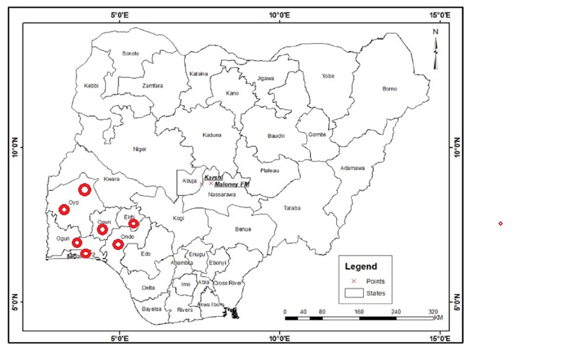

Figure 1: Map of Nigeria indicating the selected locations for the study

**2.1 Evaluation of Altitudinal Refractivity**

The variation in altitude due to the influence of temperature is calculated using Equation 1.

$T = T_{o}-6.5h (Km)$ (1)

where *T* is the temperature at the altitude, *h* in Kelvin and *To* is the standard temperature in Kelvin.

To calculate the standard pressure P, at a given altitude h, the temperature is assumed standard, and the air is assumed as a perfect gas. The altitude obtained from the measurement of the pressure is called pressure altitude (PA). The relationship between the pressure at a troposphere altitude and sea level pressure was obtained using Equation 2.

$P= P_{o}*exp⁡(-\frac{h}{H})$ (2)

where *P* is the pressure at a given altitude *h*, *Po* is the sea-level pressure and *H* is the atmospheric scale height.

The atmospheric refractivity, *N*, is calculated using Equation 3 in relation to parameters commonly used in Meteorology which are air-temperature (*T*, in Kelvin), vapour pressure (*e*, in millibars, related to dew point temperature) and air- pressure (*P*, in millibars).

$N=77.677\left(\frac{P}{T}\right)+3.37*{10}^{5}\left(\frac{e}{T^{2}}\right)$ (3)

**2.2 Evaluation of Refractivity Gradient**

The refractivity gradient of a surface is the difference in refractive index between the surface and a given altitude. One of the most significant factors in the influence of radio wave propagation is the large-scale variation of refractive index with height, and the extent to which this changes with time. The refractive index gradient is the rate of change of refractivity with altitude and it was calculated using Equation 4.

 (4)

where $\frac{dN}{dh}\left(h\right)$ is change in refractivity with respect to altitude (*h*), Ns is the refractivity of a standard atmosphere and *H* is the height.

**3.0 Results and Discussions**

**3.1 Variations in Altitudinal Refractivity due to the influence of Air-Temperature, Air-Pressure, Relative humidity and Vapour Pressure**

Profiles of average temperature-altitude variation, pressure-altitude variation, refractivity-altitude variation and vapour pressure-altitude variation over the selected study areas for 2022 and 2023 are shown in Figures 2a and 2b respectively. The variation of surface refractivity, air temperature, pressure, vapour pressure and relative humidity from the ground surface to altitude of 12 Km is presented. It shows that the values of refractivity are higher at the ground surface than at elevated altitudes. It was also observed that with increasing altitude; air-temperature, pressure and vapour pressure decrease continually up to the tropopause (12 Km above sea level). Only relative humidity is constant irrespective of height. The refractive index of air and hence *N* depends mainly on the atmospheric pressure *P* (millibars), the temperature *T* (Kelvin) and the partial pressure of water vapour *e* (millibars) through the Equation 2.

$N=77.6 \frac{P}{T}+3.73×10 \frac{e}{T^{2}}$ (2)

There are two terms, the 'dry term' which covers the dry gases (mainly Nitrogen and Oxygen) and the 'wet term' which is governed by water vapour. The atmospheric pressure falls exponentially with height, falling to 1/e (that is e an in natural logs) of the surface value at a height of 8 Km. Temperature falls by about 1 degree every 100 m. The behaviour of water vapour is much more complex as it is governed by the weather and is limited to the saturated vapour pressure (how much water the air can hold before it condenses as rain or ice). The saturated water vapour pressure is around 40 mbar at 300 K (a warm day) and 6 mbar at 273 K (freezing). As a result, the amount of water vapour above the zero degree isotherm is negligible. The net result is that *N* usually decreases as weather parameters decrease. This decrease is called the lapse rate of *N*. Variations in pressure, temperature and humidity do cause significant deviations in the lapse rate [9, 13]. Values of *N* that are less than -40/km cause sub-refraction and greater than -40/km cause super-refraction.

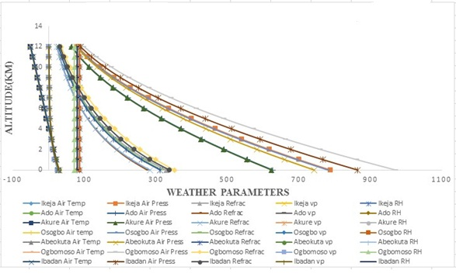

**(a)**

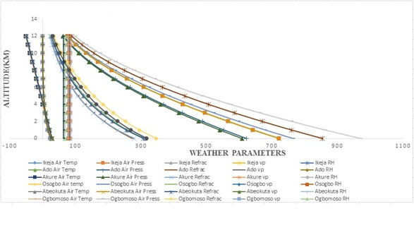

**(b)**

Figure 2: Variations in altitude due to the influence of weather parameters in (a) 2022 and (b) 2023

**3.2 Variations of Refractivity Gradient**

The vertical gradients of refractivity values are calculated on the basis of the mean monthly statistical distribution of refractivity at each of the levels. These show that the monthly variations give large negative values near the surface than at elevated heights. Figures 3a and 3b show the refractivity gradient up to a height of 7 Km above sea level for the years 2022 and 2023 over the selected study area. The value is greater than -40 N up to a height of 4 Km and less than -40 N above 4 Km. From these values, it could be deduced that propagation condition in this geographic zone is mostly super-refractive up to a height of 4 Km and sub-refractive above 4 Km [8, 15].

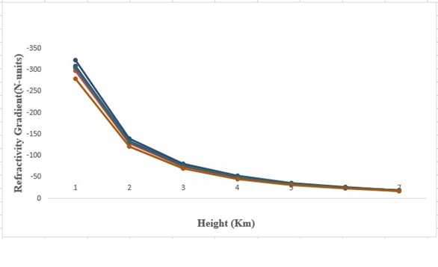

(a)

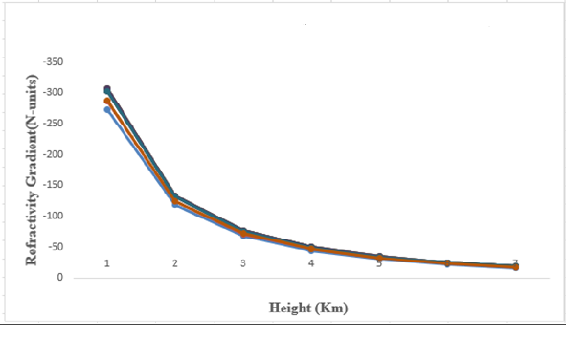

(b)

Figure 3: Average Refractivity Gradient versus Height in (a) 2022 and (b) 2023

**4.0 Conclusions**

In this study, the effects of weather parameters on the altitudinal refractivity and refractivity in some selected locations in Nigeria was investigated. These properties were evaluated using already existing mathematical models relating them with some meteorological parameters which are air-temperature, vapour pressure and air-pressure from the ground surface to altitude of 12 Km. Refractivity was found to be higher at the ground surface than at elevated altitudes. The air-temperature, pressure and vapour pressure were also observed to decrease continuously up to the tropopause as the altitude was increasing. Refractivity gradient was observed to be greater than -40 N up to a height of 4 Km and less than -40 N above 4 Km. Super-refractive mode was observed up to a height of 4 Km while sub-refractive mode was observed above 4 Km for propagation condition in this geographic zone. In conclusion, the weather parameters affected the altitudinal refractivity and refractivity in the examined locations.

**Declarations**

**Data Availability Statement**

Data will be made available on request.

**References**

[1] Agbo, GA; Okoro, ON; Amechi, AO (2013). Atmospheric Refractivity over Abuja, Nigeria. Inter.Res. Journal Pure Appl. Physics, 1(1): 37- 45.

[2] Ukhurebor, KE; Abiodun, IC; Azi, SO; Otete, I; Obogai LE (2017). A Cost Effective Weather Monitoring Device. Archives of Current Res.Inter.7 (4): 1-9.

[3] Ojeifo, MO; Akhimien, FO (2013). Pattern of Fencing and Impacts in Urban Auchi, Edo State, Nigeria. Inter. J. Physical and Human Geography, 1(1), 26-34.

[4] Abimbola OJ, Bada SO, Falaiye AO, Sukam YM, Otto MS, Muhammad S (2021). Estimation of radio refractivity from satellite-derived meteorological data over a decade for West Africa. Scientific African, 14, e01054.

[5] Lawal YB, Omotoso ET (2023) Investigation of Point Refractivity Gradient and Geoclimatic Factor at 70 m Altitude in Yenagoa, Nigeria. J. Nig. Soc. Phys. Sci., 5, 1081.

[6] Ukhurebor KE; Azi SO; Abiodun IC; Ojiemudia SE (2018) Influence of Weather Variables on Atmospheric Refractivity over Auchi Town, Edo State, Nigeria. J. Appl. Sci. Environ. Manage., 22(4), 471 – 475.

[7] Usman SL, Ikechiamaka FN, Akinbolati A, Owolabi JA, Akusu CO (2024) Exploring Vertical Gradients of Radio Refractivity and Their Significance for Radio Wave Propagation in Abuja, Jos and Makurdi of North-Central Nigeria. Science World Journal, 19(1), 58 – 63.

[8] Alade MO (2023) Investigation of the Effect of Ground and Air Temperature on Very High Frequency Radio Signals. *Journal of Information Engineering and Applications*,.3, 9-16.

[9] Ukhurebor KE, Umukoro OJ (2018) Influence of Meteorological Variables on UHF Radio Signal: Recent Findings for EBS, Benin City, South-South, Nigeria. *IOP Conference Series: Earth and Environmental Science*, 173, 012017.

[10] Obiegbu UA, Anene CR (2023) Experimental Study on the Impact of Meteorological Variables on Ultra High Frequency Radio Signal Generated by Anambra Broadcasting Corporation (ABS) for Sustainable Development in Awka, Anambra State, Metropolis, Nigeria, 2023.

[11] Gunashekar SD, Siddle DR, Warrington EM (2006) Trans horizon Radio wave Propagation due to Evaporation Ducting: The Effect of Tropospheric Weather Conditions on VHF and UHF Radio Paths over the Sea. *Resonance*, 51-62.

[12] Emmanuel I (2019) Linkage of meteorological parameters and anomalous radio propagation profile over Nigeria. Journal of Atmospheric and Solar–Terrestrial Physics, 191, 105047.

[13] Chima AI, Onyia AI, Chikeleze PC (2020) Investigating the impact of weather parameters on signal strength of satellite Dish in Enugu metropolis. Int’l J. of Astrophysics and Space Sc, 8, 11–15.

[14] Oyewole OJ (2025) Weather parameters influence on radio wave transmission signals in some selected South-Western parts of Nigeria. International Astronomy and Astrophysics Research Journal, 7(1), 20 – 30.

[15] Sheu AL (2021) The impact of atmospheric conditions on satellite signals between (10GHz – 14 GHz) at ku band in low latitude region of oyo, southwestern, Nigeria. FJPAS, 6, 85–93.

[16] Odu OJ, Adebayo AD, Donatus BE, Ayibapreye KB (2024) Characterization of the influence of radio wave refractivity in South South Nigeria. *International Journal of Recent Research in Electrical and Electronics Engineering*, 11, 3, 12-21.

[17] Felix A, Abdullahi A, Olufemi A, Jaiyeola OP (2024) Effects of some weather variables on the signal strength of Maloney FM radio, Nasarawa State, Nigeria. *Heliyon*, 10, e25978.