**Numerical study of the effect of kenaf fiber content and size on the thermal inertia of adobe walls**

**Abstract**

The aim of the study is to assess the impact of adding kenaf fibers on the thermal performance of adobes. In a context of increasing research into sustainable, energy-efficient construction alternatives, adobes, raw earth bricks, are often considered. However, their thermal properties can be improved, hence our interest in exploring the use of plant fibers, such as kenaf, as reinforcement in the composition of adobes. Using a numerical model, we simulated the thermal behavior of these innovative materials. The simulation results were compared with those of the literature, and a maximum relative deviation of 2.3 % was obtained in the temperature at the outer surface. This highlights the accuracy and reliability of the numerical code used. The results indicate that the addition of the fibers results in a reduction and time shift of the peak flux densities at the outlet face of the adobe walls. A reduction of over 90 % in peak flux densities at the inner surface of the walls was achieved with 0.8 % kenaf fibers. This contributes significantly to reducing the temperature at the inner face of the walls, resulting in a reduction in the damping factor and an increase in the time lag with fiber size and content. This study thus demonstrates the potential of kenaf fiber-reinforced adobes as sustainable, energy-efficient building materials.

**Keywords:** Adobes, Kenaf fibers, thermal performance, numeric simulation, Matlab

**Nomenclature**

|  |  |  |  |
| --- | --- | --- | --- |
| $$a$$ | : | Thermal diffusivity | m2/s |
|  | : | Specific thermal capacity | J/(kg.K) |
| $$E$$ | : | Thermal effusivity | J/s1/2.m-2.K-1 |
|  | : | Wall thickness | $$m$$ |
| $$f$$ | : | Decrement factor | - |
| $$F_{st}$$ | : | Stored heat flux | W/m2 |
|  | : | Outside surface heat flux | W/m2 |
|  | : | Inside surface heat flux | W/m2 |
|  | : | Outside surface convective heat transfer coefficient | W/(m2.K) |
|  |  | Inside surface convective heat transfer coefficient | W/(m2.K) |
|  | : | Outside surface heat transfer coefficient | W/(m2.K) |
|  | : | Inside surface heat transfer coefficient | W/(m2.K) |
|  | : | Outside surface radiative heat transfer coefficient | W/(m2.K) |
|  | : | Inside surface radiative heat transfer coefficient | W/(m2.K) |
| RD |  | Relative deviation | % |
| $$t$$ | : | Time | $$s$$ |
| $$T_{ae}$$ | : | Outside air temperature | °C |
| $$T_{ai}$$ | : | Inside air temperature | °C |
| $$T_{g}$$ | : | Sol-air temperature | °C |
| $$T_{we}$$ | : | Outside surface temperature | °C |
| $$T_{wi}$$ | : | Inside surface temperature | °C |
| $$T(x,t)$$ | : | Temperature at time $t$ t wall position $x$ | °C |
| $$v_{f}$$ | : | Daily average wind speed | $$m/s$$ |
| $$x$$ | : | Position | $$m$$ |
| Greek letters | | | |
| $$α_{e}$$ | : | Solar absorptivity | - |
| $$Δt$$ | : | Time lag | $$h$$ |
| $$λ$$ | : | Thermal conductivity | W/(m.K) |
| $$ρ$$ | : | Density | kg/m3 |
|  | : | Solar heat flux density | W/m2 |

**1.Introduction**

A building's envelope is its external structure. It is a combination of opaque and transparent walls, roof, floor and foundation, acting together to provide a healthy and pleasant living environment for human beings [1]. It acts as a thermal filter, creating and maintaining an interior microclimate independent of external weather fluctuations [2]. As such, its design requires the best possible knowledge of the thermal behavior of materials and structures, as well as of the physical phenomena that act on them. The study of the thermal behavior of a building material is carried out either in a stationary thermal regime or in a dynamic thermal regime, which is the situation encountered in tropical climates such as Burkina Faso, where very high outside temperatures impact the energy efficiency of building envelope walls.

Moreover, in the current environmental context, where global warming is a major concern, energy needs are becoming increasingly exacerbated, especially for Sahelian countries like Burkina Faso. Indeed, according to a study by Ouedraogo et al, (2012)[3], climate change is having a profound effect on building cooling load requirements. The authors estimate that if nothing is done between now and 2080, air conditioning load requirements will increase by 99 % compared to the current situation in Burkina Faso. With this in mind, building experts are promoting the use of ecologically sound, highly energy-efficient materials in the construction sector in place of modern materials such as cementitious materials, which are responsible for up to 10 % of greenhouse gas emissions and also have high thermal conductivity [4, 5]. Alternative materials include earthen materials. Earthen materials are known to have good thermal inertia and do not emit greenhouse gases. However, because of their high sensitivity to water, earth materials such as adobes have very poor mechanical properties and durability, especially in the presence of moisture. These materials are therefore blended with other raw materials such as fibers to improve their mechanical performance. In addition to improving mechanical properties, the addition of fibers also reduces the thermal conductivity of bricks.

Many studies have focused on the effect of natural fibers on the mechanical and thermophysical properties of adobes. Among these fibers, we find kenaf fibers[6, 7], rice husks, fonio husks, sugarcane bagasse, cow mud [8-12]. The results obtained with kenaf fibers are generally the best, which motivates us to choose them as reinforcement. Most studies on the effect of kenaf fibers on the thermal performance of adobes have been limited to the experimental determination of thermophysical properties. However, if this material is to be used in construction, we need to know how it performs under dynamic conditions. Such knowledge will enable us to carry out a reliable analysis of its dynamic behavior. This is our main objective.

**2. Thermal performance analysis methodology**

**2.1. Description physical wall model**

In this section, we consider a homogeneous vertical wall with a thickness of 15 cm (**figure 1**). The external and internal surfaces of the wall are subject to radiative and convective heat exchange. The inside air temperature is assumed to be constant, while the outside air temperature and solar flux are assumed to be variable. **Figure 1** shows the physical wall.

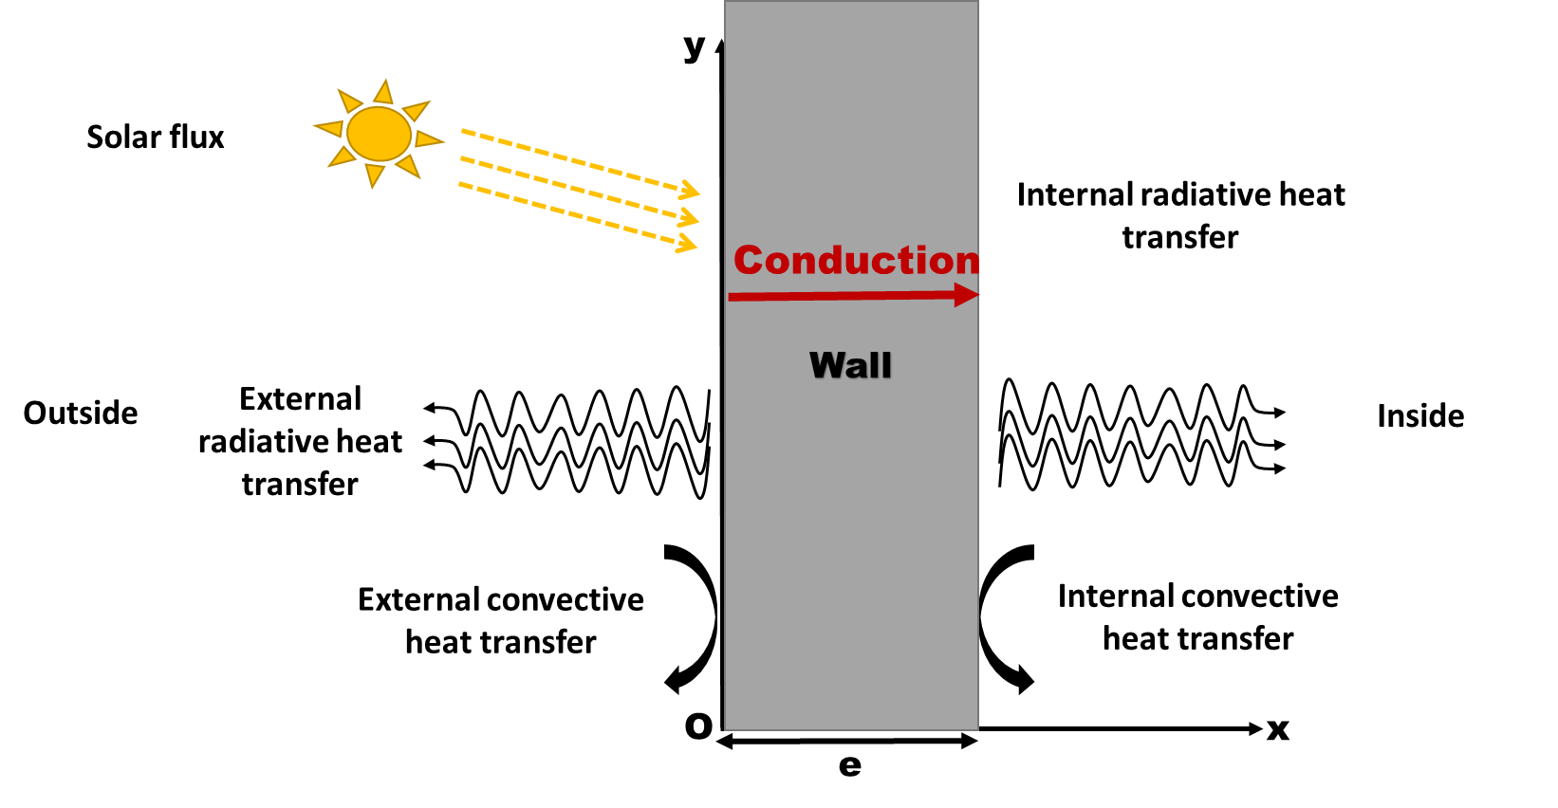

**Figure 1: Physical wall model**

The thermophysical properties of the wall materials are shown in table 1. These properties were determined experimentally by Serebe et al.,(2024)[13].

**Table 1** : Thermophysical properties of adobes[13]

|  |  |  |  |  |  |
| --- | --- | --- | --- | --- | --- |
| **Size of kenaf fibers [cm]** | **Kenaf fibers content [%]** | **Nomenclature of adobes** | **Density σ [kg/m3]** | **Thermal conductivity λ [W/m/°C]** | **Specific thermal capacity Cp [J/kg/°C]** |
| 0 | 0 | AK0 | 1700 | 0.93 | 898 |
| 2 | 0.2 | AK0.2L2 | 1623 | 0.81 | 1052 |
| 0.4 | AK0.4L2 | 1597 | 0.76 | 1143 |
| 0.6 | AK0.6L2 | 1587 | 0.71 | 1085 |
| 0.8 | AK0.8L2 | 1583 | 0.47 | 1155 |
| 3 | 0.2 | AK0.2L3 | 1643 | 0.80 | 1029 |
| 0.4 | AK0.4L3 | 1623 | 0.75 | 1100 |
| 0.6 | AK0.6L3 | 1593 | 0.62 | 1122 |
| 0.8 | AK0.8L3 | 1547 | 0.44 | 1204 |

**2.2. Mathematical model**

* For $0<x<e$

The expression of the heat transfer equation in the wall is given by the following relationship (relation (1)):

|  |  |
| --- | --- |
| $$ρC_{p}\frac{∂T\left(x,t\right)}{∂t}=λ\frac{∂^{2}T\left(x,t\right)}{∂x^{2}}$$ | (1) |

$ρ\left[[{kg}/{m^{3}}\right] and C_{p} [J/{{kg}/K}]$ correspond respectively to the density and specific thermal capacity of wall’s materials. $λ[W/{m/{°K}}]$ is its thermal conductivity. $T\left(x,t\right)$ [°C] is the temperature of wall at position $x$ at the time $t$.

At $t=0$, the temperature at the position x of wall is considered constant.

|  |  |
| --- | --- |
| $$T\left(x,o\right)=26°C.$$ | (2) |

* **For**

|  |  |
| --- | --- |
|  | (3) |

[W/m2/°K], corresponds to outside surface heat transfer coefficient. $T_{g} [°C]$ is the outside equivalent temperature. It’s defined according Mazzeo et al., (2016)[14] :

|  |  |
| --- | --- |
|  | (4) |

[W/m2] is the solar heat flux. $T_{ae}$ and $T_{sky}$ [°C] correspond respectively to the outside air temperature and the temperature of sky. According standart ISO 13790, $T_{sky}$ based on Tae [15] . The relation (5) gives its expression for tropic areas:

|  |  |
| --- | --- |
| $$T_{sky}=T_{ae}-13$$ | (5) |

$α_{e}=0.3$ correspond au coefficient d’absorption solaire de la paroi **[16].**

and [W/m2/°K] are outside thermal convective and radiative coefficients. The formula of Mc Adams enables us to evaluate $h_{ce}$ [17] :

|  |  |
| --- | --- |
| $$h_{ce}=5,678\left[{m+n\left(\frac{v_{f}}{0.3048}\right)}^{p}\right]$$ | (6) |

$v_{f}$ is the wind speed in [m/s]. $m, n and p$ are McAdams correlation coefficients. A constant value of $h_{re}$ equal to 4,84 W/m2/°K was used according to the European Passive Solar Handbook [18].

The 2017 meteorological data (solar radiation and air temperature) for the city of Ouagadougou were used. The hourly data of the hottest and sunniest day (March 17) were considered for the simulation needs. On this day, the average wind speed was 3.78 m/s. Thus, in our study, a value of 20.75 W/m2/°K was used for $h_{ce}$**.**

* For $x=e$

At the inner surface, we have:

|  |  |
| --- | --- |
|  | (8) |

$T_{ai}$ [°C], corresponds to the indoor air temperature. It is assumed to be constant and equal to 26 °C. $h_{i}=h_{ci}$ + $h_{ri}$ corresponds to the overall internal heat transfer coefficient of the wall.

The system of equations formed by equations (1)-(8) was solved using the implicit finite difference method. This method involves transforming the system of equations into a discrete matrix relation obtained by applying the Taylor series approximation to the spatial and temporal derivatives. The numerical matrix system, resulting from this transformation, is solved using a numerical code based on matrix functions. MATLAB was used for our simulations, and the numerical data obtained were processed in OriginPro.

A validation study of our numerical model was conducted. This study consists of comparing the results of our model with those obtained by Jin et al. (2012)[19] in their study. For this purpose, a homogeneous wall was considered

The relative deviation (RD), defined in equation (9), was used to assess the reliability of the model by measuring the relative difference between the simulated values and those obtained in [19]. This indicator was evaluated for two simulation data points: the temperatures at the exterior surface (Twe) and the interior surface (Twi):

|  |  |
| --- | --- |
|  | (9) |

Where $Twi_{s}$ and $Twe_{s}$ correspond to the simulated temperatures ; $Twi_{Jin}$ and $Twe_{Jin}$ correspond to those obtained in [19]. ${RD}_{Twi}$ and ${RD}_{Twe}$ represent the absolute relative deviations associated with the different temperatures, expressed in [%].

The obtained results are presented in figures 2 and 3.

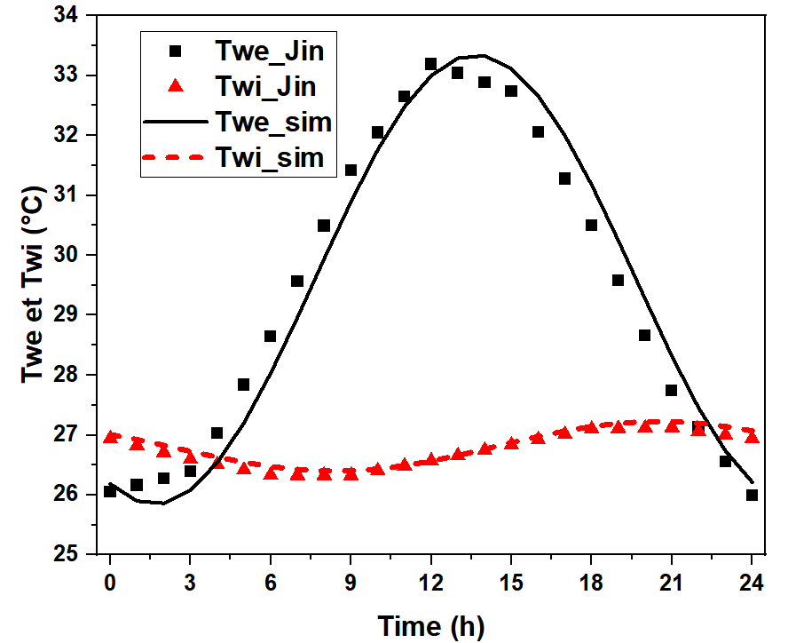

**Figure 2: Comparison of Simulation Results with Those Obtained by Jin et al. (2012) [19]**

Figure 2 compares the simulation results of the temperatures at the external and internal surfaces of the wall with those from the literature. The comparison shows a small discrepancy between the simulation results and the literature values, especially at the external surface. In percentage terms, maximum deviations of 0.5 % and 2.3 % were obtained for Twi and Twe, respectively (**Figure 3**). These acceptable maximum deviations can be explained by the fact that the spatial discretization methods and the solution algorithm used in the two numerical codes differ. Indeed, in the study conducted by Jin et al., (2012)[19], the central difference method was used for spatial discretization, and the Thomas algorithm was applied for solving the system. These acceptable deviation values highlight the reliability of the numerical code developed in our study.

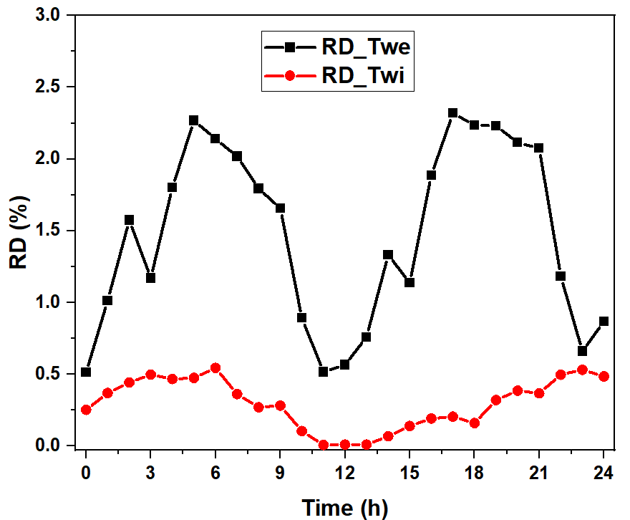

**Figure 3: Absolute relative Deviations (RD)**

**2.3. Evaluation of dynamic thermal performances of walls**

Based on the study by Vincenzo et al. (2016) [20] the knowledge of $T_{wi}$ and $T_{we}$ allows for the determination of the thermal parameters characterizing the dynamic thermal performance of our opaque walls, particularly the time lag $∆t$ and the dumping factor $f$. These two parameters are defined with respect to external conditions and also with respect to temperatures through the following relations (10) and (11) :

|  |  |
| --- | --- |
| $$f=\frac{max\left(T_{wi}\right)-min\left(T_{wi}\right)}{max\left(T_{we}\right)-min\left(T_{we}\right)}$$ | (10) |

|  |  |
| --- | --- |
|  | (11) |

**3. Results and discussion**

**3.1. Profiles of incoming, outgoing, and stored heat flux densities by the wall**

The profiles of incoming (Fwe), outgoing (Fwi), and stored (Fst) heat flux densities for non-insulated walls are presented in this section. A thickness of 15 cm was used for the simulation, and the results are shown in figures 4, 5, and 6.

Figures 4a and 4b compare the profiles of incoming heat flux densities for stabilized adobes with 2 cm and 3 cm long kenaf fibers, respectively.

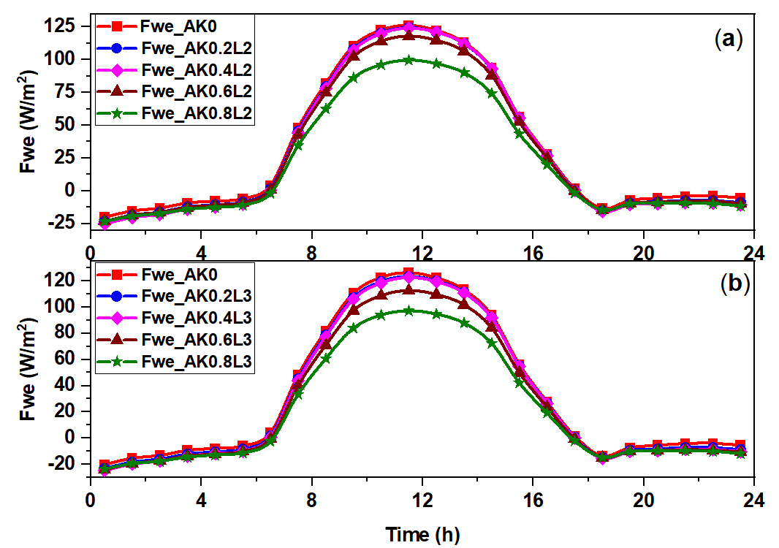

**Figure 4: Profiles of incoming heat flux densities: (a) Stabilized adobes with 2 cm fibers and (b) Stabilized adobes with 3 cm fibers**

From this comparison, it appears that the heat flux densities at the outer surface of the different walls show both positive and negative values. Indeed, during the time interval between 7 AM and 6 PM, the incoming flux is positive. During this period, heat transfer occurs from the outside to the inside, due to the presence of solar radiation. During the rest of the time, when solar fluctuations are null or nearly null, the flux density shows negative values, highlighting the dissipation of heat from the inner surface of the wall to the outside. Compared to non-stabilized adobes, stabilized adobes exhibit slightly lower peaks in incoming flux density due to their lower thermal conductivities. Similarly, the higher the kenaf fiber content, the lower the peak of incoming flux density in the wall.

Figures 5a and 5b compare the profiles of outgoing flux densities for stabilized adobes with 2 cm and 3 cm kenaf fibers, respectively.

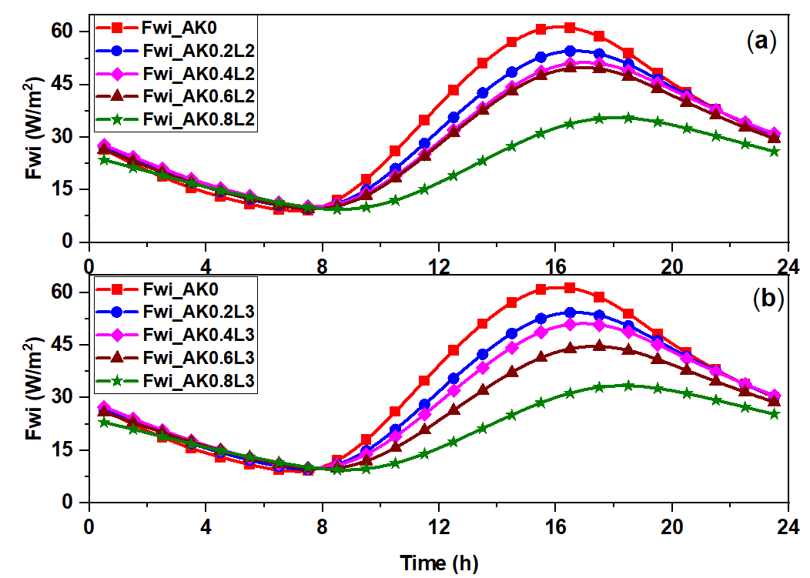

**Figure 5: Profiles of outgoing heat flux densities: (a) Stabilized adobes with 2 cm fibers and (b) Stabilized adobes with 3 cm fibers**

From these curves, we observe that the heat flux densities at the inner surface of the different walls show positive values, highlighting a one-way heat transfer from the inner surface of the walls to the interior environment. The profiles of 𝐹𝑤𝑖 indicate an increase in the flux between 8 AM and 7 PM. Compared to the incoming flux densities, the outgoing flux densities have lower peaks and reduced fluctuation amplitudes. This reflects a damping of the variation amplitude of the flux densities as it transitions through the wall. The higher the fiber content in the material, the greater the damping. In the case of non-stabilized adobes, the fluctuation amplitude of the flux density, from the outer surface to the inner surface, decreases from 146 W/m² to 35 W/m², representing a 76 % reduction. When 0.8 % of kenaf fibers are added, the variation amplitude of the flux density changes from 123 W/m² to 12 W/m² and from 120 W/m² to 10.4 W/m² for fiber sizes of 2 cm and 3 cm, respectively. This represents a 90.24 % reduction for the 2 cm fibers and a 91.33 % reduction for the 3 cm fibers. This also highlights the impact of fiber size on the ability of adobes to dampen fluctuations in flux density. Furthermore, the profiles of the outgoing flux densities show a thermal phase shift, with the peaks occurring at later times compared to the peaks of the incoming flux density. The results from the analysis of Figures 4 and 5 indicate an improvement in the thermal inertial behavior of the adobes with the addition of kenaf fibers to the clay matrix. Such improvements are due to the reduction in thermal conductivity of the adobes with fiber addition, as reported by Serebe et al., (2024)[13].

Figures 6a and 6b show the stored flux densities within the different walls.

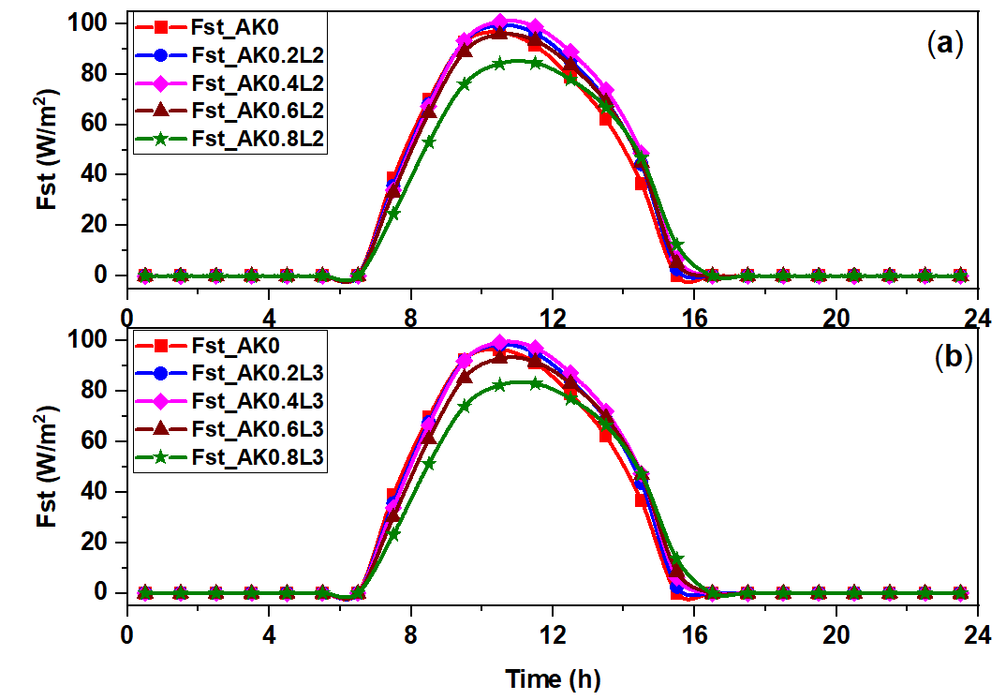

**Figure 6: Profiles of store heat flux densities: (a) Stabilized adobes with 2 cm fibers and (b) Stabilized adobes with 3 cm fibers**

The profiles of stored flux densities within the wall are almost identical to those of the incoming flux, except during the period when heat is dissipated to the outside through the wall, where the stored flux density is zero. Indeed, the observation of the stored flux density profiles reveals that heat storage within the wall occurs during the period between 6 AM and 4 PM. During this storage period, the stored flux densities increase from 6 AM to 12 PM, then decrease and eventually cancel out for a given adobe formulation. The period when the flux is zero corresponds to the time when heat is dissipated within the wall to the outer and inner surfaces.

Moreover, the profiles of the stored flux density indicate a slight increase in the peaks of Fst with the increase in fiber content up to 0.4 %, followed by a decrease beyond this content. The variations in the peaks of Fst​ as a function of fiber content are linked to those of Fwe​ and Fwi​. Indeed, as we can observe from figures 4 and 5, the profiles of Fwe​ obtained for adobes with fiber contents less than 0.4 % are similar, while beyond this content, a significant decrease is observed. This is not the case for the evolution of the Fwi profiles, where a significant decrease is observed when the content increases from 0 % to 0.8 %.

Thus, the variation of Fwe​ and the sharp decrease of Fwi​ at fiber contents below 0.4 % lead to an increase in Fst with fiber content up to 0.4 %, while the decrease in Fst​ beyond 0.4 % is explained by the significant simultaneous decreases in both Fwe and Fwi.

**3.2. Profiles of temperatures at the external and internal surfaces of the wall.**

The evolution of the temperature at the external and internal surfaces of 15 cm thick, non-insulated walls is analyzed in this section. The simulation results are presented in Figures 7 and 8.

Figures 7a and 7b show the temperature at the external surface of the wall.

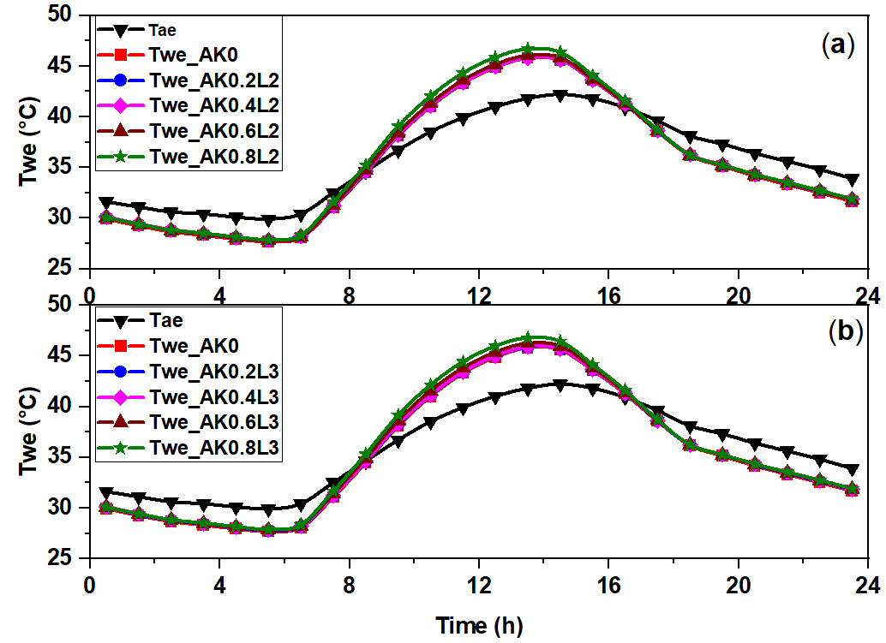

**Figure 7: Profiles of temperature at the external surface of the walls: (a) Stabilized adobes with 2 cm fibers and (b) Stabilized adobes with 3 cm fibers**

The observation of these curves indicates an increase in temperature at the external surface from 6 AM to 2 PM, followed by a decrease. This increase in temperature at the external surface is linked to the rise in outdoor air temperature and the absorbed solar radiation. Values of Twe​ higher than those of Tae​ (outdoor air temperature) are related to the effect of solar absorption at the external surface of the wall. Indeed, a study by Vijayan et al. (2022) [21]; showed that solar absorption directly increases the temperature of the external surface. This can reach very high levels, especially in summer and in hot climates. For a given fiber length, we observe that the peaks of Twe​ are higher with formulations containing higher fiber content. Indeed, the more resistant materials tend to oppose the penetration of the thermal wave. This results in a decrease in the heat flux density Fwe. However, a greater opposition to the penetration of the thermal wave would lead to heat concentration at the external interface of the wall, hence the increase in temperature [21].

Figures 8a and 8b show the evolution of the temperature at the internal surface Twi of walls.

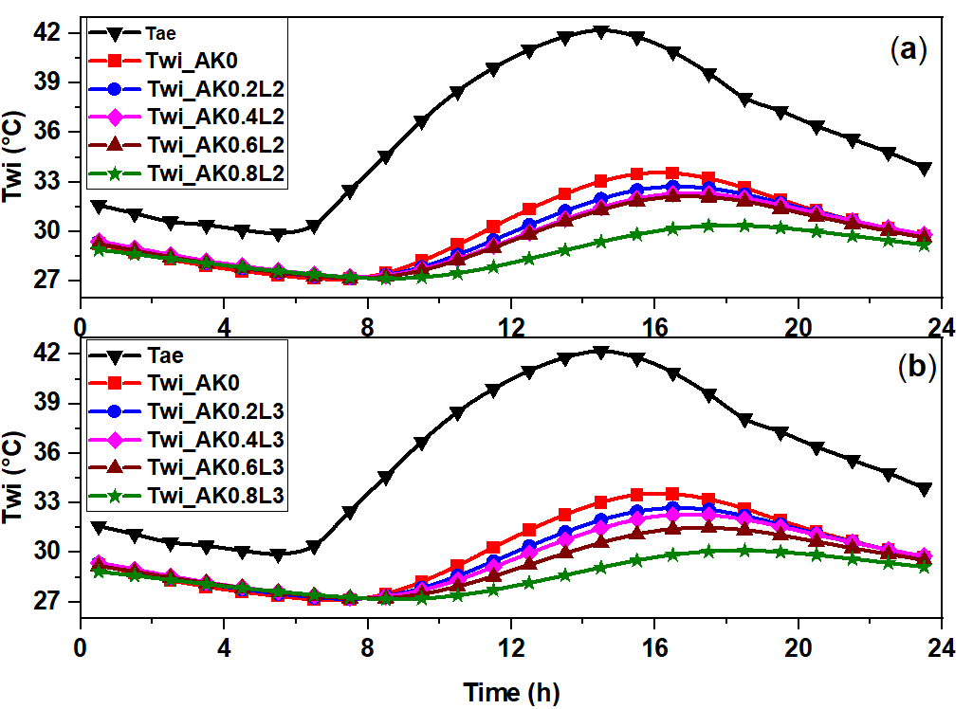

**Figure 8: Profiles of temperature at the internal surface of the walls: (a) Stabilized adobes with 2 cm fibers and (b) Stabilized adobes with 3 cm fibers.**

The profiles of Twi​ show a similar evolution to that of Twe​. Indeed, we observe an increase in Twi​ from 8 AM to around 6 PM. Similarly to the observations made at the level of Fwi​, there is a damping of the amplitudes and a time shift of the peak of Twi​ relative to that of Twe​.

Furthermore, we observe a decrease in the fluctuation amplitude of Twi​ and an increase in the time shift of Twi​ with the addition of fibers. The decrease in Twi​ with the addition of fibers highlights the effectiveness of kenaf fiber addition in the passive cooling of buildings. Such results were obtained by Charai et al. (2020)[22] who evaluated the thermal impact of wood shavings content on earthen building envelopes.

**3.3. Effect of kenaf fibers on the thermal inertial performance**

The previous results indicate an influence of the addition of kenaf fibers on the dynamic thermal performance of adobe. This motivates us to study, in this section, the effect of kenaf fibers on the damping factor (f) and the thermal phase shift (∆t).

Figures 9a and 9b compare, respectively, the dynamic thermal resistance, the damping factor, and the thermal phase shift of the different walls.

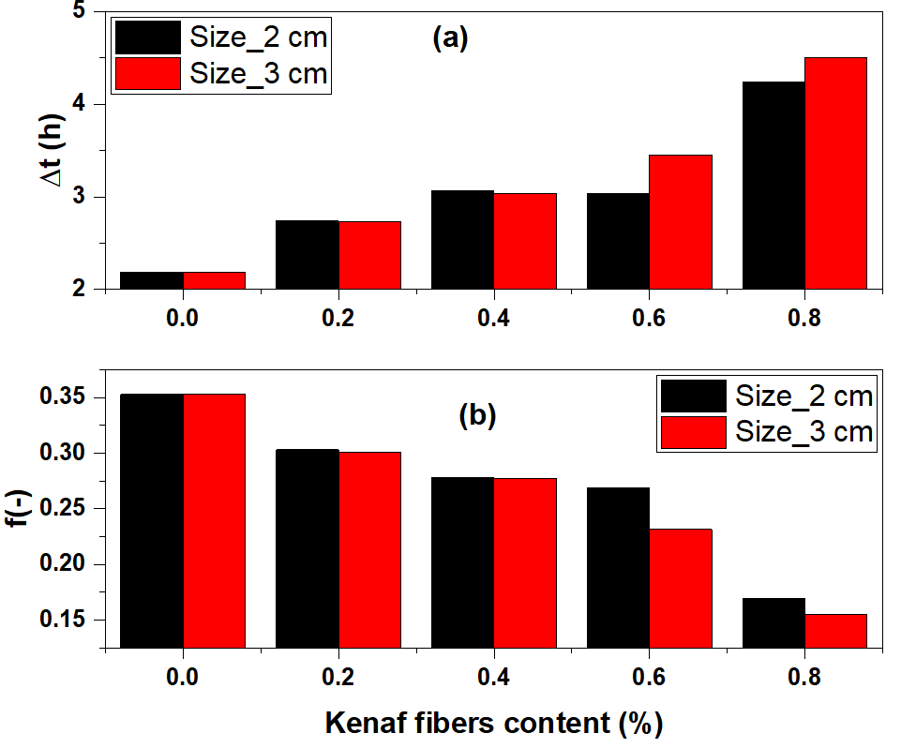

**Figure 9: Effect of kenaf fibers on : (a) ldumpinf factor and (b) time lags of adobes**

The addition of kenaf fibers leads to a decrease in the damping factor and an increase in the thermal phase shift of the adobes. Indeed, the damping factor decreases with the fiber content and size. When the content increases from 0 % to 0.8 %, the damping factor decreases from 0.35 to 0.17 and from 0.35 to 0.14 for fibers of 2 cm and 3 cm, respectively, corresponding to a decrease of 51.4 % and 60 % for the two fiber sizes. These observations highlight the effect of the fiber content and size on the damping factors of adobe. However, for higher contents, the difference between the damping factors becomes quite significant for both fiber sizes.

As for the thermal phase shift, an increase is observed with both the fiber content and size. When the fiber content increases from 0 % to 0.8 %, the thermal phase shift increases from 2.19 to 4.24 hours and from 2.19 to 4.5 hours for fibers of 2 cm and 3 cm, respectively, which corresponds to an increase of 48.34 % and 51.33 % for the two fiber sizes. However, a slight decrease is observed for the adobes stabilized with 0.6 % kenaf fibers of 2 cm. This decrease at 0.6% is attributed to a reduction in the specific heat of the adobes caused by the heterogeneity induced by the fiber addition. Indeed, the evolution of the thermal phase shift with fiber content for different fiber sizes is similar to that of the specific heat observed in the results presented by Serebe et al. (2024) [13].

In general, the addition of kenaf fibers in the clay matrix improves the dynamic thermal performance of the adobe. This improvement is due to the decrease in thermal conductivity and the increase in thermal capacity induced by the fibers. These results are similar to those found by Saidi et al. (2016) regarding the effect of stabilizing compressed earth bricks (CEB) on the internal surface temperature of the wall [23]. The authors found that adding paper to the CEB reduced its maximum temperature by 0.2°C and increased the thermal phase shift by one hour. The work of Mellaikhafi et al. (2021)[24] indicates a maximum reduction of about 46% in thermal flux through walls containing pennate leaf fibers. Moreover, the thermal phase shift and the flux reduction factor improve, ensuring better energy efficiency. According to some authors, such good thermal performance is related to their low thermal conductivity [19, 25, 26].

**4. Conclusion**

This study presents the effect of kenaf fiber content and size on the dynamic thermal performance of adobe. A physical model of a homogeneous wall made of adobe and a numerical simulation model based on the implicit finite difference method were considered. After analyzing the simulation data, the following results were obtained:

* The validation results show a maximum relative deviation of 2.3 % for the temperature at the external surface of the wall, highlighting the accuracy and reliability of the obtained numerical code;
* The addition of fibers leads to a reduction and temporal shift of the peak flux densities at the outer face of the adobe walls;
* This greatly contributes to reducing the temperature at the inner face of the walls, leading to a reduction in the damping factor and an increase in the thermal phase shift with fiber size and content.

Thus, based on the results obtained, the vegetative stabilization of adobes with kenaf fibers could passively contribute to energy savings. However, considering the sensitivity of earth-based materials to water, it would be desirable to examine the effect of moisture on the dynamic thermal performance of these adobes. This could contribute to investigating the hygrothermal comfort of a building made from these adobes.

**COMPETING INTERESTS DISCLAIMER:**

Authors have declared that they have no known competing financial interests OR non-financial interests OR personal relationships that could have appeared to influence the work reported in this paper.

**6. References**

1. Hwaish, A. N. A. (2015). Impact of heat exchange on building envelope in the hot climates. Int. J. Emerg. Technol. Adv. Eng, 5(2).

2. Alassane, M. (2020). Étude du transfert thermique à travers les parois enveloppes de batiment en régime thermique dynamique: principes et calculs. Rev. Ivoir. Sci. Technol., 35, 138 – 162. ISSN 1813-3290 <http://www.revist.ci>.

3. Ouedraogo, B. I., Levermore, G. J., & Parkinson, J. B. (2012). Future energy demand for public buildings in the context of climate change for Burkina Faso. Building and Environment, 49, 270-282. <https://doi.org/10.1016/j.buildenv.2011.10.003>

4. Eslami, A., Mohammadi, H., & Banadaki, H. M. (2022). Palm fiber as a natural reinforcement for improving the properties of traditional adobe bricks. Construction and Building Materials, 325, 126808. <https://doi.org/10.1016/j.conbuildmat.2022.126808>

5. Ramakrishnan, S., Loganayagan, S., Kowshika, G., Ramprakash, C., & Aruneshwaran, M. (2021). Adobe blocks reinforced with natural fibres: A review. Materials Today: Proceedings, 45, 6493-6499. <https://doi.org/10.1016/j.matpr.2020.11.377>

6. Millogo, Y., Morel, J. C., Aubert, J. E., & Ghavami, K. (2014). Experimental analysis of Pressed Adobe Blocks reinforced with Hibiscus cannabinus fibers. Construction and Building Materials, 52, 71-78. <https://doi.org/10.1016/j.conbuildmat.2013.10.094>

7. Ouedraogo, M., Dao, K., Millogo, Y., Seynou, M., Aubert, J. E., & Gomina, M. (2017). Influence des fibres de kenaf (Hibiscus altissima) sur les propriétés physiques et mécaniques des adobes. Journal de la Société Ouest-Africaine de Chimie, 43, 48-63.

8. Antunes, A., Faria, P., Silva, V., & Brás, A. (2019). Rice husk-earth based composites: A novel bio-based panel for buildings refurbishment. Construction and Building Materials, 221, 99-108. <https://doi.org/10.1016/j.conbuildmat.2019.06.074>

9. Ouedraogo, M., Bamogo, H., Sanou, I., Dao, K., Ouedraogo, KAJ, Aubert, JE, & Millogo, Y. (2022) Microstructure, propriétés physiques et mécaniques des Adobes stabilisés avec des balles de riz. Journal international du patrimoine architectural. p. 1-16.

10. Ouedraogo, M., Bamogo, H., Sanou, I., Mazars, V., Aubert, J. E., & Millogo, Y. (2023). Microstructural, physical and mechanical characteristics of adobes reinforced with sugarcane bagasse. Buildings, 13(1), 117. <https://doi.org/10.3390/buildings13010117>

11. Bamogo, H., Ouedraogo, M., Sanou, I., Ouedraogo, K. A. J., Dao, K., Aubert, J. E., & Millogo, Y. (2020). Improvement of water resistance and thermal comfort of earth renders by cow dung: an ancestral practice of Burkina Faso. Journal of Cultural Heritage, 46, 42-51. <https://doi.org/10.1016/j.culher.2020.04.009>

12. Ouedraogo, M., Dao, K., Millogo, Y., Aubert, J. E., Messan, A., Seynou, M., ... & Gomina, M. (2019). Physical, thermal and mechanical properties of adobes stabilized with fonio (Digitaria exilis) straw. Journal of Building Engineering, 23, 250-258. <https://doi.org/10.1016/j.jobe.2019.02.005>

13. Serebe, Y. A. A., Ouedraogo, M., Sere, A. D., Sanou, I., Zagre, W. K. J. E., Aubert, J. E., ... & Millogo, Y. (2024). Optimization of kenaf fiber content for the improvement of the thermophysical and mechanical properties of adobes. Construction and Building Materials, 431, 136469. <https://doi.org/10.1016/j.conbuildmat.2024.136469>

14. Mazzeo, D., Oliveti, G., & Arcuri, N. (2016). Influence of internal and external boundary conditions on the decrement factor and time lag heat flux of building walls in steady periodic regime. Applied Energy, 164, 509-531. <https://doi.org/10.1016/j.apenergy.2015.11.076>

15. EN, P. (2008). 13790 Energy performance of buildings-Calculation of energy use for space heating and cooling. Warsaw: Polish Standards Institution.

16. Defraeye, T., Blocken, B., & Carmeliet, J. (2011). Convective heat transfer coefficients for exterior building surfaces: Existing correlations and CFD modelling. Energy Conversion and Management, 52(1), 512-522. <https://doi.org/10.1016/j.enconman.2010.07.026>

17. Achard, P., & Gicquel, R. (1986). European passive solar handbook. Basic principles and concepts for passive solar architecture.

18. Alredaisy, S. M. A. H. (2019). Arid Environment and Rock Mineral Content as a Catalyst for Higher Vulnerability to Cancer Morbidity in the Northern State of Sudan. The Arab World Geographer, 22(1-2), 150-164.

19. Jin, X., Zhang, X., Cao, Y., & Wang, G. (2012). Thermal performance evaluation of the wall using heat flux time lag and decrement factor. Energy and Buildings, 47, 369-374. <https://doi.org/10.1016/j.enbuild.2011.12.010>

20. Corrado, V., & Paduos, S. (2016). New equivalent parameters for thermal characterization of opaque building envelope components under dynamic conditions. Applied energy, 163, 313-322. <https://doi.org/10.1016/j.apenergy.2015.10.123>

21. Vijayan, D. S., Sivasuriyan, A., Patchamuthu, P., & Jayaseelan, R. (2022). Thermal performance of energy-efficient buildings for sustainable development. Environmental Science and Pollution Research, 29(34), 51130-51142.  <https://doi.org/10.1007/s11356-021-17602-3>

22. Charai, M. (2020). Etude thermomécanique d’une éco-brique locale pour la construction. Academic Journal of Civil Engineering, 38(1), 289-292. <https://doi.org/10.26168/ajce.38.1.68>

23. Meriem, S., Cherif, A., Ezeddine S., Zeghmati, B. R. (2016) Conference paper on Researchgate. Etude numérique du comportement thermique de brique de terre stabilisée. p.8

24. Mellaikhafi, A., Ouakarrouch, M., Benallel, A., Tilioua, A., Ettakni, M., Babaoui, A., & Hamdi, M. A. A. (2021). Characterization and thermal performance assessment of earthen adobes and walls additive with different date palm fibers. Case Studies in Construction Materials, 15 <https://doi.org/10.1016/j.cscm.2021.e00693>

25. Asan, H., & Sancaktar, Y. S. (1998). Effects of wall's thermophysical properties on time lag and decrement factor. energy and buildings, 28(2), 159-166. <https://doi.org/10.1016/S0378-7788(98)00007-3>

26. Ulgen, K. (2002). Experimental and theoretical investigation of effects of wall’s thermophysical properties on time lag and decrement factor. energy and buildings, 34(3), 273-278. <https://doi.org/10.1016/S0378-7788(01)00087-1>