**Management of Bilateral Corneal Perforation Complicating Rheumatoid Arthritis: *A Case Report***

**Abstract :**

Rheumatoid arthritis (RA) can lead to severe ophthalmological complications, particularly peripheral ulcerative keratitis (PUK), which may progress to corneal perforation, threatening both functional and anatomical prognosis. We report the case of a 65-year-old patient with erosive and deforming RA who developed bilateral corneal perforation. Management required a multidisciplinary approach combining medical and surgical treatments, including amniotic membrane transplantation and anti-TNF biotherapy. The outcome was marked by satisfactory corneal healing and partial functional improvement. This case highlights the importance of early diagnosis and appropriate management to optimize visual prognosis.

**Keywords:** Corneal perforation, rheumatoid arthritis, peripheral ulcerative keratitis, amniotic membrane transplantation, anti-TNF biotherapy

---

**Introduction** :

Rheumatoid arthritis (RA) is a systemic autoimmune disease characterized by chronic inflammation that primarily affects the synovial joints but can also involve extra-articular organs, including the eyes. Peripheral ulcerative keratitis (PUK) is the most severe ocular manifestation of RA, often leading to corneal thinning and perforation, which threaten visual function and ocular integrity. Corneal perforation is a rare but devastating complication that requires urgent intervention to preserve vision and the structural integrity of the eye.

Several therapeutic strategies have been employed to manage RA-associated corneal perforations, including medical treatment with immunosuppressive agents and surgical interventions such as amniotic membrane transplantation (AMT) and keratoplasty. This article presents a detailed case report of a patient with bilateral corneal perforation associated with RA and provides an extensive discussion based on a review of the literature.

---

**Case Report :**

A 65-year-old patient followed for 17 years for seropositive erosive and deforming RA, was hospitalized in internal medicine for a severe flare of her disease. She presented to ophthalmology with bilateral decreased visual acuity associated with ocular pain and redness.

Ophthalmological examination revealed:

- Bilateral corneal perforation.

- Left eye (LE): 4 mm perforation nasally. **(figure 2)**

- Right eye (RE): 3 mm perforation superonasally. **(figure 1)**

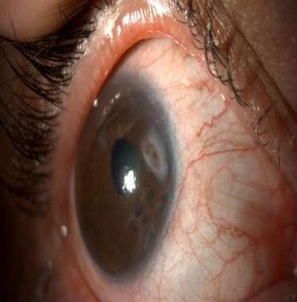 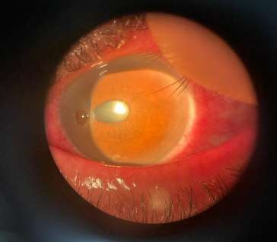

**Figure 1** : Perforation 3 mm RE **Figure 2** : Perforation 4mm LE

Management was conducted in two stages:

**1. Control of perforation and inflammation:**

- Administration of corticosteroid boluses.

- Immunosuppressive therapy with anti-TNF biotherapy.

- Amniotic membrane transplantation (AMT) using the inlay and onlay technique. **(figure 3)**

- Use of scleral lenses and autologous serum.

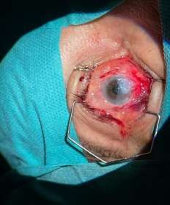

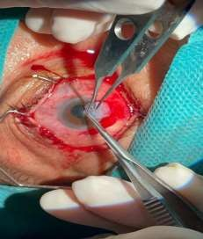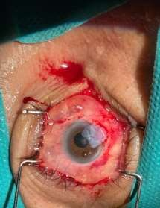

**Figure 3** : Amniotic membrane transplantation

2. **Management of underlying RA:**

- Adaptation of systemic therapy with the introduction of anti-TNF biotherapy.

- Treatment of severe dry eye syndrome.

Postoperative evolution showed satisfactory anatomical restoration, with complete graft epithelialization within five weeks. (Figure 4 and 5 )

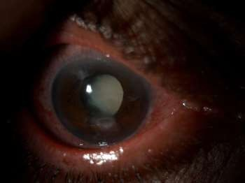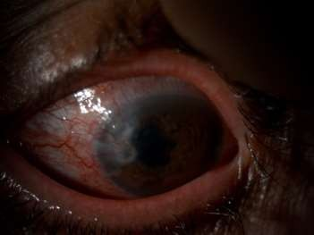

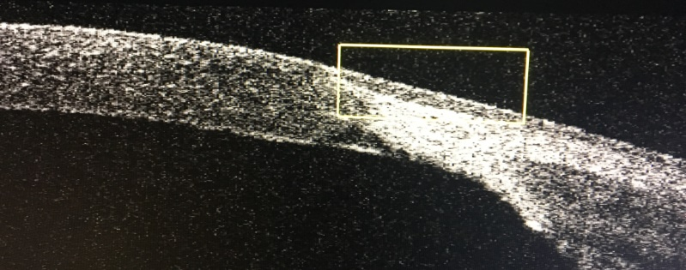 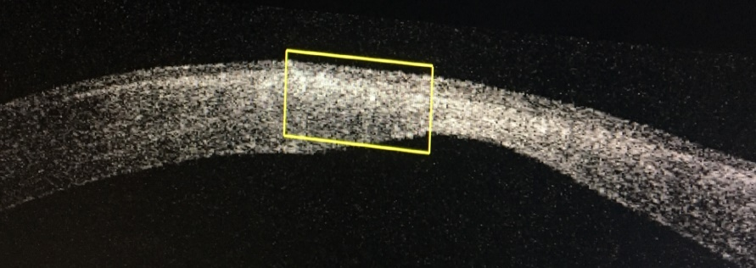

Figure 4. : complete graft epithelialization RE. Figure 5. : complete graft epithelialization LE.

Functionally after scleral adaptation the best visual acuity was 1/10 RE (**figure 6)** and 2/10 LE **(figure 7)**

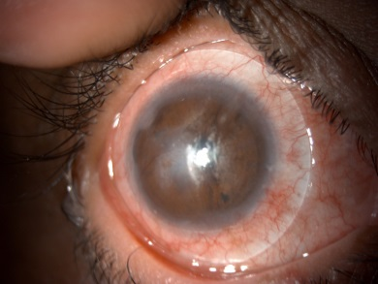 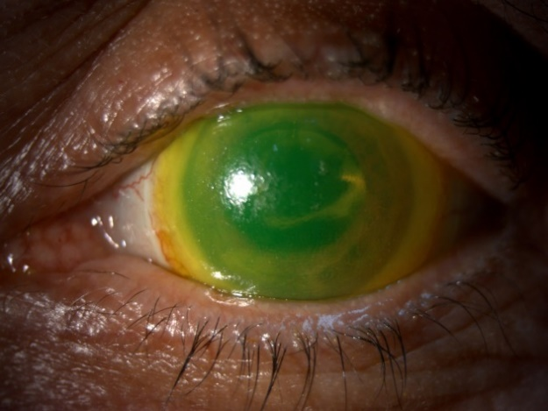

Figure 6 : Right eye Figure 7 : Left eye

**Discussion :**

Peripheral ulcerative keratitis (PUK) is a severe manifestation of RA resulting from inflammatory and immune-mediated corneal tissue destruction. Corneal perforation represents the most critical complication, necessitating rapid and tailored intervention.

**Pathophysiology of RA-associated Corneal Perforations :**

RA-related ocular complications are primarily mediated by an immune response targeting corneal stromal components. The inflammatory cascade is driven by an imbalance in cytokines, particularly tumor necrosis factor-alpha (TNF-α), interleukin-1 (IL-1), and matrix metalloproteinases (MMPs), leading to corneal thinning and eventual perforation. Vascular compromise exacerbates tissue damage, impairing corneal healing mechanisms.

**Therapeutic Management :**

The management of RA-associated corneal perforations relies on several pillars:

- **Medical treatment:** Systemic immunosuppression, particularly with anti-TNF biotherapies, is crucial to controlling RA inflammatory activity and preventing ocular complications. Methotrexate, azathioprine, and cyclophosphamide have been historically used; however, the advent of biologic agents such as infliximab and adalimumab has significantly improved disease control.

- **Surgical treatment:** Amniotic membrane transplantation (AMT) is an effective therapeutic option due to its anti-inflammatory, anti-angiogenic, and antibacterial properties. Several techniques have been described:

- Inlay technique: Integration of the membrane within the corneal stroma to provide structural support.

- Onlay technique: Surface coverage of the cornea acting as a biological dressing.

- Combined inlay and onlay technique: Offers enhanced restoration of corneal thickness and surface protection.

In cases where AMT alone is insufficient, tectonic penetrating keratoplasty (PK) or lamellar keratoplasty (LK) may be required. The use of fibrin glue and scleral patch grafts has also been explored in severe cases.

**Role of Biotherapy in RA-Associated Ocular Disease :**

Biologic agents, particularly anti-TNF drugs, have revolutionized the management of RA and its ocular manifestations. These agents effectively reduce systemic inflammation and slow disease progression. Studies have shown that anti-TNF therapy not only improves joint symptoms but also stabilizes corneal involvement, reducing the risk of perforation.

However, long-term immunosuppression requires careful monitoring due to potential adverse effects, including an increased risk of infections. Thus, a tailored approach balancing disease control and minimizing systemic complications is necessary.

**Comparative Outcomes and Prognosis :**

Recent studies analyzing outcomes in patients with RA-associated corneal perforations have reported variable prognoses. Watson et al. (1992) and Bernauer et al. (1995) demonstrated that prompt intervention with AMT and immunosuppressive therapy significantly improves outcomes, with a high rate of corneal stabilization. However, delays in treatment or inadequate immunosuppression often result in progressive thinning and subsequent perforation requiring more invasive procedures such as PK.

---

**Conclusion:**

Peripheral ulcerative keratitis complicating RA is a therapeutic emergency requiring a multidisciplinary approach. Amniotic membrane transplantation combined with systemic immunosuppressive therapy is an effective treatment strategy. Early and appropriate management significantly improves the visual and sometimes vital prognosis of patients with severe RA.

This case underscores the importance of collaboration between ophthalmologists and rheumatologists in managing RA-related ocular complications and highlights the growing role of biotherapies in this treatment approach.

---

**References :**

1. Wolfe AM. The epidemiology of rheumatoid arthritis: a review: Part I. Surveys Part II. Incidence and Diagnostic Criteria. Bull Rheum Dis 1968;19:518-529.

2. Jabs DA. Ocular manifestations of the rheumatic diseases. In: Tasman W, Jaeger EA, eds. Duane's Clinical Ophthalmology, rev ed. Vol. 4. Philadelphia: JB Lippincott 1992; chap. 26.

3. Brown SI, Grayson M. Marginal furrows: a characteristic corneal lesion of rheumatoid arthritis. Arch Ophthalmol 1968;79:563-567.

4. Watson PG. Diseases of the sclera and episclera. In: Tasman W, Jaeger EA, eds. Duane's Clinical Ophthalmology, rev ed. Vol. 4. Philadelphia: JB Lippincott 1992; chap. 23.

5. Watson PG. Vascular changes in peripheral corneal destructive disease. Eye 1990;4:65-73.

6. Pfister RR, Murphy GE. Corneal ulceration and perforation associated with Sjogren's syndrome. Arch Ophthalmol 1980;98:89-94.

7. Gudas PP, Altman B, Nicholson DH, et al. Corneal perforations in Sjogren syndrome. Arch Ophthalmol 1973;90:470-472.

8. Cohen KL. Sterile corneal perforation after cataract surgery in Sjogren's syndrome. Br J Ophthalmol 1982;66:179-182.

9. Duy TP. Keratomalacia perforans, Klinische und pathohistologische Befunde. Monatsbl Augenheilkd 1985;187:290-292.

10. Tauber J, Sainz de la Maza M, Hoang-Xuan T, et al. An analysis of therapeutic decision making regarding immunosuppressive chemotherapy for peripheral ulcerative keratitis. Cornea 1990;9:66-73.

11. Leibowitz HM, Berrospi AR. Initial treatment of descemetocele with hydrophilic contact lenses. Ann Ophthalmol 1975;7:1161-1166.

12. Paton D, Milauskas AT. Indications, surgical technique, and results of thin conjunctival flaps on the cornea: a review of 122 consecutive cases. Int Ophthalmol Clin 1970;10:329-345.

13. Hirst LW, Smiddy WE, Stark WJ. Corneal perforations: changing methods of treatment, 1960-1980. Ophthalmology 1982;89:630-635.

14. Weiss JL, Williams P, Lindstrom RL, et al. The use of tissue adhesive in corneal perforations. Ophthalmology 1983;90:610-615.

15. Watson PG. Anterior segment fluorescein angiography in the surgery of immunologically induced corneal and scleral destructive disorders. Ophthalmology 1987;94:1452-1464.

16. Nobe JR, Moura BT, Robin JB, et al. Results of penetrating keratoplasty for the treatment of corneal perforations. Arch Ophthalmol 1990;108:939-941.