***Review Article***

**“Remediation potential of Biochar: A physicochemical perspective”**

**ABSTRACT**

Several anthropogenic and weathering activities accumulate different types of organic and inorganic pollutants such as chromium (Cr), lead (Pb), arsenic (Ar), etc in soils, causing adverse effects on soil characteristics, soil microbial activity (diversity), agricultural practices, and underground aquifers. It inhibits plants growth mainly by creating stress of ion toxicity, osmotic imbalances, and high pH causing nutritional disorders and reducing soil water potential, limiting the uptake of essential plant nutrients (K, Ca, Mg, P, etc.) and water, hindering root respiration (Saha 2017). All these together reduce the crop yield directly or indirectly by affecting the various physiological and developmental stages of crop plants such as photosynthesis, biomass, root and shoot length, etc. Heavy metal-contaminated soil is difficult to manage due to its persistence in soils for a long time, resulting in the deposition and transmission into the food web through agricultural food products, ultimately affecting human health. The remediation of soil by using biochar is a promising approach to mitigate soil contamination via immobilizing heavy metals and organic pollutants. Biochar is a type of charcoal made by the thermal decomposition of biomass, without the availability of oxygen. (Saha et al., 2017). However, various types of feedstocks such as rice husk, bagasse, animal manure, and urban green waste are used for the production of biochar. Thermal decomposition of this biomass is involved in various methods. Pyrolysis, torrefaction, gasification, and Hydrothermal carbonization are involved in this production process. Pyrolysis is the process of thermal decomposition of biomass at a temperature range from 300-900º C. The good physiochemical properties of biochar possess high water holding capacity, cation exchange capacity, pH, and porosity, etc, improve soil health and crop physiological status. Biochar can increase crop yields by improving the properties of salt-affected soil, increasing the water status of crops, reducing Na+ uptake, increasing mineral uptake, and regulating stomatal conductance and phytohormone (Kumari et al.,2013) Hence, biochar produced from agro environmental waste is attracting huge interest as a low-cost amendment due to its potential numerous benefits to the environment and crop productivity. Thus, biochar addition in the agro-environment emerges as a “winwin strategy” for sustainable soil health and environmental eco-friendly assets.

**Key words**: Biochar, remediation, immobilization, pyrolysis, anthropogenic etc.

**Introduction**

Soil contamination due to industrialization and agricultural practices poses a major threat to environment particularly human health through food chain accumulation. It inhibits plants growth mainly by creating stress of ion toxicity, osmotic imbalances and high pH which reduces crop yield directly or indirectly by affecting the various physiological and developmental stages of crop. Several anthropogenic and weathering activities accumulate different types of organic and inorganic pollutants such as chromium (Cr), lead (Pb), arsenic (Ar), etc in soils, causing adverse effects on soil characteristics, soil microbial activity (diversity), agricultural practices, and underground aquifers (Saha et al.,2017). It inhibits plants growth mainly by creating stress of ion toxicity, osmotic imbalances, and high pH causing nutritional disorders and reducing soil water potential, limiting the uptake of essential plant nutrients (K, Ca, Mg, P, etc.) and water, hindering root respiration (Srivastava and Kumar., 2017). All these together reduce the crop yield directly or indirectly by affecting the various physiological and developmental stages of crop plants such as photosynthesis, biomass, root and shoot length, etc. Heavy metal-contaminated soil is difficult to manage due to its persistence in soils for a long time, resulting in the deposition and transmission into the food web through agricultural food products, ultimately affecting human health. On average, global surface temperature has risen about 0.85°C relative to the pre-industrial era, which is mainly attributed to the increased greenhouse gas (GHG) emissions by human activities (Sahid et al., 2015). To mitigate global climate change, withdrawing carbon dioxide (CO2) from the atmosphere has been suggested as a more feasible mitigation strategy since some emissions are inevitable. Soil carbon (C) sequestration through biochar, which contains a large portion of recalcitrant chemical oxidants and is resistant to biological degradation for hundreds and even thousands of years, has been proposed as one of the technologies to minimize GHG emissions (Lehman et al.,2006).

**DEFINITION**

Biochar is a remediation technique which produced from heating biomass using various techniques improves soil fertility and crop physiology (Singh et al.,2021). It enhances crop growth status by improving different growth parameter such as photosynthesis, chlorophyll content, oxidative stress, biomass, root, shoot length, crop yield etc (Singh et al.,2022). Biochar is a type of charcoal made by thermal decomposition of biomass without availability of Oxygen. Black highly porous, fine grained and light weight substance with a large surface area composed of 70% carbon (C).

**ROLE OF BIOCHAR IN CARBON SEQUESTRATION**

An increase in ambient temperature has now been unequivocally proven and reported to increase at an unprecedented rate. Since the late nineteenth century, global surface temperatures have increased by 0.88 °C. Carbon dioxide (CO2), methane (CH4), and nitrous oxides (NO2) are considered to be the important anthropogenic GHGs, which are released into the atmosphere through the burning of fossil and biomass fuels as well decomposition of above and belowground organic matter. Intergovernmental Panel on Climate Change (IPCC). (2021). As per the report, carbon dioxide (CO2) concentration has increased from 280 ppmv in 1850 to 380 ppmv in 2005 (up to 31% increase). An increase in the concentrations of methane (CH4) and nitrous oxide (N2O) has also been observed over the same period but at a steady rate, Forster (2017). According to Pacala and Socolow (2004), approximately 7 PgCyr−1 (1 Pg = 1015 g) is emitted by fossil fuel combustion and around 1.6 PgCyr−1 through deforestation, land-use change, and soil cultivation which in turn plays an important role in contributing to climate change leading to global warming. Thus, there lies a strong quest for mitigating the risks of global warming by stabilizing the GHGs present in the atmosphere, three strategies can be adopted to lower CO2 emissions viz. (i) reducing global energy use, (ii) developing low- or no-carbon fuel, and (iii) sequestering CO2 from point sources or the atmosphere through natural and engineering techniques. From the view of CO2 sequestration, there is a wide range of processes and technological options available in agricultural, industrial, and natural ecosystems which include biotic and abiotic sequestration. Studies have considered the potential of bio-based carbon materials for gas capture and storage, and biochar has emerged as one of the important tools among different carbon sequestration techniques. The application of biochar in the soil poses a novel approach to establishing a significant long-term sink of atmospheric carbon dioxide (CO2) in terrestrial ecosystems. With the use of a wide variety of biochar application programs, an estimation of 9.5 BTof carbon can be potentially stored in the soils by the year 2100 . About 50% of the carbon can be sequestered during the conversion of biomass carbon to biochar as compared to only 3% carbon retention in soil by burning and less than 10–20% (after 5–10 years) through biological decomposition, thereby giving higher yields of stable soil carbon in soil upon application, Lehmann (2006). The recalcitrance mechanism in biochar is considered to be one of the most important phenomena for sequestering carbon for a longer period. Long-term carbon sinks of biochar are also due to slow microbial decomposition and chemical transformation. Biochar amended at 2, 5, 10, 20, 40, and 60% w/w levels corresponding to field application rate of 24–720 Mg ha−1 has been reported to reduce CO2 production as well as significant suppression of the ambient CH4 oxidation and N2O production at all levels as compared to unamended soils, Laird (2010). Thus, biochar can offer both large and long-term C sink in the soil making it one of the desirable choices for carbon sequestration for mitigating climate change. The figure (Figure 1) below represents the mechanism through which biochar acts as a carbon sink. Thus, biochar production from biowaste can not only act as a promising precursor for CO2 sequestration but also has also emerged as a sustainable strategy for solid waste management, Singh (2024).

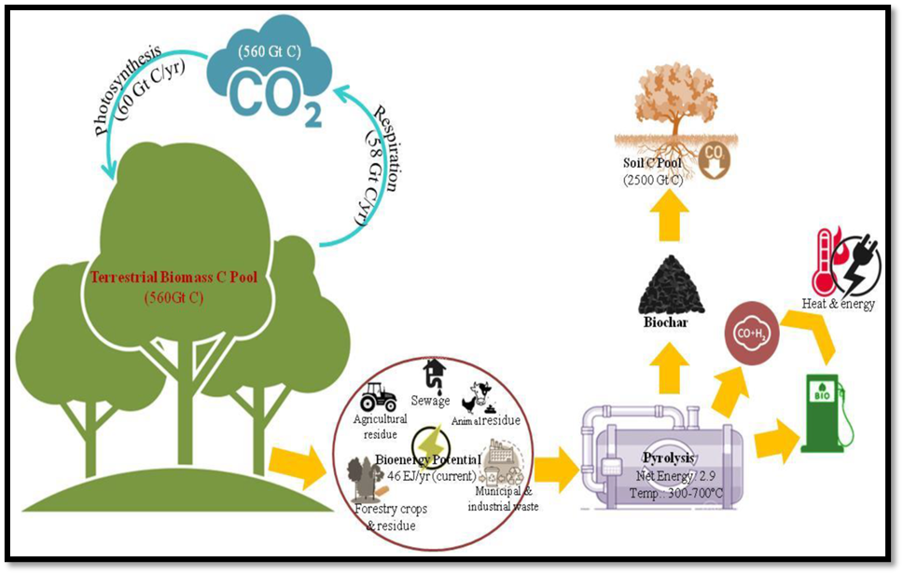

**Fig:**1 Schematic diagram of biochar-induced carbon sequestration (Lehmann,2006)

**BIOCHAR PRODUCTION AND PROPERTIES:**

Biochar is stabilized biomass, which may be mixed into soil with intentional changes in the properties of the soil’s atmosphere to increase crop productivity and to mitigate pollution. The raw material (biomass) used and processing parameters dictate the properties of the biochar. 18 Feedstocks currently used on a commercial scale include tree bark, wood chips, crop residues (nut shells, straw, and rice hulls), grass, and organic wastes including distillers’ grain, bagasse from the sugarcane industry, mill waste, chicken litter, dairy manure, sewage sludge, and paper sludge as reported by National Institute of Soil Science (2022).The biomass used for the production of biochar is mainly composed of cellulose, hemicellulose, and lignin polymers . Among these, cellulose has been found to be the main component of most plant-derived biomasses, but lignin is also important in woody biomass.

**BENEFITS OF BIOCHAR ON SOIL:**

Biochar is known to sequester carbon and improve soil functions. Within a short period, the interaction between biochar, soils, microbes, and plant roots occurs after its incorporation into the soil. The factors influencing the types of interactions are (i) feedstock composition, in particular, the total percentage and specific composition of the mineral fraction; (ii) pyrolysis process conditions; (iii) biochar particle size and delivery system; and (iv) soil properties and local environmental conditions. The aging of biochar starts before addition to soils and once incorporated, the rate is partly governed by the soil moisture and temperature condition [21]. Immediately after the application of biochar amendment, the evolution of biochar-derived carbon can be observed within the first 2 weeks and decreases exponentially with time. Water plays a major role in mineral weathering processes such as hydrolysis, dissolution, carbonation and decarbonation, hydration, and redox reactions (Zhang et al.,2022). The rate of these reactions depends on the type of biochar, nature of reactions, and pedoclimatic conditions. The dissolution and leaching of soluble salts (e.g., K and Na carbonates and oxides) present in the biochar is the first reaction among all the interactions. The dissolution makes the pH increase in the water film around the biochar particles (Wang et al.,2021).

**IMPACT OF BIOCHAR ON SOIL PHYSICAL AND CHEMICAL L PROPERTIES:**

**Physical Properties:**

Improved soil physical, chemical, and biological properties are desirable for optimum plant growth and development. Applications of biochar in soil are known to have a significant impact on various properties of soil . The high porosity of biochar tends to improve a wide range of soil physical properties such as total porosity, soil density, soil moisture content, water holding capacity, and hydraulic conductivity (2017). Improvement in water retention capacity of the soil is mainly attributed to improved soil texture and aggregation posed by higher surface area and porosity of biochar . Biochar applications at higher rates significantly increase the field capacity of the soil .The effects can be more pronounced in non-irrigated regions with an increase in available water for crop growth as well as reducing the occurrence of water stress in between the events of rainfall ( Blanco-Canqui, 2017). Addition of biochar decreases soil bulk density which affects the infiltration rate in soil. Improved bulk density due to increased soil porosity will have a positive impact on soil aeration which is desirable for root and microbial respiration. Higher organic carbon content, as well as surface charge in biochar, is another aspect that plays a crucial role in enhancing soil aggregation and its stability (Wang *et al*.,2023). The stable soil aggregates change the structure of soil and thus improve soil moisture retaining capacity, infiltration, run-off reduction, and erosion.

**Chemical Properties:**

Biochar plays a significant role in improving soil’s chemical properties which includes raising pH, organic carbon, and exchangeable cations [10]. Most studies reported an increase in soil pH upon biochar additions .An increase in cation exchange capacity (CEC) is confirmed by Lehmann et al. 2024, which is an important property to prevent leaching loss of nutrients and thus can increase the fertilizer use efficiency (FUE). The higher CEC of biochar is reported to possibly enhance soil aggregation by aiding in forming certain complexes between organic matter and other minerals with that biochar (Aurangzeib ,2024). However, it is observed that the effective cation exchange capacity is reported to increase with time after being incorporated into the soil . This is so because the surfaces of biochar tend to get oxidized after getting in contact with moisture (water) and air . The advantages of an increase in pH value on biochar application are more pronounced, especially in acidic soils that are associated with heavy metal toxicity or nutrient deficiencies. Depending on the pH-buffering capacity of the soil, biochar is reported with typical high liming equivalence in raising the pH value in acidic soils. The increase in pH due to liming effect of biochar can play a significant role in the availability of essential nutrients in the soil. Important macro (N, P, K, Ca, Mg) and micro-nutrients (Cu, Fe, Mn, Zn,) which are essential for plant growth and development are reported to increase upon application of biochar in soil . Apart from this, biochar due to its high affinity to hold nutrients reduces nutrient loss through leaching which in turn increases fertilizer use efficiency by the plant Several investigations have confirmed that volatilization of NH4− decreases significantly with a high biochar application rate (10% or 20%, w/w) due to high CEC (Lee et al., 2021).

**METHODS OF BIOCHAR PREPARATION**

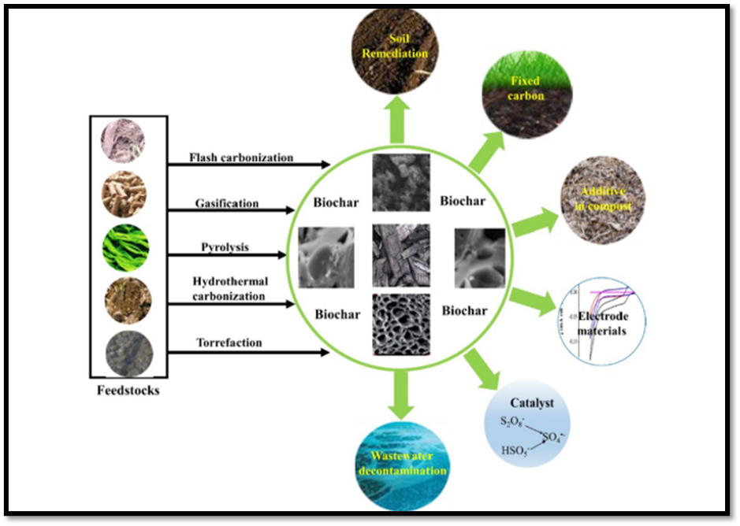

**Fig :2**Biochar derived from different feedstock and its role in remediation (Wang &Wang, 2019)

**1.PYROLYSIS:**

The process of thermal decomposition of organic materials in an oxygen-free environment under the temperature range of 250−900 °C is called pyrolysis. This process is an alternate strategy for converting the waste biomass into value-added products like biochar, syngas and bio-oil. During the process, the lignocellulosic components like cellulose, hemicellulose and lignin undergo reaction processes like depolymerization, fragmentation and cross-linking at specific temperatures resulting in a different state of products like solid, liquid and gas. The solid and liquid products comprise of the char and bio-oil whereas the gaseous products are carbon dioxide, carbon monoxide and hydrogen and also syngas (C1-C2 hydrocarbons). Various types of reactors such as paddle kiln, bubbling fluidized bed, wagon reactors and agitated sand rotating kilns are used for biochar production. The biochar yield during the pyrolysis process depends on the type and nature of biomass used. Mechanism of Pyrolysis can be classified as a fast and slow pyrolysis process depending on the heating rate, temperature, residence time and pressure.

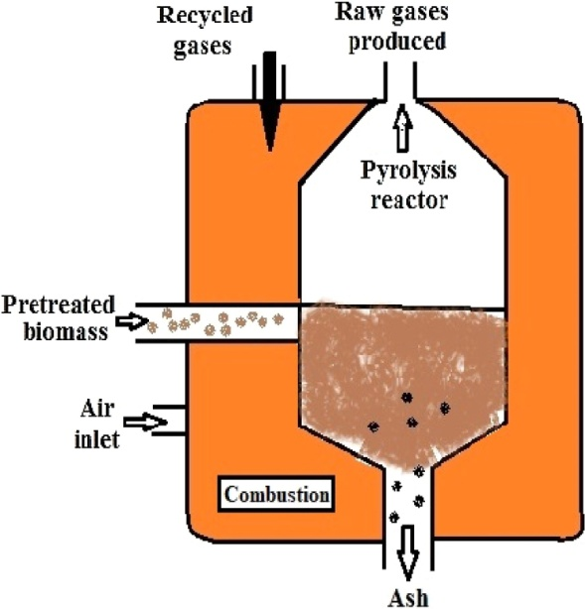

**Fig :3** Mechanism of Pyrolysis (Wang and Wang ,2019)

**Fast pyrolysis:**

Fast pyrolysis is deliberated as a direct thermochemical procedure that can liquefy solid biomass into liquid bio-oil with a high potential for energy application. Fast pyrolysis conditions are described by: (i) fast warming paces of biomass particles (>100 °C/min), (ii) joined with short times of the biomass particles and pyrolysis fumes (0.5–2 s) at high temperatures and (iii) moderate pyrolysis treatment temperatures (400−600 °C).

**Slow pyrolysis:**

In slow pyrolysis, the rate of heating is very less around 5−7 °C/min and possesses a longer residence time of more than 1 h (Fryda and Visser , 2015). The slow pyrolysis innovation has a better yield of char contrasted different pyrolysis and carbonization strategies. The biochar could be utilized as a dirt enhancer to improve soil quality.

The majority of biomass is composed of cellulose, hemicellulose and lignin. These components are converted into biochar using different reaction conditions and mechanisms.

**Cellulose decomposition:**

The mechanism of cellulose decomposition is identified by reducing the degree of polymerization constituting of two reactions: 1) By slow pyrolysis, comprising of cellulose decomposition at longer residence time and less heating rate 2) By fast pyrolysis, occurring at a high heating rate through rapid volatilization resulting in the development of levoglucosan (Wang et al., 2020). In addition to solid product biochar, the levoglucosan also undergoes the dehydration process to produce hydroxymethyl furfural that can decompose either to produce liquid and gaseous products like bio-oil and syngas respectively.

**Hemicellulose decomposition**

The decomposition mechanism of hemicellulose is similar to those of cellulose. The hemicellulose undergoes depolymerization to form oligosaccharides. This can proceed through a series of reactions including decarboxylation, intramolecular rearrangement, depolymerization and aromatization to produce either biochar or the compound decomposes to syngas and bio-oil (Chen et al., 2022).

**Lignin decomposition**

In contrast to the decomposition mechanism of cellulose and hemicellulose, the lignin decomposition mechanism is complex. The β-O-4 lignin linkage breaks resulting in the production of free radicals (Zhang et al., 2022). These free radicals capture the protons from other species resulting in the formation of decomposed compounds. The free radicals move to other molecules conducting chain propagation.

**2.HYDROTHERMAL CARBONIZATION**

Hydrothermal carbonization is considered to be a cost-effective method for biochar production as the process can be performed at a low temperature around 180−250 °C . The product using the hydrothermal process is referred to as the hydrochar to differentiate the product produced from dry processes such as pyrolysis and gasification . During the process, the biomass is blended using water and is placed in a closed reactor. The temperature is slowly increased for maintaining stability (Lucian, 2017). At different temperatures, the products are produced as follows: biochar at a temperature below 250 °C referred to as hydrothermal carbonization , bio-oil between 250−400 °C known as hydrothermal liquefaction and gaseous products syngas such as CO, CO2, H2 and CH4 produced at a temperature above 400 °C referred as hydrothermal gasification , represents hydrothermal carbonization procedure. The hydrolysed product proceeds through series of reactions such as dehydration, fragmentation and isomerization to form intermediate product 5-hydroxymethylfurfural and their derivatives. (Rana &Rana , 2020). Furthermore, the reaction proceeds through condensation, polymerization and intramolecular dehydration to produce the hydrocar . The high molecular weight and complex nature of lignin make the mechanism complicate. The lignin decomposition starts through dealkylation and hydrolysis reaction producing phenolic products like phenols, catechols, syringols, etc . Finally, the char is produced through repolymerization and cross-linking of intermediates (Singh &Kumar , 2021). The lignin components that are not dissolved in liquid phase are transformed into hydrochar similar to pyrolysis reaction.

**3.GASIFICATION**

Gasification is a thermochemical method of decomposition of the carbonaceous material into gaseous products i.e., the syngas comprising CO, CO2, CH4, H2 and traces of hydrocarbons in presence of gasification agents such as oxygen, air, steam, etc and high temperature. It is noted that the reaction temperature is the most significant factor in determining the production of syngas (Singh and cowie.,2020). It was found that as temperature increased carbon monoxide, hydrogen production increased while other contents such as methane, carbon dioxide and hydrocarbons were decreased .

**4.TORREFACTION AND FLASH CARBONIZATION**

Torrefaction is a newly emerging technique for biochar production. It employs a low heating rate thus referred to as mild pyrolysis. The oxygen, moisture and carbon dioxide present in the biomass removed using inert atmospheric air in absence of oxygen at temperature of 300 °C using various decomposition processes (Lin et al., 2023). The torrefaction process modifies the biomass properties such as particle size, moisture content, surface area, heating rate, energy density, etc. The process of torrefaction can be performed (a) Steam torrefaction: The biomass is treated using steam in this process with temperature not more than 260 °C and residence time of around 10 min. (b) Wet torrefaction: It is also called hydrothermal carbonization proceeds with the contact of biomass with water at temperature 180−260 °C and residence time of 5−240 min. (c) Oxidative torrefaction: This process is carried out by treating biomass with oxidizing agents like gases that are utilized for combustion process for generating heat energy. This heat energy is used to produce required temperature.

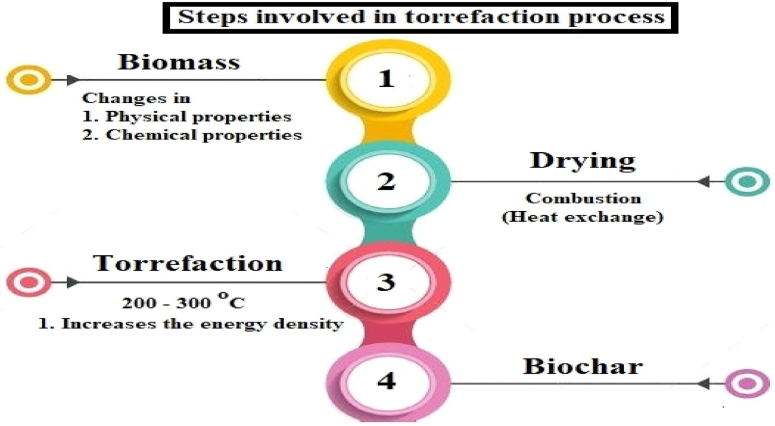

**Fig: 4**Steps invoved in Torrefection process (Lin et al., 2023).

The mechanism of torrefaction process is an incomplete pyrolysis process and the process proceeds as following reaction conditions: temperature – 200−300 °C, residence time – less than 30 min, heating rate – less than 50 °C/min and in absence of oxygen. The process of dry torrefaction process can be classified into various phases such as heating, drying, torrefaction and cooling. Again, drying can be classified as pre-drying and post-drying process (Lin et al., 2023).

**Heating**

During this process, the biomass is heated till the desired drying temperature is maintained and the moisture content of the biomass evaporates.

**Pre-heating**

This process occurs at a temperature of 100 °C until the moisture content present in the biomass evaporates completely.

**Post-drying**

The temperature is increased up to 200 °C and the water content completely evaporates. The mass content is lost due to increased temperature.

**Torrefaction**

This process is the main stage of whole torrefaction process. It takes place at a 200 °C and a stable temperature is obtained during the process.

**Cooling**

After product formation, the temperature is allowed to cool before it gets contact with the air and room temperature is obtained.

The flash fire is ignited on the packed bed of biomass at high pressure and the biomass is converted into solid-phase and gas-phase products. The whole process is carried out at temperature 300−600 °C and reaction time less than 30 min. About 40 % of biomass is converted into solid products and the process decreases with increasing pressure. The process of flash carbonization is very limited to literature and not used commonly (Antal , 2023).

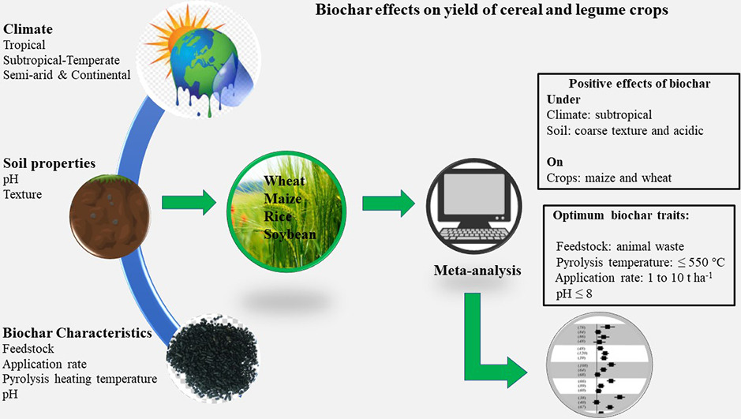

**FIG:5**Diagramatical view how biochar effects on yield of cereal crops (Antal, 2023).

The increase in pH due to liming effect of biochar can play a significant role in the availability of essential nutrients in the soil. Important macro (N, P, K, Ca, Mg) and micro-nutrients (Cu, Fe, Mn, Zn,) which are essential for plant growth and development are reported to increase upon application of biochar in soil (Bulk.,2020). Apart from this, biochar due to its high affinity to hold nutrients reduces nutrient loss through leaching which in turn increases fertilizer use efficiency by the plant. Several investigations have confirmed that volatilization of NH4− decreases significantly with a high biochar application rate (10% or 20%, w/w) due to high CEC however, biochar with high N content may lead to a higher leaching of NO3− . Biochar particles are assumed to act like clay and thus hold large amounts of immobile water even at increased matric potentials. Several other studies also reveal that the addition of biochar significantly increases the nodulations of rhizobia thereby confirming the improvement in nitrogen fixation (Zhang et al., 2023). . As per Biederman and Harpole, the increase in N-fixation following biochar application was reported to be 72%. In terrestrial ecosystems, biochar is also observed to act as a habitat for mycorrhizal fungi. The porous structure of biochar provides a habitat for microbes in soil and protects them from predation. The habitat leads to a ubiquitous symbiotic association between them and favors the soils to carry out various ecosystem services in contributing to sustainable plant production and ecosystem restoration, helps in plant growth and productivity (Biederman ,2013).

Biochar has the capability to stimulate the soil microflora, which results in greater accumulation of carbon in soil. Besides adsorbing organic substances, nutrients, and gases, biochars are likely to offer a habitat for bacteria, actinomycetes and fungi. It has been suggested that faster heating of biomass (fast pyrolysis) will lead to the formation of biochar with fewer microorganisms, smaller pore size, and more liquid and gas components. The enhancement of water retention after biochar application in soil has been well established and this may affect the soil microbial populations. Biochar provides a suitable habitat for a large and diverse group of soil microorganisms, although the interaction of biochar with soil microorganisms is a complex phenomenon (Zhu, 2018). Many studies reported that addition of biochar along with phosphate solubilizing fungal strains promoted growth and yield of Vigna radiata and Glycine max plants, with better performances than control or those observed when the strains and biochar are used separately.

**Table 1 : The effect of biochar amendment on plant growth**

|  |  |  |  |
| --- | --- | --- | --- |
| Biochar source material | Soil/substrate | Effect on plant growth | Crop |
| Citrus wood | Coconut fibre | Increase | Pepper and tomato |
| Gasified rice hulls | Peat | Decrease /Increase | Geranium/hortorum |
| Hardwood | Soil | Increase | Maize |
| Hardwood/Hardwood  pelletes | Peat moss | Little/no effect | Tomato/Mariogold |
| Mixed hard wood | Pink bark | Increase | *Hydrangea paniculata ‘*Silver dollar’ |

**CONCLUSION**

Biochar potentially influences soil health and functions and interacts with many soil properties because of the wide range of effects from biochar addition to soil. The long-term effects of biochar application on soil health and functions includinits fate in different soil types and under diverse management practices still need to be explored. The characterization of biochar produced from a range of feedstocks is also vital. The insecurity of crop production gains at the accurate application rate of biochar and lack of information about additional benefits and few other concerns may have resulted in poor uptake of biochar technology in elsewhere in the world. Therefore, Singh and cowie (2020) suggested exploring new opportunities to value-add to biochar beyond C sequestration by identifying emerging and novel applications of biochar. For example, Major et al. (2020) reported feeding cows with biochar has potential benefit to soil health and farm production.

In conclusion, biochar remediation has emerged as a promising and effective approach in addressing various physiological perturbations in the environment. The unique properties of biochar, such as its high carbon content, porous structure, and surface area, make it an excellent candidate for soil and water remediation. Through its ability to retain water and nutrients, biochar improves soil fertility and promotes plant growth. It enhances soil structure, reducing erosion and increasing soil carbon sequestration. Additionally, biochar acts as a sorbent for pollutants, effectively immobilizing heavy metals, organic contaminants, and excess nutrients, preventing their migration into water bodies or uptake by plants. In physiological terms, biochar plays a crucial role in mitigating the negative impacts of environmental stressors on organisms. It provides a stable habitat for beneficial soil microorganisms, fostering a healthy soil microbiome and promoting nutrient cycling. The presence of biochar in contaminated soil reduces the bioavailability of toxic substances, reducing their potential harm to plants, animals, and humans.

Furthermore, the application of biochar in water bodies aids in water purification. Its porous structure acts as a filter, removing impurities and organic pollutants, thus improving water quality and supporting aquatic ecosystems. Despite its numerous benefits, it is important to note that the efficacy of biochar remediation may vary depending on the specific contaminants, soil type, and environmental conditions. Long-term studies are needed to assess the persistence and stability of biochar in different ecosystems.

In summary, biochar remediation offers a sustainable and eco-friendly solution to address physiological perturbations in soil and water environments. Its ability to enhance soil fertility, sequester carbon, and immobilize contaminants makes it a valuable tool in mitigating environmental degradation and promoting ecological health. Continued research and implementation of biochar remediation strategies hold great promise for a more sustainable and resilient future.

**FUTURE PERSPECTIVE**

Recent discoveries suggest that a proper selection of the feedstock materials and pyrolysis conditions might substantially reduce the emission levels of atmospheric pollutants and particulate matter associated with the biochar production. The implications of pollutants from pyrolysis to human health remain mostly an occupational risk, but a vigorous qualitative and quantitative assessment of such emissions from pyrolysis of biomass feedstock are lacking. While there is potential for reducing GHG emission by biochar addition to soil but careful selection of biochar type and rate of application in a range of soils is essential. In respect to a climate change mitigation perspective, biochar needs to be considered in parallel with other mitigation strategies as it may not be enough as an alternative to reducing GHG emission. State-of-the-art biochar use strategies can help mitigate GHG emission, while farmers get benefits of improved soils and crop production. However, a risk assessment is necessary to protect the food web and human health. At present biochar research is often fragmented and repetitive. Therefore, national collaborative approaches are needed that will focus on (i) biochar production and characterization, (ii) potential for soil fertility improvement and crop production, (iii) economic analysis that includes life cycle assessment and (iv) environmental impact assessment. This approach should be used overcoming diverse soil issues in sustainable agriculture practices and recommendations for further research relating to biochar application to soil.

**REFERNCES**

Antal, M. J., Mochidzuki, K., & Paredes, L. S. (2003). Flash carbonization of biomass. *Industrial & Engineering Chemistry Research*, **42**(16), 3690–3699

Aurangzeib, M., Zhang, S., Yan, S., Zhou, J., Niu, X., Yan, P., & Wang, J. (2024). Biochar application can improve most of the chemical properties of acidic soils: A global meta-analysis. *ACS Agricultural Science & Technology*, **4**(3), 292–306.

Basso, D., Patuzzi, F., Castello, D., Baratieri, M., Rada, E. C., Weiss-Hortala, E., & Fiori, L. (2016). Agro-industrial waste to solid biofuel through hydrothermal carbonization. *Waste Management*, **47**, 114–121.

Biederman, L. A., & Harpole, W. S. (2013). Biochar and its effects on plant productivity and nutrient cycling: a meta-analysis. *GCB Bioenergy*, **5**(2), 202–214

Blanco-Canqui, H. (2017). Biochar and soil physical properties. *Soil Science Society of America Journal*, **81**(4), 687–711.

Chen, D., Cen, K., Zhuang, X., Gan, Z., Zhou, J., Zhang, Y., & Zhang, H. (2022). Insight into biomass pyrolysis mechanism based on cellulose, hemicellulose, and lignin: Evolution of volatiles and kinetics, elucidation of reaction pathways, and characterization of gas, biochar and bio-oil. *Combustion and Flame*, 242, 112142.

Forster, P., Ramaswamy, V., Artaxo, P., Berntsen, T., Betts, R., Fahey, D. W., Haywood, J., Lean, J., Lowe, D. C., Myhre, G., Nganga, J., Prinn, R., Raga, G., Schulz, M., & Van Dorland, R. (2007). Changes in atmospheric constituents and in radiative forcing.

Fryda, L., & Visser, R. (2015). Biochar for soil improvement: Evaluation of biochar from gasification and slow pyrolysis*. Agriculture*, **5**(4), 1076–1115.

Hassan, M. U., Chattha, M. U., Khan, I., Qadeer, A., Nawaz, M., & Khan, M. A. (2023). The critical role of biochar to mitigate the adverse impacts of drought stress on plants. *Frontiers in Plant Science*, **14**, 1163451.

Kumari, P., Mishra, A., & Singh, R. (2023). Effect of biochar on soil health and crop productivity: A review. *Agricultural Reviews*, **44**(3), 367–373.

Kumawat, R., Sharma, S., & Meena, R. S. (2022). Production Technology of Biochar. *Agri Articles*, **2**(2), 116–118

Laird, D. A., Novak, J. M., Collins, H. P., Ippolito, J. A., & Karlen, D. L. (2017). A review of the impact of biochar on soil physical properties. *Soil Science Society of America Journal*, **81**(4), 761–779.

Lee, Y. L., Ahmed, O. H., Wahid, S. A., Jalloh, M. B., &Muzah, A. A. (2021). Nutrient release and ammonia volatilization from biochar-blended fertilizer with and without densification. *Agronomy*, **11**(10), 2082.

Lehmann, J., Gaunt, J., & Rondon, M. (2006). Bio-char sequestration in terrestrial ecosystems – a review. *Mitigation and Adaptation Strategies for Global Change*, **11**(2), 403–427.

Liang, B., Lehmann, J., Solomon, D., Kinyangi, J., Grossman, J., O'Neill, B., Skjemstad, J. O., Thies, J., Luizão, F. J., Petersen, J., & Neves, E. G. (2006). Black carbon increases cation exchange capacity in soils. *Soil Science Society of America Journal*, **70**(5), 1719–1730.

Liu, Z., He, T., Cao, T., Yang, T., Meng, J., & Chen, W. (2017). Effects of biochar application on nitrogen leaching, ammonia volatilization and nitrogen use efficiency in two distinct soils. *Journal of Soil Science and Plant Nutrition*, **17**(2), 515–528.

Lucian, M., & Fiori, L. (2017). Hydrothermal carbonization of waste biomass: Process design, modeling, energy efficiency and cost analysis. *Energies*, **10**(2), 211.

Mukherjee, A., Lal, R., & Zimmerman, A. R. (2014). Biochar effects on soil organic carbon and nitrogen content: a meta-analysis. *Soil Science Society of America Journal*, **78**(4), 1219–1230.

Nazos, A., Politi, D., Giakoumakis, G., &Sidiras, D. (2022). Simulation and Optimization of Lignocellulosic Biomass Wet- and Dry-Torrefaction Process for Energy, Fuels and Materials Production: A Review. *Energies*, **15**(23), 9083 .

Pacala, S., & Socolow, R. (2004). Stabilization wedges: Solving the climate problem for the next 50 years with current technologies. Science, **305**(5686), 968–972.

Pramanik, K., Bandyopadhyay, P. K., Bhaduri, D., & Sarkar, A. (2021). Role of biochar in improving soil fertility, plant growth and mitigating stress: A review. *Journal of Environmental Management*, 290, 112876.

Rana, M. S., & Rana, A. (2020). The formation of 5-hydroxymethylfurfural and hydrochar during the valorization of biomass using a microwave hydrothermal method. *Science of The Total Environment*, 742, 140660

Saha, J. K. (2017). Major Inorganic Pollutants Affecting Soil and Crop Quality. In Soil Pollution - An Emerging Threat to Agriculture (pp. 47–69)

Saha, J. K., Panwar, N. R., & Singh, M. V. (2017). Soil Pollution—An Emerging Threat to Agriculture. In R. S. Meena (Ed.). *Soil Health Restoration and Management*. pp. 217–238.

Saha, J. K., Selladurai, R., Coumar, M. V., Dotaniya, M. L., Kundu, S., & Patra, A. K. (2017). Major Inorganic Pollutants Affecting Soil and Crop Quality. In Soil Pollution - An Emerging Threat to Agriculture .pp. 75–104.

Saleem, M. H., Rehman, M., Zahid, M., Imran, M., Xiang, W., Liu, L., & Kamran, M. (2023). Biochar in the bioremediation of metal-contaminated soils. *Agronomy*, **15**(2), 273.

Shahid, M., Khalid, S., Abbas, G., Batool, A., Nadeem, M., Sabir, M., Aslam, M., &Dumat, C. (2015). Heavy metal stress and crop productivity*. Crop production and global environmental issues*. pp. 1–25

Shrivastava, P., & Kumar, R. (2015). Soil salinity: A serious environmental issue and plant growth promoting bacteria as one of the tools for its alleviation. *Saudi Journal of Biological Sciences*. **22**(2), 123–131.

Singh, B. P., & Cowie, A. (2020). Effects of biochar from slow pyrolysis of papermill waste on agronomic performance and soil fertility. *Plant and Soil*, **327**(1), 235–246

Singh, R. K., Shukla, S. K., Patel, S., Singh, P., & Chang, S. X. (2024). Biochar in global carbon cycle: Towards sustainable development. *Carbon Capture Science & Technology*, 4, 100014.

Singh, R. P., Singh, P., Ibrahim, M., & Awasthi, M. K. (2022). Biochar application for the remediation of trace metals in contaminated soils: Implications for stress tolerance and crop production. *Chemosphere*, **286**(3), 131853.

Singh, R., & Kumar, A. (2021). Mechanism of lignin transformation during hydrothermal carbonization: A review. *Journal of Biomass Conversion and Biorefinery*, **11**(3), 567–578

Wang, H., Zhang, W., Wang, D., Zhang, M., Gao, H., & Zhai, Y. (2024). Assessment of the effects of biochar on the physicochemical properties of saline–alkali soil based on meta-analysis. *Agronomy*, **14**(10), 2431

Wang, X., Zhao, Y., Li, X., & Zhang, W. (2023). Drivers of biochar-mediated improvement of soil water retention capacity based on soil texture: A meta-analysis. Geoderma, 437, 116591.

Wang, Y., Zhang, W., Wang, J., Meng, J., & Li, Y. (2022). Effects of Biochar with Inorganic and Organic Fertilizers on Soil Nutrient Availability, Enzyme Activity, and Crop Yield: A Meta-Analysis. *Frontiers in Plant Science*, 13, 871021

Zhang, X., Wang, L., Zhang, Y., & Zhang, Z. (2023). Interaction of biochar and rhizobia inoculation enhances biological nitrogen fixation and growth of legumes. *Agronomy*, **13**(5), 1234.

Zhang, Y., Cao, X., Zhao, L., Sun, K., & Sorption, C. (2022). Changes in soil properties and CO₂ emissions after biochar addition: Role of pyrolysis temperature and aging. *Science of The Total Environment*, 851, 158121

Zhang, Y., Li, Y., Wang, Q., & Wang, S. (2022). Unraveling the radical chain mechanism in the pyrolysis of β-O-4 lignin model compounds. *Journal of Analytical and Applied Pyrolysis*, 164, 105567.

Zhu, L., & Sheng, Y. (2018). Biochar alters microbial community and carbon sequestration potential across different soil pH.*Science of The Total Environment*, 622, 1391–1399.