*Original Research Article*

**Assessment of YOLOv10n for tomato plant and weed detection using a lightweight deep learning approach in agricultural fields**

ABSTRACT

|  |
| --- |
| This study investigates the performance of the YOLOv10n model, a lightweight and computationally efficient deep learning architecture, for object detection in tomato crop fields. A custom dataset containing field images of tomato plants and diverse weed species was collected and annotated. A total of 2157 annotated instances across two classes; plant and weed, were collected from field conditions. The model achieved a mean Average Precision (mAP@50) of 62.5% and mAP@50–95 of 40.7%, with an inference time of 5.6 milliseconds per image. Class-wise evaluation revealed high detection accuracy for tomato plants, with a precision of 87.3% and recall of 83.5%, indicating the model’s strong potential to identify and preserve crop regions. Weed detection, however, showed relatively lower performance, primarily due to intra-class variability and class imbalance. These findings suggest that YOLOv10n can effectively detect tomato plants in complex backgrounds, providing a reliable basis for future integration into real-time precision agriculture systems. Further enhancement in weed detection may be achieved through data augmentation and improved class-specific representation. |

*Keywords: Deep learning, YOLOv10n, Object detection, Computer vision*

1. INTRODUCTION

Agriculture plays a crucial role in global food production, and ensuring efficient crop management is essential for meeting the increasing demand for food. As global population continue to grow, the demand for food, especially nutritious crops such as tomatoes, increases. However, the challenge of ensuring efficient and sustainable crop production continues to grow, particularly in managing weeds, pests, and diseases, which can have a direct impact on crop yield and quality. Weeds are defined as any plants growing in the wrong place, doing more harm than good, and can significantly reduce crop yields (Kumar et al., 2017) . Weeds are estimated to cause a 30% loss in potential crop production, equating to approximately $90 billion annually in India alone (Sharma et al., 2019). Traditionally, farmers have relied on herbicides and manual labour to control weeds, but these methods are not only resource-intensive but also harmful to the environment and human health. As the need for sustainable and environmentally friendly farming practices increases, it is critical to develop more precise and targeted approaches to weed management. Traditional methods of weed management have been foundational in agriculture, encompassing a range of strategies that include mechanical, chemical, biological, and cultural practices. Mechanical control involves physical removal of weeds through tillage or hand-pulling. While effective, it can lead to soil erosion and is labour-intensive (Gao & Su, 2024). Chemical control utilizes herbicides to suppress weed growth. However, over-reliance has led to herbicide-resistant weed species and environmental pollution (Xuan et al., 2025). Employs natural predators or pathogens to manage weeds. This method can be costly and may pose risks to non-target species (Gao & Su, 2024). Cultural practices includes crop rotation and cover cropping to enhance crop competitiveness against weeds. These practices can improve soil health but require careful management to be effective (Kaur et al., 2024). While these methods have been effective in controlling weed populations, modern challenges such as herbicide resistance and environmental concerns necessitate a re-evaluation of their effectiveness and integration with innovative approaches. Traditionally, farmers have relied on herbicides and manual labour to control weeds, but these methods are not only resource-intensive but also harmful to the environment and human health. As the need for sustainable and environmentally friendly farming practices increases, it is critical to develop more precise and targeted approaches to weed management. In recent years, precision agriculture has emerged as a promising solution to address these challenges. By utilizing advanced technologies such as remote sensing, GPS, and real-time data analysis, precision agriculture enables farmers to make more informed decisions and apply inputs only where needed. Precision agriculture technologies, such as remote sensing and UAVs, enable accurate weed density estimation and real-time monitoring, allowing for timely and effective weed management interventions (Hussain et al., 2023) (Aparna et al., 2024). By reducing weed competition through precise control measures, crops can access more nutrients, water, and sunlight, leading to improved growth and higher yields (Dwivedi et al., 2022). One of the key aspects of precision agriculture is the ability to accurately detect and classify different plants and weeds in the field, a task that has traditionally been a complex and time-consuming process. Recent advances in computer vision and deep learning have revolutionized the field of plant detection, offering new opportunities for automating weed detection and crop management. With the advent of deep learning and computer vision, the ability to detect and classify weeds and crops from images has significantly improved. Among various deep learning models, the YOLO (You Only Look Once) family of models has gained widespread attention due to its efficiency and speed in real-time object detection tasks. These models have shown promising results in agricultural applications, including weed detection and crop classification. While YOLOv10n offers the promise of more efficient detection due to its reduced model size and faster inference time, its application to weed and crop detection in agricultural settings, particularly in real-world field conditions, remains underexplored. Agricultural fields, especially those with diverse vegetation and varying lighting conditions, pose significant challenges to image-based plant detection systems. YOLOv10n-FCDS improved mAP50 by 2.6%, enhancing detection of small (2.5%), obscured (2.8%), and similar weeds (3.0%) (Li et al., 2024) . YOLOv10n's architecture allows for efficient processing, making it suitable for real-time applications in smart spraying systems (Oğuz Saltık et al., 2024). YOLOv10n outperforms its predecessors like YOLOv9 in terms of accuracy and speed, making it a preferred choice for UAV applications in agriculture (Oğuz Saltık et al., 2024).

The main objective of this study is to evaluate the performance of YOLOv10n for detecting weeds and tomato plants in agricultural fields using annotated image data. The focus is on assessing detection accuracy, inference speed, and model efficiency across two key classes: weeds and tomato plants, which frequently coexist in crop fields and require accurate distinction for effective weed management. Additionally, the study examines the model's suitability for potential deployment on edge devices by analyzing its lightweight architecture and inference performance. The results aim to offer insights into the applicability of YOLOv10n for precision agriculture and automated weed control.

2. material and methods

* 1. **Data Collection**

The dataset used in this study was collected from the Vegetable Research Centre at Govind Ballabh Pant University of Agriculture and Technology, Pantnagar, Uttarakhand, India. Images of tomato plants along with weeds were captured using a POCO M4 Pro smartphone camera positioned 90-100 cm above ground level to ensure consistency in scale and clarity. Data acquisition was conducted during daylight hours under natural illumination to replicate real-world conditions. Photographs were taken over multiple days to account for variations in lighting, background, and plant–weed interaction. Different crop growth stages were documented, from early vegetative to early fruiting, to ensure variability in plant morphology and weed emergence. Only high-quality images were retained, while those affected by poor focus or lighting were excluded.

* 1. **Image Annotation and Data Preprocessing**

The images used in this study were annotated using Roboflow, an online tool designed for organizing and labeling image datasets. The dataset was divided into three parts: training, validation and testing. Each image was labeled to identify two categories, plant and weed—by manually marking the areas of interest. To improve the diversity and quality of the training data, dataaugmentation techniques such as rotation, flipping, and brightness adjustment were applied. This helped the model to better understand different scenarios and made the learning process more effective. All images were resized to a consistent dimension of 640 × 640 pixels to maintain uniformity. The final dataset was exported in a format compatible with the deep learning model used in this study.

* 1. **Model Architecture and Training**

YOLOv10n, a lightweight variant of the YOLOv10 architecture, consists of 285 layers and 2,695,196 parameters, optimizing it for real-time detection tasks. The model achieves 8.2 Gflops (Giga Floating Point Operations per second), indicating its computational efficiency in terms of processing speed. YOLOv10's architecture incorporates a dual label assignment strategy and a Path Aggregation Network, which significantly improves both object localization and classification precision. The detailed architecture of YOLOv10n is illustrated in Figure 1.

For training, the model was executed on Google Colab, utilizing high-performance NVIDIA GPUs to provide optimal computational resources. The training process spanned 100 epochs, where each epoch represented a full iteration over the dataset, allowing the model to progressively refine its predictions. A batch size of 16 was selected to balance memory usage and training stability. To ensure uniformity across models, the input image size was standardized to 640 pixels. Pretrained weights for YOLOv10n were employed to initialize the model, providing a strong starting point for fine-tuning it specifically for weed and tomato plant detection tasks. This initialization approach facilitated faster convergence during training and contributed to improved performance on the specific task. The training was performed using the YOLOv10n model with the following configuration parameters, as detailed in Table 1.

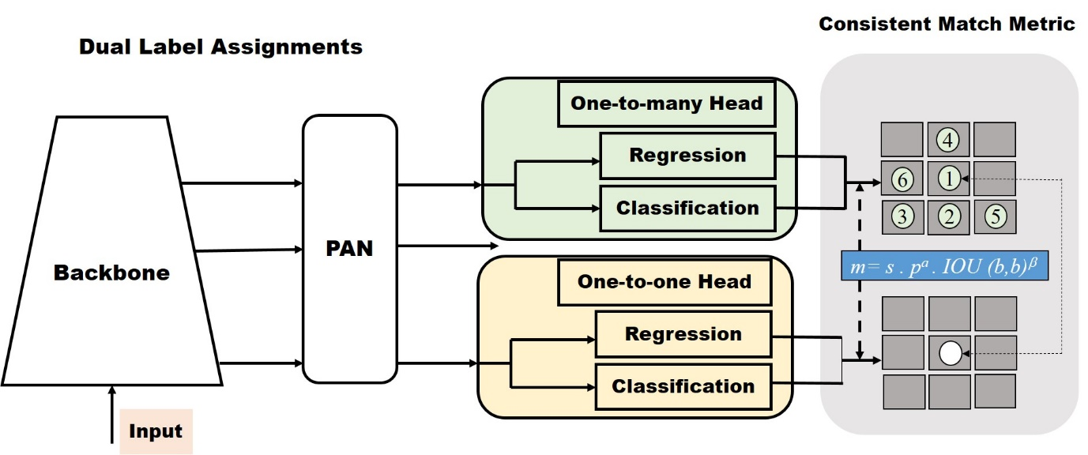

**Fig. 1. Architecture of YOLOv10**

**Table 1. YOLOv10n model training configuration and architecture details**

|  |  |
| --- | --- |
| Epochs | 100 |
| Image size | 640 |
| Optimizer | AdamW |
| layers | 285 |
| parameters | 2,695,196 |
| Gflops | 8.2 |

* 1. **Evaluation Metrics**

**Precision** is defined as the ratio of true positive detections to the total predicted positives, indicating how accurately the model identifies only the relevant objects. A high precision score means fewer false positives, which is essential in applications where incorrect detections can be costly, such as autonomous driving and surveillance (Pateriya et al., 2023). **Recall**, on the other hand, measures the ratio of true positives to all actual positives in the dataset, with high recall indicating the model successfully captures most of the relevant objects and minimizes false negatives — crucial in comprehensive detection scenarios (Panda et al., 2022). **Average Precision (AP)** summarizes the precision-recall curve as the area under the curve (AUC), providing a balanced measure of both precision and recall across different confidence thresholds (Kuznetsova, 2020). The **mean Average Precision (mAP)** extends this evaluation by averaging the AP over all classes or queries. Specifically, **mAP@0.5** (also written as mAP50) evaluates performance at a fixed Intersection over Union (IoU) threshold of 0.5, while mAP50–95 computes the average precision across multiple IoU thresholds from 0.5 to 0.95 in 0.05 increments, providing a more comprehensive and robust assessment of the model’s detection capability (Thom et al., 2007).

3. results and discussion

The results and discussion section presents a comprehensive evaluation of the YOLOv10n model applied for tomato plant and weed detection in agricultural field conditions. The performance of the model was assessed using standard object detection metrics, including precision, recall, mean Average Precision at IoU thresholds (mAP50 and mAP50–95), and inference time. These metrics provide insights into the model’s accuracy, reliability, and real-time applicability. The evaluation was conducted on a test dataset containing diverse field images with varying lighting conditions and plant growth stages to ensure robustness. The analysis is organized into overall performance metrics, class-wise detection effectiveness, and inference efficiency, followed by loss metric evaluation and confusion matrix interpretation to further understand model behaviour.

* 1. **Performance Evaluation of YOLOv10n Model**

This section outlines the performance of the YOLOv10n model in detecting tomato plants and weeds under field conditions. Key evaluation metrics such as precision, recall, mAP scores, and inference time are discussed (Table 2) to highlight the model’s effectiveness and suitability for real-time agricultural applications.

### **3.1.1 Overall performance of YOLOv10n model**

The YOLOv10n model was evaluated on a test set comprising **326 images** containing a total of **2,157 instances**. As a lightweight model optimized for real-time applications, YOLOv10n demonstrated **solid performance in object detection tasks** with an overall **bounding box precision of 0.639**, **recall of 0.612**, **mAP@0.50 of 0.625**. The more stringent metric, **mAP@0.50-0.95**, stood at **0.407**, reflecting the model’s moderate ability to precisely localize and classify objects at multiple intersection-over-union (IoU) thresholds. Despite being computationally efficient with an inference time of just **5.6 milliseconds**, the model maintained a balance between **accuracy and speed**, making it well-suited for **real-time agricultural applications** such as weed detection and precision spraying. This demonstrates that even with limited computational complexity, YOLOv10n is capable of delivering **practical field-ready results.**

### **Class-wise detection performance**

#### **3.1.2.1 Tomato plant detection**

When evaluated specifically on **tomato plant instances (690 in total)**, the YOLOv10n model performed exceptionally well. It achieved a **box precision of 0.873**, **recall of 0.835**, and a **mAP@0.50 of 0.873**, indicating a **high level of accuracy and consistency** in detecting plant regions. Additionally, the **mAP@0.50-0.95 value of 0.663** further confirms that the model maintained its performance across varying IoU thresholds. These results highlight the model's **strong generalization** for detecting well-structured and distinguishable objects like tomato plants, which tend to have **consistent features** such as shape, size, and colour. The effectiveness of YOLOv10n in this category underscores its suitability for tasks such as **crop monitoring, growth tracking, and yield estimation.**

#### **3.1.2.2 Weed detection**

In contrast, performance on **weed instances (1,467 in total)** was notably lower. The model achieved a **box precision of 0.448,** a **recall of 0.389,** and a relatively lower **mAP@0.50 of 0.378**. The **mAP@0.50-0.95 dropped further to 0.151**, reflecting the challenge of detecting weeds accurately in natural field environments. The reduced accuracy in weed detection can be attributed to the **diverse morphological traits** and **less defined boundaries** of weeds compared to cultivated tomato plants. Weeds often appear in **cluttered backgrounds**, overlap with crops, or show significant **intra-class variation**, making them harder to annotate and detect precisely. These results indicate the **need for either more training data**, enhanced data augmentation strategies, or **advanced post-processing techniques** to boost weed identification performance.

### **3.1.3 Real-time inference efficiency**

The inference time per image was recorded at **5.6 milliseconds**, confirming the efficiency of YOLOv10n for near real-time object detection. This fast processing capability underscores its potential for deployment in embedded systems where timely decision-making is crucial, such as in automated spraying or monitoring systems.

**Table 2. Performance metrics of YOLOv10n model on tomato plant and weed detection**

|  |  |  |  |  |  |  |  |  |
| --- | --- | --- | --- | --- | --- | --- | --- | --- |
| Model | Class | Images | Instances | Box P | Recall | mAP50 | mAP50-95 | Inference Time (ms) |
| YOLOv10n | All | 326 | 2157 | 0.639 | 0.612 | 0.625 | 0.407 | 5.6ms |
| Plant | 326 | 690 | 0.831 | 0.835 | 0.873 | 0.663 | 5.6ms |
| Weed | 326 | 1467 | 0.448 | 0.389 | 0.378 | 0.151 | 5.6ms |

* 1. **Evaluation of Loss Metrics**

The training of the YOLOv10n model was evaluated over 100 epochs using key loss metrics and performance indicators. The bounding box regression loss (train/box_om and train/box_oo), which reflects the model's ability to localize objects accurately, showed a steady decline. The values reduced from approximately 1.9 to below 1.4, indicating improved precision in bounding box predictions as training progressed.

The classification loss (train/cls_om and train/cls_oo), responsible for distinguishing between the two classes (plant and weed), also declined significantly. In particular, the object-only classification loss (cls_oo) dropped from around 3.5 to approximately 1.5, while cls_om followed a similar but slightly less steep trajectory demonstrating the model’s growing confidence and accuracy in classifying detected objects.

The Distribution Focal Loss (DFL) (train/dfl_om and train/dfl_oo), which enhances bounding box quality by modeling the distribution of box locations, showed a consistent decline from 1.8 to 1.4 in both training modes. This trend reflects the model's increasing capability to predict accurate and confident bounding boxes. Evaluation metrics plotted in the bottom row further affirm the model’s performance gains. The recall improved from around 0.3 to over 0.6, indicating an enhanced ability to detect relevant instances, particularly for the plant class. Precision steadily rose and stabilized around 0.67, demonstrating a reduction in false positives. The mAP@50 increased from ~0.3 to ~0.63, while the more stringent mAP@50–95 rose from ~0.15 to ~0.41, both indicating substantial improvements in overall object detection accuracy. Collectively, the loss curves and performance metrics highlight that the YOLOv10n model achieved effective learning, stable convergence, and improved generalization making it suitable for real-world agricultural applications such as plant and weed discrimination in tomato crop fields.

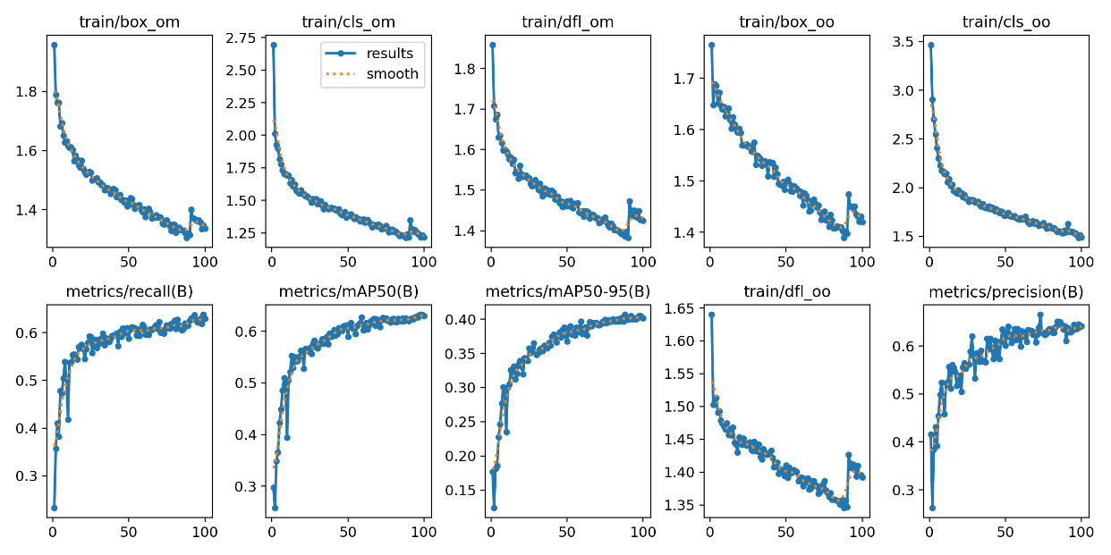

**Fig. 2. YOLOv10n training curves showing reduced loss and improved detection accuracy over epochs.**

* 1. **Confusion Matrix Analysis**

The confusion matrix in Figure 3 illustrates the performance of the YOLOv10n model in classifying plant, weed, and background instances. The matrix shows the true positives, false positives, and false negatives for each class, providing an in-depth view of the model's accuracy in distinguishing between the different categories. The normalized confusion matrix reveals the proportion of correct and incorrect classifications for each class, offering insights into areas of potential improvement. The YOLOv10n model demonstrates strong performance in identifying plant instances, with high accuracy in classifying them correctly, but shows challenges in distinguishing between weeds and background, as evidenced by the misclassification of background instances as weeds.

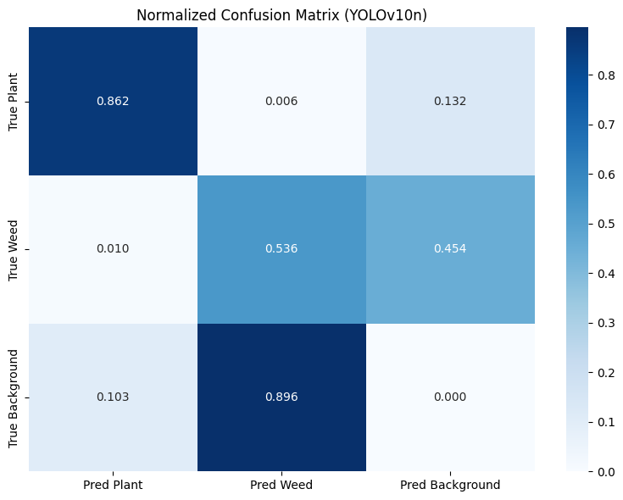

**Fig. 3.Normalized confusion matrix of YOLOv10n model showing class-wise prediction accuracy for tomato plant and weed detection**

4. Conclusion

This research evaluates the performance of the YOLOv10n model for automated detection of tomato plants and weeds under field conditions. The model was trained on a diverse dataset and assessed using standard performance metrics, including class-wise precision, recall, and mean Average Precision (mAP). The results show that the model achieves a class-agnostic mAP@50 of 62.5% and a mAP@50–95 of 40.7%, with an average inference time of 5.6 ms, indicating its suitability for real-time deployment. Class-wise analysis reveals that the model accurately detects tomato plants with a recall of 83.5%, and mAP@50 of 87.3%, suggesting high reliability in avoiding damage to crops during automated spraying. On the other hand, weed detection performance was relatively lower, largely due to visual diversity and class imbalance within the weed category. Despite the lower weed detection accuracy, the consistent detection of tomato plants ensures the model's effectiveness for precision herbicide application, where avoiding crop damage is critical. This also makes the model viable for integration into real-time agricultural robotics and decision-support systems. Future work may focus on increasing weed detection accuracy through improved annotation strategies, inclusion of more diverse weed images, and model enhancement techniques like attention modules. Overall, the YOLOv10n model demonstrates a promising balance between speed, accuracy, and computational efficiency, aligning with the practical needs of precision agriculture and sustainable weed management.

Competing interests

Authors have declared that no competing interests exist.

**COMPETING INTERESTS DISCLAIMER:**

Authors have declared that they have no known competing financial interests OR non-financial interests OR personal relationships that could have appeared to influence the work reported in this paper.

References

Aparna, M., Baskaran, R., [Harisudan, C.,](https://ui.adsabs.harvard.edu/search/q=author:%22Harisudan%2C+C.%22&sort=date%20desc,%20bibcode%20desc) [Kalpana, R.,](https://ui.adsabs.harvard.edu/search/q=author:%22Kalpana%2C+R.%22&sort=date%20desc,%20bibcode%20desc) [Boominanthan, P.](https://ui.adsabs.harvard.edu/search/q=author:%22Boominanthan%2C+P.%22&sort=date%20desc,%20bibcode%20desc)& [Jaghadeeswaran, R.](https://ui.adsabs.harvard.edu/search/q=author:%22Jaghadeeswaran%2C+R.%22&sort=date%20desc,%20bibcode%20desc)(2024). Advances and trends in weed management: A comprehensive review. *Ui.Adsabs.Harvard.Edu*. Retrieved April 13, 2025, from <https://ui.adsabs.harvard.edu/abs/2024PlScT..11.5141A/abstract>

Dwivedi, N., Suryavanshi, P., Kumar, D., Dwivedi, N., Kumar, D., & Suryavanshi, P. (2022). Precision farming techniques for sustainable weed management. *Emergentresearch.OrgN Dwivedi, D Kumar, P SuryavanshiEmergent Life Sciences Research, 2022•emergentresearch.Org*, *8*(2), 142–149. <https://doi.org/10.31783/elsr.2022.82142149>

Gao, W. T., & Su, W. H. (2024). Weed Management Methods for Herbaceous Field Crops: A Review. *Agronomy 2024, Vol. 14, Page 486*, *14*(3), 486. <https://doi.org/10.3390/AGRONOMY14030486>

Hussain, A. A., & Nair, P. S. (2023, December). Enhancing Crop Yield through Weed Density Estimation and Management: A Comprehensive Review. In *2023 IEEE International Conference on ICT in Business Industry & Government (ICTBIG)* (pp. 1-10). IEEE.

Kaur, A., Singh, G., Menon, S., & Kumari, K. (2024). Integrated weed management: A comprehensive review of conventional, non-conventional, and emerging strategies for sustainable agriculture. *Journal of Advances in Biology & Biotechnology*, *27*(8), 156-67.

Kumar, S., Kumar, A., & Kumar, S. (2017). Performance evaluation of developed manually operated rotary weeder for vegetable crops. *International Journal of Current Microbiology and Applied Sciences*, *6*(11), 4012-4019.

Kuznetsova, A. A. (2020). Statistical Precision – Recall curves for object detection quality assessment. *Journal Of Applied Informatics*, *15*(90), 42–57. <https://doi.org/10.37791/2687-0649-2020-15-6-42-57>

Li, Y., Guo, Z., Sun, Y., Chen, X., & Cao, Y. (2024). Weed Detection Algorithms in Rice Fields Based on Improved YOLOv10n. *Agriculture*, *14*(11), 2066–2066. <https://doi.org/10.3390/AGRICULTURE14112066>

Oğuz Saltık, A., Allmendinger, A., & Stein, A. (2024). Comparative Analysis of YOLOv9, YOLOv10 and RT-DETR for Real-Time Weed Detection. *ArXiv*, arXiv:2412.13490. <https://doi.org/10.48550/ARXIV.2412.13490>

Panda, M., Mishra, D. P., Patro, S. M., & Salkuti, S. R. (2022). Prediction of diabetes disease using machine learning algorithms. *IAES International Journal of Artificial Intelligence*, *11*(1), 284–290. <https://doi.org/10.11591/IJAI.V11.I1.PP284-290>

Pateriya, N., Hasan, Z., Mehra, J., & Sahu, A. (2023). Innovative Techniques for Object Detection and Recognition: A Study on Accuracy and Efficiency Improvements. *International Journal of Innovative Research in Computer and Communication Engineering*, *12*(02), 1094–1098. <https://doi.org/10.15680/IJIRCCE.2024.1202063>

Sharma, V., & Pant, S. (2019). Weed as underutilized bio-resource and management tool: A comprehensive review. *Waste and biomass valorization*, *10*, 1795-1810.

Thom, J. A., & Scholer, F. (2007, December). A comparison of evaluation measures given how users perform on search tasks. In *ADCS 2007–in Proceedings of the Twelfth Australasian. Doctoral. Computing. Symposium* (pp. 100-103).

Xuan, T. D., Khanh, T. D., & Minh, T. T. N. (2025). Implementation of Conventional and Smart Weed Management Strategies in Sustainable Agricultural Production. *Weed Biology and Management*, *25*(1), e70000.