Modulating Antioxidant Capacity and Preserving Chlorophyll Levels in Pointed Gourd (Trichosanthes dioica Roxb.) Fruit through Synergistic Application of 6-Benzyl Amino Purine and Sodium Alginate Coating during Ambient Storage

Abstract
Under ambient conditions, maintaining the shelf life of pointed gourd fruits beyond 2-3 days after harvest becomes a challenge. In this study, we investigate the potential synergistic application of 6-benzyl amino purine and sodium alginate coating in extending the shelf life of pointed gourd fruit.
Experimental approach. Fruits were treated with 2 mM and 3 mM 6-benzyl amino purine solutions, alone or with a 2% sodium alginate coating. The control fruits were treated with distilled water. The experiment was conducted over a continuous 6 days storage period at ambient condition, and parameters including weight loss, chlorophyll and carotenoid levels, lipid peroxidation, antioxidant content, phenol, flavonoids and radical scavenging activity were monitored at arbitrary intervals of 2 days.
Results and conclusions. Results showed that applying 3.0 mM 6-benzyl amino purine and sodium alginate coating effectively reduced weight loss, preserved chlorophyll and carotenoid levels, and inhibited lipid peroxidation. During storage, the treatment maintained high levels of antioxidants, phenols, flavonoids, and radical scavenging activity.
Novelty and scientific contribution. The integrated approach of 6-benzyl amino purine (BAP) treatment and alginate coating holds promise for extending the shelf life and maintaining the quality of pointed gourd fruits.

Keywords: sodium alginate; pointed gourd; antioxidant capacity; chlorophyll content; 6-benzyl amino purine; shelf life

INTRODUCTION
Pointed gourd (Trichosanthes Dioica Roxb.) is a cucurbitaceous vegetable commonly grown in India during the summer and monsoon seasons. It is grown abundantly in India, Bangladesh, Nepal, Myanmar, Sri Lanka, and China. Its dioecism, perenniality, and vegetative propagation make it notable in Bihar, Uttar Pradesh, Odisha, Assam, and West Bengal. Its non-climacteric nature is reflected in the low ethylene production during storage. Rich in nutrients, fibre, calories, and phytochemicals, it contains notable vitamins such as vitamin A (255 IU), vitamin C (29 mg), riboflavin (0.06 mg), and thiamine (0.05 mg), along with minerals like Mg (9.0), K (83.0 mg), and S (17.0 mg) per 100 g of fresh weight. Furthermore, the pointed gourd is abundant in phytochemicals, including phenols, flavonoids, glycosides, sterols, saponins, and alkaloids. The pointed gourd holds a place in traditional Ayurvedic medicine for its uses in addressing gastrointestinal issues, anthelmintic activity, cholesterol reduction, diuretic effects, and expectorant properties (1). In West Bengal and Odisha, tribal communities have used it for skin conditions, liver and spleen swelling, and even chickenpox scars (2), contributing to its domestic and international popularity. However, the challenge lies in extending the shelf life of pointed gourd fruits beyond 2-3 days after harvest under normal conditions. Rapid moisture loss, desiccation, loss of cellular rigidity, skin discolouration, and seed induration have been identified as factors leading to decreased marketability (3). These issues prompt cultivators to turn to synthetic pigments, which come with health risks, to maintain the fruit's visual appeal and colour.
The first synthetic cytokinin, 6-benzylaminopurine (BAP), preserves fruit and vegetable quality. BAP treatment lowers respiration, softening, moisture loss, decay loss, and senescence, extending fruit shelf life (4). It keeps plants green by inhibiting chlorophyll breakdown and preserving chloroplast activity (5,6). Ascorbic acid (AA), phenolics, antioxidants, and sensory quality features also maintain better with BAP treatment (7,8). Alginate is a desirable film-forming chemical due to its biocompatibility, biodegradability, non-toxicity, and low cost (9). D-mannuronic and L-guluronic acid monomers comprise a linear copolymer (10). When applied to a surface, sodium alginate, in contrast to other alginates, creates films with features that are moisture and oxygen barriers (11). Alginate coating preserves product quality by preventing moisture loss, shrivelling, respiration, and turgidity (12). According to reference (13), sodium alginate thickens, stabilises, suspends, forms films, and stabilises emulsions and gels. Sodium alginate coating prevents weight loss, delays fruit and vegetable ripening, and maintains firm, sweet, and acidic produce (14). According to reference (15), an alginate layer prevents pigment loss and maintains fruit colour. It maintains fruit antioxidant activity and total phenol concentration (16). Given the limited knowledge of postharvest strategies to prolong the shelf life and improve the quality of pointed gourd, this research assessed the impact of an alginate coating enriched with 6-benzyl amino purine. The goal was to enhance the storage duration and extend the market presence of fresh pointed gourd.

MATERIALS AND METHODS

Fruit Material
The investigation employed the cultivar "Navdhari" of Trichosanthes dioica Roxb. The fruits were procured at optimal commercial maturity in the early morning and expeditiously conveyed to the esteemed Department of Horticulture laboratory at Banaras Hindu University in Varanasi, India. Within the confines of this empirical investigation, a meticulous and systematic procedure was executed to classify and rank a representative subset of 400 fruits. The process was carried out sequentially based on the following criteria: colour, shape, uniform size, number of strips, and maturity stage. The fruits that satisfied the predetermined criteria were classified as nutritionally beneficial and incorporated into the research investigation. The fruits exhibiting optimal physiological conditions were subsequently subjected to a random allocation process, dividing them into four distinct and separate experimental cohorts.

Preparation of coating solution
A 2% (w/v) sodium alginate solution was created by dissolving sodium alginate powder (acquired from Sigma-Aldrich Co., Steinhein, Germany) in distilled water under continuous agitation at 70°C for 2 hours. Cooling followed the methodology outlined by reference (17), reducing the solution's temperature to 25°C. After formulation, samples underwent 30 minutes of ambient air-drying, adhering rigorously to the prescribed research protocol. The fruit specimens were subjected to coating, either with a solution containing sodium alginate or a mixture of sodium alginate and 6-benzyl amino purine. The latter was applied at concentrations of 2 mM and 3 mM. Control fruits received distilled water treatment. The uniformity of the intervention duration was maintained across all samples. External moisture was removed through desiccation. The desiccated fruits were placed within corrugated fibreboard containers, exposed to ambient conditions of 29° ± 2°C temperature and 82% relative humidity. At arbitrary intervals of 2 days, representative fruits from each treatment group were procured for qualitative assessment. The experimental procedures were conducted over a continuous 6-day period.

Fresh Weight Loss
A digital precision weighing balance was used to measure the pointed gourd's fresh weight loss during storage. The initial and final weights of the specimens were recorded on the same day, allowing the calculation of the percentage reduction in fresh weight.

Total Chlorophyll and Total Carotenoid Content
Chlorophyll content in the peel was assessed spectrophotometrically at 645 nm and 663 nm wavelengths. Reference (18) technique of 80% v/v acetone extraction yielded milligrams per gram of fresh weight. Total carotenoids in the peel were measured using a Labtronics LT2201 UV-Vis Double Beam Spectrophotometer at 480 nm wavelength and quantified in milligrams per gram of fresh weight using the procedure (19).

Membrane lipid peroxidation Content
Membrane lipid peroxidation was measured via spectrophotometry. Malondialdehyde concentration (nmol/g FW) was assessed using trichloroacetic acid (5% w/v) and thiobarbituric acid (0.6% w/v) solution. Readings were taken at 450 nm, 532 nm, and 600 nm wavelengths, following the reference (20).

Ascorbic Acid Content
The ascorbic acid in the fruit was quantified using the methodology outlined (21). The obtained outcomes are shown in milligrams per one hundred grams of fresh weight (mg/100 g FW). The analysis included using a solution containing 3% metaphosphoric acid and the dye known as 2,6-dichlorophenol indophenol. The titration procedure was carried out until the pink hue exhibited stability for a duration of 15 seconds.

Total phenol content
The reference method (22) assessed total phenols in pointed gourd fruit. A mixture of 80% ethanol, 1 N Folin-Ciocalteau reagent, and 20% sodium carbonate treated the fruit sample. The spectrophotometer reading for absorbance was taken at 760 nm. Gallic acid formed the reference for a standard curve, expressed as µg GAE/g FW.

Total Flavonoids Content
Aluminium chloride was used to determine flavonoid concentration (23). Spectrophotometry was used to determine the absorbance at 510 nm. The procedure involved 10% aluminium chloride, 1 N sodium hydroxide, and 5% sodium nitrite solutions. Rutin served as the reference compound for a standard curve, expressed as µg RE/g FW.

Total antioxidant capacity
The CUPRAC assessment (24) measured total antioxidant capacity. The sample extract was combined with a pH 7.0 ammonium acetate buffer, 10-2 M copper (II) chloride solution, 7.5 x 10-3 M neocuproine solution, and 80% ethanol. Analysis was done by measuring absorbance at 450 nm. The data was reported in units of mol TE/g FW.

Radical scavenging activity (DPPH assay)
The DPPH method assessed radical scavenging (25). The sample extract interacted with DPPH (0.0634 mM) within methanol (95%). A spectrophotometer measured 515 nm absorbance and gave findings as percentages.

Statistical Analyses
A randomised design (CRD) with four replications was used. Mean and standard error represented results for various parameters, organised in tables and figures. SAS statistical system 14.3 (26) analysed the study.

RESULTS AND DISCUSSION
Fresh Weight Loss
Results indicate an increased physiological loss in weight (PLW%) as storage time grew, particularly evident in samples treated with alginate coating combined with a 6-benzyl amino purine. Both coated and uncoated samples exhibited significant weight loss (Table 1), with control fruits losing more weight than coated ones. Notably, fruits treated with 3.0 mM 6-BAP and 2% sodium alginate solution displayed the best outcomes, comparable to those treated with 2.0 mM 6-BAP and 2% sodium alginate within four days. Even after six days, 3.0 mM 6-BAP with 2% sodium alginate-coated fruits had the lowest weight loss, while uncoated fruits had the highest. The 6-BAP and sodium alginate combo curtailed weight loss, attributed to reduced respiration, ethylene production, and moisture exchange (8, 27). 6-BAP's impact on weight loss mitigation is well-documented across crops (7, 28, 29). Sodium alginate's barrier properties also reduced weight loss (17, 30). Various products have had such effects (31, 32).
Table 1: Impact of diverse concentrations of 6-benzyl amino purine in conjunction with alginate coating on the reduction in weight of pointed gourd fruit during ambient storage conditions (29 ± 1°C).
Storage at ambient room condition (29 ± 1°C)
Parameters | Treatment | 2 DAS | 4 DAS | 6 DAS
 | Control | 14.10 ± 0.18 a | 19.69 ± 0.28 a | 29.86 ± 0.75 a
Weight loss (%) | BA (2.0 mM) + Na alginate 2% | 5.96 ± 0.21 c | 9.01 ± 0.28 c | 16.31 ± 0.45 c
 | BA (3.0 mM) + Na alginate 2% | 7.55 ± 0.24 c | 8.35 ± 0.23 c | 14.28 ± 0.45 d
 | Na alginate 2% | 7.61 ± 0.55 b | 10.73 ± 0.22 b | 19.16 ± 0.59 b
Values represent the mean ± standard error of four determinations (n=4). Treatments sharing the same letters indicate no significant differences (p < 0.05).

Total Chlorophyll Content
Pointed gourd's marketability hinges on its green colour, with yellow-toned fruits often rejected. Thus, preserving chlorophyll is vital for consumer approval. This study tracked chlorophyll decline in fruit skin during storage. Overall chlorophyll content waned as storage progressed (Table 2). Initially, no disparities emerged between coated and uncoated fruits in chlorophyll breakdown. Post 4 DAS, uncoated fruits exhibited heightened degradation, while 3.0 mM BAP + 2% sodium alginate-treated ones demonstrated the lowest degradation, akin to 2.0 mM BAP + 2% sodium alginate. This trend persisted, with 3.0 mM BAP + 2% sodium alginate significantly mitigating chlorophyll loss. BAP's action in repressing chlorophyll-degrading enzymes (33, 34) underpinned this outcome. Similar effects are observed in crops like asparagus and broccoli (35, 36). Sodium alginate coating also retained chlorophyll by modifying the fruit's atmosphere, delaying degradation, in line with CO2's retarding effect (37). Sodium alginate demonstrated similar outcomes in crops like carambola and chili (32, 38).
Table 2: The impact of concentrations of 6-benzyl amino purine (6-BAP) in conjunction with alginate coating on the total chlorophyll and carotenoid content in pointed gourd fruit during ambient storage conditions (29 ± 1°C).
Treatment | Storage at ambient room condition (29 ± 1°C)
Treatment | Total chlorophyll content (mg/ g) |  |  | Total carotenoids content (mg/ g)
Treatment | 2 DAS | 4 DAS | 6 DAS | 2 DAS | 4 DAS | 6 DAS
Control | 7.77 ± 0.12 a | 5.65 ± 0.13 c | 4.50 ± 0.15 c | 1.09 ± 0.04 a | 1.61 ± 0.04 a | 1.87 ± 0.07 a
BA (2.0 mM) + Na alginate 2% | 9.21 ± 0.11 a | 7.39 ± 0.13 a | 6.06 ± 0.18a | 0.91 ± 0.02 b | 1.18 ± 0.04 c | 1.79 ± 0.06 b
BA (3.0 mM) + Na alginate 2% | 8.93 ± 0.09 a | 7.49 ± 0.18 a | 6.51 ± 0.24 a | 0.90 ± 0.02 b | 1.11 ± 0.03 c | 1.59 ± 0.04 b
Na alginate 2% | 8.63 ± 0.05 a | 6.60 ± 0.14 b | 5.11 ± 0.13 b | 0.96 ± 0.02 b | 1.31 ± 0.023 b | 1.51 ± 0.004 b
 | Initial value: 9.65 ± 0.19 (mg/ g) |  |  | Initial value: 0.84 ± 0.02 (mg/ g)
Values represent the mean ± standard error of four determinations (n=4). Treatments sharing the same letters indicate no significant differences (p < 0.05).

Total Carotenoid content
Colour alteration in the pointed gourd, shifting from chloroplast to chromoplast, is documented (32). The total carotenoid content in fruit gradually increased during storage (Table 2). After 2 DAS, uncoated fruits had the highest carotenoid content, while alginate-coated had less. Post 4 DAS, 3.0 mM BAP + 2% sodium alginate-treated fruits exhibited the least accumulation, akin to 2.0 mM BAP + 2% sodium alginate. Storage end saw uncoated fruits with most carotenoids and alginate-coated with least, statistically similar. 6-benzyl amino purine curbed chlorophyllase, lowering carotenoid synthesis and content. Sodium alginate's atmosphere may have preserved chlorophyll and delayed carotenoid synthesis via increased CO₂, echoing prior findings. Sodium alginate demonstrated similar outcomes in other crops (32).

Malondialdehyde Content
Intracellular membrane oxidation leads to malondialdehyde (MDA) generation, reflecting cellular senescence pace (39). Our study shows that salicylic acid (SA) treatment delayed MDA accumulation (Table 3). Initially, uncoated fruits had the most MDA, while coated ones had the least, both statistically similar. After 4 days (DAS), 3.0 mM BAP + 2% sodium alginate-treated pointed gourd had the least MDA. The storage end saw no significant difference between coated and uncoated. BAP possibly decelerated membrane oxidative damage, retaining integrity (40). It likely inhibited glucosinolate hydrolysis, curbing MDA production (41). Similar responses are noted in cucumber, broccoli, and cauliflower (7, 41, 42). Sodium alginate coating postponed ripening, sustained antioxidants, delaying membrane oxidation and MDA reduction.

Table 3: Influence of varying concentrations of 6-benzyl amino purine and sodium alginate coating combination on the levels of malondialdehyde (MDA) content and ascorbic acid in pointed gourd fruit throughout ambient storage conditions (29 ± 1°C).
Treatment | Storage at ambient room condition (29 ± 1°C)
Treatment | Malondialdehyde Content (nmol/g FW) |  |  | Ascorbic Acid Content (mg/100 g FW)
Treatment | 2 DAS | 4 DAS | 6 DAS | 2 DAS | 4 DAS | 6 DAS
Control | 0.51 ± 0.021 a | 0.69 ± 0.037 a | 0.91 ± 0.019 a | 4.83 ± 0.27 a | 4.10 ± 0.18 b | 3.24 ± 0.08 c
BA (2.0 mM) + Na alginate 2% | 0.40 ± 0.012 b | 0.53 ± 0.005 bc | 0.71 ± 0.007 a | 5.43 ± 0.20 a | 4.63 ± 0.06 a | 4.05 ± 0.15 a
BA (3.0 mM) + Na alginate 2% | 0.40 ± 0.008 b | 0.53 ± 0.013 c | 0.65 ± 0.014 a | 5.48 ± 0.16 a | 4.59 ± 0.08 a | 4.15 ± 0.09 a
Na alginate 2% | 0.42 ± 0.017 b | 0.60 ± 0.015 b | 0.78 ± 0.014 a | 5.43 ± 0.10 a | 4.47 ± 0.10 a | 3.67 ± 0.13 b
Initial value: 0.34 ± 0.017 (nmol/g FW) |  |  |  | Initial value: 5.55 ± 0.12 (mg/100 g FW)
Values represent the mean ± standard error of four determinations (n=4). Treatments sharing the same letters indicate no significant differences (p < 0.05).
Ascorbic Acid Content
Ascorbic acid is an antioxidant countering free radicals, yet degrades over storage (43, 44). Senescence is linked to AA decline (45). At 2 DAS, coated and uncoated had similar AA (Table 3). By 4 DAS, uncoated AA plummeted, while coated remained stable. Storage end, 3.0 mM BAP + 2% sodium alginate-coated had the least AA reduction, like 2.0 mM BAP + 2% sodium alginate, unlike uncoated. BAP likely slowed respiration, aiding AA retention (7). Similar outcomes emerged in crops like asparagus, broccoli, carrot, and cucumber (28, 35, 42, 46). As seen in green chilli and mandarin, sodium alginate's oxygen barrier preserves AA (32, 47, 48).

Total phenol content
Phenolic compounds encompass water-insoluble (e.g., hydroxycinnamic acids, lignins) and water-soluble types (e.g., phenolic acids, flavonoids), influencing fruit taste and quality (49). Postharvest phenolics shift due to instability (50). At 2 DAS, uncoated had the most phenol degradation (92.60 ± 1.96), whereas 2.0 mM BAP + 2% sodium alginate coated had the least (103.53 ± 3.26), like 3.0 mM BAP + 2% sodium alginate (102.85 ± 2.49) (Figure. 1a). By 4 DAS, 3.0 mM BAP + 2% sodium alginate-coated had the least phenol degradation (98.33 ± 2.58), akin to 2.0 mM BAP + 2% sodium alginate (93.22 ± 2.27). BAP preserved membrane, curbed peroxidation (7), reducing H₂O₂, browning, microbial infection, and retaining phenols. Similar outcomes emerge in broccoli, cucumber, and summer squash (29, 41, 42). Sodium alginate coating also retained phenols (51), lessening oxygen and polyphenol oxidase activity and delaying degradation (52). Similar effects occur in sweet cherry and blueberry (15, 19).

Total Flavonoids Content
The correlation between the decline in flavonoid content in pointed gourd fruits during storage and the presence of total phenolic compounds (53). This decline results from ripening, possibly involving their transformation into secondary phenolic compounds or enzymatic processes (54). Initial storage stages did not reveal significant differences in flavonoid content between coated and uncoated fruits (Figure. 1b). Uncoated fruits exhibited the most substantial decline in total flavonoid content (3.80± 0.20) after 4 days of storage, while coated fruits displayed minimal degradation with consistency among different coatings. Similar trends persisted throughout storage. The application of BAP effectively delayed the senescence of pointed gourd fruits, likely contributing to the delayed degradation of flavonoid compounds. Conversely, sodium alginate coating potentially altered the internal fruit atmosphere, retarding the degradation of flavonoids (55).
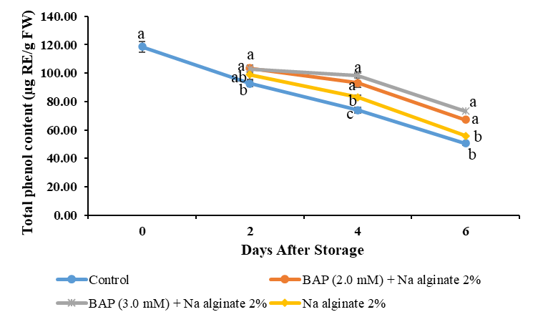
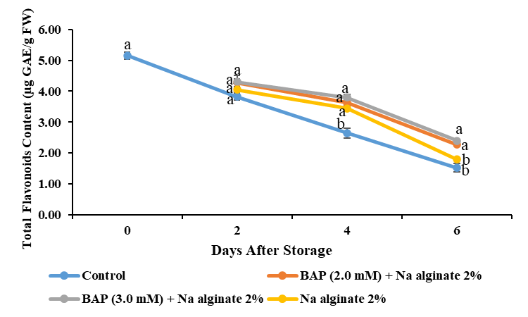
(a)
(b)

Figure 1: The combined effect of 6-benzyl amino purine and sodium alginate coating treatments on total phenol content (a) and total flavonoid content (b) of the pointed gourd fruit during storage under ambient conditions. On each day, data with the same letters are not significantly different (p < 0.05).

Total antioxidant capacity
Bioactive compounds (phenols, flavonoids, ascorbic acid, pigments) contribute to fruit antioxidant capacity (56). Initially, no coated/uncoated antioxidant difference. By 4 DAS, uncoated had the most decline (1.96 ± 0.12), 2.0 mM BAP + 2% sodium alginate coated least (2.35 ± 0.12), akin to 3.0 mM BAP + 2% sodium alginate (2.33 ± 0.06) (Figure. 2a). End storage, uncoated, had the most decline (1.57 ± 0.07), akin to 2% sodium alginate (1.72 ± 0.08). Least degradation (2.00 ± 0.09) occurred in 3.0 mM BAP + 2% sodium alginate, akin to 2.0 mM BAP + 2% sodium alginate (1.97 ± 0.06). BAP delayed senescence via reduced respiration, membrane integrity, lipid peroxidation, H₂O₂, and microbial attacks (7, 8, 36, 46). Sodium alginate coating delays respiration and senescence by limiting exchange, modifying the atmosphere, and curbing oxidation and degradation (52, 55).

Radical scavenging activity (DPPH assay)
DPPH assay measures free radical scavenging ability (57). During storage, antioxidant properties (phenols, ascorbic acid, flavonoids) decline due to oxidation, reducing total antioxidant capacity. Initially, no coated/uncoated difference (Figure. 2b). By 4 DAS, least decline (4.63 ± 0.06) in 2.0 mM BAP + 2% sodium alginate coated fruits, while uncoated had rapid decline (4.10 ± 0.18). At 6 DAS, 3.0 mM BAP + 2% sodium alginate coated fruits showed a minimal decline (4.15 ± 0.09), and uncoated had the highest decline (3.24 ± 0.08). BAP reduced respiration, preserved integrity, reduced lipid peroxidation, H₂O₂, and microbial attacks (7, 8, 36, 46). Sodium alginate coating limited exchange, modified atmosphere, and slowed antioxidant degradation (52, 55).

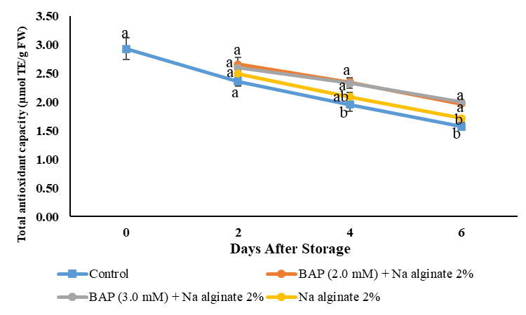
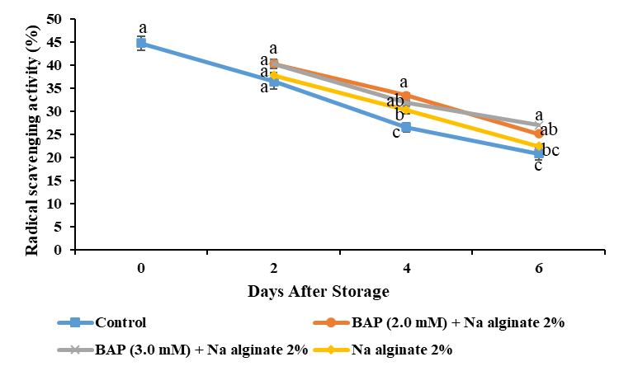
(a)
(b)

Figure 2: The combined effect of 6-benzyl amino purine and sodium alginate coating treatments on total antioxidant (a) and radical scavenging activity (b) of pointed gourd fruit during ambient storage. On each day, data with the same letters are not significantly different (p < 0.05).

CONCLUSIONS
In conclusion, the exogenous application of 6-benzyl amino purine (BAP) and sodium alginate coating to pointed gourd fruits effectively delayed senescence, preserved quality, and reduced weight loss, chlorophyll degradation, and lipid peroxidation during ambient storage conditions. The combination of 3.0 mM BAP + 2% sodium alginate proved the most effective, leading to higher retention of total phenols, flavonoids, and radical scavenging activity than the control. Further investigations into the molecular mechanisms and long-term effects of these treatments are warranted to enhance postharvest management strategies and improve the marketability of horticultural produce.

REFERENCES

- Kumar S, Singh BD. 5 Pointed Gourd: Botany and Horticulture. Horticultural Reviews. 2012; 39(1):203-38. http://dx.doi.org/10.1002/9781118100592.ch5
- Sharmila BG, Kumar G, Rajasekara PM. Cholesterol lowering activity of the aqueous fruit extract of Trichosanthes dioica Roxb. in normal and streptozotocin diabetic rats. J Clinical Diagno Res. 2007;1(6):561-9. https://doi.org/10.7860/JCDR/2007/.164
- Sahoo NR, Bal LM, Pal US, Sahoo D. Effect of packaging conditions on quality and shelf-life of fresh pointed gourd (Trichosanthes dioica Roxb.) during storage. Food Pack Shelf Life. 2015;5:56-62. https://doi.org/10.1016/j.fpsl.2015.06.003
- Kumari M, Solankey SS. Eco-friendly shelf life enhancement of green vegetables by using synthetic cytokinin (6 Benzylaminopurine): An overview. J Pharma Phytoche. 2018;7(5):514-8.
- Wingler A, von Schaewen A, Leegood RC, Lea PJ, Paul Quick W. Regulation of leaf senescence by cytokinin, sugars, and light: effects on NADH-dependent hydroxypyruvate reductase. Plant Physiology. 1998;116(1):329-35.
- Clarke SF, Jameson PE, Downs C. The influence of 6-benzylaminopurine on post-harvest senescence of floral tissues of broccoli (Brassica oleracea var Italica). Plant growth regul. 1994; 14:21-7.
- Siddiqui MW, Singh JP, Nayyer MA, Barman K, Ahmad MS, Kumar V. 6-Benzylaminopurine affects lipid peroxidation and membrane permeability and thereby preserves curd quality and antioxidants during storage of cauliflower. Acta Physio Plantarum. 2015; 37:1-8. http://dx.doi.org/10.1007/s11738-015-1848-1
- Zhang D, Xu X, Zhang Z, Jiang G, Feng L, Duan X, Jiang Y. 6-Benzylaminopurine improves the quality of harvested litchi fruit. Postharvest Biology and Technology. 2018; 143:137-42. http://dx.doi.org/10.1016/j.postharvbio.2018.05.002
- Vu CH, Won K. Novel water-resistant UV-activated oxygen indicator for intelligent food packaging. Food chemistry. 2013; 140(1-2):52-6. https://doi.org/10.1016/j.foodchem.2013.02.056
- Dhall RK. Advances in edible coatings for fresh fruits and vegetables: a review. Critical Rev in Food Sci Nutri. 2013; 53(5):435-50. https://doi.org/10.1080/10408398.2010.541568
- Raghav PK, Agarwal N, Saini M. Edible coating of fruits and vegetables: A review. Education. 2016;1(2):188-204.
- Hershko V, Nussinovitch A. Physical properties of alginate-coated onion (Allium cepa) skin. Food Hydrocoll. 1998; 12(2):195-202. https://doi.org/10.1016/S0268-005X(98)00029-0
- Dhanapal A, Sasikala P, Rajamani L, Kavitha V, Yazhini G, Banu MS. Edible films from polysaccharides. Food Sci Quality Manag. 2012;3(0):9.
- Azarakhsh N, Osman A, Ghazali HM, Tan CP, Mohd Adzahan N. Optimization of alginate and gellan-based edible coating formulations for fresh-cut pineapples. Intern Food Res J. 2012 Feb 1;19(1).
- Chiabrando V, Giacalone G. Effects of alginate edible coating on quality and antioxidant properties in sweet cherry during postharvest storage. Italian J Food Sci. 2015; 27(2):173-80. https://doi.org/10.14674/1120-1770/ijfs.v184
- Díaz-Mula HM, Serrano M, Valero D. Alginate coatings preserve fruit quality and bioactive compounds during storage of sweet cherry fruit. Food Bioproc Techno. 2012:2990-7. http://dx.doi.org/10.1007/s11947-011-0599-2
- Poverenov E, Danino S, Horev B, Granit R, Vinokur Y, Rodov V. Layer-by-layer electrostatic deposition of edible coating on fresh cut melon model: Anticipated and unexpected effects of alginate–chitosan combination. Food Bioproc Techno. 2014:1424-32. http://dx.doi.org/10.1007/s11947-013-1134-4
- Arnon DI. Copper enzymes in isolated chloroplasts. Polyphenoloxidase in Beta vulgaris. Plant physio. 1949;24(1):1. https://doi.org/10.1104%2Fpp.24.1.1
- Roy SK. A simple and rapid method for estimation of total carotenoid pigments in mango. J Food Sci Techno. 1973;10, 38–42.
- Zheng X, Tian S. Effect of oxalic acid on control of postharvest browning of litchi fruit. Food Chem. 2006;96(4):519-23. http://dx.doi.org/10.1016/j.foodchem.2005.02.049
- Jones, E. and Hughes, R. E. Foliar ascorbic acid in some angiosperms. Phytochem, (1983);22(11), 2493-2499. https://doi.org/10.1016/0031-9422(83)80147-2
- Singleton VL, Orthofer R, Lamuela-Raventós RM. [14] Analysis of total phenols and other oxidation substrates and antioxidants by means of folin-ciocalteu reagent. In Methods in Enzymology 1999 (Vol. 299, pp. 152-178). Academic press. http://dx.doi.org/10.1016/S0076-6879(99)99017-1
- Zhishen J, Mengcheng T, Jianming W. The determination of flavonoid contents in mulberry and their scavenging effects on superoxide radicals. Food chem. 1999;64(4):555-9. https://doi.org/10.1016/S0308-8146(98)00102-2
- Apak R, Güçlü K, Özyürek M, Çelik SE. Mechanism of antioxidant capacity assays and the CUPRAC (cupric ion reducing antioxidant capacity) assay. Microchi Acta. 2008;160:413-9. http://dx.doi.org/10.1007/s00604-007-0777-0
- Brand-Williams W, Cuvelier ME, Berset CL. Use of a free radical method to evaluate antioxidant activity. LWT-Food Sci Technol. 1995;28(1):25-30. https://doi.org/10.1016/S0023-6438(95)80008-5
- SAS/STAT^{Ò} user's guide, v. 14.3. Cary, NC, USA: SAS Institute, Inc; 2017. Available from: http://documentation.sas.com/?docsetId=statug&docsetTarget=titlepage.htm&docsetVersion=14.3&locale=en.
- Bhardwaj RL, Sen NL, Mukherjee S. Effect of benzyladenine on Physico-chemical characteristics and shelf-life of mandarin cv Nagpur Santra. Indian J Horti. 2005;62(2):181-3.
- Mandal D, Hazarika TK. Salicylic acid maintained quality and enhanced shelf life of tomato'Samrudhi'at refrigerated storage. In IV Asia Symposium on Quality Management in Postharvest Systems 1210 2017 (pp. 207-212). https://doi.org/10.17660/ActaHortic.2018.1210.29
- Massolo JF, Lemoine ML, Chaves AR, Concellón A, Vicente AR. Benzyl-aminopurine (BAP) treatments delay cell wall degradation and softening, improving quality maintenance of refrigerated summer squash. Posthar Bio Technol. 2014; 93:122-9. http://dx.doi.org/10.1016/j.postharvbio.2014.02.010
- Brasil IM, Gomes C, Puerta-Gomez A, Castell-Perez ME, Moreira RG. Polysaccharide-based multilayered antimicrobial edible coating enhances quality of fresh-cut papaya. LWT-Food Sci Techno. 2012; 47(1):39-45. https://doi.org/10.1016/j.lwt.2012.01.005
- Del Nobile MA, Conte A, Scrocco C, Laverse J, Brescia I, Conversa G, Elia A. New packaging strategies to preserve fresh-cut artichoke quality during refrigerated storage. Innov Food Sci Emerg Techno. 2009;10(1):128-33. http://dx.doi.org/10.1016/j.ifset.2008.06.005
- Chitravathi K, Chauhan OP, Raju PS. Shelf life extension of green chillies (Capsicum annuum L.) using shellac-based surface coating in combination with modified atmosphere packaging. J food Sci technol. 2016; 53:3320-8. https://doi.org/10.1007/s13197-016-2309-6
- Gomez‐Lobato ME, Civello PM, Martínez GA. Effects of ethylene, cytokinin and physical treatments on BoPaO gene expression of harvested broccoli. J Sci Food Agri. 2012;92(1):151-8. https://doi.org/10.1002/jsfa.4555
- Xu F, Yang Z, Chen X, Jin P, Wang X, Zheng Y. 6-Benzylaminopurine delays senescence and enhances health-promoting compounds of harvested broccoli. J Agri Food Chem. 2012;60(1):234-40. https://doi.org/10.1021/jf2040884
- An J, Zhang M, Lu Q, Zhang Z. Effect of a prestorage treatment with 6-benzylaminopurine and modified atmosphere packaging storage on the respiration and quality of green asparagus spears. J Food Engeer. 2006;77(4):951-7. http://dx.doi.org/10.1016/j.jfoodeng.2005.08.024
- Wei Y, Ye X. Effect of 6‐benzylaminopurine combined with ultrasound as pre‐treatment on quality and enzyme activity of green asparagus. J Food Process Preser. 2011;35(5):587-95. https://doi.org/10.1111/j.1745-4549.2010.00504.x
- Maftoonazad N, Ramaswamy HS. Postharvest shelf-life extension of avocados using methyl cellulose-based coating. LWT-Food Sci Techno. 2005;38(6):617-24. http://dx.doi.org/10.1016/j.lwt.2004.08.007
- Gol NB, Chaudhari ML, Rao TR. Effect of edible coatings on quality and shelf life of carambola (Averrhoa carambola L.) fruit during storage. J Food Sci Techno. 2015;52:78-91. http://dx.doi.org/10.1007/s13197-013-0988-9
- Long J, Wang X, Gao H, Liu Z, Liu C, Miao M, Liu J. Malonaldehyde acts as a mitochondrial toxin: Inhibitory effects on respiratory function and enzyme activities in isolated rat liver mitochondria. Life Sci. 2006;79(15):1466-72. https://doi.org/10.1016/j.lfs.2006.04.024
- Wang Y, Yang ZM, Zhang QF, Li JL. Enhanced chilling tolerance in Zoysia matrella by pre-treatment with salicylic acid, calcium chloride, hydrogen peroxide or 6-benzylaminopurine. Bio Planta. 2009;53:179-82. http://dx.doi.org/10.1007/s10535-009-0030-2
- Xu Y, Falk IN, Hallen MA, Fitzgerald MC. Mass spectrometry-and lysine amidination-based protocol for thermodynamic analysis of protein folding and ligand binding interactions. Analytical chem. 2011; 83(9):3555-62. https://doi.org/10.1021/ac200211t
- Chen B, Yang H. 6‐Benzylaminopurine alleviates chilling injury of postharvest cucumber fruit through modulating antioxidant system and energy status. J Sci Food Agri. 2013;93(8):1915-21. https://doi.org/10.1002/jsfa.5990
- Khaliq G, Mohamed MT, Ali A, Ding P, Ghazali HM. Effect of gum arabic coating combined with calcium chloride on physico-chemical and qualitative properties of mango (Mangifera indica L.) fruit during low temperature storage. Sci Horticul. 2015; 190:187-94. http://dx.doi.org/10.1016/j.scienta.2015.04.020
- Cantwell M, Nie X, Hong G. Impact of storage conditions on grape tomato quality. In 6th ISHS postharvest symposium, Antalya, Turkey 2009 Apr 8 (Vol. 8).
- Sammi S, Masud T. Effect of different packaging systems on storage life at different ripening stages and quality of tomato. Internet J food safety. 2007; 9:37-44.
- Siddiqui MW, Bhattacharjya A, Chakraborty I, Dhua RS. 6-Benzylaminopurine improves shelf life, organoleptic quality and healthpromoting compounds of fresh-cut broccoli florets. 2011; 70(6), 461-465.
- Pagliarulo C, Sansone F, Moccia S, Russo GL, Aquino RP, Salvatore P, Di Stasio M, Volpe MG. Preservation of strawberries with an antifungal edible coating using peony extracts in chitosan. Food and Bioprocess Technology. 2016; 9:1951-60. http://dx.doi.org/10.1007/s11947-016-1779-x
- Chen C, Peng X, Zeng R, Chen M, Wan C, Chen J. Ficus hirta fruits extract incorporated into an alginate-based edible coating for Nanfeng mandarin preservation. Sci Horticult. 2016; 202:41-8. http://dx.doi.org/10.1016/j.scienta.2015.12.046
- Rispail N, Morris P, Webb KJ. Phenolic compounds: extraction and analysis. Lotus japonicus handbook. 2005:349-54. http://dx.doi.org/10.1007/1-4020-3735-X_34
- Sharma M, Sitbon C, Paliyath G, Subramanian J. Changes in nutritional quality of fruits and vegetables during storage. Post-harv Bio Techno Fruits, Veget Flow. 2008;45:443-56.
- Nair MS, Saxena A, Kaur C. Effect of chitosan and alginate based coatings enriched with pomegranate peel extract to extend the postharvest quality of guava (Psidium guajava L.). Food chemistry. 2018 Feb 1;240:245-52. https://doi.org/10.1016/j.foodchem.2017.07.122
- Ali A, Muhammad MT, Sijam K, Siddiqui Y. Effect of chitosan coatings on the physicochemical characteristics of Eksotika II papaya (Carica papaya L.) fruit during cold storage. Food chem. 2011 Jan 15;124(2):620-6. https://doi.org/10.1016/j.foodchem.2010.06.085
- Pinelo M, Manzocco L, Nuñez MJ, Nicoli MC. Interaction among phenols in food fortification: negative synergism on antioxidant capacity. J Agri Food Chem. 2004;52(5):1177-80. https://doi.org/10.1021/jf0350515
- Howard LR, Clark JR, Brownmiller C. Antioxidant capacity and phenolic content in blueberries as affected by genotype and growing season. J Sci Food Agri. 2003;83(12):1238-47. http://dx.doi.org/10.1002/jsfa.1532
- Gonzalez-Aguilar GA, Villa-Rodriguez JA, Ayala-Zavala JF, Yahia EM. Improvement of the antioxidant status of tropical fruits as a secondary response to some postharvest treatments. Trends Food Sci Techno. 2010 Oct 1;21(10):475-82. http://dx.doi.org/10.1016/j.tifs.2010.07.004
- Imahori Y, Takemura M, Bai J. Chilling-induced oxidative stress and antioxidant responses in mume (Prunus mume) fruit during low temperature storage. Posthar Bio Techno. 20081;49(1):54-60. https://doi.org/10.1016/j.postharvbio.2007.10.017
- Mishra K, Ojha H, Chaudhury NK. Estimation of antiradical properties of antioxidants using DPPH assay: A critical review and results. Food chem. 2012;130(4):1036-43. http://dx.doi.org/10.1016/j.foodchem.2011.07.127

